Priming Effect Of Low Drought Stress Affects The Regulation Of The Dehydration Responsive Element Binding 4 (DREB4) Gene In Rice Cv. Inpago 6 And Inpago 9 Based On Transcriptome And Gene Expression Analysis

Miftahul Huda Fendiyanto¹,Mentari Putri Pratami², Elsa Gafira Cahyani¹, Ifan Rizky Kurniyanto³, Eko Setiawan⁴, Fandri Sofiana Fastanti², Dwi Lestari⁵, Achmad Kautsar Baharuddin⁶, Muhammad Fuad Anshori^{5,6*},
¹Department of Biology, Faculty of Military Mathematics and Natural Sciences, Indonesia Defense University, Kompleks Indonesia Peace and Security Center (IPSC) Kampus Universitas Pertahanan- Sentul, Bogor 16680 Indonesia.
²Research Center for Biosystematics and Evolution, National Research and Innovation Agency of Indonesia. Jl. Raya Jakarta-Bogor Km. 46, Cibinong, Bogor 16911, West Java, Indonesia
³Department of Agricultural Science and Technology, Faculty of Agriculture, University of Trunojoyo Madura, Bangkalan 69162, Indonesia.
⁴Natural Resource Management Study Program, Faculty of Graduate, University of Trunojoyo Madura, Bangkalan 69162, Indonesia.
⁵Department of Agronomy, Hasanuddin University, Makassar, 90245, Indonesia
⁶Rice Research Group, Faculty of Agriculture, Hasanuddin University, Makassar, 90245, Indonesia
*Corresponding author: Muhammad Fuad Anshori (fuad.anshori@unhas.ac.id)
ABSTRACT

Drought stress is one of the major limiting factors in rice (Oryza sativa L.) cultivation, as it can hinder growth and reduce yield. Improving drought tolerance can be achieved by analyzing the expression of genes involved in the plant's response to drought stress. One of the key genes in the drought tolerance mechanism is the Dehydration Responsive Element Binding 4 (DREB4) gene, which regulates the expression of stress-responsive genes.This study aimed to identify the expression of DREB4 genes in rice under drought stress using transcriptomic analysis of RNA-Seq data, as well as to analyze the expression pattern of the DREB4 in several rice genotypes through qRT-PCR. RNA-Seq data were obtained from an NCBI BioProject and analyzed using the Galaxy platform to identify members of the DREB gene family involved in drought response. Subsequently, expression analysis of the DREB4 gene was performed on rice cv. Inpago 6, Inpago 9, and IR64. The RNA-Seq transcriptomic analysis revealed that members of the DREB4 gene family, particularly OsDREB2A, play important roles in rice's response to drought stress. Meanwhile, qRT-PCR analysis showed that the highest expression level of the DREB4 gene under low drought stress was observed in Inpago 9 (250- fold), followed by IR64 (7.5-fold), and Inpago 6 (2.5-fold). These findings indicate that DREB4 plays an active role in the drought tolerance mechanism as priming effect and may serve as a potential candidate gene for the development of drought-tolerant rice varieties particularly Inpago 9.
Keywords: DREB4, drought stress, inpago 6, inpago 9, transcriptomics
1. INTRODUCTION
Rice (Oryza sativa L.) is a principal food crop extensively cultivated in numerous countries, including Indonesia. The production of rice is vital for ensuring national food security, particularly in the face of increasingly severe climate change (Lathif & Listyorini, 2018). Drought represents one of the most significant abiotic stresses affecting rice production globally (Nurdin, 2011). Regions characterized by low precipitation encounter substantial difficulties in sustaining agricultural yields, especially in rice cultivation, thereby necessitating the development of drought-resistant rice cultivars (Roy et al., 2025). Drought stress in arid regions poses a major challenge to agricultural productivity, including in Central Java Province (Nurdin, 2011). Satellite imagery analysis during the 2024 dry season indicated a Vegetation Health Index (VHI) of less than 10. The extent of agricultural land in Central Java experiencing extreme drought is 31.54 km², strong drought is 194.19 km², moderate drought is 778.61 km², low drought is 3,377.00 km², and normal drought is 14,652 km² (Mulyanti et al., 2023). These drought categories are determined based on the VHI value, with a VHI value of less than 10 categorized as extreme, 10–20 as strong, 21–30 as moderate, 31–40 as low, and greater than 40 as normal. The reduction in rice production in several central regions of Indonesia, such as Central Java, is projected to reach 2.8% by 2024 (Nazirah et al., 2015).
Several rice cultivars, such as cv. Inpago 6 and Inpago 9, have been developed to withstand drought stress, demonstrating characteristics of drought resistance and potential adaptability to suboptimal land conditions (Azzahroh et al., 2024; Cahyani et al., 2024; Suwarno et al., 2016). Rice is notably sensitive to water scarcity (Singh et al., 2024; Ramadhan et al., 2024). However, in drought-tolerant cultivars, yield reductions are less pronounced compared to those in susceptible varieties (Azzahroh et al., 2024; Vardhana et al., 2024; Henry et al., 2016). Consequently, the utilization of drought-tolerant cultivars is essential for cultivating plants capable of enduring drought conditions. To elucidate the mechanisms underlying drought resistance in these cultivars, a molecular-based approach is necessary, particularly through the analysis of gene expression associated with drought stress responses.
Rice plants exhibit adaptive responses to drought through a variety of mechanisms, both physiological, such as enhanced water use efficiency and osmolyte accumulation, and molecular, including the activation of protective genes to sustain cellular function (Guo et al., 2022). A critical molecular pathway involves the regulation of gene expression by the AP2/ERF family of Dehydration Responsive Element Binding (DREB) transcription factors. DREBs are proteins that specifically bind to the cis-element DRE (core motif G/ACCGAC) in the promoters of target genes, thereby modulating the expression of numerous genes induced by drought, salinity, or cold stress (Sakuma et al., 2002).
Several cDNAs encoding DRE-binding (DREB) proteins have been identified in species such as Arabidopsis, wheat, rye, canola, and barley (Jaglo et al., 2001). DREB proteins function as trans-activating factors, binding specifically to DRE/CRT sequences and activating the transcription of genes influenced by these sequences. Additionally, DREB transcription factors have been identified in rice (Sakuma et al., 2002). Notable DREB genes identified include OsDREB4-1 and OsDREB4-2 (Tian et al., 2005). The expression of OsDREB4-1 is induced by dehydration and high salinity, whereas OsDREB4-2 is constitutively expressed (Tian et al., 2005). Both genes are classified within the DREB4 subgroup, with OsDREB4-1 acting as a trans-active factor in response to dehydration (Tian et al., 2005). The activation of DREB genes enables plants to maintain water homeostasis and mitigate cellular damage caused by drought stress (Huang et al., 2020; Fendiyanto et al., 2025).
RNA-Seq-based transcriptomic methodologies have been extensively employed in research to elucidate the regulation of gene expression under diverse environmental conditions. Transcriptomic analysis facilitates the comprehensive identification of gene expression patterns, thereby enhancing our understanding of plant adaptation mechanisms to drought stress (Zaffar et al., 2025). Through this approach, researchers can identify pivotal genes, such as DREB4, that contribute to drought response and pinpoint candidate genes with greater adaptability to climate change (Fendiyanto et al., 2025; Zaffar et al., 2025). Nonetheless, research on rice transcriptomics in response to drought stress remains limited. Consequently, this study aims to identify genes involved in the molecular response to drought stress through a transcriptomic approach utilizing RNA sequencing data and to verify DREB4 gene expression concerning the priming effect of low drought stress in Inpago 6 and 9 cultivar..
2. MATERIALS AND METHODS
2.1 Experimental Design
The materials needed in this research are rice seeds cv. Inpago 6, Inpago 9, and IR64, plant growth medium, PEG 6000 drought stress solution, RNA extraction reagent, DREB and Actin gene primers, qRT-PCR kit, liquid nitrogen, Trizol reagent, Chlorofoam, Isopropanol, ethanol, ddH2O, TBE buffer, DN Master Mix, Green Master Mix, Forward and Reverse primers, cDNA template, Tris HCl, RevertAid RT, RiboLock RNase Inhibitor 250 mM Tris-HCl (pH 8.3) 250 mM, KCl 20 mM MgCl2 50 mM DTT, 10 mM dNTP Mix, Oligo(dT)18 primer 100 μM, Random Hexamer primer 100 μM, Forward GAPDH primer 10 μM, Reverse GAPDH primer 10 μM
2.2 Research Procedure
2.2.1. Seed Preparation, Germination, and PEG-Induced Drought Stress Treatment in Rice Cultivars
Rice cultivar seeds of cv. Inpago 6, Inpago 9, and IR64 were selected to ensure their quality using a water-soaking method, selecting seeds that sank as an indication of good viability (Fendiyanto et al., 2025). The rice seeds were germinated on moist cotton for 5 days. The germination process began with sterilization of the petri dishes and other equipment to prevent contamination. The petri dishes were lined with cotton that had been evenly moistened with water, but not submerged. The rice seeds were placed on the moist cotton, with sufficient spacing to prevent mold growth due to excess moisture. The petri dishes were then tightly closed to maintain humidity and prevent contamination from outside air. The environmental conditions were then adjusted to a dark environment to support the germination process. The germination process lasted for 7 days before the seeds were transferred to a liquid medium. Germinated rice seeds were planted using Hoagland medium (Wulandari & Mar’Atussholihah, 2022), with a standard solution of 2 liters: 10 mL of 1M Ca(NO3)2, 1 mL of KNO3, 4 mL of 1M MgSO4, 2 mL of 1M KH2PO4, and 2 mL of 1M FeEDTA. In the stress treatment group, PEG 6000 1% (w/v) was added to the medium to induce an initial plant response without causing severe stress, thus triggering a priming effect that can increase resistance to subsequent osmotic stress (Arnon & Hoagland, 1944). During the growth process, the water in the medium was changed every two days to prevent fungal growth (Susilawati et al., 2022). Each rice cultivar was allowed to grow under normal conditions for three days before being subjected to drought stress. Initially, all plants showed normal growth. The drought stress treatment was then administered for four days, with plant conditions monitored periodically to ensure the drought had produced physiological effects, such as wilting or changes in leaf color. After the treatment period, plants from both groups were harvested for further analysis. After the treatment, leaf tissue samples from the control and treatment plants were carefully taken using sterile scissors. Samples were taken from different plants to ensure biological variation, with five plants per group. Data on leaf and root length from each cultivar were then statistically evaluated using analysis of variance (ANOVA). Data were first tested for normality using the Shapiro-Wilk test, and if the data were normally distributed, then tested for homogeneity using Levene's test.
2.2.2. RNA Isolation
RNA isolation was performed using the TRIzol method. Rice plant leaves were ground using liquid nitrogen until they became powder. A total of 1 mL of TRIzol Reagent was added to a 1.5 mL Eppendorf tube containing the ground rice, then vortexed and left for 5 minutes at room temperature. After that, 0.2 mL of chloroform per 1 mL of TRIzol was added, then the mixture was inverted for 15 seconds and incubated for 2-3 minutes at room temperature.
The mixture was then centrifuged at 12,000 × g for 15 minutes at 4°C, forming three phases: the upper phase (containing RNA), the interphase (containing DNA), and the lower phase (containing protein). The upper phase containing RNA was carefully transferred to a new tube. A total of 0.5 mL of isopropanol was added to the RNA solution, then mixed gently and centrifuged again at 12,000 × g for 10 minutes at 4°C. The supernatant was discarded, and a transparent RNA pellet was visible at the bottom of the tube. After that, 0.5 mL of 75% ethanol was added, incubated at room temperature for 10 minutes, and then centrifuged again at the same speed. After that, the supernatant was discarded, and the RNA pellet was dried for 5-10 minutes. The RNA was then dissolved by adding 20 μL of ddH2O. The dissolution process was carried out using a tapping technique (gently tapping the tube) to prevent damage to the RNA. The RNA solution was then incubated in a water bath at 55-60°C for 10 minutes to dissolve completely. After that, the RNA was ready to use or stored at -70°C for long-term storage (Puspitaningrum & Salamah, 2021).
RNA purity was analyzed using a Nanodrop spectrophotometer by measuring absorbance at a wavelength of 260 nm, and determined based on the A260/A280 ratio. The isolated RNA was tested using electrophoresis on a 1% agarose gel with 1x TBE buffer, run at 48 Volts for 30 minutes. The electrophoresis results were observed using a UV transilluminator (Rio et al., 2010).
2.2.3. cDNA Synthesis from Isolated RNA
The cDNA synthesis process begins with preparing an RNA template that has been confirmed free of DNA contamination through DNase I treatment. The RNA template is then mixed with an oligo(dT) primer, which serves as the primer for cDNA synthesis initiation. This mixture is heated at 65°C for 5 minutes, then cooled to 4°C to allow the primer to bind optimally to the RNA template. Next, the cDNA synthesis reaction is carried out by adding reaction buffer, dNTP mix, RNase inhibitor, and reverse transcriptase enzyme (ReverAid RT 200 U/μL) to the RNA-primer mixture. The reaction is incubated at 42°C for 60 minutes to allow the reverse transcriptase enzyme to efficiently synthesize cDNA from the RNA template (Velayati et al., 2023; Fendiyanto et al., n.d.).
The reaction is then stopped by heating at 70°C for 5 minutes to inactivate the enzyme. Once synthesis is complete, the resulting cDNA can be diluted and used for PCR or RT-qPCR amplification. To avoid degradation, cDNA is stored at -20°C or -70°C for long-term storage. Verification of cDNA products is carried out through electrophoresis of PCR results using Actin gene primers and DREB4 genes, as listed in Table 1. The amplification process is carried out using a PCR machine, with a temperature setting of 95°C for 10 minutes, followed by 50 repetition cycles
2.3 Data Observation and Analysis
RNA-seq data were processed using the Galaxy bioinformatics platform for transcript mapping. This analysis enabled the identification of genes involved in rice’s response to drought stress, including DREB4 genes and other regulatory pathways. Subsequently, RT-qPCR data were analyzed to determine the relative expression levels of selected target genes. Relative expression was calculated using the 2^(-ΔΔCt) method (Fendiyanto et al., n.d.; Sindiya et al., 2024), as follows:
DREB4 Gene Expression: 2^(-ΔΔCt)
Where ΔCt represents the difference between the cycle threshold (Ct) of the target gene and that of the actin reference gene, and ΔΔCt represents the difference between the ΔCt of the treatment sample and the ΔCt of the control sample.
3. RESULTS AND DISCUSSION
3.1 Analysis of Inpago Rice Growth Under Drought Stress
Drought stress in rice plants can impede growth by restricting cell elongation and root system development, leading to smaller leaves, underdeveloped roots, and ultimately reduced grain yield (Schmittgen & Livak, 2008)*. In this investigation, rice plants were cultivated until they reached the early vegetative growth phase, specifically at the stage when drought stress typically occurs. On the 10th day post-germination, drought stress was induced in half of each rice cultivar by incorporating PEG 6000 1% (w/v) into Hoagland's solution. Following a 4-day stress period, variations in growth were observed among the cultivars, particularly in terms of leaf and root length (Fig. 1).
Visual observations 14 days after germination revealed striking differences between the control and drought-stressed conditions. The tested rice cultivars, cv. Inpago 6, Inpago 9, and IR64 showed leaves that appeared shorter and wilted under mild drought stress, while the roots showed a variable pattern (Fig. 1). Morphologically, drought can reduce the turgor potential of leaf cells, thereby slowing cell elongation and limiting leaf growth (Sadhukhan et al., 2024). Observations showed that the leaf and root length of rice cv. Inpago 6 under drought stress appeared shorter than those under normal conditions (Fig. 1).
A similar finding was found in rice cv. IR64 (Fig. 1), which showed visibly shorter leaf length. Furthermore, plant accessions died under drought stress conditions in rice cv. IR64. Meanwhile, rice cv. Inpago 9 showed relatively stable growth between the control and stress treatments (Fig. 1). No significant differences were observed in leaf length between the two treatments, although there was a reduction in the number of tillers in the roots. Inpago 9 rice has been officially recognized as having drought tolerance, which allows for relatively stable plant growth even under water-stressed conditions (Susanto et al., 2022).
3.2 Characteristics of Leaf Length and Root Length of rice cv. Inpago
In this study, leaf and root length growth were statistically evaluated using analysis of variance (ANOVA) to determine significant differences between cultivars under control and drought stress conditions. Prior to conducting the analysis of variance (ANOVA), assumption tests were conducted to ensure that the data met the requirements for parametric testing. Normality was tested using the Shapiro-Wilk normality test for root and leaf length. The results showed a p-value of 0.1522 for root length and 0.1488 for leaf length. Because both p-values were greater than the α = 0.05 significance level, it can be concluded that the data were normally distributed (Kwak, 2023).
Homogeneity of variance was tested using Levene's test using the median centering method. The p-values for leaf and root length were 0.3719 and 0.2451, respectively, indicating no significant difference in variance between groups (p > 0.05). Therefore, the assumption of homogeneity of variance was also met, allowing further data analysis using ANOVA (Das et al., 2022). The results of the ANOVA analysis of leaf length and root length are presented in Appendix 1. No significant effect of treatment or variety was found on leaf length (p > 0.05), although there was a tendency for differences in the means between cultivars. Similarly, for root length, neither treatment nor cultivar showed a significant effect (p > 0.05). These results indicate that drought stress treatment did not statistically affect leaf or root length in the three cultivars tested.
The data visualization in Fig. 1 provides additional information regarding the data distribution. In the leaf length boxplot (Fig. 1D), the Inpago 6 cultivar showed a decrease in leaf length due to the stress treatment, while Inpago 9 showed a relatively stable median value with a more central distribution. The IR64 cultivar experienced a decrease in median leaf length under stress. Overall, there is an indication that the treatment tended to decrease leaf length, although this was not statistically significant. These results align with previous findings that drought stress can inhibit leaf growth by affecting turgor and cell division rate (Sobahan et al., 2022).
A similar pattern was observed in the root length boxplot (Fig. 1E). Inpago 6 had a higher primary root length under control conditions, while Inpago 9 showed high variability in its response. IR64 experienced a decrease in median root length under stress treatments. The varying responses among cultivars suggest differences in drought adaptation strategies, both morphologically and physiologically. Some cultivars exhibited reduced root growth as a water conservation strategy, while others may prioritize root growth to explore deeper water (Tiwary et al., 2025).
Although not statistically significant, the observed patterns suggest a tendency for drought stress to affect root and leaf morphology, depending on the cultivar. This indicates that drought adaptation mechanisms are complex, involving physiological and genetic regulation that is not solely reflected in morphological parameters. Therefore, to further understand the mechanisms of this adaptation, molecular approaches such as gene expression analysis related to drought tolerance are necessary. One of the genes involved in the response to drought stress is DREB4, which functions to regulate the molecular pathway of abiotic stress signal transduction and activate the expression of target genes involved in osmotic tolerance and cell protection (Lata & Prasad, 2011). Analysis of DREB4 gene expression along with transcriptomic approaches will provide more in-depth information regarding cultivar-specific responses to drought stress and support the development of superior drought-tolerant varieties through marker-based selection.
3.3 Transcriptomic Analysis of Gene Expression Patterns in Response to Drought Stress
The factor analysis focused on four factor dimensions based on the optimal percentage of variance, which reached 86% (Fig. 2A). Based on this analysis, biological yield variability was found in factor 1 with a loading value of 0.26. This potential was also in line with the total number of tillers, the number of productive tillers, flowering age, harvest age, panicle length, and grain number per panicle. However, flowering age (0.08) and panicle length (0.05) have very low loading values below 0.1, so these two traits were not recommended for further analysis. Therefore, total tiller number, productive tiller number, flowering age, and grain number per panicle become the ideal criteria to proceed with in the path analysis of biological yield.
The transcriptomic data in this study were obtained from Bioproject PRJNA922103, which contains a gene expression dataset from Oryza sativa L. Japonica Group cv. Nipponbare plants subjected to 8 hours of drought stress at 10 days after germination. This bioproject was selected because it provided relevant RNA-Seq data for analyzing plant responses to water-limited environmental conditions. The sequencing instrument used was Illumina MiSeq. The dataset consisted of samples categorized into control and drought-stressed conditions, allowing for differential gene expression (DGE) analysis.
RNA-Seq data quality was assessed using FastQC and summarized using MultiQC. The analysis results showed that all samples had high quality values, with an average Phred Score >30, GC content consistent with rice genome characteristics (~49-50%), and duplication levels within reasonable limits (37.9% - 47.1%). Based on these results, the sequencing data was suitable for further differential gene expression analysis (Conesa et al., 2016). After analyzing the data quality, preprocessing was performed using Cutadapt to remove adapters or low-quality sequences. This process aims to ensure that only high-quality data is used in the analysis, resulting in more accurate and standardized results (Martin, 2013).
After the trimming process was complete, alignment was performed against the rice reference genome using RNA-STAR. The reference genome used in this analysis was obtained from the International Rice Genome Sequencing Project (IRGSP), with the reference genome file IRGSP-1.0_genome.fasta.gz and the annotation IRGSP-1.0_representative_annotation_2024-07-12.tsv.gz. The alignment results showed a high mapping rate (>90%), indicating that the data was of good quality and suitable for further analysis. Read orientation validation analysis was performed using the Infer Experiment tool. The Infer Experiment results showed that the read orientation was predominantly distributed in one direction (++/--) or (+-/-+), depending on the sample, with values ranging from 0.31 to 0.76. This variation corresponds to the type of stranded library used (Appendix 2). No failures in determining orientation were found (0.0000 failed), so the data were deemed valid for expression quantification analysis.
Next, gene expression was quantified using FeatureCounts, which counts the number of reads mapped to each gene in the dataset. These quantification results were then used in differential expression analysis with DESeq2, which aimed to identify genes differentially expressed between drought-stressed and control samples. The analysis revealed that 1,793 genes were identified as upregulated and 1,793 genes as downregulated, with a threshold of |log2 Fold Change| ≥ 1 and an adjusted p-value (FDR) < 0.05. Genes showing significant expression changes were further analyzed to understand the response mechanisms to drought stress in the studied rice cultivars. This analysis resulted in a gene expression dataset ready for further exploration of rice drought resistance mechanisms, including the identification of candidate genes with potential roles in regulating plant adaptation to environmental stress conditions.
Differentially Expressed Genes (DEG) analysis is a crucial step in transcriptomic studies to identify genes that experience significant changes in expression levels due to a specific treatment, in this case, drought stress. This analysis generally uses a negative binomial distribution model to detect differences in gene expression between two groups: control and drought stress (Love et al., 2014). Before evaluating significantly differentially expressed genes, data quality analysis and global visualization of gene expression are performed to ensure the reliability of the results. Initial visualizations such as Principal Component Analysis (PCA) and heatmaps of intersample distances are used to assess data quality, intersample relationships, and verify separation between treatment groups. The results of this DEG analysis provide the basis for understanding the molecular response of rice plants to mild drought stress.
The first visualization performed is Principal Component Analysis (PCA), which aims to reduce the dimensionality of transcriptomic data and observe global variation in gene expression between samples. PCA results are displayed as a two-dimensional plot that maps each sample based on its first (PC1) and second (PC2) principal components. In this analysis, PC1 explained 95% of the total variation in the data, while PC2 accounted for 3% of the variation, indicating that most of the variation in gene expression between samples can be explained by the PC1 axis (Fig. 2A). This separation indicates significant changes in gene expression in response to the drought treatment.
The PCA plot shows a very clear separation between samples from the Control and Drought Stress groups. Control samples are located on the left side (negative PC1 values), while samples from the drought treatment group are clustered on the right side (positive PC1 values). This pattern indicates that the drought treatment has a consistent and significant effect on overall gene expression. Furthermore, the close clustering within each group indicates that the biological replicates within each condition have good consistency. These results are consistent with the literature stating that PCA can be used to identify key variables influencing gene expression and validate data quality and structure before further differential analysis (Pereira et al., 2018). Thus, PCA successfully demonstrated that the drought treatment has a significant transcriptomic effect distinct from the control condition.
After PCA visualization demonstrated a clear separation between the control and drought-stressed groups based on global gene expression, the analysis continued with a heatmap of intersample distances to evaluate the expression proximity between replicates within each group. The heatmap results showed that samples from the control and drought-stressed treatment groups formed two clearly separated clusters, reflecting that treatment conditions were the primary factor differentiating gene expression patterns (Fig. 2B). The distances between samples within each group were relatively small, indicating a high degree of consistency between replicates. Conversely, the distances between samples from the control and treatment groups were quite large, indicating significant changes in gene expression patterns due to drought stress.
The heatmap visualization of intersample distances (Fig. 2B) shows the pattern of gene expression proximity between rice plants under control and mild drought stress conditions. Based on the distance analysis, samples from the drought-stressed group formed a dense cluster with a low interreplicate distance, indicated by the dark blue color on the diagonal of the cluster. This indicates that replicates in the drought-stressed group exhibit consistent gene expression patterns. In contrast, samples from the control group showed greater variation between replicates, reflected by the lighter color (white to light blue) in the interaction areas between control samples. This indicates a relatively larger distance between control samples compared to the drought-stressed group, although still within reasonable limits.
Furthermore, the distance between biological replicates within a single group (both control and drought-stressed) showed good uniformity, indicating consistent data quality and low technical variation between replicates. Meanwhile, the higher distance values between the control and drought-stressed groups strengthen evidence that the drought treatment affected changes in gene expression patterns. These results support the sustainability of the differential gene expression (DEG) analysis, as the data structure showed cluster separation consistent with the treatment design, and no outliers were found among the samples.
DESeq2 models RNA-Seq count data using Negative Binomial (NB) with mean μ and dispersion parameters α (Love et al., 2014). With NB, variance is calculated as var = μ + α · μ², so that genes with relatively low expression have high variance (dispersion), and genes with high expression are relatively stable. DESeq2 estimates dispersion per gene separately (gene-wise), then fits a dispersion trend curve to the mean expression (Love et al., 2014). A dispersion estimation plot is then generated, showing the estimated dispersion for each gene (black dots) and the fitted/predicted dispersion value (red curve).
Based on the resulting plot (Fig. 2C), most genes are distributed around the fitted curve (red), indicating that the NB model fits the data well (Petrany et al., 2024). According to Nowicka and Robinson (2025), a characteristic of good RNA-Seq is a downward trend between mean expression and dispersion. Genes with low expression have relatively high dispersion, while genes with high expression have low dispersion. The negative mean-dispersion pattern in the plot (Fig. 2C) indicates that the RNA-Seq data have been well normalized and fit the assumptions of the NB model, and the statistical model fits the data.
Conversely, the distribution of p-values from the DESeq2 differential gene expression analysis between drought stress and control treatments shows a high-frequency peak near p=0 (Fig. 2D). This pattern is consistent with the expectation that p-value histograms in high-resolution experiments will be a combination of a uniform distribution (for genes with no differential expression) and a distribution dominated by low p-values (for genes with significant differential expression) (Ereful et al., 2021). A peak near 0 indicates that most genes reject the null hypothesis (many genes differ between conditions) (Ereful et al., 2021). Thus, the observed p-histogram pattern (a clustering of low p-values) adds confidence that the DESeq2 analysis results are valid and reflect a real biological signal, not a statistical artifact. The DESeq2 method itself models count data using a negative binomial GLM and performs a Wald test to obtain p-values, which are then adjusted (FDR adjustment) using the Benjamini–Hochberg procedure (Love et al., 2014). A total of 1,793 genes were upregulated and 1,793 genes were downregulated (a total of 3,586 genes significant with adjusted p<0.05), which was found to be consistent with the p-value distribution of a real biological effect under drought stress conditions.
In the MA plot, the X-axis represents the mean expression (mean normalized counts) and the Y-axis represents the log2 fold change (LFC) between the drought stress and control groups (Love et al., 2014). Colored gene dots (e.g., blue) indicate significant genes (padj <0.1 or other threshold). A general characteristic of the MA plot is symmetry of the dots around the zero horizontal line (no change in expression), with some genes scattered above/below it for positive/negative log2FC. The log2FC value itself indicates the magnitude of the biological effect; for example, a log2FC of 1.5 represents an approximately 2^1.5-fold increase in expression under stress conditions (Wang et al., 2025).
Biologically, genes that are differentially expressed under drought stress play a role in the water stress response mechanism. Many studies have reported that under drought stress conditions, high gene expression is involved in the accumulation of osmoregulatory substances (e.g., proline and soluble sugars) for antioxidant defense in dry plants. The accumulation of proline and sugars is a crucial strategy for resisting cellular osmotic stress during drought. Antioxidant enzymes such as superoxide dismutase (SOD) and peroxidase (POD) increase to mitigate oxidative damage, reflecting the activation of cellular defense genes (Wang et al., 2025). Conversely, photosynthesis and primary metabolism genes are often repressed (negative log2FC) during drought (Ma et al., 2022). Metabolites sometimes correlate to the gene expression in other plants like Jatropha (Fendiyanto et al., 2024). Thus, the results of this analysis demonstrate an expression profile consistent with plant adaptive mechanisms to drought. DEG identification revealed 1,227 genes with increased expression and 1,227 with decreased expression (p.adj <0.05 and log2FC >=2). This knowledge is important for understanding specific molecular pathways and can serve as a starting point for further functional analysis, such as gene annotation or co-expression module analysis in the context of drought tolerance.
Analysis of various plots demonstrated clear differences in gene expression between control and drought-stressed samples. The heatmap indicates clustering that differentiates the two conditions, while the dispersion estimation plot demonstrates the stability of the data for differential analysis. The histogram of p-values and MA-plot revealed that most genes did not experience significant changes, but several genes showed significant upregulation or downregulation. These results confirm that drought stress affects the expression of specific genes, which could be the focus of further research in understanding plant adaptation mechanisms.
In this study, differential gene expression data was visualized using a volcano plot, a common graphical representation method in RNA-seq analysis. Volcano plots map the relationship between statistical significance (p-value) and the magnitude of gene expression change (log2 fold change) (O’Connell, 2025). This approach allows genes experiencing the most significant changes in expression, both biologically and statistically, to be visually identified more easily. Significantly upregulated genes are displayed on the right side of the graph, while significantly downregulated genes are displayed on the left side. Genes with the highest level of statistical significance are displayed at the top (O’Connell, 2025).
The volcano plot results in this study were obtained from differential expression data analysis using the DESeq2 package (Fig. 3), which has proven reliable in identifying genes involved in responses to environmental stresses, including drought stress (Love et al., 2014). One of the genes that appeared in the significantly up-expressed group was the DREB (Dehydration Responsive Element Binding) gene, which is known to function as an important transcription factor in the regulation of gene expression related to abiotic stress, including drought.
In this analysis, several genes from the DREB (Dehydration Responsive Element Binding) family were successfully detected in the differential expression results (Fig. 3C), including the Os01t0165000-01/02 and Os08t0545500-01 genes. The Os01t0165000-01/02 gene showed a very high expression level with a log2 fold change (log2FC) value of 21.03 and an adjusted p-value (padj) of 2.52 × 10⁻⁷. This value shows very strong significance, indicating that the expression of this gene experienced a dramatic increase under drought stress conditions. This gene is suspected to be a homolog of OsDREB2A, which is known to be an important transcription factor in the regulation of abiotic stress response genes, including drought (Yavuz, 2025).
In contrast, the Os08t0545500-01 gene had a log2FC value of -0.65 and a padj value of 0.772. These values are well above the general significance threshold (padj <0.05), so this gene was not categorized as significantly differentially expressed. In other words, the expression of the Os08t0545500-01 gene showed no significant changes between control and drought stress conditions. In addition to these two genes, several other DREB genes were also detected in the dataset, but had a baseMean value of 0, meaning there were no gene expression readings in either the control or stress conditions. This suggests that these genes are likely not expressed in the tissue or sampling time used in this study, or are below the detection limit of the sequencing technology used. Overall, these findings support the role of the Os01t0165000 gene as a strong candidate in the molecular response of rice plants to drought stress, and strengthen our understanding of the role of DREB transcription factors in abiotic stress tolerance. DREB2 (Dehydration-Responsive Element-Binding Protein 2) is a member of the AP2/ERF family of transcription factors that plays a key role in regulating plant responses to drought stress. Activation of DREB2 expression triggers a stress protection pathway by binding to the DRE/C-repeat element in the promoter region of target genes, which subsequently induces the expression of various stress response genes such as LEA (Late Embryogenesis Abundant) genes, dehydrins, starch-degrading proteins, and HSP (Heat Shock Proteins). These proteins function to protect cell structure and maintain plant physiological stability under water deficit conditions (Kumar et al., 2024).
Increased expression of OsDREB2A, thought to be represented by the Os01t0165000 gene in this study, may increase the accumulation of protective proteins and osmolytes, which play a role in maintaining turgor and cellular stability during stress. Previous research has shown that transgenic rice plants overexpressing OsDREB2A have a higher survival rate under drought stress than control plants, confirming the important role of this gene in adaptation to abiotic stress (Cui et al., 2011). The very high log2FC value indicates dramatically increased expression under drought stress conditions. This strengthens the hypothesis that increased DREB2 expression, particularly OsDREB2A, is positively correlated with increased rice plant drought tolerance.
Based on the literature, the DREB (Dehydration-Responsive Element-Binding) gene family is divided into two main subgroups, DREB1/CBF and DREB2, which are regulated by distinct signaling pathways. The DREB1/CBF genes are predominantly induced by low temperatures (cold stress), while DREB2 is activated by drought, high salinity, and high temperatures (heat stress) (Ma et al., 2016). Thus, DREB1 is generally associated with the response to cold stress, while DREB2 plays a key role in drought adaptation mechanisms. This finding aligns with the analysis in this study, where 8 hours of drought stress significantly increased DREB2 gene expression, particularly OsDREB2A (Os01t0165000), while the DREB1/CBF gene showed no significant expression changes. This reinforces the interpretation that the observed regulation of DREB expression is directly related to drought tolerance mechanisms, and not a consequence of cold exposure. The literature also reports that overexpression of DREB1 or DREB2 genes can enhance plant resistance to various abiotic stresses. However, this increase is often accompanied by phenotypic side effects, such as stunted plant growth (Ma et al., 2016).
3.4 DREB4 Gene Expression as Priming Effect of Drought Stress in Inpago cultivars
To analyze gene expression, isolates verified to have the target gene were subjected to qRT-PCR using a pair of primers specific for the Actin gene and the target gene DREB4. The qRT-PCR results are depicted as an amplification plot. For the housekeeping Actin gene, the curves in all three test samples (Inpago 6, Inpago 9, and IR64) reached the detection threshold (threshold cycle or Ct) at around 20–25 cycles, indicating relatively high and consistent expression. This indicates that Actin gene expression is stable and unaffected by drought stress.
Meanwhile, the amplification results for the target gene (DREB4) reflected varying levels of expression (Fig. 3). In some samples, the amplification curves crossed the detection threshold early (Ct around 28–32), indicating induction of gene expression. Conversely, several other curves did not reach the detection threshold, indicating very low or undetectable expression (control condition). The DREB4 gene showed low expression in the control and was strongly induced by drought treatment, which can be quantified using the ΔΔCt method.
Quantitative calculation of qRT-PCR results using the ΔΔCt method, with the reference gene ACTIN, is shown in a bar chart (Fig. 4). In the Inpago 6 cultivar under normal, non-stress conditions, DREB4 gene expression was relatively low. A high Ct indicates minimal transcriptional activity of the DREB4 gene under control conditions. An increase then occurred after drought treatment, with DREB4 gene expression increasing approximately 2.5-fold compared to the control (Fig. 4). This indicates that DREB4 is induced by drought stress, signifying the activation of the molecular response pathway to dehydration (Lata & Prasad, 2011).
In Inpago 9, DREB4 gene expression was very low under control conditions. Expression then increased 14-fold after drought treatment compared to the control. This is the highest expression among the three cultivars, indicating that Inpago 9 has a highly responsive molecular mechanism to drought through the DREB4 regulatory pathway. On the other hand, the IR64 cultivar also showed very low DREB4 expression under normal conditions. The high Ct in the amplification plot supports that this gene is almost inactive in the absence of environmental stress. Then, after drought stress, DREB4 expression in IR64 increased drastically up to 16-fold compared to the control. This increase was the highest of all cultivars, indicating a strong genetic induction ability of DREB4 when facing drought (Susanto et al., 2022).
3.2 Discussion
Dehydration-Responsive Element Binding (DREB) genes were initially identified in Arabidopsis thaliana. The AtDREB1 and AtDREB2 genes have been demonstrated to enhance plant tolerance to drought and low temperatures (Sakuma et al., 2002). DREBs are part of the AP2/ERF superfamily and contain highly conserved AP2/ERF domains, which facilitate their interaction with the DRE/CRT cis-elements in target gene promoters (Huang et al., 2020). In numerous plant species, including rice, DREBs are instrumental in regulating the expression of genes involved in abiotic stress defense mechanisms (Sakuma et al., 2002). DREB genes are pivotal in enabling plants to manage stress independently of ABA (Lata & Prasad, 2011). These genes contribute to the expression of various stress-responsive genes. The initial cDNAs isolated for DRE-binding proteins, specifically CBF1, DREB1A, and DREB2A, were discovered through a yeast one-hybrid screening method from Arabidopsis. Subsequently, numerous other DREB genes have been isolated from various plant species. These proteins possess the specific capability to bind DRE sequences, thereby triggering the expression of associated genes (Lata & Prasad, 2011).
Transcriptomics is a scientific discipline focused on the study of transcriptomes, which are the complete set of RNA molecules transcribed from the genome of a specific organism or cell, along with their expression levels. Research in transcriptomics entails the analysis of gene expression patterns through the detection and quantification of RNA transcripts (Shahid, 2024). RNA sequencing (RNA-Seq) is a widely employed technique in this field, involving the sequencing of RNA molecules to achieve a comprehensive and precise representation of the transcriptome. This technology facilitates the measurement of gene expression levels and aids in identifying variations in gene expression across different samples or conditions. The analysis of transcriptomics data necessitates the application of various computational and statistical methodologies. This analytical process encompasses read sequence alignment, transcript assembly, quantification of gene expression levels, differential expression analysis, and functional annotation. Bioinformatics tools and databases are indispensable for managing and analyzing the substantial volumes of data generated from transcriptomics experiments (Shahid, 2024).
Transcriptomics holds significant potential in the realms of biological and medical research. Within the agricultural sector, transcriptomics is employed to elucidate the mechanisms underlying plant tolerance to abiotic stresses, such as drought and salinity. By examining alterations in gene expression under stress conditions, researchers can pinpoint key genes implicated in plant adaptive responses. Additionally, transcriptomics facilitates the discovery of potential disease biomarkers, the identification of novel metabolic pathways, and the comprehension of complex gene-environment interactions (Huang et al., 2020).
DREB genes are categorized into several subgroups based on their structural and functional attributes, encompassing six primary groups (A1–A6) or four clades (I–IV) (Chai et al., 2020). A prominent example is OsDREB4, a member of the rice DREB gene family. This gene, comprising two homologs, OsDREB4-1 and OsDREB4-2, modulates responses to drought and salinity stress and functions as a transactivating factor in stress signaling pathways (Tian et al., 2005). Both genes encode proteins with a conserved AP2 domain, which binds to DRE elements in DNA. They also possess an N-terminal region that potentially serves as a nuclear localization signal (NLS) and a C-terminal region that may act as a transcriptional activation domain. The OsDREB4 gene plays a crucial role in regulating plant responses to abiotic stress, particularly stress induced by drought and salinity (Tian et al., 2005).
Most plants are inherently immobile and thus incapable of evading adverse environmental changes. Consequently, they have evolved physiological mechanisms to recognize and adapt to such conditions (Batool et al., 2025). A notable form of this adaptation is the response to drought stress, which can be simulated in vitro using polyethylene glycol (PEG). PEG serves as an osmotic agent that reduces the water potential in the root environment without being absorbed by plant tissues, thereby effectively replicating drought-like conditions in a laboratory setting (Sobahan et al., 2022). The application of PEG at low concentrations, such as 1% (w/v), can induce mild osmotic stress, sufficient to trigger initial stress signals in plants (Sobahan et al., 2022). This response involves the activation of specific genes, such as DREB, which are crucial transcription factors in regulating the expression of protective genes against water stress. In this early activation phase, the plant prepares its internal defense mechanisms to withstand hostile environmental conditions (Zaffar et al., 2025; Sobahan et al., 2022).
When confronted with pathogens or environmental stress, rice plants can activate localized defense mechanisms. Systemic Acquired Resistance (SAR) is a well-documented phenomenon in some dicotyledonous plants, initiating a systemic defense response to inhibit the spread of infection. A study by Ahn et al. (2005) demonstrated a priming mechanism in rice through the administration of thiamine to the Hwacheong and Nakdong varieties prior to inoculation with the pathogens Magnaporthe grisea (the causative agent of blast disease) and Xanthomonas oryzae pv. oryzae (the causative agent of leaf blight). The findings revealed that the priming effect significantly mitigated disease severity. Thiamine induced the expression of defense genes such as PR-1, PBZ1, and POX22.3 earlier than the typical response. These results suggest that thiamine holds substantial potential as a SAR-inducing agent for disease management in rice (Ahn et al., 2005). In the future, Rice cv. Inpago 9 could be transformed into a multi-tolerant variety through gene editing, particularly utilizing CRISPR/Cas9 gene editing methods, to enhance drought stress resilience (Fendiyanto et al., 2025).
4. CONCLUSION
In summary, the in silico analysis of RNA-Seq data effectively identified several genes within the DREB family that are implicated in the response of rice plants to drought stress. The expression levels of these DREB genes varied, with OsDREB2A exhibiting the most significant increase in expression (log2FC = 21.03), while several other genes demonstrated low or negative expression levels. Validation of DREB4 gene expression through qRT-PCR analysis across three rice cultivars revealed that drought stress treatment led to an increase in the expression of this gene in all tested cultivars. Specifically, the Inpago 6 cultivar exhibited an approximately 2.5-fold increase in DREB4 gene expression, Inpago 9 showed a 250-fold increase, and IR64 demonstrated a 7.5-fold increase compared to the control condition. These findings suggest that the DREB4 gene plays a pivotal role in the adaptive response mechanism of rice plants to drought conditions, with the Inpago 9 cultivar potentially exhibiting enhanced tolerance to low drought stress, as indicated by priming effect studies
Declarations
Funding: This research was funded by the Indonesian Endowment Fund for Education (LPDP/Lembaga Pengelola Dana Pendidikan) and the National Research and Innovation Agency (BRIN/ Badan Riset dan Inovasi Nasional), through number 152/IV/KS/11/2023, for their financial support of the Riset dan Inovasi untuk Indonesia Maju Gelombang 4 (RIIM 4) research, particularly for the Fiscal Year (FY) 2023-2025 grant PI Mentari Putri Pratami. In addition, this research was supported by Ongoing Research Funding Program, (ORF-2026-751), King Saud University, Riyadh, Saudi Arabia.

Acknowledgments: This research was fully supported by the Indonesian Endowment Fund for Education (LPDP/Lembaga Pengelola Dana Pendidikan) and the National Research and Innovation Agency (BRIN/ Badan Riset dan Inovasi Nasional), through number 152/IV/KS/11/2023, for their financial support of the Riset dan Inovasi untuk Indonesia Maju Gelombang 4 (RIIM 4) research, particularly for the Fiscal Year (FY) 2023-2025 grant PI Mentari Putri Pratami. Also, Ongoing Research Funding Program, (ORF-2026-751), King Saud University, Riyadh, Saudi Arabia is acknowledged.

Conflicts of Interest: The authors declare that they have no known competing financial interests or personal relationships that could have influenced the work reported in this study

Data Availability: The datasets analysed during the current study are available at https://doi.org/10.5281/zenodo.19642846, including RNA-seq data processing and gene expression data, including p-values, gel electrophoresis, and amplification plots from qRT-PCR. The RNA-Seq data used in this study are RNA data with accession number PRJNA922103, available on NCBI.

Ethics Statement: not applicable

Author's Contributions:
MHF: Conceptualization, Methodology, Formal analysis, Investigation, Data curation, Software, Visualization, Writing – original draft, Writing – review & editing.
MPP: Conceptualization, Investigation, Data curation, Writing – original draft, Writing – review & editing.
EGC: Methodology, Formal analysis, Data curation, Investigation, Writing – original draft, Writing – review & editing.
IRK: Methodology, Formal analysis, Writing – original draft, Writing – review & editing. ES: Writing – review & editing.
FSF: Writing – review & editing.
AKB: Writing – review & editing.
MFA: Conceptualization, Methodology, Supervision, Writing – original draft, Writing – review & editing.

Generative AI Statements: The authors declare that no Gen AI/DeepSeek was used for writing/creation of this manuscript. The AI just focus to English Editing Improvement

Publisher's Note: All claims stated in this article are exclusively those of the authors and do not necessarily represent those of their affiliated organizations or those of the publisher, editors, and reviewers. Any product that may be evaluated in this article or claimed by its manufacturer is not guaranteed or endorsed by the publisher or editors.

REFERENCES
Ahn, I.P., Kim, S., Lee, Y.H., 2005. Vitamin B1 functions as an activator of plant disease resistance. Plant Physiology 138, 1505–1515.
Azzahroh, E.Q., Vardhana, D.P., Fendiyanto, M.H., 2024. Carotenoid content test of drought-tolerant Inpago paddy cultivars to support national food security. MUNISI: Military Mathematics and Natural Sciences 2, 54–57.
Batool, I., Ayyaz, A., Qin, T., Wu, X., Chen, W., Hannan, F., Zafar, Z.U., Naeem, M.S., Farooq, M.A., Zhou, W., 2025. Morphological, physiological, and molecular responses to heat stress in Brassicaceae. Plants 14, 152.
Cahyani, E.G., Azzahroh, E.Q., Fendiyanto, M.H., Pratami, M.P., 2024. Enhancing food security: chlorophyll B content in several rice genotypes as an indicator of drought stress tolerance. MUNISI: Military Mathematics and Natural Sciences 2, 49–53.
Chai, M., Cheng, H., Yan, M., Priyadarshani, S., Huang, X., Lai, L., Chen, H., Cai, H., 2020. Identification and expression analysis of the DREB transcription factor family in pineapple (Ananas comosus (L.) Merr.). PeerJ.
Conesa, A., Madrigal, P., Tarazona, S., Gomez-Cabrero, D., Cervera, A., McPherson, A., Szcześniak, M.W., Gaffney, D.J., Elo, L.L., Zhang, X., Mortazavi, A., 2016. A survey of best practices for RNA-seq data analysis. Genome Biology 17, 13.
Cui, M., Zhang, W., Zhang, Q., Xu, Z., Zhu, Z., Duan, F., Wu, R., 2011. Induced over-expression of the transcription factor OsDREB2A improves drought tolerance in rice. Plant Physiology and Biochemistry 49, 1384–1391.
Das, B.K., Jha, D.N., Sahu, S.K., Yadav, A.K., Raman, R.K., Kartikeyan, M., 2022. Analysis of variance (ANOVA) and design of experiments, in: Concept Building in Fisheries Data Analysis. Springer Nature Singapore, Singapore, pp. 119–136.
Ereful, N.C., Laurena, A., Liu, L.Y., Kao, S.M., Tsai, E., Greenland, A., Powell, W., Mackay, I., Leung, H., 2021. Unraveling regulatory divergence, heterotic malleability, and allelic imbalance switching in rice due to drought stress. Scientific Reports 11, 13489.
Fendiyanto, M.H., Anshori, M.F., Pratami, M.P., Wasonga, D.O., Seleiman, M.F., 2024. Metabolite comparative variation related to lipid metabolisms among fruit, leaf, and stem of Jatropha curcas. Heliyon 10.
Fendiyanto, M.H., Kurniyanto, I.R., Setiawan, E., Pratami, M.P., Fastanti, F.S., Wosonowati, C., Vardhana, D.P., 2025. Engineering of sgRNA targeting DREB4 isolated from Oryza sativa using pRGEB32 in CRISPR/Cas9 gene editing. SABRAO Journal of Breeding and Genetics 57, 989–998.
Fendiyanto, M.H., Setiawan, E., Pratami, M.P., Kurniyanto, I.R., Fastanti, F.S., 2025. Construction of a CRISPR/Cas9-mediated genome editing system in manipulating OsART1 from Oryza sativa cv. Inpago 5. Biodiversitas 26.
Fendiyanto, M.H., Setiawan, E., Pratami, M.P., Kurniyanto, I.R., Fastanti, F.S. Construction of a CRISPR/Cas9-mediated genome editing system in manipulating OsART1 from Oryza sativa cv. Inpago 5.
Guo, Z., Cai, L., Liu, C., Chen, Z., Guan, S., Ma, W., Pan, G., 2022. Low-temperature stress affects reactive oxygen species, osmotic adjustment substances, and antioxidants in rice (Oryza sativa L.) at the reproductive stage. Scientific Reports 12, 6224.
Henry, A., Wehler, R., Grondin, A., Franke, R., Quintana, M., 2016. Environmental and physiological effects on grouping of drought-tolerant and susceptible rice varieties related to rice (Oryza sativa) root hydraulics under drought. Annals of Botany 118, 711–724.
Huang, X., Song, X., Chen, R., Zhang, B., Li, C., Liang, Y., Qiu, L., Fan, Y., Zhou, Z., Zhou, H., Lakshmanan, P., Li, Y., Wu, J., 2020. Genome-wide analysis of the DREB subfamily in Saccharum spontaneum reveals their functional divergence during cold and drought stresses. Frontiers in Genetics 10.
Jaglo, K.R., Kleff, S., Amundsen, K.L., Zhang, X., Haake, V., Zhang, J.Z., Deits, T., Thomashow, M.F., 2001. Components of the Arabidopsis C-repeat/dehydration-responsive element binding factor cold-response pathway are conserved in Brassica napus and other plant species. Plant Physiology 127, 910–917.
Kumar, P., Paul, D., Jhajhriya, S., Kumar, R., Dutta, S., Siwach, P., Das, S., 2024. Understanding heat-shock proteins’ abundance and pivotal function under multiple abiotic stresses. Journal of Plant Biochemistry and Biotechnology 33, 492–513.
Kwak, S., 2023. Are only p-values less than 0.05 significant? A p-value greater than 0.05 is also significant!. Journal of Lipid and Atherosclerosis 12, 89.
Lata, C., Prasad, M., 2011. Role of DREBs in regulation of abiotic stress responses in plants. Journal of Experimental Botany 62, 4731–4748.
Lathif, Y., Listyorini, D., 2018. Varietas padi lokal Jawa Timur tahan cekaman kekeringan berdasarkan gen DREB2A. Journal of Tropical Biology 6, 89–95.
Love, M.I., Huber, W., Anders, S., 2014. Moderated estimation of fold change and dispersion for RNA-seq data with DESeq2. Genome Biology 15, 550.
Ma, X., Xia, H., Liu, Y., Wei, H., Zheng, X., Song, C., Chen, L., Liu, H., Luo, L., 2016. Transcriptomic and metabolomic studies disclose key metabolism pathways contributing to well-maintained photosynthesis under the drought and the consequent drought-tolerance in rice. Frontiers in Plant Science 7, 1886.
Ma, Z., Jin, Y.M., Wu, T., Hu, L., Zhang, Y., Jiang, W., Du, X., 2022. OsDREB2B, an AP2/ERF transcription factor, negatively regulates plant height by conferring GA metabolism in rice. Frontiers in Plant Science 13, 1007811.
Martin, M., 2013. Cutadapt removes adapter sequences from high-throughput sequencing reads. Advances in Environmental Biology 7, 2803–2809.
Mulyanti, H., Istadi, I., Gernowo, R., 2023. Historical, recent, and future threat of drought on agriculture in East Java, Indonesia: a review. E3S Web of Conferences 448, 03016.
Nazirah, L., Purba, E., Hanum, C., Rauf, A., 2015. Evaluasi toleransi berbagai varietas padi gogo terhadap cekaman kekeringan dengan penggunaan PEG (Polytilene Glicol). Lentera: Jurnal Ilmiah Sains dan Teknologi 15, 61–68.
Nowicka, M., Robinson, M.D., 2025. DRIMSeq: Dirichlet-multinomial framework for differential transcript usage and transcript usage QTL analyses in RNA-seq.
Nurdin, 2011. Antisipasi perubahan iklim untuk keberlanjutan ketahanan pangan. Jurnal Dialog Kebijakan Publik 4, 21–28.
O’Connell, T.M., 2025. Pathway volcano: an interactive tool for pathway guided visualization of differential expression data. Bioinformatics 41.
Pereira, M.B., Wallroth, M., Jonsson, V., Kristiansson, E., 2018. Comparison of normalization methods for the analysis of metagenomic gene abundance data. BMC Genomics 19, 274.
Petrany, A., Chen, R., Zhang, S., Chen, Y., 2024. Theoretical framework for the difference of two negative binomial distributions and its application in comparative analysis of sequencing data. Genome Research 34, 1636–1650.
Puspitaningrum, H., Salamah, A., 2021. Analisis karakteristik vegetatif dari empat varietas padi dalam perlakuan cekaman kekeringan. Berita Biologi 20, 1–12.
Qin, Y., 2017. Genome-wide identification and expression profiling of ATP-binding cassette (ABC) transporter gene family in pineapple (Ananas comosus (L.) Merr.) reveal the role of AcABCG38 in pollen development. Frontiers in Plant Science 8.
Ramadhan, D.P., Fendiyanto, M.H., Sihombing, O.D.E., Vardhana, D.P., 2024. Oryza sativa cv. Inpago 10 shows significant drought tolerance differences based on relative water content (RWC) for national food sovereignty. MUNISI: Military Mathematics and Natural Sciences 2, 44–48.
Rio, D.C., Ares, M., Hannon, G.J., Nilsen, T.W., 2010. Nondenaturing agarose gel electrophoresis of RNA. Cold Spring Harbor Protocols 2010.
Roy, N., Debnath, P., Gaur, H.S., 2025. Adoption of multi-omics approaches to address drought stress tolerance in rice and mitigation strategies for sustainable production. Molecular Biotechnology.
Sadhukhan, D., Mukherjee, T., Devi, N.D., Bisarya, D., 2024. A comprehensive analysis of drought stress responses in rice (Oryza sativa L.): insights into developmental stage variations from germination to grain filling. International Journal of Environmental & Climate Change 14, 4260.
Sakuma, Y., Liu, Q., Dubouzet, J.G., Abe, H., Yamaguchi-Shinozaki, K., Shinozaki, K., 2002. DNA-binding specificity of the ERF/AP2 domain of Arabidopsis DREBs, transcription factors involved in dehydration- and cold-inducible gene expression. Biochemical and Biophysical Research Communications 290, 998–1009.
Shahid, M., 2024. Molecular Dynamics of Plant Stress and Its Management. Springer, 650 p.
Schmittgen, T.D., Livak, K.J., 2008. Analyzing real-time PCR data by the comparative CT method. Nature Protocols 3, 1101–1108.
Sindiya, V., Fendiyanto, M.H., Hamim, H., Miftahudin, M., 2024. Expression of TAD1 (Tillering & Dwarf1) gene in Hawara Bunar and IR64 rice cultivars. Journal of Tropical Life Science 14.
Singh, P., Sundaram, K.T., Vinukonda, V.P., Venkateshwarlu, C., Paul, P.J., Pahi, B., Gurjar, A., Singh, U.M., Kalia, S., Kumar, A., Singh, V.K., 2024. Superior haplotypes of key drought-responsive genes reveal opportunities for the development of climate-resilient rice varieties. Communications Biology 7, 89.
Sobahan, M.A., Akter, N., Rana, M.M., 2022. Polyethylene glycol mediated drought stress impacts on germination, growth and accumulation of proline in rice (Oryza sativa L.). SAARC Journal of Agriculture 20, 107–119.
Suwarno, P.M., Wirnas, D., Junaedi, A., 2016. Kendali genetik toleransi kekeringan pada padi sawah (Oryza sativa L.). Indonesian Journal of Agronomy 44, 119–125.
Susanto, U., Rohaeni, W.R., Arifin, S., 2022. Drought tolerance screening of selected rice varieties by limited semi controlled field system. IOP Conference Series: Earth and Environmental Science 978, 012020.
Susilawati, P.N., Tajima, R., Giamerti, Y., Yang, Y., Yufdy, M.P., Lubis, I., Homma, K., 2022. Application of consecutive polyethylene glycol treatments for modeling the seminal root growth of rice under water stress. Scientific Reports 12, 2096.
Tian, X.H., Li, X.P., Zhou, H.L., Zhang, J.S., Gong, Z.Z., Chen, S.Y., 2005. OsDREB4 genes in rice encode AP2-containing proteins that bind specifically to the dehydration-responsive element. Journal of Integrative Plant Biology 47, 467–476.
Tiwary, R., Chettri, U., Hasnu, C., Borah, P., 2025. Dig deeper–insights into the genetic, physiological and climatic implications of deep root architecture of rice plants. Frontiers in Plant Physiology 3, 1665196.
Vardhana, D.P., Pratami, M.P., Fendiyanto, M.H., Ramadhan, D.P., Cahyani, E.G., 2024. Comparative study of chlorophyll A on several rice genotypes for food resilience against drought stress. MUNISI: Military Mathematics and Natural Sciences 2, 40–43.
Velayati, M.A., Suharsono, S., Miftahudin, M., 2023. Analisis ekspresi gen MmCu/Zn-SOD dan ketahanan tanaman kentang kultivar IPB CP3 transgenik terhadap cekaman herbisida parakuat. Al-Kauniyah: Jurnal Biologi 16, 376–385.
Wang, C., Hu, C., Yang, X., Zhao, Y., 2025. ScJAZ15-1 attenuates drought tolerance and promotes flowering through interaction with JA and auxin pathways in sugarcane. Journal of Agricultural and Food Chemistry 73, 29459–29471.
Wulandari, A.S., Mar’Atussholihah, D.M., 2022. Efek praperlakuan untuk pematahan dormansi benih Ketapang Kencana (Terminalia mantaly H. Perrier). Journal of Tropical Silviculture 13, 245–252.
Yavuz, C., 2025. A meta-analysis of the overexpression of AP2/ERF genes in response to drought stress in plants. Eurasian Journal of Science Engineering and Technology 6, 61–68.
Zaffar, A., Abhinav, Dutta, S., Mhetre, V.B., Prusty, R., Das, R., Sharma, S., Chitranshi, A., Kumar, A., Irfan, M., Bharati, A., 2025. Transcriptomics approaches for understanding the dynamics of climate-resilient traits, in: From Gene Discovery to Climate-resilient Crops: Omics in Crop Improvement. CABI, pp. 44–95.

able 1. DREB4 primers for gene expression studies
Primer | Sequence (5’-’3)
DREB_F | ATGGAAGCAGACGCGAGCCATA
DREB_R | GGCTACYCGGCCCACAAGAGT
Actin_F | GAAGGATGCCTATGTTGGTGA
Actin_R | CTTCATAGATTGGCACGGTGT

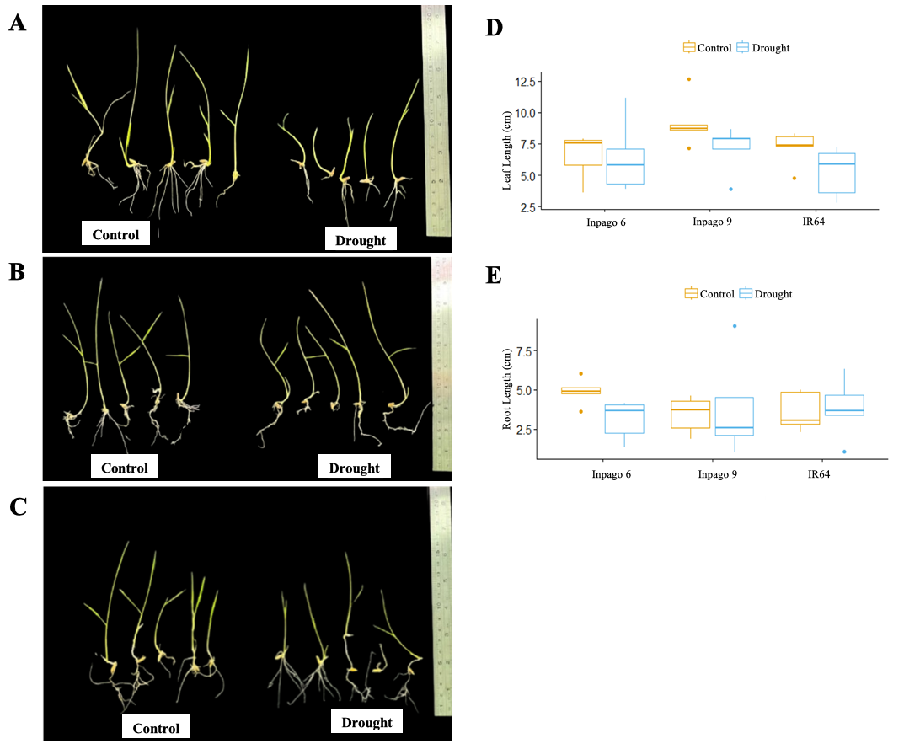
Fig-1. Comparison of rice plant growth over 14 Days in rice cv. Inpago 6 (A), Inpago 9 (B), IR64 (C) under Control and Treatment conditions. Boxplot: Leaf Length (D), Root Length (E) under control (yellow) and treatment stress (blue).

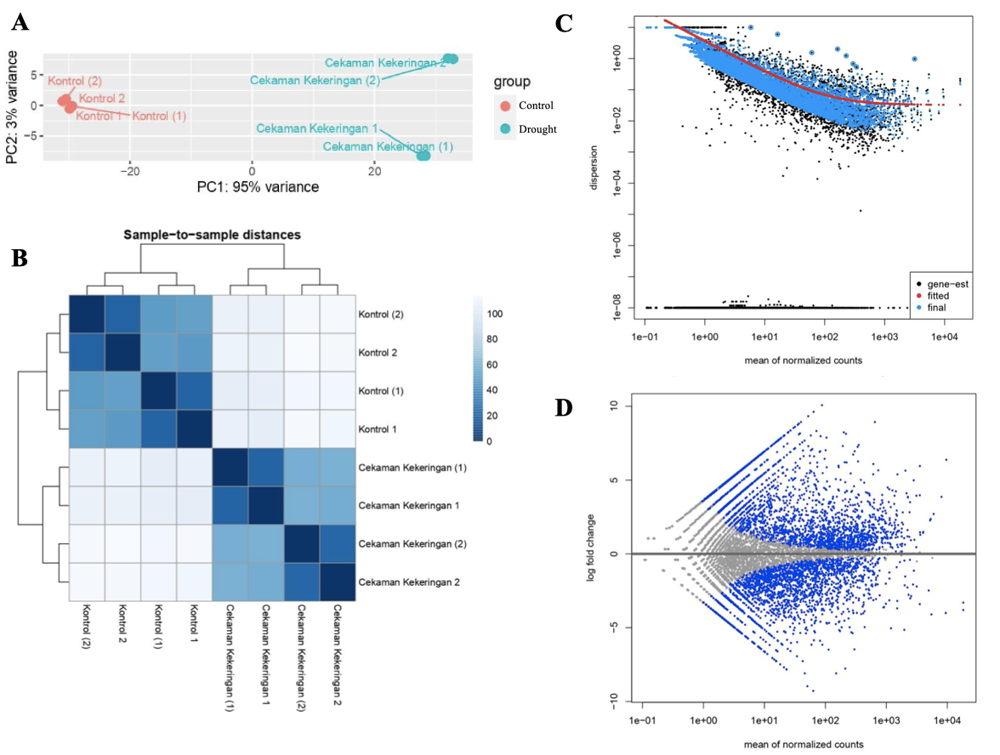
Fig-2. Clustering study and quality checking of dataset expression. Visualization of Principal Component Analysis (PCA) of Rice Plant Gene Expression under Control and Drought Stress Conditions (A). Heatmap of Inter-Sample Distances Based on Rice Plant Gene Expression under Control and Drought Stress Conditions (B). Gene Dispersion Estimation Based on the Negative Binomial Model (C). MA plot of Differential Gene Expression Analysis (DEGs) between Drought Stress Treatment Groups and the Control (D).

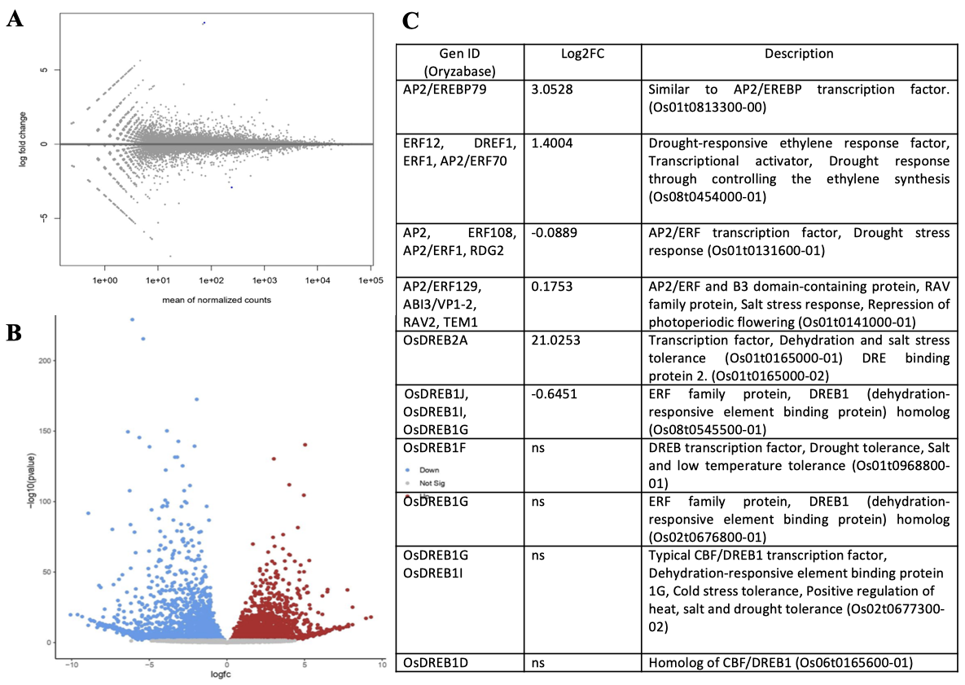
Fig-3. DEF

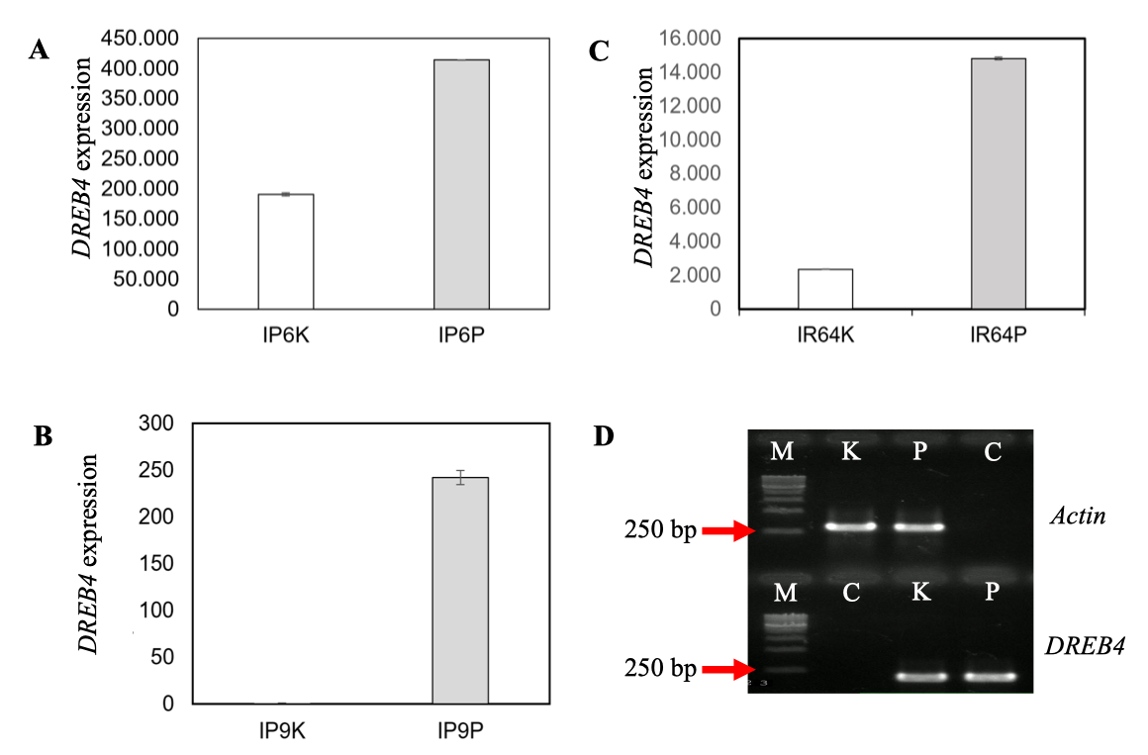
Fig-4. Gene expression of DREB4 in rice cv. Inpago 6 (A), Inpago 9 (B) and IR64 (C) between control and drought stress treatment. Electrophoregram of RT-PCR of DREB4 gene of rice in control and drought stress treatment (D). Houskeeping gene: Actin as internal control. M= marker 1kb, K= control and P= drought treatment, C= ddH₂O or non-template cDNA (Supplementary 1 for raw data).

