GENETIC DIVERSITY STUDY OF SEVERAL LOCAL CHILI GENOTYPES (CAPSICUM ANNUUM L.) FROM WEST SUMATRA, INDONESIA

Tri Budiyanti^{1,2*}, Riska Riska², Rinda Kirana², Sri Hadiati², Irfan Suliansyah³, Dini Hervani³, Eko Dharma Husada⁴
¹Doctoral Program in Agricultural Sciences, Postgraduate, Faculty of Agriculture, Andalas University, Limau Manis Padang Indonesia
²Research Center for Horticulture, National Research and Innovation Agency, Soekarno Science and Technology Area, Jl. Raya Jakarta–Bogor KM 46, Cibinong, Bogor 16915, West Java, Indonesia
³Department of Agronomy, Faculty of Agriculture, Andalas University, Limau Manis Padang Indonesia
⁴Research Centre for Applied Microbiology, National Research and Innovation Agency (BRIN). Jl. Raya Jakarta-Bogor Km 46, Cibinong, Bogor Indonesia 16911
*Corresponding author: tri006@brin.go.id
ORCID and Email
Tri Budiyanti | trib006@brin.go.id | https://orcid.org/0000-0001-7630-0366
Riska | risk011@brin.go.id | https://orcid.org/0000-0001-5251-0027
Rinda Kirana | rind005@brin.go.id | https://orcid.org/0000-0003-1196-6006
Sri Hadiati | srih020@brin.go.id | https://orcid.org/0000-0001-7630-0366
Irfan Suliansyah | irfansuliansyah@agr.unand.ac.id | https://orcid.org/0000-0001-7497-229X
Dini Hervani | dinihervani@agr.unand.ac.id | https://orcid.org/0000-0003-1067-5354
Eko Dharma Husada | ekod001@brin.go.id | https://orcid.org/0000-0003-0500-1478

ABSTRACT
Indonesia has very high diversity of genetic resources because it consists of several chili production centers. One of the areas that has a diversity of local curly chili types is West Sumatra. Studies on genetic diversity information of local curly chili from West Sumatra are still limited. Therefore, this study aimed to evaluate the production potential, morphological diversity, and genetic variability levels among local curly chili genotypes from West Sumatra. This study was arranged with a complete randomized block design with treatments, namely 23 local curly chili genotypes and three replications. Observations were carried out on both vegetative and generative morphological traits. The collected data were analyzed using ANOVA, followed by the Duncan Multiple Range Test (DMRT) at the 5% significance level, and further assessed through Principal Component Analysis (PCA) and cluster analysis to determine the diversity pattern. The results indicated genotypes Randah and Kampung Manangah exhibited the highest yield (up to 706.6 g plant⁻¹), while Kopay showed the longest fruit (23 cm). Several yield-related traits, including fruit number, fruit weight per plant, fruit length, and plant height, showed wide genetic variability, indicating strong potential for selection and genetic improvement. Conversely, traits such as fruit diameter and leaf length exhibited narrow diversity, suggesting limited scope for genetic enhancement in those characters. Cluster analysis based on quantitative traits grouped the 23 genotypes into three major clusters, reflecting distinct morphological variation patterns. These findings provide baseline information for the selection and conservation of high-yielding local curly chili genotypes from West Sumatra.
Keywords: Capsicum annuum, local chili, West Sumatra
- INTRODUCTION
In 2023, global chili (Capsicum spp.) production reached approximately 38.1 million tons, with China (16.9 million tons), Turkey (3.2 million tons), Indonesia (2.8 million tons), and Mexico (2.6 million tons) listed among the top producers (FAO 2024). Indonesia’s chili production in 2021 was reported at 2.7 million tons, maintaining its position as the third-largest producer worldwide (BPS, 2023). Among Indonesian chili types, red chili or curly chili is widely cultivated and consumed due to its flavor intensity and nutritional content. Chili fruits are rich in pro-vitamins A (carotene) (Villa-Rivera and Ochoa-Alejo 2020), E (α-tocopherol), and vitamin C (ascorbic acid) (Martirosyan et al. 2024). Red chilies also contain carotenoids, which have anticarcinogenic and antioxidant capabilities (Akhter et al. 2024). Both ripe and immature fruits have high phenolic content, especially flavonoids, which are reported to have antioxidant and other bioactive properties (Herison et al. 2018; Tripodi and Kumar 2019; Lahbib et al. 2023).
Chili is one of the most important horticultural commodities in Indonesia due to its high economic value and fluctuating market prices, which often contribute significantly to food inflation (Anwar et al. 2023). The national demand for chili continues to increase, projected to reach 840 thousand tons of red chili by the end of 2025 (Susenas 2021). According to the Badan Pusat Statistik (2022), West Sumatra was categorized as the fifth-largest chili-producing province in Indonesia, with a production approximately 26,656 tons of cayenne pepper and 123,504 tons of curly chili. The largest red chili-producing region in West Sumatra was Agam, with a production of 33,463.80 tons. Solok Regency had a production capacity of 32,474.50 tons, Tanah Datar Regency 19,917.30 tons, and Lima Puluh Kota Regency 19,818.70 tons. Pasaman Barat Regency produced 9,558.50 tons, Pesisir Selatan Regency 5,505.50 tons, and Solok Selatan Regency 5,428.40 tons. The province with the highest large red chili consumption in 2021 was West Sumatra, at 0.59 kg per capita per month, followed by Bengkulu at 0.58 kg per capita per month, Jambi at 0.46 kg per capita per month, and Riau at 0.37 kg per capita per month. Although chili production in West Sumatra exceeds local consumption needs, the province still imports chili from outside regions such as Aceh, North Sumatra, Lampung, and Central Java at certain times. Chili production from West Sumatra is partially distributed to Riau, South Sumatra, and Bengkulu (Puspitasari et al. 2022).
West Sumatra is one of Indonesia’s main chili production centers. The region harbors a wide range of local curly chili genotypes adapted to diverse agroecological zones. Exploration results by Suliansyah et al. (2023a) identified several local chili genotypes in West Sumatra. Some local chili varieties from West Sumatra that have been released as national varieties include Keriting Bukittinggi chili, Kopay chili, Gero chili, Keriting Aka chili, and Keriting Kuhay chili. Other genotypes such as Randah, Kaput, Lemarsi, Mada, Likobar, and Kawek continue to be cultivated by local farmers without formal genetic characterization.
Local curly chili genotypes from West Sumatra also exhibit significant morphological and agronomic variation, including differences in fruit length, pungency, and yield potential. Previous studies reported that genotypes from the South Coast and Tanah Datar regions contained the highest levels of capsaicin, while those from Dharmasraya and West Pasaman exhibited comparatively lower concentrations (Susanti et al. 2023). Such diversity is a valuable genetic reservoir for the development of superior cultivars with enhanced yield stability and market-preferred traits. Despite their long history of cultivation, scientific information regarding the morphological and genetic variability of these genotypes is still limited (Suliansyah et al. 2023b; Budiyanti et al. 2024). This gap limits the effective use of local germplasm in breeding and conservation programs. Rapid agricultural modernization and replacement of traditional landraces further threaten the loss of this genetic diversity. Therefore, assessing the diversity of local Capsicum annuum genotypes from West Sumatra is urgently needed to support sustainable selection, breeding, and in situ conservation efforts.
The present study provides the first integrated morphological and genetic variability analysis of 23 local curly chili genotypes using ANOVA, PCA, and cluster analysis. Principal Component Analysis (PCA) can reduce the multidimensional structure of data and facilitate the interpretation of complex genotype interactions. Biplot analysis effectively visualizes and interprets patterns of genotype diversity by combining the results of correlation analysis and PCA. Diversity studies that combine correlation analysis, PCA, and biplot analysis can provide valuable insights into the relationships between various traits, identify key traits that contribute to genetic variation, and visualize the distribution of genotypes associated with these traits (Al-Naggar et al. 2020; Zayed et al. 2022; Sruthi et al. 2024). Therefore, this study aimed to evaluate the production potential, morphological diversity, and genetic variability levels among local curly chili genotypes from West Sumatra. The results are expected to provide fundamental information for the selection, conservation, and utilization of superior local chili genotypes adapted to the agroecological conditions of West Sumatra.
- MATERIALs AND METHODS
2.1 Study area and material genetic
The research was conducted at a farmer's nursery in Lingkar Utara street, Tanjung Bingkung, Koto Singkarak District, Solok Regency, West Sumatra, Indonesia (coordinates: 0°45′54″S, 100°37′59″E; altitude 379 m above sea level). The site has an average temperature of 25–28°C with relative humidity between 72–89% and annual rainfall of 2,800–3,000 mm/year. A total of 23 local chili genotypes were used as experimental material to observe their morphological characters (Table 1). The experiment was arranged in a Randomized Complete Block Design (RCBD) consisting of 23 local curly chili genotypes as treatments and three replications. Each replication represented one block, and each block contained six healthy and uniform plants per genotype, resulting in a total of 18 plants per genotype across three replications. Prior to data collection, any damaged, diseased, or stunted plants were excluded to ensure data reliability and reduce environmental noise.
Table 1: Twenty three of local chili genotypes from West Sumatera
No | Genotype Name | Region of Origin
1 | Tali | Solok Selatan
2 | Ateng Maninjau | Agam
3 | Kampung Manangah | Solok Selatan
4 | Randah | Agam
5 | Sijunjung | Sijunjung
6 | Paijan | Pasaman
7 | Bonsai hijau Tanah Datar | Tanah Datar
8 | Ateng Pasbar | Pasaman Barat
9 | Kaput | Solok Selatan
10 | Lontabar Payakumbuh | Limapuluh Kota
11 | Keriting Bukittinggi | Bukittinggi
12 | DM-2 | Damasraya
13 | Lokal Tanah Datar | Tanah Datar
14 | Damasraya 1 | Damasraya
15 | Pasir Pasaman Timur | Pasaman
16 | Kuhay | Padang Pariaman
17 | Limersi | Tanah Datar
18 | Lolai | Pasaman Barat
19 | TDS | Tanah Datar
20 | Kopay | Payakumbuh
21 | Aka Solsel | Solok Selatan
22 | Lokal Maninjau | Agam
23 | Gero Tanah Datar | Tanah Datar

2.2 Procedures
Plants were grown in polybags (40 × 35 cm) filled with a mixture of field soil, husk charcoal, and well-decomposed cow manure in a 2:1:1 ratio (v/v). The experiment started with seeding. Seeds were sown as many as 2 seeds per tray hole. The seeds were then transferred to the media in the polybags. Watering was done every day in the morning and evening. Fertilization was done once a week after the seedlings were 2 weeks after sowing (MSS).
The fertilizers used were NPK Mutiara fertilizer with a concentration of 10 g L-1 and Gandasil 2 g L-1. Pesticide application was standardized across all treatments and conducted preventively once every two weeks using the same formulation and dosage to minimize pest and disease variation among genotypes. Plant isolation was done by covering one genotype of chili population with cross stitch fabric during flowering and fruiting periods. Observations were made per individual plant with variables refers to the list of UPOV (UPOV, 2024). The total growing period from sowing to the final harvest was about 180 days (approximately six months). Morphological traits were recorded at the beginning of the first harvest, around three months after transplanting, when plants reached physiological maturity. Productivity traits, including fruit number and fruit weight per plant, were recorded continuously from the first harvest until six months after transplanting, representing the full production cycle of each genotype.
Morphological quantitative characters observed were fruit number, yield, weight per fruit, fruit length, stalk cavity depth, stalk thickness, stalk length, fruit diameter, number of locules, plant height, stem diameter, stem length, leaf length, leaf width, petiole length, number of corollas, corolla length, anther number, anther length, filament length. Morphological qualitative characters are plant orientation, internode shortening (upper part), anthocyanin staining intensity on the segment, hair on the segment, stem shape, hair on the stem, upper leaf color, lower leaf color, leaf shape, leaf blade edge / lamina, anthocyanin staining on the leaf, blistering on leaf, leaf cross section profile, leaf gloss, flower position, corolla color, secondary color on corolla, corolla spot color, anther color, anthocyanin staining on anter, filament color, anthocyanin staining on filament, stylus color.
2.3 Data analysis
For each genotype, six plants per replication were observed, and the mean value of these six plants was used as a single data point per replication for subsequent ANOVA and multivariate analyses. If ANOVA showed a significant effect at the 5% level, it was followed by the Duncan Multiple Range Test (DMRT). Additionally, genetic and phenotypic diversity analyses were conducted. The genetic variance and phenotypic variance were calculated according to Singh and Chaudhary (1979), as follows:
Genetic variability $σ_{g}^{2}$=$\frac{M2-M1}{r}$
Phenotype variability $σ_{f}^{2}$= $σ_{g}^{2}$ + M1
M₁= mean square of error, M₂= mean square of genotype and r = number of replications
Genetic and phenotypic coefficients of variation were computed based on Anderson and Bancroft (1952):
$σ_{σ_{g}^{2}}$ = $\sqrt{\frac{2}{r^{2}}\left(\frac{M_{2}^{2}}{Db genotipe+2}+ \frac{M_{1}^{2}}{Db error +2}\right) }$
$σ_{σ_{f}^{2}}$ = $\sqrt{\frac{2}{r^{2}}\left(\frac{M_{2}^{2}}{Db genotipe+2}\right) }$
A character is categorized as wide variability if: $σ_{σ_{g}^{2}}$ >${2σ}_{σ_{g}^{2}}$ and $σ_{σ_{f}^{2}}$ >${2σ}_{σ_{f}^{2}}$
Heritability was estimated using variance component analysis and calculated based on the broad-sense method according to Allard (1960), with heritability value criteria following McWhirter (1979):
H= $\frac{σ_{g}^{2} }{σ_{f}^{2}}$
where: H (%): 0–20 (low), 20 < H ≤ 50 (moderate), H > 50 (high)
Principal component analysis (PCA) and cluster analysis were performed on morphological data to determine the grouping of the tested genotypes. Traits with absolute loading values ≥ 0.35 were considered influential contributors to the corresponding principal component. Loadings below this threshold were interpreted as having minimal contribution.”For clustering and dendrogram heatmap analysis, R software version 4.3.2 was used with the gplots, cluster, factoextra, and FactoMineR packages.
- RESULTS AND DISCUSSION
The results of statistical analysis show that the tested chili genotypes have significantly different characteristics in terms of the number of fruits per plant, fruit weight per plant, weight per fruit, fruit length, and fruit stalk length, based on the DMRT test (P<0.05) (Table 1). The number of fruits per plant affects plant production: the more fruits produced by a single plant, the greater the contribution to total production. The chili genotype with the highest number of fruits per plant is Randah (216.67), which is significantly different from the genotypes of Sijunjung, Keriting Bukittinggi, DM-2, Pasir East Pasaman, Kuhay, Lolai, Local Maninjau, and Gero Tanah Datar. Kuhay chili has the least number of fruits per plant (36.33), significantly different from the Tali chili, Kampung Manangah, Randah, Kaput, Lontabar, Damasraya 1, and TDS genotypes.
Fruit weight per plant also significantly contributes to the total production of chili. The Randah genotype has the highest fruit weight per plant (706.57 g), which is significantly different from the Tali, Ateng Maninjau, Sijunjung, Paijan, Bonsai Hijau, Ateng Pasbar, Lontabar Payakumbuh, Keriting Bukittinggi, DM-2, Lokal Tanah Datar, Damasraya 1, Pasir Pasaman Timur, Kuhay, Lolai, Aka Solsel, Lokal Maninjau, and Gero Tanah Datar genotypes. Conversely, the Gero Tanah Datar genotype has the lowest fruit weight per plant (139.05 g) and is not significantly different from the Lokal Maninjau, Aka Solsel, Lolai, Kuhay, Pasir Pasaman Timur, Lontabar Payakumbuh, and Bonsai Hijau Tanah Datar genotypes.
Fruit weight per chili varies among genotypes. The Paijan genotype has the largest fruit weight (7.20 g), which is significantly different from the Tali, Bonsai Hijau, Ateng Pasbar, Pasir Pasaman Timur, Kuhay, Aka Solsel, Lokal Maninjau, and Gero Tanah Datar genotypes. Conversely, the Bonsai Hijau Tanah Datar genotype has the smallest fruit weight (2.44 g), and is not significantly different from the Gero Tanah Datar, Lokal Maninjau, Aka Solsel, and Pasir Pasaman Timur genotypes. Fruit length also varies among chili genotypes. Fruit length affects visual appeal and perceived quality, especially for the fresh market. Large red chilies with uniform length are more preferred by traders and consumers in the modern market. The Kopay chili has the longest fruit length (23 cm), whereas the Gero Tanah Datar chili has the shortest (9.77 cm). Fruit stalk length can be an important consideration in harvesting, storage, and marketing. Stalks that are too short can complicate packaging and accelerate wilting, while longer stalks help maintain chili freshness during distribution. The observed chili genotypes had relatively similar or not significantly different fruit stalk lengths (Table 2). The Sijunjung genotype had the largest fruit diameter (9.54 mm), while the Bonsai Hijau Tanah Datar chili had the smallest fruit diameter (5.99 mm), and the two genotypes were significantly different.
Table 2: The average fruit weight, fruit length, fruit stalk length, fruit diameter, number of fruits per plant, and fruit weight per plant of 23 local chili genotypes of West Sumatra
No | Genotype | Number of fruit/plant | Fruit weight/plant (g) | Fruit weight (g) | Fruit length (cm) | Length of fruit stalk (cm) | Fruit diameter (mm)
1 | Tali | 152.22^{abcd} | 459.67^{bcde} | 5.03^{bcd} | 13.87^{bcde} | 4.53ª | 8.09^{ab}
2 | Ateng Maninjau | 121.78^{abcde} | 462.69^{bcde} | 6.37^{abc} | 16.93^{bcd} | 4.60ª | 8.93^{ab}
3 | Kampung Manangah | 207.67^{ab} | 608.50^{ab} | 5.61^{abc} | 14.65^{bcde} | 4.49ª | 8.71^{ab}
4 | Randah | 216.67ª | 706.57ª | 6.39^{abc} | 17.99^{abc} | 4.33ª | 9.09^{ab}
5 | Sijunjung | 104.67^{bcde} | 440.84^{bcdef} | 6.18^{abc} | 15.84^{bcd} | 4.65ª | 9.54ª
6 | Paijan | 110^{abcde} | 368.62^{cdefgh} | 7.20ª | 16.17^{bcd} | 4.12ª | 9.02^{ab}
7 | Bonsai hijau T.Datar | 106^{abcde} | 240.05^{ghij} | 2.44e | 11.12de | 3.6a | 5.99^{b}
8 | Ateng Pasbar | 139.33^{abcde} | 467.90^{bcde} | 4.88^{bcd} | 13.62^{bcde} | 3.80ª | 8.46^{ab}
9 | Kaput | 163.33^{abc} | 535.61^{abc} | 6.25^{abc} | 15.67^{bcd} | 5.03ª | 8.55^{ab}
10 | Lontabar Payakumbuh | 163.33^{abc} | 259.41^{fghij} | 6.14^{abc} | 15.54^{bcde} | 4.18ª | 8.63^{ab}
11 | Keriting Bukittinggi | 105^{bcde} | 412.52^{cdefg} | 5.50^{abc} | 13.83^{bcde} | 5.21ª | 8.34^{ab}
12 | DM-2 | 98^{bcde} | 483.61^{bcd} | 5.87^{abc} | 14.39^{bcde} | 5.03ª | 8.90^{ab}
13 | Lokal Tanah Datar | 117.67^{abcde} | 482.43^{bcd} | 6.17^{abc} | 16.03^{bcd} | 4.76ª | 9.17^{ab}
14 | Damasraya 1 | 150.33^{abcd} | 338.58^{defghi} | 5.64^{abc} | 13.92^{bcde} | 4.28ª | 8.96^{ab}
15 | Pasir Pasaman Timur | 77.67^{cde} | 258.50^{fghij} | 4.51^{cde} | 13.53^{bcde} | 3.30ª | 7.88^{ab}
16 | Kuhay | 36.33e | 175.45^{ij} | 4.72^{bcd} | 12.90^{bcde} | 3.43ª | 7.54^{ab}
17 | Limersi | 130.33^{abcde} | 596.81^{ab} | 6.74^{ab} | 18.48^{ab} | 4.93ª | 8.79^{ab}
18 | Lolai | 58.67^{cde} | 234.64^{ghij} | 5.56^{abc} | 15.17^{bcde} | 4.20ª | 7.94^{ab}
19 | TDS | 158.67^{abcd} | 605.02^{ab} | 5.69^{abc} | 15.12^{bcde} | 4.64ª | 8.93^{ab}
20 | Kopay | 116.33^{abcde} | 551.29^{abc} | 6.73^{ab} | 23.00ª | 4.96ª | 8.77^{ab}
21 | Aka Solsel | 128.67^{abcde} | 287.09^{efghij} | 3.30de | 11.19de | 4.41ª | 7.33^{ab}
22 | Lokal Maninjau | 51.67de | 192.18^{hij} | 4.51^{cde} | 12.30^{cde} | 2.89^{ab} | 7.62^{ab}
23 | Gero Tanah Datar | 70.67^{cde} | 139.05^{j} | 2.60e | 9.77e | 3.24ª | 6.73^{ab}
Notes: Numbers followed by the same letter in one column are not significantly different according to the DMRT test at P<0.05.
The significant variation among the 23 chili genotypes in fruit number, fruit weight per plant, individual fruit weight, fruit length, and fruit stalk length indicates the existence of broad genetic diversity within the local chili population of West Sumatra. This diversity is consistent with previous findings by Suliansyah et al. (2023) and Budiyanti et al. (2024), who reported that local curly chili accessions in West Sumatra exhibit wide variability in yield components and morphological traits. The results confirm that these genotypes still maintain diverse genetic backgrounds, possibly due to limited formal breeding and continuous open pollination under different micro-environmental conditions.
The high fruit number per plant observed in the Randah genotype (216.67 fruits/plant) contributes significantly to overall yield potential. Fruit number is a major determinant of productivity because it represents the reproductive success and efficiency of assimilate partitioning. According to Bekele et al. (2023), the number of fruits per plant is strongly influenced by both genetic control and environmental adaptability, particularly under conditions that favor flower retention and fruit set. The superiority of Randah chili in this trait suggests that this genotype has favorable genetic factors regulating floral fertility and fruit set stability. Conversely, the Kuhay genotype, with the lowest fruit number (36.33 fruits/plant), may have lower flower-to-fruit conversion efficiency, possibly due to limited carbohydrate allocation to reproductive organs or sensitivity to microclimatic stress (Pedroza-Sandoval et al. 2024).
The significant differences observed among the chili genotypes suggest that these local accessions have undergone natural and farmer-driven selection processes that favored diverse morphological and productive characteristics. The Randah and Kopay genotypes, which showed superior yield and fruit size, can be considered as potential parental lines for future breeding programs aiming to combine high productivity with desirable fruit morphology. Meanwhile, genotypes with smaller fruits or lower yield may serve as sources of specific traits, such as early maturity or tolerance to abiotic stress. These findings reinforce the importance of conserving and characterizing local chili germplasm to support genetic improvement and sustainable chili production systems.
The plant height, stem diameter, leaf width, and stalk length showed significant differences, while dichotomous height and leaf length were not significantly different (Table 3). The Gero Tanah Datar chili had the lowest average plant height (66.00 cm) and was not significantly different from several other tested chili accessions, except for Tali, Ateng Maninjau, TDS, and Aka Solsel. Conversely, the Atang Maninjau and Aka Solsel chilies had the highest plant heights and were not significantly different from the other tested chilies, except for Gero Tanah Datar, Lokal Maninjau, Kuhay, and Pasir Pasaman Timur. Atang Maninjau and Aka Solsel chilies were significantly different from Gero Tanah Datar chili.
Tall plants have several advantages, including: a) Higher yield potential: tall plants often have greater biomass, allowing for more branches and leaves to support photosynthesis. b) Adaptation to open fields: tall chili plants are suitable for intensive cultivation in open fields with wide spacing. c) better light competition: tall plants are more efficient at capturing light, especially in dense environments. However, the disadvantage is that they are more vulnerable to wind or heavy rain, making them prone to lodging.
Table 3: The average plant height, stem diameter, dichotomous height, leaf length, leaf width and petiole length of 23 local chili genotypes of West Sumatra
No | Genotype | Plant height (cm) | Stem diameter (mm) | Dichotomous length (cm) | Leaf length (cm) | Leaf width (cm) | Stalk length (cm)
1 | Tali | 90.00^{abc} | 7.67^{cd} | 24.67ª | 12.7 | 3.37^{bcde} | 4.83^{bcd}
2 | Ateng Maninjau | 98.00ª | 11.43^{b} | 30.83ª | 11.5 | 5.07^{ab} | 7.60ª
3 | Kampung Manangah | 79.67^{abcd} | 9.33^{bcd} | 27.83ª | 11 | 4.17^{abcde} | 4.33^{bcd}
4 | Randah | 76.67^{abcd} | 9.37^{bcd} | 26.33ª | 11.33 | 4.00^{abcde} | 6.33^{ab}
5 | Sijunjung | 79.67^{abcd} | 15.30ª | 19.50ª | 12.57 | 4.00^{abcde} | 4.83^{bcd}
6 | Paijan | 81.33^{abcd} | 10.07^{bcd} | 26.50ª | 9.53 | 4.67^{abc} | 4.17^{bcd}
7 | Bonsai hijau T.Datar | 88.33^{abcd} | 10.10^{bcd} | 26.33ª | 8.67 | 5.33ª | 4.33^{bcd}
8 | Ateng Pasbar | 78.67^{abcd} | 9.20^{bcd} | 21.67ª | 12.67 | 2.93de | 3.83^{bcd}
9 | Kaput | 83.67^{abcd} | 9.37^{bcd} | 27.67ª | 11.67 | 4.57^{abcd} | 4.83^{bcd}
10 | Lontabar Payakumbuh | 76.33^{abcd} | 9.57^{bcd} | 23.00ª | 11.5 | 4.57^{abcd} | 4.50^{bcd}
11 | Keriting Bukittinggi | 81.67^{abcd} | 10.70^{bc} | 27.67ª | 11.67 | 4.33^{abcde} | 5.57^{abc}
12 | DM-2 | 75.00^{abcd} | 9.83^{bcd} | 26.67ª | 11.67 | 4.07^{abcde} | 5.10^{abcd}
13 | Lokal Tanah Datar | 74.67^{abcd} | 8.83^{bcd} | 25.33ª | 13.33 | 4.00^{abcde} | 2.77^{d}
14 | Damasraya 1 | 74.33^{abcd} | 8.83^{bcd} | 24.67ª | 12 | 4.10^{abcde} | 4.43^{bcd}
15 | Pasir Pasaman Timur | 65.00^{d} | 8.40^{bcd} | 25.33ª | 9.83 | 4.00^{abcde} | 4.50^{bcd}
16 | Kuhay | 70.67^{d} | 7.57^{d} | 24.00ª | 11.25 | 3.33^{cde} | 4.07^{bcd}
17 | Limersi | 87.00^{abcd} | 8.67^{bcd} | 25.00ª | 12.47 | 3.67^{abcde} | 6.33^{ab}
18 | Lolai | 79.17^{abcd} | 9.00^{bcd} | 25.33ª | 11.17 | 4.07^{abcde} | 4.23^{bcd}
19 | TDS | 94.33^{ab} | 10.87^{b} | 25.50ª | 11.77 | 4.33^{abcde} | 4.43^{bcd}
20 | Kopay | 81.33^{abcd} | 9.70^{bcd} | 31.17ª | 11.5 | 3.80^{abcde} | 6.43^{ab}
21 | Aka Solsel | 96.00ª | 8.80^{bcd} | 26.67ª | 11 | 3.67^{abcde} | 3.33^{cd}
22 | Lokal Maninjau | 66.33^{cd} | 8.93^{bcd} | 24.00ª | 7.83 | 2.83e | 4.17^{bcd}
23 | Gero Tanah Datar | 66.00^{d} | 8.33^{bcd} | 19.67ª | 9 | 3.33^{cde} | 5.33^{abcd}
Notes: Numbers followed by the same letter in one column are not significantly different according to the DMRT test at P<0.05
The observed chili genotypes have varying stem diameters. Kuhay chili has the smallest stem diameter (7.57 mm) and is not significantly different from most of the observed chilies, except for Ateng Maninjau, Sijunjung, Keriting Bukittinggi, and TDS chilies. Sijunjung chili has the largest stem diameter (15.30 mm) and is significantly different from other tested chilies. Chili plants with larger stem diameters are stronger and more resistant to lodging. The tested genotypes did not show significant differences in dichotomous height. Leaf width also varied among the observed chili genotypes. The Lokal Maninjau chili had the smallest leaf width (2.83 cm) and was not significantly different from most other tested genotypes, except for Ateng Maninjau, Paijan, Bonsai Hijau Tanah Datar, Kaput, and Lontabar Payakumbuh. Conversely, the Bonsai Hijau Tanah Datar chili had the largest leaf width (5.33 cm) and was not significantly different from most other tested genotypes, except for Tali, Ateng Pasbar, Kuhay, Lokal Maninjau, and Gero Tanah Datar. Bonsai Hijau Tanah Datar chili was significantly different from Lokal Maninjau chili.
Wide genetic diversity within a population supports significantly to the success of plant breeding. Wide genetic diversity indicates a more dominant genetic influence compared to environmental factors. Selection is most effective when applied to traits with wide genetic and phenotypic diversity. Table 3 shows that all observed traits have wide phenotypic and genetic diversity, except for fruit diameter and leaf length, which have narrow genetic diversity. High heritability values were observed in fruit number, fruit weight per plant, fruit length, plant height, and stem diameter, indicating that these traits are mainly controlled by additive genetic effects with minimal environmental influence (Table 4). Therefore, selection for these traits in early generations can be expected to yield significant genetic gains. Moderate heritability was found in fruit stalk length, petiole length, and leaf width, suggesting a partial influence of environmental variation. In contrast, fruit diameter and leaf length had low heritability (Table 4), meaning that environmental conditions strongly affected their phenotypic expression and that direct selection for these traits would be less effective. Similar trends were reported by Budiyanti et al. (2024) and Suliansyah et al. (2023), who also found that fruit number and plant height had high heritability in local chili genotypes from West Sumatra. This consistency across studies reinforces that yield components in chili are genetically stable and can be targeted in breeding programs aimed at productivity improvement.

Table 4: Genetic diversity, phenotypic diversity and heritability of 23 local chili genotypes in West Sumatra
No | Parameters | Genetic variability  (σ²g) | Genetic Std. Dev. (σg) | Genetic Variability Criteria | Phenotype variability  (σ²f) | Phenotype  Std. Dev. (σf) | Phenotype  Variability Criteria | Herita bilitas | Heritability Category
1 | Numbers of fruit | 1.682 | 0.605 | Wide | 2.867 | 0.082 | Wide | 58.663 | High
2 | Fruit weight  /plant | 24318.333 | 7333.654 | Wide | 27541.333 | 224.014 | Wide | 88.298 | High
3 | Weight/fruit | 0.064 | 0.021 | Wide | 0.093 | 0.002 | Wide | 68.657 | High
4 | Fruit length | 0.271 | 0.093 | Wide | 0.419 | 0.010 | Wide | 64.570 | High
5 | Fruit stalk | 0.036 | 0.014 | Wide | 0.073 | 0.003 | Wide | 49.363 | Moderate
6 | Fruit diameter | 0.009 | 0.010 | Narrow | 0.077 | 0.005 | Wide | 11.446 | Low
7 | Plant height | 64.993 | 3.799 | Wide | 119.653 | 3.799 | Wide | 54.318 | High
8 | Stem diameter | 0.084 | 0.031 | Wide | 0.148 | 0.004 | Wide | 56.474 | High
9 | Leaf length | 0.041 | 0.031 | Narrow | 0.233 | 0.019 | Wide | 17.793 | Low
10 | Leaf width | 0.010 | 0.005 | Wide | 0.030 | 0.001 | Wide | 34.884 | Moderate
11 | Petiole length | 0.038 | 0.016 | Wide | 0.087 | 0.003 | Wide | 43.850 | Moderate
The criteria for estimating heritability (h²) according to Stansfield (1991) are as follows: high if h² > 0.50, moderate if 0.20 ≤ h² ≤ 0.50, and low if h² < 0.20.
Principal component analysis (PCA) is a useful technique to determine the contribution of a character to diversity and successfully identify characters that distinguish a genotype. The number of principal components (PCs) as the main component is determined based on the eigenvalue >1.00 (Akin-Idowu et al. 2020; Girgel 2021) and > PCA with a total cumulative diversity value of 75% is sufficient to differentiate diversity (Rosmaina et al. 2021). The first six principal components explained 80.5% of the total variance, indicating that the observed traits effectively captured the diversity among the 23 local genotypes (Table 4). PC1 (36.0% of total variation) was mainly associated with fruit yield, fruit number, fruit weight, fruit length, and plant height traits that are directly linked to productivity. PC2 (12.3%) reflected variation in reproductive morphology, particularly flower and stalk-related traits (Table 5).
Table 5: Eigenvalue, diversity, cumulative diversity and factor loading of 23 local chili genotypes of West Sumatra morphological characters
Variable | PC1 | PC2 | PC3 | PC4 | PC5 | PC6
Numbers of fruit (JB) | 0.237 | -0.277 | -0.152 | -0.215 | -0.164 | 0.292
yield (H) | 0.303 | -0.022 | -0.185 | -0.112 | -0.284 | 0.082
Fruit weight (BB) | 0.307 | 0.256 | -0.135 | -0.023 | 0.062 | 0.000
Fruit length (PB) | 0.257 | 0.247 | -0.270 | 0.114 | -0.133 | 0.062
Cavity of the stalk (RTG) | 0.230 | 0.299 | 0.073 | 0.086 | 0.021 | -0.138
Stalk thickness (TTG) | -0.010 | -0.230 | -0.532 | 0.054 | -0.163 | -0.354
Stalk length (PTG) | 0.299 | 0.078 | 0.024 | -0.075 | -0.154 | -0.032
Fruit diameter (DB) | 0.325 | 0.203 | -0.045 | -0.104 | 0.014 | -0.069
Numbers of locus (JL) | 0.188 | 0.268 | -0.011 | 0.052 | 0.260 | -0.307
Plant height (TT) | 0.124 | -0.195 | -0.069 | 0.448 | 0.115 | -0.080
Stem diameter (DBT) | 0.188 | -0.259 | -0.405 | -0.055 | 0.042 | 0.166
Stem length (PBT) | 0.189 | 0.111 | 0.238 | 0.433 | 0.022 | 0.111
Leaf length (PD) | 0.284 | 0.021 | 0.178 | 0.075 | -0.308 | 0.092
Leaf width (LD) | 0.304 | -0.037 | 0.104 | 0.070 | 0.252 | 0.034
Petiole length (PTD) | 0.072 | -0.228 | 0.039 | 0.380 | 0.108 | 0.534
Numbers of corola (JC) | -0.211 | 0.329 | -0.012 | 0.117 | -0.487 | 0.102
Corola length (PJ) | -0.171 | 0.274 | -0.271 | 0.170 | 0.148 | 0.373
Numbers of anther (JA) | -0.244 | 0.268 | -0.220 | 0.228 | -0.302 | 0.066
Anther length (PA) | -0.105 | 0.246 | -0.400 | -0.028 | 0.456 | 0.083
Filament length (PF) | 0.003 | 0.220 | 0.095 | -0.507 | 0.096 | 0.397
Eigenvalue | 7.1974 | 2.4519 | 2.2024 | 1.9976 | 1.1738 | 1.0826
Proportion (%) | 36.0 | 12.3 | 11.0 | 10.0 | 5.9 | 5.4
Cumulative (%) | 36.0 | 48.2 | 59.3 | 69.2 | 75.1 | 80.5
Traits with absolute loading values (|loading|) ≥ 0.35 are considered influential contributors to each principal component
The pattern of trait loading across components suggests that fruit-related traits (yield, weight, length, diameter) are the main axes of variation in West Sumatran curly chili genotypes, while vegetative and floral traits contribute secondary differentiation. This distribution aligns with findings from Karim and Nesa (2022) and Karim et al. (2022), who demonstrated that fruit morphology and yield attributes consistently explain the largest proportion of variability in Capsicum germplasm studies. From a breeding perspective, these results emphasize that selection based on the first principal component particularly yield and fruit morphology can effectively capture the majority of genetic diversity relevant to productivity improvement.
Figure 1 shows the trends and relationships among characters in 23 chili genotypes. The length of the vector represents the diversity of a character: the longer the vector, the greater the genetic diversity for that character, and vice versa (Iqbal et al. 2025). Characters with long vectors, such as yield (H), fruit diameter (DB), and fruit weight (BB), have greater genetic diversity compared to other characters. The angle between two vectors indicates the relationship (correlation) between two variables. An angle less than 90° indicates a positive correlation, while an angle greater than 90° indicates a negative correlation (Iqbal et al. 2025). The PCA loading plot (Fig. 1) illustrates how yield-related characters (e.g., fruit number, fruit length, and diameter) form a distinct cluster, showing strong positive correlations among these traits. In contrast, floral traits such as corolla length, filament length, and anther number showed weaker associations, indicating their minor role in yield differentiation.

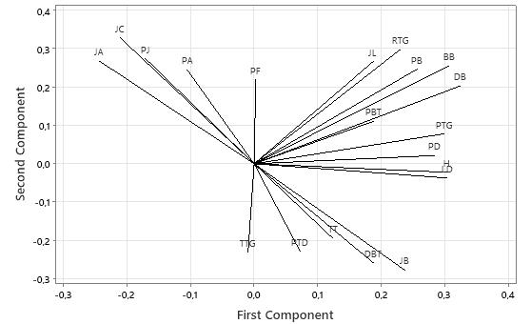
Fig 1: Loading plot of 20 variable on 23 chilli genotypes. Numbers of fruit (JB), yield (H), Fruit weight (BB), Fruit length (PB), Cavity of the stalk (RTG), Stalk thickness (TTG), Stalk length (PTG), Fruit diameter (DB), Numbers of locus (JL), Plant height (TT), Stem diameter (DBT), Stem length (PBT), Leaf length (PD), Leaf width (LD), Petiole length (PTD), Numbers of corolla (JC), Corola length (PJ), Numbers of anther (JA), Anther length (PA), Filament length (PF).
The trait relationships identified in PCA were consistent with the grouping pattern observed in the heatmap and dendrogram analyses (Fig. 2; Fig. 3). Cluster analysis grouped the 23 genotypes into three major clusters. Cluster I contained high-yielding and tall plants with large fruits (Randah, Kampung Manangah, Solok 1), suitable for breeding and farmer adoption. Cluster II consisted of moderate-yield genotypes (Sarikayo, Solok 2, Pesisir) with adaptive potential for conservation and stress-prone areas. Cluster III included diverse intermediate genotypes, indicating genetic bridging materials for crossbreeding. These patterns are consistent with previous reports by Karim et al. (2022) and Bekele et al. (2023), who found that fruit morphology and plant vigor are the major discriminators of Capsicum diversity.
Similar patterns of morphological and yield-related variability have been reported in Capsicum annuum germplasm from Asia and Africa, indicating that fruit number, fruit weight, and plant height are key contributors to overall productivity and adaptability (Karim et al. 2022; Bekele et al. 2023). The high heritability of these traits observed in this study suggests a strong genetic basis, making them reliable selection criteria for breeding programs aimed at yield improvement. Comparable studies in Bangladesh and Ethiopia demonstrated that genotypes with stable yield components tend to perform consistently under environmental fluctuations, reflecting their potential resilience to climate stress (Chowdhury et al. 2023; Pedroza-Sandoval et al. 2024).
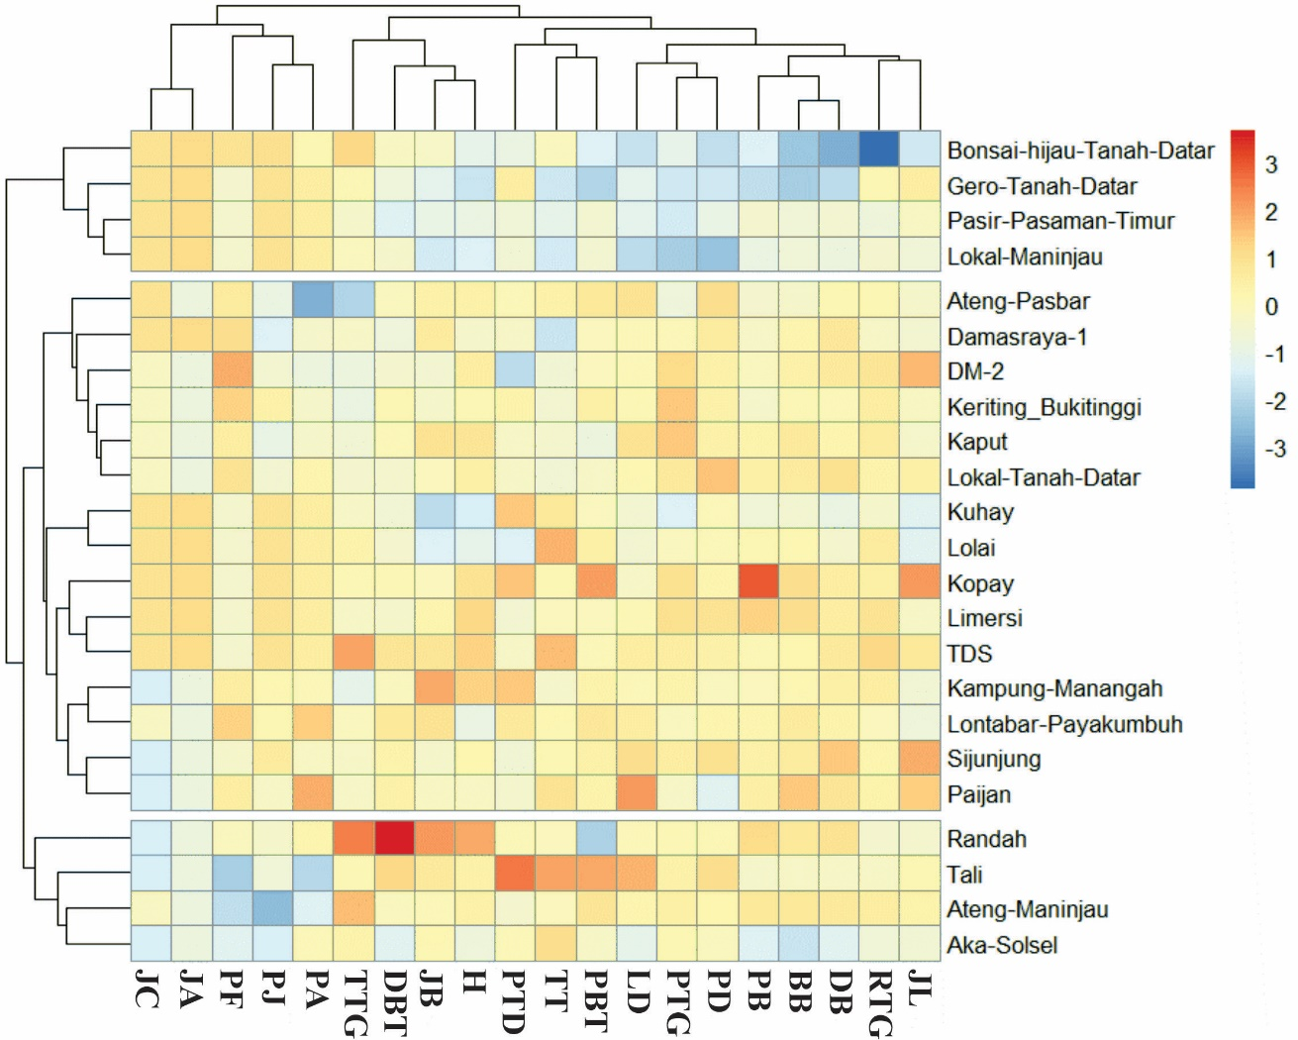
Fig 2: Heatmap clustergram analysis of 23 chili genotypes on quantitative characters. Numbers of fruit (JB), yield (H), Fruit weight (BB), Fruit length (PB), Cavity of the stalk (RTG), Stalk thickness (TTG), Stalk length (PTG), Fruit diameter (DB), Numbers of locus (JL), Plant height (TT), Stem diameter (DBT), Stem length (PBT), Leaf length (PD), Leaf width (LD), Petiole length (PTD), Numbers of corola (JC), Corola length (PJ), Numbers of anther (JA), Anther length (PA), Filament length (PF).
The results of heatmap clustering analysis of quantitative characters show three major groups of chili genotypes. The first group consists of four genotypes: Bonsai Green Tanah Datar, Gero Tanah Datar, Pasir Pasaman Timur, and Lokal Maninjau. This group is characterized by a relatively large number of anthers but a relatively small number of fruits and yields. The second group consists of two sub-groups. Sub-group 1 includes six genotypes, while sub-group 2 includes nine genotypes. The third group consists of the Randah, Tali, Ateng Maninjau, and Aka Solsel genotypes. This group is characterized by moderately high to high fruit values, especially the Randah genotype, which has the largest yield character (C2).
The third cluster comprises Randah, Tali, Ateng Maninjau, and Aka Solsel genotypes, all of which are characterized by moderately high to high yield performance, particularly the Randah genotype, which showed the highest yield. These genotypes share traits associated with efficient assimilate translocation, larger fruit size, and greater fruit number per plant. Such genotypes can be considered as superior lines with strong yield potential and are highly valuable for use in breeding programs aimed at improving productivity. Similar clustering of high-yielding genotypes has been observed by Chowdhury et al. (2023) and Kusumaningrum et al. (2025), who reported that yield-dominant groups often cluster together due to shared physiological mechanisms such as enhanced photosynthetic activity, stronger sink strength in fruits, and better tolerance to water or nutrient stress.
The presence of distinct clusters also indicates that local West Sumatran chili genotypes have undergone both natural and farmer-driven selection, resulting in genotypic differentiation according to preferred agronomic traits. Farmers in this region have long propagated chili landraces based on fruit shape, color, and productivity, which may explain why high-yielding genotypes like Randah and Tali are grouped separately from smaller-fruited types such as Bonsai Green or Lokal Maninjau. This pattern reflects both genetic divergence and local adaptation, as described by Budiyanti et al. (2024) and Suliansyah et al. (2023), where farmer selection and environmental variation contribute jointly to the morphological diversification of Capsicum annuum.

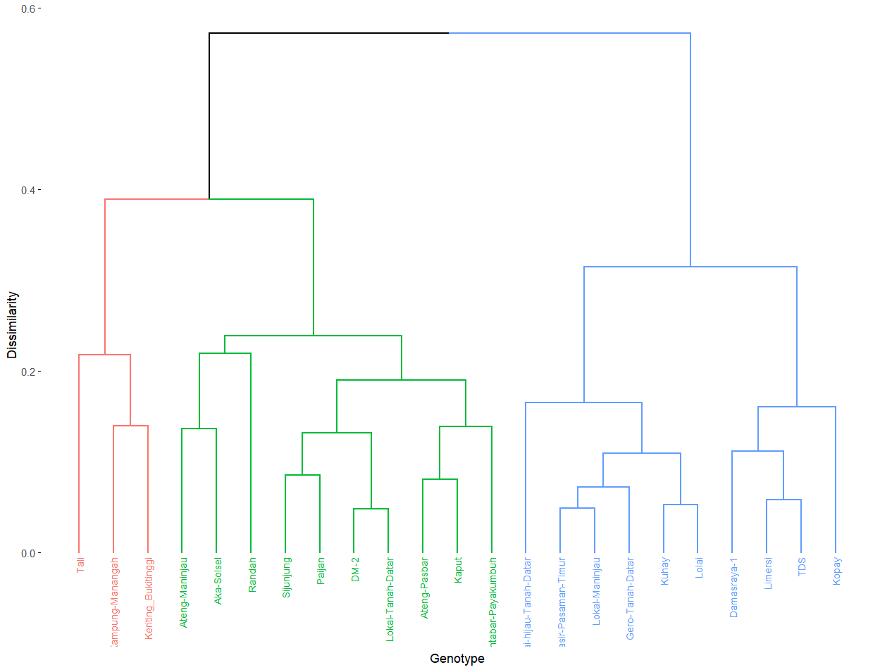
Fig 3: Dendrogram analysis of 23 chili genotypes on quantitative and qualitative characters.

Hierarchical cluster analysis divided the 23 chili genotypes into three major clusters (Fig. 3). The three-group division was supported by the agglomeration schedule and validation metrics (cophenetic correlation = 0.82; silhouette width = 0.46), indicating an adequate and interpretable clustering structure (Figure 3). The first group consisted of three genotypes: Tali, Kampung Manangah, and Keriting Bukittinggi. The second group consisted of two subgroups: Subgroup 1 consisted of three genotypes, and subgroup 2 consisted of seven genotypes. The third group had two subgroups: Subgroup 1 consisted of six genotypes, and subgroup 2 consisted of four genotypes. Combined analysis of qualitative and quantitative traits is more accurate because it uses more complete data, increasing the precision of the grouping. Both quantitative and qualitative variables have their own advantages and disadvantages in genetic diversity studies, so both should be included (Sari et al. 2021; Copati et al. 2022).
A phylogenetic analysis of 23 local chili pepper varieties from West Sumatra, Indonesia, based on 15 ISSR markers was conducted based on observations of the overall DNA bands that appeared and the results of the SAHN-UPGMA dendrogram. The dendrogram (Fig. 3) shows the genetic relationships among the 23 chili pepper genotypes based on ISSR markers. The similarity coefficient values ranged from approximately 81% to 96%. This range indicates that all analyzed chili genotypes exhibit a fairly high level of genetic similarity, though genetic variation still exists among genotypes. At a genetic similarity level of 81%, two main clusters were formed (Fig. 2). The first cluster is further divided into two subclusters: the first subcluster consists of a single genotype, namely the Tali chili, while the second subcluster comprises the Kampung Manangah, Bonsat, and Lontabar chili genotypes, meaning these three share a closer genetic relationship. The second cluster is divided into two subclusters, with the first subcluster consisting of 17 genotypes and the second subcluster consisting of one genotype, namely Kopay. Genotypes located on adjacent branches share a close genetic relationship, whereas genotypes that diverged earlier exhibit greater genetic differences. This information is crucial for selecting parent lines in breeding programs. Genotypes that are genetically more distant can be selected as potential breeding parents because they have the potential to produce offspring with a wider range of genetic variation.
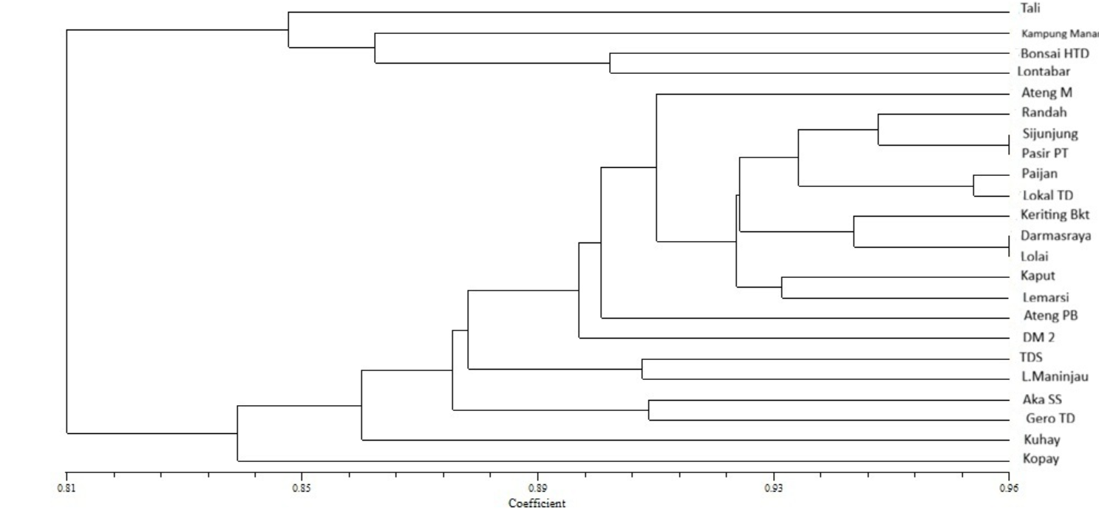
Fig 3: Dendrogram analysis of 23 chili genotypes on ISSR primer. A=Tali, B=Ateng Maninjau, C=Kampung Manangah, D=Randah, E=Sijunjung, F=Paijan, G=Bonsai hijau Tanah DatarH=Ateng Pasbar, I=Kaput, J=Lontabar Payakumbuh, K=Keriting Bukittinggi, L=DM-2, M=Lokal Tanah Datar, N=Damasraya 1, O=Pasir Pasaman Timur, P=Kuhay, Q=Limersi, R=Lolai,S=TDS, T=Kopay, U=Aka Solsel, V=Lokal Maninjau,W=Gero Tanah Datar

Conclusion: This study identified considerable morphological and genetic variation among 23 local curly chili (Capsicum annuum L.) genotypes from West Sumatra. Traits related to yield performance such as fruit number, fruit weight per plant, and fruit length showed wide genetic diversity and high heritability, making them key targets for selection. Cluster analysis grouped the genotypes into three main clusters, with Kampung Manangah and Randah identified as the most promising high-yielding genotypes. These genotypes also showed broad genetic variability in yield-related traits, indicating a high selection response potential. In addition, DS, Limersi, and Kopay showed consistent fruit morphology and moderate plant height, suggesting adaptability under diverse environmental conditions. These three accessions may be valuable for developing stable varieties suitable for open-field cultivation. These findings provide valuable information for chili breeding and conservation programs, supporting the selection of superior local genotypes for developing improved varieties adapted to West Sumatra’s growing conditions.
Funding: the study was funded by Andalas University, through the Institute for Research and Community Service (LPPM), for funding this research through the Doctoral Dissertation Research Scheme (PDD), under decree number 93/UN16.19/KPT/PT.01.00/2024 and agreement/contract number 7/UN16.19/PT.01.03/PDD/2024.
Acknowledgments: The authors gratefully acknowledge to Andalas University, through the Institute for Research and Community Service (LPPM). The author also expresses his appreciation to all parties and institutions that provided support and assistance during the implementation of this research.
Conflict of Interest: The authors declare that no potential conflict of interest in the study.
Data Availability: All the data is available in the article.
Ethics Statement: This study did not use laboratory animals, so it does not require an ethics statement.
Author’s Contribution: TB and RR: Conceptualization, Formal Analysis, Methodology, Writing – Review & Editing. RK and SH: Data Curation, Formal Analysis, Writing – Review & Editing. IS, DH and EDH: Investigation, Supervision, Writing – Original Draft, Writing – Review & Editing.
Generative AI Statement: Artificial intelligence (AI) served as a tool to correct grammar and structure sentences. The authors are solely responsible for the content and substance of this article.
REFERENCES
Akhter M, Akhter S, Islam S, Sarker M and Hasan S, 2024. Varietal influence on bioactive compounds and antioxidant activity in chilies during development stages. Heliyon 10: e37406. https://doi.org/10.1016/j.heliyon.2024.e37406
Akin-Idowu PE, Adebo UG, Egbekunle KO, Olagunju YO, Aderonmu OI and Aduloju AO, 2020. Diversity of mango (Mangifera indica L.) cultivars based on physicochemical, nutritional, antioxidant, and phytochemical traits in South West Nigeria. International Journal of Fruit Science 20: S352–S376. https://doi.org/10.1080/15538362.2020.1735601
Al-Naggar AMM, Shafik MM and Musa RYM, 2020. Genetic diversity based on morphological traits of 19 maize genotypes using principal component analysis and GT biplot. Annual Research & Review in Biology 35: 68–85. https://doi.org/10.9734/ARRB/2020/v35i230191
Anwar C, Suhendra I, Srimulyani A, Zahara V, Ginanjar R and Suci S, 2023. Food price and inflation volatilities during COVID-19 period: empirical study of a region in Indonesia. WSEAS Transactions on Business and Economics 20: 161. https://doi.org/10.37394/23207.2023.20.161
Badan Pusat Statistik (BPS), 2022. Produksi Tanaman Sayuran di Indonesia Menurut Jenis Komoditas 2021–2022. BPS RI, Jakarta. https://www.bps.go.id.
Bekele B, Petros Y, Oljira T and Andargie M, 2023. Genotypes performance and genetic variability studies in hot pepper (Capsicum annuum L.). Trends in Current Biology 1: 1-6. https://doi.org/10.14719/tcb.2863
Budiyanti T, Riska R, Kirana R, Putu Indriyani NL, Darma Husada E, Wahyuni S, Suliansyah I and Hervani D, 2024. Genetic diversity of local chili (Capsicum annuum L.) from West Sumatra Indonesia based on inter simple sequence repeat (ISSR) markers. KnE Social Sciences 9: 181–190. https://doi.org/10.18502/kss.v9i26.17083
Chowdhury M, Rafii M, Ismail S, Ramlee S, Hosen M, Karim K, Yusuff O and Ridzuan R, 2023. Genetic analysis of anthracnose resistant and heat tolerant chili inbred lines based on morpho-physiological characteristics. Chilean Journal of Agricultural Research 83: 168. https://doi.org/10.4067/S0718-58392023000200168
Copati M, Torres L, Dariva F, Pessoa H, Almeida G, Nascimento AC, Nascimento M and Nick C, 2022. Combining quantitative and qualitative descriptors to predict genetic diversity in Capsicum. Australian Journal of Crop Science 16: 706–801. https://doi.org/10.21475/ajcs.22.16.06.p3525
FAO, 2024. FAOSTAT Database: Crops and Livestock Products – Chillies and Peppers (Capsicum spp.) Production (2023 Data). Food and Agriculture Organization of the United Nations, Rome. https://www.fao.org/faostat/en/#data/QCL.
Girgel U, 2021. Principal component analysis (PCA) of bean genotypes (Phaseolus vulgaris L.) concerning agronomic, morphological and biochemical characteristics. Applied Ecology and Environmental Research 19: 1999–2011. https://doi.org/10.15666/aeer/1903_19992011
Herison C, Surmaini E, Rustikawati R and Yulian Y, 2018. Morphological characterization of 10 hot pepper genotypes in low altitude location. Akta Agrosia 21: 47–54. https://doi.org/10.31186/aa.21.2.47-54
Iqbal A, Alam B, Iqbal R, Binobead MA, Elshikh MS, İzgü T and Ahmed T, 2025. Characterization of brown rust resistance in bread wheat using yield-related morphological indices. Genetic Resources and Crop Evolution 72: 3083–3095. https://doi.org/10.1007/s10722-024-02141-w
Karim K, Rafii M, Misran A, Ismail M, Harun A, Ridzuan R, Chowdhury M, Hosen M, Yusuff O and Haque M, 2022. Genetic diversity analysis among Capsicum annuum mutants based on morpho-physiological and yield traits. Agronomy 12: 2436. https://doi.org/10.3390/agronomy12102436
Karim M and Nesa M, 2022. Genetic variability, character association and path coefficient analysis of sweet pepper (Capsicum annuum L.) germplasms. Journal of Science and Technology Research 3: 3-9. https://doi.org/10.3329/jscitr.v3i1.62811
Kusumaningrum S, Sulistyaningsih E, Harimurti R and Dewi K, 2025. Leaf defoliation tolerance of root-cutting chili varieties (Capsicum annuum L.) planted in lowland areas related to improve yield and physiological activity. Trends in Sciences 22: 9389. https://doi.org/10.48048/tis.2025.9389
Lahbib K, Bnejdi F, Pandino G, Lombardo S, El-Gazzah M, El-Bok S and Dabbou S, 2023. Changes in yield-related traits, phytochemical composition, and antioxidant activity of pepper (Capsicum annuum) depending on its variety, fruit position, and ripening stage. Foods 12: 3948. https://doi.org/10.3390/foods12213948
Martirosyan G, Avagyan A, Pahlevanyan A, Adjemyan G, Vardanian I, Khachatryan L and Tadevosyan L, 2024. Biochemical composition of Armenian chili pepper varieties: insights for functional food applications. Functional Food Science 4: 1495. https://doi.org/10.31989/ffs.v4i11.1495
McWhirter KS, 1979. Breeding of cross-pollinated crops. In: Knight R (ed.). Plant Breeding. AAVCS, Brisbane; pp: 79-110.
Pedroza-Sandoval A, Minjares-Fuentes J, Trejo-Calzada R and Gramillo-Ávila I, 2024. Physiological and productivity responses in two chili pepper morphotypes (Capsicum annuum L.) under different soil moisture contents. Horticulturae 10: 92. https://doi.org/10.3390/horticulturae10010092
Puspitasari DA, Malahayati N and Fadillah ZN, 2022. Distribusi Perdagangan Komoditas Cabai Merah Indonesia. Badan Pusat Statistik, Jakarta.
Rosmaina R, Elfianis R, Almaksur A and Zulfahmi, 2021. Minimal number of morphoagronomic characters required for the identification of pineapple (Ananas comosus) cultivars in peatlands of Riau, Indonesia. Biodiversitas 22: 3854–3862. https://doi.org/10.13057/biodiv/d220931
Sari VK, Rosdiana E and Asmono SL, 2021. Analisis Klaster Durian (Durio zibethinus Murr.) Unggul Lokal Di Kabupaten Jember Dan Banyuwangi. Jurnal Agroteknologi 11: 53–60. https://doi.org/10.24014/ja.v11i2.9056
Singh RK and Chaudhary BD, 1979. Biometrical Methods in Quantitative Genetic Analysis. Kalyani Publishers, New Delhi.
Sruthi SR, Kumar NL, Kishore D, Ivin JS and Anbuselvam Y, 2024. Principal component analysis in rice (Oryza sativa L.) varieties for three seasons in Annamalai Nagar, an east coast region of Tamil Nadu. Plant Science Today 11: 634–639. https://doi.org/10.14719/pst.4105
Suliansyah Ia, Ekawati F and Hariandi D, 2023a. Identification and morphological characterization of local red chilies from West Sumatra. IOP Conference Series Earth and Environmental Science 1160: 012013. https://doi.org/10.1088/1755-1315/1160/1/012013
Suliansyah Ib, Nova B, Ekawati F and Hariandi D, 2023b. Genetic diversity of West Sumatra pepper (Capsicum annuum L.) based on sequence-related amplified polymorphism. AIP Conference Proceedings 2730: 040002. https://doi.org/10.1063/5.0128030
Susanti S, Suliansyah I and Irawati, 2023. Pertumbuhan dan hasil enam genotipe cabai (Capsicum annuum L.) lokal Sumatera Barat. Jurnal Pertanian Agros 25: 1584-1592. https://e-journal.janabadra.ac.id/index.php/JA/article/view/2816/1870
Susenas (Survei Sosial Ekonomi Nasional), 2021. Konsumsi cabai merah meningkat 9.94% pada 2021. Databoks 1. https://databoks.katadata.co.id/datapublish/2022/10/26/konsumsi-cabai-merah-meningkat-994-pada-2021.
Tripodi P and Kumar S, 2019. The Capsicum crop: an introduction. In: The Capsicum Genome. Springer, Cham. https://doi.org/10.1007/978-3-319-97217-6_1
UPOV, 2024. Guidelines for the Conduct of Tests for Distinctness, Uniformity and Stability: Sweet Pepper, Hot Pepper, Paprika, Chili (Capsicum annuum L.) (TG/76/9). UPOV, Geneva.
Villa-Rivera M and Ochoa-Alejo N, 2020. Chili pepper carotenoids: nutraceutical properties and mechanisms of action. Molecules 25: 5573. https://doi.org/10.3390/molecules25235573
Zayed EM, Ghareeb E, Zeinab Z and Saad KI, 2022. Genetic diversity and principal component analysis (PCA) of faba bean landraces based on yield traits and protein SDS-PAGE. Journal of Global Agriculture and Ecology 13: 1–16. https://doi.org/10.56557/jogae/2022/v13i47506

