Nutritional Value of Natural Forages Under Oil Palm Plantations
Damhuri Damhuri^{1*} and La Ode Muh. Munadi²
1 Department of Biology, Faculty of Teacher Training and Education, Halu Oleo University, Jl. H.E.A Mokodompit, Campus Hijau Bumi Tridharma, Kendari, Southeast Sulawesi, 93232 Indonesia; email: damhuri_fkip@uho.ac.id; ORCID: https://orcid.org/0000-0002-7923-5296
2 Faculty of Animal Science, Halu Oleo University, Jl. H.E.A Mokodompit, Campus Hijau Bumi Tridharma, Kendari, Southeast Sulawesi, 93232 Indonesia; email: lmmunadi@uho.ac.id; ORCID: https://orcid.org/0000-0002-9895-1888
Corresponding author: damhuri_fkip@uho.ac.id
Abstract
Natural forage growing beneath oil palm stands can serve as a local feed source for Bali cattle, yet species-level nutritional information from oil palm plantation areas in Kolaka Regency remains limited. This study evaluated the nutritional composition of natural forages collected from oil palm plantation areas in Tanggetada District, Kolaka Regency, Southeast Sulawesi. From January to April 2026, forage samples were collected from species commonly found beneath oil palm stands and potentially consumed by Bali cattle. Each species was analyzed by proximate analysis to determine the contents of dry matter, ash, organic matter, crude fat, crude protein, and crude fiber. A total of 15 forage species were analyzed. The highest dry matter content was found in Brachiaria mutica (Forssk.) Stapf (80.83%), whereas the lowest was observed in Pennisetum polystachyon (12.64%). The highest crude protein content was recorded in Ischaemum timorense Kunth. (13.76%), followed by Digitaria ciliaris (10.80%), Panicum maximum (Jacq.) (10.53%), and Axonopus compressus (Sw.) P. Beauv (10.33%). The highest crude fiber content was found in Imperata cylindrica (L.) P. Beauv. (28.80%), whereas the lowest was recorded in Pennisetum polystachyon (8.32%). These findings indicate that selected natural forages beneath oil palm stands, particularly Panicum maximum and Axonopus compressus, have potential as local feed resources for Bali cattle. However, their utilization should consider crude protein, crude fiber, dry matter content, and field availability to support a balanced palm-cattle integration system.
Keywords: Bali cattle; crude protein; forage quality; palm-cattle integration; understory vegetation
Introduction
Green forage is the main feed source for ruminants because it provides the fiber, protein, minerals, vitamins, and energy required for rumen microbial activity and animal productivity (Pratama et al. 2022; Widodo et al. 2023). In smallholder and extensive livestock systems, forage availability is one of the main factors influencing the sustainability of cattle production (Guo et al. 2022; Ovani et al. 2026). However, forage availability and quality are not constant, as they are influenced by season, land conditions, shading intensity, soil fertility, and vegetation management (Fu et al. 2022; Sandiah et al. 2022; Grinnell et al. 2022; Munadi et al. 2023; Kandari et al. 2024).
Bali cattle are well adapted to various environmental conditions and can utilize low-quality feed resources (Achmad et al. 2023; Asrika et al. 2023; Munadi et al. 2024). This characteristic supports their development within integrated oil palm-cattle systems. In such systems, oil palm plantations not only produce fresh fruit bunches but also provide understory vegetation for forage (Munadi et al. 2023; Damhuri et al. 2025). This vegetation is often treated as weed growth in plantation management, although it may function as a valuable local feed source for livestock (Tohiran et al. 2019; Azhar et al. 2021).
The utilization of under-canopy forage in oil palm plantations offers several benefits. In addition to providing livestock feed, grazing or forage cutting in plantation areas can help control understory vegetation, reduce herbicide use, maintain soil cover, and support a more sustainable integrated livestock-plantation system. Previous studies have shown that cattle-oil palm integration can assist vegetation management, improve land-use efficiency, and strengthen the sustainability of tropical agricultural production systems (Silalahi et al. 2019; Tohiran et al. 2019; Azhar et al. 2021; Grinnell et al. 2022).
Kolaka Regency in Southeast Sulawesi has oil palm plantations and potential for Bali cattle development. Farmers around the plantation areas commonly use natural forage beneath oil palm stands as feed. However, the use of these forages still largely depends on plant availability and farmers' experience rather than species-specific nutritional information. Each forage species has a different nutritional composition, including crude protein, crude fiber, dry matter, ash, and organic matter, which determines its value as ruminant feed.
Information on the nutritional quality of natural forage under oil palm plantations in Kolaka Regency remains limited. This knowledge gap needs to be addressed because nutritional data can inform the selection of promising forage species to support the integration of Bali cattle into oil palm systems. Therefore, this study aimed to assess the nutritional composition of natural forage species found beneath oil palm stands in Kolaka Regency and to identify species with potential as feed sources for Bali cattle.
Materials and Methods
This study did not involve experimental procedures on live animals or human participants. The research was limited to field collection of forage samples and laboratory-based proximate analysis. Therefore, formal ethical approval was not required; however, field sampling was conducted with permission from the relevant plantation stakeholders and local authorities.
The research was conducted from January to April 2026 in Tanggetada District, Kolaka Regency, Southeast Sulawesi (Fig. 1). This location was purposively selected because it is one of the oil palm plantation areas in Kolaka Regency and is associated with the development of Bali cattle.
The study area has a substantial population of Bali cattle, and some farmers use vegetation beneath oil palm stands as livestock feed (Fig. 2). The research area included oil palm plantations comprising producing, non-producing, and non-productive stands. Samples were collected during the rainy season, when rainfall ranged from 237.0 to 306.0 mm and there were approximately 22-23 rainy days. This environmental condition is relevant because forage availability and quality are affected by rainfall and humidity.
Sampling was conducted by identifying vegetation species growing in oil palm plantations that were commonly used or potentially consumed by Bali cattle. Forage species were selected based on their occurrence at the research site and their potential value as livestock feed. Each species was collected as fresh forage, and approximately 500 g of each species was taken to the laboratory for analysis. This study analyzed 15 forage species: Eleusine indica (L.) Gaertn, Axonopus compressus (Sw.) P. Beauv, Brachiaria mutica (Forssk.) Stapf, Cynodon dactylon (L.) Pers, Chrysopogon aciculatus (Retz.) Trin., Calopogonium mucunoides Desv, Alysicarpus vaginalis (L.) DC., Desmodium triflorum (L.) DC., Panicum brevifolium (Link) Kunth, Panicum maximum (Jacq.), Cyrtococcum accrescens, Pennisetum polystachyon, Digitaria ciliaris, Ischaemum timorense Kunth., and Imperata cylindrica (L.) P. Beauv.
Nutritional analysis was conducted at the Feed Analysis Laboratory, Faculty of Animal Science, Halu Oleo University. Samples were analyzed using proximate analysis according to AOAC (2005). The measured parameters were dry matter, ash, organic matter, crude fat, crude protein, and crude fiber. Dry matter indicates the proportion of feed material remaining after water removal. Ash reflects the total mineral fraction, while organic matter represents the organic fraction after mineral content is excluded. Crude fat, crude protein, and crude fiber were used as primary indicators for assessing the potential of each forage species as a ruminant feed resource.
Data were analyzed descriptively and comparatively to show variation in nutrient composition among forage species. This approach was chosen because the study aimed to provide baseline information on the nutritional quality of natural forage under oil palm stands, rather than to test treatment effects. Because the study was not designed as an experiment with independent biological replications, analysis of variance was not performed. Data are presented by comparing nutrient values among species, particularly crude protein and crude fiber, to assess the potential of forage as feed for Bali cattle.
Results
A total of 15 natural forage species growing beneath oil palm stands were identified and analyzed. The proximate analysis showed clear variation among species in the contents of dry matter, ash, organic matter, crude fat, crude protein, and crude fiber (Table 1). Dry matter content ranged from 12.64 to 80.83%. The highest dry matter content was found in Brachiaria mutica (Forssk.) Stapf (80.83%), whereas the lowest was recorded in Pennisetum polystachyon (12.64%). Ash content also varied among species, with Brachiaria mutica (Forssk.) Stapf showing the highest value (84.51%) and Imperata cylindrica (L.) P. Beauv. the lowest value (6.47%).
Organic matter content ranged from 0.04 to 90.05%. The highest organic matter content was found in Cyrtococcum accrescens (90.05%), followed by Panicum maximum (Jacq.) (88.72%) and Imperata cylindrica (L.) P. Beauv. (87.20%). The lowest organic matter content was found in Brachiaria mutica (Forssk.) Stapf (0.04%). Crude fat content ranged from 0.18 to 5.76%, with the highest value in Panicum maximum (Jacq.) (5.76%), followed by Panicum brevifolium (Link) Kunth (5.51%). The lowest crude fat content was found in Chrysopogon aciculatus (Retz.) Trin. (0.18%).
Crude protein content ranged from 1.97 to 13.76%. The highest crude protein content was recorded in Ischaemum timorense Kunth. (13.76%). Other species with relatively high crude protein contents were Digitaria ciliaris (10.80%), Panicum maximum (Jacq.) (10.53%), and Axonopus compressus (Sw.) P. Beauv (10.33%). The lowest crude protein content was found in Brachiaria mutica (Forssk.) Stapf (1.97%). Crude fiber content ranged from 8.32 to 28.80%, with the highest value in Imperata cylindrica (L.) P. Beauv. (28.80%), followed by Digitaria ciliaris (25.12%) and Cyrtococcum accrescens (24.61%). The lowest crude fiber content was recorded in Pennisetum polystachyon (8.32%), followed by Axonopus compressus (Sw.) P. Beauv (8.76%).
Discussion
The results indicate that natural forage beneath oil palm stands in Kolaka Regency has considerable interspecific variation in nutrient composition. This variation is important because each species differs not only in field occurrence but also in its contribution to dry matter, protein, energy, minerals, and fiber. Therefore, the use of natural forage as feed for Bali cattle should be based on nutritional quality rather than plant abundance alone.
The highest dry matter content was found in Brachiaria mutica (Forssk.) Stapf, indicating a large proportion of solid material in the forage sample. However, this species had the lowest crude protein content among the analyzed forages. This finding shows that high dry matter content does not necessarily indicate high feed quality. For ruminant feeding, dry matter should be evaluated together with crude protein, crude fiber, organic matter, and forage availability. In this context, Brachiaria mutica can contribute biomass but appears less suitable as a primary protein source.
Crude protein is a key indicator of forage quality because it provides nitrogen required by rumen microorganisms for fiber digestion and fermentation. In this study, the species with relatively high crude protein content were Ischaemum timorense Kunth., Digitaria ciliaris, Panicum maximum (Jacq.), and Axonopus compressus (Sw.) P. Beauv. Among these, Ischaemum timorense had the highest crude protein content (13.76%), indicating its potential as a forage protein source for Bali cattle in oil palm plantation areas.
Although crude protein is important, it should not be the sole basis for selecting forage. Crude fiber must also be considered because excessive fiber can reduce digestibility and limit feed intake. For example, Digitaria ciliaris had relatively high crude protein but also high crude fiber. Similarly, Ischaemum timorense had the highest crude protein but also contained nearly 20% crude fiber. Therefore, these species may be more appropriate as components of a forage mixture rather than as single feed sources.
From the perspective of nutrient balance, Panicum maximum (Jacq.) and Axonopus compressus (Sw.) P. Beauv showed strong potential. Panicum maximum had 10.53% crude protein, 11.20% crude fiber, 88.72% organic matter, and the highest crude fat content (5.76%). This combination indicates that Panicum maximum can contribute protein, energy, and organic matter. Axonopus compressus was also promising, with 10.33% crude protein and only 8.76% crude fiber. Its lower fiber content may make it more useful in local forage-based feeding strategies.
Conversely, some species should be used with caution due to their high fiber content. Imperata cylindrica (L.) P. Beauv. had the highest crude fiber content (28.80%). Although this species contained 8.05% crude protein, its high fiber content may limit digestibility and intake when it dominates the forage offered to livestock. Therefore, Imperata cylindrica should not be used as the main forage, although it may be included in limited amounts as part of a mixed forage supply.
Cyrtococcum accrescens showed a distinctive pattern. It had the highest organic matter content, but its crude protein was only 5.14% and its crude fiber was relatively high at 24.61%. This indicates that high organic matter content does not always reflect optimal feed quality. In ruminant forage evaluation, organic matter should be interpreted together with protein and fiber. When organic matter is high but crude fiber is also high and protein is low, the forage may have limited value as a high-quality feed resource.
Several leguminous species were also found, including Calopogonium mucunoides Desv, Alysicarpus vaginalis (L.) DC., and Desmodium triflorum (L.) DC. Calopogonium mucunoides had 6.99% crude protein and 12.01% crude fiber, suggesting its potential as part of mixed forage. However, Alysicarpus vaginalis and Desmodium triflorum had lower crude protein contents of 5.21 and 2.61%, respectively.
These findings have practical implications for integrating Bali cattle and oil palm in Kolaka Regency. Undergrowth beneath oil palm stands does not always need to be regarded solely as weed vegetation to be removed. Some species can serve as valuable local feed resources if managed selectively. Species such as Panicum maximum and Axonopus compressus, which combine relatively high crude protein with lower crude fiber, should be prioritized in forage utilization. Species with higher fiber content may still be used but should be combined with other forages to achieve more balanced feed quality.
This study has limitations. The data represent preliminary information on the nutritional composition of forage based on proximate analysis. The study did not measure biomass production per unit area, dry matter digestibility, actual livestock intake, or Bali cattle performance responses to the different forage species. Further studies using field designs with independent biological replicates, digestibility assays, and evaluations of animal responses are needed to strengthen recommendations for the use of natural forage beneath oil palm stands.
Conclusion
Natural forage growing beneath oil palm stands in Kolaka Regency varies in nutrient composition and has potential as a local feed source for Bali cattle. Ischaemum timorense Kunth. had the highest crude protein content, followed by Digitaria ciliaris, Panicum maximum (Jacq.), and Axonopus compressus (Sw.) P. Beauv. However, several species with high crude protein also had relatively high crude fiber, indicating that they should be used in combination with other forage species. Panicum maximum and Axonopus compressus showed strong potential because they contained relatively high crude protein and lower crude fiber than several other species. These findings provide baseline evidence that understory vegetation beneath oil palm stands can support feed supply in Bali cattle-oil palm integration systems, but its utilization should be guided by nutritional quality and supported by further research on biomass production, digestibility, and livestock performance.
Funding
This study did not get any financial support from any organization/agency.
Acknowledgments
The authors express their gratitude to the oil palm plantation companies in Kolaka Regency, the Department of Plantations and Livestock of Kolaka Regency, the community, and the farmers for their contributions to the implementation of this research. The authors also extend appreciation to the Feed Analysis Laboratory, Faculty of Animal Science, Halu Oleo University, for assistance in analyzing the forage samples.
Conflict of Interest
The authors declare no potential conflict of interest.
Data Availability
All the data is available in the article.
Ethics Statement
This study did not involve experimental procedures on live animals or human participants. The work was limited to forage sample collection and laboratory proximate analysis; therefore, formal ethical approval was not required.
Authors' Contributions
DD: Conceptualization, investigation, field sampling, writing - original draft, and writing - review and editing. LOMM: Methodology, laboratory coordination, data curation, formal analysis, supervision, and writing - review and editing. All authors read and approved the final manuscript.
Generative AI Statement
Digital support was limited to linguistic editing, refinement of academic English, and formatting assistance. No generative AI tool was used in designing the research, producing data, conducting statistical analyses, generating findings, or formulating scientific interpretations. The authors remain fully accountable for the accuracy, integrity, and originality of the manuscript.
References
Achmad SA, Yamin Y, Takdir S, Harapin H, Munadi LOM, Fitria D and Surya CRK, 2023. Mapping of reproduction disorders caused by infectious diseases in Bali cattle (Bos sundaicus) in Muna Regency, Indonesia. Indian Journal of Animal Research 57(2): 241-244. https://doi.org/10.18805/IJAR.BF-1424
AOAC, 2005. Official Methods of Analysis of AOAC International. AOAC International, Gaithersburg, Maryland, USA.
Asrika R, Tawai A, Saidi L, Sani L, Pagala M, Zulkarnain D, Munadi LO, Aku A, Abadi M and Jabuddin L, 2023. Extension performance and satisfaction level of Bali cattle farmers in South Konawe Regency, Indonesia. Revista de Gestão Social e Ambiental 17: 1-19. https://doi.org/10.24857/rgsa.v17n8-004
Azhar B, Tohiran KA, Nobilly F, Zulkifli R, Syakir MI, Ishak Z, Razi N, Oon A, Shahdan A and Maxwell TMR, 2021. Time to revisit oil palm-livestock integration in the wake of United Nations Sustainable Development Goals (SDGs). Frontiers in Sustainable Food Systems 5: 640285. https://doi.org/10.3389/fsufs.2021.640285
Damhuri D, Munadi LOM, Darlian L and Ahmad SW, 2025. Plant species in immature oil palm plantation areas in Kolaka Regency, Indonesia. Sarhad Journal of Agriculture 41(2): 737-751. https://doi.org/10.17582/journal.sja/2025/41.2.737.751
Fu G, Wang J and Li S, 2022. Response of forage nutritional quality to climate change and human activities in alpine grasslands. Science of the Total Environment 845: 157552. https://doi.org/10.1016/j.scitotenv.2022.157552
Grinnell NA, van der Linden A, Azhar B, Nobilly F and Slingerland M, 2022. Cattle-oil palm integration - a viable strategy to increase Malaysian beef self-sufficiency and palm oil sustainability. Livestock Science 259: 104902. https://doi.org/10.1016/j.livsci.2022.104902
Guo C, Wu Y, Li S, Cao Z, Wang Y, Mao J, Shi H, Shi R, Sun X, Zheng Y, Kong F, Hao Y and Xu X, 2022. Effects of different forage types on rumen fermentation, microflora, and production performance in peak-lactation dairy cows. Fermentation 8(10): 507. https://doi.org/10.3390/fermentation8100507
Kandari AM, Marwah S, Kasim S, Indriyani L, Albasri, Mando LOAS, Nurdin A, Syamsuddin, Munadi LOM and Fahyuddin, 2024. Microclimate impacts of land cover types in Halu Oleo University Botanical Garden and its surroundings. Jurnal Sylva Lestari 12(2): 258-278. https://doi.org/10.23960/jsl.v12i2.829
Munadi LOM, Pagala MA, Nafiu LO and Zulkarnain D, 2023. Oil palm plantation and plant species diversity in Kolaka District, Indonesia. WSEAS Transactions on Systems 22: 249-254. https://doi.org/10.37394/23202.2023.22.26
Munadi LOM, Purwanti B, Sasmita F, Haloho RD, Telupere FMS, Mekiuw Y, Rizal M, Adrianus A, Rosmalah S and Kasmin MO, 2024. Optimizing the utilization of plantation waste for carrying capacity of beef cattle feed in Southeast Sulawesi, Indonesia. In: Technological Innovations in Tropical Livestock Development for Environmental Sustainability and Food Security. 1st Ed. CRC Press. https://doi.org/10.1201/9781003468943-26
Ovani V, Lopes LS, Takahashi LS, Corrêa PS, Righeto P, Maranhão TD, Timm TG, Louvandini H and Abdalla AL, 2026. Forage-free diet in finishing cattle: Effects on performance, ruminal fermentation, and enteric methane mitigation. Veterinary and Animal Science 32: 100608. https://doi.org/10.1016/j.vas.2026.100608
Pratama S, Amiruddin S, Jayanegara A and Samadi S, 2022. Evaluation of some forage as feed for ruminant animal: Chemical composition, in vitro rumen fermentation, and methane emissions. Animal Production 24: 150-160. https://doi.org/10.20884/1.jap.2022.24.3.179
Sandiah N, Syamsuddin, Aka R and Munadi LOM, 2022. Diversity of forage species in oil palm plantation area in Kolaka Regency. Proceedings of the International Conference on Improving Tropical Animal Production for Food Security, pp: 237-243. https://doi.org/10.2991/absr.k.220309.048
Silalahi FR, Rauf A, Hanum C and Siahaan D, 2019. SWOT analysis of development of beef cattle-palm oil integration in Indonesia. IOP Conference Series: Earth and Environmental Science 347(1): 012105. https://doi.org/10.1088/1755-1315/347/1/012105
Tohiran KA, Nobilly F, Zulkifli R, Ashton-Butt A and Azhar B, 2019. Cattle-grazing in oil palm plantations sustainably controls understory vegetation. Agriculture, Ecosystems and Environment 278: 54-60. https://doi.org/10.1016/j.agee.2019.03.021
Widodo S, Shiddieqy MI, Wahyono T, Widiawati Y and Muttaqin Z, 2023. Analysis of correlation between nutrient content, digestibility, and gas production of forages in Indonesia. Advances in Animal and Veterinary Sciences 11(11): 1770-1778. https://doi.org/10.17582/journal.aavs/2023/11.11.1770.1778
Table and Figure
Table 1. Nutrient composition of natural forage samples collected under oil palm plantation areas.
Plant species | DM (%) | Ash (%) | OM (%) | EE (%) | CP (%) | CF (%)
Eleusine indica (L.) Gaertn | 30.04 | 52.89 | 42.16 | 2.14 | 5.24 | 20.54
Axonopus compressus (Sw.) P. Beauv | 27.97 | 31.04 | 58.03 | 2.49 | 10.33 | 8.76
Brachiaria mutica (Forssk.) Stapf | 80.83 | 84.51 | 0.04 | 3.02 | 1.97 | 16.33
Cynodon dactylon (L.) Pers. | 49.11 | 26.19 | 73.81 | 3.09 | 5.45 | 15.33
Chrysopogon aciculatus (Retz.) Trin. | 35.37 | 25.08 | 68.98 | 0.18 | 3.56 | 17.51
Calopogonium mucunoides Desv | 34.84 | 26.03 | 68.65 | 3.09 | 6.99 | 12.01
Alysicarpus vaginalis (L.) DC. | 30.23 | 16.71 | 78.95 | 2.21 | 5.21 | 20.58
Desmodium triflorum (L.) DC. | 23.49 | 38.69 | 57.62 | 2.57 | 2.61 | 12.08
Panicum brevifolium (Link) Kunth. | 27.84 | 19.84 | 75.49 | 5.51 | 7.75 | 14.39
Panicum maximum (Jacq.) | 20.46 | 8.01 | 88.72 | 5.76 | 10.53 | 11.20
Cyrtococcum accrescens | 62.01 | 9.95 | 90.05 | 0.59 | 5.14 | 24.61
Pennisetum polystachyon | 12.64 | 37.27 | 58.48 | 1.28 | 6.88 | 8.32
Digitaria ciliaris | 27.91 | 9.48 | 83.84 | 2.20 | 10.80 | 25.12
Ischaemum timorense Kunth. | 26.91 | 9.16 | 84.14 | 1.37 | 13.76 | 19.58
Imperata cylindrica (L.) P. Beauv. | 31.35 | 6.47 | 87.20 | 1.53 | 8.05 | 28.80
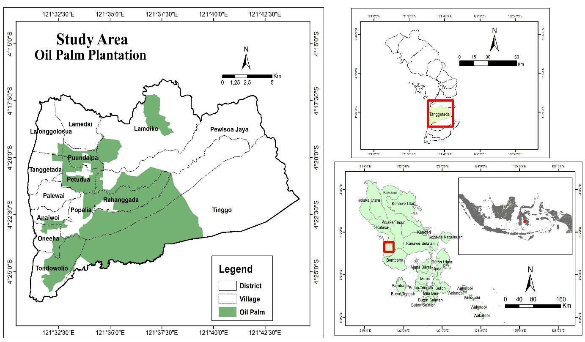
Note: DM = dry matter; OM = organic matter; EE = ether extract/crude fat; CP = crude protein; CF = crude fiber. Values represent proximate analysis results and indicate relative nutritional potential among forage species.

Fig. 1. Study area of Tanggetada District.

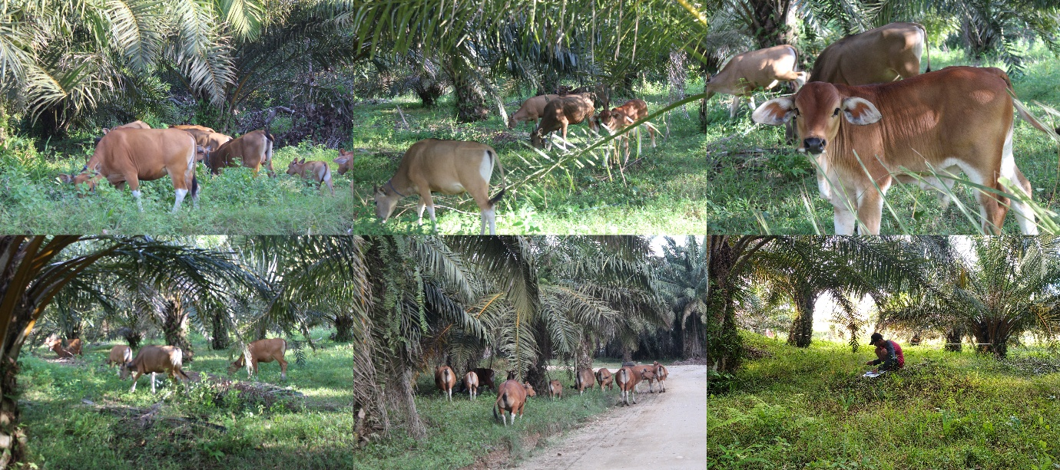

Fig. 2. Field condition during forage sampling collection.

