Combination of Seaweed Meal (Gracilaria verrucosa) and Moringa Leaf Meal (Moringa oleifera) in Diets on Digestibility, Intestinal Histology, Blood Profile, and Growth of Saline Nile Tilapia (Oreochromis niloticus)
Wellem Henrik Muskita¹*, Zaim Bahtiar², Ruslaini¹, Indriyani Nur¹, Agus Kurnia¹, Muhaimin Hamzah¹, La Ode Baytul Abidin¹, Hamsah³, and La Ode Muh. Munadi⁴
1 Department of Aquaculture, Faculty of Fisheries and Marine Sciences, Halu Oleo University, Kendari, Southeast Sulawesi, Indonesia
2 Student of the Department of Aquaculture, Faculty of Fisheries and Marine Sciences, Halu Oleo University, Kendari, Southeast Sulawesi, Indonesia
3 Department of Aquaculture, Universitas Muhammadiyah Makassar, Makassar, South Sulawesi, Indonesia
4 Department of Animal Science, Faculty of Animal Science, Halu Oleo University, Kendari, Southeast Sulawesi, Indonesia
*Corresponding author: wellemhenrikmuskita@uho.ac.id
ABSTRACT
Saline Nile tilapia (Oreochromis niloticus) has strong potential to support aquaculture production in coastal and brackish-water areas, but its production efficiency depends heavily on the availability of affordable, nutritious, and sustainable feeds. This study evaluated the effects of seaweed meal (Gracilaria verrucosa) and moringa leaf meal (Moringa oleifera), used alone or in combination, on protein digestibility, total digestibility, intestinal histology, blood profile, organ indices, and growth of saline Nile tilapia. A completely randomized design with four treatments and three replicates was used: A, 5% moringa leaf meal + 5% seaweed meal; B, 10% seaweed meal; C, 10% moringa leaf meal; and D, commercial feed. Fish with an initial body weight of 4.26 ± 0.87 g were reared for 45 days at a salinity of 13-15 ppt. The measured parameters were protein digestibility, total digestibility, absolute growth, villus height and width, intestine somatic index, hepatosomatic index, total erythrocytes, total leukocytes, and water quality. The dietary treatments significantly affected all major parameters. Commercial feed produced the best overall performance. Among the experimental diets based on alternative ingredients, treatment C produced the most favorable responses in total digestibility, absolute growth, villus width, total erythrocytes, and total leukocytes. These findings indicate that 10% moringa leaf meal is more promising as an alternative feed ingredient than the direct combination of seaweed and moringa leaf meals at the tested inclusion levels. Fermentation or other pretreatments are recommended to improve digestibility and reduce the limiting effects of fiber, ash, and antinutritional compounds.
Keywords: digestibility; Gracilaria verrucosa; intestinal histology; Moringa oleifera; Oreochromis niloticus
INTRODUCTION
Aquaculture has become one of the most strategic food production systems because it provides animal protein, employment, and income for coastal and inland communities. Global fisheries and aquaculture production continues to increase, and aquatic foods are now recognized as important components of food security, nutrition, and the sustainable transformation of food systems. However, the expansion of aquaculture also increases pressure on feed ingredient supply, especially conventional marine-derived protein and lipid sources. This condition has intensified global research on feeds that are more efficient, affordable, and environmentally responsible (Naylor et al. 2021; Zlaugotne et al. 2022; FAO 2024).
The state of the art in aquaculture nutrition shows a clear shift from fishmeal-based feeds to formulations incorporating plant ingredients, local resources, agro-industrial by-products, microalgae, macroalgae, and functional additives. This shift is driven not only by feed cost but also by the need to improve nutrient efficiency, intestinal health, immune responses, and fish resilience to environmental stress. Nevertheless, plant and algal ingredients often contain crude fiber, inorganic minerals, complex polysaccharides, and antinutritional compounds that can limit digestibility and protein utilization (Mmanda et al. 2020; Zlaugotne et al. 2022; Hussain et al. 2024).
Nile tilapia (Oreochromis niloticus) is a major global aquaculture commodity because of its rapid growth, broad environmental tolerance, and capacity to utilize plant-based feed ingredients. The development of saline Nile tilapia is particularly important because it can expand fish production in coastal areas, marginal ponds, and brackish-water resources. Several studies have shown that Nile tilapia can survive and grow at certain salinity levels after acclimation, but their physiological responses remain strongly influenced by feed quality, osmoregulatory efficiency, and the availability of digestible energy and protein (Thomas et al. 2021; Kamble et al. 2024).
Red seaweeds from the genus Gracilaria have attracted attention as functional feed ingredients because they contain minerals, fiber, sulfated polysaccharides, pigments, and bioactive compounds that may modulate intestinal microbiota, improve gut barrier function, and support fish immune responses. However, international studies also show that seaweed inclusion at certain levels can reduce palatability, alter intestinal morphology, or suppress growth when fiber and ash contents are too high. Therefore, seaweed should be evaluated not only as a nutrient source but also as a functional ingredient that requires appropriate inclusion levels and processing methods (Silva et al. 2015; Siddik et al. 2023).
Moringa leaves (Moringa oleifera) also have strong potential as feed ingredients and functional additives because they contain protein, vitamins, minerals, flavonoids, phenolics, and natural antioxidants. Studies on Nile tilapia show that moringa extracts or moringa-based ingredients at appropriate levels can improve growth, feed utilization, hematological status, innate immunity, and resistance to bacterial infection. However, unprocessed moringa leaf meal may contain fiber and secondary metabolites that limit digestibility when included at high levels. Evaluation of inclusion level, processing method, and ingredient combination remains necessary (Hussain et al. 2024; Kamble et al. 2024; Saleh et al. 2025).
The novelty of this study lies in its integrated evaluation of G. verrucosa seaweed meal and M. oleifera leaf meal in diets for saline Nile tilapia. The evaluation was not limited to growth, but also included protein digestibility, total digestibility, intestinal histology, blood profile, intestine somatic index, and hepatosomatic index. This approach is relevant to an international readership because it addresses a global issue in sustainable feed formulation using local resources while considering fish physiological responses under brackish conditions. This study also provides a scientific basis for determining whether two locally available functional ingredients are more effective when used individually or in combination in saline tilapia diets (Silva et al. 2015; Naylor et al. 2021; Hussain et al. 2024).
MATERIALS AND METHODS
Bioethical statement
The animal-use protocol was approved by the Ethical Committee Research of the Institution of Research and Community Service, Halu Oleo University, Kendari, Indonesia (approval No. 1421/UN29.20.1.2/PG/2025; approved on July 7, 2025). The approval was issued for the research protocol entitled "Combination of Seaweed Flour (Gracilaria verrucosa) and Moringa Leaf Flour (Moringa oleifera) in Feed on Digestibility Level, Intestinal Histology, Blood Picture, and Growth of Tilapia (Oreochromis niloticus)." Fish handling was conducted to minimize stress during acclimation, feeding, sampling, and blood collection.
Study time and location
The study was conducted from April to July 2025 at the Laboratory of Aquaculture, Hatchery, and Fisheries Production, Faculty of Fisheries and Marine Sciences, Halu Oleo University, Kendari, Southeast Sulawesi, Indonesia. Proximate analysis and chromium analysis of feed and feces were conducted at the Fish Nutrition Laboratory, Department of Aquaculture, Faculty of Fisheries and Marine Sciences, IPB University, Bogor, Indonesia. Intestinal histology was examined at the Center for Veterinary Assembly and Modernization, Bogor, Indonesia. Blood profile analysis was performed at the Laboratory of Aquaculture, Hatchery, and Fisheries Production, Halu Oleo University. The use of several laboratories ensured that nutrient, digestibility, histological, and hematological indicators were measured using procedures appropriate for fish nutrition studies (Mmanda et al. 2020; Kamble et al. 2024).
Experimental design
The study used a completely randomized design with four dietary treatments and three replicates. The treatments were A: 5% moringa leaf meal + 5% seaweed meal; B: 10% seaweed meal + 0% moringa leaf meal; C: 0% seaweed meal + 10% moringa leaf meal; and D: commercial feed as a practical control. This design was used to compare the effects of alternative ingredients, used individually and in combination, on nutritional and physiological responses of saline Nile tilapia.
Diet formulation and preparation
The experimental diets were prepared as pellets using scad fish meal, shrimp head meal, soybean meal, G. verrucosa seaweed meal, M. oleifera leaf meal, corn meal, rice bran, sago flour, tapioca flour, fish oil, squid oil, corn oil, and premix. All ingredients were ground, weighed according to the formulation, and mixed gradually from the smallest to the largest inclusion level until homogeneous. The mixture was pelleted according to fish mouth size, dried using an oven and sunlight, and stored in closed plastic containers. Feed preparation was carried out to maintain ingredient homogeneity and reduce nutrient variation among feed units, as emphasized in the evaluation of alternative feed ingredients for fish (Mmanda et al. 2020; Hussain et al. 2024).
Rearing units and test fish
The rearing units consisted of 12 container boxes measuring 60 x 40 x 40 cm. Each container was washed, dried, filled with water, and equipped with aeration. The test fish were saline Nile tilapia O. niloticus with an initial average body weight of 4.26 ± 0.87 g per fish, obtained from a community hatchery unit in Kendari City. Fish were acclimated for 15 days. Salinity was increased gradually by 1 ppt per day until it reached 15 ppt. Gradual acclimation is important because salinity change affects osmoregulation, feed intake, and energy efficiency in tilapia (Thomas et al., 2021).
Fish rearing
After acclimation, fish were stocked into the 12 containers at a density of 10 fish per container. Fish were fasted for 24 hours before the feeding trial to reduce residual feed in the digestive tract. The rearing period lasted 45 days. Feed was provided twice daily at 08:00 and 16:00 Central Indonesia Time on an ad libitum basis. A 45-day feeding period enabled observation of growth, digestibility, blood profile, and intestinal tissue responses within a single cycle of functional feed evaluation (Kamble et al. 2024; Nassar et al. 2024).
Digestibility test
Digestibility was evaluated by adding 0.5% chromium oxide (Cr2O3) to the feed as an inert marker. Fecal collection began after fish had consumed the experimental diets for three days. Feces were collected by siphoning approximately three to four hours after feeding, placed in bottles, frozen, and dried before proximate and Cr2O3 analyses. Protein digestibility and total digestibility were calculated using an indirect marker method, which is commonly applied in fish feed ingredient digestibility studies (Köprücü & Özdemir, 2005; Mmanda et al. 2020).
Intestinal histology
Intestinal histology was examined after 45 days of rearing. Fish were dissected to collect intestinal tissue, and samples were placed in microtubes containing 10% formalin. Samples were packed in a cooled container and sent for histological preparation and examination. Villus height and villus width were measured. Villus morphometry was used because intestinal mucosal structure is associated with absorptive surface area and with fish's ability to use nutrients from the diet (Aanyu et al. 2014; Silva et al. 2015; Schneider et al. 2025).
Blood profile, organ indices, and growth
Blood profiles were measured at the beginning and end of the study by counting total erythrocytes and leukocytes using a hemocytometer. Blood was collected from the caudal vein using a syringe containing anticoagulant. The intestinal somatic index and hepatosomatic index were calculated as the ratios of organ weight to body weight. Absolute growth was calculated as the difference between final and initial average body weight. Hematological parameters and organ indices were used as indicators of physiological condition, metabolism, and fish health in response to functional diets (Kamble et al. 2024; Nassar et al. 2024; Villasante et al. 2025).
Water quality and data analysis
Temperature and salinity were measured daily in the morning and afternoon, while pH and dissolved oxygen were measured every 15 days. Data on digestibility, growth, histology, organ indices, and blood profile were analyzed using analysis of variance at a 95% confidence level. When significant differences were detected, Duncan’s multiple range test was applied. Water quality data were analyzed descriptively because they were used as supporting environmental data.
RESULTS
Protein digestibility, total digestibility, and growth
Dietary treatments significantly affected protein digestibility, total digestibility, and absolute growth of saline Nile tilapia (P < 0.05). The highest protein digestibility was observed in treatment D (commercial feed), at 69.87 ± 1.42%, whereas the lowest was in treatment A, at 46.37 ± 3.09%. Among the diets based on alternative ingredients, treatments B and C produced relatively similar protein digestibility values, 56.26 ± 3.73% and 55.72 ± 1.13%, respectively. A similar pattern was observed for total digestibility. Treatment D produced the highest value, 60.47 ± 0.22%, followed by treatment C at 42.19 ± 0.47%, treatment B at 39.12 ± 5.74%, and treatment A at 29.45 ± 4.22%. Absolute growth was also highest in treatment D at 15.35 ± 0.84 g, whereas among the alternative diets, treatment C produced the highest growth at 12.36 ± 1.13 g.
Intestinal histology
Villus height and width changed after the feeding trial. Initial villus height was 139.02 ± 16.96 µm. At the end of the study, the highest villus height was found in treatment B at 356.91 ± 135.96 µm, followed by treatment A at 352.37 ± 129.79 µm, treatment D at 264.44 ± 70.74 µm, and treatment C at 161.12 ± 24.39 µm. Initial villus width was 126.91 ± 63.02 µm. At the end of the study, the highest villus width was found in treatment C at 186.47 ± 55.84 µm, followed by treatment D at 151.53 ± 54.56 µm, treatment B at 146.59 ± 53.31 µm, and treatment A at 87.58 ± 36.24 µm.
Intestine somatic index and hepatosomatic index
The intestine somatic index increased from the initial value of 4.41 ± 1.03% to 6.83 ± 0.70% in treatment A, 7.92 ± 0.36% in treatment B, 8.26 ± 0.68% in treatment C, and 9.24 ± 1.27% in treatment D. The hepatosomatic index also increased from the initial value of 0.19 ± 0.11% to 0.42 ± 0.04% in treatment A, 0.51 ± 0.14% in treatment B, 0.57 ± 0.15% in treatment C, and 0.70 ± 0.16% in treatment D. These results indicate that digestive and hepatic organ responses differed according to feed quality and digestibility.
Blood profile
Total erythrocyte and leukocyte counts increased across all treatments compared with the initial values. Initial total erythrocytes were 0.40 ± 0.00 x 10^6 cells/mm3 and increased to 3.36 ± 0.64 x 10^6 cells/mm3 in treatment A, 2.72 ± 0.40 x 10^6 cells/mm3 in treatment B, 5.58 ± 0.30 x 10^6 cells/mm3 in treatment C, and 5.87 ± 0.43 x 10^6 cells/mm3 in treatment D. Initial total leukocytes were 0.03 ± 0.00 x 10^4 cells/mm3 and increased to 67.41 ± 6.39 x 10^4 cells/mm3 in treatment A, 71.06 ± 12.44 x 10^4 cells/mm3 in treatment B, 109.67 ± 35.55 x 10^4 cells/mm3 in treatment C, and 127.99 ± 8.76 x 10^4 cells/mm3 in treatment D.
Water quality
Water quality during the rearing period remained within a suitable range for saline Nile tilapia. Temperature ranged from 26 to 28°C, pH from 7.3 to 8.1, dissolved oxygen from 5.4 to 6.7 mg/L, and salinity from 13 to 15 ppt. These ranges indicate that the main differences in fish response were more likely related to dietary treatment than to environmental fluctuation.
DISCUSSION
This study showed that commercial feed produced the highest protein digestibility, total digestibility, and growth values. This result is reasonable because commercial feeds are generally designed with a more stable balance of protein, energy, lipids, minerals, vitamins, and amino acids. In Nile tilapia, protein and energy digestibility are key factors that determine feed-use efficiency and tissue deposition. International studies on ingredient digestibility in Nile tilapia also show that ingredients with highly digestible protein and balanced amino acid profiles are used more efficiently than alternative ingredients that are high in fiber or contain indigestible fractions (Köprücü & Özdemir, 2005; Mmanda et al. 2020).
Among the alternative diets, treatment C, containing 10% moringa leaf meal, showed the best performance in total digestibility, absolute growth, villus width, and erythrocyte and leukocyte profiles. This response supports evidence that moringa has functional value for fish because it contains protein, minerals, vitamins, and bioactive compounds such as flavonoids and phenolics. Studies on Nile tilapia have shown that moringa can improve growth, feed utilization, hematological profile, innate immunity, and disease resistance when used at an appropriate level or after processing that reduces its limiting factors (Kamble et al., 2024; Nassar et al., 2024; Saleh et al., 2025).
However, protein digestibility in treatment C remained lower than in the commercial feed treatment. This finding indicates that although moringa leaves have potential as an alternative feed ingredient, unprocessed leaf meal may still contain fiber and antinutritional compounds that limit protein breakdown and absorption. Recent literature emphasizes that plant ingredients in fish diets often require pretreatments, such as fermentation, heating, enzyme supplementation, or functional additives, to improve digestibility and nutrient utilization (Jiang et al. 2023; Hussain et al. 2024; Nassar et al. 2024).
Treatment B, containing 10% seaweed meal, produced the highest villus height, but it did not produce the highest total digestibility or growth among the alternative diets. This result indicates that changes in intestinal morphology do not always translate directly into growth if the feed ingredient contains fractions that are difficult to digest. Studies on tilapia fed diets containing Gracilaria, Porphyra, and Ulva show that seaweed may affect intestinal morphology and growth performance differently, depending on seaweed species and inclusion level. Gracilaria at certain inclusion levels may reduce palatability, feed intake, and growth performance, although seaweed remains a promising functional ingredient when used at appropriate levels and with suitable processing (Silva et al. 2015; Siddik et al. 2023).
Treatment A, which combined 5% seaweed meal and 5% moringa leaf meal, produced the lowest digestibility and growth. This finding indicates that combining two functional ingredients does not always produce a synergistic effect. The combination may have increased the accumulation of fiber, ash, complex polysaccharides, and antinutritional compounds, thereby reducing palatability, increasing the digestive burden, and decreasing the availability of protein and energy. In sustainable aquaculture feed development, the use of alternative ingredients should be based on nutritional compatibility, not only on the bioactive potential of each ingredient (Zlaugotne et al. 2022; Hussain et al. 2024).
The blood profile supports the interpretation that treatment C was more promising than the other alternative diets. Total erythrocytes and leukocytes in treatment C approached those in the commercial feed treatment and were higher than those in treatments A and B. Erythrocytes are associated with oxygen transport capacity, whereas leukocytes reflect the body’s defense response. Kamble et al. (2024) reported that supplementation with moringa leaf extract in Nile tilapia improved red blood cells, white blood cells, hemoglobin, hematocrit, and innate immune responses. Therefore, the hematological response observed in treatment C may be associated with the contribution of moringa bioactive compounds to fish physiological status.
The increases in intestine somatic index and hepatosomatic index in treatments D and C indicate organ responses to nutrient status and feed metabolism. A higher HSI in diets associated with better growth may reflect increased hepatic metabolic activity and energy storage. However, excessively high HSI under certain dietary conditions should be interpreted with caution, as it may also reflect lipid accumulation or metabolic burden. Further research should include liver histology and body composition analysis to determine whether increased HSI reflects healthy energy status or metabolic stress (Schneider et al. 2025; Villasante et al. 2025).
Water quality remained within a suitable range for saline Nile tilapia, indicating that the observed results can be interpreted mainly as responses to the dietary treatments. Salinity of 13-15 ppt remained within the range tolerated by Nile tilapia after gradual acclimation. Under saline conditions, high-quality feed becomes more important because fish require energy for osmoregulation in addition to growth. Therefore, alternative feed ingredients for saline tilapia should be evaluated not only for nutrient content but also for their ability to support digestibility, physiological status, and energy efficiency in a brackish environment (Thomas et al. 2021).
Overall, the results indicate that 10% moringa leaf meal is more suitable as an alternative feed ingredient for saline Nile tilapia than 10% seaweed meal or the direct combination of 5% seaweed meal and 5% moringa leaf meal. For an international readership, this finding is important because it provides evidence that tropical local ingredients can support the sustainable aquaculture feed agenda, but formulation must be guided by integrated evaluation of digestibility, intestinal health, blood profile, and growth performance. The findings also open opportunities for further studies on seaweed and moringa fermentation, inclusion-level optimization, and isoenergetic and isoproteic formulation to improve the competitiveness of local feeds in saline tilapia farming systems (Silva et al. 2015; Naylor et al. 2021; Nassar et al. 2024).
CONCLUSION
Dietary inclusion of G. verrucosa seaweed meal and M. oleifera leaf meal significantly affected protein digestibility, total digestibility, absolute growth, intestinal histology, intestine somatic index, hepatosomatic index, total erythrocytes, and total leukocytes of saline Nile tilapia. Commercial feed produced the highest response in most parameters. Among the alternative diets, 10% moringa leaf meal produced the most favorable and consistent performance, especially in total digestibility, growth, villus width, and blood profile. The direct combination of 5% seaweed meal and 5% moringa leaf meal did not show a synergistic effect. Its use should therefore be improved through ingredient processing, especially fermentation, to reduce fiber, ash, and antinutritional compounds. Further studies should evaluate isoproteic and isoenergetic diets, lower inclusion levels, ingredient fermentation, microbiota profiles, and liver histology to better explain the mechanisms of nutrient utilization.
DECLARATIONS
Funding
This study did not receive financial support from any organization or agency.
Acknowledgments
The authors thank the Laboratory of Aquaculture, Hatchery, and Fisheries Production, Faculty of Fisheries and Marine Sciences, Halu Oleo University, Kendari, Indonesia; the Fish Nutrition Laboratory, Department of Aquaculture, Faculty of Fisheries and Marine Sciences, IPB University, Bogor, Indonesia; and the Center for Veterinary Assembly and Modernization, Bogor, Indonesia, for technical support during fish rearing, proximate and chromium analyses, blood profile observation, and intestinal histology examination.
Conflict of interest
The authors declare no financial or nonfinancial conflicts of interest that could have influenced the conduct, analysis, interpretation, or reporting of this study.
Data availability
The main data supporting the findings of this study are presented in the article. Raw data are available from the corresponding author upon reasonable request.
Ethics statement
The animal-use protocol was approved by the Ethical Committee for Research of the Institution of Research and Community Service, Halu Oleo University, Kendari, Indonesia (approval No. 1421/UN29.20.1.2/PG/2025; approved on July 7, 2025). The approval was valid for one year from the approval date. The study was conducted in accordance with applicable institutional requirements for the use of animal subjects.
Authors’ contributions
WHM: conceptualization, methodology, project administration, supervision, and writing - review and editing. ZB: investigation, data collection, data curation, formal analysis, and writing - original draft. R: methodology, validation, resources, and writing - review and editing. IN: methodology, data interpretation, validation, and writing - review and editing. AK: supervision, methodology, validation, and writing - review and editing. MH: investigation, resources, validation, and writing - review and editing. LOBA: investigation, data curation, visualization, and writing - review and editing. H: methodology, validation, and writing - review and editing. LOMM: formal analysis, validation, data interpretation, and writing - review and editing. All authors read and approved the final manuscript.
Generative AI statement
Digital assistance was used only for language editing, academic English refinement, and manuscript formatting. No generative AI tool was used to design the study, generate data, perform statistical analysis, create results, or determine the scientific interpretation. The authors take full responsibility for the accuracy, integrity, and originality of the manuscript.
REFERENCES
Aanyu M, Ondhoro CC, Ganda E, Kato DC and Basiita RK, 2014. Intestine histology, nutrient digestibility and body composition of Nile tilapia (Oreochromis niloticus) fed on diets with both cotton and sunflower seed cakes. African Journal of Biotechnology 13: 3831-3839. https://doi.org/10.5897/AJB12.1895
FAO, 2024. The State of World Fisheries and Aquaculture 2024: Blue Transformation in Action. Food and Agriculture Organization of the United Nations, Rome, Italy. https://doi.org/10.4060/cd0683en
Hussain SM, Bano AA, Ali S, Rizwan M, Adrees M, Zahoor AF, Sarker PK, Hussain M, Arsalan MZ-H, Yong JWH and Naeem A, 2024. Substitution of fishmeal: Highlights of potential plant protein sources for aquaculture sustainability. Heliyon 10: e26573. https://doi.org/10.1016/j.heliyon.2024.e26573
Jiang W, Qian L, Zhao Y, Lin Y, Yang Y, Shen H, Ge X and Miao L, 2023. The application of Moringa oleifera leaf meal and its fermentation products in the diet of Megalobrama amblycephala juveniles. Fermentation 9: 577. https://doi.org/10.3390/fermentation9060577
Kamble MT, Gallardo W, Salin KR, Pumpuang S, Chavan BR, Bhujel RC, Medhe SV, Kettawan A, Thompson KD and Pirarat N, 2024. Effect of Moringa oleifera leaf extract on the growth performance, hematology, innate immunity, and disease resistance of Nile tilapia (Oreochromis niloticus) against Streptococcus agalactiae biotype 2. Animals 14: 953. https://doi.org/10.3390/ani14060953
Köprücü K and Özdemir Y, 2005. Apparent digestibility of selected feed ingredients for Nile tilapia (Oreochromis niloticus). Aquaculture 250: 308-316. https://doi.org/10.1016/j.aquaculture.2004.12.003
Mmanda FP, Lindberg JE, Norman Haldén A, Mtolera MSP, Kitula R and Lundh T, 2020. Digestibility of local feed ingredients in tilapia Oreochromis niloticus juveniles, determined on faeces collected by siphoning or stripping. Fishes 5: 32. https://doi.org/10.3390/fishes5040032
Nassar AAMA, Gharib AAEA, Abdelgalil SY, AbdAllah HM and Elmowalid GA, 2024. Immunomodulatory, antioxidant, and growth-promoting activities of dietary fermented Moringa oleifera in Nile tilapia (Oreochromis niloticus) with in-vivo protection against Aeromonas hydrophila. BMC Veterinary Research 20: 231. https://doi.org/10.1186/s12917-024-04070-3
Naylor RL, Hardy RW, Buschmann AH, Bush SR, Cao L, Klinger DH, Little DC, Lubchenco J, Shumway SE and Troell M, 2021. A 20-year retrospective review of global aquaculture. Nature 591: 551-563. https://doi.org/10.1038/s41586-021-03308-6
Saleh SY, Younis NA, Sherif AH and Gaber HG, 2025. The role of Moringa oleifera in enhancing fish performance and health: A comprehensive review of sustainable aquaculture applications. Veterinary Research Communications 49: 308. https://doi.org/10.1007/s11259-025-10889-4
Schneider TLS, Scheid RC, Peixoto NC and Lazzari R, 2025. Metabolic and intestinal morphometric responses of Nile tilapia fed diets containing soybean and protease. Animals 15: 349. https://doi.org/10.3390/ani15030349
Siddik MAB, Francis P, Rohani MF, Azam MS, Mock TS and Francis DS, 2023. Seaweed and seaweed-based functional metabolites as potential modulators of growth, immune and antioxidant responses, and gut microbiota in fish. Antioxidants 12: 2066. https://doi.org/10.3390/antiox12122066
Silva DM, Valente LMP, Sousa-Pinto I, Pereira R, Pires MA, Seixas F and Rema P, 2015. Evaluation of IMTA-produced seaweeds (Gracilaria, Porphyra, and Ulva) as dietary ingredients in Nile tilapia, Oreochromis niloticus L., juveniles: Effects on growth performance and gut histology. Journal of Applied Phycology 27: 1671-1680. https://doi.org/10.1007/s10811-014-0453-9
Thomas RM, Verma AK, Krishna H, Prakash S, Kumar A and Peter RM, 2021. Effect of salinity on growth of Nile tilapia (Oreochromis niloticus) and spinach (Spinacia oleracea) in aquaponic system using inland saline groundwater. Aquaculture Research 52: 6288-6298. https://doi.org/10.1111/are.15492
Villasante A, Figueroa E, Godoy K, Dantagnan P, López-Polo J, Opazo R and Romero J, 2025. Impact of plant-based diets on hepatosomatic index, circulating globulins and growth in rainbow trout (Oncorhynchus mykiss). Fishes 10: 110. https://doi.org/10.3390/fishes10030110
Zlaugotne B, Pubule J and Blumberga D, 2022. Advantages and disadvantages of using more sustainable ingredients in fish feed. Heliyon 8: e10527. https://doi.org/10.1016/j.heliyon.2022.e10527
TABLES AND FIGURE
Table 1. Experimental diet formulation (g/100 g feed).
Feed ingredient | A | B | C
Scad fish meal | 20 | 20 | 20
Shrimp head meal | 20 | 20 | 20
Soybean meal | 20 | 20 | 20
Seaweed meal (G. verrucosa) | 5 | 10 | 0
Moringa leaf meal (M. oleifera) | 5 | 0 | 10
Corn meal | 10 | 10 | 10
Rice bran | 7 | 8 | 8
Sago flour | 4 | 4 | 4
Tapioca flour | 7 | 7 | 7
Fish oil | 0.5 | 0.5 | 0.5
Squid oil | 0.5 | 0.5 | 0.5
Corn oil | 0.5 | 0.5 | 0.5
Top mix | 0.5 | 0.5 | 0.5
Total | 100 | 100 | 100
Note: A = 5% MLM + 5% SM; B = 10% SM + 0% MLM; C = 0% SM + 10% MLM. MLM = moringa leaf meal; SM = seaweed meal.
Table 2. Protein digestibility, total digestibility, and absolute growth of saline Nile tilapia after 45 days of rearing.
Treatment | Protein digestibility (%) | Total digestibility (%) | Absolute growth (g)
A | 46.37 ± 3.09ª | 29.45 ± 4.22ª | 9.60 ± 0.60ª
B | 56.26 ± 3.73^{b} | 39.12 ± 5.74^{ab} | 11.16 ± 0.95^{ab}
C | 55.72 ± 1.13^{b} | 42.19 ± 0.47^{b} | 12.36 ± 1.13^{b}
D | 69.87 ± 1.42^{c} | 60.47 ± 0.22^{c} | 15.35 ± 0.84^{c}
Note: Different superscript letters in the same column indicate significant differences based on Duncan’s multiple range test (P < 0.05).
Table 3. Intestinal villus morphometry of saline Nile tilapia.
Parameter | Initial | A | B | C | D
Villus height (µm) | 139.02 ± 16.96 | 352.37 ± 129.79 | 356.91 ± 135.96 | 161.12 ± 24.39 | 264.44 ± 70.74
Villus width (µm) | 126.91 ± 63.02 | 87.58 ± 36.24 | 146.59 ± 53.31 | 186.47 ± 55.84 | 151.53 ± 54.56
Table 4. Intestine somatic index (ISI) and hepatosomatic index (HSI) of saline Nile tilapia.
Treatment | ISI (%) | HSI (%)
Initial | 4.41 ± 1.03 | 0.19 ± 0.11
A | 6.83 ± 0.70 | 0.42 ± 0.04
B | 7.92 ± 0.36 | 0.51 ± 0.14
C | 8.26 ± 0.68 | 0.57 ± 0.15
D | 9.24 ± 1.27 | 0.70 ± 0.16
Table 5. Total erythrocytes and leukocytes of saline Nile tilapia.
Treatment | Total erythrocytes (x 10^6 cells/mm3) | Total leukocytes (x 10^4 cells/mm3)
Initial | 0.40 ± 0.00 | 0.03 ± 0.00
A | 3.36 ± 0.64 | 67.41 ± 6.39
B | 2.72 ± 0.40 | 71.06 ± 12.44
C | 5.58 ± 0.30 | 109.67 ± 35.55
D | 5.87 ± 0.43 | 127.99 ± 8.76
Table 6. Water quality during the rearing period.
Parameter | Value
Temperature (°C) | 26-28
pH | 7.3-8.1
Dissolved oxygen (mg/L) | 5.4-6.7
Salinity (ppt) | 13-15

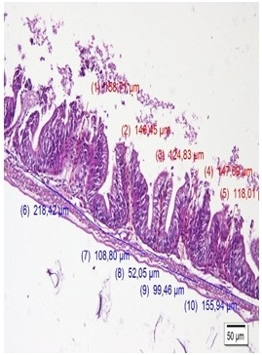  Initial sample (OZ). Height and width of intestinal mucosal villi. H&E, x200. | 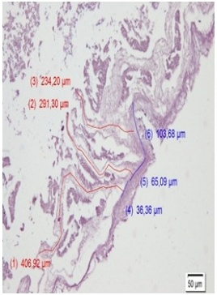  Fig. 1a. Sample AZ. Height and width of intestinal mucosal villi. H&E, x200. |  | 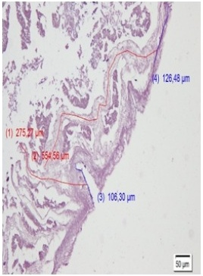  Fig. 1b. Sample AZ. Height and width of intestinal mucosal villi. H&E, x200.
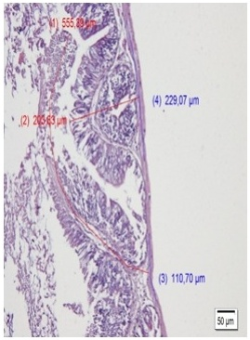  Fig. 3a. Sample BZ. Height and width of intestinal mucosal villi. H&E, x200. | 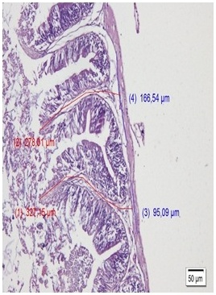  Fig. 3b. Sample BZ. Height and width of intestinal mucosal villi. H&E, x200. |  | 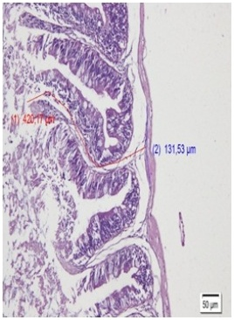  Fig. 3c. Sample BZ. Height and width of intestinal mucosal villi. H&E, x200.
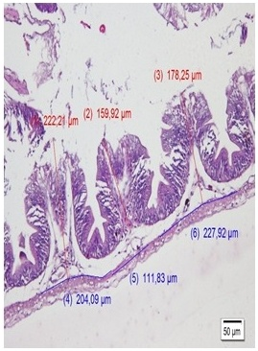  Fig. 2a. Sample CZ. Height and width of intestinal mucosal villi. H&E, x200. | 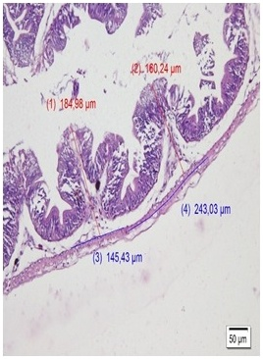  Fig. 2b. Sample CZ. Height and width of intestinal mucosal villi. H&E, x200. |  | 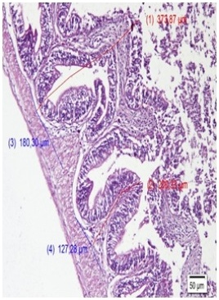  Fig. 4a. Sample DZ. Height and width of intestinal mucosal villi. H&E, x200.
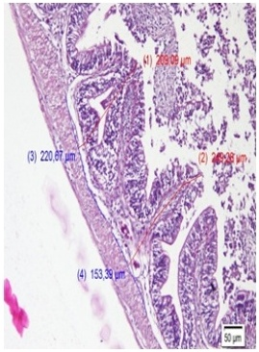  Fig. 4b. Sample DZ. Height and width of intestinal mucosal villi. H&E, x200. |  | 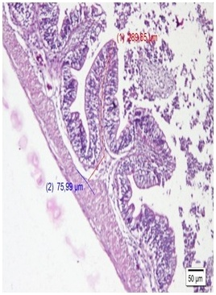  Fig. 4c. Sample DZ. Height and width of intestinal mucosal villi. H&E, x200.
Fig. 1. Intestinal villus histology of saline Nile tilapia at the beginning of the study and after feeding treatments. Hematoxylin and eosin staining, 200x magnification. The figure should be prepared as a separate JPG/TIFF file with at least 300 dpi before submission.

