RESEARCH ARTICLE
MOLECULAR–GENETIC CHARACTERIZATION OF MERIONES TAMARISCINUS (RODENTIA: MURIDAE)
Oybek Amirov¹ (0000-0002-6840-2036), Wang Muyang^{2, 3} (0000-0002-5593-632X), Alisher Khurramov⁴ (0009-0009-2958-7224), Barno Sharipova⁵ (0009-0001-8587-6276), Odinakhon Turdiyeva⁶ (0009-0003-6451-3665), Barno Davronov⁷ (0009-0003-0258-6957), Khikoyat Nurova⁸(0009-0007-3767-53188), Khurshida Keldiyorova⁹ (0000-0002-9975-6259), Abdunabi Mamashukurov⁹ (0000-0003-0934-6529), Muratbay Jumanov¹⁰ (0009-0009-4145-4176), Samandarov Otabek¹⁰ (0009-0004-2640-3825), Zafarjon Mustafoyev¹¹
¹Institute of Zoology of the Academy of Sciences of the Republic of Uzbekistan, Tashkent, Uzbekistan; ²State Key Laboratory of Ecological Safety and Sustainable Development in Arid Lands, Xinjiang Institute of Ecology and Geography, Chinese Academy of Sciences, Urumqi, China;
³China-Tajikistan Belt and Road Joint Laboratory on Biodiversity Conservation and Sustainable Use, Xinjiang Institute of Ecology and Geography, Chinese Academy of Sciences, Urumqi, China;
⁴Termez State University, faculty of Natural Sciences, Termez, Uzbekistan;

⁵ Fergana State University, Fergana, Uzbekistan
⁶Kokand State University, Kokand, Uzbekistan;
⁷Karshi State University, Karshi, Uzbekistan;
⁸Bukhara State Pedagogical Institute, Bukhara, Uzbekistan.

⁹Samarkand State University named after Sharof Rashidov, Samarkand, Uzbekistan.

¹⁰Karakalpak state University, Nukus, Uzbekistan

¹¹Samarkand State Medical University, Samarkand, Uzbekistan

*Corresponding author: balikulov@samdu.uz

Abstract. This article presents a molecular-genetic characterization of the species Meriones tamariscinus (Pallas, 1773), belonging to the genus Meriones Illiger, 1811, based on specimens collected from the Bukhara and Navoi regions and the Republic of Karakalpakstan. For M. tamariscinus, the phylogenetic tree constructed using the mitochondrial DNA COI gene was divided into three main clades, and all major nodes were shown to be statistically well supported with high bootstrap values (69–100%).
Based on the results of the phylogenetic tree analyses reconstructed using the mitochondrial DNA 16S rRNA gene, all examined samples were classified into clearly distinct clades (Clade I–III). All of these clades were found to be statistically well supported with high bootstrap values.

Key words: Genus, species, mitochondrial DNA, COI, 16S rRNA, phylogeny, phylogenetic tree

INTRODUCTION

Uzbekistan’s fauna is characterized by a rich diversity of species. Its biological diversity is an integral part of our national wealth. This richness has developed over several thousand years of evolution and represents a great heritage passed down to us by our ancestors. Preserving this heritage and passing it on to future generations in the form of a diverse and stable system is a significant and responsible task that lies before us. At present, the fauna of Uzbekistan includes 714 species of vertebrates, while the number of invertebrate species exceeds 15,000 (Red Book of the Republic of Uzbekistan, 2019).
The distribution of species diversity across the Earth’s surface is markedly uneven and exhibits strong spatial heterogeneity. Although biogeographers have conducted extensive studies at broad spatial scales, in biodiversity hotspot regions, and along major natural gradients such as latitude and elevation, comparatively little attention has been given to examining patterns of species diversity in arid environments (Belmaker and Jetz 2015; Li et al., 2021; Kinlock et al., 2017; Quintero and Jetz 2018; Zhang et al., 2023).
Arid regions–including hyper–arid, arid, and semi–arid zones–have traditionally been regarded as harsh and unproductive landscapes. As a result, they have been studied far less than other biomes such as forests and steppes, despite covering nearly one–third of the Earth’s terrestrial surface and supporting unique forms of biodiversity (Byrne et al., 2008; Durant et al., 2012; Zhang et al., 2023).
Understanding the factors that determine the spatial patterns of species diversity remains one of the central challenges in evolutionary biology and ecology (Pennisi, 2005; Jin et al., 2021). Numerous drivers have been proposed to explain spatial variation in species diversity across different scales. For instance, habitat heterogeneity is strongly associated with species richness in terrestrial plants and animals (Stein et al., 2014), whereas contemporary climate plays a key role in shaping the geographic distribution of mammal diversity in Europe (Santos et al., 2020).
Recent research has also shown that Quaternary climate change has been a major driver of species richness and rarity among mammals, birds, amphibians, and dragonflies in sub–Saharan Africa (Pinkert et al., 2020). However, studies focusing on large–scale patterns suggest that relying solely on correlations between environmental variables and species richness is insufficient to fully explain how diversity has developed over time. A more comprehensive understanding requires the inclusion of evolutionary processes in analytical models (Wiens and Donoghue, 2004; Cai et al., 2020).
From an evolutionary perspective, phylogenies combined with spatial data can be used to infer historical processes and ultimately explain the formation of contemporary patterns of biodiversity (Stevens, 2006; Feijó et al., 2022a). In fact, the spatial distribution of species diversity is shaped over evolutionary time by the processes of speciation, extinction, and dispersal (Wiens and Donoghue, 2004; Shrestha et al., 2018; Feijó et al., 2022a).
In arid regions, species diversity is mainly represented by animals that are well adapted to dry environments, typically small–bodied species with high population sizes, including rodents (Shenbrot et al., 2012). Rodents have large populations and long evolutionary histories, and their fossil records are widely distributed. Therefore, they represent a suitable model group for studying the mechanisms underlying diversity patterns in desert ecosystems. In this study, we assessed the relative importance of ecological and evolutionary factors in shaping large–scale patterns of rodent diversity in arid regions, using one of the largest rodent subfamilies, Gerbillinae, as an example.
Gerbillinae is the second–largest subfamily within the family Muridae (after Murinae) and comprises 14 genera and 102 species. Nearly all of them are adapted to arid environments (Shenbrot et al., 2012; Burgin et al., 2018; Mammal Diversity Database, 2023). They play an important role in the arid ecosystems of Africa and Eurasia and are widely distributed across deserts, semi–deserts, steppes, savannas, and other dry habitats (Shenbrot and Krasnov, 2001).
Murinae consists of 135 genera and 656 species and represents the largest subfamily within Muridae (Wilson and Mittermeier, 2018). Muridae show a higher level of variation in diversification rates than any other rodent group (Fabre et al., 2012). In addition, due to the medical importance and genomic advantages of Murinae species, studies involving DNA sequencing, phylogenetic reconstruction, and divergence time estimation are particularly significant.
Although the phylogenetic relationships of some rodent subfamilies have been studied from different perspectives, those of Murinae have not yet been fully resolved (Steppan et al., 2005). To address this gap, S.J. Steppan et al. (2005) clarified the phylogeny of Murinae and identified seven distinct geographic lineages. Using three nuclear genes and one mitochondrial fragment, they inferred that Murinae originated in Southeast Asia.
Musser and Carleton. (2005) divided Murinae into 29 groups. Lecompte et al. (2008) proposed that the phylogenetic relationships within Murinae should be described at the tribal level and indicated that Phloeomyini represents the basal lineage of Murinae. P.H. Fabre et al. (2013) further reconstructed the phylogenetic relationships and biogeographic history of Murinae, also confirming that Phloeomyini occupies a basal position. They showed that Micromys belongs to the tribe Murini rather than forming a separate tribe, and that Murinae consists of nine tribes.
I.G. Meschersky et al. (2016) demonstrated that Chiropodomys is neither part of the Micromys lineage nor closely related to Hapalomys. A.D. Missoup et al. (2016) clarified the phylogenetic relationships within the Arvicanthini tribe. In the same year, M. Pagès et al. (2016) used molecular analyses and morphological comparisons to determine the taxonomic status of the Micromys and Pithecheir groups within Murinae.
The body length of M. tamariscinus is approximately 180 mm. The tail is slightly shorter than the combined length of the head and body (about 95%). The tail tuft is short and has a light chestnut coloration. The sole of the hind foot is completely covered with brown hairs; in M. t. texartensis, these hairs extend to the heel region, whereas in M. t. siscaucasicus, they are absent. The hairs on the lateral and anterior parts of the sole are white, while the part shows a distinct dark brown stripe or triangular marking.
The tail lacks a well–developed tuft of long hairs; instead, it is covered with short hairs along its entire length, which become slightly longer at the tip, forming a small tuft. The dorsal surface of the foot often bears an elongated dark spot. The claws are yellowish–brown. The dorsal side of the body is light–colored, whereas the ventral side is off–white.
Cranial characteristics: In this species, the auditory bullae are small, without hypertrophy and lacking any additional cavity in the anterior external part. The external bony auditory meatus is simple in structure, but its anterior margin is crescent–shaped. The bony lamina of the auditory meatus is present. The suprameatal triangle is small and closed. The upper suprameatal triangle process is well developed and broad.
Taxonomy: The placement of this species within the subgenus Meriones is explained by the highly distinctive morphology of the male genitalia of M. tamariscinus compared to other species within the genus (Wilson & Reeder, 2005).
Currently, molecular genetic studies on both vertebrate and invertebrate animals are being actively conducted in our country. In particular, molecular genetic research on invertebrates (Aliyev et al., 2025; Soliyeva et el., 2025; Shakarboev et el., 2025), fishes (Ubaydullayev et el., 2025) and lizards (Amirov et el., 2025; Kuchboev et el., 2025) is being carried out.
The aim of this study is to perform the molecular genetic characterization of Meriones tamariscinus (Pallas, 1773), a species belonging to the genus Meriones Illiger, 1811, distributed in the desert regions of Navoi and Bukhara regions and the Republic of Karakalpakstan of the Republic of Uzbekistan.

MATERIALs AND METHODS
The materials for this study were collected during 2025 from the Navoi and Bukhara regions of the Republic of Uzbekistan, as well as from the Republic of Karakalpakstan. The research focused on genetic samples obtained from M. tamariscinus (Pallas, 1773), a species belonging to the genus Meriones Illiger, 1811. The following method was used to obtain genetic samples from the rodents (Figure 1).
Prior to setting up a snare, an ideal location has to be determined within the pika habitat or talus slope. This includes hay piles, which are vegetation caches that the animals collect in late summer as well as fresh scats found at latrine sites. Strips of packing tape (10–50 cm in length) are rolled up to provide a 360° sticky surface and are arranged in a web–like manner to envelope the entrance to the pika's hay pile or latrine site. Depending on the configuration of the rocks, a piece of fishing line may be used to support the structure of the hair snare, but this is often not necessary when entrances are quite small (<30 cm in diameter), a complete description of the use of fishing line can be found in P. Henry and A. Russello. (2010). Hair snares are checked as often as possible, and hair samples deposited on the tape are then collected and labeled. Once transported back to the lab, hairs are removed from the sticky tape using sterile forceps and transferred into cryogenic tubes and stored at –20°C until further manipulation (Henry et el., 2011).
DNA was extracted from the selected samples using the GeneJET Genomic DNA purification kit (Vogelstein et el., 1979; Marko et el., 1982; Boom et el., 1990).
Genomic DNA extracted from M. tamariscinus was used to determine the nucleotide sequences of the 16S rRNA gene. For this purpose, the universal mitochondrial 16Sbr primer (5′–CCGGTCTGAACTCAGATCACGT–3′) was employed. PCR amplification was carried out under the following conditions: an initial denaturation at 95°C for 10 min, followed by 35 cycles of denaturation at 94°C for 1 min, annealing at 52°C for 1 min, extension at 72°C for 1 min, and a final extension at 72°C for 7 min (Jung–Ha Kang et el., 2015).
In addition, the COI gene was analyzed using the following primers: forward primer (5′–GGTCAACAAATCATAAAGATATTGG–3′) and reverse primer (5′–TAAACTTCAGGGTGACCAAAAAATCA–3′). The PCR cycling conditions were as follows: 95°C for 1 min, followed by 40 cycles of 95°C for 20 s, 50°C for 50 s, and 68°C for 1.5 min, with a final extension at 72°C for 5 min (Parinya et el., 2020).
The presence of DNA in the PCR products was confirmed by electrophoresis on a 1.0% agarose gel under 120 V. DNA amplification and gel purification were carried out according to the manufacturer’s instructions using reagent kits provided by “Silex M” (Moscow, Russia). DNA sequencing was performed using the ABI PRISM® BigDye™ Terminator v. 3.1 Cycle Sequencing Kit, and sequencing reactions were analyzed on an ABI PRISM 3100–Avant Genetic Analyzer (Moscow, Russia).
Phylogenetic Tree Construction. For phylogenetic analysis, COI gene nucleotide sequences from 15 specimens representing 4 species of the genus Meriones Illiger, 1811, as well as 16S rRNA gene sequences from 12 specimens of the same 4 species, were used. As outgroups, sequences of Apodemus uralensis and Acomys spinosissimus with GenBank accession numbers MK329621 and AM409241 were included.
The obtained nucleotide sequences were manually edited using BioEdit version 7.0.5.2 (Hall, 1999), and subsequently all sequences were aligned using the MAFFT algorithm (Katoh et al., 2002). Phylogenetic trees were reconstructed using the Maximum Likelihood (ML) method implemented in IQ-TREE 2 (Minh et al., 2020). The best-fitting evolutionary model was selected using the ModelFinder algorithm, which is integrated into the IQ-TREE software (Kalyaanamoorthy et al., 2017).
The reliability of the tree topology was assessed using 1000 bootstrap replications (Felsenstein, 1985). Additional analyses were performed using Bayesian Inference (BI) with the MrBayes 3.1.2 software (Huelsenbeck & Ronquist, 2001). The MCMC (Markov Chain Monte Carlo) algorithm was run for 4 million generations, with samples taken every 1000 generations. The first 1000 trees were discarded as burn–in. Phylogenetic tree reliability was evaluated using Bayesian posterior probabilities (PP) and bootstrap values (BS) as follows: PP ≥ 0.95 and BS ≥ 70% – high support; PP = 0.90–0.94 and BS = 50–69% – moderate support; PP < 0.90 and BS < 50% – low support (Huelsenbeck & Hillis, 1993). The final phylogenetic trees were visualized graphically using the iTOL (Interactive Tree of Life) online platform (Letunic & Bork, 2021).

RESULTS
Phylogenetic tree constructed based on the COI gene of mitochondrial DNA
As a result of the conducted molecular genetic analyses, nucleotide sequences of mitochondrial DNA belonging to the COI gene (625 base pairs) and the 16S rRNA gene (555 base pairs) were obtained from M. tamariscinus, a species of the genus Meriones Illiger, 1811.
Based on the results of the phylogenetic tree analyses, a well–defined and strongly supported evolutionary structure among rodent representatives was revealed for species of the genus Meriones based on the mitochondrial COI gene. The phylogenetic tree constructed using the Maximum Likelihood method was divided into three main clades, and all major nodes were statistically well supported with high bootstrap values (69–100%). The obtained results were visualized using the iTOL platform.
Among the samples of M. tamariscinus, a particularly strong phylogenetic signal was observed, with all samples forming a monophyletic clade. Within this clade, the Bukhara, Navoi, and Karakalpak populations were characterized by very low genetic divergence (0.001–0.003), indicating either recent separation or ongoing microevolutionary differentiation processes. The Bukhara and Navoi samples formed the closest evolutionary lineage, while the Karakalpak population occupied a relatively intermediate but slightly more divergent position. This clade clustered together with GenBank reference sequences (KT834971, NC034314) in a highly supported cluster, confirming species–level identity with a genetic distance of ≤0.01.
The clade of M. meridianus was identified as a stable evolutionary unit with high bootstrap support (73–100%), and the low level of intraclade genetic variation suggests evolutionary stability within this species. In contrast, M. musculus exhibited relatively higher intraclade genetic divergence (0.002–0.005), indicating the presence of population structure. M. libycus and M. tristrami formed clearly separated and highly supported independent clades, reflecting pronounced interspecific phylogenetic differentiation.
As an outgroup, A. uralensis was positioned at a significantly greater evolutionary distance from all ingroup taxa (≈0.052–0.767), ensuring proper rooting of the tree and reliable reconstruction of evolutionary relationships among the internal clades (Figure 2).
Overall, reconstruction of the phylogenetic tree based on the COI gene revealed a highly structured evolutionary pattern among rodent taxa. In particular, the low genetic divergence and geographic clustering observed within M. tamariscinus suggest that this species is currently in a stage of population–level differentiation. The obtained results demonstrate that the COI marker has a high resolution for distinguishing both species–level relationships and fine–scale microgeographic population structure in rodents.
As a result of the conducted molecular genetic studies, the nucleotide sequences of the mitochondrial DNA COI gene of M. tamariscinus were deposited in an international bioinformatics database (ncbi.nlm.nih.gov), and the corresponding accession numbers were obtained (M. tamariscinus_ Karakalpakstan-- PZ336191, Bukhara- PZ336190, Navoi- PZ336192).

Phylogenetic tree constructed based on the 16S rRNA gene of mitochondrial DNA
The phylogenetic relationships among different rodent representatives were analyzed based on mitochondrial DNA 16S rRNA gene sequences. The results of the phylogenetic tree analysis showed that all examined samples were grouped into distinct clades (Clade I–III), which were reliably supported by high bootstrap values.
Samples belonging to M. unguiculatus (KC762224, NC023263, MN122859) formed a single clade, strongly supported by a 100% bootstrap value. The genetic distance within this group was very low (0.001–0.004), confirming their conspecific status and high genetic similarity. Phylogenetically, M. persicus was identified as the closest related species to this clade, with genetic distances ranging between 0.02 and 0.03.
Similarly, M. libycus (NC027683, OR159306) formed a distinct clade, which was also strongly supported with a 100% bootstrap value. This clade clustered together with M. tristrami, indicating interspecific–level differentiation between these taxa.
One of the key findings of the study concerns samples of M. tamariscinus. Specifically, specimens collected from Karakalpakstan, Bukhara, and Navoi regions formed a single monophyletic clade in the phylogenetic tree. The genetic distance among these samples was very low (0.003–0.004), confirming their belonging to the same species.
In addition, these regional samples clustered together with M. tamariscinus sequences retrieved from the GenBank database (KT834971, NC034314), showing a high level of genetic similarity. The low genetic distance between the regional samples and GenBank sequences (≤0.01) further confirms their conspecificity. This also validates the correct identification of the analyzed specimens as M. tamariscinus.
The close clustering of the Bukhara and Navoi samples corresponds to their geographic proximity, whereas the Karakalpakstan sample formed a relatively separate sub–branch within the same clade. This pattern may be explained by initial microevolutionary differentiation driven by geographic isolation.
This clade was strongly supported by bootstrap values of 90–95%, confirming the reliability of the obtained results.
In the phylogenetic tree, A. spinosissimus was used as an outgroup and exhibited a considerably greater genetic distance compared to all ingroup taxa, supporting proper rooting of the tree and reliable reconstruction of evolutionary relationships (Figure 3).
As a result of the conducted molecular genetic studies, the nucleotide sequences of the mitochondrial DNA 16S rRNA gene of M. tamariscinus were deposited in an international bioinformatics database (ncbi.nlm.nih.gov), and the corresponding accession numbers were obtained (M. tamariscinus_ Karakalpakstan-PX226302, Bukhara-PZ340938, Navoi- PZ340939).

DISCUSSION

Convergent evolution may occur as a result of different Meriones species adapting to similar environmental conditions (Petter, 1961; Chetbourn et al., 1983). Therefore, morphological characters at the subgeneric level may lead to homoplasy and the formation of paraphyletic subgenera (McKenna et al., 1997). The characters used to distinguish subgenera within the genus Meriones (Pavlinov et al., 1990)–including the presence or absence of hair on the plantar surface of the hind feet, the presence, absence, and size of proximal pads on the hind feet, the position of the posterior palatine foramina, and the presence or absence of cheek vibrissae–are not consistent with the results of molecular studies (Chevret and Dobigny, 2005).
At the same time, supraspecific morphological characters are relatively conservative and stable during evolutionary processes. They tend to be retained through successive speciation events from ancestral forms and can therefore be used to determine the “polarity” of characters, that is, whether a trait represents a primitive or derived condition.
Phylogenetic reconstruction based on the mitochondrial COI gene revealed a well–resolved and strongly supported evolutionary structure among representatives of the genus Meriones. The tree constructed using the Maximum Likelihood method was divided into three main clades, and all major nodes were supported by high bootstrap values (69–100%), indicating the reliability of the obtained results.
The phylogenetic relationships among different rodent representatives were analyzed based on mitochondrial DNA 16S rRNA gene sequences. The results of the phylogenetic tree analysis showed that all examined samples were grouped into clearly defined clades (Clade I–III), which were reliably supported by high bootstrap values.
Sequences belonging to M. unguiculatus (KC762224, NC023263, MN122859) formed a single clade strongly supported by a 100% bootstrap value. The genetic distance within this group was very low (0.001–0.004), confirming their conspecific status and high genetic similarity. Phylogenetically, M. persicus was identified as the closest related species to this clade, with genetic distances ranging between 0.02 and 0.03.

CONCLUSION
Phylogenetic analyses of species belonging to the genus Meriones based on mitochondrial DNA COI and 16S rRNA genes revealed a clear and well–supported evolutionary structure among them. The low genetic distance within species (≤0.01), as well as the formation of monophyletic clades, confirms the reliability of species–level identification.
In particular, the very low level of genetic differentiation observed among populations of M. tamariscinus (from Karakalpakstan, Bukhara, and Navoi regions) indicates the absence of significant genetic divergence and suggests the presence of ongoing gene flow among these populations. The high level of similarity between these samples and GenBank records further confirms their correct taxonomic identification.
Overall, the obtained results demonstrate the high efficiency of mitochondrial markers in phylogenetic studies and highlight their importance in elucidating the evolutionary relationships among species of the genus Meriones.

Acknowledgements:
We express our sincere gratitude to the scientific team of the Molecular Zoology Laboratory of the Institute of Zoology of the Academy of Sciences of the Republic of Uzbekistan for their practical assistance in identifying the composition of rodent species, as well as to the leadership of the scientific project “Molecular Genetic Characterization of Wild Vertebrate Species in the Bukhara and Navoi Regions” for carrying out the molecular genetic analyses.

Funding:
The research was funded by the Institute of Zoology of the Academy of Sciences of the Republic of Uzbekistan as part of their research plans.
Data Availability:
All data generated and analyzed during this study are included in this article; no additional datasets were produced.
Author’s contribution:
All authors performed the experiments. All authors wrote the draft of the manuscript. All authors conducted the criti-cal revision of the manuscript. All authors worked out the concept and design, supervised and funded the experiments. All authors read and approved the final manuscript.
Conflict of interest:
The authors confirm that there are no conflicts of interest related to this study

REFERENCES
Aliyev ShT, Amirov O. Kadirov IT, Muminova RN, Xujamqulova IF, Abdunazarova ZKh. 2025. Morphological and Molecular-Genetic Characterization of the Nematode Oswaldocruzia filiformisGoeze, 1782 (Nematoda: Molineoidea) in the Amphibians of Southern and Central Uzbekistan. Egyptian Journal of Aquatic Biology & Fisheries. - Cairo, 29(6): 245–252. doi: www.ejabf.journals.ekb.eg.
Amirov O, Yuldoshkhonov A, Kuchboev A, Shapaotov R, Abduraupov T, Ismatov A, Murotova D. 2025. Molecular genetic characterization and phylogenetic placement of Teratoscincus rustamovi (Squamata: Sphaerodactylidae). Biosystems Diversity, 33(3): 1–6. https://doi.org/10.15421/012550.
Belmaker J, Jetz W. 2015. Relative roles of ecological and energetic constraints, diversification rates, and regional history on global species richness gradients. Ecology Letters, 18: 563–571.
Boom R, Sol CJ, Salimans MM, Jansen CL, Wertheim-van Dillen PM, Noordaa J. 1990. Rapid and simple method for purification of nucleic acids. Journal of Clinical Microbiology, 28: 495–503.
Burgin C.J, Colella J.P, Kahn P.L, Upham N.S. 2018. How many species of mammals are there? Journal of Mammalogy, 99: 1–14.
Byrne M, Yeates DK, Joseph L, Kearney M, Bowler J, Williams MAJ, Cooper S, Donnellan SC, Keogh JS, Leys R, Melville J, Murphy DJ, Porch N, Wyrwoll KH. 2008. Birth of a biome: insights into the assembly and maintenance of the Australian arid zone biota. Molecular Ecology, 17: 4398–4417.
Cai T, Shao Sh, Kennedy JD, Alström P, Moyle RG, Qu Y, Lei F, Fjeldså J. 2020. The role of evolutionary time, diversification rates, and dispersal in determining the global diversity of a large radiation of passerine birds. Journal of Biogeography, 47: 1612–1625.
Chetbour R, Tchernov E. 1983. Temporal and spatial morphological variation in Meriones tristrami (Rodentia: Gerbillidae) from Israel. Israel Journal of Ecology and Evolution, 32: 63–90.
Chevret P and Dobigny G. 2005. Systematics and evolution of the subfamily Gerbillinae (Mammalia: Rodentia: Muridae). Molecular Phylogenetics and Evolution, 35: 674–688.

Durant SM, Pettorelli N, Bashir S, Woodroffe R, Wacher T, Ornellas PD, Ransom C, Abáigar T, Abdelgadir M, Alqamy HE, Beddiaf M, Belbachir F, Belbachir-Bazi A, Berbash AA, Beudels-Jamar R, Boitani L, Breitenmoser C, Cano M, Chardonnet P, Collen B, Cornforth WA, Cuzin F, Gerngross P, Haddane B, Hadjeloum M, Jacobson A, Jebali A, Lamarque F, Mallon D, Minkowski K, Monfort S, Ndoassa B, Newby J, Ngakoutou BE, Niagate B, Purchase G, Samaïla S, Samna AK, Sillero-Zubiri C, Soultan AE, Stanley Price MR, Baillie JEM. 2012. Forgotten biodiversity in desert ecosystems. Science, 336: 1379–1380.
Fabre PH, Hautier L, Dimitrov D, Douzery EJP. 2012. A glimpse on the pattern of rodent diversification: a phylogenetic approach. BMC Evolutionary Biology, 12: 1–19.
Fabre PH, Pagès M, Musser GG, Fitriana YS, Fjeldså J, Jennings A, Jønsson KA, Kennedy J, Michaux J, Semiadi G., Supriatna N., Helgen K.M. 2013. A new genus of rodent from Wallacea (Rodentia: Muridae: Murinae: Rattini) and its implication for biogeography and Indo-Pacific Rattini systematics. Zoological Journal of the Linnean Society, 169(2): 408–447.
Feijó A, Ge D, Wen Z, Cheng J, Xia L, Patterson BD, Yang Q. 2022. Mammalian diversification bursts and biotic turnovers are synchronous with Cenozoic geoclimatic events in Asia. Proceedings of the National Academy of Sciences of the United States of America, 119(39): e1191928.
Felsenstein J. 1985. Phylogenies and the comparative method. The American Naturalist, 125(1): 1–15.
Hall TA. 1999. BioEdit: a user-friendly biological sequence alignment editor and analysis program for Windows 95/98/NT. Nucleic Acids Symposium Series, 41: 95–98.
Henry P, Henry A, Russello MA. 2011. A noninvasive hair sampling technique to obtain high-quality DNA from elusive small mammals. Journal of Visualized Experiments, 49: 27–91.
Henry P, Russello MA. 2010. Obtaining high-quality DNA from elusive small mammals using low-tech hair snares. European Journal of Wildlife Research, 56(5): 709–715.
Huelsenbeck JP, Hillis D.M. 1993. Success of phylogenetic methods in the four-taxon case. Systematic Biology, 42(3): 247–264.
Huelsenbeck JP, Ronquist F. 2001. MrBayes: Bayesian inference of phylogenetic trees. Bioinformatics, 17(8): 754–755.
Jin WT, Gernandt DS, Wehenkel Ch, Xia XM, Wei XX, Wang XQ. 2021. Phylogenomic and ecological analyses reveal the spatiotemporal evolution of global pines. Proceedings of the National Academy of Sciences of the United States of America, 118: e211–e228.
Jung-Ha K, Eun-Soo N, Jung-Youn P, Chel-Min A, Jung-Hwa Ch, Jin-Koo K. 2015. Rapid Origin Determination of the Northern Mauxia Shrimp (Acetes chinensis) Based on Allele Specific Polymerase Chain Reaction of Partial Mitochondrial 16S rRNA Gene. Asian Australas. J. Anim. Sci., 28(4): 568-572.

Kalyaanamoorthy S, Minh BQ, Wong TKF, Haeseler A, Jermiin LS. 2017. ModelFinder: fast model selection for accurate phylogenetic estimates. Nature Methods, 14(6): 587–589.
Kang JH, Noh ES, Park JY, An CM, Choi JH, Kim JK. 2015. Rapid origin determination of the Northern Mauxia shrimp (Acetes chinensis) based on allele-specific PCR of mitochondrial 16S rRNA gene. Asian-Australasian Journal of Animal Sciences, 28(4): 568–572.
Katoh K, Misawa K, Kuma K, Miyata T. 2002. MAFFT: a novel method for rapid multiple sequence alignment based on fast Fourier transform. Nucleic Acids Research, 30(14): 3059–3066.
Kinlock NL, Prowant L, Herstoff EM, Foley CM, Akin-FajiyeM, Bender N, Umarani M, Ryu HY, Şen B, Gurevitch J. 2017. Explaining global variation in the latitudinal diversity gradient: meta-analysis confirms known patterns and uncovers new ones. Global Ecology and Biogeography, 27: 125–141.
Kuchboev AE, Oybek OO, Yoldoshxonov AA, Shapaotov RK, Rakhmatullayev BA, Abduraupov TV. 2025. Taxonomic status and phylogenetic relationships of the desert monitor Varanus griseus caspius (Squamata: Varanidae) from Uzbekistan. Acta Biologica Sibirica, 11: 1261–1274.
Lecompte E, Aplin KP, Denys C, Catzeflis FM, Chades M, Chevret P. 2008. Phylogeny and biogeography of African Murinae based on mitochondrial and nuclear genes. BMC Evolutionary Biology, 8: 1–21.
Letunic I, Bork P. 2021. Interactive Tree of Life (iTOL) v5: an online tool for phylogenetic tree display and annotation. Nucleic Acids Research, 49(W1): W293–W296.
Li J, Li Q, Wu Y, Ye L, Liu H, Wei J, Huang X, Meireles JE. 2021. Mountains act as both museum and cradle for insects in China. Global Ecology and Biogeography, 30: 1070–1085.
Marko MA, Chipperfield R, Birnboim HC. 1982. Large-scale isolation of highly purified plasmid DNA using alkaline extraction. Analytical Biochemistry, 121: 382–387.
McKenna MC, Bell SK. 1997. Classification of Mammals Above the Species Level. New York: Columbia University Press.
Meschersky I.G., Abramov A.V., Lebedev V.S., Chichkina A.N., Rozhnov V. 2016. Phylogeographic structure in Chiropodomys gliroides. Biochemical Systematics and Ecology, 65: 147–157.
Minh BQ, Schmidt HA, Chernomor O, Schrempf D, Woodhams MD, Haeseler A, Lanfear R. 2020. IQ-TREE 2: new models and methods for phylogenetic inference. Molecular Biology and Evolution, 37(5): 1530–1534.
Missoup AD, Nicolas V, Eiscb S, Chung EK, Denys C. 2016. Phylogenetic position of Lamottemys okuensis. Zoological Journal of the Linnean Society, 177(1): 209–226.
Musser G.G., Carleton M.D. 2005. Superfamily Muroidea. In: Wilson D.E., Reeder D.M. (eds.) Mammal Species of the World. Baltimore: Johns Hopkins University Press, 5(2): 21-42.

Pagès M, Fabre PH, Chaval Y, Mortelliti A, Nicolas V, Wells K, Michaux JR, Lazzari V. 2016. Molecular phylogeny of South-East Asian Murine rodents. Zoologica Scripta, 45(4): 349–364.
Parinya W, Rinzin N, Rusdiyah Sudirman Made A, Jassada S, Atiporn S, Anuluck J, Catherine W, Ralph EH, Pradya S. 2020. A Multiplex PCR Based on Mitochondrial COI Sequences for Identification of Members of the Anopheles barbirostris Complex (Diptera: Culicidae) in Thailand and Other Countries in the Region. Insects, 11; 2-13.
Pavlinov IY. 2008. A Review of Phylogeny and Classification of Gerbillinae (Mammalia: Rodentia). Moscow: Moscow University Publishing, 39: 401–409.
Pennisi E. 2005. What determines species diversity. Science, 309: 90–102.
Petter F. 1961. Répartition géographique et écologique des rongeurs désertiques. Mammalia, 25: 1–219.
Phillips SJ, Anderson RP, Schapire RE. 2006. Maximum entropy modeling of species distributions. Ecological Modelling, 190: 231–259.
Quintero I, Jetz W. 2018. Global elevational diversity and diversification of birds. Nature, 555: 246–250.
Red Book of the Republic of Uzbekistan. 2019. Volume II. Tashkent: 336–353.
Santos AMC, Cianciaruso MV, Barbosa AM, Bini LM, Diniz-Filho JAF, FaleiroFV, Gouveia SF, Loyola R, Medina NG, Rangel TF, Tessarolo G, Hortal J. 2020. Current climate, but also long-term climate changes and human impacts, determine the geographic distribution of European mammal diversity. Global Ecol Biogeogr, 29: 1758– 1769. https://doi.org/10.1111/geb.13148
Shakarboev EB, Turgunov SN, Toshov UJ, Berdibaev AS, Abduganiyev OA, Pirnazarov II. 2025. Helminths of reptiles from southern Uzbekistan. Biosystems Diversity, 33(4): 25–57. https://doi.org/10.15421/012557.
Shenbrot G, Krasnov B. 2001. Geographic variation in gerbils and jirds. In: African Small Mammals. Paris: IRD Editions, 511–529.
Shrestha N, Wang ZH, Su XY, Xu XT, Lyu LS, Liu Y, Dimitrov D, Kennedy JD,Wang Q, Tang Z, Feng X. 2018. Global patterns of Rhododendron diversity. Global Ecology and Biogeography, 27: 913–924.
Soliyeva GD, Bazarbayeva KS, Amirov OO, Yuldoshkhonov AA, Egamberdiyev MK, Fozilov ShM. 2025. Morphomolecular identification of Contracaecum rudolphii. Egyptian Journal of Aquatic Biology & Fisheries, 29(4): 4995–5006.
Stein A, Gerstner K, Kreft H. 2014. Environmental heterogeneity as a driver of species richness. Ecology Letters, 17: 866–880.
Steppan SJ, Adkins RM, Spinks PQ, Hale C. 2005. Multigene phylogeny of Murinae. Molecular Phylogenetics and Evolution, 37(2): 370–388.

Stevens RD. 2006. Historical processes and latitudinal diversity gradients. Proceedings of the Royal Society B, 273: 2283–2289.
Suata-Alpaslan F. 2009. Pseudomeriones hansi nov. sp. Open Geology Journal, 3: 58–63.
Ubaydullayev OK, Amirov OO, Quvatov AQ, Yusupov AP, Zokhid NU, Donayeva ShA, Nomonov JN. 2025. Molecular-genetic analysis of Channa argus in Uzbekistan. Egyptian Journal of Aquatic Biology & Fisheries, 29(1): 1171–1180.
Vogelstein B, Gillespie D. 1979. DNA purification from agarose. PNAS, 76: 615–619.
Wiens JJ, Donoghue MJ. 2004. Historical biogeography and species richness. Trends in Ecology & Evolution, 19: 639–644.
Wilson DE, Mittermeier RA. 2018. Handbook of the Mammals of the World: Rodents. Barcelona: Lynx Edicions, 8: 104-117.
Wilson DE, Reeder DM. 2005. Mammal Species of the World. Baltimore: Johns Hopkins University Press, 3: 2142.
Xu S., Li W., Liu Q., Wang Y, Li X, Duan X, He J, Song F. 2023. Mitochondrial genome of Binodoxys acalephae. Molecular Biology Reports, 50(3): 2641–2649. https://doi.org/10.1007/s11033-022-08232-0.
hang Y, Tariq A, Hughes AC, Hong D, Wei F, Sun H, Sardans J, Peñuelas J, PerryG, Qiao J, Kurban A, Jia X, Raimondo D, Pan B, Yang W, Zhang D, Li W, Ahmed Z, Beierkuhnlein C, Lazkov G, Toderich K, Karryeva Sh, Dehkonov D, Hisoriev H, Dimeyeva L, Milko D, Soule A, Suska-Malawska M, Saparmuradov J, Bekzod A, Allin P, Dieye S, Cissse B, Whibesilassie W, Ma K. 2023. Biodiversity conservation in arid lands. Science of the Total Environment, 20(3): 159195. doi: 10.1016/j.scitotenv.2022.159695

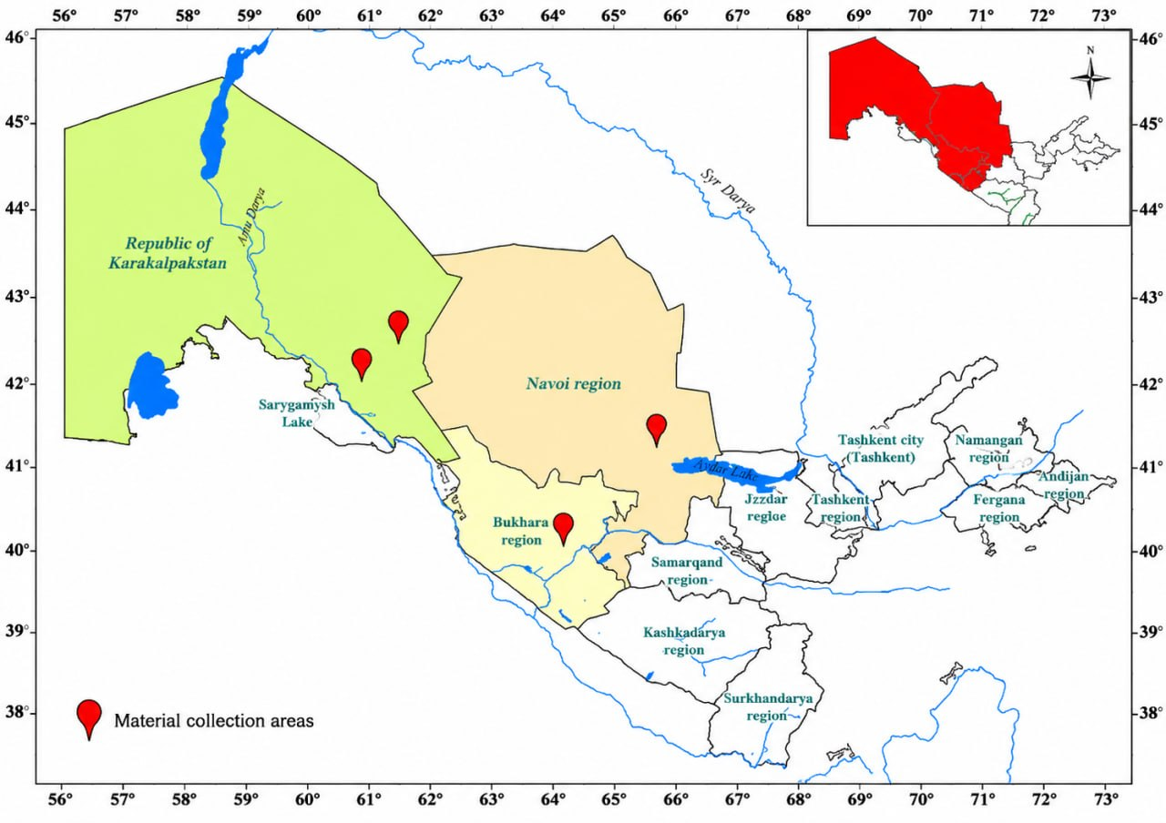
Figure 1. Regions where genetic samples were collected.

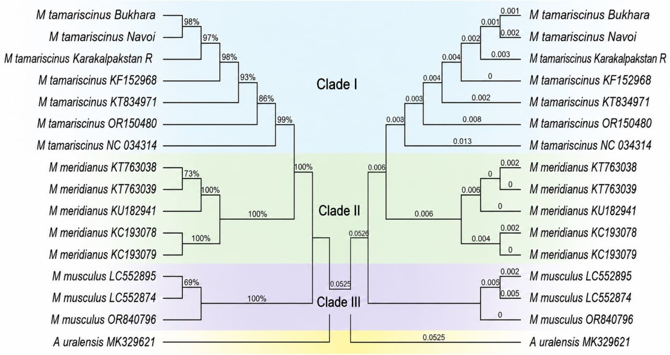
Figure 2. Phylogenetic tree of Meriones representatives reconstructed based on the mitochondrial DNA COI gene

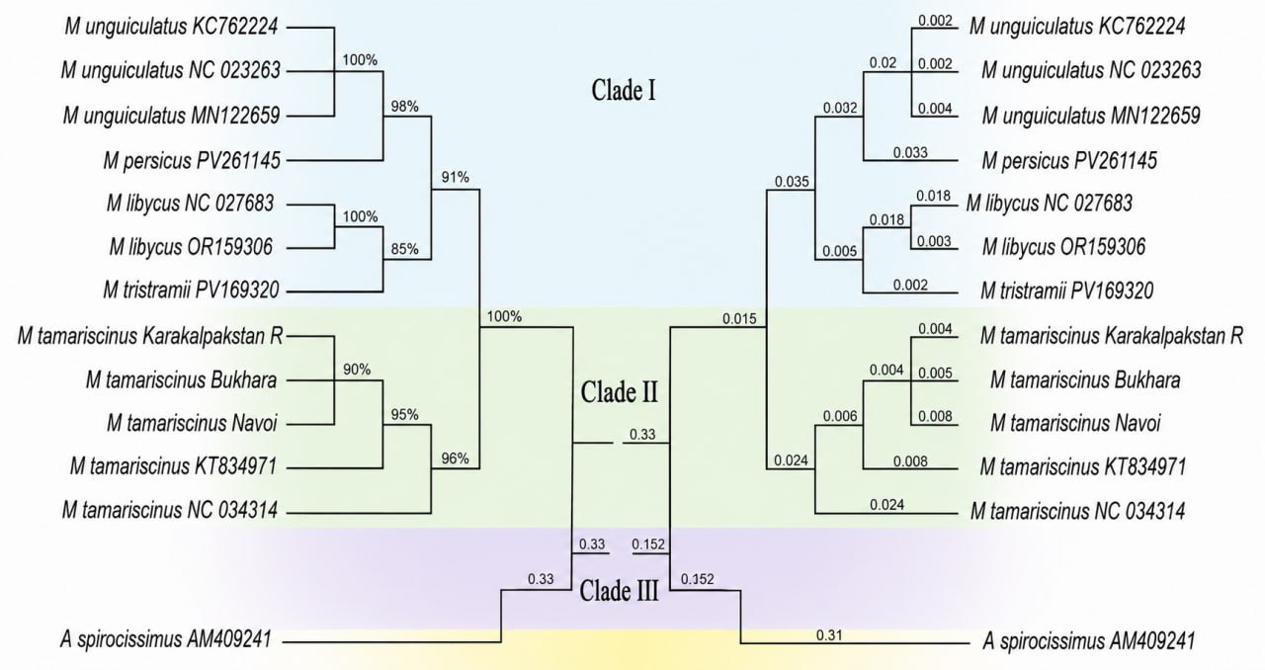
Figure 3. Phylogenetic tree constructed based on the mitochondrial DNA 16S rRNA gene of representatives of the genus Meriones.

