Optimization Of the Honey Conveyor in the Arid Steppe Conditions of Northern Kazakhstan

Sultan Saurov ¹*, Nurlan Serekpaev ² and Vladimir Zotikov ³

¹S.Seifullin Kazakh Agro Technical Research University, Astana, Republic of Kazakhstan
²AgroInnovaConsalt” LLP, Astana, Republic of Kazakhstan
³Federal Scientific Center for Legumes and Groat Crops, Streletsky, Russia
*Corresponding author: sultan.saurov@mymail.academy

- The article is good and needs moderate revision before acceptance.
- Arrange all references in text year-wise: low to high.
- Specific points are mentioned on various sections of the article, address those.
- The Language needs much improvement. Get help from any Language Editing Agency and provide us with a certificate of fact along with the revision or opt for Language editing services from the publisher of this journal (US$150/article).

ABSTRACT

This study evaluated the potential of perennial and annual honey crops to optimize honey production under arid steppe conditions in Northern Kazakhstan. Field experiments were conducted from 2022 to 2024 on dark chestnut soils in the Akmola region using blue hybrid alfalfa (Lazurnaya), sandy sainfoin (Shortandinsky Rubin), yellow sweet clover (Sarbas), buckwheat (Shortandinskaya-4), rapeseed (Maybulak), mustard (Slavyanka), sunflower (Sochinsky), and phacelia (Ulyanovskaya). Six Carpathian bee colonies were placed on experimental plots, with control areas isolated from pollination. Observations included nectar productivity, flowering duration, bee visitation, and honey quality parameters. Results demonstrated significant interannual variation influenced by precipitation and hydrothermal conditions. Yellow sweet clover and sandy sainfoin showed the highest nectar productivity (103.8 and 90.8 kg/ha), while buckwheat provided both high nectar productivity (163.2 kg/ha) and the longest flowering period (42 days). Bee visitation peaked between 11:00 and 15:00, with sweet clover and sainfoin proving especially attractive. Pollination increased flower set by 2–3 times compared to control plots, particularly in buckwheat (20% vs. 69%) and rapeseed (40% vs. 85%). Honey quality indicators varied by crop, with buckwheat honey showing the highest diastase number (28.4) and sainfoin honey demonstrating low acidity and high sweetness. Overall, combining crops with staggered flowering periods ensures continuous nectar availability, enhancing honey yields and maintaining bee colony health. The findings highlight yellow sweet clover, sandy sainfoin, and buckwheat as priority crops for forming a sustainable honey conveyor in the steppe zone of Northern Kazakhstan.

Keywords: Honey conveyor, Nectar productivity, Honey productivity, Yield, Annual crops.

1. INTRODUCTION

Write references in the text as
Single author: Doğan (2024) or (Doğan, 2024)
Two authors: Nigusse & Birhane (2024) or (Nigusse & Birhane, 2024)
Three or more authors: Du et al. (2023) or (Du et al., 2023)
Follow the green
The honey bee (Apis mellifera) is a keystone eusocial insect critical in maintaining natural ecosystems and providing significant benefits to humanity (Klein et al. 2007). The species produces honey, royal jelly, propolis, and bee bread products and performs important pollination functions for wild and agricultural plants (Ahmad et al. 2021; Anjum et al. 2019; Klein et al. 2007; Requier et al. 2019: Arrange year-wise: low to high). However, honey bee populations are subject to various pressures, including habitat loss, predators, parasites, diseases, pesticide use, and climate change (Goulson et al. 2015; Smith et al. 2013). Bee feeding dynamics are important in maintaining populations and colony health (Khan and Ghramh 2021; Vaudo et al. 2015). In addition, adequate food availability is essential for normal colony growth and development. The challenges faced by honey bees are particularly acute in arid and semi-arid regions, such as the steppe zone of Northern Kazakhstan. Northern Kazakhstan's arid steppe climate is distinguished by harsh, cold winters and scorching, dry summers. The region receives little precipitation, averaging 150-300 mm per year, making moisture scarce, particularly in the summer. These elements, along with strong winds, create weak, poorly constructed soils that are prone to wind and water erosion, raising the danger of wildfires and desertification. The potential productivity of natural pasture is modest, and there are issues with ongoing degradation. The degradation is attributable to the complicated environment, local ecology, and inadequate agronomic management in recent decades, such as overgrazing (Akhylbekova et al., 2022; Stybayev et al. 2021). Due to the agricultural pressure and difficulties faced in Nothern Kazakhstan such as climate related challenges, sporadic land degradation, poor land management and seed availability, these conditions makes the optimization of agricultural practices, like establishing a reliable honey conveyor, not just an economic issue but an ecological imperative (Ryssaliyeva et al., 2025).
Honey bees can simultaneously visit various food sources and can travel up to 10 kilometers to collect primary food resources such as nectar and pollen. These resources are stored in their colonies as honey and bee bread (Wright et al. 2018). Nectar, in particular, is the main source of carbohydrates needed to meet the energy needs of bees (Abou-Shaara, 2014; Khan et al., 2021). Pollen, in turn, provides honey bees with macro- and micronutrients, including proteins, minerals, vitamins, and lipids, which are critical for brood growth, maturation, longevity of adults, and overall colony development (Arien et al. 2018; Loidl and Crailsheim 2001). The fatty acid content and nutritional components of pollen vary depending on the diversity of plant species (Roulston and Cane 2000) and are directly related to the health of honey bees (Alaux et al. 2010). Importantly, the nutritional value of pollen can be more accurately estimated based on its amino acid composition rather than its total protein content, as its nutritional value is reduced by a deficiency of essential amino acids (Al-Kahtani et al. 2020; Cook et al. 2003). Determining the forage intake of honey bees is a complex process due to significant variations in nutrient requirements that depend on the caste and life stage of the bee, as well as inter- and intra-seasonal changes in food availability.
Additionally, supplemental feeding practices in beekeeping show significant variability (Rodney & Purdy, 2020). During winter or drought conditions, when food resources become limited, negative effects on queen reproductive performance are observed, leading to decreased worker numbers and an increased risk of migration or colony abandonment (Morais et al. 2013). In the Middle East, high temperatures and dry conditions during summer increase mortality in honey bees due to reduced flowering and reduced pollen availability caused by heat stress, an important food source for foraging bees (Awad et al. 2017). Thus, to ensure the health of the bee colony, necessary for honey production and pollination functions, a food base is required during the warm period, especially in the arid steppe of Northern Kazakhstan. In this regard, the creation and use of honey conveyors is one of the pressing issues of modern beekeeping since they allow optimization of the availability of nutritional resources and ensure the sustainable development of bee populations. A honey conveyor is a simple system of honey value crops that provides a continuous supply of pollen and efficiently keeps bees in the field. The best techniques in beekeeping and pollination management result in higher agricultural yields. Placing beehives near agricultural fields with flowering cultivated plant species, where honey yield is heavily reliant on the optimal design strategy, is critical for maximizing bee efficiency in pollination and bee product production. There are mathematical methods that can help optimize the number of bee colonies and apiary sites by selecting the optimum option from a list of alternatives. Creating a "honey conveyor" of flowering cultivated plants during the active honey gathering season is an intriguing method to provide food supplies to bee colonies (Atanasov and Vezirov 2021). When designing a honey conveyor, it's crucial to consider the honey base and plant classification based on phenological criteria, such as flowering stage length and season (Cîrlig 2022). Effective planning of honey conveyors can include the selection of perennial and annual honey crops that provide a continuous flow of nectar and pollen and contribute to the improvement of the ecosystem and increased agricultural productivity in the region. According to recent studies, the plants chosen for this study include annuals like buckwheat, phacelia, and sunflower as well as perennial legumes like yellow sweet clover, sandy sainfoin, and alfalfa (Medicago sativa). Buckwheat is renowned for its quick nectar secretion and long flowering, while sweet clover is well-known for its high nectar sugar content (Akter et al. 2023; Žiganova et al. 2022). However, the majority of their recorded performance comes from more temperate or humid areas. There is still much to learn about their relative effectiveness, resistance to the unique abiotic stresses of the Kazakh steppe, and potential for synergy in a coordinated conveyor system. For Kazakhstan's agricultural industry, closing this knowledge gap is crucial. Considering the potential to increase both domestic honey production and the pollination services needed for other important agricultural commodities, beekeeping is an essential part of the rural economy (Selamoglu et al. 2025). Strong pollinator populations directly affect the yield of entomophilous crops like sunflower, buckwheat, and other fruits and vegetables. This study contributes to food security and rural livelihoods by securing a robust forage base through optimized honey conveyors, supporting not only apiculture but also the region's overall agricultural system's resilience and productivity.
The aim of the study is to optimize the honey conveyor in the arid steppe of Northern Kazakhstan, increasing beekeeping productivity and the sustainability of the region's ecosystem.
The research paper is structured as follows: In Section Materials and Methods, we describe the methodology for a scientific experiment assessing the impact of honey bee pollination compared to isolation from bee activity on the yield and productivity of various flowering agricultural crops. The results of the influence of meteorological and environmental conditions, bee pollination, and plant-specific nectar productivity on the yield and honey quality of various agricultural honey crops, as well as verification and comparison with the experimental study, are represented in Section Results. Lastly, In the Sections Conclusion and Discussion, we summarized all of our remarks and gave a brief discussion of our study about limitations and areas of improvement.

2. MATERIALS AND METHODS
The research was conducted on an area of 0.448 hectares in the A.I. Barayev Scientific and Production Center for Agricultural Production on dark chestnut soils in the Talapkersky rural, Tselinograd, and Akmola regions. The objects of the research were perennial legumes: blue-fleshed alfalfa, Lazurnaya variety; sandy sainfoin, Shortandinsky Rubin variety; yellow sweet clover, Sarbas variety; annual crops: common buckwheat (sown), Shortandinskaya-4 variety; rapeseed, Maybulak variety; Sarepta mustard, Rushena variety; sunflower, Sochinsky variety; phacelia pygmy-leaved, Ulyanovskaya variety; honey bees of the Carpathian breed. Total area of the plot: 8×4×140=4480 m². Plot size – 140 m², 4-fold repetition. The control plot of 1 m² will be unavailable (isolated) for pollination by honey bees to study the dependence of bee pollination on crop yield.
In May, 6 bee colonies of the Carpathian breed were placed on the experimental plot to pollinate the experimental plots (Fig. 1). The Dadan hives contain 10 frames in one body. Observations were also carried out on wild pollinators, which also perform pollination functions, but full local pollination can be achieved by transporting the apiary to honey-bearing lands. The hives were installed directly near the plots, which gives the advantage of pollinating the necessary areas. As the studied crops bloomed, observations were carried out according to the methodology and the set tasks.
The control variant was a variant without pollination. In the control variant, in order to prevent pollination of plant flowers by honeybees, gauze insulators were installed according to the design of Dmitry Pankov's patent No. 2420950 "Method for determining the dependence of the seed yield of entomophilous crops on pollination by bees" (Dospekhov 1985) (Fig. 2).
The method simplifies the process and reveals the advantages of honey bees over wild pollinators. Using a polymer mesh with a hole size of 355-390 microns to manufacture group insulators provides a reliable barrier against unwanted penetration of foreign pollen onto flowering plants. The experiments used the generally accepted and recommended technology for buckwheat cultivation for the region (Osobennosti provedeniya 2023), except for the studied bee pollination factor. To study the dependence of bee pollination on yield. The control plot of 1 m² was not available (isolated) for pollination by honey bees. The experiments are laid out with repetition in time 2022-2024. The experimental scheme is presented in Table 1.
During the research, the following records and observations were made:
1. Determination of the sowing suitability of seeds according to GOST 12038-84 (USSR State Committee on Standards 1984).
2. Phenological observations of plant growth and development phases and determination of interphase periods were carried out according to the generally accepted method of state variety testing of agricultural crops (Golovachev and Kirilovskaya 1989; Ministry of Agriculture of the Republic of Kazakhstan 2011).
3. The nectar productivity of flowers was determined according to the "Study of nectar productivity indicators of honey plants by the flushing method" (Kirillenko and Golovin 1985). This method is simple and accessible in the field, where it is used with the RL-1 refractometer.
4. Accounting for the density of plant standing according to the method of State variety testing of crops (Golovachev and Kirilovskaya 1989; Ministry of Agriculture of the Republic of Kazakhstan 2011).
5. Plant height is determined by development phases according to the method of State variety testing (Golovachev and Kirilovskaya 1989; Ministry of Agriculture of the Republic of Kazakhstan 2011).
6. Accounting for the number of visits by honey bees in crop pollination (Kirillenko and Golovin 1985; Pankov 2011). We defined the effect of bee pollination and the degree of self-fertility, a method for determining the dependence of the yield of seeds of entomophilous crops on pollination by bees was used (Kirillenko and Golovin 1985).
7. Accounting for the number of pollinating insects visiting crop flowers was carried out in 20x1m2 counting strips in four replicates located 250 m from the apiary using the pollinator counting strip method of Fasulati K.K.
Fig. 4 shows the counting strips in the field marked with twine, tied to stakes and located on both sides of the center of the plot. Pollinator counts are conducted daily from 6 a.m. to 6 p.m., every 2 hours. The observer walks along the counting strip and counts the number of honey bees visiting the flowers. We determined the structural elements of yield using the State Variety Testing methodology (Golovachev and Kirilovskaya 1989; Ministry of Agriculture of the Republic of Kazakhstan 2011).
Data analysis is missing.
- LITERATURE REVIEW This is not in our format. Do not create this heading; adjust text in the introduction and some in the discussion.
The productivity of entomophilous crops and the conservation of the biodiversity of natural phytochromes directly depend on the number and biological diversity of pollinator populations. More than 500 species of cultivated plants are cultivated globally, of which more than 95% require pollination, carried out by honey bees and single or wild bee swarms. Entomophilous crops occupy more than half of the cultivated agricultural areas and provide more than a third of the total volume of food products. In Kazakhstan and neighboring countries, about 190 plant species, excluding medicinal and ornamental ones, also require bee pollination to achieve optimal yield indicators (Chenikalova & Cherkashin, 2019).
In modern conditions, agrocenoses formed and maintained by humans are becoming the main type of ecosystem in the steppe and foothill regions since their main purpose is producing agricultural products. Unlike natural ecosystems, agrocenoses are characterized by a limited diversity of species, with more than 70% of them being entomophilous plants that require cross-pollination (Komlatsky et al. 2020). The active use of chemical plant protection products has significantly reduced the number of insects that act as natural pollinators (Kashina and Kashin 2007). As a result, honeybees have become the main pollinators in these conditions (Sergienko et al. 2018). The efficiency of entomophilous crops is determined not only by their variety but also, to a large extent, by the quality of pollination processes. Among the various insect pollinators, honeybees play a leading role (Komlatsky et al. 2013).
Bee pollination is the most effective method of increasing crop yields, which agrotechnical measures cannot replace. Pollination of crops such as sunflower, buckwheat, and alfalfa, as well as fast-growing orchards and other plants whose yields significantly depend on cross-pollination, is especially important (Komlatsky 2016). The efficiency of development and productivity of bee colonies is determined by the quality of queens and their genetic potential (Eremia and Neicovcena 2011; Eremia et al. 2018). One of the unique features of Carpathian bees is their ability to quickly and vigorously mobilize forces for the optimal use of the average honey flow (Malkova 2007). The selection of bee colonies is carried out mainly based on criteria such as honey productivity, winter hardiness, disease resistance, queen fertility, colony strength, swarming and wax productivity, and other characteristics (Krivtsov 1995, 2009). It is important to note that disease resistance, viability, adaptation to local conditions, methods of artificial feeding of bees, and other approaches to managing bee colonies help mitigate the negative factors affecting their productivity (Büchler et al. 2010).
Beekeeping is key in the agricultural sector and ecosystems (Szczurek et al. 2023; Vassilev et al. 2019). Honey bees act as the main pollinators of both cultivated and wild plants, which helps to increase crop yields and vegetation diversity (Kashkovsky 2021).
Research is needed to cultivate and restore honey-producing plants in the arid steppes of Northern Kazakhstan to ensure the preservation and sustainability of honey sources. This, in turn, will help to raise awareness of the importance of the honey base for ecology. Knowledge exchange and interaction between scientists, beekeepers, and ecologists will allow for the effective development and implementation of strategies for the sustainable management of honey resources and the conservation of their biological diversity in the arid steppes of Northern Kazakhstan.

- RESULTS AND DISCUSSION
A study of honey productivity data from honey resources showed complex relationships dependent on many factors. These include microclimatic conditions such as illumination, temperature, humidity, wind, drought, and geographical parameters including latitude and altitude. No less important is the anthropogenic impact, including soil type, agricultural practices, fertilizer use, and irrigation. According to studies by other authors (Samsonova 2004), the optimal temperature range for active nectar secretion is 22-31°C. During the flowering period of honey crops (from June to August), average daily temperatures ranged from 20.0 to 24.4°C (Fig. 5). Comparison of actual temperatures with the optimal temperatures for the growth and development of perennial grasses (25-32°C) and photosynthesis (25-28°C) (Samsonova 2004) allows us to conclude that the temperature conditions contributed to intensive nectar secretion and an increase in honey productivity.
Analysis of the distribution of atmospheric precipitation during the growing season revealed significant unevenness, which affected the growth and development of honey crops (Fig. 6).
The year 2024 was characterized by the maximum amount of precipitation (334 mm), with the key factors being heavy precipitation in May (76.9 mm) and August (106.6 mm). This ensured optimal moisture supply during the critical growth and flowering phases, which positively affected honey productivity.
The year 2023 was the least favorable (156 mm of precipitation). Despite heavy precipitation in April (64.1 mm, 3 times higher than the long-term average), a sharp decrease in precipitation in May and June during the critical phases negatively affected plant development.
The year 2022 demonstrated specific dynamics. Low moisture at the beginning of the growing season (April-May) limited initial growth. However, sufficient precipitation in July (52.9 mm, at the level of long-term average values) during the budding-flowering phase compensated for the initial moisture deficit.
Therefore, the year with the maximum total precipitation is not necessarily the most favorable. The dynamics of precipitation distribution throughout the growing season and the correspondence of this precipitation to the needs of plants in critical phases of development are important.
Analysis of available literature shows that for most plants, optimal conditions for nectar secretion are achieved at a relative air humidity of 60% to 80% and soil moisture at 50-60% of the total moisture capacity. However, some species, such as meadow knapweed and sweet clover, can produce nectar even under low humidity conditions, indicating the presence of adaptive mechanisms and the possible independence of nectar productivity from standard humidity indicators.
During the study, conducted from June to August, the relative air humidity in the growing area of ​​legumes ranged from 52% to 79%, which is close to the optimal values described in scientific sources. However, interannual variability was observed: the most favorable humidity conditions were recorded in 2024, while in 2023, the conditions were less favorable (see Fig. 6). This suggests that in 2024, the nectar production potential of honey crops could be realized to a greater extent compared to 2023, which requires identifying the relationships between humidity indicators and the actual nectar productivity of the studied plants.
The analysis of meteorological conditions during the study years revealed the following characteristics: 2022 is marked by dry conditions with a hydrothermal coefficient (HTC) of -0.173, while 2023 is characterized by dry conditions (HTC -0.126). Unlike previous years, 2024 shows moderate conditions with a HTC of -0.303.
The study of bioclimatic potential (BCP) according to the Shashko method for the period 2022–2024 showed significant fluctuations in values: in 2022, the BCP was -0.74, which corresponds to the category of very low potential (≤0.8), in 2023 it improved to -0.53, and in 2024 it reached a value of 2.2, indicating an average bioclimatic potential (1.6-2.2).
The data analysis revealed significant differences in the attractiveness of honey crops for bees during the day. Bees' greatest activity and, as a consequence, optimal conditions for pollination are recorded in the interval 11:00-15:00 (see Table 2), which is consistent with generally accepted ideas about the peak of bee flight activity.
At the same time, significant differences are observed between the crops. Sainfoin and yellow sweet clover demonstrate superior bee visitation rates compared to blue hybrid alfalfa during the specified period. It is noted that blue hybrid alfalfa has the fewest bees at 9:00, which may indicate specific features of its flowering or nectar secretion, leading to a later start of bee activity on it. During the observation period, yellow sweet clover stands out as the most attractive crop for bees, which allows us to predict its potentially higher honey productivity than the other studied crops.
Data analysis revealed the differentiation of honey crops by the degree of their attractiveness to bees during the day. Rapeseed and yellow sweet clover are recorded as the most in-demand by bees; the peak of visitation occurs between 11:00 and 13:00, consistent with previously published data (Samsonova 2004), emphasizing the high entomophily of these species. At the same time, the visitation rate of mustard and phacelia was significantly lower, possibly due to the specificity of nectar productivity or competition with more attractive food sources. Notably, sunflower, traditionally considered a significant honey plant (Samsonova 2004), demonstrated relatively low visitation rates in this study (see Table 3). This discrepancy may be explained by the varietal characteristics of the hybrids or the influence of meteorological factors, requiring further study to establish a cause-and-effect relationship.
The study's results highlight the significant influence of honey bees on flower sets in various crops. In the control plots where bees were absent, the flower set rate was significantly lower compared to the plots pollinated by bees. The most pronounced difference is observed in buckwheat, where the flower set rate was 20% in the control plots versus 69% in the pollinated plots and rapeseed - 40% versus 85%. These data indicate a high dependence of these crops on insect pollination. In addition, yellow sweet clover and sand sainfoin demonstrate a significant increase in flower set in the presence of bees, consistent with previously obtained results (Samsonova 2005а). Interestingly, even in crops such as sunflower and phacelia, which can be partially pollinated by the wind or independently, an increase in flower set by 30–40% is observed with the participation of bees. This is consistent with the findings of (Samsonova 2005b), which indicate that additional pollination by bees can increase sunflower yields by 20–30%.
The results also confirm the data of (Samsonova 2005b), according to which, without bees' participation, the flower setting level of most honey plants remains low. In particular, this figure does not exceed 25–30% for buckwheat without bees, which is consistent with our data (20%). Similar trends are observed for rapeseed, emphasizing the need to place apiaries near crops to optimize yields.
Nectar productivity is a quantitative characteristic of the volume of nectar produced by plants, mainly by floral organs. It can be expressed in various units of measurement, such as milliliters per flower or grams per hectare. This indicator is of significant importance both in ecology and agriculture since it directly affects the food base for pollinators, including bees, butterflies, and other insects, and the volume of honey production. The study of nectar productivity is an important aspect of increasing the efficiency of agricultural production, protecting biodiversity, and maintaining the sustainability of ecosystems. The quality of honey produced is affected by temperature, humidity, light, and soil quality. Different plant species demonstrate different levels of nectar productivity, which can be critical for optimizing agronomic practices.
An analysis of the results of the study, conducted as part of the surveys and observations of plants in single-species crops of agrophytocenoses of perennial and annual honey crops, shows that in the honey conveyor over three years (2022-2024), buckwheat crops provided the highest seed yield per unit area among all the studied crops. The buckwheat yield was 8.0 centners per hectare, and the nectar productivity reached 81.6 kilograms per hectare, which was also accompanied by the most extended flowering period of up to 42 days (see Table 4). These results highlight the importance of buckwheat as a valuable element in agroecosystems, contributing to both increased agricultural productivity and ecosystem sustainability.
The study revealed high nectar productivity of sainfoin and yellow sweet clover crops, amounting to 90.8 and 103.8 kg/ha, respectively. These crops play a key role in the honey conveyor, providing a stable source of nectar for 55 days of flowering (from May 30 to July 25).These results aligns with the study of Serekpayev and Saurov (2025), who observed similar results while studying the double effect a honey conveyor has on both honey production and seed productivity. Serekpayev and Saurov (2025) also observed similar results for sainfoin and yellow sweet clover crops, stating that this high productivity trait makes buckwheet, yellow sweet clover and sainfoin excellent candidates for honey conveyor systems in arid regions.
In the steppe zone of the Akmola region, sunflower and mustard demonstrated high yields, averaging 12.4 and 11.7 c/ha over three years. However, their nectar productivity was lower than that of other crops studied. Nevertheless, mass cultivation of these plants can provide a significant amount of nectar from the first ten days of July to the second ten days of August, with a total flowering period of 35 days. Buckwheat, with a nectar productivity of 163.2 kg / ha, stands out as one of the most valuable crops, playing an important role in the honey conveyor. These results are consistent with regional surveys that identify buckwheat, sweet clover and sainfoin as key honey plants in Central Asia and Kazakhstan. Kurmanov (2023) in his study on honey and nectar-free pergan-bearing plants of Central Asia and Kazakhstan reported that in northern Kazakhstan sunflower and white mustard are important nectar sources, while Onobrychis (sainfoin) is prevalent farther south.
Buckwheat, clover, and sainfoin all produce a lot of nectar, which probably explains why bees find them appealing. Because it provides a lot of nectar and pollen, sainfoin is known to draw in dense bee communities (Butters et al. 2022). According to Sakhraoui et al. (2024), sainfoin flowers attract ten times as many bees as alfalfa or white clover because they produce rich nectar and pollen. They noted that sainfoin is commonly foraged by native and managed pollinators, including Apis, Bombus, and Osmia, in a variety of climates.
Similarly, yellow sweet clover, Melilotus officinalis, blooms for several weeks, offering a sustained supply of nectar. Sweet clover's long bloom and high nectar content in this study were in line with predictions made by earlier research, and its honey yield was calculated to be substantial. Honeybees significantly boost oilseed crop yield, according to empirical research. Mazzilli et al. (2023) found that additional Apis mellifera visitation increased rapeseed yield by about 14% (2089 vs. 1836 kg/ha), and Hossain et al. (2021) found that bee pollination increased mustard seed set by 15%. The high nectar values for buckwheat, clover, and sainfoin suggest that those crops would draw a lot of bees and improve pollination, even though we did not measure pollination services specifically. However, even though they produced a lot of flowers, sunflower and mustard had shorter bloom times and lower nectar concentrations, which made them less dependable sources during dry years. Sunflower nectar's value to bees may be limited due to its variable nectar quality, pollen's low protein content, and nectar sugar content (Husband et al. 2025). Its late-season bloom, however, helps to cover midsummer voids.
Notably, pollination produces co-benefits: in Kazakhstan, rape and sunflower integration in crop rotations has been promoted in part due to bee cross-pollination, which increases seed size and oil content (reported increases of 20–30% in sunflower and canola yields). This pattern (high harvest index but modest nectar) is consistent with the rapeseed plots in this study. In contrast, new research indicates that bee pollination increased buckwheat seed yields in northern Kazakhstan, a sign of true meliferous plants like buckwheat. According to Defalque et al. (2025), buckwheat's floral resources are extremely vulnerable to heat, drought, and stress, all of which significantly lower nectar and pollen levels and, consequently, pollinator visits.
Yellow sweet clover and sandy sainfoin also demonstrated results, which makes them important for maintaining the bee population during the flowering period. At the same time, phacelia tanacetifolia showed low yield and nectar productivity (0.43 c / ha and 21.2 kg / ha), which makes it less preferable for the honey conveyor in the conditions of the arid steppe zone. Rapeseed crops, despite high yield (10.5 c / ha) and flowering duration (27 days), also demonstrated low nectar productivity (37 kg / ha) compared to other crops.
Yellow sweet clover is leading in flowering duration, providing nectar for 37 days. Buckwheat and mustard also have significant flowering periods (42 and 29 days, respectively), which makes them important for maintaining a stable nectar flow. The quality of honey obtained from single-species crops of honey plants depends on the botanical origin, growing conditions, and meteorological factors. Table 5 presents the quality indicators of honey, such as moisture, acidity, diastase number, and inverted sugar content, obtained from different crop periods in the conveyor. Staggered flowering is an essential characteristic of a honey belt. According to our data, sainfoin and sweet clover flower for one to two months each, while mustard and buckwheat have somewhat longer flowering periods. Phacelia, which is known for its long bloom in temperate regions, did not fare well in this area, most likely as a result of its late planting and drought stress. On the other hand, the prolonged bloom of sainfoin is consistent with earlier findings (Żarczyński et al. 2025). This study's crop combination roughly corresponds to a nectar calendar that runs from late May to mid-August. Such sequencing is essential in practice because, even in the absence of late-flowering species, bees will starve despite an abundance of nectar in the early season. This aligns with the opinions of UNDP beekeepers that bees can be kept busy throughout the year by mass-flowering legumes and cereal belts, also known as the "green grass conveyor."
In contrast, monocultural fields in other areas frequently exhibit gaps. Thus, phacelia, sainfoin, and mixes have been promoted by West European schemes. According to recent studies, bees may not find phacelia appealing if other blooms compete with it, even if it is planted for pollinators (Żarczyński et al., 2025). The high nectar content of clover and buckwheat in our environment indicates that bees would be drawn to those plants before phacelia.
The optimum moisture content of honey should be below 20%. The lowest moisture content was recorded in honey obtained from sunflower, amounting to 15.8%. This value may indicate the high quality of this product. At the same time, the highest moisture content is observed in buckwheat honey (18.6%), which is acceptable, but may indicate an increased likelihood of crystallization.
Honey acidity is an important parameter that determines its quality. Low acidity is considered optimal, which helps improve the organoleptic characteristics of the product. The lowest acidity was recorded in honey from sand sainfoin (1°), which makes it preferable for consumption. In contrast, the highest acidity value (3°) is observed in rapeseed and buckwheat honey, which may negatively affect the taste of these products.
The diastase number, reflecting the activity of enzymes, also significantly affects the quality of honey. The highest diastase number was recorded in buckwheat honey (28.4), indicating its high quality. In contrast, sweet clover honey demonstrated the lowest diastase number (13.8), which may indicate its lower quality.
The content of invert sugar is an important criterion for assessing the sweetness of honey. The highest content of invert sugar was found in sainfoin honey (78), making it sweeter than other samples. The lowest value of invert sugar is observed in sweet clover honey (73). In particular, buckwheat honey frequently has a high phenolic and antioxidant content, and the honey produced from our conveyor crops satisfies standard quality criteria and has chemical characteristics that reflect floral origin (Ongalbek et al. 2024; Pătruică et al. 2022). Sunflower honey had significantly more flavonoids than rapeseed honey, according to a study of Romanian honeys by Pătruică et al. (2022), demonstrating how bioactive compounds are driven by botanical sources. The findings demonstrated comparable patterns and support the notion that blending different nectar sources will produce honey with a range of health and sensory qualities. Additionally, they back up research trends that indicate the chemical profiles of buckwheat and sainfoin make them particularly promising for "high-quality" honey.
The crops under examination show varying degrees of resistance to the cold springs and hot, dry summers of northern Kazakhstan's arid continental climate. According to Sakhraoui et al. (2024), sainfoin's protective physiology naturally adapts it to semi-arid environments. Similarly, Żarczyński et al. (2025) recommend phacelia for low-input mixtures due to its remarkable resistance to frost and drought. However, buckwheat is more sensitive to heat or drought, which significantly lowers its flower count, nectar production, and bee visits. This is important because Kazakhstan's summers are notoriously dry (Defalque et al. 2025). While oilseeds like rapeseed require more moisture, leguminous clovers increase soil nitrogen content and are more drought-tolerant. Overall, the species tested exhibit a variety of adaptations.
The relatively poor performance of alfalfa and phacelia in the Northern Kazakhstan region is probably due to the region's unpredictable precipitation. These findings support more general analyses showing that plant-pollinator synchrony is changing due to climate change. Thus, any management plan must account for phenology under variable weather. The ecological implications show that it is entirely possible to strengthen the pollinator base in an otherwise harsh landscape by choosing drought-tolerant nectar plants (clover, sainfoin) and staggered bloom times.

  - Correlation Analysis of Honey Productivity and Crop Yield
An additional important aspect of the conducted research was the performance of a correlation analysis between the honey productivity indicators (kg/ha) and the yield of the studied crops with and without pollination. For this analysis, a linear relationship was constructed using a regression model (Amirgaliyev et al. 2019; Merembayev et al. 2022; Nick and Campbell 2007) between the yield and honey productivity for different crops, and a comparative analysis was carried out with and without pollination. The R2 metric (Sotirchos et al. 2019) was used to assess the proximity of the indicators.
The analysis's results confirmed the importance of bee pollination for most of the studied crops, demonstrating a close correlation and an increase in yield compared to without pollination. Thus, according to the results of the correlation analysis, the highest degree of relationship between yield and honey productivity was noted in yellow sweet clover and sand sainfoin. This confirms the previously obtained results on the high attractiveness of these crops for bees and their significant role in the formation of the honey conveyor.
Blue hybrid alfalfa and tansy-leaved phacelia also demonstrated a positive correlation, although the degree was lower compared to sweet clover and sainfoin. This may be due to the peculiarities of these plants' flowering and nectar secretion, which require additional study and consideration when planning honey conveyors.
Rapeseed, mustard, and sunflower crops showed a moderate correlation between yield and honey productivity. This emphasizes the need for an integrated approach when including these crops in the honey conveyor system. Despite its high nectar productivity, Buckwheat showed a relatively low correlation with yield in the presence and absence of pollination, which may be due to other factors affecting yield formation, such as agronomic conditions or variety characteristics.
Thus, the correlation analysis emphasized the importance of organizing high-quality pollination to increase the yield and honey productivity of most of the studied crops, especially yellow sweet clover and sandy sainfoin, which can be recommended for priority inclusion in the honey conveyor in the conditions of the arid steppe zone of the Akmola region.
Analysis of the quality indicators of honey allows us to conclude that honey obtained from sandy sainfoin and buckwheat has high quality characteristics due to low acidity and high diastase number. Blue hybrid alfalfa and sunflower also show promising results, but honey from these plants has a slightly higher acidity.
When interpreting the results of this study, it is important to take into account a number of limitations. The field trials' three-year duration and single-site location might not have adequately captured longer trends or wider spatial variability, indicating that a larger multi-site study would strengthen the validity of our findings. Additionally, uncontrolled extreme events like late frosts and heatwaves could skew results, and interannual weather fluctuations; particularly in rainfall during critical flowering periods, probably affected nectar yields and may have obscured the true potential of the studied crops.
The use of a single cultivar for each crop, such as "Shortandyrskaya" buckwheat and "Lazurnaya" alfalfa, limits the findings' ability to be extrapolated because different cultivars may have different nectar or bloom characteristics. Although the monitoring scope was centered on nectar and honey parameters, it did not identify pollinator species or include continuous bee visitation counts, so our evaluation of pollination effects is still indirect. Lastly, the direct application of our findings may be limited because the use of pure monoculture stands for experimental clarity does not accurately represent the mixed-species composition of actual agricultural landscapes.
Future research priorities are indicated by these limitations. Breeding efforts should concentrate on producing cultivars with improved stress tolerance and nectar yield, such as buckwheat varieties that are more heat-resistant or sainfoin with a higher sugar content. To confirm a continuous nectar supply, research at the landscape scale must move from monocrops to testing integrated "nectar belts" through intercropping or sequential planting. Assessing the synergistic roles of wild and managed pollinators within diverse floral communities and comprehending pollinator foraging behavior under drought and high temperatures are crucial in light of climate change. Long-term honey quality assessment should also be a part of future research to connect agronomic practices to bioactive compounds and explore low-input, sustainable management strategies that work in concert with soil conservation, nectar production, and comprehensive climate adaptation plans.

4. CONCLUSION
A comparative assessment of various honey crops grown in the steppe zone of the Akmola region revealed that buckwheat, yellow sweet clover, and sand sainfoin are the most valuable crops for the honey conveyor due to their high nectar productivity and flowering period. Buckwheat and yellow sweet clover demonstrated the best results in nectar productivity, which makes them especially valuable for beekeeping. Meanwhile, sunflower and mustard have a high yield and lower nectar productivity rates. Some crops, such as alfalfa and phacelia, showed low nectar productivity and yield rates, which makes them less preferable for crops.
An effective honey conveyor requires a combination of crops with high nectar productivity and a long flowering period, which ensures constant access to nectar for bees. Crops should be selected depending on the goals: to maximize nectar productivity, buckwheat and sweet clover should be preferred, while sunflower and mustard are suitable for achieving high yields. Sand sainfoin and buckwheat are the most promising for obtaining high-quality honey.

Funding: State funding source(s) with grant number and sponsoring agency/organization. If you did not get any financial support from any agency/organization, write, "This study did not get any financial support from any organization/agency."

Conflict of Interest: The authors declare that they have no conflict of interest.

Data Availability: If you have presented all the data in the article, then write: All the data is available in the article. Alternatively, if you cannot present all the data and have additional information to share, write "Data will be available upon request.".

Ethics Statement: State, like, the animal study was approved by the Ethics Committee of the [insert name of institute/University; approved vide number: ?? Dated: ??] and conducted in accordance with local legislation and institutional requirements.

Authors’ Contributions:

Generative AI Statement: The authors declare that no Gen AI/DeepSeek was used in the writing/creation of this manuscript.

REFERENCES
For Full-length/Research articles, there must be 35/40 references (more than these will be fine), and out of the total references, 1/3 must be from 2023-2026.
References from 2020 and above must have DOI.
Write DOI as https://doi.org/10.47278/journal.ijvs/2024.179

References should strictly “APA” format style as given below in green font:
Doğan, M. (2024). Development of a novel real-time PCR-based test panel system for detection of infectious abortion in domestic sheep. International Journal of Veterinary Science, 13(6), 799-805. https://doi.org/10.47278/journal.ijvs/2024.179
Du, X. X., Gul, S. T., Ahmad, L., Hussain, R., & Khan, A. (2023). Fowl typhoid: Present scenario, diagnosis, prevention, and control measures. International Journal of Agriculture and Biosciences, 12(3), 172-179. https://doi.org/10.47278/journal.ijab/2023.061
Nigusse, R. & Birhane, E. (2024). Impacts of Acacia saligna canopy on indigenous woody species diversity, herbaceous cover, and biomass production in Tigray, Northern Ethiopia. Agrobiological Records, 17, 100-109. https://doi.org/10.47278/journal.abr/2024.028

Abou-Shaara, H. F. (2014). The foraging behaviour of honey bees, Apis mellifera: A review. Veterinární Medicína, 59(1), 1-10. http://dx.doi.org/10.17221/7240-VETMED
Ahmad, S., Khalofah, A., Khan, S. A., Khan, K. A., Jilani, M. J., Hussain, T., Skalicky, M., Ghramh, H. A., & Ahmad, Z. (2021). Effects of native pollinator communities on the physiological and chemical parameters of loquat tree (Eriobotrya japonica) under open field condition. Saudi Journal of Biological Sciences, 28(6), 3235-3241. https://doi.org/10.1016/j.sjbs.2021.02.062
Akhylbekova, B., Serekpayev, N., Nogayev, A., & Zhumabek, B. (2022). Pasture Productivity Depending on the Method of Pasture use in the Steppe Zone of Northern Kazakhstan. OnLine Journal of Biological Sciences, 22(4), 476-483. https://doi.org/10.3844/ojbsci.2022.476.483
Akter, M., Hossain, M., Rahman, S., Banu, M., & Akhtar, M. (2023). Insect diversity and pollination effect on buckwheat (Fagopyrum esculentum) yield. Journal of Biodiversity Conservation and Bioresource Management, 9(1), 109-118. https://doi.org/10.3329/jbcbm.v9i1.66636
Al-Kahtani, S. N., Taha, E.-K., Khan, K. A., Ansari, M. J., Farag, S. A., Shawer, D. M., & Elnabawy, E. S. M. (2020). Effect of harvest season on the nutritional value of bee pollen protein. PLoS ONE, 15(12), e0241393. https://doi.org/10.1371/journal.pone.0241393 [Retracted]
Alaux, C., Ducloz, F., Crauser, D., & Le Conte, Y. (2010). Diet effects on honeybee immunocompetence. Biology Letters, 6(4), 562-565. https://doi.org/10.1098/rsbl.2009.0986
Amirgaliyev, Y., Shamiluulu, S., Merembayev, T., & Yedilkhan, D. (2019). Using machine learning algorithm for diagnosis of stomach disorders. In I. Bykadorov, V. Strusevich, & T. Tchemisova (Eds.), International conference on mathematical optimization theory and operations research (pp. 343-355). Cham: Springer International Publishing. http://dx.doi.org/10.1007/978-3-030-33394-2_27
Anjum, S. I., Ullah, A., Khan, K. A., Attaullah, M., Khan, H., Ali, H., Bashir, M. A., Tahir, M., Ansari, M. J., Ghramh, H. A., Adgaba, N., & Dash, C. K. (2019). Composition and functional properties of propolis (bee glue): A review. Saudi Journal of Biological Sciences, 26(7), 1695-1703. https://doi.org/10.1016/j.sjbs.2018.08.013
Arien, Y., Dag, A., & Shafir, S. (2018). Omega-6:3 ratio more than absolute lipid level in diet affects associative learning in honey bees. Frontiers in Psychology, 9, 1001. https://doi.org/10.3389/fpsyg.2018.01001
Atanasov, A., & Vezirov, C. (Eds.). (2021). Approach to design sequence of field melliferous crops taking intoaccount use of agricultural machinery. In Engineering for rural development: Proceedings of the 20th International Scientific Conference Engineering for Rural Development: Jelgava, Latvia (pp. 80-85). https://doi.org/10.22616/ERDev.2021.20.TF017
Awad, A. M., Owayss, A. A., & Alqarni, A. S. (2017). Performance of two honey bee subspecies during harsh weather and Acacia gerrardii nectar-rich flow. Scientia Agricola, 74(6), 474-480. http://dx.doi.org/10.1590/1678-992x-2016-0101
Büchler, R., Berg, S., & Le Conte, Y. (2010). Breeding for resistance to Varroa destructor in Europe. Apidologie, 41(3), 263-284. http://dx.doi.org/10.1051/apido/2010011
Butters, J., Murrell, E., Spiesman, B. J., & Kim, T. N. (2022). Native flowering border crops attract high pollinator abundance and diversity, providing growers the opportunity to enhance pollination services. Environmental Entomology, 51(2), 492-504. https://doi.org/10.1093/ee/nvac013
Chenikalova, E. V., & Cherkashin, V. N. (2019). Puti povysheniya effektivnosti prirodnykh opyliteley pri organicheskom zemledelii [Ways to improve the efficiency of natural pollinators in organic farming]. International Journal of Applied and Fundamental Research, 8, 25-29. https://doi.org/10.17513/mjpfi.12820
Cîrlig, N. (2022). Brassicaceae Species (Brassicaceae Burnett) in the collection of “Alexandru Ciubotaru” National Botanical Garden (Institute) as potential honey plants. Scientific Papers. Series a. Agronomy, 57(2), 487-494.
Cook, S. M., Awmack, C. S., Murray, D. A., & Williams, I. H. (2003). Are honey bees’ foraging preferences affected by pollen amino acid composition? Ecological Entomology, 28(5), 622-627. http://dx.doi.org/10.1046/j.1365-2311.2003.00548.x
Defalque, C., Laeremans, J., Drugmand, J., Tcheutchoua, C. F., Meng, Y., Zhou, M., Zhang, K., & Quinet, M. (2025). Drought and High Temperatures Impact the Plant–Pollinator Interactions in Fagopyrum esculentum. Plants, 14(1), 131. https://doi.org/10.3390/plants14010131
Dospekhov, B. A. (1985). Metodika polevogo opyta [Field experiment methodology] (5th ed., supplemented and revised). Moscow: Agropromizdat, 121 p.
Eremia, N., & Neicovcena, I. (2011). Particularităţile morfo-productive ale albinelor carpatice din Republica Moldova [Morpho-productive characteristics of Carpathian bees from the Republic of Moldova]. Chisinau: Foxtrot, 224 p.
Eremia, N., Zagareanu, A., & Modvala, S. (2018). Particularitățile tehnologiei creșterii mătcilor de albine și stupăritului pastoral [Peculiarities of queen bee breeding technology and pastoral beekeeping]: Monograph. Chisinau: ASEM. 356 p.
Golovachev, V. I., & Kirilovskaya, E. V. (Eds.). (1989). Metodika gosudarstvennogo sortoispytaniya sel'skokhozyaystvennykh kul'tur. Vyp. 2: Zernovyye, krupyanyye, zernobobovyye, kukuruza i kormovyye kul'tury [Methodology for state variety testing of agricultural crops. Issue 2: Cereals, grains, legumes, corn and forage crops]. Moscow, 194 p.
Goulson, D., Nicholls, E., Botías, C., & Rotheray, E. L. (2015). Bee declines driven by combined stress from parasites, pesticides, and lack of flowers. Science, 347(6229), 1255957. https://doi.org/10.1126/science.1255957
Hossain, M., Paul, J., Rahman, M., Fazlullah, M., & Sarkar, S. (2021). Role of honey bee on mustard (Brassica spp.) yield. Journal of Biodiversity Conservation and Bioresource Management, 6(1), 25-30. https://doi.org/10.3329/jbcbm.v6i1.51328
Husband, S., Cankar, K., Catrice, O., Chabert, S., & Erler, S. (2025). A guide to sunflowers: floral resource nutrition for bee health and key pollination syndromes. Frontiers in Plant Science, 16, 1552335. https://doi.org/10.3389/fpls.2025.1552335
Kashina, G. V., & Kashin, A. S. (2007). Issledovaniya antropogenno-ekologicheskogo vozdeystviya na biologicheskiye aspekty razvitiya medonosnykh pchel [Study of anthropogenic and ecological impact on biological aspects of honey bee development]. Bulletin of Krasnoyarsk SAU, 2, 203-205.
Kashkovsky, V. G. (2021). Soderzhaniye i razvedeniye medonosnykh pchel Apis Mellifera L [Maintenance and breeding of honey bees Apis mellifera L]. St. Petersburg: St. Petersburg branch of the FSUE “Nauka”, 423 p.
Khan, K. A., & Ghramh, H. A. (2021). Pollen source preferences and pollination efficacy of honey bee, Apis mellifera (Apidae: Hymenoptera) on Brassica napus crop. Journal of King Saud University – Science, 33(1), 101487. http://dx.doi.org/10.1016/j.jksus.2021.101487
Khan, K. A., Ghramh, H. A., Ahmad, Z., El-Niweiri, M. A., & Mohammed, M. E. A. (2021). Honey bee (Apis mellifera) preference towards micronutrients and their impact on bee colonies. Saudi Journal of Biological Sciences, 28(6), 3362-3366. https://doi.org/10.1016/j.sjbs.2021.02.084
Kirillenko, S. K., & Golovin, V. P. (1985). Nectar secretion in some forage crops. Beekeeping, 5, 11.
Klein, A.-M., Vaissiere, B. E., Cane, J. H., Steffan-Dewenter, I., Cunningham, S. A., Kremen, C., & Tscharntke, T. (2007). Importance of pollinators in changing landscapes for world crops. Proceedings of the Royal Society B, 274(1608), 303-313. https://doi.org/10.1098/rspb.2006.3721
Komlatsky, G. V., Sokolsky, S. S., & Usenko, T. A. (2020). Pchelovodstvo kak neobkhodimyy faktor razvitiya APK [Beekeeping as a necessary factor of APC development]. Scientific Journal of KubSAU, 157(03), 52-64. https://doi.org/10.21515/1990-4665-157-005
Komlatsky, V. I. (2016). Mobil'no-opylitel'nyye kompleksy kak paradigma industrial'nogo pchelovodstva [Mobile-pollination complexes as a paradigm of industrial beekeeping]. Polythematic Online Electronic Scientific Journal of Kuban State Agrarian University, 118(04), 990-1000.
Komlatsky, V. I., Loginov, S. V., & Komlatsky, G. V. (2013). Pchelovodstvo [Beekeeping]. Rostov-on-Don: Phoenix, 412 p.
Krivtsov, N. I. (1995). Srednerusskiye pchely [Central Russian bees]. St. Petersburg: Lenizdat.
Krivtsov, N. I. (2009). Selektsionnyye priznaki pchel [Selection characteristics of bees]. Beekeeping, 2, 20-22.
Kurmanov, R. G. (2023). Resources of melliferous and polleniferous plants of Central Asia and Kazakhstan based on melissopalynological analysis. Vegetation Resources, 59(4), 367-377. https://doi.org/10.31857/s0033994623040076
Loidl, A., & Crailsheim, K. (2001). Free fatty acids digested from pollen and triolein in the honeybee (Apis mellifera carnica Pollmann) midgut. Journal of Comparative Physiology B, 171(4), 313-319. https://doi.org/10.1007/s003600100178
Malkova, S. A. (2007). Karpatskaya poroda pchel (Apis mellifera Carpatica) v Adygeye [Carpathian breed (Apis mellifera Carpatica) in Adygea]. In Sovremennyye napravleniya nauchno-tekhnicheskogo progressa v pchelovodstve [Modern directions of scientific and technological progress in beekeeping] (pp. 82-86). Rybnoe: Federal State Budgetary Scientific Institution “Research Institute of Beekeeping” (FSBI “Research Institute of Beekeeping”).
Mazzilli, S. R., Abbate, S., Silva, H., & Mendoza, Y. (2023). Apis mellifera visitation enhances productivity in rapeseed. Journal of Apicultural Research, 62(2), 402-410. https://doi.org/10.1080/00218839.2020.1856558
Merembayev, T., Amirgaliyev, Y., Saurov, S., & Wójcik, W. (2022). Soil salinity classification using machine learning algorithms and radar data in the case from the South of Kazakhstan. Journal of Ecological Engineering, 23(10), 61-67. http://dx.doi.org/10.12911/22998993/152281
Ministry of Agriculture of the Republic of Kazakhstan. (2011). Methodology for conducting variety testing of agricultural plants, approved by the order of the Ministry of Agriculture of the Republic of Kazakhstan of May 13, 2011, No. 06-2/254. https://online.zakon.kz/Document/?doc_id=31016934&ysclid=me6c2a1mc5517968642
Morais, M. M., Turcatto, A. P., Francoy, T. M., Gonçalves, L. S., Cappelari, F. A., & De Jong, D. (2013). Evaluation of inexpensive pollen substitute diets through quantification of haemolymph proteins. Journal of Apicultural Research, 52(3), 119-121. http://dx.doi.org/10.3896/IBRA.1.52.3.01
Nick, T. G., & Campbell, K. M. (2007). Logistic regression. In W. T. Ambrosius (Ed.), Topics in biostatistics. Methods in molecular biology™ (Vol. 404, pp. 273-301). Humana Press. https://doi.org/10.1007/978-1-59745-530-5_14
Ongalbek, D., Tokul-Ölmez, Ö., Şahin, B., Küçükaydın, S., Aydoğmuş-Öztürk, F., Sıcak, Y., Yeskaliyeva, B., & Öztürk, M. (2024). Classification of buckwheat honey produced in Kazakhstan according to their biochemical ingredients and bioactivities by chemometric approach. Food Chemistry, 451, 139409. https://doi.org/10.1016/j.foodchem.2024.139409
Osobennosti provedeniya vesenne-polevykh rabot v Akmolinskoy oblasti v 2023 godu: Prakticheskiye rekomendatsii [Features of spring field work in Akmola Region in 2023: Practical recommendations]. (2023). Shortandy: A.I. Barayev Scientific and Production Center of Grain Farming, 60 p.
Pankov, D. M. (2011). Sposob opredeleniya zavisimosti urozhaynosti semyan entomofil'nykh kul'tur ot opyleniya pchelami [Method to detect dependence of entomophilous crops seeds productivity on pollination with bees] (RU Patent No. 2420950. IPC A01H 1/02). Federal Service for Intellectual Property, Patents and Trademarks.
Pătruică, S., Alexa, E., Obiștioiu, D., Cocan, I., Radulov, I., Berbecea, A., Lazăr, R. N., Simiz, E., Vicar, N. M., Hulea, A., & Moraru, D. (2022). Chemical composition, antioxidant and antimicrobial activity of some types of honey from Banat Region, Romania. Molecules, 27(13), 4179. https://doi.org/10.3390/molecules27134179
Requier, F., Garnery, L., Kohl, P. L., Njovu, H. K., Pirk, C. W., Crewe, R. M., & Steffan-Dewenter, I. (2019). The conservation of native honey bees is crucial. Trends in Ecology & Evolution, 34(9), 789-798. https://doi.org/10.1016/j.tree.2019.04.008
Rodney, S., & Purdy, J. (2020). Dietary requirements of individual nectar foragers, and colony-level pollen and nectar consumption: A review to support pesticide exposure assessment for honey bees. Apidologie, 51(2), 163-179. https://doi.org/10.1007/s13592-019-00694-9
Roulston, T. H., & Cane, J. H. (2000). Pollen nutritional content and digestibility for animals. In A. Dafni, M. Hesse, & E. Pacini (Eds.), Pollen and pollination (pp. 187-209). Vienna: Springer. https://doi.org/10.1007/978-3-7091-6306-1_10
Ryssaliyeva, L., Salnikov, V., Lin, Z., & Raimbekova, Z. (2025). Seasonal sensitivity of drought indices in Northern Kazakhstan: A comparative evaluation and selection of optimal indicators. Sustainability, 17(21), 9413. https://doi.org/10.3390/su17219413
Sakhraoui, A., Ltaeif, H. B., Sakhraoui, A., Villalba, J. J., Castillo, J. M., & Rouz, S. (2024). Sainfoin (Onobrychis viciifolia) a legume with great ecological and agronomical potential under climate change. The Journal of Agricultural Science, 162(4), 307-331. https://doi.org/10.1017/s0021859624000327
Samsonova, I. D. (2004). Nektaroproduktivnost' podlesochnykh porod v lesnykh nasazhdeniyakh stepnoy zony [Nectar productivity of undergrowth species in forest plantations of the steppe zone]. In Ratsional'noye prirodopol'zovaniye v stepnoy zone [Rational nature management in the steppe zone] (pp. 67-72). Novocherkassk: NGMA.
Samsonova, I. D. (2005a). Medonosy dikorastushchego raznotrav'ya [Honey plants of wild herbs]. In Sovremennyye problemy okhrany okruzhayushchey sredy [Modern problems of environmental protection] (pp. 95-100). Novocherkassk: NGMA.
Samsonova, I. D. (2005b). Osobennosti tsveteniya i modoproduktivnost' podleska i raznotrav'ya v fitotsenozakh Rostovskoy oblasti [Peculiarities of flowering and honey productivity of undergrowth and forbs in phytocenoses of the Rostov region]: Dissertation for the Degree of Candidate of Agricultural Sciences. Novocherkassk State Land Reclamation Academy, Novocherkassk, 189 p.
Selamoglu, Z., Naeem, M. Y., Ubaev, F., & Salybekova, N. (2025). Beekeeping in Kazakhstan: Production, practice and prospects for sustainable development. Eurasian Journal of Medical and Biological Sciences, 5(2), 89-95.
Serekpayev, N., & Saurov, S. (2025). Comparative assessment of nectar bearing capacity of single-species agrophytocenoses in conditions of arid steppe of the Akmola Region. 3i Intellect Idea Innovation, 1, 209-215. https://doi.org/10.52269/22266070_2025_1_209
Sergienko, A. V., Komlatsky, V. I., Kononenko, S. I., Svistunov, S. V., & Fomin, A. S. (2018). Organizatsiya opyleniya sel'skokhozyaystvennykh kul'tur v Krasnodarskom kraye [Organization of pollination of agricultural crops in the Krasnodar Territory]. Krasnodar: OOO “Operativnaya poligrafiya i dizayn”, 60 p.
Smith, K. M., Loh, E. H., Rostal, M. K., Zambrana-Torrelio, C. M., Mendiola, L., & Daszak, P. (2013). Pathogens, pests, and economics: drivers of honey bee colony declines and losses. EcoHealth, 10(4), 434-445. https://doi.org/10.1007/s10393-013-0870-2
Sotirchos, E. S., Fitzgerald, K. C., & Crainiceanu, C. M. (2019). Reporting of R² statistics for mixed-effects regression models. JAMA Neurology, 76(4), 507. https://doi.org/10.1001/jamaneurol.2018.4720
Stybayev, G., Serekpayev, N., Yancheva, H., Baitelenova, A., Nogayev, A., Khurmetbek, O., & Mukhanov, N. (2021). Succession dynamics, quality, and production in improved and natural pastures in Northern Kazakhstan. Bulgarian Journal of Agricultural Science, 27(Suppl. 1), 95-102.
Szczurek, A., Maciejewska, M., & Batog, P. (2023). Monitoring system enhancing the potential of urban beekeeping. Applied Sciences, 13(1), 597. https://doi.org/10.3390/app13010597
USSR State Committee on Standards. (1984). GOST 12038-84 Semena sel'skokhozyaystvennykh kul'tur. Metody opredeleniya vskhozhesti [Agricultural seeds. Methods for determination of germination]. Moscow: IPK Izdatel'stvo standartov, 38 p.
Vassilev, K. V., Assenov, A. I., Velev, N., Grigorov, B. G., & Borissova, B. B. (2019). Distribution, characteristics and ecological role of protective forests in Silistra Municipality, Northeastern Bulgaria. Ecologia Balcanica, 11(1), 191-204.
Vaudo, A. D., Tooker, J. F., Grozinger, C. M., & Patch, H. M. (2015). Bee nutrition and floral resource restoration. Current Opinion in Insect Science, 10, 133-141. https://doi.org/10.1016/j.cois.2015.05.008
Wright, G. A., Nicolson, S. W., & Shafir, S. (2018). Nutritional physiology and ecology of honey bees. Annual Review of Entomology, 63, 327-344. https://doi.org/10.1146/annurev-ento-020117-043423
Żarczyński, P. J., Mackiewicz-Walec, E., Krzebietke, S. J., Sienkiewicz, S., & Żarczyńska, K. (2025). Phacelia tanacetifolia Benth. as a Multifunctional Plant: Support for Pollinators and Sustainable Agricultural Practices. Agronomy, 15(8), 1843. https://doi.org/10.3390/agronomy15081843
Žiganova, M., Ābele, A., Iesalniece, Z., & Meri, R. M. (2022). Mercerization of agricultural waste: sweet clover, buckwheat, and rapeseed straws. Fibers, 10(10), 83. https://doi.org/10.3390/fib10100083
Table 1. Field experiment scheme
No. | Crop | Variety | Sowing rate  (million germinated seeds) | Sowing date | Sowing method
1 | Sainfoin | Shortandinsky ruby | 4 | 02.05 | Wide-row  60 cm
2 | Alfalfa | Lazurnaya | 3 | 02.05 | Wide-row  60 cm
3 | Yellow sweet clover | Sarbas | 3 | 02.05 | Wide-row  60 cm
4 | Rapeseed | Maybulak | 3 | 15.05 | Row  15 cm
5 | Mustard | Slavyanka | 3 | 15.05 | Row  15 cm
6 | Phacelia | Ulyanovskaya | 3 | 15.05 | Wide-row  60 cm
7 | Sunflower | Sochinsky | 0.06 | 14.05 | Wide-row  70 cm
8 | Buckwheat | Shortandinskaya-4 | 2.5 | 30.05 | Row  15 cm

Table 2. Number of pollinating bees per 20 m² of honey crops in a conveyor during the day, hour (average for 2022-2024)
Crops | Times
Crops | 9:00 | 11:00 | 13:00 | 15:00 | 17:00
Blue hybrid alfalfa | 8 | 76 | 96 | 47 | 23
Sand sainfoin | 11 | 66 | 115 | 54 | 25
Yellow sweet clover | 10 | 85 | 124 | 95 | 22
Phacelia tanacetifolia | 4 | 13 | 27 | 14 | 6
Sunflower | 7 | 74 | 118 | 92 | 36
Mustard | 6 | 68 | 112 | 58 | 24
Rapeseed | 29 | 125 | 86 | 57 | 22
Buckwheat | 28 | 41 | 101 | 84 | 17

Table 3. The number of flowers set in honey crops in the conveyor from pollination by honey bees, % m²
Crops | Years
Crops | 2022 |  | 2023 |  | 2024 |  | Average for 3 years
Crops | plots without bees (control) | plots with bees | plots without bees (control) | plots with bees | plots without bees (control) | plots with bees | plots without bees (control) | plots with bees
Blue hybrid alfalfa | 7 | 55 | 6 | 52 | 9 | 65 | 7 | 57
Sand sainfoin | 17 | 65 | 15 | 60 | 22 | 75 | 18 | 67
Yellow sweet clover | 6 | 55 | 5 | 50 | 9 | 65 | 7 | 57
Phacelia tanacetifolia | 15 | 72 | 22 | 78 | 30 | 85 | 22 | 78
Sunflower | 42 | 88 | 48 | 92 | 55 | 95 | 48 | 92
Mustard | 35 | 85 | 42 | 90 | 50 | 95 | 42 | 90
Rapeseed | 40 | 85 | 35 | 80 | 50 | 95 | 42 | 87
Buckwheat | 20 | 68 | 18 | 65 | 25 | 75 | 21 | 69

Table 4. Productivity and nectar productivity of single-species crops of honey plants in the conveyor
Crop | Sowing method, row spacing | Sowing rate, million germinated seeds/ha | Sowing time | Yield, c/ha | Beginning and end of flowering | Flowering duration, days | Nectar productivity, kg/ha
Blue hybrid alfalfa | wide-row, 60 cm | 3,0 | 02.V | 1,6 | 07.VI  04.VII | 27 | 42,6
Sand sainfoin | wide-row, 60 cm | 4,0 | 02.V | 3,8 | 30.V  15.VI | 16 | 90,8
Yellow sweet clover | wide-row, 60 cm | 3,0 | 02.V | 1,4 | 18.VI  25.VII | 37 | 103,8
Phacelia tanacetifolia | wide-row, 60 cm | 3,0 | 15.V | 0,43 | 02.VII  29.VII | 27 | 21,2
Sunflower | wide-row, 60 cm | 0,06 | 14.V | 12,4 | 25.VII  07.VIII | 13 | 54,8
Mustard | row, 15 cm | 3,0 | 15.V | 11,7 | 03.VII  01.VIII | 29 | 42,4
Rapeseed | row, 15 cm | 3,0 | 15.V | 10,5 | 07.VII  02.VIII | 27 | 37
Buckwheat | row, 15 cm | 2,5 | 30.V | 8,0 | 27.VI  08.VIII | 42 | 163,2

Table 5. Quality indicators of honey from single-species crops of honey plants in the conveyor
Crop | Sowing method, row spacing | Seeding rate, million shoots. seeds/ha | Sowing period | Honey quality indicators
 |  |  |  | humidity, % | acidity (degrees) | дdiastase number (Gothe units) | invert sugar
Blue hybrid alfalfa | wide-row, 60 cm | 3,0 | 02.V | 17,3 | 2 | 17,3 | 75
Sand sainfoin | wide-row, 60 cm | 4,0 | 02.V | 16,8 | 1 | 15,7 | 78
Yellow sweet clover | wide-row, 60 cm | 3,0 | 02.V | 16,2 | 1 | 13,8 | 73
Phacelia tanacetifolia | wide-row, 60 cm | 3,0 | 15.V | 17,2 | 2 | 16,4 | 72
Sunflower | wide-row, 60 cm | 0,06 | 14.V | 15,8 | 2 | 13,8 | 75
Mustard | row, 15 cm | 3,0 | 15.V | 16,6 | 2 | 18,6 | 73
Rapeseed | row, 15 cm | 3,0 | 15.V | 16,3 | 3 | 20,8 | 75
Buckwheat | row, 15 cm | 2,5 | 30.V | 18,6 | 3 | 28,4 | 77

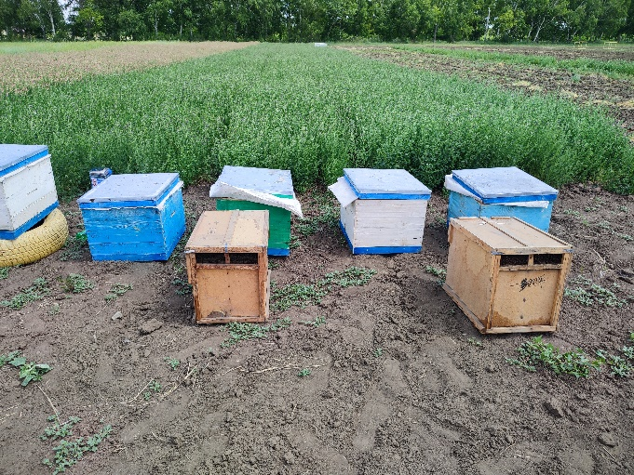 | 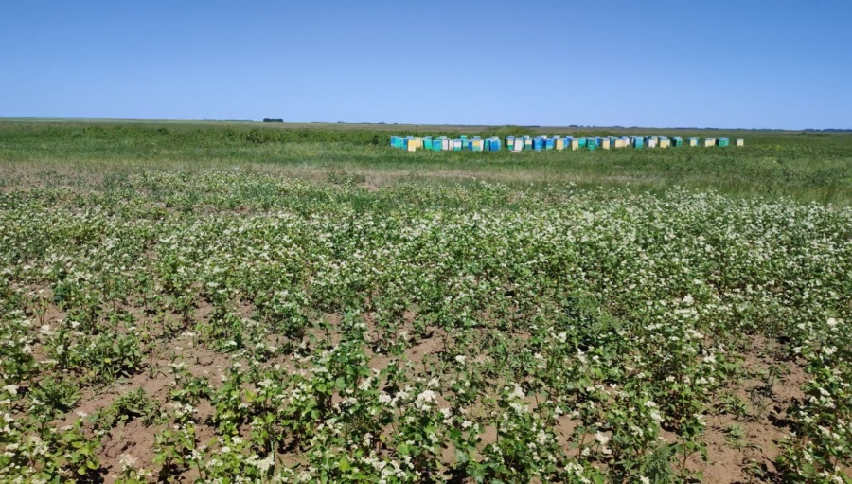
Fig. 1: Location of bee colonies for pollination of experimental plots

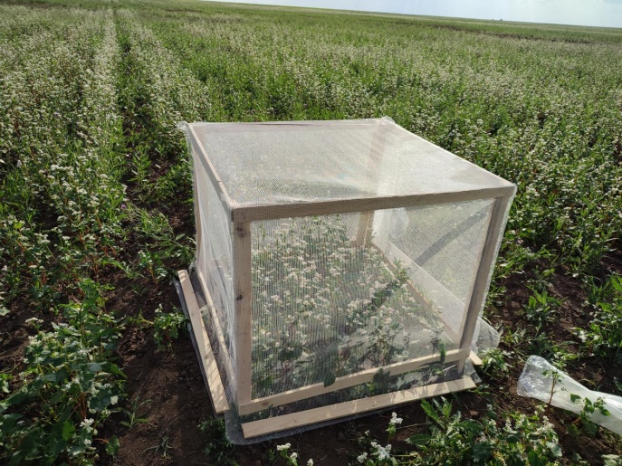 | 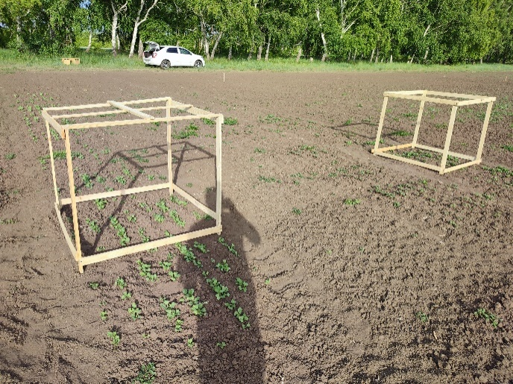
Fig. 2: Location of gauze insulators in experimental areas

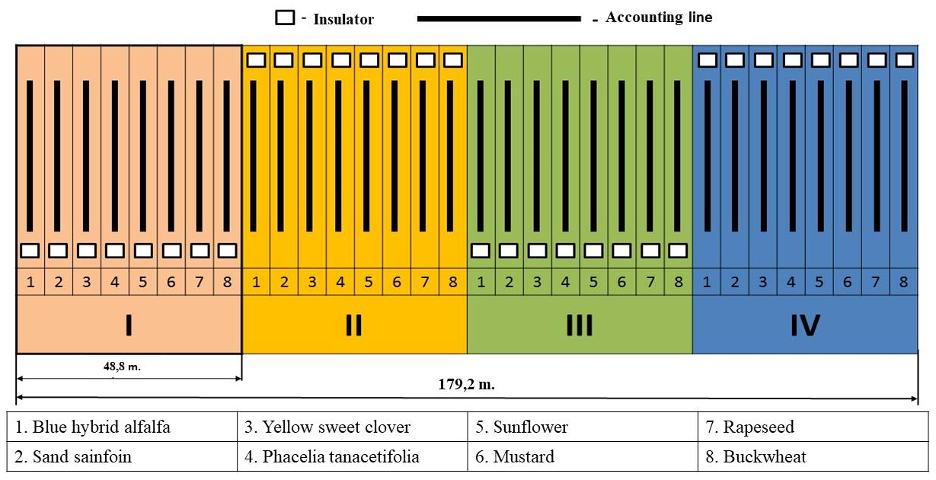
Fig. 3: Field experiment scheme

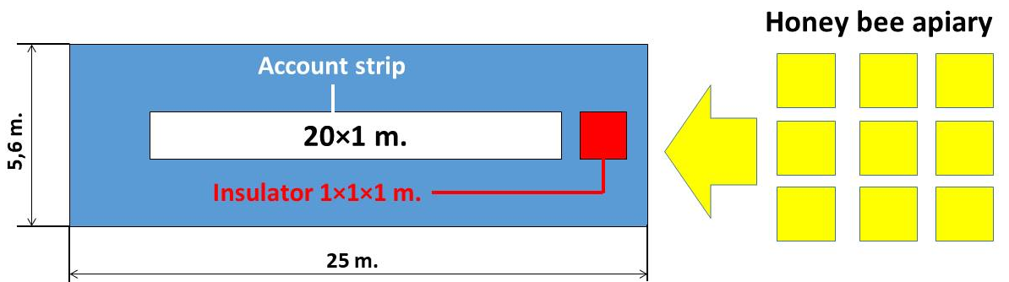
Fig. 4: Layout of honey bee apiary, counting strips and isolators in seed plots

Fig. 5: Average daily air temperature during the growing season of perennial legumes, 0 C (2022-2024)

Fig. 6: Intake of atmospheric precipitation during the growing season of perennial legume crops, mm (2022-2024)

Fig. 7: Relative air humidity during the growing season of perennial legumes, % (2022-2024)

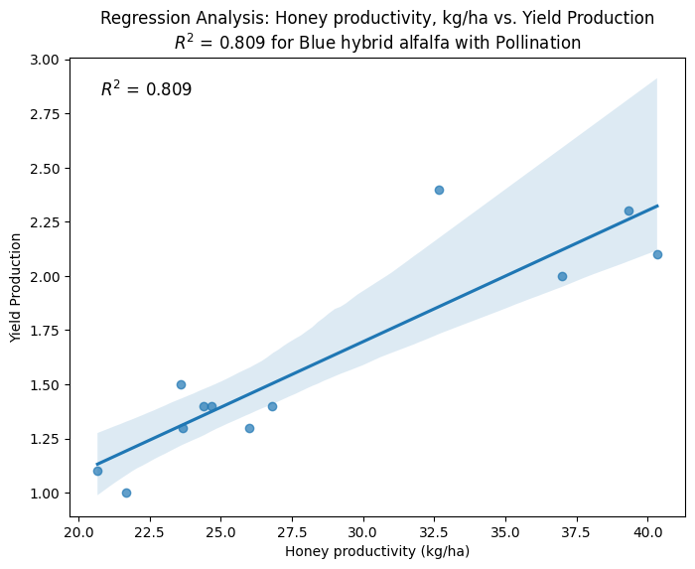 | 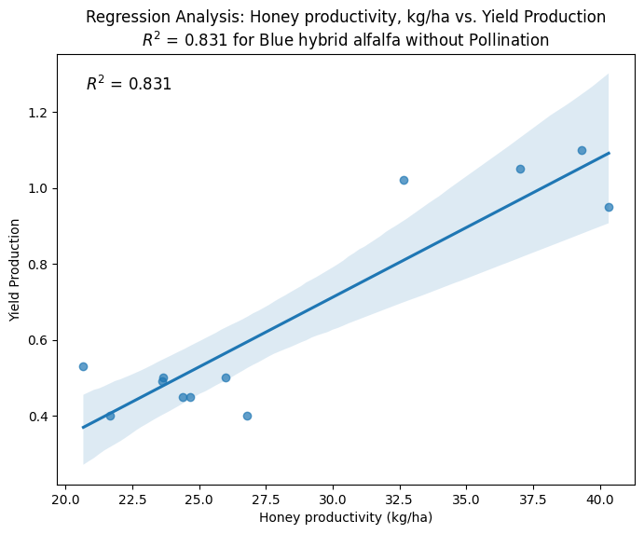
Blue hybrid alfalfa with pollution | Blue hybrid alfalfa without pollution
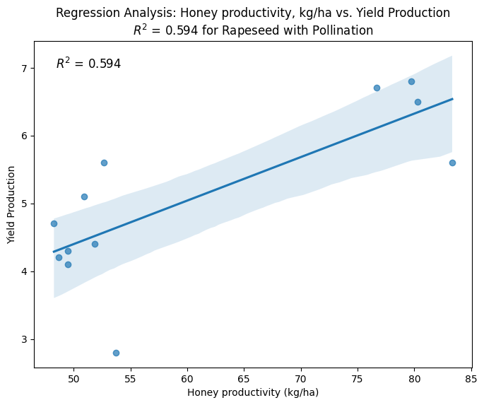 | 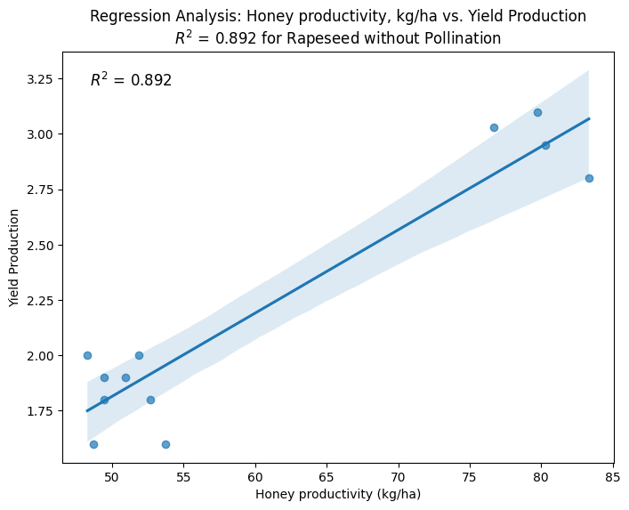
Sand sainfoin with pollination | Sand sainfoin without pollination
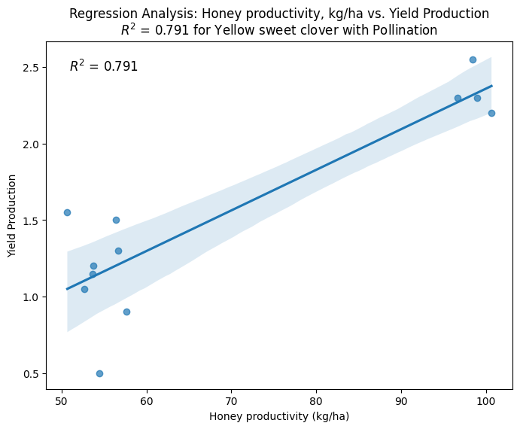 | 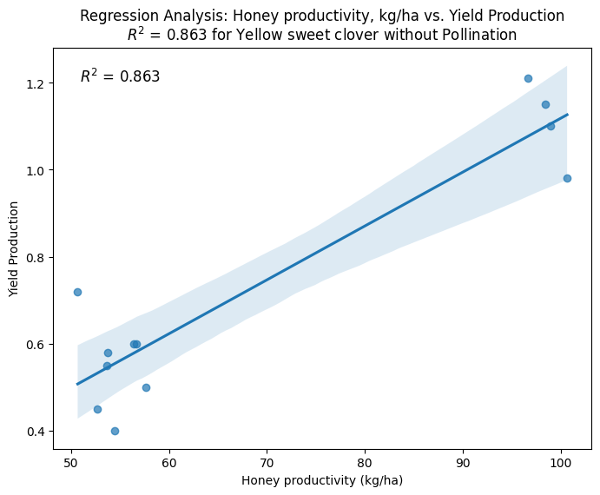
Yellow sweet clover with pollination | Yellow sweet clover without pollination
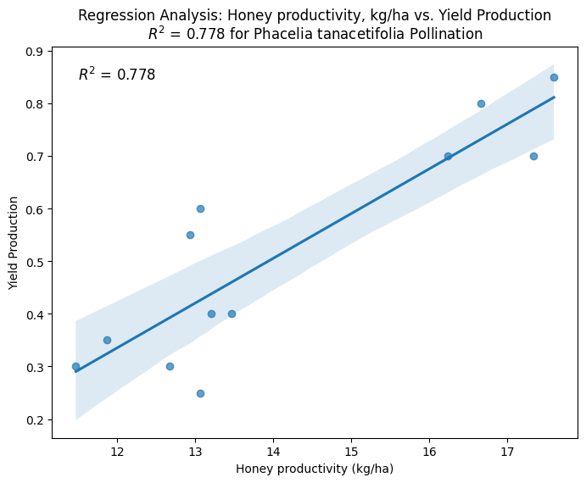 | 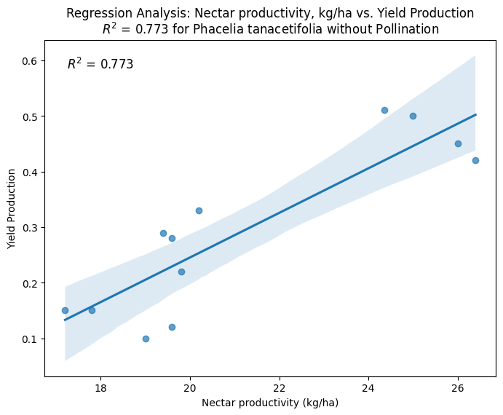
Phacelia tanacetifolia with pollination | Phacelia tanacetifolia without pollination
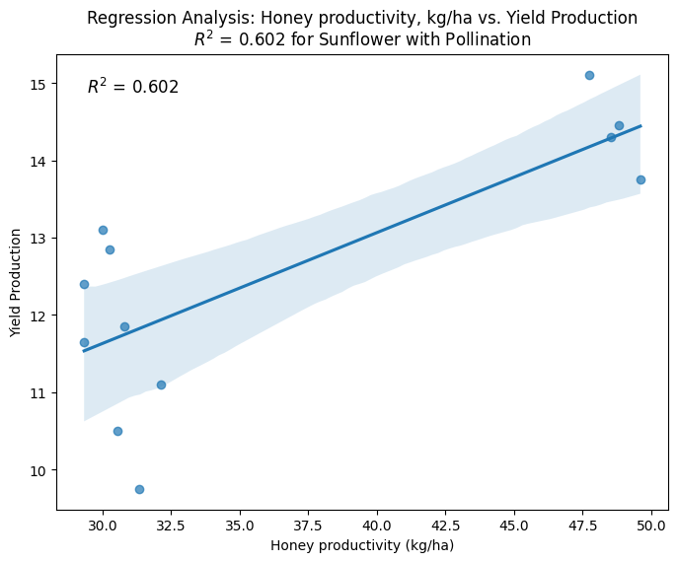 | 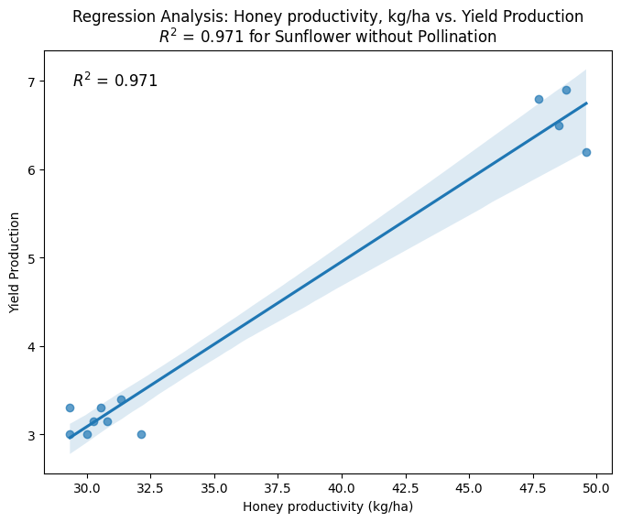
Sunflower with pollination | Sunflower without pollination
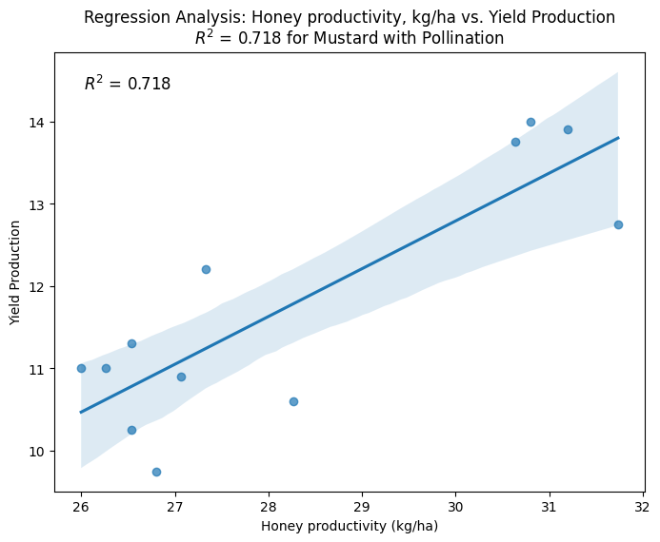 | 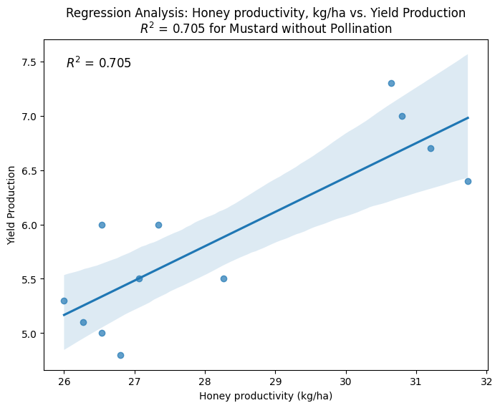
Mustard with pollination | Mustard without pollination
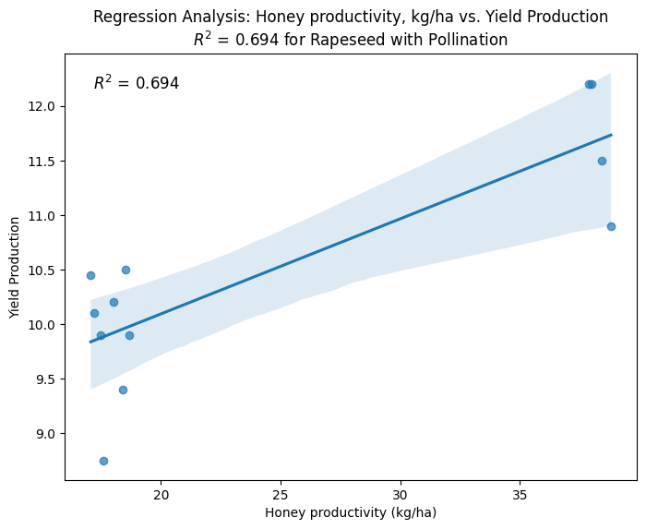 | 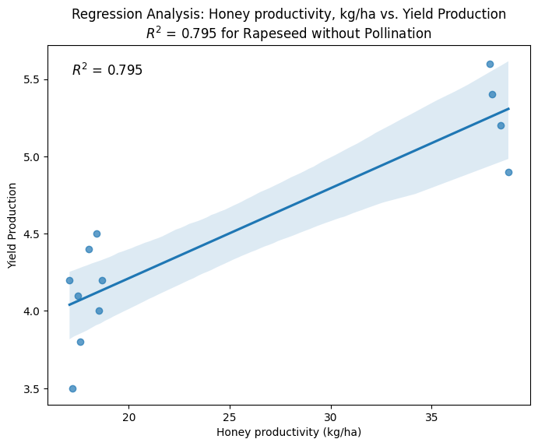
Rapeseed with pollination | Rapeseed without pollination
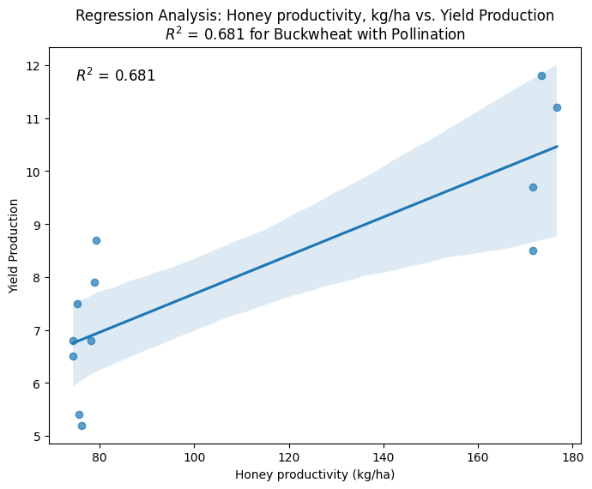 | 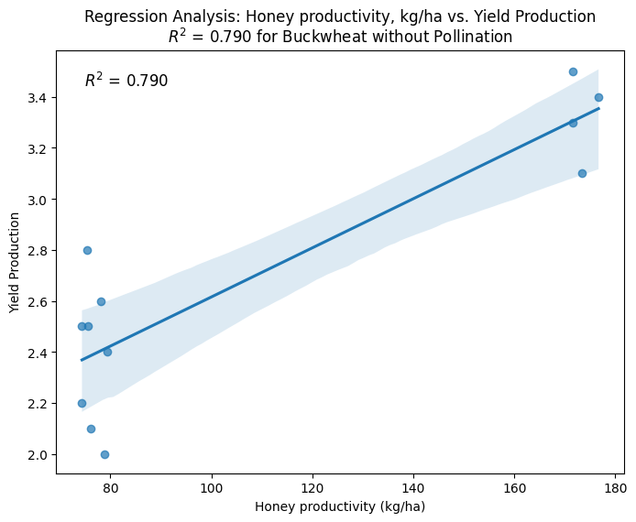
Buckwheat with pollination | Buckwheat without pollination
Fig. 8: Correlation analysis for the Honey productivity indicators, kg/ha

