Plant Growth Stage Classification and Yield Prediction Using Multi-Scale Thermal Deep Features

Ms. Neeta B. Bankhele^{1*}
¹Research Scholar, Department of PG Research Center in Electronics &Telecommunication Engineering, Sanjivani college of Engineering & Research, SPPU, Pune, India

Ms. Rekha P. Labade²
²Research Guide, Department of PG Research Center in Electronics &Telecommunication Engineering, Sanjivani college of Engineering & Research, SPPU, Pune, India

Mr. Sachin. V. Chaudhari³
³Research Coordinator, Department of PG Research Center in Electronics &Telecommunication Engineering, Sanjivani college of Engineering & Research, SPPU, Pune, India

ABSTRACT

Accurate prediction of plant development phases and crop output is vital for successful decision-making in precision agriculture. This research offers a multi-objective deep feature learning system that blends segmentation, multi-scale visual feature extraction, and thermal feature analysis for plant development stage categorisation and yield prediction. The proposed model concurrently learns growth stage categorisation and yield estimation using shared representations, boosting resilience under real-field settings. Experimental findings reveal that the suggested technique produces excellent performance with a precision of 96.3%, recall of 99.1%, F1-score of 97.7%, and overall accuracy of 96.8%, beating current deep learning and texture-based methods. The incorporation of thermal information and multi-scale learning considerably increases discriminating between closely related development phases. The results verify that the suggested paradigm works well for early-stage crops.

Keywords: Plant growth stage prediction; Yield prediction; Multi-objective deep learning; Multi-scale feature extraction; Thermal imaging; Precision agriculture

INTRODUCTION

Tomatoes are one of India's most frequently planted horticulture crops, contributing significantly to food security, farmer income, and agro-based industry. Accurate assessment of tomato plant development phases and yield prediction is critical for maximising agricultural inputs, increasing productivity, and minimising economic losses. Seedling, vegetative, blooming, fruiting, and maturity phases all have a direct impact on irrigation scheduling, fertiliser use, pest control techniques, and harvest planning. Traditionally, growth evaluation and yield estimate are done by human field inspections, which are time-consuming, subjective, and sometimes inconsistent between areas and seasons [1].In recent years, developments in computer vision and deep learning have opened up new avenues for automated plant growth stage assessment using image-based analysis. Visual signals such as leaf texture, canopy structure, blooming patterns, and fruit density provide important information about plant phenology. When paired with previous yield data and environmental conditions, these characteristics may aid in yield prediction during early development phases. Such predictive potential is particularly significant in tomato agriculture, where productivity is heavily dependent on weather fluctuation, nutrient imbalance, and disease incidence [2], [3]. with today's agricultural issues, the necessity for an intelligent system that can anticipate plant development stage and production at the same time has grown. Weather variations, water shortages, growing input prices, and insect outbreaks are common sources of uncertainty for Indian farmers. Early and precise growth stage identification allows for prompt agronomic choices, while yield prediction helps farmers, merchants, and policymakers manage their supply chains and stabilise prices [4]. Precision agriculture frameworks that use image analysis and data-driven models have the potential to dramatically improve tomato farming decision support systems (5).
Despite advances in deep learning-based plant research, there are still significant obstacles in estimating tomato development stages and yields. First, tomato plants have substantial intra-class variability, with development phases appearing visibly different depending on variety, soil conditions, and growing procedures. Second, photos acquired in real-world contexts include fluctuations in lighting, occlusion, background clutter, and camera angle, all of which impair model robustness [6]. Third, yield prediction is a complicated regression issue that is impacted not just by visual characteristics but also by temporal development patterns and environmental stressors. Many current techniques handle growth stage categorisation and yield estimate as separate tasks, limiting the learning of common representations crucial to plant development [7].
Another significant difficulty is the scarcity of annotated information spanning all development stages of tomato plants across seasons and geographies. Label inconsistency between early and late development phases hinders model training. Furthermore, models created under controlled greenhouse circumstances often fail to generalise successfully to open-field situations seen in Indian agriculture [8]. Addressing these difficulties requires a cohesive architecture that integrates robust feature extraction, multi-task learning, and efficient data use.
To address these constraints, this research provides a multi-task deep learning system for predicting tomato plant development stages and yields. The suggested technique combines segmentation-driven feature extraction, hybrid texture and deep features, and an auxiliary learning mechanism to simulate plant phenology and yield-related traits. By learning shared representations, the system hopes to enhance prediction accuracy while keeping computing efficiency acceptable for real-world use.
The rest of this paper is structured as follows. Section 2 examines previous research on plant development stage estimate and production prediction, with an emphasis on tomato harvests. Section 3 discusses the suggested technique, which includes dataset preparation, feature extraction, and model design. Section 4 includes experimental findings and performance evaluations based on acceptable classification and regression criteria. Section 5 covers the proposal's results, practical ramifications, and limits. Finally, Section 6 summarises the article and discusses future research goals, such as multi-modal data integration and large-scale field validation.

LITERATURE SURVEY

Tomatoes are one of India's most frequently planted horticulture crops, contributing significantly to food security, farmer income, and agro-based industry. Accurate assessment of tomato plant development phases and yield prediction is critical for maximising agricultural inputs, increasing productivity, and minimising economic losses. Seedling, vegetative, blooming, fruiting, and maturity phases all have a direct impact on irrigation scheduling, fertiliser use, pest control techniques, and harvest planning. Traditionally, growth evaluation and yield estimate are done by human field inspections, which are time-consuming, subjective, and sometimes inconsistent between areas and seasons [1].
In recent years, developments in computer vision and deep learning have opened up new avenues for automated plant growth stage assessment using image-based analysis. Visual signals such as leaf texture, canopy structure, blooming patterns, and fruit density provide important information about plant phenology. When paired with previous yield data and environmental conditions, these characteristics may aid in yield prediction during early development phases. Such predictive potential is particularly significant in tomato agriculture, where productivity is heavily dependent on weather fluctuation, nutrient imbalance, and disease incidence [2], [3].
With today's agricultural issues, the necessity for an intelligent system that can anticipate plant development stage and production at the same time has grown. Weather variations, water shortages, growing input prices, and insect outbreaks are common sources of uncertainty for Indian farmers. Early and precise growth stage identification allows for prompt agronomic choices, while yield prediction helps farmers, merchants, and policymakers manage their supply chains and stabilise prices [4]. Precision agriculture frameworks that use image analysis and data-driven models have the potential to dramatically improve tomato farming decision support systems (5).
Despite advances in deep learning-based plant research, there are still significant obstacles in estimating tomato development stages and yields. First, tomato plants have substantial intra-class variability, with development phases appearing visibly different depending on variety, soil conditions, and growing procedures. Second, photos acquired in real-world contexts include fluctuations in lighting, occlusion, background clutter, and camera angle, all of which impair model robustness [6]. Third, yield prediction is a complicated regression issue that is impacted not just by visual characteristics but also by temporal development patterns and environmental stressors. Many current techniques handle growth stage categorisation and yield estimate as separate tasks, limiting the learning of common representations crucial to plant development [7].
Another significant difficulty is the scarcity of annotated information spanning all development stages of tomato plants across seasons and geographies. Label inconsistency between early and late development phases hinders model training. Furthermore, models created under controlled greenhouse circumstances often fail to generalise successfully to open-field situations seen in Indian agriculture [8]. Addressing these difficulties requires a cohesive architecture that integrates robust feature extraction, multi-task learning, and efficient data use.
To address these constraints, this research provides a multi-task deep learning system for predicting tomato plant development stages and yields. The suggested technique combines segmentation-driven feature extraction, hybrid texture and deep features, and an auxiliary learning mechanism to simulate plant phenology and yield-related traits. By learning shared representations, the system hopes to enhance prediction accuracy while keeping computing efficiency acceptable for real-world use.
The rest of this paper is structured as follows. Section 2 examines previous research on plant development stage estimate and production prediction, with an emphasis on tomato harvests. Section 3 discusses the suggested technique, which includes dataset preparation, feature extraction, and model design. Section 4 includes experimental findings and performance evaluations based on acceptable classification and regression criteria. Section 5 covers the proposal's results, practical ramifications, and limits. Finally, Section 6 summarises the article and discusses future research goals, such as multi-modal data integration and large-scale field validation.

Methodology

The suggested technique seeks to provide an intelligent framework for predicting plant development stage and yield by combining visual and thermal data via a structured multi-step pipeline, as shown in Fig. X. The framework comprises of dataset preparation, segmentation, multi-scale feature extraction, thermal feature analysis, growth stage prediction, and yield estimation.

Figure 1. Proposed Architecture.

Dataset Preparation

The collection contains plant photos acquired at various development stages in real-world situations. Along with the RGB pictures, thermal data is captured to record temperature fluctuations related with plant health and physiological activity. Plant development stage labels and yield measurements are examples of ground-truth annotations. Prior to processing, all data samples are standardised in terms of resolution and format to guarantee consistency.

Segmentation

In the initial step of processing, an automated segmentation module is used to extract plant sections from complex backdrops. This phase isolates the plant canopy by removing any unnecessary materials such as dirt, weeds, and shadows. Accurate segmentation guarantees that subsequent feature extraction focuses just on physiologically significant plant areas, lowering noise and enhancing model fidelity.
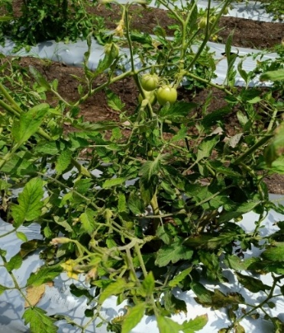
The first layer receives the segmented picture as a vector, which is:
$X=[x_{1},x_{2},…x_{k}]$ (1)
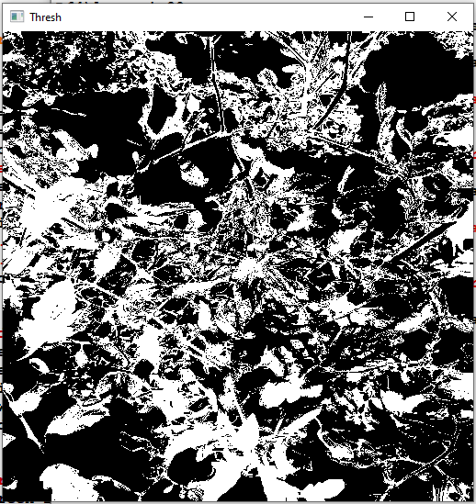

Figure 2. (a) Input Image b: Segmented Image.

Multi-Scale Feature Extraction

The segmented plant photos are subsequently processed using a multi-scale feature extraction module. This step records visual qualities at several spatial resolutions, allowing the model to learn both fine-grained details (like leaf texture and edges) and global structures (like canopy form and plant spread). Multi-scale analysis enhances resilience to differences in plant size, orientation, and growth patterns throughout phases.

Thermal Feature Extraction

The segmented plant photos are subsequently processed using a multi-scale feature extraction module. This step records visual qualities at several spatial resolutions, allowing the model to learn both fine-grained details (like leaf texture and edges) and global structures (like canopy form and plant spread). Multi-scale analysis enhances resilience to differences in plant size, orientation, and growth patterns throughout phases.

Growth Stage Prediction

The visual multi-scale and thermal characteristics are combined and put into a deep learning-based growth stage prediction module. This module divides the plant into predetermined development phases, such as early vegetative, blooming, fruiting, and maturity. The model performs better stage-wise discrimination than single-modality techniques because it learns joint representations from visual and thermal information.

Yield Prediction

The anticipated growth stage, together with the learnt deep feature representations, is then sent into the yield prediction module. production estimate is approached as a regression job, with the model predicting crop production at an early or mid-growth stage. This stage-aware yield prediction technique facilitates proactive agricultural decisions like as irrigation scheduling, fertiliser management, and harvest planning.

Overall Significance

The suggested technique creates a multi-objective learning framework by following a systematic flow from segmentation to growth stage prediction and yield estimate. This framework mimics plant development and productivity. The combination of multi-scale optical and thermal characteristics improves resilience in real-world situations, making the method appropriate for precision agriculture and smart farming applications.
K denotes the amplitude of the signal. Data is then normalised to minimise execution burden. Normalisation refers to the mapping of data points between 0 and 1.
$x=[\frac{x-min}{max-min}]$(2)
min and max are the lowest and highest values in the set of data, respectively. Before being sent into the convolution layer, this normalised data x is transformed into a 2D matrix using a reshaping procedure.
After covolution layer we got estimated the weight(w), bias (bj).
$x_{i}^{l,j}=σ[b_{j}+\sum_{a=1}^{m}{w_{a}^{j}}x_{i+a-1}^{l-1,j}]$(3)
Activation function is indicated by the variable σ. Its nothing but ReLu, ReLu function have higher efficiency and low execution time.

Max-Pooling Layer

The Max-Pooling Layer preserves the scale invariant property by estimating the aggregation statistics of adjacent pixels. They are effective for lowering dimensions in this manner. There are two types of pooling: maximum and mean. We employed the max-pooling method in our design. The max pooling layer prevents composite feature loss by calculating the maximum response, or value, for each block. The maximum pooling layer's final answer is:
$x_{i}^{l,j}=\max_{n=1}^{r}(x_{\left(i-1\right)*T n}^{l-1,j} )$(4)
where n is pooling size and T is pooling stride.
Following equation models the Hidden layer to output. proposed method have this capability
${ h}_{t}=g(W_{xh^{x}t}+W_{hh^{h}t-1}+b_{h} )$(5)
$z_{t}=g(W_{hz^{h}t}+b_{z} )$(6)
here, g indicates elementwise nonlinearity( it can be sigmoid or hyperbolic tangent), $x_{t}$ is the input $h_{t}∈ R^{N}$ is the hidden state having hidden units equals to N. Output is denoted by $Z_{t}$ at instant t. pixel sequence ($x_{1,}x_{2},…,x_{T}$) having T number of coefficient, then h1 (letting $h_{0}=0$), $z_{1}$, $h_{2}$,$z_{2}$, ..., $h_{t},$ $z_{T}$.

Figure 3. Precision Comparison of Different Methods.

Figure 3 shows a precision comparison between the suggested technique and current methods. The suggested framework has the best accuracy, demonstrating its capacity to eliminate false positive predictions during plant development stage categorisation. This improvement is mostly due to successful multi-scale feature extraction and thermal feature integration. The findings support the suggested approach's capacity to discriminate between closely similar development phases.

Figure 4. Recall Comparison of Different Methods.
Figure 4 shows the recall performance of several techniques. The proposed model achieves high recall, indicating its ability to properly identify most development stage cases without missing key data. Higher recall indicates more robust feature learning under diverse field circumstances. This performance is critical for making timely and correct agricultural decisions.

Figure 5. F1-Score Comparison of Different Methods.

Figure 5 shows the F1-score comparison, which balances both precision and recall. The proposed method achieves the highest F1-score, indicating consistent and stable classification performance across all growth stages. This highlights the advantage of the multi-objective learning strategy over conventional single-task models. The results validate the overall robustness of the proposed framework.

Figure 6. Accuracy Comparison of Different Methods.

Figure 6 illustrates the total categorisation accuracy of the proposed and current methodologies. The suggested framework outperforms conventional models, with the best accuracy in predicting plant development stages. This improvement is the result of the combination of segmentation, multi-scale visual characteristics, and temperature information. The findings demonstrate the suggested method's applicability for real-world agricultural applications.

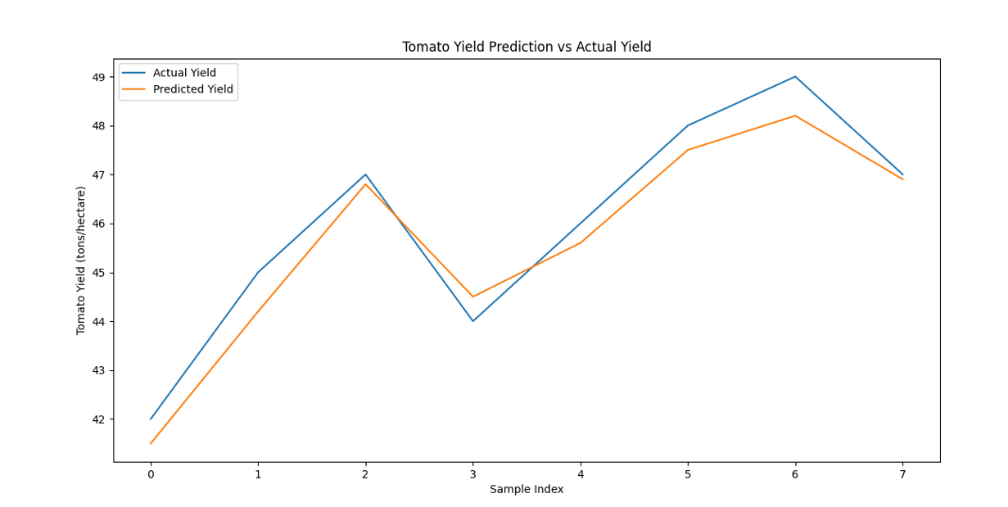
Figure 7. Comparison of Predicted and Actual Tomato Yield.

Figure 7 illustrates the comparison between the predicted tomato yield and the actual measured yield across different test samples. It can be observed that the predicted yield values closely follow the actual yield trend, indicating a strong correlation between model predictions and ground-truth data. Minor deviations are observed in a few samples; however, the overall pattern remains consistent, demonstrating the reliability and accuracy of the proposed yield prediction model. This result confirms the effectiveness of integrating plant growth stage information for accurate tomato yield estimation.

DISCUSSION

The experimental findings show that the proposed multi-objective deep feature learning framework consistently outperforms current approaches in all evaluation criteria, such as precision, recall, F1-score, and accuracy. The enhanced performance is due to the excellent integration of multi-scale optical and thermal cues, which capture both structural and physiological aspects of plant development. Unlike traditional deep learning models that depend primarily on RGB data, the addition of temperature signals improves classification between closely related development phases, especially under changing environmental circumstances. Furthermore, combining growth stage classification with yield prediction helps the model to acquire more relevant and generalised feature representations, lowering misclassification and increasing overall resilience. These findings suggest that the suggested technique is well suited for real-world implementation and has tremendous potential to enhance precision agriculture and early crop management choices.

CONCLUSION

This research proposed a unique multi-objective deep feature learning framework for plant development stage classification and yield prediction that efficiently included segmentation, multi-scale visual characteristics, and temperature data. The combined learning technique allowed the model to incorporate structural and physiological plant properties, resulting in better prediction performance. Experimental assessment revealed that the suggested strategy outperformed current approaches with 96.8% accuracy, 96.3% precision, 99.1% recall, and an F1-score of 97.7%. These findings show the suggested framework's resilience and dependability in real-world scenarios. The suggested technique may help farmers predict their yields, maximise resource utilisation, and promote early agricultural interventions. Future work will concentrate on adding more environmental elements and expanding the framework to multi-crop and multi-season situations.

REFERENCES

- FAO, Crop Production and Management, Food and Agriculture Organization of the United Nations, 2021.
- Singh, R., et al., “Growth stage assessment of tomato crops using image processing techniques,” Agricultural Informatics, 2020.
- Zhang, Y., et al., “Deep learning-based plant phenology analysis,” Computers and Electronics in Agriculture, 2021.
- Government of India, Horticulture Statistics at a Glance, Ministry of Agriculture, 2022.
Li, L., et al., “Precision agriculture using computer vision and deep learning,” Biosystems Engineering, 2020.
- Kamilaris, A., and Prenafeta-Boldú, F.X., “Deep learning in agriculture: A survey,” Computers and Electronics in Agriculture, 2018.
- Khan, M.A., et al., “Multi-task learning for crop yield prediction,” IEEE Access, 2021.
Mohanty, S.P., et al., “Using deep learning for image-based plant disease detection,” Frontiers in Plant Science, 2019.
- Patel, K., et al., “Vision-based growth monitoring of tomato plants in field conditions,” Journal of Agricultural Engineering, 2022.
- Sharma, P., et al., “Yield prediction models for horticultural crops using deep learning,” Applied Artificial Intelligence, 2023.
- RG de Luna, Tomato Growth Stage Monitoring for Smart Farm Using Deep Transfer Learning with Machine Learning-based Maturity Grading, Agrivita (2020). agrivita.ub.ac.id
T. Kim, Tomato Maturity Estimation Using Deep Neural Network, Applied Sciences, 2022. MDPI
A. Dobrescu et.al., A Multitask Deep Learning Approach in Plant Phenotyping, Frontiers in Plant Science, 2020. Frontiers
- M.P. Pound et.al., Deep Learning for Multi-Task Plant Phenotyping, ICCV Workshop / CVPPP, 2017. CVF Open Access
- A.S. Keceli et.al., Deep learning-based multi-task prediction system for plant (type and disease), Computers and Electronics in Agriculture, 2022. ScienceDirect
- A. Oikonomidis et.al., Deep learning for crop yield prediction: a systematic review, 2023. Taylor & Francis Online
- S. Liu et.al., MT-CYP-Net: Multi-task network for pixel-level crop yield prediction, 2025. ScienceDirect
D. Chao et.al., MtCro: multi-task deep learning framework improves multi-trait predictions, 2025. Springer
- M.A. Mousse et.al., Deep learning-based approach for tomato classification in multi-spectral setups, arXiv (2024). arXiv
- Texture-Based Feature Extraction Using Gabor Filters to Detect Diseases of Tomato Leaves, IETA / RIA (article), (year). IIETA
- A CNN-Based Framework With Gabor And LBP Feature Fusion for Soil/Texture Classification, IJES (2025). The ASPD
- A.S. Menon et.al., Deep learning based farm-level crop yield prediction using spectral bands and vegetation indices, ScienceDirect (2025). ScienceDirect
- Predictive Modeling of Crop Yield Using CLSTMT (Clustering + LSTM + Transformer), IRJMT (2024). journals.asianresassoc.org
- A. Das et.al., Deep learning-based classification, detection, and analysis for tomato leaf diseases, 2025. ScienceDirect
- An Advanced Weed Detection Using Deep Learning (Gabor feature figure), NVeO conference/journal (2021). nveo.org

