Investigating The Mediating Role of Economic Growth between Natural Disasters and Carbon Emissions: The evidence from Pakistan
Zunaira Zulfiqar¹, Fariha Rehman¹, Sangam Khalil², Muhammad Madnee², Md. Manik Ali³, Nugraha Akbar Nurrochmat⁴
¹Department of Economics, COMSATS University Islamabad. zunairazulfiqar112@gmail.com, fariharehman@cuilahore.edu.pk
²Institute of Forest Sciences, Faculty of Agriculture and Environment, The Islamia University of Bahawalpur, Bahawalpur, 63100, Pakistan. sangam.khalil@iub.edu.pk, muhammad.madnee@iub.edu.pk
³Department of Agroforestry and Environment, Hajee Mohammed Danish Science and Technology University, Dinajpur, Bangladesh. manikali@hstu.ac.bd
⁴Department of Forest Management, Dendrometry and Forest Economics, Institute of Forest Sciences, Warsaw University of Life Sciences, Warsaw 02-776, Poland. nugraha_nurrochmat@sggw.edu.pl
Corresponding author’s email: sangam.khalil@iub.edu.pk

Abstract

Pakistan is extremely vulnerable to natural calamities and has seen large increases in carbon emissions in the last few years. This study investigates at the relationship between natural disasters, economic growth, and carbon emissions in Pakistan, by considering multiple variables including energy consumption, urbanization, and population growth, utilizing time series data from 1980 to 2022. Structural equation modeling (SEM) was employed to explore both direct and indirect effects among the variables. The findings reveal that natural disasters have a significant negative impact on economic growth coefficient is -0.729, while economic growth strongly contributes to carbon emissions with coefficient of 0.397. Additionally, energy consumption emerges as the most significant driver of carbon emissions (path coefficient = 0.501, p < 0.001), while urbanization and population growth show minimal effects. The indirect effect of natural disasters on carbon emissions through economic growth is also significant and negative with path coefficient of -0.289, highlighting the mediating role of economic growth. This research aims to highlight that post- disaster economic recovery frequently increased investments and productivity however, this growth depends on fossil fuels consumption, and this leads to increase in greenhouse gas emissions. Finally, several policy recommendations are proposed to mitigate CO₂ emissions and minimize the impacts of natural disasters.

Keywords: Mediating Effect; Natural Disasters; Economic Growth; Carbon Emissions

Introduction
Global climate change, caused by global warming is now emerging as the most severe issue in the world (Mann, 2023). Global warming is affecting the Earth's climate and weather systems due to an increase in the atmosphere's average temperature. These rapid changes occur because humans are releasing greenhouse gases, which trap heat into the atmosphere (Rajak, 2021). The emission of greenhouse gases (Shabnam, 2014) such as methane, nitrous oxide, and carbon dioxide causes global warming, with poorer nations frequently facing the most negative effects (Muhammad et al., 2011; Safeer et al., 2025). When the annual concentration of CO₂ exceeds 6.7 ppm (Nunes, 2023) global warming will worsen and increase the frequency of extreme events like droughts, heavy rains, severe floods, water scarcity, high temperatures and soil degradation. These impacts will threaten the socioeconomic sustainability of affected nations (Furtak & Wolińska, 2023).
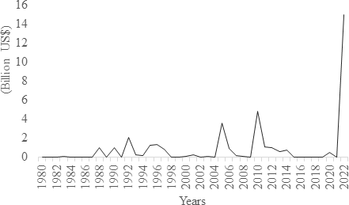
Figure 1: Economic Loss from Natural Disasters in Pakistan Source: EM-DAT
In July and August of 2022, Pakistan, which has been ranked among the 5th most prone countries to climate change, saw long and extreme monsoon rains, highlighting the impact of rising global temperatures (JS et al., 2022). It is anticipated that GHG emissions will significantly decline in the upcoming decades, but in the 21st century, global temperature will rise by more than 1.5°C to 2°C over levels before industrialization (Henriques, 2024).
Pakistan is especially faced with the negative effects of climate change and regularly faces natural catastrophes (Sadia, 2013). Every year, around 3 million people in Pakistan are affected by natural disasters (Ullah & Takaaki, 2016). Disasters can have a negative influence on a country's economic growth by affecting labor force participation and reducing household expenditures due to the loss of income. Also, in order to slow down the GDP growth rate and the whole human development index, resources are moved from the producing sector to the rehabilitation sector and reconstruction sectors by the government and non- government sectors (Sardar & Phil, 2015).
Pakistan has seen rapid economic growth and extensive energy consumption during the last 10 years as a result of industrialization and related market changes (Mudakkar et al., 2013). As the country's

GDP grows, its energy demands usually rise, resulting in increasing CO₂ emissions as organizations expand and transportation needs grow. This pattern is representative of a larger one in which economic growth frequently results in higher carbon emissions, which causes global warming (Haque et al., 2022). In 2020, Global Climate Risk Index (GCRI) states that, Pakistan's GDP per unit has dropped to 0.53%, and the nation has seen economic losses reaching around US$ 3792.52 million as a result of extreme weather events (Aftab et al., 2021).
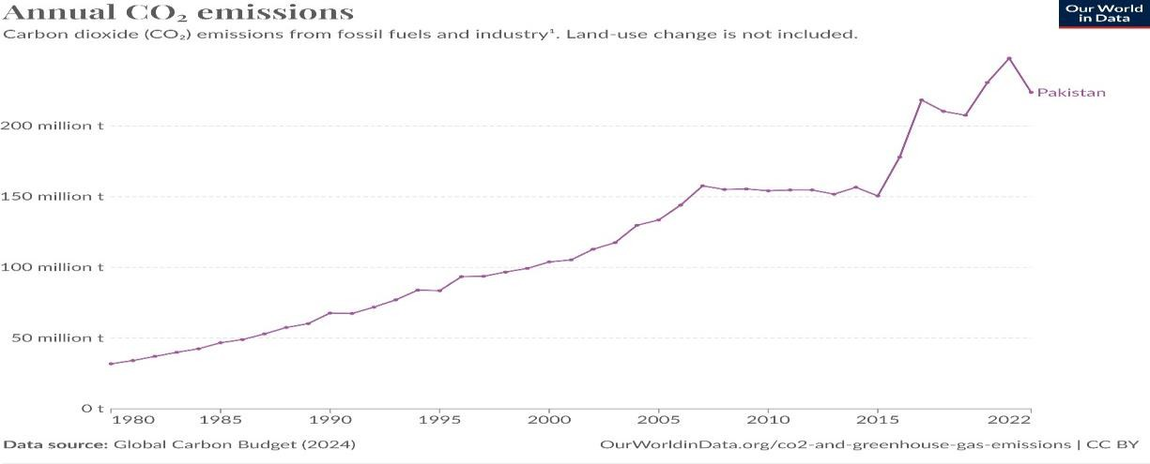

Figure 2: The Increasing Carbon Emissions from Pakistan Source: Our World in Data Pakistan has consistently shown a positive relationship between carbon emissions and economic growth due to increased energy use and industrial activity, primarily from fossil fuels (Khan et al., 2020). Fossil fuels are most important influence in a country's economic growth in developing countries (Hanif et al., 2019). At this time, fossil fuels provide for almost all of Pakistan's energy supply; gas makes up the biggest part, followed by oil and coal. However, economic expansion may contribute to higher carbon emissions. This occurs because as economies grow, there is a greater need for energy, which is frequently fulfilled by burning fossil fuels which release carbon dioxide into the atmosphere (Igini, 2024). Since 1990, global CO₂ emissions have increased by more than 60% (Lin & Ullah, 2024). Pakistan's CO₂ emissions grew from 230.75 million tonnes (MT) in 2020 to 247.90 million tonnes (MT) in 2021 (Mako et al., 2022).
A major flood event, like the one in 2010, could lead to damages exceeding 15$ billion, which is nearly 7% of the Pakistan’s GDP (Khan, 2017). Natural catastrophes are predicted to disturb economic activity in the short term because of the direct and indirect losses they cause (Panwar & Sen, 2019). The term "direct disaster losses" describes losses that can be measured directly, for example the number of deaths and the damage caused to natural resources and infrastructure. Indirect damages from disasters typically occur due to disturbance in the movement of goods and services and include losses in output or revenue as well as effects on people's wellbeing (Noy &

Nualsri, 2007). This results in harm to both human and physical capital, which, particularly in emerging nations, can slow down the accumulation of skilled human capital in the future and lead to large opportunity costs (Baez et al., 2010).
Additionally, a nation's propensity for natural calamities can create fear and discourage long-term investment. On the other hand, alternative concepts believe that natural disasters might increase gross domestic product in the long run (Kim, 2010; Sardar et al., 2016). In Pakistan, climate and weather related calamities resulted in economic losses of $29.3 billion between 1992 and 2021 (Ahmad, 2023). Endogenous growth models such as the Schumpeterian creative destruction hypothesis predict that after recovery efforts, development may accelerate in disaster-affected areas, resulting in increased investments and long-term productivity effects (Panwar & Sen, 2019).
Pakistan's economy has expanded quickly in the last ten years, and market reforms and industrialization have caused a rise in energy consumption. Both output and domestic demand have gradually increased as a result of this growth (Raza & Tang, 2024). Such a situation is estimated to cause a rise in the frequency of severe weather conditions, creating a threat to both the environment and economic growth (Carleton & Hsiang, 2016).
Pakistan's agriculture, which contributes significantly to its GDP, has been seriously harmed by these floods. Although the fact that Pakistan produces less greenhouse gases (GHG) than developed countries, global efforts are being made to protect the environment from climate change (Searle et al., 2016). Natural disasters, such as floods or earthquakes, frequently cause extensive infrastructure damage and slow down economic activity (Chhibber & Laajaj, 2013; Nurrochmat et al., 2024). When cities and industries start to recover and rebuild, economic growth frequently increases as investments are directed towards restoration and recovery activities (Hallegatte et al., 2018).
Economic growth plays a critical role as a mediator between natural calamities and carbon emissions. This study highlights that the natural disasters not only have an immediate impact on growth by damages such as a decline in prospective earnings, damage of infrastructure and disturb economic activities (M. T. I. Khan et al., 2023) but also have an impact on long term growth because of things like innovation and process reconstruction. Accelerating economic growth frequently results increase carbon emissions, which causes global warming (Singh, 2024). Around 150 severe weather events occurred in Pakistan between 1998 and 2018 due to climate change (Sajjad & Ghaffar, 2019). As a result, economic growth may consequently slow, increasing the community’s vulnerability to natural disasters (Zhou et al., 2014).
Global temperatures have risen by around 1ºC over the past century, affecting weather patterns and increasing the frequency of natural disasters (Seneviratne et al., 2021). Studies suggest that economic growth following disasters can have major effects on emissions, with higher growth rates leading to higher emissions if not supported by investment in renewable energy and sustainable practices (Zhao et al., 2022). Therefore, while economic growth has become crucial for disaster recovery, the environmental impact of these growth periods must be limited by adopting policies and practices that support sustainable development and lower carbon emissions (Knäble et al., 2022).
Natural catastrophes effects on economic growth and social development have been comprehensively studied, their effect on carbon emissions is still unclear, highlighting the need for more empirical study. Therefore this study observes the correlation between natural disasters, economic growth and carbon emissions in Pakistan. This study objectives to provide information on how natural disasters recovery and development activates boost economic growth which in turn impact on carbon emissions in short and long run. The findings of this study will give policymakers important information to help them create policies that promote sustainable economic growth, lower carbon emissions, and enhance efforts to prevent and mitigate disasters.

Research Objectives
- To examine the direct impact of natural disasters on economic growth in Pakistan.
- To examine the direct effect of natural disasters on carbon emissions in Pakistan.
- To explore the effect of economic growth on carbon emissions in Pakistan.
- To investigate the mediating role of economic growth between natural disasters and carbon emissions in Pakistan.
This review article highlights the interconnectedness of natural disasters, economic expansion, and environmental sustainability, aiming to offer insights that can guide future interventions to balance economic development with climate resilience. By focusing on Pakistan as a case study, this paper will fill a critical gap in the literature, providing evidence on how growth mediates the correlation between natural catastrophes and carbon emissions (CO₂), might be an important source of information for policymakers and practitioners seeking to promote sustainable growth in disaster- prone regions. Section 2 presents the literature review and critically evaluates the results. The investigation methodology is discussed in Section 3, Section 4 comprised of the results and their discussion. The conclusion and policy implications are presented in Section 5.

Literature Review
This section represents the existing work on the effect of natural catastrophes on economic growth and carbon emissions emphasize the crucial need of developing resilience strategies in the face of environmental issues.

Natural Disasters and Economic Growth

Many studies are more concerned about how natural catastrophes will affect economic development. Natural catastrophes have a substantial effect on the social development of an area, especially when they cause large-scale mortality and loss of property (Cavallo et al., 2022). Most natural catastrophes have an adverse effect on economic activity, and some are positive effects.
A study found the relationships between natural catastrophes and economic development have been conducted across the world since 1990. Pakistan has always been prone to disasters, including floods caused by monsoon rains due to its geographical location. However, in recent years, Pakistan has suffered massive losses as a result of the 2010 floods, which damaged over 20 million people, and the 2005 earthquake, which affected 3.9 million, which are regarded as the worst disasters in the country's history (Baig et al., 2021).
Another research showed that natural catastrophes have serious effects, such as increased poverty, inflation, and financial deficits, all of which have a negative impact on people's physical and mental health and prevent growth in the economy (Baez et al., 2010). Similarly, Cao et al. (2023) conducted that natural disaster have a large impact on socioeconomic development of an area and suffer heavy expenses in terms of property destruction and mortality. They also have negative effects including increased rates of poverty, inflation, and financial deficits. As a result, this adversely affects people's physical and mental health and impedes economic development.
In 84 nations, Fomby et al. (2013) the study examined that natural catastrophes including earthquakes, floods, hurricanes, and droughts affected GDP development in both the agricultural and non-agricultural sectors. Different countries were affected differently by these calamities; industrialized countries were less affected than developing countries. Surprisingly, several calamities actually helped the economy expand. For example, minor floods increased agricultural output, which in turn helped the economy grow. On the other hand, major catastrophes caused a great deal of harm to economic activity.
Noy (2009) observed that natural disasters have a short-term negative influence on the economy, with differences among areas. While the effects of disaster shocks are more acute in poorer nations, developed countries often manage them more efficiently. In addition, other research has discovered the inverse link between catastrophes and economic growth, indicating that disasters may, in some cases, actually boost growth in the economy. A case study about disasters in developing nations, Loayza et al. (2012) discovered that following disasters, the majority of nations had strong economic growth, indicating that natural disasters might, in some cases, boost economic development.
Shabnam (2014) stated that the reciprocal relationship between economic growth and natural man- made disasters. A competitor devastates a country with fire and sword, destroying or carrying away

practically all of its transportable wealth: all of the populations are destroyed, yet everything returns to normal after a few years. A natural disaster has an immediate negative impact on a country's capital stock; however, this damage can be recovered in the long term. Baig et al. (2018) utilized the Auto Regressive Distributed Lag (ARDL) model as well as method of co-integration test to investigate the association between natural catastrophes and economic development in Pakistan. The findings showed a one-way causal link, suggesting that natural catastrophes have a short- and long-term negative impact on economic growth.
Zaidi (2020) found that natural catastrophes have increased in frequency in recent years, which has caused economists to differ in their opinions of their effects on the economy. While Khan et al. (2023) some contend that natural catastrophes encourage economic growth in the impacted areas, others think the opposite. This study Wu et al. (2021) divides natural catastrophes into two categories: meteorological and geological, using provincial data collected from 31 Chinese provinces between 2000 and 2010. According to the study, geological catastrophes have a negative effect on growth whereas meteorological disasters have positive effects due to the accumulation of physical capital. Similarly, Mukherjee and Hastak (2018); Ma et al. (2023) further discovered that natural calamities have promote to economic growth.

Natural Disasters and Carbon Emissions
Natural disasters and CO₂ emissions are inextricably linked, with serious economic, social, and environmental effects. CO₂ are causing global warming, which increases the frequency and strength of extreme weather occurrences, resulting in widespread damage to infrastructure, livelihoods, and natural resources, constraining economic progress. Recovery activities after disasters can increase emissions (Ferguson & Wollersheim, 2020).
Previous research has focused largely about the economic and social implications of natural catastrophes, with little focus on their environmental effects, as discussed above. However, given the negative impacts of natural catastrophes on energy consumption (Bui et al., 2014; Karim & Noy, 2016; Warr & Aung, 2019), it is extremely likely that such catastrophes lower overall energy consumption within an economy, causing in a reduction in carbon emissions (Acheampong, 2018).Natural catastrophes have been shown a negative effect on energy consumption. For example Lee et al. (2021) applying panel data from 123 nations from 1990 to 2015, discovered that natural catastrophes significantly reduce consumption of oil, nuclear energy and renewable energy.
According to the authors, natural calamities lead to consumption poverty, which reduces energy usage (Azzarri & Signorelli, 2020; Ogbeide-Osaretin, 2021). Natural catastrophes can also promote green energy through decreasing vehicle traffic and cargo transportation (Dominković et al., 2018).

For example, the COVID-19 epidemic caused more people to work from home, drastically reducing travel and production operations (Kaushik & Guleria, 2020; Zhang et al., 2021). These changes adverse impact on natural catastrophes and energy consumption, showing that such events can help reduce CO2 emissions (Ren et al., 2021).
However, other researchers have come to different results. Using an unbalanced dataset including 80 nations from 1961 to 2011, (Abbas Khan et al., 2019; Wei et al., 2023) revealed a positive correlation between energy consumption and natural catastrophes, however the effect varied depending on the kind of energy and the country's level of development. Natural disasters that cause infrastructure damage (such as climatic and geophysical occurrences) tend to boost the usage of renewable energy, particularly in high-income countries with advanced technologies (Thomas, 2017). Natural disasters, on the other hand, have a favorable impact on residential and industrial energy consumption between low and middle income countries (Zhao et al., 2022).
The research evaluation above indicates an underlying association between natural disasters and carbon emissions, even though the relationship between natural disasters and energy consumption remains unclear. However, to our knowledge, only a few researches have directly evaluated the effect of natural disasters on carbon emissions.

Economic Growth and Carbon Emissions
Nathaniel et al. (2021) investigated the link between carbon emissions and economic growth in developing nations such as Pakistan. They confirmed the energy-led growth hypothesis by using the FGLS process with PCSE estimators for a static model and the GMM model for dynamic analysis. Their studies also showed a positive correlation between CO₂ and economic growth, indicating that CO₂ rises, so does economic growth.
In a recent study, Khan et al. (2020) studied the links between carbon emissions, economic development, and energy use in Pakistan. The study found that economic expansion leads to higher carbon emissions in short and long run. Our research shows that economic growth strongly impact CO₂ emissions in Pakistan. Researchers have investigated the relationship for many years, evaluating multiple economic parameters and carbon emissions figures, with conflicting results.
Mardani et al. (2018) examined the link between GDP and CO₂ in G20 countries. This study found a strong correlation between CO₂ and economic growth, indicates that as a country’s economy expands, so also increase in carbon emissions.
Wang et al. (2019) empirical research found that Pakistan’s economic growth and CO₂ are positively correlated. The result showed a short and long term correlation between economic expansion and rising carbon emission. Similarly Bekhet and Othman (2017) discovered a strong

relationship between variables over a number of decades. But this study did find adverse relationship between CO₂ and GDP per capita in certain cases.
Rafique et al. (2020) examined a long term negative relationship between financial development and foreign direct investment. Additionally, it explores the complex correlation between technological innovation and CO₂ in the BRICS nations. This study also indicates that urbanization, energy consumption, entrepreneurship ease, and general economic growth all contribute to rising CO₂ emissions.
This study found that higher CO₂ negatively impact income growth and usage of renewable energy. It also showed that free industry raises CO₂ emissions. Positively, this study found that spending money on human capital like education and skills can reduce carbon emissions. According to ecological hypothesis of the Pakistan Kuznets curve analyzed how the environment changes as a country economy grows (Mahmood et al., 2019).
Energy consumption mostly which of fossil fuels contribute greatly to carbon emissions while also allowing for social and economic progress. In 2019, Ronaghi and Scorsone (2023) showed Pakistan’s social carbon emissions decreased by 8.6% from the past year, producing approximately
34.8 (Gt) of CO2. This was the cause of nearly 0.9% of global carbon emissions from energy related activities. According to research (Hanif et al., 2019; Mudakkar et al., 2013) natural disasters can have an impact on both economic growth and energy consumption. This happens because energy and the economy are closely related.
Baig and Baig (2014) using the ARDL econometric technique, this study analyzed the connection between population, GDP, energy consumption and CO₂ per capita, increase in Pakistan from 1970 to 2010. Long term correlation between GDP per capita, population increase and energy consumption has been shown by the ARDL test. The ADF test shows that every variable has a unit root of 1% significance level. For every one percent increase in population, GDP per capita, energy consumption, and CO₂ per capita increase by 0.46%, 9.70%, and 0.005% respectively. Moreover, the study found the study found no correlation between these variables, with remaining constant at a 5% significance level.
Amusa and Leshoro (2013) examined the link between energy costs and economic development in Botswana, discovering a long-term correlation between GDP and usage of electricity. The findings show that, while energy use has no immediate impact on GDP, it does have a long-term impact. In contrast, GDP has an impact on energy consumption in short and long run, while the short term effects are negligible.
Siddiqui (2004) studied the link between energy and economic growth in Pakistan. The findings

imply that increasing energy supply can encourage consistent economic growth, whereas a lack of sufficient electricity may hinder progress. The result of several energy sources on economic growth is not consistent. While electricity and fuel usage have a major impact, the interaction with oilseeds looks to be more complicated, with potential negative causal link.

Natural Disasters, Economic Growth and Carbon Emissions
Wu et al. (2024) investigated the impact of Pakistan’s GDP growth in relation to natural disasters and climate change. It examines CO₂ emissions create climate change, which in turn causes natural catastrophes that harm people and crops, as well as high inflation that lowers GDP. The effects indicate that a negative correlation between GDP development, CO₂ emissions, climate change, and natural catastrophes because of the huge losses caused by calamities like floods, strong rains, and earthquakes. On the other hand, GDP growth is positively and strongly correlated with employment in the agricultural sector. Since these variables have a detrimental influence on long- term GDP growth, the research suggests building robust technology to battle climate change, regulate CO₂ emissions, and manage inflation.
Lee et al. (2021) found that, natural disasters may have a negative impact on energy usage. This study categorized data from 123 nations using a two-step system-GMM method, showing a significantly negative effect, particularly in low-income nations. They also used quantile regression techniques, which showed that natural catastrophes had an adverse effect on the use of oil, nuclear energy and renewable energy, with the consequences being clearer in economies with lower levels of energy consumption.
Mudakkar et al. (2013) investigates the causal relationships between energy use and economic, environmental, and resource-related issues in Pakistan. It discovers both one-way and two-way causal correlations between energy use and metrics like as GDP, population density, and CO₂ emissions; some of these associations provide support to the neutrality theory. It also highlights negative links, such as the effect of nuclear energy on CO₂ emissions. Similarly (Haddad & Solomon, 2023; Raza & Tang, 2024) found natural disasters affect the economy and raise carbon emissions at the same time.
According to certain research, natural catastrophes have different impacts on the consumption of energy, Qudrat-Ullah (2022); Hanif et al. (2019) found natural catastrophes and energy use have a positive correlation, according to an analysis of dynamic simulation model in developing countries. Dou et al. (2022) claim that due to disturbances in economic activity and the subsequent use of fossil fuels for recovery, natural disasters result in temporary increases in carbon emissions.
Rakshit (2021) examined the energy consumption was affected by natural catastrophes that

damaged infrastructure in 80 nations between 1961 and 2011, confirms that the usage of renewable energy increased five years resulting from those events. Beatley (2012) creating new infrastructure is usually a part of the reconstruction process after a disaster, and if this isn't done sustainably, it may lead to a long-term rise in carbon emissions.
Shahbaz et al. (2012) research the association between Pakistan's economic development and its consumption of energy. The study found that renewable energy consumption has the potential to accelerate economic growth in the long run, as conventional sources of energy, like fossil fuels, are unsustainable and contribute to high carbon emissions. Ullah et al. (2023) examined the asymmetries in governmental spending, technical advancements, and other controlled variables on Pakistan's environmental degradation. The research emphasized the need for policies that encourage sustainable growth, energy effectiveness, and the use of technologies with low carbon footprint to maintain a sustainable environment.
Bhatt et al. (2015) studied on the socioeconomic impacts of catastrophes indicates an ongoing discussion concerning the relationship between natural catastrophes and economic growth, particularly due to climate change threats. While both qualitative and theoretical studies of how growth might cause catastrophe risks and how disaster risks can restrict development are largely acknowledged, empirical study of this complicated connection is still debated.
Some studies indicate a clear connection between economic growth and CO₂ emissions, while others present conflicting findings, highlighting the need for further investigation into how economic growth mediates the effect of natural disasters on carbon emissions. This article contributes to the existing literature by examining creates an opportunity for more in-depth exploration into how economic growth influences carbon emissions within the framework of natural disasters in Pakistan.

Research Methodology
This article utilized time series data from 1980 to 2022 investigates the direct effects of natural disasters on economic growth and carbon emissions, economic growth and carbon emissions, and indirect effects of natural disasters on carbon emissions, with economic growth serving as a mediating variable. It uses a structural equation model through partial least square approach (PLS) to investigate the relationship between these variables and control variables (Sidhu et al., 2021).
Carbon emissions as a dependent variable, representing the total CO₂ from energy consumption and industrial activity in Pakistan. The economic damages caused by natural disasters as an independent variable. Economic growth is a mediating variable represented by GDP. In this relationship economic growth by promoting industrial growth, energy demand, and other elements that have a

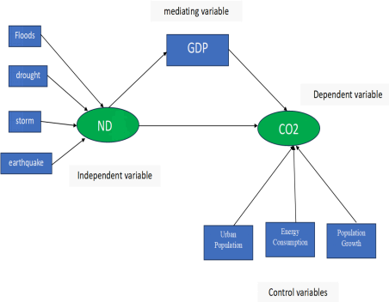
direct impact on CO₂. We used a three control variables that have been connected to economic growth and carbon emissions: Energy consumption represented by EC, Urban Population represented by UP, and another control variable is population growth expresses as an annual percentage increase in the population. GDP acts as a mediator, determining whether natural catastrophes have a direct impact on carbon emissions.
Figure 3: The mediating influence of Economic Growth between Natural Disasters and Carbon Emissions

The data has been determined using a SEM model to quantify the direct and indirect associations between the specified variables (Gyimah et al., 2024; Kline, 2023; Sidhu et al., 2021). Previous study (N. Baig et al., 2018; Kasman & Duman, 2015; Wajahat et al., 2024) worked on energy consumption and urbanization in the analytical structure, and we provided the following definition for the multi-factor theoretical model of carbon emissions:
Direct impact of Natural Disasters on Economic Growth
GDPt = β01 + β11 + β21ECt + β31UPt + β41PGt + ε1t
Direct impact of Natural Disasters on Carbon Emissions
Carbt = β02 + β12+ β22ECt + β32UPt + β42PGt + ε2t Direct impact of Economic Growth on Carbon Emissions
Carbt = β03 + β13GDPt + β23ECt + β33UPt + β43PGt + ε3t
The addition of GDP in the model mitigates the impact of Natural Disasters on Carbon Emissions. If so, GDP serves as a mediator
Carbt = β04 + β14 + β24GDPt + β34ECt + β44UPt + β54PGt + ε4t

Carbt = β0 + (β12 + β24 ∗β11) + (β22ECt+β32UPt+β42PGt) + ϵt
The coefficient β0 is the intercept, β12 represents the direct effect of natural catastrophes on carbon emissions. While the coefficient β24∗β11 reflect the indirect impact of natural disasters on carbon emissions through economic growth. Where coefficient β11 represents the impact of natural disasters on economic growth and coefficient β24 represents the impact of economic growth on carbon emissions. Additionally, τ represents various natural disasters, including earthquakes, droughts, floods, and storms. Each type of disaster has a different impact on GDP and carbon emissions.
In this article we created an econometric model with natural disasters, economic growth, and carbon emissions, utilized SEM through partial least square that measure direct and indirect relationship between variables. The model has been tested for reliability, accuracy and predictive power using the following techniques: Path analysis was utilized to evaluate the relationship between variables and their hypotheses through bootstrap method was used to determine the path coefficient significance.
Weights and loadings technique were computed to ascertain the impact and correlation of variables in composite term. Variance Inflation Factor (VIF) evaluates how strongly the independent variables in a regression analysis are correlated. This correlation is known as multicollinearity, and it can pose issues with regression models. A Cohen’s effect size for comparing two means which size indicates into three different kinds: small (f2= 0.2), medium (f2= 0.5), and large (f2= 0.8), whereas the coefficient of determination (R2) is a value that ranges from 0 to 1 and indicates how accurately a statistical model estimates a result. Another method was used to evaluate the SEM through Construct cross-validated redundancy examined (Q²) in PLS assesses the predictive relevance of the model whereas the Communality Index evaluated how much one variable is explained by all the factors and the common variation among variables. All of these techniques provide a detailed review of the structural model. This study also employs descriptive statistics to understand and summarize important elements of data, such as variability, central tendency, and distribution.

Results and Discussion

Descriptive Statistics
The summary statistics in Table 1 offer a quantitative insight into the relationship between environmental, economic, and demographic trends over the observed period of 43 years. Carbon emissions is measured in million tonnes, minimum of 31.93 million tonnes to a maximum of 223.45 million tonnes, with an average of 115.95 million tonnes and a standard deviation of 57.10 million

tonnes, reflecting moderate variability in emissions. This variability suggests fluctuations in industrial activity and energy consumption over time. Natural disaster economic losses, expressed in billion US dollars, vary from $0.00 billion to $15.02 billion, with an average of $0.84 billion and a standard deviation of $2.42 billion. While the mean loss is relatively low, the high standard deviation indicates that certain years experienced significant financial impacts from extreme events.The data on GDP, reported in current US dollars expressed in billion US$, highlights a considerable range from $23.65 billion to $374.79 billion, with an average of $142.99 billion and a standard deviation of $115.33 billion. This suggests a substantial economic growth trend over time, though with variability due to economic fluctuations. Energy consumption per capita, measured in kilowatt-hours (KWh), shows values ranging from 1,919.39 KWh to 4,683.58 KWh, with a mean of 3,234.34 KWh and a standard deviation of 748.35 KWh, reflecting moderate differences in energy access and usage over the years. Urbanization trends reveal that the urban population percentage ranges from 28.07% to 37.73%, with an average of 33.02% and a relatively low standard deviation of 2.80%, indicating a steady, gradual increase in urbanization. Similarly, population growth rates vary between 1.20% and 4.42%, with a mean of 2.59% and a standard deviation of 0.83%, showing consistent annual growth with minor fluctuations. These trends collectively highlight the interplay between economic growth, environmental pressures, and demographic changes, providing a comprehensive understanding of the dynamics shaping development during the studied period.
Table 1: Descriptive Statistic

Variables | N | Minimum | Maximum | Mean | Std.  Deviation
CO₂  (Million Tonnes) | 43 | 31.93 | 223.45 | 115.95 | 57.10
Economic Loss from  Natural Disasters (billion US$) | 43 | 0.00 | 15.02 | 0.84 | 2.42
GDP  (Current billion US$) | 43 | 23.65 | 374.79 | 142.99 | 115.33
Energy Consumption  (KWh/person) | 43 | 1919.39 | 4683.58 | 3234.34 | 748.35

Urban Population  ( % of total population) | 43 | 28.07 | 37.73 | 33.02 | 2.80
Population Growth (Annual %) | 43 | 1.20 | 4.42 | 2.59 | 0.83
Considering that in the model, each of the variables CO₂, GDP, and the control variables (Energy Consumption, Population Growth, and Urban Population) has only one indicator, they are not considered latent variables. Therefore, criteria related to latent variables, such as AVE, CR, rho, and Cronbach's alpha, are not evaluated for them (Kamranfar, 2023). In such cases, all obtained values for these indicators are equal to 1.In structural equation modeling, when a variable is considered as a composite variable, reliability and validity indicators are typically not assessed. This is due to the composite nature of these variables, which are formed from multiple indicators and are evaluated as a whole rather than assessing each indicator individually (Haji- Othman, 2022). In this study, the variable is treated as a composite variable; hence, reliability and validity indicators are not evaluated for it. Therefore, considering that the research model does not include any multi-indicator reflective constructs and only has one composite construct and the rest are single item convergent validity, constructs, discriminant validity, and reliability criteria are not assessed for them.

Evaluation of the significance of indicators
In structural equation modeling when the weights of indicators inside composite constructs are insignificant and their loadings are significant, the indicator is not removed due to the importance of loadings in suggesting a strong relationship between the indicator and the construct while the weight has no direct effect on the overall model. This technique assist in preserving the models accuracy and validity (Hardin, 2011; Libório, 2024). A strong loading suggests the indicator is very closely related to the construct and will provide useful information about it. Therefore, maintaining the indicator can increase the validity and accuracy of the model (Giuseppe, 2005). The findings of examining the weights and loadings for the indicators connected to the variable are given in the following table:
Table 2: Weights and loadings of composite variable indicators are evaluated for its significance

Structure | Indicator | Weights |  |  |  | Loadings
Structure | Indicator | Estimate | STDEV | t- Statistic | P  Value | Estimate | STDEV | t- Statistic | P  Value
 | Droughts | 0.233 | 0.159 | 1.459 | 0.146 | 0.758 | 0.077 | 9.911 | 0.000

 | Earthquak  e | 0.196 | 0.255 | 0.768 | 0.443 | 0.784 | 0.069 | 11.420 | 0.000
 | Floods | 0.446 | 0.100 | 4.465 | 0.000 | 0.606 | 0.105 | 5.798 | 0.000
 | Storm | 0.473 | 0.184 | 2.568 | 0.011 | 0.846 | 0.064 | 13.302 | 0.000
The model uses statistical weights and loadings for evaluating the relationship between natural disasters and their primary variables. In this table shows that storms are the most significant indicator with the loading (0.846) and weight (0.473) by the p-values of 0.000 for loading and 0.011 for weight, showing their value as well as statistical significance in analyzing the concept of natural disasters. Floods also a significant impact with a weight of 0.446 and a loading of 0.606, both statistically significant (p-value = 0.000). These results suggest that the most significant indicators in the model are floods and storms. On the other hand, earthquakes and droughts contribute less to the model. Although droughts have a moderate weight of 0.233, the p-value is 0.146, meaning that it is not statistically significant. However, their loading is relatively strong (0.758), indicating that droughts are still relevant in capturing the concept of natural disasters. Similarly, earthquakes have a lower weight (0.196), which is not statistically significant (p-value = 0.443), but their loading (0.784) is significant and highlights their importance in the broader framework. Overall, the model emphasizes that while all indicators are relevant, storms and floods are the most critical factors in understanding the impact of natural disasters. As observed, all indicators of the variable are significant in terms of loadings, even though the weights of two indicators are not significant. These two indicators can still be retained in the model.

Evaluation of the VIF Indicator
In structural equation modeling (SEM), the Variance Inflation Factor (VIF) is used to evaluate multicollinearity among predictor variables. An accepted threshold for VIF is a value of 10. Values exceeding this threshold indicate problematic multicollinearity, which can distort the model's results (Sahu, 2019; Kalnins, 2023; Jung, 2015). The VIF results are presented in the table below: Table 3: Evaluation of the VIF (Variance Inflation Factor)
Variables | VIF
CO₂ | 1.00
Floods | 1.33
Droughts | 2.56

Storm | 4.36
Earthquake | 6.56
GDP | 1.00
Energy Consumption | 1.00
Urban Population | 1.00
Population growth | 1.00
The Variance Inflation Factor (VIF) results help us determine how much overlap exists between the model's independent variables. A VIF near to 1 indicates no overlap, whereas a value greater than 10 suggests high similarities between variables, which may make the results less reliable. In this case, variables such as CO₂, GDP, Energy Consumption, Urban Population, and Population Growth all have VIF values of one, indicating that there is no overlap and that these variables contribute independently to the model. Floods (1.33), droughts (2.56), and storms (4.36) all have low to moderate overlap, which is acceptable and unlikely to impact the model. However, the Earthquake variable has a VIF of 6.56, showing an increased level of a similarity to other disaster-related variables such as floods or storms. While not significantly high, it does indicate some data overlap.

Structural model
In Figures 4 and 5, the numbers on the arrows between the factors show the importance of the path relationships between the variables based on the path coefficients and t-statistic values. Paths with a t-statistic value less than 1.96 are considered non-significant.

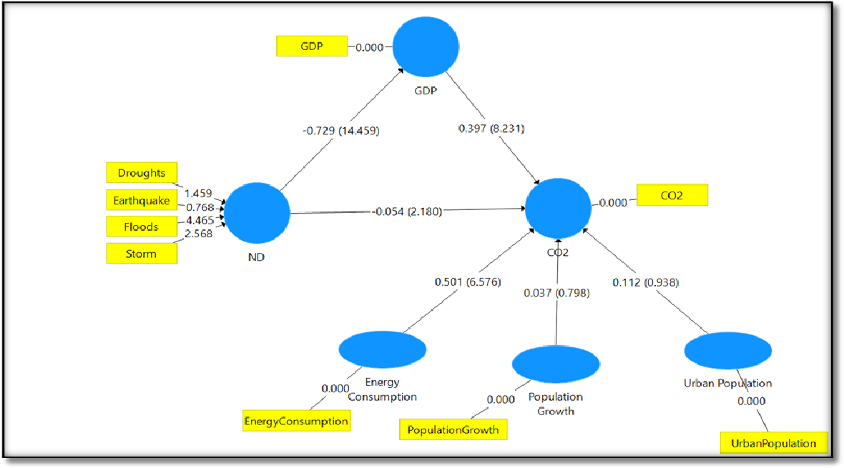
Figure 4: The structural model with path coefficients (on the arrows) and t-statistic values (in parentheses). In Figure 4, the relationships between natural disasters (), economic growth (GDP), carbon emissions (CO₂), and other influencing factors are illustrated using path coefficients and t-statistic values. The paths help in understanding the strength and statistical significance of each relationship. Natural Disasters () exhibit a strong and significant negative relationship with GDP, as indicated by path coefficient of -0.729 and an extremely significant t-statistic of 14.459. This suggests that natural disasters, particularly floods and storms, cause a major reduction in economic output. Meanwhile, GDP has a positive and significant effect on CO₂ emissions, with a path coefficient of
0.397 and t-statistic of 8.231, emphasizing the role of economic activities in heavy emissions.
The direct relationship between and CO₂ emissions is weakly negative (-0.054) but statistically significant (t = 2.180). This could indicate that disruptions in industrial and energy-related activities during disasters slightly reduce emissions.
Looking at the factors influencing CO₂ emissions, energy consumption emerges as a major driver with a strong path coefficient of 0.50 and a highly significant t-statistic of 6.576, showing that higher energy usage directly increases CO₂ emissions. However, both population growth (0.037, t
= 0.798) and urban population (0.112, t = 0.938) have weak and statistically insignificant effects, implying their minimal role in CO₂ emissions within this model.
The indicators that define the variable show that floods (t = 4.465) and storms (t = 2.568) are the most significant contributors to the natural disaster construct. In contrast, droughts (t = 1.459) and earthquakes (t = 0.768) are less impactful in shaping. As seen in the structural model, the paths with t-statistic values larger than 1.96 are considered significant at the 95% confidence level.


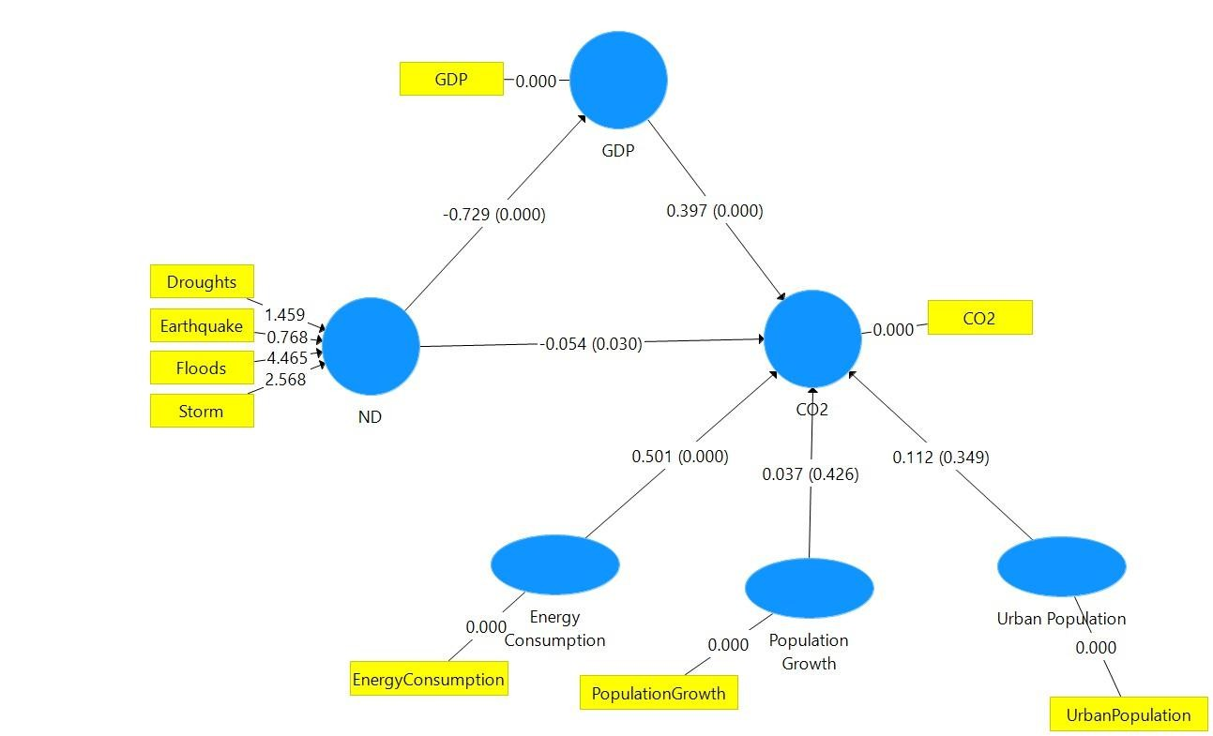
Figure 5: Structural model with path coefficients (on the arrows) and p-values (in parentheses). In Figure 5, the relationships between the same variables remain similar, but the significance of the relationships shifts slightly when evaluated using p-values (in parentheses). The relationship between natural disasters and GDP remains strongly negative, using a path coefficient of -0.729, but its p-value (0.000) indicates strong statistical significance. Similarly, GDP has a positive and significant effect on CO₂ (path coefficient = 0.397, p-value = 0.000), reinforcing the connection between economic development and environmental degradation. However, the direct relationship between natural disasters () and CO₂ emissions weakens in this model, with a path coefficient of - 0.054 and a p- value of 0.030. While still statistically significant, this suggests a smaller but measurable reduction in emissions during disaster-related disruptions. The energy consumption factor continues to be the most significant driver of CO₂ emissions, with a path coefficient of 0.501 and a p-value of 0.000. This reinforces the role of energy use, particularly from non-renewable sources, in contributing to emissions. Conversely, population growth (0.037, p = 0.426) and urban population (0.112, p = 0.349) remain weak and statistically insignificant, confirming their minimal impact on CO₂ emissions. For indicators, the findings remain consistent, with floods and storms emerging as the most significant contributors to the construct. Floods have a strong effect (t
= 4.465), while storms show moderate significance (t = 2.568). On the other hand, droughts (t = 1.459) and earthquake (t = 0.768) are non-significant indicators. As seen in the Figure 5, the paths with p-values of less than 0.05 are considered significant at the 95% confidence level.
Both diagrams show consistent results regarding the strong negative effect of natural disasters on GDP and the positive relationship between GDP and CO₂ emissions. Energy consumption remains

the dominant driver of emissions, while population growth and urbanization have negligible impacts. The relationship between natural catastrophes and carbon emissions, though weak, reflects slight reductions during disaster-related disruptions. Among natural disaster indicators, floods and storms are the most impactful, while droughts and earthquakes have less influence.
The key difference between the two figures lies in the statistical evaluation: Figure 4 uses t-statistics to determine significance, while Figure 5 presents p-values, refining the interpretation of relationships and their reliability.
The table below presents the results of the direct and indirect path coefficients, along with their significance:
Table 4: Direct and Indirect paths examined in the model and their significance

Path | Path Coefficient | STDEV | t-Statistic | P value
-> GDP | -0.729 | 0.050 | 14.459 | 0.000
-> CO₂ | -0.054 | 0.025 | 2.180 | 0.030
GDP -> CO₂ | 0.397 | 0.048 | 8.231 | 0.000
-> GDP -> CO₂ | -0.289 | 0.042 | 6.888 | 0.000
Energy Consumption -> CO₂ | 0.501 | 0.076 | 6.576 | 0.000
Urban Population -> CO₂ | 0.112 | 0.120 | 0.938 | 0.349
Population Growth -> CO₂ | 0.037 | 0.046 | 0.798 | 0.426
The results of the structural equation model (Table 4) indicate a significant negative direct effect of on GDP (path coefficient = -0.729, p < .001), and slightly decreasing carbon emissions (path coefficient = -0.054, p < .001), likely due to temporary disruptions in industrial activity, while a significant positive direct effect of GDP on CO₂ emissions (path coefficient = 0.397, p < .001). Additionally the indirect effect of on CO₂ emissions through GDP is also significant and negative (path coefficient = -0.289, p < .001). Furthermore, a significant positive direct effect of Energy Consumption on CO₂ emissions (path coefficient = 0.501, p < .001) and direct effects of Population Growth and Urban Population on CO₂ emissions are not significant.

Structural Model Evaluation
In this section, the structural model will be examined and evaluated using various criteria.

Coefficient of Determination (R²)
The coefficient of determination indicates the explanatory power of the model. Based on the model's results, 53.1% of the variation in GDP is explained by , while 99.3% of the variation in CO₂ is explained by GDP, , and the control variables (Table 5). Figure 6 also displays the coefficients

of determination (inside the circles) and Cohen's effect size (on the arrows). Table 5: Coefficient of Determination in the Model
R Square
CO₂ | 0.99
GDP | 0.53
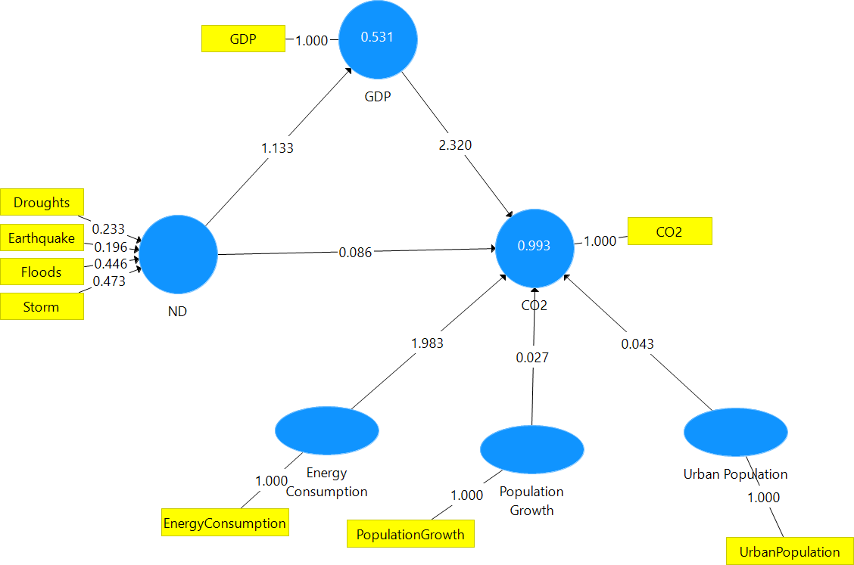
Figure 6: Structural model displaying the coefficients of determination (inside the circles) and Cohen's effect size (on the arrows).
The structural model in Figure 6 shows how, GDP, and CO₂ emissions are connected, along with factors like energy consumption, population growth, and urban population. The model explains 53.1% of the variation in GDP, highlighting the significant disruption caused by natural disasters on economic performance. Interestingly, GDP has a strong positive impact on CO₂ (2.320), indicating that as the economy develops, emissions increase due to energy consumption and industrial activity.
Natural disasters have a smaller impact on CO₂ (0.086), likely reflecting disruptions during disasters followed by recovery-related emissions. Energy consumption plays a critical role in driving CO₂ emissions, with a notable effect size of 1.983, while population growth (0.027) and urbanization (0.043) have minimal effects. Overall, the model effectively explains 99.3% of the variation in CO₂ emissions, showing that GDP growth and energy use are key contributors, while natural disasters add a modest influence.

Evaluation of Cohen’s effect size
Cohen's effect size can be seen on the arrows in Figure 6 Represent the values of small (0.02), medium (0.15), and large (0.35) effects respectively (Hiro et al., 2021). The Cohen's effect size table shows how much each independent variable has influenced the dependent variable. In this table, the f-square value has been calculated for each relationship.
Table 6: Cohen’s effect size in the model

f Square
  -> GDP | 1.133
-> CO₂ | 0.086
GDP -> CO₂ | 2.320
Energy Consumption -> CO₂ | 1.983
Urban Population-> CO₂ | 0.043
Population Growth -> CO₂ | 0.027
The results (Table 6) indicate that the path from to GDP (f² = 1.133), the paths from Energy Consumption to CO₂ (f² = 1.983) and from GDP to CO₂ (f² = 2.320) have large effect sizes, suggesting a strong relationship between these variables. However, the paths from ND to CO2 (f² = 0.086), Urban Population to CO₂ (f² = 0.043), and Population Growth to CO₂ (f² = 0.027) have small effect sizes, indicating a weak relationship between these variables.

Construct cross-validated redundancy
Another method for evaluating the structural model is called constructs cross- validated Redundancy. This indicator shows the model's ability to predict endogenous variables, which was measured by the Stone-Geisser criterion. If the value of this indicator is greater than zero, it indicates the existence of analytical relationship between the items of the corresponding factor. The values of small (0.02), medium (0.15), and large (0.35) redundancy, respectively.
Table 7: Predictive ability of endogenous variables in the model

 | SSO | SSE | Q² (=1-SSE/SSO)
CO₂ | 43 | 2.6037 | 0.9394

GDP | 43 | 21.3082 | 0.5045
Table 7 highlights the predictive ability of the model using Q² values. A Q² value greater than zero confirms the existence of a predictive relationship between the factors. For CO₂, the Q² value is 0.9394, which indicates a strong predictive ability. Similarly, for GDP, the Q² value is 0.5045, which also falls within the range of strong predictive accuracy. According to the thresholds (small
= 0.02, medium = 0.15, and large = 0.35), both CO₂ and GDP demonstrate large predictive ability, suggesting that the model reliably predicts these variables. Based on Table 6, the predictive ability of the model for CO₂ and GDP is at a large level.

Communality Index
The model's predictive power was evaluated using the communality index alongside construct cross-validated communality.
Table 8: Communality with cross-validation for factors in the model

 | SSO | SSE | Q² (=1-SSE/SSO)
CO₂ | 43 |  | 1
 | 172 | 121.9387 | 0.2911
GDP | 43 |  | 1
Energy Consumption | 43 |  | 1
Urban Population | 43 |  | 1
Population Growth | 43 |  | 1
Table 8 further evaluates the model’s predictive power using the communality index alongside cross-validated communality. A positive Q² value confirms the predictive relevance of each factor. For CO₂, GDP, energy consumption, urban population, and population growth, the Q2 values are 1, showing perfect predictive power. In contrast, for natural disasters (), the Q2 value is 0.2911, which indicates a moderate level of predictive ability.

Hypotheses Assessment
Hypothesis testing was conducted to explore direct and mediated relationships among the variables. This involved decomposing total effects into direct and indirect effects, allowing a detailed understanding of the pathways through which variables interact. This technique provided precision in verifying the relationships hypothesized in the research.

H1: Natural Disasters have a significant negative effect on Economic Growth in Pakistan.
Table 9: The statistical output of the first hypothesis

Path | Path Coefficient | STDEV | t-Statistic | P value
-> GDP | -0.729 | 0.050 | 14.459 | 0.000
As shown in Table 9, the path coefficient from the natural disasters (ND) variable to the GDP variable is -0.729, with a very high t-statistic value of 14.459 and a p-value less than 0.001. These results indicate that the relationship among natural disasters and economic growth in Pakistan is negative and statistically significant. In other words, a rise in the occurrence of natural catastrophes leads to a significant decrease in economic growth in Pakistan. Therefore, the first hypothesis is confirmed at the 95% confidence level.

H2: Natural Disasters have a significant effect on Carbon Emissions in Pakistan.
Table 10: The statistical output of the second hypothesis

Path | Path Coefficient | STDEV | t-Statistic | P value
-> CO₂ | -0.054 | 0.025 | 2.180 | 0.030
As shown in the results of Table 10, the path coefficient from the natural disasters () variable to the carbon emissions (CO₂) variable is -0.054, with a t-statistic value of 2.180 and a p-value of
0.030. These results show that the correlation between natural disasters and carbon emissions in Pakistan is negative and statistically significant at the 0.05 level. In other words, an increase in the occurrence of natural disasters leads to a slight reduction in carbon emissions in Pakistan. Therefore, the second hypothesis is confirmed at the 95% confidence level.

H3: Economic Growth has a significant positive effect on Carbon Emissions in Pakistan.
Table 11: The statistical output of the third hypothesis

Path | Path Coefficient | STDEV | t-Statistic | P value
GDP -> CO₂ | 0.397 | 0.048 | 8.231 | 0.000
As shown in the results Table 11, the path coefficient from the GDP variable to the carbon emissions (CO₂) variable is 0.397, with a very high t-statistic value of 8.231 and a p-value less than 0.001. These results show that the relationship between economic growth and carbon emissions in Pakistan is positive and statistically significant. In other words, an increase in economic growth leads to a significant rise in carbon emissions in Pakistan. Therefore, the third hypothesis is confirmed at the 95% confidence level.

H4: Economic Growth is predicted to act as mediator between Natural Disasters and Carbon Emissions in Pakistan.
Table 12: The statistical output of the forth hypothesis

Path | Path Coefficient | STDEV | t-Statistic | P value
-> GDP -> CO₂ | -0.289 | 0.042 | 6.888 | 0.000
As shown in the results of Table 12, the path coefficient from the natural disasters (ND) variable to carbon emissions (CO₂) through the Gross Domestic Product (GDP) variable is -0.289, with a very high t-statistic value of 6.888 and p-value less than 0.001. These results indicate that the relationship between natural catastrophes and CO2 in Pakistan is mediated by economic growth, and this relationship is negative and highly significant. In other words, a rise in the occurrence of natural catastrophes leads to a decrease in economic growth, which in turn indirectly causes a reduction in carbon emissions. Therefore, the fourth hypothesis is confirmed at the 95% confidence level.

H5: Energy Consumption has a significant positive impact on Carbon Emissions in Pakistan.
Table 13: The statistical output of the fifth hypothesis

Path | Path Coefficient | STDEV | t-Statistic | P value
Energy Consumption -> CO₂ | 0.501 | 0.076 | 6.576 | 0.000
As shown in the results of Table 13, the path coefficient from energy consumption to carbon emissions (CO₂) is 0.501, with a very high t-statistic value of 6.576 and a p- value less than 0.001. These results indicate that the correlation between energy consumption and CO2 in Pakistan is positive and highly significant. The path coefficient of 0.501 suggests that a one-unit increase in energy consumption leads to a 0.501 unit increase in carbon emissions, holding other factors constant. This strong positive relationship is statistically significant at the 95% confidence level, as a result, the sixth hypothesis is confirmed at the 95% confidence level.

H6: Urban Population has a significant positive impact on Carbon Emissions in Pakistan.
Table 14: The statistical output of the sixth hypothesis

Path | Path Coefficient | STDEV | t-Statistic | P value
Urban Population -> CO2 | 0.112 | 0.120 | 0.938 | 0.349
As shown in the results of Table 14, the path coefficient from the urban population variable to carbon emissions (CO₂) is 0.112, with a t-statistic value of 0.938 and a p- value of 0.349. These results indicate that the relationship between urban population and carbon emissions in Pakistan is not statistically significant at the 95% confidence level. While the path coefficient suggests a

positive relationship, the high p-value and low t-statistic indicate that this effect is not significant. Therefore, the fifth hypothesis is rejected.

H7: Population Growth has a significant positive effect on carbon emissions in Pakistan.
Table 15: The statistical output of the seventh hypothesis

Path | Path Coefficient | STDEV | t-Statistic | P value
Population Growth -> CO₂ | 0.037 | 0.046 | 0.798 | 0.426
As shown in the results of Table 15, the path coefficient from population growth to carbon emissions (CO₂) is 0.037, with a t-statistic value of 0.798 and a p-value of 0.426. These results indicate that while there is a slight positive relationship between population growth and carbon emissions in Pakistan, this relationship is not statistically significant. The low t-statistic value and high p-value (well above the conventional 0.05 threshold) suggest that we cannot reject the null hypothesis. Although the path coefficient displays a positive direction (0.037), the connection is too weak to be considered meaningful. Therefore, the seventh hypothesis is rejected at the 95% confidence level.

Conclusion and Policy Implications
Pakistan’s a developing nation, is committed to achieving economic expansion. While economic expansion is vital at this time, Pakistan must also consider the environmental effects associated with this growth. In this study, we evaluated time series data for Pakistan from 1980 to 2022 using Structural Equation Modeling (SEM), which included factors such as energy consumption, urbanization, and population increase. The augmented path analysis with a bootstrap technique indicating natural disasters (ND) had a strong negative effect on GDP and had a small but statistically significant negative effect on carbon emissions. GDP is a significant mediator, had a positive effect on CO₂ indicating a strong relation between economic development and carbon emissions. The findings contribute to theories such as Environmental Kuznets Curve (EKC) by representing the eco-friendly costs of economic growth in developing nations. Moreover, using SEM evaluation of direct impacts, energy consumption was shown to be the most significant contributor to CO₂ emissions, with a high positive effect. Urban Population and population growth had no direct effect and showed a week and statistically insignificant impact on CO₂ emissions. These weak effects identified through SEM. This study investigated that natural disasters indirectly decreased carbon dioxide by negatively impacting GDP, as showed by the significant indirect path ND⭢GDP⭢ CO₂ = -0.289. This relationship indicated the mediating role of economic growth,

natural disasters have a short term negative impact on growth and carbon emissions, while depending on growth driven recovery solutions increases long term carbon emissions. Additional tests were conducted to establish the models reliability. The variance inflation factor (VIF) proved that no evidence of multicollinearity, and the coefficient of determination (R²) showed the models predictive ability for GDP and CO₂ emissions. Cohen’s effect size measured the impact of independent variables, whereas prediction validity (Q²) determined the models correctness. The most important contributors to ND variables were storms and floods. Droughts and earthquakes had lower weight and insignificant p-values, but their substantial loadings highlighted their importance for developing the overall ND variable.
Based on this research and data, Pakistan can implement a variety of practical efforts to solve the issues of natural catastrophes, economic development and carbon emissions. Pakistan must invest in strong catastrophe-resistant infrastructure to mitigate damage due to natural disasters. Improve early warning systems and disaster awareness and management planes. Modernizing Pakistan’s power distribution network will reduce energy waste and need on fossil fuels, resulting in lower carbon emissions. The government should provide incentives for household’s and firms to use renewable energy such as wind and solar power. Manufactures in the industrial sector should be required to install devices such as catalytic converters in order to reduce harmful emissions. Industries should be encouraged to use cleaner, more effective methods of production. However, Pakistan must invest in disaster-resilient infrastructure and develop green recovery plans. This includes using renewable energy sources and implementing eco- friendly technologies during the reconstruction phase in order to prevent the rebound impact of emissions. Moreover, it is important to separate economic progress from environmental damage by encouraging energy efficiency, fostering technical innovation, and implementing stronger environmental rules.
FUNDING
No funding received.
ACKNOWLEDGMENT
The authors would like to extend their sincere appreciation to all the respondents for their time
AUTHORS CONTRIBUTIONS
Z.Z. and F.R. conceived the study design and research objectives. S.K. and Z.Z. collected the data. MM performed data analysis. M.M. and N.A.N. contributed to the interpretation of results. S.K. prepared the figures. Z.Z. and M.M.A. writing—review and editing. All authors have read and agreed to the published version of the manuscript.
DATA AVAILABILITY STATEMENT:
All the raw data in this research can be obtained from the corresponding authors upon reasonable request.
ETHICAL CONSIDERATIONS
Not applicable
Consent for publication
Not applicable.
Clinical trial number
Not applicable.
Statement on guidelines
All experimental studies and experimental materials involved in this research are in full compliance with relevant institutional, national, and international guidelines and legislation.
Competing interests
The authors stated that they had no interest which might be perceived as posing a conflict or bias.

References
Acheampong, A. O. (2018). Economic growth, CO2 emissions and energy consumption: what causes what and where?. Energy economics, 74, 677-692.
Adhikari, R., Niroula, B., & Singh, S. K. (2024). Navigating Nepal's Economic Growth and Carbon Emissions: Insights into the Environmental Kuznets Curve (EKC). Nature Environment & Pollution Technology, 23(3).
Aftab, S., Ahmed, A., Chandio, A. A., Korankye, B. A., Ali, A., & Fang, W. (2021). Modeling the nexus between carbon emissions, energy consumption, and economic progress in Pakistan: Evidence from cointegration and causality analysis. Energy Reports, 7, 4642-4658.
Ahmad, M. (2023). A Transformative Framework for the Water Sector. In Water Policy in Pakistan: Issues and Options (pp. 433-457). Cham: Springer International Publishing.
Amusa, K., & Leshoro, T. L. (2013). The relationship between electricity consumption and economic growth in Botswana. Corporate ownership & control, 10(4), 401-406.
Azzarri, C., & Signorelli, S. (2020). Climate and poverty in Africa South of the Sahara. World development, 125, 104691.
Baez, J., De la Fuente, A., & Santos, I. (2010). Do natural disasters affect human capital? An assessment based on existing empirical evidence (No. 5164). IZA Discussion Papers.
Baig, Khan, S., Gilal, N. G., & Qayyum, A. (2018). Do natural disasters cause economic growth? An ARDL bound testing approach. Studies in Business and Economics, 13(1), 5-20.
Baig, M. A., & Baig, M. A. (2014). Impact of CO 2 emissions: evidence from Pakistan. Pakistan Business Review (PBR) Volume, 16(4).
Baig, Rehman, M. U., & Janjua, N. N. (2021). District-level disaster risk and vulnerability in the Northern mountains of Pakistan. Geomatics, Natural Hazards and Risk, 12(1), 2002-2022.
Beatley, T. (2012). Planning for coastal resilience: Best practices for calamitous times. Island Press.
Bhatt, D., Mall, R. K., & Banerjee, T. (2015). Climate change, climate extremes and disaster risk reduction: Stéphane Hallegatte: Natural disasters and climate change: an economic perspective. Springer International Publishing, DOI: 10.1007/978-3-319-08933-1, ISBN: 978-3-319-08932-4.
Bindoff, N. L., Stott, P. A., AchutaRao, K. M., Allen, M. R., Gillett, N., Gutzler, D., ... & Zhang, R. (2014). Detection and attribution of climate change: from global to regional. Climate change 2013: the physical science basis.
Brandmaier, A. M., von Oertzen, T., McArdle, J. J., & Lindenberger, U. (2013). Structural equation model trees. Psychological methods, 18(1), 71.
Bui, A. T., Dungey, M., Nguyen, C. V., & Pham, T. P. (2014). The impact of natural disasters on household income, expenditure, poverty and inequality: evidence from Vietnam. Applied Economics, 46(15), 1751-1766.
Cao, M., Xu, Y., Sun, Y., & Cang, D. (2023). Natural disasters, economic growth, and carbon emissions: empirical analysis of Chinese data based on a nonlinear auto- regressive distributed lag model. Sustainability, 15(21), 15210.
Capps, K. A., Bentsen, C. N., & Ramírez, A. (2016). Poverty, urbanization, and environmental degradation: urban streams in the developing world. Freshwater Science, 35(1), 429-435.
Carleton, T. A., & Hsiang, S. M. (2016). Social and economic impacts of climate. Science, 353(6304), aad9837.
Cavallo, E. A., Becerra, O., & Acevedo, L. (2022). The impact of natural disasters on economic growth. In Handbook on the economics of disasters (pp. 150-192). Edward Elgar Publishing.
Chhibber, A., & Laajaj, R. (2013). The interlinkages between natural disasters and economic development. The economic impacts of natural disasters, 28-56.
Dominković, D. F., Bačeković, I., Pedersen, A. S., & Krajačić, G. (2018). The future of transportation in sustainable energy systems: Opportunities and barriers in a clean energy transition. Renewable and Sustainable Energy Reviews, 82, 1823-1838.
Dou, Y., Shahbaz, M., Dong, K., & Dong, X. (2022). How natural disasters affect carbon emissions: the global case. Natural Hazards, 113(3), 1875-1901.
Ferguson, P., & Wollersheim, L. (2020). The World Bank’s resilience discourse: Reactive environmental norm diffusion and the crisis of global climate governance. In Rethinking Multilateralism in Foreign Aid (pp. 160-177). Routledge.
Fomby, T., Ikeda, Y., & Loayza, N. V. (2013). The growth aftermath of natural disasters. Journal of applied econometrics, 28(3), 412-434.
Fu, A. S. (2022). Risky cities: The physical and fiscal nature of disaster capitalism. Rutgers University Press.
Furtak, K., & Wolińska, A. (2023). The impact of extreme weather events as a consequence of climate change on the soil moisture and on the quality of the soil environment and agriculture–A review. Catena, 231, 107378.
Gill, I. S., Revenga, A., & Zeballos, C. (2016). Grow, invest, insure: A game plan to end extreme poverty by 2030. World Bank Policy Research Working Paper, (7892).
Gyimah, J., Batasuma, S., Yao, X., & Wauk, G. (2024). RETRACTED: The adoption of renewable energy towards environmental sustainability: Evidence from Partial Least Square Structural Equation Modelling (PLS-SEM). PLoS One, 19(4), e0299727.
Haddad, B. M., & Solomon, B. D. (Eds.). (2023). Dictionary of ecological economics: terms for the new millennium. Edward Elgar Publishing.
Hallegatte, S., Rentschler, J., & Walsh, B. (2018). Building back better: achieving resilience through stronger, faster, and more inclusive post-disaster reconstruction.
Hanif, I., Raza, S. M. F., Gago-de-Santos, P., & Abbas, Q. (2019). Fossil fuels, foreign direct investment, and economic growth have triggered CO2 emissions in emerging Asian economies: some empirical evidence. Energy, 171, 493-501.
Haque, M. A., Raza Shah, S. M., & Arshad, M. U. (2022). Sustainable economic growth and FDI inflow: A comparative panel econometric analysis of low-income and middle-income nations. Sustainability, 14(21), 14321.
Henriques, M. (2024). Climate change: The 1.5 C threshold explained. BBC Future, 8.
Hidalgo, J., & Baez, A. A. (2019). Natural disasters. Critical care clinics, 35(4), 591-607.
Igini, M. (2024). pressing environmental issues in Pakistan in 2024. Earth. Org. https://earth. org/elections-2024-pakistans-next-government-faces-pressing-environmental-issues.
JS, N., Kushwaha, A. P., Singh, R., Malik, I., Vegad, U., Dangar, S., ... & Mishra, V. (2022, December). The Pakistan flood of august 2022: causes and implications. In AGU Fall Meeting Abstracts (Vol. 2022, pp. U23D-05).
Kamranfar, S., Damirchi, F., Pourvaziri, M., Abdunabi Xalikovich, P., Mahmoudkelayeh, S., Moezzi, R., & Vadiee, A. (2023). A partial least squares structural equation modelling analysis of the primary barriers to sustainable construction in Iran. Sustainability, 15(18), 13762.
Kamranfar, S., Damirchi, F., Pourvaziri, M., Abdunabi Xalikovich, P., Mahmoudkelayeh, S., Moezzi, R., & Vadiee, A. (2023). A partial least squares structural equation modelling analysis of the primary barriers to sustainable construction in Iran. Sustainability, 15(18), 13762.
Karim, A., & Noy, I. (2016). Poverty and natural disasters—a qualitative survey of the empirical literature. The Singapore Economic Review, 61(01), 1640001.
Khan, Anwar, S., Sarkodie, S. A., Yaseen, M. R., & Nadeem, A. M. (2023). Do natural disasters affect economic growth? The role of human capital, foreign direct investment, and infrastructure dynamics. Heliyon, 9(1).
Khan, H. (2017). Improving Pakistan’s fiscal resilience to natural disasters. World Bank blog. https://blogs. worldbank. org/endpovertyinsouthasia/improving-pakistan-sfiscal-resilience-natural-disasters.
Khan, K. A., Zaman, K., Shoukry, A. M., Sharkawy, A., Gani, S., Ahmad, J., ... & Hishan, S. S. (2019). Natural disasters and economic losses: controlling external migration, energy and environmental resources, water demand, and financial development for global prosperity. Environmental Science and Pollution Research, 26(14), 14287-14299.
Khan, M. K., Khan, M. I., & Rehan, M. (2020). The relationship between energy consumption, economic growth and carbon dioxide emissions in Pakistan. Financial Innovation, 6(1), 1.
Kim, C. K. (2010). The effects of natural disasters on long-run economic growth (Doctoral dissertation).
Kline, R. B. (2023). Principles and practice of structural equation modeling. Guilford publications.
Knäble, D., de Quevedo Puente, E., Pérez-Cornejo, C., & Baumgärtler, T. (2022). The impact of the circular economy on sustainable development: A European panel data approach. Sustainable Production and Consumption, 34, 233-243.
Lee, C.-C., Wang, C.-W., Ho, S.-J., & Wu, T.-P. (2021). The impact of natural disaster on energy consumption: International evidence. Energy Economics, 97, 105021.
Libório, M. P., Karagiannis, R., Diniz, A. M. A., Ekel, P. I., Vieira, D. A. G., & Ribeiro, L. C. (2024). The use of information entropy and expert opinion in maximizing the discriminating power of composite indicators. Entropy, 26(2), 143.
Lin, B., & Ullah, S. (2024). Modeling the impacts of changes in nuclear energy, natural gas, and coal in the environment through the novel DARDL approach. Energy, 287, 129572.
Loayza, N. V., Olaberria, E., Rigolini, J., & Christiaensen, L. (2012). Natural disasters and growth: Going beyond the averages. World Development, 40(7), 1317-1336.
Ma, Y., Feng, G. F., & Chang, C. P. (2024). From traditional innovation to green innovation: How an occurrence of natural disasters influences sustainable development?. Sustainable Development, 32(3), 2779-2796.
Mahmood, N., Wang, Z., & Hassan, S. T. (2019). Renewable energy, economic growth, human capital, and CO₂ emission: an empirical analysis. Environmental Science and Pollution Research, 26, 20619-20630.
Mako, W. P., Nabi, I., Mahmood, A., & Khan, S. (2022, May). Recent developments in climate finance: Implications for Pakistan. IGC.
Mann, M. E. (2023). Warming ends when carbon pollution stops. Frontiers in Science, 1, 1256273.
Mardani, A., Streimikiene, D., Nilashi, M., Arias Aranda, D., Loganathan, N., & Jusoh, (2018). Energy consumption, economic growth, and CO₂ emissions in G20 countries: application of adaptive neuro-fuzzy inference system. Energies, 11(10), 2771.
Mudakkar, S. R., Zaman, K., Khan, M. M., & Ahmad, M. (2013). Energy for economic growth, industrialization, environment and natural resources: living with just enough. Renewable and sustainable energy reviews, 25, 580-595.
Muhammad, S. S., Muhammad, Z., & Muhammad, S. (2011). Renewable and nonrenewable energy consumption, real GDP and CO2 emissions nexus: a structural VAR approach in Pakistan.
Mukherjee, S., & Hastak, M. (2018). A novel methodological approach to estimate the impact of natural hazard-induced disasters on country/region-level economic growth. International Journal of Disaster Risk Science, 9, 74-85.
Munda, G., & Nardo, M. (2005). Constructing consistent composite indicators: the issue of weights. EUR 21834 EN, 1-11.
Nathaniel, S., Barua, S., Hussain, H., & Adeleye, N. (2021). The determinants and interrelationship of carbon emissions and economic growth in African economies: fresh insights from static and dynamic models. Journal of Public Affairs, 21(1), e2141.
Noy, I. (2009). The macroeconomic consequences of disasters. Journal of Development economics, 88(2), 221-231.
Noy, I., & Nualsri, A. (2007). What do exogenous shocks tell us about growth theories?
Nunes, L. J. (2023). The rising threat of atmospheric CO2: a review on the causes, impacts, and mitigation strategies. Environments, 10(4), 66.
Nurrochmat, N. A., Hassan, N. U., Madnee, M., Husaain, H. S., Qanitha, M., Bronisz, K., ... & Sutrisno, S. (2024). Addressing Environmental Vulnerability: Land Cover Dynamics Assessment and Afforestation Strategies in Pakistan for Disaster Resilience. In BIO Web of Conferences (Vol. 123, p. 01021). EDP Sciences. https://doi.org/10.1051/bioconf/202412301021
Ogbeide-Osaretin, E. N. (2021). Analysing energy consumption and poverty reduction nexus in Nigeria. International Journal of Sustainable Energy, 40(5), 477-493.
Panwar, V., & Sen, S. (2019). Economic impact of natural disasters: An empirical re- examination. Margin: The Journal of Applied Economic Research, 13(1), 109- 139.
Qudrat-Ullah, H. (2022). A review and analysis of renewable energy policies and CO2 emissions of Pakistan. Energy, 238, 121849.
Rafique, M. Z., Li, Y., Larik, A. R., & Monaheng, M. P. (2020). The effects of FDI, technological innovation, and financial development on CO2 emissions: Evidence from the BRICS countries. Environmental Science and Pollution Research, 27, 23899-23913.
Rajak, J. (2021). A preliminary review on impact of climate change and our environment with reference to global warming. Int. J. Environ. Sci, 10, 11-14.
Rakshit, B. (2021). Impact of natural disasters on energy consumption: evidence from Indian states. Energy RESEARCH LETTERS, 2(3).
Raza, M. Y., & Tang, S. (2024). Nuclear energy, economic growth and CO2 emissions in Pakistan: Evidence from extended STRIPAT model. Nuclear Engineering and Technology.
Ren, F.-r., Tian, Z., Chen, H.-s., & Shen, Y.-t. (2021). Energy consumption, CO2 emissions, and agricultural disaster efficiency evaluation of China based on the two-stage dynamic DEA method. Environmental Science and Pollution Research, 28, 1901-1918.
Ronaghi, M., & Scorsone, E. (2023). The Impact of COVID-19 Outbreak on CO2 Emissions in the Ten Countries with the Highest Carbon Dioxide Emissions. Journal of Environmental and Public Health, 2023.
Sadia, B. (2013). Effects of disaster-related mortality on gross domestic product in Pakistan. International Journal of Ecology and Development, 24(1), 62-80.
Safeer, M., Zubair, M., Hussain, T., Khan, M. A., & Madnee, M. (2025). Climatic variability linkages with agroforestry adoption in Pakistan: a socio-ecological review. Agroforestry Systems, 99(8), 263. https://doi.org/10.1007/s10457-025-01359-6
Sajjad, H., & Ghaffar, A. (2019). Observed, simulated and projected extreme climate indices over Pakistan in changing climate. Theoretical and Applied Climatology, 137, 255-281.
Sardar, A., & Phil, M. (2015). Natural Disasters and Economic Growth in Pakistan: An Enquiry of Floods Related Fatalities’ Triad.
Sardar, A., Javed, S. A., & Amir-ud-Din, R. (2016). Natural disasters and economic growth in Pakistan: An enquiry into the floods related hazards’ triad. Islamabad: Pakistan Institute of Development Economics.
Searle, M. P., Robb, L. J., & Gardiner, N. J. (2016). Tectonic Processes and Metallogeny along the Tethyan Mountain Ranges of the Middle East and South Asia (Oman, Himalaya, Karakoram, Tibet, Myanmar, Thailand, Malaysia).
Seneviratne, S. I., Zhang, X., Adnan, M., Badi, W., Dereczynski, C., Luca, A. D., Ghosh, S., Iskandar, I., Kossin, J., & Lewis, S. (2021). Weather and climate extreme events in a changing climate.
Shabnam, N. (2014). Natural disasters and economic growth: A review. International Journal of Disaster Risk Science, 5, 157-163.
Shahbaz, M., Zeshan, M., & Afza, T. (2012). Is energy consumption effective to spur economic growth in Pakistan? New evidence from bounds test to level relationships and Granger causality tests. Economic Modelling, 29(6), 2310-2319.
Siddiqui, R. (2004). Energy and economic growth in Pakistan. The Pakistan Development Review, 175-200.
Singh, S. (2024). The Relationship between growth in GDP and CO2 has loosened; it needs to be cut completely. IEA, January.
Tan, R., & Lin, B. (2020). The influence of carbon tax on the ecological efficiency of China's energy intensive industries—A inter-fuel and inter-factor substitution perspective. Journal of environmental management, 261, 110252.
Thomas, V. (2017). Climate change and natural disasters: Transforming economies and policies for a sustainable future. Taylor & Francis.
Ullah, & Takaaki, N. (2016). Climate change vulnerability of Pakistan towards natural disasters: a review. International Journal of Environmental Protection and Policy, 4(5), 126.
Ullah, S., ur Rahman, S., & Rehman, C. A. (2023). Public investment, technological innovations, and environmental degradation: Asymmetric ARDL approach. Pakistan Journal of Humanities and Social Sciences, 11(2), 730–741-730–741.
Wajahat, M. N., Iqbal, T., & Ali, S. (2024). Impact of Economic Growth on Carbon Emissions In Pakistan. Bahria University Journal Of Management & Technology, 7(1).
Wang, Z., Asghar, M. M., Zaidi, S. A. H., & Wang, B. (2019). Dynamic linkages among CO 2 emissions, health expenditures, and economic growth: empirical evidence from Pakistan. Environmental Science and Pollution Research, 26, 15285-15299.
Warr, P., & Aung, L. L. (2019). Poverty and inequality impact of a natural disaster: Myanmar’s 2008 cyclone Nargis. World Development, 122, 446-461.
Wei, J., Wen, J., Wang, X.-Y., Ma, J., & Chang, C.-P. (2023). Green innovation, natural extreme events, and energy transition: Evidence from Asia-Pacific economies. Energy Economics, 121, 106638.
Wu, Guo, J., Wu, X., & Guo, J. (2021). Natural disasters and economic growth―an empirical study using provincial panel data of China. Economic impacts and emergency management of disasters in China, 81-104.
Wu, Liu, X., Ali, A. M., & Awan, A. G. (2024). The Impact of Climate Change and Natural Disasters on Pakistan's GDP Growth: An ARDL Analysis. The Journal of Environment & Development, 10704965241251664.
Zaidi, E. (2020). Pakistan saw negative economic growth first time after 1952: SBP. The News, 19.
Zhang, T., Gerlowski, D., & Acs, Z. (2021). Working from home: small business performance and the COVID-19 pandemic. Small business economics, 1-26.
Zhao, X.-X., Zheng, M., & Fu, Q. (2022). How natural disasters affect energy innovation? The perspective of environmental sustainability. Energy Economics, 109, 105992.
Zhou, Y., Li, N., Wu, W., Wu, J., & Shi, P. (2014). Local spatial and temporal factors influencing population and societal vulnerability to natural disasters. Risk analysis, 34(4), 614-639.

