Article type: Research article

Evaluation of Combined Debittering Processes for Pomelo Juice (Citrus maxima (Burm.) Merr.) Using Sensory Evaluation, Electronic Tongue Analysis, and Physicochemical Characterization

Yuttana Sudjaroen ¹, Montakan Aimkaew², Kanyapat Petcharaporn¹, Kitsanatorn Saeiam¹, Nattapol Prathengjit¹, Kanittada Thongkao ^{1*}

¹Faculty of Science and Technology, Suan Sunandha Rajabhat University, Bangkok, 10300, Thailand
²Division of Food Products and Food Contact Materials, Department of Science Service, Bangkok, 10400, Thailand

*Corresponding author: kanittada.th@ssru.ac.th

ABSTRACT
Pomelo (Citrus maxima (Burm.) Merr.) is a commercially valuable citrus fruit in Thailand, however, the use of low-grade fruits for juice extraction is constrained by a strong bitterness. The present research was explored the impact of successive debittering process of Kao Yai pomelo juice on physicochemical aspect, phytochemical profiles, antioxidative property, sensory evaluation and electronic tongue responses. Six treatments involving different combinations of scalding, brining, β-cyclodextrin addition, and mild heat treatment were investigated, and significant differences of juice parameters were observed among treatments (p < 0.05). Process No. 3 was retained the highest phytochemical contents and antioxidant activity, whereas Process No. 1 was exhibited the lowest values. From the sensory evaluation, it was found that the process No. 5 obtained the highest score of flavour balance and overall acceptability, with low intensities of bitterness, astringency and persistent aftertaste. Moreover, the electronic tongue assessment confirmed that bitterness and persistent aftertaste would be extracted to the lowest point in juice of process No. 5. We concluded that the process No. 5 was betterer pomelo juice quality, which indicated the most proportionate balance between bitterness minimization and consumer liking. These studies implied that the application of appropriative combined debittering procedures could be used in value-added utilization of wasted low-quality pomelo fruits for juice production.

Keywords: Citrus maxima; pomelo juice; combined debittering process; electronic tongue analysis; sensory evaluation; antioxidant activity

INTRODUCTION
Pomelo (Citrus maxima (Burm.) Merr., syn. Citrus grandis (L.) Osbeck) is among the most important citrus fruits grown in Southeast Asia, appreciated for its unique flavor, nutritional quality, and health benefits (Nazeer et al., 2022; Sharma et al., 2024). Pomelo has important agricultural economic value in Thailand. Samut Songkhram Province is known for the cultivation of the Kao Yai pomelo cultivar and this product has been geographical indication (GI) registered (Saeiam et al., 2026; Vorasiha et al., 2024). This cultivar possesses large fruit size, pale-yellow flesh and a good aroma with a sweet–sour taste and is highly preferred for domestic and export markets (Saeiam et al., 2026). Pomelo not only has some commercial uses, but also has gained a lot of scientific attention because polyphenolic compounds, flavonoids, tannins, vitamins and antioxidant components have been identified in this cultivar, which might have some effects on human health (Balmori et al., 2023; Nazeer et al., 2022; Sapkota et al., 2022; Sharma et al., 2024).
However, previous reports have shown that different cultivars of pomelo differ in physicochemical properties and phytochemical profiles (Chen et al., 2023; Gupta et al., 2021; Nguyen et al., 2022). In our previous study of Thai pomelo cultivars, statistically significant differences were observed in total phenolic content, total flavonoid content, total tannin content and antioxidant activity among commercially important cultivars suggesting its suitability to be used as a functional food ingredient (Saeiam et al., 2026). This data indicate that pomelo is a nutritionally and biologically valuable product with the significant potential for value-added processing (Saeiam et al., 2026; Sowmya & Lakshmi, 2023; Tocmo et al., 2020). Despite the recognized value and market demand for pomelo, a large percentage of fruits are rejected for the premium fresh-market classification due to external defects, abnormalities in size or shape, or general appearance. These low-value pomelo are then marketed at a much lower price, resulting in a reduction in profit to the producer (Saeiam et al., 2026; Vorasiha et al., 2024; Yan et al., 2024).
Hence, the processing of pomelo products has been proposed as a useful approach to add value to low-grade fruits and minimize postharvest losses (Sowmya & Lakshmi, 2023; Tocmo et al., 2020). Pomelo juice is a desirable processing product as it provides convenience and has potential market appeal while maintaining many of the benefits of the fresh fruit (Chen et al., 2023; Rose et al., 2025). However, commercialization of pomelo juice has been hindered by the development of bitterness during processing. The bitterness of citrus juices is generally related to the existence of flavonoid glycosides and limonoids (mainly limonin and naringin) released from the juice vesicles, segment membranes, as well as other tissues of fruits during juice extraction and processing. Such bitter compounds are considered to be as an undesirable factor affecting the overall acceptability in the products of citrus fruit juices (Gupta et al., 2023; Zhao et al., 2025).
Various ways have been suggested to restore citrus juices from undesirable bitter flavor, for example, salt soaking, thermal treatment, enzymatic degradation, adsorption, ion-exchange resins and cyclodextrin-mediated removals of bitter compounds (Ahmad et al., 2025; Balmori et al., 2023; Gupta et al., 2021). Despite different degrees of success achieved, many studies only manipulated each debittering method in isolation, rather than adopting continuous processing where a minimal combination of debittering mechanisms is used. Additionally, little is currently known about how a combination of debittering processes can potentially affect sensory attributes and product profiles.
The chemical analyses of the bitter compounds could determine their concentration but might not correlate to human perception of taste. Whereas taste panel could provide consumer perception (human response) and E-tongue could provide the objective and reproducible measure of taste (bitter, sour, astringency and after taste) (Behrens, 2024; Chu et al., 2024; Huang et al., 2023; Ross, 2021). The combination of all methods may provide a clearer view of debittering effectiveness on physicochemical and sensory attributes of pomelo juice.
The goal of this study was to assess the combined debittering approaches for pomelo juice by using sensory evaluation, electronic tongue, and physicochemical analysis. Different combinations of scalding, brining, β-cyclodextrin adsorption and mild heat treatment were assessed to reduce caffeine and gum bitterness, and to retain positive physicochemical attributes, phytochemicals and antioxidant activity. The result of this study would provide some knowledge to aid in designing feasible processing techniques for value-added utilization of low-grade pomelo fruits and thus may assist in developing sustainable pomelo production for the local communities.
MATERIALS AND METHODS
Plant materials and the juice of pomelo preparation

Mature fruits of Kao Yai pomelo (Citrus maxima (Burm.) Merr.) were collected from commercial orchards in Samut Songkhram Province, Thailand during harvesting season (August–September 2025). Fruits were picked based on the commercial maturity. and transported to laboratory for processing. Damaged fruits and microbial deteriorated fruits were discarded. Pomelo juice was prepared following the method described by Saeiam et al. (2026) with slight modification. The fruits were washed with potable water, peeled manually, and separated into edible segments. The juice was pressed out of the pomelo pulp by means of a domestic juice extractor and filtered through a fine mesh to remove coarse particles. The juice was pressed out of the pomelo pulp by means of a domestic juice extractor and filtered through a fine mesh to remove coarse particles [3].The freshly prepared juice was subsequently subjected to different combined debittering processes prior to physicochemical, phytochemical, antioxidant, sensory, and electronic tongue analyses.
Combined debittering processes
The combined debittering processes were designed based on different mechanisms of bitterness reduction, including thermal treatment, salt-assisted diffusion, and β-cyclodextrin adsorption (Fig. 1).
Six treatments were evaluated as follows:
Process No. 1 (Scalding treatment): Pomelo segments with the innermost membrane retained were immersed in boiling water (100°C) for 5 min, immediately cooled in cold water, and subsequently squeezed to obtain juice.
Process No. 2 (Brining + heat treatment): Pomelo pulp was soaked in 3% (w/v) sodium chloride solution for 50 min, drained, squeezed to obtain juice, and heated in hot water (90 ± 2°C) for 5 min.
Process No. 3 (β-cyclodextrin treatment): Fresh pomelo juice was mixed with 0.05% (w/v) β-cyclodextrin, stirred until completely dispersed, and heated in hot water (90 ± 2°C) for 5 min.
Process No. 4 (Brining + β-cyclodextrin + heat treatment): Pomelo pulp was soaked in 3% (w/v) sodium chloride solution for 50 min, drained, squeezed to obtain juice, followed by the addition of 0.05% (w/v) β-cyclodextrin and heating in hot water (90 ± 2°C) for 5 min.
Process No. 5 (Scalding + brining + β-cyclodextrin + heat treatment): Pomelo segments with the innermost membrane retained were first immersed in boiling water (100°C) for 5 min and cooled in cold water. The pulp was then soaked in 3% (w/v) sodium chloride solution for 50 min, squeezed to obtain juice, mixed with 0.05% (w/v) β-cyclodextrin, and heated in hot water (90 ± 2°C) for 5 min.
Process No. 6 (Control): Fresh pomelo juice was prepared without any debittering treatment.
All juice samples were stored at 4°C and analyzed within 24 h after preparation.
Physicochemical characterization
Physicochemical properties of each sample of pomelo juice were evaluated following the method protocol of Saeiam et al. (2026), in which color (L*, a*, and b*), viscosity, p H, and total soluble solids (TSS, 0 Brix) were analyzed. Viscosity was evaluated using a rotational viscometer with the use of a spindle No. 21 at 200 rpm during for 1 min. All analyses were triplicated, and results showed were mean value ± standard deviation.
Determination of phytochemical contents
Total phenolic content (TPC), total flavonoid content (TFC), and total tannin content (TTC) were determined according to the procedures reported by Saeiam et al. (2026). Results were expressed as gallic acid equivalents (GAE), quercetin equivalents (QE), and tannic acid equivalents (TAE), respectively.
Determination of antioxidant activity
Antioxidant activity was evaluated using DPPH radical scavenging activity, ABTS radical cation scavenging activity, and ferric reducing antioxidant power (FRAP) assays following the procedures previously described by Saeiam et al. (2026). All analyses were performed in triplicate.
Sensory evaluation
Sensory evaluation was conducted using thirty untrained panelists consisting of university students and staff members who regularly consumed fruit beverages. Pomelo juice samples were coded with random three-digit numbers and presented in a randomized order. The sensory attributes of appearance, color, pomelo aroma, taste, mouthfeel, and overall acceptability were evaluated using a 9-point hedonic scale, where 1 represented “dislike extremely” and 9 represented “like extremely”. Sourness intensity, bitterness intensity, astringency, and lingering aftertaste were assessed using a 9-point intensity scale, where 1 represented “extremely weak” and 9 represented “extremely strong”. Samples (approximately 30 mL) were served at refrigerated temperature (8–10°C) in transparent plastic cups. Water was provided for palate cleansing between sample evaluations.
Electronic tongue analysis
Taste characteristics of pomelo juice samples were evaluated using an electronic tongue system (TS-5000Z, Intelligent Sensor Technology Inc., Atsugi, Japan). The sensor array consisted of CA0 (sourness), C00 (bitterness and bitter aftertaste), and AE1(astringency and astringent aftertaste) sensors. Prior to analysis, juice samples were filtered through a 0.45 μm membrane filter and equilibrated to room temperature (25°C). Standard reference solutions were used to condition and calibrate the sensors, as recommended by the manufacturer. Taste response data were converted to EVs, or Estimated Values, which indicate the magnitude of individual taste attributes. The system produced two channels of taste response data: IA or initial taste, or the perceived taste of the sample; and ID or after-taste, or the change in membrane potential induced by the adsorption of taste substances onto the lipid membrane sensors. Sourness, bitterness, astringency, bitter aftertaste and astringent aftertaste responses were recorded and expressed as an estimated value. All measurements were taken three times (triplicate) and the average taken for statistical analysis. Tastes were compared among the debittering treatments using a series of radar plots.
Statistical analysis
All physicochemical, phytochemical, antioxidant, and electronic tongue measurements were recorded in triplicate and reported as Means ± Standard Deviation (SD). All data were analyzed using One-Way Analysis of Variance (ANOVA) and reported using IBM SPSS Statistics Version 22.0 (IBM Inc., Armonk, NY, USA). Duncan's Test was used to compare means between groups, and all significance was determined at p < 0.05.

RESULTS
Physicochemical properties, phytochemical contents, and antioxidant activity
The physicochemical properties, phytochemical contents, and antioxidant activities of pomelo juice subjected to different combined debittering processes are presented in Table 1. Significant differences (p < 0.05) were observed among treatments for most measured parameters. The debittering processes affected the physicochemical characteristics of pomelo juice, particularly color, pH, and viscosity. Process No. 1 exhibited the highest lightness (L*) value (36.13 ± 0.07), whereas Process No. 4 showed the lowest value (33.25 ± 0.41). The pH values ranged from 3.24 to 3.71, while total soluble solids varied only slightly among treatments (0.54–0.57 °Brix). Viscosity was significantly influenced by the processing conditions, with Process No. 3 exhibiting the highest viscosity (20.05 ± 0.12 cP), whereas Process No. 1 showed the lowest value (12.05 ± 0.41 cP).
Marked differences were also observed in phytochemical contents. Process No. 3 yielded the highest total phenolic content (61.18 ± 4.61 mg GAE/dL), total flavonoid content (22.63 ± 0.65 mg RE/dL), and total tannin content (1.98 ± 0.28 mg TAE/dL). In contrast, Process No. 1 contained the lowest levels of these compounds, with corresponding values of 38.65 ± 0.41 mg GAE/dL, 11.46 ± 0.38 mg RE/dL, and 0.95 ± 0.17 mg TAE/dL, respectively.
A similar trend was observed for antioxidant activity. Process No. 3 exhibited the highest DPPH radical scavenging activity (98.65 ± 2.96 mg TE/dL) and ABTS radical scavenging activity (76.85 ± 5.33 mg AE/dL), whereas Process No. 1 showed the lowest corresponding values (59.46 ± 1.98 mg TE/dL and 55.61 ± 2.54 mg AE/dL, respectively). Although Process No. 5 involved the most intensive combination of debittering treatments, it retained lower DPPH activity than Process No. 3, suggesting partial losses of antioxidant compounds during the additional scalding and brining steps.
Sensory characteristics of pomelo juice
The sensory characteristics of various pomelo juices processed through combined debittering methods are summarized in Table 2. Statistical differences within treatments were statistically significant (p < 0.05) for nearly all sensory attributes. Overall, the three different debittering treatments significantly increased pomelo juice's sensory quality over the unprocessed control. Average appearance and color scores ranged from 6.97-7.59 and 6.65-7.26, indicating moderate to high levels of consumer acceptance across all treatments. Among all treatments, process number five received the highest average appearance score of 7.59 ±.25; while the control sample received the highest average color score of 7.26 ± 1.26. Generally, there were greater statistical differences among treatments in relation to taste attributes of pomelo juice. Process number five had the highest average rating in terms of flavor balance (8.14 ± 1.27), as well as overall acceptance (8.01 ± 0.16); both being significantly greater than the values for the unprocessed control (7.98 ± 0.36 and 7.48 ± 0.34).
Bitterness intensity, astringency, and lingering aftertaste were substantially lower for this specific treatment than for processes 2, 3, and 4. By comparison, processes 2, 3, and 4 had extremely high bitterness intensity scores of 8.29 ± 0.42 to 8.56 ± 1.27, an increased astringency score, and an increased lingering aftertaste perception. Process 3 exhibited the highest bitterness intensity score; process 4 had the highest measured astringency score. Process 5 is therefore the most preferred method based on utilizing a combination of scalding, brining, β-cyclodextrin treatment, and gentle heat to yield the most balanced flavor profile and best acceptability by consumers, while at the same time reducing bitterness and astringency compared with the other four debittering processes.
Electronic tongue responses
Electronic tongue responses for initial taste perception are presented in Table 3 and Figure 2. Significant differences (p < 0.05) were observed among treatments for all evaluated taste attributes. Process No. 4 exhibited the highest responses for sourness, bitterness, and astringency, whereas Process No. 5 showed the lowest bitterness response (0.91 ± 0.19) and was the only treatment with a negative bitter aftertaste response (-0.68 ± 0.15). The radar plot further demonstrated that Processes No. 3 and 4 were characterized by stronger bitterness- and astringency-related responses, while Process No. 5 exhibited a more compact taste profile, indicating a reduction in undesirable taste perceptions.
The electronic tongue responses for aftertaste perception are presented in Table 4 and Figure 3. Significant differences (p < 0.05) were observed among treatments for bitterness, bitter aftertaste, and astringent aftertaste responses. The comparison of Process No. 4 to that of Process No 5 yielded significantly higher values for both bitterness and bitterness aftertaste for Process No. 4 and considerably lower values with Process No 5 containing even negative scores for both variables in addition, the same trend was observed with astringency aftertaste. The radar plot illustrated by Figure 3 supports the findings that the strength of bitterness and bitterness aftertaste was greatest with Process No. 4 followed by the weakest with Process No 5. Therefore, the combination of the treatments applied to the pomelo juice (scalding, brine, beta-cyclodextrin, and low heat processing) were the most effective on diminishing perceived negative aftertaste characteristics of pomelo juice.

DISCUSSION
The current study demonstrated that different combinations of debittering treatments significantly affected the physicochemical properties, phytochemical composition, antioxidant activity, sensory quality, and electronic tongue responses of pomelo juice. These differences may be due to different mechanisms of bitterness reduction, such as thermal disruption of bitter compound-containing tissues, diffusion of soluble bitter substances during brining, and inclusion complex formation of β-cyclodextrin with hydrophobic bitter compounds (Ahmad et al., 2025; Balmori et al., 2023; Gupta et al., 2023). The results suggest that the level of debittering treatment not only influences bitterness perception, but also affects retention of bioactive compounds, overall product quality and consumer acceptance.
Among the evaluated treatments, process No. 3 (addition of β-cyclodextrin followed by mild heat treatment) maintained the highest levels of total phenolics, flavonoids, tannins and antioxidant activity. β-Cyclodextrin is known to form inclusion complexes with hydrophobic molecules such as limonoids and other bitter compounds and has little or no effect on hydrophilic phytochemicals (Luo, 2025; Gupta et al., 2023). This treatment could therefore have reduced bitterness without substantial removal or degradation of antioxidant components. Similar results have been reported in citrus juice processing where the cyclodextrin-assisted debittering retained functional compounds with better flavor quality (Luo, 2025; Gupta et al., 2023).
In contrast, the much lower phytochemicals found in Process No. 1 could be due to leaching of water-soluble compounds and thermal degradation during scalding. Boiling water deteriorates the structure and oxidizes phenolic compounds, thus, reducing their antioxidant capacity (Lin et al., 2023; Vieira et al., 2018).
The sensory evaluation indicated that Process No. 3 had better phytochemical and antioxidant retention but Process No. 5 had the best flavor balance and overall acceptability. The combined effect of scalding, brining, β-cyclodextrin treatment and mild heat treatment probably offered complementary debittering mechanisms that could efficiently reduce undesirable taste attributes. Salt soaking can help in the diffusion of naringin and other bitter compounds from juice vesicles and membrane tissues, while β-cyclodextrin can further reduce the bitterness by selectively forming complexes with hydrophobic molecules (Gupta et al., 2023; Muñoz et al., 2022; Sihmar & Ray, 2023).
The combined effect of these processes appeared to result in a more balanced sensory profile with acceptable retention of phytochemical compounds and consumer acceptance. Similar relationships between processing conditions, phytochemical retention and sensory quality have been reported for pomelo and other citrus juices (Balmori et al., 2023; Chen et al., 2023).
The electronic tongue analysis confirmed the results of the sensory evaluation. The more desirable sensory profiles of the treatments were generally associated with lower bitterness- and astringency-related sensor responses. Specifically, high values of bitterness and aftertaste were observed for Process No. 4 and the lowest values for bitterness intensity and aftertaste for Process No. 5.
The lower and negative responses of bitter aftertaste for Process No.5 showed that the combined debittering treatments resulted in a significant reduction of bitterness-related taste attributes. The agreement between electronic tongue measurements and human sensory perception highlights the efficiency of electronic tongue technology as an objective tool to evaluate taste modification and debittering efficiency. The previous studies have shown that electronic tongue systems are useful to give reliable assessments of the attributes of bitterness, astringency, and aftertaste and can be applied to complement traditional sensory analysis in food and beverage studies (Ross, 2021; Huang et al., 2023; Behrens, 2024; Chu et al., 2024).
A key finding of this study is the practical trade-off between preserving bioactive compounds and optimizing sensory quality. Process No. 3 optimizes the retention of phytochemicals and the antioxidant activity, while Process No. 5 optimizes the sensory profile of the juice with the lowest bitterness. This trade-off is particularly important in the case of producing juice for the commercial market, as consumer acceptance typically determines whether or not a juice product will meet market demand. As such, Process No. 5, which represents a combined debittering strategy, is an effective method for creating value-added products from pomelo juice made from low-quality fruit that would otherwise not be suitable for sale in high-quality fresh fruit markets. This utilization has the potential to reduce postharvest loss, improve growers’ economic returns, and encourage sustainable uses of pomelo resources within their local agricultural communities (Sowmya & Lakshmi, 2023; Tocmo et al., 2020; Vorasiha et al., 2024).

CONCLUSION
The quality of Kao Yai pomelo juice was affected by the combined effects of debittering processes. A debittering treatment that included β-cyclodextrin and a mild heat treatment retained more phytochemicals and antioxidant activity than any other treatment. A combination of scalding, brining, β-cyclodextrin treatment, and mild heat treatment had the best sensory characteristics and was associated with the lowest bitter taste. Results from the electronic tongue supported the findings of the sensory evaluation and confirmed the effectiveness of the combined properties of the debittering process in reducing the taste of bitterness.These findings indicate the potential of using an integrated debittering process for making value-added pomelo juice products from low-quality fruit, which will improve the use of pomelo as a resource and reduce the losses that occur after harvest.

DECLARATIONS
Acknowledgements: The National Science Research and Innovation Fund (NSRF), Thailand financed this project - Project No. 14619, Supervising Suan Sunandha Rajabhat University, Bangkok, Thailand. The authors would like to express their gratitude to, Food Science and Home Economics Laboratories, Faculty of Science & Technology, Suan Sunandha Rajabhat University for their support in providing laboratory facilities and assisting with the tests. They would like also to thank, the Division of Food Products & Food Contact Materials, Department of Science Service, Bangkok, Thailand for assisting with the electronic tongue testing; and, the Large Scale Pomelo Farmers Group from Bang Sakae Subdistrict, Bang Khonthi District, Samut Songkhram Province, Thailand for helping provide product samples.
Conflict of Interest: The authors declare no conflict of interest.
Ethics Statement: The study protocol was approved by the Research Ethics Committee of Suan Sunandha Rajabhat University (COA.1-040/2025).
Author’s Contribution: KT and YS conceived the study, developed the research hypothesis, and wrote the initial draft of the manuscript. All authors contributed to the experimental design, methodology, data collection, and research implementation. MA, KP, NP, KS and YS were responsible for data curation and formal analysis. KT, MA, and YS interpreted the results. KT and YS critically reviewed the findings and contributed to the discussion. All authors contributed to manuscript preparation, reviewed, and approved the final version for submission.
Publisher’s Note: The authors alone are responsible for the content and any opinions expressed in this article; they do not necessarily reflect the opinions of the authors’ organizational affiliations or those of this publisher, other editors or reviewers. Neither the publisher nor the editors or reviewers guarantee or endorse any products discussed in the article; all manufacturer/writer claims regarding any products discussed in the article have been independently evaluated and/or assessed.

REFERENCES

Ahmad, Md. S., Devi, M. P., Aftab, M. N., Hemanta, L., Sahana, N., Anwer, Md. A., Suman, S. K., Ahmad, M. M., & Paul, P. K. (2025). Impact of adsorbent Amberlite XAD-16 in reducing bitterness of Pummelo juice. AATCC Review, 13(3), 114–117.
https://doi.org/10.21276/aatccreview.2025.13.03.113

Balmori, V. L., Marnpae, M., Chusak, C., Kamonsuwan, K., Katelakha, K., Charoensiddhi, S., & Adisakwattana, S. (2023). Enhancing Phytochemical Compounds, Functional Properties, and Volatile Flavor Profiles of Pomelo (Citrus grandis (L.) Osbeck) Juices from Different Cultivars through Fermentation with Lacticaseibacillus paracasei. Foods, 12(23), 4278. https://doi.org/10.3390/foods12234278

Behrens, M. (2024). The Growing Complexity of Human Bitter Taste Perception. Journal of Agricultural and Food Chemistry, 72(26), 14530–14534.
https://doi.org/10.1021/acs.jafc.4c02465

Chen, J., Luo, W., Cheng, L., Wu, J., Yu, Y., Li, L., & Xu, Y. (2023). Influence of Cultivar and Turbidity on Physicochemical Properties, Functional Characteristics and Volatile Flavor Substances of Pomelo Juices. Foods, 12(5), 1028. https://doi.org/10.3390/foods12051028

Chu, X., Zhu, W., Li, X., Su, E., & Wang, J. (2024). Bitter flavors and bitter compounds in foods: identification, perception, and reduction techniques. Food Research International, 183, 114234. https://doi.org/10.1016/j.foodres.2024.114234

Desmiaty, Y., Sandhiutami, N. M. D., Engita, E., Irtan, L. D., & Noor, S. U. (2025). The Bitter Taste Masking of Sour Lime (Citrus aurantiifolia) Peel Extract using Β-Cyclodextrin Complex. Journal of Food and Pharmaceutical Sciences, 13(3), 264–275. https://doi.org/10.22146/jfps.21370

Gupta, A., Dhua, S., Pratiksha, Kumar, V., Naik, B., Magwaza, L. S., Ncama, K., Opara, U. L., McClements, D. J., & Mishra, P. (2023). Current and emerging applications in detection and removal of bitter compounds in citrus fruit juice: A critical review. Food Bioscience, 55(2023), 102995. https://doi.org/10.1016/j.fbio.2023.102995

Gupta, A. K., Dhua, S., Sahu, P. P., Abate, G., Mishra, P., & Mastinu, A. (2021a). Variation in Phytochemical, Antioxidant and Volatile Composition of Pomelo Fruit (Citrus grandis (L.) Osbeck) during Seasonal Growth and Development. Plants, 10(9), 1941.
https://doi.org/10.3390/PLANTS10091941

Gupta, A. K., Yumnam, M., Medhi, M., Koch, P., Chakraborty, S., & Mishra, P. (2021b). Isolation and characterization of naringinase enzyme and its application in debittering of Pomelo juice (Citrus grandis): A comparative study with macroporous resin. Journal of Food Processing and Preservation, 45(5). https://doi.org/10.1111/JFPP.15380

Huang, Y., Shi, Y., Liang, L., Pu, D., Zheng, X., & Zhang Y. (2023). Research Progress on Perception and Regulation of Bitter Compounds in Foods. Food Science, 44(11), 185-195. https://doi.org/10.7506/spkx1002-6630-20220624-275

Lin, S., Simal-Gandara, J., Cao, H., & Xiao, J. (2023). The stability and degradation products of polyhydroxy flavonols in boiling water. Current Research in Food Science, 6, 100509. https://doi.org/10.1016/j.crfs.2023.100509

Luo, P. (2025). Food Industry Application of Cyclodextrin Inclusion System. Theoretical and Natural Science, 138(1), 126–136. https://doi.org/10.54254/2753-8818/2025.ld27942

Muñoz, M., Holtheuer, J., Wilson, L., & Urrutia, P. (2022). Grapefruit Debittering by Simultaneous Naringin Hydrolysis and Limonin Adsorption Using Naringinase Immobilized in Agarose Supports. Molecules, 27(9), 2867. https://doi.org/10.3390/molecules27092867

Nazeer, A., Hegde, K., & Shabaraya, A. R. (2022). Citrus maxima: A Brief Review on the World’s Largest Citrus Fruit. International Journal of Pharmaceutical Sciences Review and Research, 74(1), 91–95. https://doi.org/10.47583/ijpsrr.2022.v74i01.016

Nguyen, H. K., Tran, M. T., Le, T. D., Nguyen, M. V., & Tran, T. T. (2022). Chemical properties and biological properties of four varieties of pomelo (Citrus grandis (L) Osbeck) in the Mekong Delta of Vietnam. Food Research, 6(4), 267–272.
https://doi.org/10.26656/fr.2017.6(4).479

Rose, D. H., Devaprabha, P. S., Antony, G. K., Jinu, K. P., Manjushree S, M., Joseph, L., & George, M. (2025). Review on Vitamin C Enriched Citrus maxima (Pomelo). International Journal of Research in Pharmacy and Allied Science, 04(08), 36–39.
https://doi.org/10.71431/ijrpas.2025.4803

Ross, C. F. (2021). Considerations of the use of the electronic tongue in sensory science. Current Opinion in Food Science, 40, 87–93. https://doi.org/10.1016/J.COFS.2021.01.011

Sapkota, B., Devkota, H., & Poudel, P. (2022). Citrus maxima (Brum.) Merr. (Rutaceae): Bioactive Chemical Constituents and Pharmacological Activities. Evidence-Based Complementary and Alternative Medicine, 2022, 1–16. https://doi.org/10.1155/2022/8741669

Sharma, S., Singh, B., Kaur, G., Srivastava, Y., & Sandhu, R. S. (2024). Nutritional, Bioactive, and Health Potential of Pomelo (Citrus maxima): An Exotic Underutilized Fruit. Current Research in Nutrition and Food Science, 12(2), 937–955.
https://doi.org/10.12944/crnfsj.12.2.35

Saeiam, K., Petcharaporrn, K., Prathengjit, N., Thongkao, K. and Sudjaroen, Y. (2026). The Physicochemical and Antioxidant Properties of Pomelo (Citrus grandis Osbeck) Extract from Three Thai Cultivars. Asian Journal of Dairy and Food Research, 45(2), 280-287. https://doi.org/10.18805/ajdfr.DRF-586

Sihmar, D., & Barmanray, A. (2023). Effect of thermal and sonication processing on the naringin and ascorbic acid content of grapefruit juice. Journal of Applied Biology & Biotechnology, 11(6), 133-137. https://doi.org/10.7324/jabb.2023.118534

Sowmya, A., & Lakshmi, M. B. (2023). Value-addition of pummelo (Citrus grandis) Peel- A Review. Pharma Innovation, 12(2), 40–45. https://doi.org/10.22271/tpi.2023.v12.i2a.18645

Tocmo, R., Peña-Fronteras, J. T., Calumba, K. F. A., Mendoza, M. B., & Johnson, J. J. (2020). Valorization of pomelo (Citrus grandis Osbeck) peel: A review of current utilization, phytochemistry, bioactivities, and mechanisms of action. Comprehensive Reviews in Food Science and Food Safety, 19(4), 1969–2012. https://doi.org/10.1111/1541-4337.12561

Vieira, F. N., Lourenço, S., Fidalgo, L. G., Santos, S. A. O., Silvestre, A. J. D., Jerónimo, E., & Saraiva, J. A. (2018). Long-Term Effect on Bioactive Components and Antioxidant Activity of Thermal and High-Pressure Pasteurization of Orange Juice. Molecules, 23(10), 2706. https://doi.org/10.3390/MOLECULES23102706

Vorasiha, E., Soonthornpipit, H., Chuvichian, P., Lertasawaphat, P., Sornsawan, K., & Khan, M. (2024). Development of marketing management for pomelo products in Samut Songkhram province, Thailand. Environment & Social Psychology, 9(7), 2087.
https://doi.org/10.59429/esp.v9i7.2087

Yan, X., Muneer, M., Qin, M., Ou, J., Chen, X., He, Z., Liu, Y., Cheng, Z., Su, D., Liu, R., & Wu, L. (2024). Establishing quality evaluation standards for pomelo fruit: The role of harvesting time and appearance characteristic. Postharvest Biology and Technology, 212, 112863. https://doi.org/10.1016/j.postharvbio.2024.112863

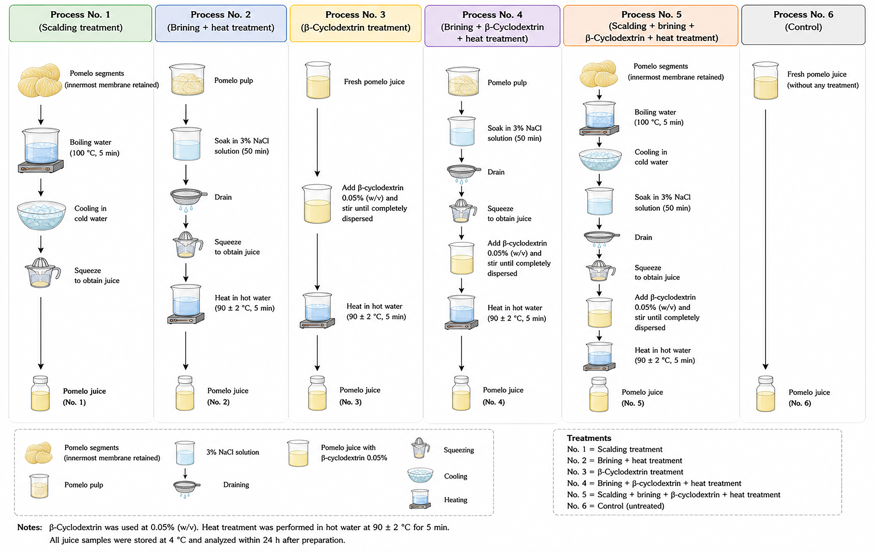

Figure 1. Schematic illustration of six combined debittering processes used for pomelo juice production

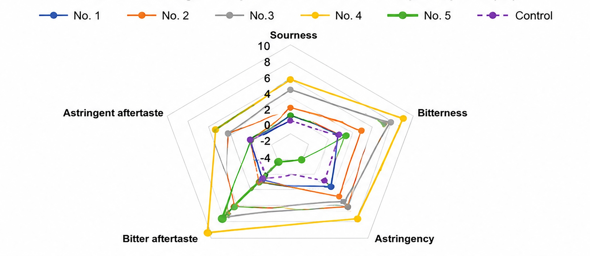

Figure 2. Radar plots of electronic tongue responses for initial taste perception (IA) of pomelo juice subjected to different combined debittering processes

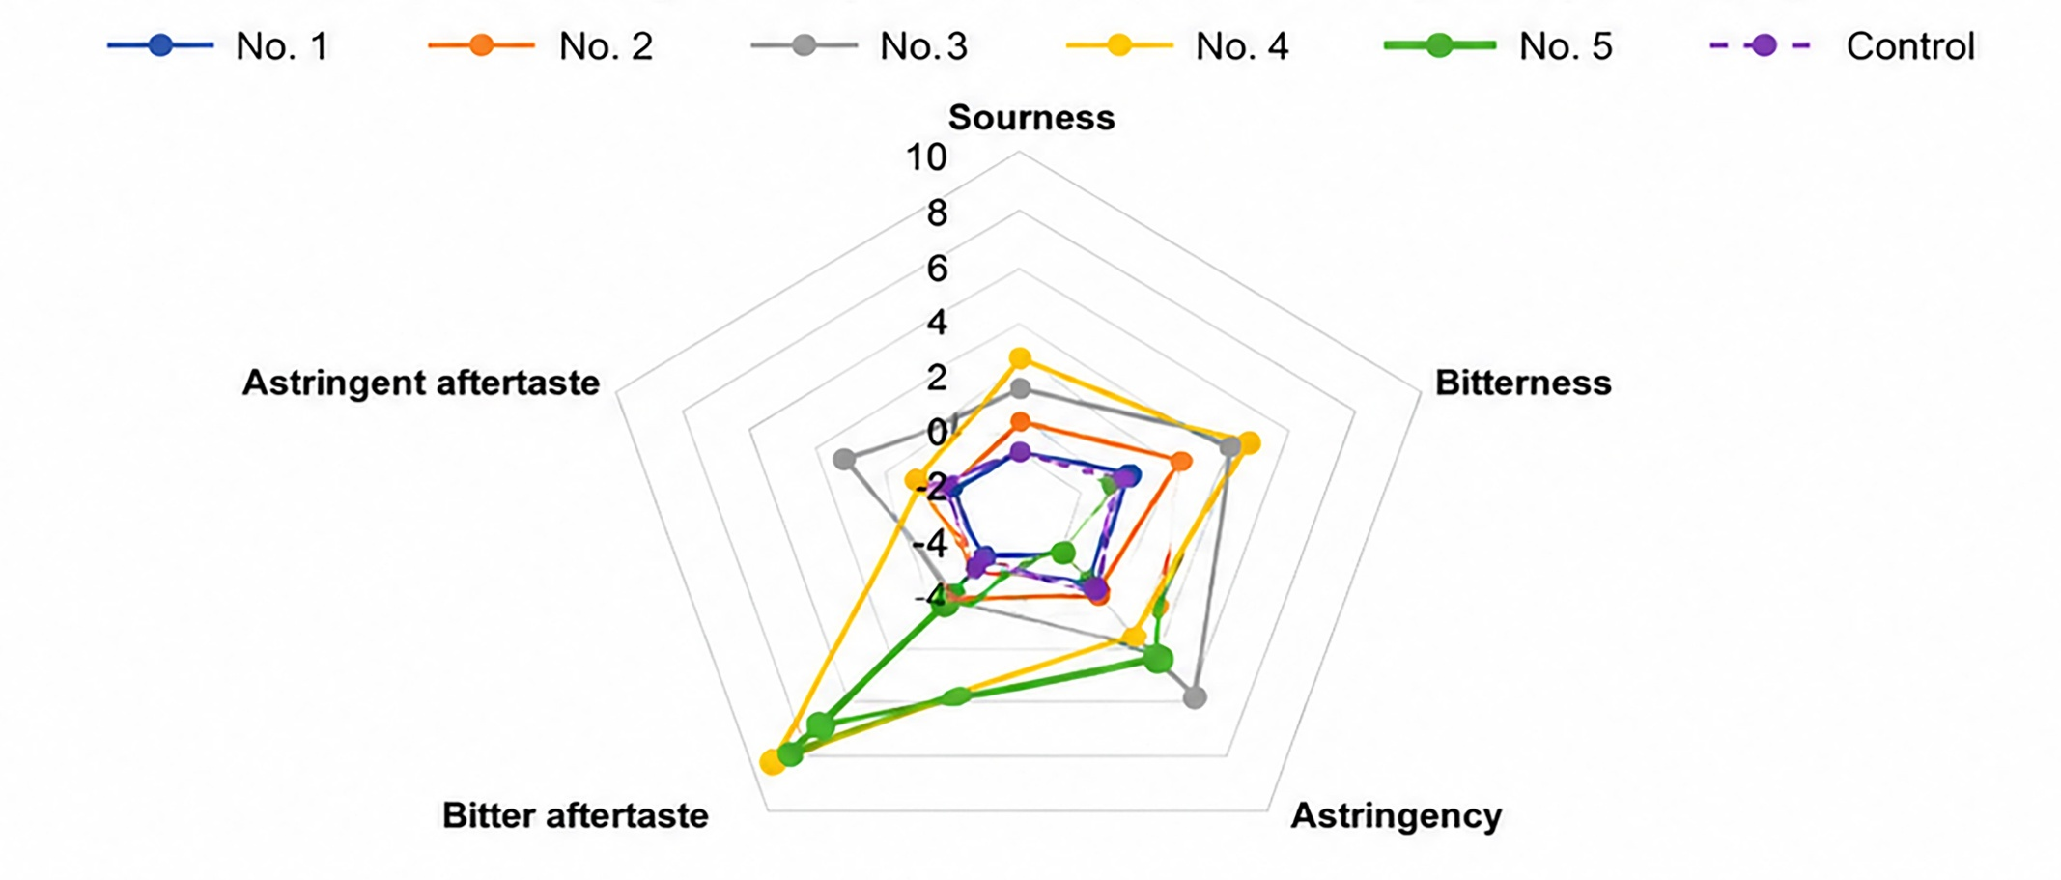
Figure 3. Radar plots of electronic tongue responses for aftertaste perception (ID) of pomelo juice subjected to different combined debittering processes

Table 1 Physicochemical properties, phytochemical contents, and antioxidant activity of pomelo juice subjected to different combined debittering processes
Combined process | Color |  |  | pH | °Brix | Viscosity | TPC | TFC | TTC | DPPH radical  scavenging activity
Combined process | L* | a* | b* |  | (%) | (cP) | (mg GAE/dL) | (mg RE/dL) | (mg TAE/dL) | mg TE/dL | mg AE/dL
1 | 36.13±0.07ª | -2.41±0.16ª | 6.67±0.25^{ac} | 3.60±0.01ª | 0.54±0.02ª | 12.05±0.41ª | 38.65±0.41ª | 11.46±0.38ª | 0.95±0.17ª | 59.46±1.98ª | 55.61±2.54ª
2 | 34.61±0.14^{bc} | -2.63±0.11ª | 5.46±0.19^{b} | 3.27±0.02^{b} | 0.55±0.01ª | 14.65±0.32^{b} | 50.13±5.57^{b} | 18.26±1.49^{b} | 1.78±4.03^{b} | 90.14±8.27^{b} | 70.82±2.74^{b}
3 | 33.98±0.62^{c} | -4.22±0.15^{b} | 7.29±0.33^{c} | 3.71±0.12ª | 0.54±0.01ª | 20.05±0.12^{c} | 61.18±4.61^{c} | 22.63±0.65^{c} | 1.98±0.28^{bc} | 98.65±2.96^{c} | 76.85±5.33^{c}
4 | 33.25±0.41^{c} | -3.81±0.23^{b} | 6.45±0.12ª | 3.24±0.01^{b} | 0.55±0.01ª | 15.56±0.16^{b} | 49.87±0.47^{b} | 17.54±0.39^{b} | 1.76±0.56^{b} | 89.27±5.31^{b} | 71.78±4.95^{b}
5 | 35.53±0.23ª | -3.14±00.6^{c} | 6.74±0.26ª | 3.46±00.1^{bc} | 0.56±0.01ª | 15.78±0.04^{b} | 45.31±1.33^{b} | 15.17±0.08^{bd} | 1.66±0.11^{b} | 73.34±3.65^{d} | 68.26±0.47^{b}
6 (Control) | 35.68±0.24ª | -2.52±0.12ª | 7.16±0.05^{ac} | 3.61±0.01ª | 0.57±0.01ª | 12.75±0.68ª | 40.13±6.12ª | 14.61±1.18^{bd} | 1.46±0.01^{d} | 80.02±6.39^{d} | 69.11±4.02^{b}

Values are expressed as mean ± standard deviation (n = 3). Different superscript letters within the same column indicate significant differences at p < 0.05 according to Duncan’s multiple range test (DMRT)
TPC: total phenolic content; TFC: total flavonoid content; TTC: total tannin content

Table 2 Sensory characteristics of pomelo juice subjected to different combined debittering processes *
Combined process | Appearance | Color | Pomelo aroma | Sweetness  perception | Sourness intensity | Flavor balance | Bitterness  intensity | Astringency | Astringent  aftertaste | Overall acceptability
1 | 6.97±0.41ª | 6.65±0.46ª | 6.07±1.86ª | 7.11±0.04ª | 7.38±1.14ª | 7.75±0.11ª | 7.91±0.56ª | 8.07±1.77ª | 7.65±0.44ª | 7.31±1.19ª
2 | 7.42±0.48^{b} | 7.08±1.14^{b} | 6.71±0.65^{b} | 7.28±0.13^{ab} | 7.76±1.15^{bc} | 7.15±0.21^{b} | 8.29±0.42^{bc} | 8.33±0.39^{b} | 8.04±1.76^{b} | 7.86±0.45^{bc}
3 | 7.16±0.17ª | 6.94±0.52^{ab} | 6.84±0.22^{b} | 7.15±0.35ª | 7.45±1.03^{ab} | 6.97±1.87^{b} | 8.56±1.27^{bc} | 8.29±1.24^{b} | 8.17±0.46^{b} | 7.23±0.56ª
4 | 7.45±0.08^{b} | 7.19±0.34^{ab} | 6.98±0.18^{b} | 7.31±0.17^{b} | 7.94±0.28^{c} | 7.06±0.33^{b} | 8.31±0.35^{bc} | 8.46±0.67^{c} | 8.11±1.35^{b} | 7.61±1.13^{b}
5 | 7.59±0.25^{b} | 7.11±0.38^{ab} | 6.46±0.31^{c} | 7.36±0.09^{b} | 7.61±0.98^{b} | 8.14±1.27^{c} | 7.55±1.13^{ad} | 7.95±2.01ª | 7.48±0.13^{ac} | 8.01±0.16^{c}
6 (Control) | 7.48±0.23^{b} | 7.26±1.26^{c} | 6.18±1.12ª | 7.19±0.27ª | 7.68±0.46^{b} | 7.98±0.36^{ac} | 7.78±0.54ª | 8.11±2.37ª | 7.88±0.31^{ab} | 7.48±0.34^{ab}
*Positive sensory attributes were evaluated using a 9-point hedonic scale, whereas sourness intensity, bitterness intensity, astringency, and lingering aftertaste were assessed using a 9-point intensity scale.

Table 3. Electronic tongue responses for initial taste perception (IA)*
Combined process | Sourness  intensity | Bitterness  intensity | Astringency | Bitter aftertaste | Astringent aftertaste
1 | 1.81±0.03ª | 2.25±0.02ª | 3.82±0.03ª | 1.06±0.05ª | 0.36±0.02ª
2 | 4.70±0.08^{b} | 3.42±0.05^{b} | 7.57±0.01^{b} | 0.81±0.02^{ad} | 0.19±0.00^{b}
3 | 2.39±0.01ª | 4.37±0.12^{c} | 6.70±0.01^{b} | 2.00±0.09^{b} | 0.51±0.00^{c}
4 | 5.10±0.04^{b} | 4.43±0.11^{c} | 8.00±0.02^{b} | 1.53±0.09^{b} | 0.22±0.00^{b}
5 | 2.06±0.06ª | 0.91±0.19^{d} | 4.71±0.01^{c} | -0.68±0.15^{c} | 0.43±0.01^{c}
6 (Control) | -0.36±0.00^{c} | 2.10±0.00ª | 4.40±0.00^{ac} | 0.50±0.00^{d} | 0.39±0.00ª

*Values are expressed as mean ± standard deviation (n = 3).
Different superscript letters within the same column indicate significant differences at p < 0.05 according to Duncan's multiple range test.
Positive and negative values represent relative sensor responses obtained from the electronic tongue system.

Table 4. Electronic tongue responses for aftertaste perception (ID)*
Combined process | Sourness  intensity | Bitterness  intensity | Astringency | Bitter aftertaste | Astringent aftertaste
1 | 2.17±0.02ª | 0.15±0.02ª | -0.58±0.03ª | 0.56±0.04ª | -0.03±0.02ª
2 | 5.06±0.08^{b} | 1.31±0.05^{b} | 3.17±0.01^{b} | 0.31±0.02ª | -0.19±0.00^{b}
3 | 2.75±0.01ª | 2.26±0.12^{c} | 2.31±0.01^{c} | 1.50±0.09^{b} | 0.12±0.00^{c}
4 | 5.46±0.04^{b} | 2.33±0.11^{c} | 3.61±0.02^{b} | 1.03±0.09^{b} | -0.16±0.00^{b}
5 | 2.42±0.06ª | -1.20±0.19^{d} | 0.32±0.01e | -1.18±0.15^{c} | 0.05±0.01^{c}
6 (Control) | -0.00±0.00^{c} | 0.00±0.00e | 0.00±0.00^{f} | 0.00±0.00^{d} | 0.00±0.00e

*Values are expressed as mean ± standard deviation (n = 3).
Different superscript letters within the same column indicate significant differences at p < 0.05 according to Duncan's multiple range test.
Positive and negative values represent relative sensor responses obtained from the electronic tongue system.

