Integrative Genomic, Evolutionary, and Structural Analysis of Plastid-Encoded RNA Polymerase Genes in Elite Indonesian Sugarcane (Saccharum spp. hybrid) ‘Kidang Kencana’ and ‘Bululawang’

Tiara Putria Judith¹, Aliyah Syahidah¹, Denianto Agung Wicaksono¹, Kah Ooi Chua², Ganies Riza Aristya^{1*}

¹Laboratory of Genetics and Breeding, Departement of Tropical Biology, Faculty of Biology, Universitas Gadjah Mada, Yogyakarta 55281, Indonesia
²Centre for Research in Biotechnology for Agriculture (CEBAR) & Institute of Biological Sciences (ISB), Faculty of Science, Universiti Malaya, Kuala Lumpur 50603, Malaysia
*Corresponding author: ganies_riza@ugm.ac.id

ORCID Number
Tiara Putria Judith https://orcid.org/0000-0001-9274-5728; tiara.putria2103@mail.ugm.ac.id
Aliyah Syahidah https://orcid.org/0009-0000-3854-882X; aliyahsyahidah@mail.ugm.ac.id
Denianto Agung Wicaksono https://orcid.org/0009-0009-5605-7464; deniantoagungwicaksono@mail.ugm.ac.id
Kah Ooi Chua htpps://orcid.org/0000-0002-4380-598X; kahooi@um.edu.my
Ganies Riza Aristya https://orcid.org/0000-0001-9251-5076; ganies_riza@ugm.ac.id

ABSTRACT
Sugarcane (Saccharum spp. hybrid) is a major tropical C4 crop with high sucrose productivity, supported by efficient photosynthesis occurring in the chloroplasts. Plastid-encoded RNA polymerase (PEP), comprising of core subunits encoded by the rpo gene family (rpoA, rpoB, rpoC1, and rpoC2), plays a key role in regulating chloroplast gene expression. Despite Indonesian high-yielding varieties such as Kidang Kencana and Bululawang having significant agronomic importance, genomic insights into essential chloroplast genes remain limited. In this study, we applied an integrative analysis of rpo genes to examine the genomic characteristics, evolutionary relationships, and structural features. Fresh young leaves were used for DNA extraction, followed by long-read sequencing, chloroplast genome assembly, and annotation. The rpo genes were analyzed for gene structure, conserved motifs, codon usage bias, protein structure, and phylogenetic relationships using Maximum Likelihood and Bayesian Inference approaches. The four rpo genes were identified as single-copy, intronless genes located in the LSC region, ranging in lengths from 1,020 bp (rpoA) to 4,605 bp (rpoC2). Analysis of conserved motifs revealed up to 30 highly significant motifs, while codon usage patterns were highly similar across cultivars, indicating strong translational selection. Predicted protein structures showed high confidence levels (pLDDT > 90) with low structural divergence, although rpoC2 exhibited slightly greater variation. Phylogenetic analysis produced a well-supported topology (ML = 100%, BI = 1.00), clustering both cultivars into a closely related hybrid clade. These findings indicate strong purifying selection maintaining the structural and functional integrity of the rpo genes, providing valuable genomic insights for molecular-based sugarcane improvement.

Keywords: Conserved motifs, Molecular evolution, Plastid-encoded RNA polymerase, Protein structure, Sugarcane

INTRODUCTION
Sugarcane (Saccharum officinarum and modern Saccharum hybrids) is widely recognized as a C4 plant, known for its high capacity to accumulate sucrose, and serves as a major feedstock for the production of sugar (80%), bioethanol (40%), bioenergy, and various derivative products (Desalegn et al., 2023; Perera et al., 2025; Wu et al., 2024; Zhou et al., 2025). This high biomass accumulation and sucrose yield are primarily driven by efficient photosynthesis, a process that converts light energy to sustain plant growth and sugar synthesis (Croce et al., 2024; Khan et al., 2023; Zhang et al., 2025). Chloroplasts, as the central organelle of this process, not only regulate photosynthesis but also participate in a range of essential metabolic pathways (Sun et al., 2023; Zhang et al., 2025). The sugarcane chloroplast genome is roughly ~141 kb in size and exhibits a typical quadripartite structure, consisting of a large single copy (LSC) region, a small single copy (SSC) region, and two inverted repeat (IRa/b) regions, harboring around 110-120 genes (Evans & Joshi, 2016; Li et al., 2025; Lohmaneeratana et al., 2024; Xu et al., 2019). These genes can be broadly grouped into three categories based on the molecular functions: (1) components involved in plastid gene expression machinery, including RNA polymerase, ribosomal proteins, tRNAs, and rRNAs; (2) subunits of photosynthetic complexes, such as Rubisco, photosystem II, the cytochrome b6f complex, photosystem I, NADPH dehydrogenase, and ATP synthase; and (3) additional proteins supporting these processes, including ClpP1 and ycf3 (Yu et al., 2014). The relatively low rates of nucleotide substitution and recombination in chloroplast genomes make them particularly useful for studying various biological aspects in plants, including gene families and their functions, as well as genome structure and evolution (Wonok et al., 2023).
Chloroplast genes are transcribed by two distinct types of RNA polymerases: the nucleus-encoded RNA polymerase (NEP) and the other is made in the plastid itself (plastid-encoded RNA polymerase (PEP)) (Palomar et al., 2022; Wang et al., 2024; Yu et al., 2014). During early chloroplast development, NEP transcribes essential housekeeping genes, including members of the rpo gene family such as rpoA, rpoB, rpoC1, and rpoC2 (Ali et al., 2024; Börner et al., 2015; Palomar et al., 2022; Yu et al., 2014). The mRNA transcripts of these rpo genes are subsequently translated into four core subunits of plastid-encoded RNA polymerase (PEP), namely α (38 kDa), β (120 kDa), β′ (85 kDa), and β″ (185 kDa), which assemble into a functional PEP enzyme that serves as the primary transcription machinery for photosynthesis-related genes in chloroplasts (Ahrens et al., 2025; Börner et al., 2015; Loiacono & Bock, 2024; Zhang et al., 2025). PEP is a bacterial-type RNA polymerase which inherited its catalytic core from its cyanobacterial endosymbiotic ancestor (Palomar et al., 2022). This enzyme stably interacts to several PEP-associated proteins (PAPs) encoded by nuclear genes, reflecting the complex integration between the chloroplast and nuclear genomes (Vergara-Cruces et al., 2024; Wang et al., 2024). The central role of PEP emphasizes the importance of characterizing the rpo gene family, as its presence and function regulate the transition from young chloroplasts to mature chloroplasts capable of efficient photosynthesis (Yu et al., 2014).
Indonesia harbors a range of elite sugarcane cultivars with advantageous agronomic traits, including the cultivars Kidang Kencana and Bululawang, both known for their superior sucrose accumulation (Amanah & Putra, 2018; P3GI, 2025; Widyasari et al., 2022). Reported sucrose yields reach 10.99 ± 1.65% under irrigated conditions and 9.51 ± 0.88% in dryland systems for Kidang Kencana, while Bululawang shows approximately 7.51% under dryland cultivation (P3GI, 2025). Despite these agronomic advantages, such traits are not yet supported by comprehensive genomic information. To date, the potential of local sugarcane cultivars remains largely unexplored and insufficiently documented at the genomic level. The limited availability of local genomic databases, combined with the dominance of global genomic references that poorly represent Indonesian agroecosystems, has hindered the optimal implementation of molecular breeding in sugarcane (Basuki & Sari, 2024; Evans & Joshi, 2016; Widyasari et al., 2022). One promising way to address this gap is the exploration through the characterization of genes involved in chloroplast function and photosynthetic processes. Evidence from model plants, such as Nicotiana tabacum, shown that mutations in rpo genes can lead to albino or chlorotic phenotypes, underscoring the essential role of this gene family in chloroplast biogenesis (Vergara-Cruces et al., 2024; Wang et al., 2024). These observations suggest that the characterization of rpo genes is not only important for understanding plastid gene expression but also holds potential as a informative molecular marker to uncover genetic conservation, variation, as well as structural and evolutionary dynamics in sugarcane cultivars. Therefore, this study aims to applied an integrative genomic, evolutionary, and structural analysis of plastid-encoded RNA polymerase (rpo) genes in elite Indonesian sugarcane ‘Kidang Kencana’ and ‘Bululawang’, to reveal their genetic features, evolutionary patterns, and structural characteristics that may support molecular-based selection and improvement of sugarcane cultivars in Indonesia.

MATERIAL AND METHODS
Plant Materials and DNA Extraction
Fresh young leaves of Saccharum hybrid ‘Kidang Kencana’ and ‘Bululawang’ were collected from PT Madubaru–PG Madukismo located in Bantul, Special Region of Yogyakarta, Indonesia (7°49′40″S, 110°20′14″E). The leaf samples were immediately placed into tubes containing liquid nitrogen and transported to the laboratory for DNA extraction. The samples were subsequently stored at −20 °C prior to DNA extraction. High-molecular weight genomic DNA was extracted from approximately 100 mg of leaf tissue using the Wizard® HMW DNA Extraction Kit (Promega Corporation, Madison, WI, USA) following the manufacturer’s protocol. DNA quality and quantity were measured using a NanoDrop Lite Plus Spectrophotometer and a Qubit 4 Fluorometer (Thermo Fisher Scientific, Waltham, MA, USA). DNA integrity was further verified by electrophoresis on a 1% agarose gel using the Mupid-exU system (Advance Co., Ltd., Japan).

Library Preparation and Long-Read Sequencing
DNA library preparation was performed using the Ligation Sequencing Kit V14 (SQK-LSK114; Oxford Nanopore Technologies, UK) according to the manufacturer’s instructions. The library preparation included DNA repair and end-preparation, adapter ligation, flow-cell priming, and loading. Sequencing was carried out on the PromethION 24 platform using MinKNOW v.24.11.10 software (Oxford Nanopore Technologies, UK). The sequencing run lasted approximately 72 hours, generating raw nanopore signal data (.pod5). The raw signal data were basecalled using the super-acuracy (SUP) model in Dorado v0.9.6 and exported as FASTQ format for downstream analysis. Low-quality reads and adapter sequences were filtered using Filtlong v0.3.1 to obtain high- quality reads suitable for genome assembly. The quality of the output FASTQ reads was assessed using NanoPlot v.1.41.6 (De Coster & Rademakers, 2023).

Chloroplast Genome Assembly and Annotation
Chloroplast genome assembly from the filtered long reads was performed using TIPPo pipeline (https://github.com/Wenfei-Xian/TIPP). The assembly graph was visualized and inspected using Bandage v0.8.1 (Wick et al., 2015) to confirm the circular structure of the chloroplast genome. The assembled genome was subsequently annotated using GeSeq (Tillich et al., 2017) to obtain the GenBank (GB) file. The final annotation results were visualized to generate circular chloroplast genome maps using OGDRAW v.1.3.1 (Greiner et al., 2019). The chloroplast genome sequence obtainezzd in this study has been submitted to the NCBI GenBank database (https://www.ncbi.nlm.nih.gov/nuccore).

Extraction of rpo Gene Family
The annotated chloroplast genome in GenBank (GB) format was imported into Unipro UGENE v53.0, and all genes belonging to the rpo family were identified based on gene annotations. The full gene sequences, coding DNA sequences (CDS), and amino acid sequences were extracted and exported in FASTA format for downstream analysis.

Gene Structure and Predicted 3D Protein Structure Analysis
The CDS and full gene sequences of the rpo gene family were used to analyze intron and exon organization using the Gene Structure Display Server 2.0 (Hu et al., 2015). The analysis included sequences from the studied genome together with 15 reference sequences from the genus Saccharum and one outgroup sequence from Miscanthus sinensis (GenBank: LN896358) from the NCBI GenBank database.
Amino acid sequences of the rpo gene family were used to predict three-dimensional protein structures using the AlphaFold 3 Server (https://alphafoldserver.com). The predicted protein models were visualized and analyzed using PyMOL software. Structural similarity among the predicted proteins was evaluated by calculating the root mean square deviation (RMSD) values through structural alignment with reference protein structures.

Conserved Motif Analysis
Conserved motif analysis was performed using the MEME Suite v5.5.7 online server (https://meme-suite.org/meme/tools/meme). The amino acid sequences of the rpo gene family, together with reference and outgroup protein sequences, were used as input for motif discovery. The MEME algorithm was applied with the maximum number of motifs set to 30 to allow comprehensive detection of conserved motifs, including potentially rare or lineage-specific motifs within the rpo protein family, while other parameters were kept at their default settings.

RSCU-Based Codon Usage Analysis
Codon usage bias analysis was performed using a custom Python pipeline executed through the Anaconda Prompt (Python 3) environment. The input data consisted of a complete chloroplast genome annotation file in GenBank format (.gbk). CDS shorter than 60 nucleotides were excluded from the analysis and stop codons were removed before codon counting to avoid statistical bias in codon frequency estimation. The rpo gene family, including rpoA, rpoB, rpoC1, and rpoC2, was identified based on gene annotations in the GenBank file, while all remaining CDS were grouped as the other chloroplast genes. The pipeline generated output files, including CSV tables and heatmap visualizations.

Phylogenetic Reconstruction
Phylogenetic relationships were reconstructed using Maximum Likelihood (ML) and Bayesian Inference (BI) approaches based on a concatenated dataset of the rpo gene family. The coding sequences of rpoA, rpoB, rpoC1, and rpoC2 were aligned into a single alignment file. The optimal partitioning scheme for the dataset was determined by PartitionFinder v.2.1.1 (Lanfear et al., 2017) based on the Bayesian Information Criterion (BIC). ML analysis was conducted in IQ-TREE v2.3.1 (Nguyen et al., 2015) with 1000 bootstrap replicates, whereas BI analysis was performed in MrBayes v3.2.6 (Ronquist et al., 2012) using a Markov Chain Monte Carlo (MCMC) run of 4,000,000 generations. Miscanthus sinensis (GenBank: LN896358) was used as the outgroup. The resulting phylogenetic trees were visualized using Fig Tree v1.4.4.

RESULTS AND DISCUSSION
Identification of rpo Gene Family
A total of four genes belonging to the plastid-encoded RNA polymerase (PEP) were identified in the chloroplast genomes of Saccharum hybrid ‘Kidang Kencana’ and ‘Bululawang’. These genes include rpoA, rpoB, rpoC1, and rpoC2, each present as a single copy within the plastome. All identified rpo genes were located in the large single copy (LSC) region, consistent with the plastome organization reported in members of the Poaceae family (Chen et al., 2025; Kim et al., 2026; Li et al., 2025; Lohmaneeratana et al., 2024; Sathyamurthy et al., 2025). The gene sequence, coding DNA sequence (CDS), and amino acid lengths of each rpo gene were obtained from genome annotation results, with detailed characteristics summarized in Table 1.
The rpo genes identified in both cultivars exhibited similar gene and protein lengths, indicating structural stability within the chloroplast genome. Among them, rpoC2 was the largest gene (4605 bp; ~1535 amino acids), whereas rpoA was the smallest (1020 bp; 339 amino acids). This size distribution aligns with the functional roles of the plastid-encoded RNA polymerase (PEP) subunits, in which the β'' subunit encoded by rpoC2 contributes to DNA interaction during transcription, while the α subunit encoded by rpoA is comparatively smaller and mainly involved in enzyme assembly and structural stabilization. Similar patterns have been reported in other Saccharum plastomes, suggesting a stable structural framework of PEP-related genes in sugarcane (Palanivelu, 2019; Tadini et al., 2020).
The genomic organization revealed relatively short intergenic spacer (IGS) regions between adjacent genes, particularly 37 bp between rpoB and rpoC1 and 199 bp between rpoC1 and rpoC2. The proximity of these genes supports a tightly arranged gene cluster within the LSC region. In many chloroplast genomes, genes are organized into operons or operon-like clusters and transcribed as polycistronic RNAs before RNA processing (Ping et al., 2023; Stern et al., 2010). Consistent with this transcriptional architecture, rpoB, rpoC1, and rpoC2 encode the β, β′, and β″ subunits of the plastid-encoded RNA polymerase (PEP), respectively, which together form the catalytic core responsible for chloroplast transcription. The clustered arrangement of these functionally related genes may facilitate coordinated transcription as a polycistronic precursor (Ahrens et al., 2025; Ping et al., 2023; Wang et al., 2024). However, since this inference is based solely on genomic organization, experimental validation such as transcript mapping would be required to confirm coordinated transcription. The genomic organization and short intergenic distances among the rpo genes suggest a conserved plastid transcriptional architecture in both Saccharum cultivars, reflecting the functional importance and evolutionary constraints of the PEP system in chloroplast gene expression.

Gene Structure Analysis
The exon–intron structure of the rpo genes was analyzed using GSDS by comparing genomic sequences with their coding DNA sequences (CDS) across the two studied cultivars, 15 additional Saccharum accessions, and one outgroup species to evaluate structural conservation among related taxa (Fig. 1). All four genes exhibited a simple intron-less structure consisting of a single exon. The gene lengths varied among the rpo genes, with rpoA, rpoB, rpoC1, and rpoC2 measuring 1020 bp, 3228 bp, 2052 bp, and 4605 bp, respectively. This intron-less organization is commonly observed in plastid genes and reflects a conserved structural pattern in chloroplast genomes. The absence of introns may support a streamlined transcriptional process without the requirement for RNA splicing, potentially enabling efficient expression of genes involved in plastid transcription (Aviña-Padilla et al., 2021; Liu et al., 2021).

Conserved Motif Analysis
The sugarcane rpo proteins vary in size from 339 amino acids (rpoA) to 1,535 amino acids (rpoC2), reflecting their distinct structural and functional roles within the plastid-encoded RNA polymerase (PEP) complex. Analysis using the MEME Suite v5.5.7 online server revealed 30 conserved motifs across the rpo gene family proteins, as shown in Fig. 2, demonstrating substantial structural conservation. The statistical significance of motif conservation is strongly supported by extremely low p-values. The rpoA protein in both ‘Kidang Kencana’ and ‘Bululawang’ exhibited a p-value of 1.64 × 10⁻¹⁵⁸, which is comparable to those observed in several Saccharum spp. hybrids. Slightly lower yet still highly significant p-values (2.12 × 10⁻¹⁵⁸) were detected in species such as Saccharum spontaneum, S. fulvum, S. narenga, S. barberi, S. officinarum, and Taiwanese hybrids, suggesting strong evolutionary constraint across the genus.
In contrast, rpoB, rpoC1, and rpoC2 exhibited p-values of 0.00e+0, indicating statistical significance beyond the computational precision limit of the MEME algorithm. This pattern reflects an exceptional conservation of functional motifs, consistent with their essential roles in forming the catalytic core of the plastid-encoded RNA polymerase (PEP) complex, particularly in transcriptional regulation within the chloroplast. The observed pattern indicates a remarkable preservation of functional elements, which aligns with their critical function in constructing the catalytic center of the plastid-encoded RNA polymerase (PEP) complex, especially for transcriptional control within the chloroplast. This pattern might also suggest intensely purifying selection on these genes, maintaining their functional regions throughout evolutionary timescales. This is consistent with the general pattern in protein-coding genes, where purifying selection eliminates deleterious non-synonymous mutations, thereby preserving conserved functional motifs across different species (Chen et al., 2025; Douglas & Shapiro, 2024).

Predicted 3D Protein Structure
The predicted three-dimensional (3D) structures of rpo proteins in Saccharum hybrid ‘Kidang Kencana’ and ‘Bululawang’ were generated to evaluate their structural organization and stability (Fig. 3). All rpo proteins exhibited well-defined folded conformations with high-confidence regions predominantly represented in blue (pLDDT > 90), indicating reliable structural predictions. Lower-confidence regions (yellow to orange) were mainly located at the terminal ends and loop regions, suggesting intrinsic flexibility commonly observed in protein structures (Hossen et al., 2025; Sriram et al., 2025). Among the four proteins, rpoB and rpoC2 displayed more complex and extended architectures, consistent with their larger protein sizes and roles as core catalytic subunits of the plastid-encoded RNA polymerase (PEP). The rpoA protein exhibited a more compact structure, reflecting its role in enzyme assembly and stabilization rather than direct catalytic activity, whereas rpoC1 showed an intermediate structural complexity, supporting its function as part of the catalytic machinery (Palanivelu, 2019; Tadini et al., 2020). In particular, the rpoC2 protein exhibited not only a more extended architecture but also predominantly light blue regions, indicating slightly lower yet still high confidence scores compared to other rpo proteins. This structural pattern is consistent with its previously described role as the β'' subunit of the plastid-encoded RNA polymerase (PEP), where a certain degree of flexibility may be required to facilitate interactions within the catalytic complex.
Comparative structural analysis based on RMSD values (Table 2) further supported the overall conservation of rpo proteins across Saccharum species. Most rpoB and rpoC1 proteins exhibited consistently low RMSD values, generally ranging from approximately 0.275 to 1.224 Å, indicating a high degree of structural similarity. The rpoA protein also showed relatively low RMSD values in most accessions, although moderate variation was observed in several species. However, markedly higher RMSD values were observed in specific cases. Notably, rpoA exhibited extreme values of 12.583 Å in Saccharum barberi (‘Kidang Kencana’ comparison) and 22.966 Å in the ‘Bululawang’ comparison, indicating substantial structural deviation. Elevated RMSD values were observed for rpoC2 in comparisons with Bululawang, including 15.357 Å in Saccharum hybrid ‘RB72454’ and 10.107 Å in Saccharum hybrid ‘SP-80-3280’.
These pronounced deviations are likely associated with structural variability in flexible or poorly aligned regions, particularly in larger or more complex proteins. In rpoC2, this pattern is consistent with its predominantly light blue confidence distribution in the predicted structures, suggesting increased flexibility and variation in domain orientation. Importantly, such high RMSD values do not necessarily indicate functional divergence, as the conserved core regions and motif architecture remain largely preserved. The occurrence of extreme RMSD values in certain species, particularly in S. barberi, may also reflect greater evolutionary divergence relative to other Saccharum accessions. The combination of low RMSD values across most proteins and localized structural deviations supports the notion that rpo proteins are highly conserved, with structural flexibility accommodating functional requirements within the plastid-encoded RNA polymerase (PEP) complex (Hossen et al., 2025; Palomar et al., 2022; Sriram et al., 2025; Vergara-Cruces et al., 2024).

Codon Usage Bias of rpo Genes
The comparative analysis of codon usage between rpo genes and other chloroplast genes revealed a highly consistent pattern in both cultivars, Kidang Kencana (KK) and Bululawang (BL) (Fig. 4). The deviation values for most codons were nearly identical, with differences generally less than 0.02, indicating that codon usage bias in rpo genes is highly conserved across cultivars.
Several synonymous codon pairs exhibited opposite deviation values, indicating strong codon preference in rpo genes. The lysine codons AAA and AAG displayed contrasting patterns, with AAA being overrepresented (0.07 in KK; 0.08 in BL) and AAG underrepresented (−0.07 in KK; −0.08 in BL). Similarly, the glutamine codons CAA and CAG showed opposing deviations, with CAA having a positive deviation (0.16 in both KK and BL) and CAG a negative deviation (−0.16 in both KK and BL). These consistent opposing patterns among synonymous codons suggest selective codon usage, potentially associated with tRNA availability and translational efficiency in chloroplasts (Geng et al., 2026).
Several codons exhibited extreme deviations, indicating that codon usage in rpo genes is non-random. The arginine codon CGT showed the strongest negative deviation (−0.57 in KK; −0.59 in BL), reflecting strong avoidance, whereas GCG (alanine) was highly preferred (0.36 in KK; 0.37 in BL). Glycine codons followed a similar trend, with GGA overrepresented (0.36 in KK; 0.34 in BL) and GGT underrepresented (−0.35 in both KK and BL). Additional codons displayed mirrored patterns: CTT (leucine) was underrepresented (−0.17 in both KK and BL) while CTG was overrepresented (0.13 in KK; 0.12 in BL), and TGC (cysteine) was preferred (0.26 in KK; 0.28 in BL) relative to TGT (−0.26 in KK; −0.28 in BL). These trends indicate strong codon-specific selection rather than random mutational bias.
Minor quantitative differences between cultivars were observed, such as AGG (0.21 in KK; 0.22 in BL) and TGC (0.26 in KK; 0.28 in BL), which are unlikely to be biologically significant. The conserved and non-random codon usage in rpo genes likely optimizes the translational efficiency of plastid-encoded RNA polymerase subunits, essential for chloroplast gene expression. This pronounced codon bias may reflect the critical role of rpo genes in plastid transcription, requiring high translational accuracy and efficiency. These observations suggest that translational selection is a primary driver of codon usage in these essential genes (Li et al., 2024; Yao et al., 2023).

Phylogenetic Reconstruction of rpo Genes
The phylogenetic tree was constructed based on concatenated sequences of four plastid-encoded RNA polymerase genes (rpoA, rpoB, rpoC1, and rpoC2), including the two studied cultivars (Saccharum hybrid ‘Kidang Kencana’ and ‘Bululawang’), as well as related Saccharum species and an outgroup. The tree was inferred using both Maximum Likelihood (ML) and Bayesian Inference (BI) methods, which produced a consistent topology with strong statistical support across most nodes (Fig. 5).
The phylogenetic tree robustly resolved all Saccharum accessions into a well-supported monophyletic clade, indicating a shared evolutionary origin of the rpo gene family within the genus. Within this clade, the two studied cultivars, Saccharum hybrid ‘Kidang Kencana’ and ‘Bululawang’, were clearly positioned within the modern hybrid lineage. Both cultivars clustered tightly with other commercial hybrids, including ‘GXASF1’, ‘NCo 310’, ‘Q155’, and ‘Q165’, forming a strongly supported subclade (ML = 100%; BI = 1.00). The short branch lengths observed within this group indicate minimal sequence divergence among hybrid accessions, reflecting a high degree of conservation in the rpo genes. This pattern is consistent with the shared genetic background and relatively narrow diversity of modern sugarcane cultivars derived from interspecific hybridization (Wang et al., 2022).
Within the broader Saccharum clade, several Saccharum officinarum accessions were positioned in close proximity to, or intermixed with, the hybrid clade. This pattern is consistent with the breeding history of modern sugarcane, in which interspecific hybrids derived from S. officinarum and Saccharum spontaneum have undergone repeated backcrossing to S. officinarum to recover desirable agronomic traits. As a result, modern cultivars retain a substantial proportion of the S. officinarum genome, which likely contributes to their close phylogenetic affinity and partial clustering within the same clade. In contrast, Saccharum spontaneum accessions were resolved as a distinct sister clade, indicating a more divergent evolutionary lineage while remaining an important genetic contributor to hybrid cultivars. The separation between S. officinarum and S. spontaneum lineages is supported by moderate to high node support values, suggesting clear phylogenetic differentiation despite their shared role in hybrid formation (Oliveira et al., 2023; Paterson, 2013).
More distantly related taxa, including Saccharum barberi, Saccharum longisetosum, Saccharum fulvum, and Saccharum narenga, were positioned outside the main hybrid progenitor cluster and exhibited relatively longer branch lengths, indicative of greater evolutionary divergence. Notably, S. barberi displayed a markedly extended branch, consistent with the elevated structural variation observed in the RMSD analysis, particularly for the rpoA protein. The outgroup, Miscanthus sinensis, was clearly separated from all Saccharum taxa with strong support, confirming appropriate tree rooting and the robustness of the inferred topology.
These results demonstrate that the rpo gene family is highly conserved across Saccharum, with limited sequence divergence among modern hybrids. The close phylogenetic association between ‘Kidang Kencana’, ‘Bululawang’, and S. officinarum accessions reflects the impact of repeated backcrossing during sugarcane domestication, while the distinct placement of S. spontaneum highlights its contribution as a genetically divergent progenitor. This overall pattern is consistent with strong purifying selection maintaining the functional integrity of rpo genes involved in plastid transcription (Chen et al., 2025; Douglas & Shapiro, 2024).

Conclusion
The rpo gene family in Saccharum barely changes over time, which underscores the importance it holds regarding plastid transcription machinery. The reliability conservation across gene structure, protein architecture, and codon usage underscores the essential role of these genes in maintaining chloroplast function and photosynthetic efficiency. The limited divergence observed between the Indonesian cultivars ‘Kidang Kencana’ and ‘Bululawang’ further highlights the narrow genetic base of modern sugarcane hybrids shaped by intensive breeding and continual backcrossing. Notably, localized structural variability in rpoC2 implies that functional flexibility may occur in conjunction with overall conservation, potentially facilitating interplay within the PEP complex. These discoveries of rpo genes appear to be relatively stable components of the genome and could serve as useful markers for comparative and evolutionary studies in Saccharum, while also offering insights relevant to the improvement of locally adapted cultivars. Further investigation incorporating functional validation and broader genomic datasets will be key to refining its role in molecular breeding strategies.

DECLARATIONS
Funding: This research is funded by the Faculty of Biology, Universitas Gadjah Mada, under the International Collaborative Research and Publication Grant (No. 1629/UN1/BI.1/KSA/PT.01.03/2026), and by the Directorate General of Research and Development, Ministry of Higher Education, Science, and Technology, under Master’s Thesis Research Grant (No: 067/C3/DT.05.00/PL/2025 and 2633/UN1/DITLIT/Dit-Lit/PT.01.03/2025).

Acknowledgement: The authors express sincere gratitude to the head and staff of PT Madubaru–PG Madukismo for their valuable collaboration and assistance throughout the research process, as well as to the Laboratory of Genetics and Breeding, Faculty of Biology, Universitas Gadjah Mada, for their technical support and facilities.

Conflict of Interest: The authors declare no conflicts of interest.

Data Availability: All the data generated during the research are present in the article.

Ethics Statement: Ethical approval/statement was not required for this research.

Author’s Contribution: TPJ: Conceptualization; Methodology; Software; Investigation; Formal Analysis; Data Curation; Writing - Original Draft; Visualization. AS and DAW: Methodology; Software; Formal Analysis; Visualization. KOC: Methodology; Software; Formal Analysis; Data Curation. GRA: Supervision; Funding Acquisition; Resources; Conceptualization; Validation; Writing - Review & Editing.

REFERENCES
Ahrens, F. M., do Prado, P. F. V., Hillen, H. S., & Pfannschmidt, T. (2025). The plastid-encoded RNA polymerase of plant chloroplasts. In Trends in Plant Science (Vol. 30, Number 7, pp. 712–723). Elsevier Ltd. https://doi.org/10.1016/j.tplants.2025.01.010.
Ali, N. A., Song, W., Huang, J., Wu, D., & Zhao, X. (2024). Recent advances and biotechnological applications of RNA metabolism in plant chloroplasts and mitochondria. In Critical Reviews in Biotechnology (Vol. 44, Number 8, pp. 1552–1573). Taylor and Francis Ltd. https://doi.org/10.1080/07388551.2023.2299789.
Amanah, D. M., & Putra, S. M. (2018). Effect of biostimulants on drought tolerance and growth of sugarcane var. Kidang Kencana at green house. E-Journal Menara Perkebunan, 86(1), 46–55. https://doi.org/10.22302/iribb.jur.mp.v1i1.287.
Aviña-Padilla, K., Ramírez-Rafael, J. A., Herrera-Oropeza, G. E., Muley, V. Y., Valdivia, D. I., Díaz-Valenzuela, E., García-García, A., Varela-Echavarría, A., & Hernández-Rosales, M. (2021). Evolutionary Perspective and Expression Analysis of Intronless Genes Highlight the Conservation of Their Regulatory Role. Frontiers in Genetics, 12, 1. https://doi.org/10.3389/fgene.2021.654256.
Basuki, B., & Sari, V. K. (2024). Specifications of Sugar Cane Varieties Based on Land Characteristic and Typology. Journal of Agricultural Engineering, 13(1), 132. https://doi.org/10.23960/jtep-l.v13i1.132-146.
Börner, T., Aleynikova, A. Y., Zubo, Y. O., & Kusnetsov, V. V. (2015). Chloroplast RNA polymerases: Role in chloroplast biogenesis. In Biochimica et Biophysica Acta - Bioenergetics (Vol. 1847, Number 9, pp. 761–769). Elsevier B.V. https://doi.org/10.1016/j.bbabio.2015.02.004.
Chen, C., Guo, H., Abdullah, Li, T., Li, G., Liu, J., & Tian, X. (2025). The complete chloroplast genome of Phyllostachys aureosulcata McClure (Bambusoideae: Poaceae): Comparative genomics and phylogenetic analysis. Journal of Asia-Pacific Biodiversity, 18(1), 190–196. https://doi.org/10.1016/j.japb.2024.10.003.
Chen, Y., Liu, N., Wang, H., Luo, H., Xie, Z., Yu, H., Chang, Y., Zheng, B., Zheng, X., Sheng, J., Jiang, Y., Ye, S., Hua, Y., Ma, H., & Li, F. (2025). Comparative chloroplast genomics of Rutaceae: structural divergence, adaptive evolution, and phylogenomic implications. Frontiers in Plant Science, 16. https://doi.org/10.3389/fpls.2025.1675536.
Croce, R., Carmo-Silva, E., Cho, Y. B., Ermakova, M., Harbinson, J., Lawson, T., McCormick, A. J., Niyogi, K. K., Ort, D. R., Patel-Tupper, D., Pesaresi, P., Raines, C., Weber, A. P. M., & Zhu, X. G. (2024). Perspectives on improving photosynthesis to increase crop yield. In Plant Cell (Vol. 36, Number 10, pp. 3944–3973). American Society of Plant Biologists. https://doi.org/10.1093/plcell/koae132.
De Coster, W., & Rademakers, R. (2023). NanoPack2: population-scale evaluation of long-read sequencing data. Bioinformatics, 39(5). https://doi.org/10.1093/bioinformatics/btad311.
Desalegn, B., Kebede, E., Legesse, H., & Fite, T. (2023). Sugarcane productivity and sugar yield improvement: Selecting variety, nitrogen fertilizer rate, and bioregulator as a first-line treatment. Heliyon, 9(4). https://doi.org/10.1016/j.heliyon.2023.e15520.
Douglas, G. M., & Shapiro, B. J. (2024). Pseudogenes act as a neutral reference for detecting selection in prokaryotic pangenomes. Nature Ecology and Evolution, 8(2), 304–314. https://doi.org/10.1038/s41559-023-02268-6.
Evans, D. L., & Joshi, S. V. (2016). Complete chloroplast genomes of Saccharum spontaneum, Saccharum officinarum and Miscanthus floridulus (Panicoideae: Andropogoneae) reveal the plastid view on sugarcane origins. Systematics and Biodiversity, 14(6), 548–571. https://doi.org/10.1080/14772000.2016.1197336.
Geng, X., Xue, Y., Wang, H., Tu, H., Jing, R., Li, Z., & Gai, Y. (2026). Comprehensive analysis of chloroplast genome evolution in Poaceae: codon usage patterns, selection pressures, and phylogenomic relationships. BMC Genomics, 27(1). https://doi.org/10.1186/s12864-025-12498-6.
Greiner, S., Lehwark, P., & Bock, R. (2019). OrganellarGenomeDRAW (OGDRAW) version 1.3.1: expanded toolkit for the graphical visualization of organellar genomes. Nucleic Acids Research, 47(W1), W59–W64. https://doi.org/10.1093/nar/gkz238.
Hossen, M. A., Jahan, U. M. S., Hossain, M. A., Asif, K. H., Rahman, A., Ahmed, S., Uddin, M. M., Amin, M. F., Barik, M. A., Islam, M. J., Kamruzzaman, M., Hasnat, S., Uddin, M. N., Islam, T., & Hoque, M. N. (2025). Computational investigation unveils pathogenic LIG3 non-synonymous mutations and therapeutic targets in acute myeloid leukemia. PLOS ONE, 20(6 June). https://doi.org/10.1371/journal.pone.0320550.
Hu, B., Jin, J., Guo, A. Y., Zhang, H., Luo, J., & Gao, G. (2015). GSDS 2.0: An upgraded gene feature visualization server. Bioinformatics, 31(8), 1296–1297. https://doi.org/10.1093/bioinformatics/btu817.
Khan, Q., Qin, Y., Guo, D. J., Yang, L. T., Song, X. P., Xing, Y. X., & Li, Y. R. (2023). A Review of the Diverse Genes and Molecules Involved in Sucrose Metabolism and Innovative Approaches to Improve Sucrose Content in Sugarcane. Agronomy, 13(12). https://doi.org/10.3390/agronomy13122957.
Kim, K. R., Choi, C., Kim, J. S., Kim, M. H., Jung, H. J., Jeon, D. H., & Kim, J. H. (2026). Complete chloroplast genome of Triticum aestivum cultivar ‘Keumkang’ from Korea (Poaceae) and comparative chloroplast genomes of the members of the Triticum genus. Journal of the Science of Food and Agriculture. https://doi.org/10.1002/jsfa.70489.
Lanfear, R., Frandsen, P. B., Wright, A. M., Senfeld, T., & Calcott, B. (2017). Partitionfinder 2: New methods for selecting partitioned models of evolution for molecular and morphological phylogenetic analyses. Molecular Biology and Evolution, 34(3), 772–773. https://doi.org/10.1093/molbev/msw260.
Li, S., Wang, Z., Xu, C., Zhang, L., Zhang, B., Huang, Y., Lu, X., Duan, W., & Yang, X. (2025). Chloroplast genome diversity and phylogenetic insights of Saccharum spontaneum across Southeast Asia. PLANTS, PEOPLE, PLANET, 7(6), 1834–1844. https://doi.org/10.1002/ppp3.70056.
Li, T., Ma, Z., Ding, T., Yang, Y., Wang, F., Wan, X., Liang, F., Chen, X., & Yao, H. (2024). Codon usage bias and phylogenetic analysis of chloroplast genome in 36 gracilariaceae species. Functional and Integrative Genomics, 24(2). https://doi.org/10.1007/s10142-024-01316-z.
Liu, H., Lyu, H.-M., Zhu, K., de Peer, Y. Van, & Cheng, Z.-M. (Max). (2021). The emergence and evolution of intron‐poor and intronless genes in intron‐rich plant gene. The Plant Journal, 105(105), 1072–1082. https://doi.org/10.1111/tpj.15088.
Lohmaneeratana, K., Gutiérrez, G., Thamchaipenet, A., & Wellinger, R. E. (2024). Phytoplasma DNA Enrichment from Sugarcane White Leaves for Shotgun Sequencing Improvement. Plants, 13(21). https://doi.org/10.3390/plants13213006.
Loiacono, F. V., & Bock, R. (2024). An RNA polymerase that became a Swiss army knife. In Cell (Vol. 187, Number 5, pp. 1106–1108). Elsevier B.V. https://doi.org/10.1016/j.cell.2024.01.044.
Nguyen, L. T., Schmidt, H. A., Von Haeseler, A., & Minh, B. Q. (2015). IQ-TREE: A fast and effective stochastic algorithm for estimating maximum-likelihood phylogenies. Molecular Biology and Evolution, 32(1), 268–274. https://doi.org/10.1093/molbev/msu300.
Oliveira, G. K., Soares, N. R., Costa, Z. P., Almeida, C. B., Machado, R. M., Mesquita, A. T., Carneiro, M. S., Forni‐Martins, E. R., Mondin, M., & Vieira, M. L. C. (2023). Meiotic abnormalities in sugarcane (Saccharum spp.) and parental species: Evidence for peri‐ and paracentric inversions. Annals of Applied Biology, 183(3), 271–286. https://doi.org/10.1111/aab.12855.
P3GI. (2025, January 31). Varietas Komersial di Indonesia.
Palanivelu, P. (2019). Active Sites of the Multi-subunit RNA Polymerases of Eubacteria and Chloroplasts are Similar in Structure and Function. Indian Journal of Science and Technology, 12(20), 1–32. https://doi.org/10.17485/ijst/2019/v12i20/142613.
Palomar, V. M., Jaksich, S., Fujii, S., Kuciński, J., & Wierzbicki, A. T. (2022). High-resolution map of plastid-encoded RNA polymerase binding patterns demonstrates a major role of transcription in chloroplast gene expression. Plant Journal, 111(4), 1139–1151. https://doi.org/10.1111/tpj.15882.
Paterson. (2013). Genomics of the Saccharinae (Jorgensen A Richard, Ed.; Vol. 11). Springer. http://www.springer.com/series/7397.
Perera, M. F., Peña Malavera, A. N., Henriquez, D. D., Noguera, A. S., Racedo, J., & Ostengo, S. (2025). Sugarcane Genetic Diversity Study of Germplasm Bank and Assessment of a Core Collection. Agronomy, 15(11). https://doi.org/10.3390/agronomy15112638.
Ping, J., Zhong, X., Wang, T., & Su, Y. (2023). The Broken Chloroplast Gene Clusters in Gymnosperms Exhibit Elevated Substitution Rates. Forests, 14(8). https://doi.org/10.3390/f14081681.
Ronquist, F., Teslenko, M., Van Der Mark, P., Ayres, D. L., Darling, A., Höhna, S., Larget, B., Liu, L., Suchard, M. A., & Huelsenbeck, J. P. (2012). Mrbayes 3.2: Efficient bayesian phylogenetic inference and model choice across a large model space. Systematic Biology, 61(3), 539–542. https://doi.org/10.1093/sysbio/sys029.
Sathyamurthy, D., Mannu, J., Natesan, S., Nathan, B., Nallusamy, S., Narayanan, M. B., & Duraisamy, K. (2025). Comparative chloroplast genome analysis of six millet species along with related Poaceae family members. Nucleus (India), 68(1), 13–24. https://doi.org/10.1007/s13237-023-00464-0.
Sriram, S., Palanichamy, C., Subash, P. T., Gupta, M. K., & Sudandiradoss, C. (2025). Molecular dynamics simulations based siRNA design against GPR10 reveals stable RNAi therapeutics for hormone-dependent uterine fibroids. Scientific Reports, 15(1). https://doi.org/10.1038/s41598-025-16936-z.
Stern, D. B., Goldschmidt-Clermont, M., & Hanson, M. R. (2010). Chloroplast RNA metabolism. Annual Review of Plant Biology, 61, 125–155. https://doi.org/10.1146/annurev-arplant-042809-112242.
Sun, Y., Li, J., Zhang, L., & Lin, R. (2023). Regulation of chloroplast protein degradation. In Journal of Genetics and Genomics (Vol. 50, Number 6, pp. 375–384). Institute of Genetics and Developmental Biology. https://doi.org/10.1016/j.jgg.2023.02.010.
Tadini, L., Jeran, N., Peracchio, C., Masiero, S., Colombo, M., & Pesaresi, P. (2020). The plastid transcription machinery and its coordination with the expression of nuclear genome: Plastid-encoded polymerase, nuclear-encoded polymerase and the genomes uncoupled 1-mediated retrograde communication. In Philosophical Transactions of the Royal Society B: Biological Sciences (Vol. 375, Number 1801). Royal Society Publishing. https://doi.org/10.1098/rstb.2019.0399.
Tillich, M., Lehwark, P., Pellizzer, T., Ulbricht-Jones, E. S., Fischer, A., Bock, R., & Greiner, S. (2017). GeSeq – versatile and accurate annotation of organelle genomes. Nucleic Acids Research, 45(W1), W6–W11. https://doi.org/10.1093/nar/gkx391.
Vergara-Cruces, Á., Pramanick, I., Pearce, D., Vogirala, V. K., Byrne, M. J., Low, J. K. K., & Webster, M. W. (2024). Structure of the plant plastid-encoded RNA polymerase. Cell, 187(5), 1145-1159.e21. https://doi.org/10.1016/j.cell.2024.01.036.
Wang, T., Fang, J., & Zhang, J. (2022). Advances in Sugarcane Genomics and Genetics. In Sugar Tech (Vol. 24, Number 1, pp. 354–368). Springer. https://doi.org/10.1007/s12355-021-01065-4.
Wang, T., Wang, G. L., Fang, Y., Zhang, Y., Peng, W., Zhou, Y., Zhang, A., Yu, L. J., & Lu, C. (2024). Architecture of the spinach plastid-encoded RNA polymerase. Nature Communications, 15(1). https://doi.org/10.1038/s 41467-024-54266-2.
Wick, R. R., Schultz, M. B., Zobel, J., & Holt, K. E. (2015). Bandage: Interactive visualization of de novo genome assemblies. Bioinformatics, 31(20), 3350–3352. https://doi.org/10.1093/bioinformatics/btv383.
Widyasari, W. B., Putra, L. K., Ranomahera, M. R. R., & Puspitasari, A. R. (2022). Historical Notes, Germplasm Development, and Molecular Approaches to Support Sugarcane Breeding Program in Indonesia. Sugar Tech, 24(1), 30–47. https://doi.org/10.1007/s12355-021-01069-0.
Wonok, W., Sudmoon, R., Tanee, T., Lee, S. Y., & Chaveerach, A. (2023). Complete Chloroplast Genome of Four Thai Native Dioscorea Species: Structural, Comparative and Phylogenetic Analyses. Genes, 14(3). https://doi.org/10.3390/genes14030703.
Wu, Q., Li, A., Zhao, P., Xia, H., Zhang, Y., & Que, Y. (2024). Theory to practice: a success in breeding sugarcane variety YZ08–1609 known as the King of Sugar. Frontiers in Plant Science, 15. https://doi.org/10.3389/fpls.2024.1413108.
Xu, F., He, L., Gao, S., Su, Y., Li, F., & Xu, L. (2019). Comparative analysis of two sugarcane ancestors Saccharum officinarum and S. spontaneum based on complete chloroplast genome sequences and photosynthetic ability in cold stress. International Journal of Molecular Sciences, 20(15). https://doi.org/10.3390/ijms20153828
Yao, H., Li, T., Ma, Z., Wang, X., Xu, L., Zhang, Y., Cai, Y., & Tang, Z. (2023). Patterns of Ancestral Green Plants Codon Usage Bias Revealed through Rhodophyta. BMC Genomics, 1. https://doi.org/10.21203/rs.3.rs-2878656/v1.
Yu, Q. B., Huang, C., & Yang, Z. N. (2014). Nuclear-encoded factors associated with the chloroplast transcription machinery of higher plants. In Frontiers in Plant Science (Vol. 5, Number JUL). https://doi.org/10.3389/fpls.2014.00316.
Zhang, C., Li, W., Wu, Y., Li, S., Hua, B., & Sun, H. (2025). Chloroplast Functionality at the Interface of Growth, Defense, and Genetic Innovation: A Multi-Omics and Technological Perspective. In Plants (Vol. 14, Number 6). Multidisciplinary Digital Publishing Institute (MDPI). https://doi.org/10.3390/plants14060978.
Zhou, Y., Mihail, E. S., Luo, Z., Sood, S., Islam, M. S., & Wang, J. (2025). Exploring Morphological, Transcriptomic, and Metabolomic Differences Between Two Sister Lines with Contrasting Resistance to Orange Rust Disease in Sugarcane. International Journal of Molecular Sciences, 26(8). https://doi.org/10.3390/ijms26083490.

Tables
Table 1: Basic features of rpo genes identified in the chloroplast genomes of Saccharum hybrid ‘Kidang Kencana’ and ‘Bululawang’.
Sugarcane cultivar | Gene | Start (bp) | End  (bp) | Gene Length (bp) | CDS Length  (bp) | Protein Length (aa) | Plastome Region
Kidang Kencana | rpoA | 76817 | 77836 | 1020 | 1020 | 339 | LSC
Kidang Kencana | rpoB | 21918 | 25145 | 3228 | 3228 | 1075 | LSC
Kidang Kencana | rpoC1 | 25183 | 27234 | 2052 | 2052 | 683 | LSC
Kidang Kencana | rpoC2 | 27434 | 32038 | 4605 | 4605 | 1535 | LSC
Bululawang | rpoA | 5205 | 6224 | 1020 | 1020 | 339 | LSC
Bululawang | rpoB | 57900 | 61127 | 3228 | 3228 | 1075 | LSC
Bululawang | rpoC1 | 55811 | 57862 | 2052 | 2052 | 683 | LSC
Bululawang | rpoC2 | 51007 | 55611 | 4605 | 4605 | 1535 | LSC

Table 2: Comparative root mean square deviation (RMSD) values of rpo proteins among Saccharum species and selected outgroup (Å).
Species | Saccharum hybrid ‘Kidang Kencana’ |  |  |  | Saccharum hybrid ‘Bululawang’
 | rpoA | rpoB | rpoC1 | rpoC2 | rpoA | rpoB | rpoC1 | rpoC2
Saccharum officinarum ‘IJ76-514’ | 0.922 | 0.370 | 0.642 | 4.902 | 0.506 | 0.310 | 1.224 | 3.824
Saccharum officinarum ‘Badila’ | 0.567 | 0.434 | 0.500 | 4.141 | 0.472 | 0.300 | 0.642 | 4.992
Saccharum officinarum ‘GT35’ | 0.473 | 0.320 | 0.348 | 4.792 | 0.298 | 0.378 | 0.690 | 4.059
Saccharum hybrid ‘RB72454’ | 0.534 | 0.306 | 0.456 | 8.293 | 0.639 | 0.285 | 0.651 | 15.357
Saccharum hybrid ‘Q165’ | 0.995 | 0.419 | 0.694 | 4.484 | 2.060 | 0.367 | 1.034 | 8.788
Saccharum hybrid ‘Q155’ | 0.698 | 0.358 | 0.487 | 3.144 | 1.189 | 0.351 | 0.854 | 6.406
Saccharum hybrid ‘GXASF1’ | 1.049 | 0.327 | 0.421 | 3.819 | 1.333 | 0.346 | 0.668 | 5.039
Saccharum hybrid ‘SP-80-3280’ | 4.463 | 0.382 | 0.450 | 3.997 | 3.109 | 0.343 | 0.814 | 10.107
Saccharum hybrid ‘NCo 310’ | 0.373 | 0.297 | 0.449 | 6.532 | 0.387 | 0.278 | 0.951 | 3.350
Saccharum spontaneum ‘SES205A’ | 0.781 | 0.342 | 0.404 | 3.516 | 1.319 | 0.396 | 0.888 | 7.348
Saccharum spontaneum isolate Taiwansp | 2.977 | 0.451 | 0.441 | 3.421 | 0.801 | 0.301 | 0.384 | 4.413
Saccharum spontaneum | 0.446 | 0.367 | 0.386 | 3.787 | 0.833 | 0.275 | 0.631 | 6.376
Saccharum fulvum | 0.686 | 0.333 | 0.349 | 3.648 | 1.069 | 0.315 | 0.726 | 5.269
Saccharum longisetosum | 0.685 | 0.379 | 0.541 | 4.168 | 1.806 | 0.329 | 0.736 | 8.073
Saccharum barberi | 12.583 | 0.393 | 0.420 | 5.567 | 22.966 | 0.414 | 0.753 | 4.753
Saccharum narenga | 3.134 | 0.346 | 0.866 | 6.541 | 0.677 | 0.339 | 0.527 | 6.167
Miscanthus sinensis ‘Gold Bar’ | 0.785 | 0.478 | 0.606 | 6.218 | 0.337 | 0.366 | 0.917 | 7.640

Fig. 1: Gene structure of the rpo genes. The structure of rpo genes was visualized using the online tool GSDS by submitting their genomic and CDS sequences. The yellow boxes indicate exons (coding sequences) and horizontal scale represents gene length in base pairs (bp).
Fig. 2: rpo gene family protein motifs. Thirty motifs were detected in rpo proteins using online MEME tool. (A) Motifs and (B) motif sequences.
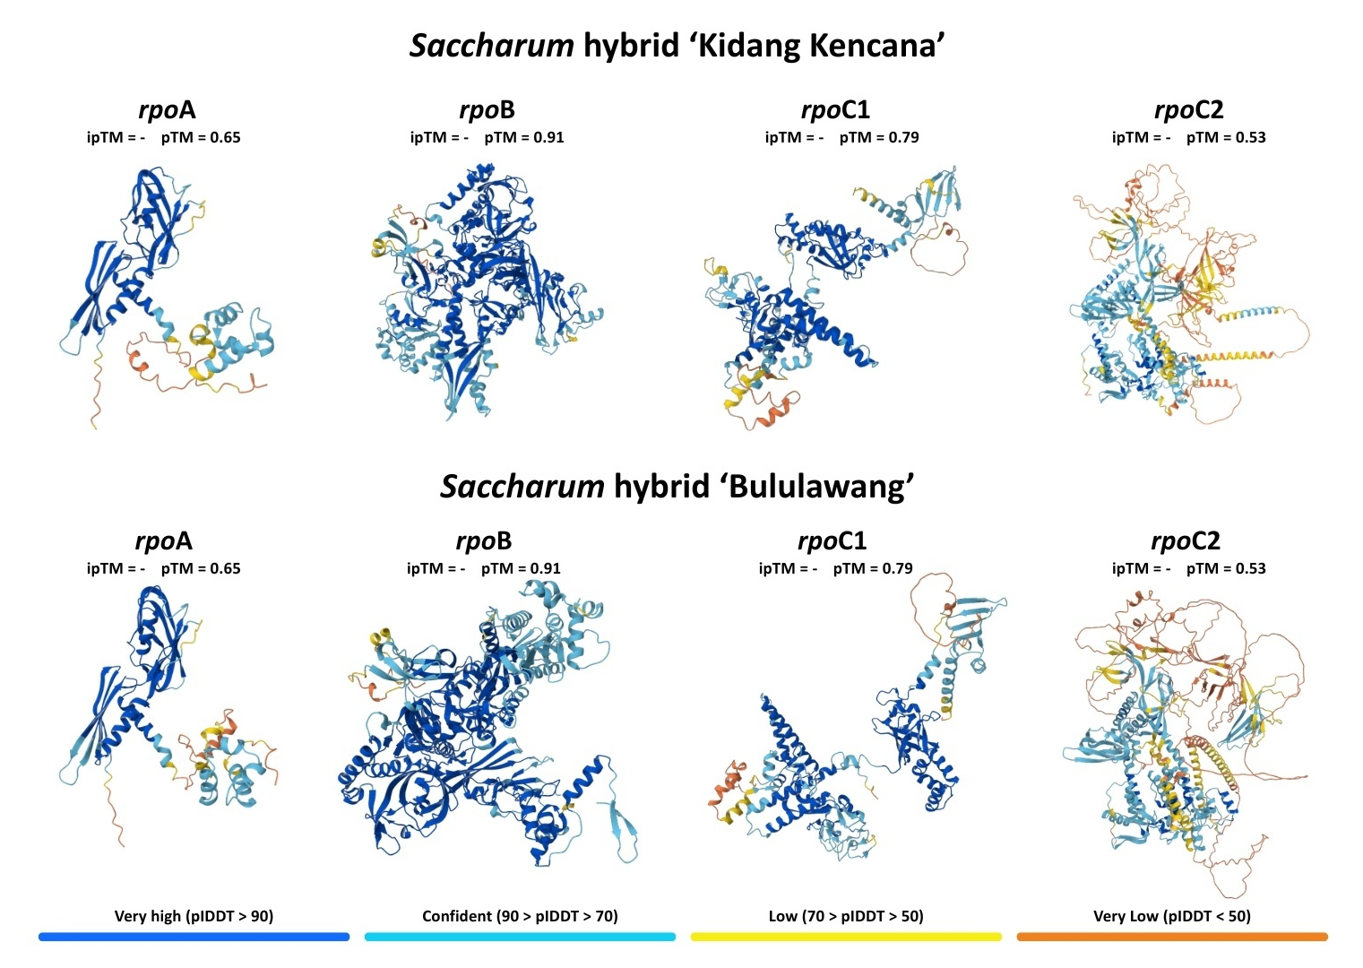
Fig. 3: Predicted 3D structures of rpo proteins in Saccharum hybrid ‘Kidang Kencana’ and ‘Bululawang’.

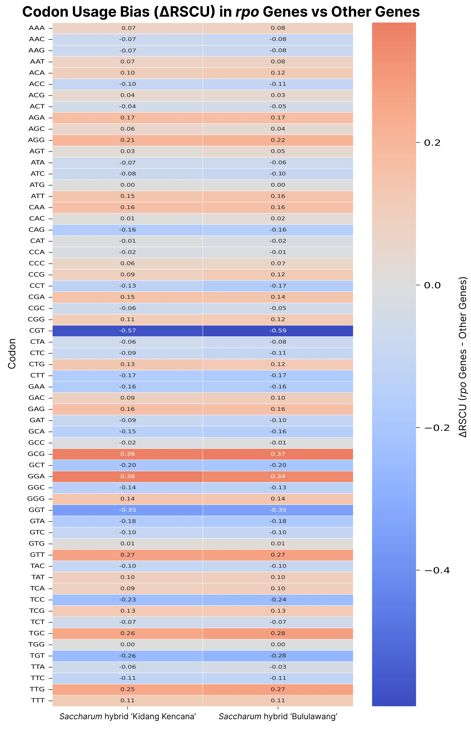
Fig. 4: Comparative codon usage bias of rpo genes vs other chloroplast genes in Saccharum hybrid ‘Kidang Kencana’ and ‘Bululawang’.
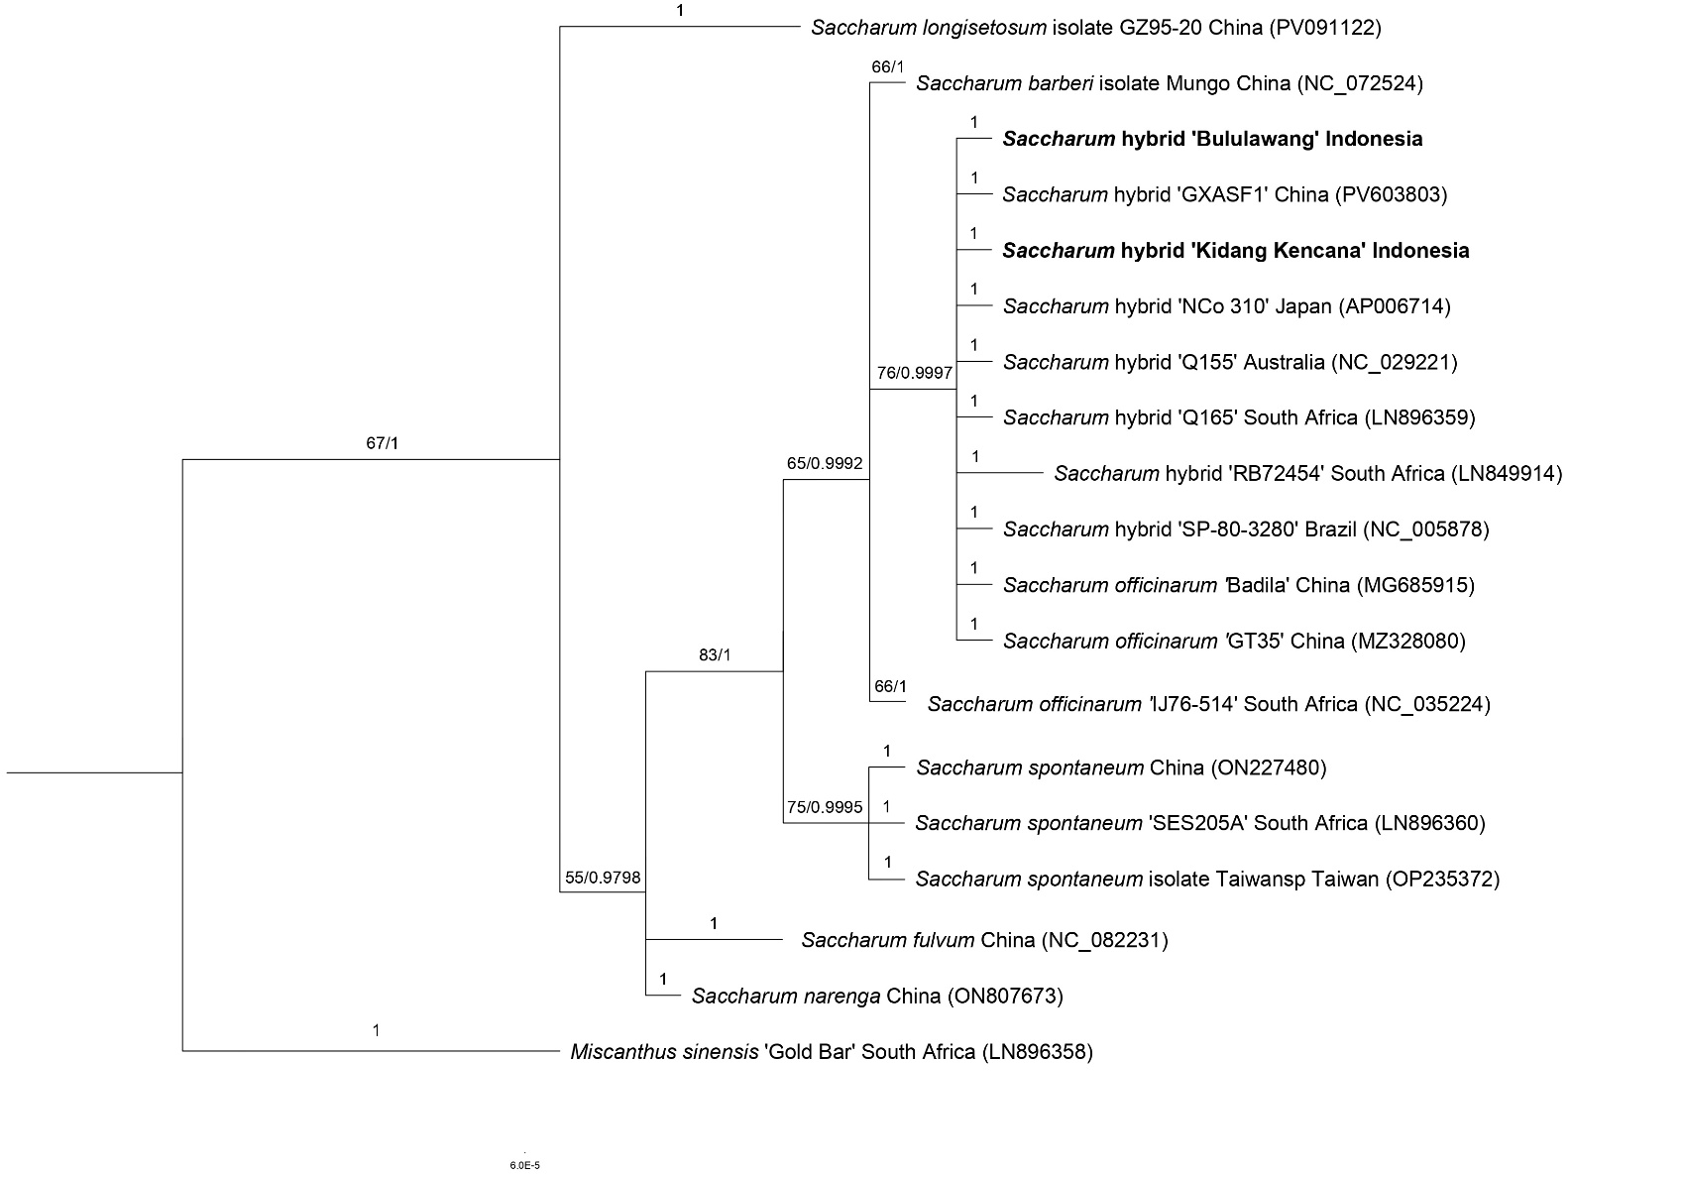
Fig. 5: Phylogenetic reconstruction of the rpo gene family in Saccharum hybrid ‘Kidang Kencana’ and ‘Bululawang’, including related Saccharum species and an outgroup, inferred using Maximum Likelihood (ML) and Bayesian Inference (BI) methods. Node support values are presented as ML bootstrap percentages followed by BI posterior probabilities (ML/BI).

