Research Article
Proteomic Signatures Associated with Breeding Soundness Status and Cryopreservation Resilience in Peranakan Etawah Bucks

Rahmat Rahmat¹ (https://orcid.org/0000-0002-4179-8990), Andi Ni’mahtul Churriyah¹ (https://orcid.org/0000-0003-1731-7226), Dian Tria Fatmila² (https://orcid.org/0000-0001-7083-1000), Muhammad Rizal¹ (https://orcid.org/0000-0001-8011-6748), Nursyam Andi Syarifuddin¹ (https://orcid.org/0000-0002-5311-0364), Athhar Manabi Diansyah³ (https://orcid.org/0009-0002-2338-8215), Muhammad Yusuf³(https://orcid.org/0000-0003-3421-4384), Muhammad Fajar Amrullah^{4,5}(https://orcid.org/0000-0003-1589-4572), Andi Muhammad Alfian³ (https://orcid.org/0009-0009-4874-9110)

¹Department of Animal Science, Faculty of Agriculture, Lambung Mangkurat University, Jl. Jenderal Ahmad Yani, Banjarbaru, South Kalimantan, 70714, Indonesia
²Animal Science Study Program, Faculty of Agriculture, Universitas Sumatera Utara, Medan 20155, Indonesia
³Department of Animal Production, Faculty of Animal Science, Hasanuddin University, Indonesia. Jl. Perintis Kemerdekaan 10 Tamalanrea Makassar, South Sulawesi, 90245, Indonesia
⁴Doctoral Student of Animal Biomedical Science, School of Veterinary Medicine and Biomedical Sciences, IPB University, Bogor, 16680, West Java, Indonesia
⁵Research Center for Applied Zoology, National Research and Innovation Agency, Cibinong Science Center, Jalan Raya Jakarta-Bogor, 16680, West Java, Indonesia.

*Corresponding author: Rahmat; Email: rahmatr@ulm.ac.id, Department of Animal Science, Faculty of Agriculture, Lambung Mangkurat University, Jl. Jenderal Ahmad Yani, Banjarbaru, South Kalimantan, 70714, Indonesia
Abstract
Breeding soundness examination (BSE) is widely used to evaluate male reproductive suitability, but its relationship with sperm cryopreservation resilience and molecular sperm characteristics remains insufficiently understood in Peranakan Etawah (PE) bucks. This study aimed to compare post-thaw sperm quality and sperm proteomic profiles between PE bucks classified as satisfactory (SAT; n = 10) and unsatisfactory (UNS; n = 10) using a modified BSE framework. BSE classification was based on body condition score, locomotion score, scrotal circumference, progressive motility, and sperm morphology. Frozen–thawed semen was evaluated for motility recovery and morphology preservation, while sperm proteomic profiles were analyzed using LC–MS/MS followed by differential abundance, multivariate, functional enrichment, and correlation analyses. SAT bucks showed higher total BSE score, locomotion score, progressive motility, motility recovery, and morphology preservation than UNS bucks. Proteomic analysis identified distinct sperm protein signatures between groups, with SAT-associated proteins mainly related to flagellar organization, axonemal structure, membrane regulation, energy metabolism, and oxidative stress response, including CFAP43, AKAP4, AQP3, ALDOC, CS, FLOT1, SPAG6, DNAI1, and GSTM3. In contrast, UNS-associated proteins, including MSN, ALB, and MMP9, were associated with altered membrane remodeling, extracellular protein environment, and reduced sperm functional or structural resilience. Correlation analysis showed that selected SAT-associated proteins were positively associated with progressive motility and morphology preservation, whereas UNS-associated proteins were negatively associated with these outcomes. These findings indicate that integrating BSE classification, post-thaw semen assessment, and sperm proteomic profiling provides a more comprehensive framework for evaluating reproductive soundness in PE bucks. The identified sperm protein signatures represent exploratory candidates for future validation in fertility and cryopreservation resilience studies.
Keywords: Peranakan Etawah buck; breeding soundness examination; sperm; cryopreservation resilience; proteomics

INTRODUCTION
Peranakan Etawah (PE) goats are an important local genetic resource in Indonesia and are widely maintained in smallholder production systems for meat, milk, and breeding purposes. In goat breeding programs, the reproductive performance of bucks has a major influence on herd productivity because a single male can contribute genetically and reproductively to multiple females. Therefore, accurate evaluation of buck reproductive potential is essential for breeding selection, semen utilization, and reproductive management in PE goat populations (Husen et al., 2025; Warmadewi et al., 2026).
Breeding soundness examination (BSE) is commonly used as a practical and structured approach for evaluating the reproductive suitability of male livestock. In small ruminant males, BSE generally integrates physical condition, locomotor ability, scrotal development, and semen quality parameters to support reproductive decision-making (Harighi et al., 2022). Body condition score and locomotion reflect general health and mating ability, while scrotal circumference is associated with testicular development and sperm production capacity. Semen-based parameters, particularly progressive motility and sperm morphology, provide direct information regarding sperm functional competence and structural integrity (Alam et al., 2024). Together, these parameters allow bucks to be classified according to their reproductive soundness status.
Despite its practical value, BSE remains largely dependent on phenotypic and semen-based observations. This approach is useful for routine reproductive screening, but it may not fully explain the molecular variation underlying sperm function, semen freezability, and post-thaw resilience. This limitation is particularly relevant in semen cryopreservation programs, where individual variation in post-thaw semen quality is frequently observed even when semen is processed under comparable laboratory conditions (Tanga et al., 2021). Bucks with acceptable reproductive characteristics before freezing may show different levels of sperm motility recovery and morphology preservation after thawing, indicating that conventional evaluation alone may not capture the biological mechanisms associated with cryopreservation tolerance.
Semen cryopreservation is an essential technology for the conservation, storage, distribution, and wider utilization of superior genetic material. However, freezing and thawing expose spermatozoa to cold shock, osmotic stress, membrane destabilization, oxidative damage, and structural disruption, which may reduce sperm motility and alter sperm morphology after thawing (Bodu et al., 2025). In goat semen production, individual differences in cryotolerance remain a major challenge because they can affect the efficiency of artificial insemination and the utilization of selected bucks. Therefore, evaluating sperm motility recovery and morphology preservation after cryopreservation in relation to BSE status may provide a more informative assessment of buck reproductive potential.
Sperm proteomic analysis offers a complementary molecular approach for understanding the biological basis of sperm quality and cryopreservation resilience. Sperm proteins are involved in key processes such as flagellar movement, axonemal organization, membrane stability, energy metabolism, oxidative stress response, and fertilization-related functions (Sahiruddin et al., 2026). Changes in sperm protein abundance may therefore reflect differences in sperm functional capacity and cellular adaptation to cryopreservation-induced stress. Previous studies in livestock have shown that sperm proteomic profiles are associated with semen quality, fertility-related traits, and freezing tolerance (Jia et al., 2022; Keller et al., 2026). However, information linking BSE-based reproductive classification with frozen–thawed semen quality and sperm proteomic signatures in PE bucks remains limited.
This knowledge gap is important because PE buck selection is still largely based on conventional reproductive evaluation, while the molecular characteristics that distinguish satisfactory and unsatisfactory bucks are poorly understood. Integrating BSE classification with cryopreservation outcome assessment and sperm proteomic profiling may provide a more comprehensive framework for identifying reproductive soundness-associated protein signatures. Such an approach may improve the biological interpretation of BSE status and support the selection of bucks with better semen quality and cryopreservation resilience.
Therefore, this study aimed to compare sperm motility recovery, sperm morphology preservation, and sperm proteomic profiles between PE bucks classified as satisfactory and unsatisfactory based on a modified BSE framework. This study was designed to determine whether BSE status is associated with post-thaw sperm resilience and distinct sperm protein signatures, thereby providing an integrated phenotypic and molecular interpretation of reproductive soundness in PE bucks.
MATERIALS AND METHODS
Experimental Design and Ethical Approval
This study was designed to compare breeding soundness status, sperm motility recovery, sperm morphology preservation, and sperm proteomic profiles in Peranakan Etawah (PE) bucks. Twenty clinically healthy PE bucks were used and classified into two groups based on a modified breeding soundness examination (BSE) framework: satisfactory (SAT; n = 10) and unsatisfactory (UNS; n = 10). The BSE framework included body condition score, locomotion score, scrotal circumference, progressive motility, and sperm morphology.
All bucks were maintained under comparable feeding, housing, and management conditions to minimize non-experimental variation. Physical and scrotal examinations were performed before semen collection. Fresh semen was evaluated for progressive motility and sperm morphology and used as the basis for BSE classification. Semen samples were then processed for cryopreservation, and frozen–thawed semen was used to evaluate sperm motility recovery and sperm morphology preservation. Sperm pellets obtained from frozen–thawed semen were further processed for LC–MS/MS-based proteomic analysis. This design was used to determine whether BSE status was associated with cryopreservation-related sperm resilience and sperm protein abundance profiles.
The use of animal biological materials was reviewed and approved by the Ethics Committee of the Department of Animal Science, Faculty of Agriculture, Lambung Mangkurat University, South Kalimantan, Indonesia (Approval No. 381/UN8.1.23.5/PG/2026). All procedures were conducted in accordance with institutional and national ethical standards for research involving animal biological samples.

BSE and Group Classification

Breeding soundness examination was used as the primary framework to classify PE bucks into SAT and UNS groups. The modified BSE system was based on selected physical and semen-based reproductive soundness indicators, including body condition score, locomotion score, scrotal circumference, progressive motility, and sperm morphology. This scoring framework was adapted from reproductive soundness evaluation principles for small ruminant males, in which physical condition, locomotor ability, scrotal development, and semen quality are considered key components of male reproductive evaluation (Whitesell et al., 2020; Harrison et al., 2022).

A modified total BSE score was calculated from five indicators with a maximum total score of 100 points. Body condition score and locomotion score contributed 10 points each, scrotal circumference contributed 20 points, progressive motility contributed 30 points, and sperm morphology contributed 30 points. Greater weighting was assigned to semen-based parameters because progressive motility and sperm morphology directly reflect sperm functional competence and structural integrity.

The detailed scoring criteria and cut-off values used in this study are presented in Table 1. Bucks were classified as SAT when they obtained a total BSE score of ≥70 and fulfilled both major semen-based criteria, namely progressive motility ≥70% and sperm morphology ≥80% morphologically normal spermatozoa. Bucks were classified as UNS when they obtained a total BSE score of <70, failed to meet the progressive motility criterion, failed to meet the sperm morphology criterion, and/or failed to meet both major semen-based criteria. The final BSE classification was used as the primary grouping variable for subsequent comparison of sperm motility recovery, sperm morphology preservation, and sperm proteomic profiles.

Physical and Scrotal Examination

Physical and scrotal examinations were performed before semen collection. Body condition score was assessed using a 1–5 scale, where 1 indicated emaciated, 2 thin, 3 moderates to ideal, 4 fat, and 5 obese body condition. Locomotion was evaluated using a modified 1–5 scale based on the ability of each buck to stand, walk, and support reproductive activity, with higher scores indicating better locomotor function. Scrotal circumference was measured at the widest part of the scrotum using a flexible measuring tape and recorded in centimeters (Ouchene-Khelifi & Ouchene, 2021).

Fresh Semen Assessment

Fresh semen assessment focused on progressive motility and sperm morphology. Immediately after collection, semen samples were gently homogenized and maintained at 37°C before evaluation.

Progressive motility was evaluated using a computer-assisted sperm analysis system (SpermVision™, Minitube GmbH, Tiefenbach, Germany). For CASA analysis, fresh semen was diluted in a physiological medium to obtain an appropriate sperm concentration for motility assessment. A 10 µL aliquot of diluted semen was loaded onto a pre-warmed chamber slide and examined at 37°C. Progressive motility was expressed as the percentage of spermatozoa showing forward progressive movement. Several microscopic fields were analyzed for each sample according to the CASA system settings (Diansyah et al., 2025a).

Sperm morphology was assessed using eosin–nigrosin staining. Briefly, 10 µL of fresh semen was mixed with 20 µL of eosin–nigrosin stain on a clean glass slide, gently homogenized, and smeared to produce a thin and uniform film. The smear was air-dried and examined under a trinocular microscope (Olympus CX33, Olympus Corporation, Tokyo, Japan) at 400× magnification. A minimum of 200 spermatozoa per sample were evaluated in duplicate smears, and the mean value was used for analysis. Morphological defects were classified as head, midpiece, and tail defects (Diansyah et al., 2025b). Sperm morphology was expressed as the percentage of morphologically normal spermatozoa relative to the total number of spermatozoa observed.

Semen Processing and Cryopreservation

Semen processing and cryopreservation were performed following standard laboratory procedures with minor modifications (Sun et al., 2020). Fresh semen samples were diluted using a commercial soybean lecithin-based extender, AndroMed® (Minitube GmbH, Tiefenbach, Germany), according to the manufacturer’s instructions. Diluted semen was loaded into 0.25 mL sterile straws, equilibrated at 4°C, frozen in liquid nitrogen vapor, and stored in liquid nitrogen at −196°C until further evaluation.

Before post-thaw assessment, frozen semen straws were thawed in a water bath at 37°C for 30 s. Frozen–thawed progressive motility and sperm morphology were evaluated using the same CASA-based and eosin–nigrosin staining procedures described for fresh semen assessment.

Cryopreservation Outcomes

Cryopreservation outcomes were assessed based on sperm motility recovery and sperm morphology preservation. Motility recovery was determined by comparing progressive motility after thawing with the corresponding fresh progressive motility value. Sperm morphology preservation was determined by comparing the percentage of morphologically normal spermatozoa after thawing with the corresponding fresh morphology value. These parameters were used to evaluate the ability of spermatozoa to maintain functional movement and structural integrity after cryopreservation. Both cryopreservation outcome variables were analyzed as post-classification endpoints and were not included in the initial BSE-based group classification (Tamburrino et al., 2025).

Proteomic Analysis and Data Processing

Proteomic analysis was performed using a Thermo Scientific™ Vanquish™ Horizon UHPLC system coupled to a Thermo Scientific™ Orbitrap™ Exploris 240 high-resolution mass spectrometer (Thermo Fisher Scientific, Waltham, MA, USA) (Zheng et al., 2022). Peptide separation was carried out on a reversed-phase C18 analytical column using a binary mobile phase system consisting of MS-grade water with 0.1% formic acid as mobile phase A and MS-grade acetonitrile with 0.1% formic acid as mobile phase B. Peptide samples were injected into the LC system and separated using a gradient elution program optimized for peptide analysis. The gradient was initiated at a low proportion of mobile phase B, gradually increased to elute peptides according to their hydrophobicity, and then returned to the initial condition for column re-equilibration.

Mass spectrometric acquisition was performed using electrospray ionization in positive ion mode. Full-scan MS spectra were acquired across an appropriate peptide mass range, followed by data-dependent MS/MS acquisition of selected precursor ions. Peptide fragmentation was performed using higher-energy collisional dissociation with optimized collision energy settings, and nitrogen was used as the collision gas.

Raw LC–MS/MS data were processed using Proteome Discoverer software, version 3.0 (Thermo Fisher Scientific, Waltham, MA, USA). The acquired MS/MS spectra were searched against the Capra hircus protein database retrieved from UniProt, together with common contaminant sequences. Database searching was performed using trypsin as the digestion enzyme. Carbamidomethylation of cysteine was set as a fixed modification, while methionine oxidation was set as a variable modification. Protein identifications were filtered using a false discovery rate threshold of 1% at both peptide and protein levels (Diansyah et al., 2025c).

Bioinformatic and Statistical Analysis

The resulting protein abundance matrix was used for downstream bioinformatic and statistical analyses. Protein identifiers were standardized using the UniProt database (https://www.uniprot.org/) to obtain accession numbers, gene names, protein names, and functional annotations. Protein distribution and overlap between SAT and UNS bucks were visualized using Venny 2.1 (https://bioinfogp.cnb.csic.es/tools/venny/) after protein identifier standardization.

Proteomic statistical analysis was performed using MetaboAnalyst 6.0 (https://www.metaboanalyst.ca/). The protein abundance matrix was processed through missing value checking, normalization, transformation, and scaling before analysis. Differentially abundant proteins were identified using fold-change analysis and statistical significance testing. Proteins with fold change ≥2.0 and p-value <0.1 were considered exploratory differentially abundant candidate proteins. The comparison direction was set as SAT/UNS; therefore, positive log2 fold-change values indicated higher abundance in SAT bucks, while negative log2 fold-change values indicated higher abundance in UNS bucks.

Principal component analysis, hierarchical clustering heatmap, volcano plot, and partial least squares–discriminant analysis were used to evaluate proteomic separation patterns between groups. Proteins with variable importance in projection scores >1.0 were considered important contributors to group discrimination. Functional enrichment analysis was performed using g (https://biit.cs.ut.ee/gprofiler/) to identify enriched Gene Ontology terms related to biological process, molecular function, and cellular component. Candidate proteins were prioritized by integrating differential abundance direction, VIP score, functional annotation, and biological relevance to sperm motility, morphology preservation, energy metabolism, membrane function, flagellar structure, oxidative stress response, and reproductive soundness status (Xu et al., 2022; Damayanti et al., 2026).

Correlation analysis was performed to evaluate the association between selected candidate proteins and reproductive parameters, including progressive motility, normal sperm morphology, motility recovery, and morphology preservation. Pearson correlation analysis was used to determine the direction and strength of association, with statistical significance set at p < 0.05.

Statistical analysis of BSE parameters, fresh semen quality, sperm motility recovery, and sperm morphology preservation was performed using IBM SPSS Statistics, version 27 (IBM Corp., Armonk, NY, USA). Data normality was assessed using the Shapiro–Wilk test. Total BSE score, individual BSE components, fresh progressive motility, fresh sperm morphology, motility recovery, and sperm morphology preservation were compared between SAT and UNS bucks using an independent samples t-test when data were normally distributed. Results were presented as mean ± standard deviation, with statistical significance set at p < 0.05.

RESULTS AND DISCUSSION
Result

Breeding Soundness Examination and Classification of PE Bucks

Breeding Soundness Examination revealed differences in selected reproductive soundness parameters between SAT and UNS bucks (Table 2). Locomotion score and progressive motility were significantly higher in SAT bucks than in UNS bucks (p < 0.05), whereas body condition score, scrotal circumference, and normal sperm morphology did not differ significantly between groups (p > 0.05). Total BSE score was also significantly higher in SAT bucks compared with UNS bucks (p < 0.001). Although the mean total BSE score of UNS bucks remained above the minimum numerical threshold, these bucks were classified as UNS because they failed to meet at least one major semen-based criterion, particularly progressive motility. These findings indicate that the BSE-based classification was primarily driven by cumulative reproductive soundness score, locomotor capacity, and progressive sperm motility, while body condition, scrotal circumference, and sperm morphology showed relatively comparable values between groups.

Cryopreservation Resilience of SAT and UNS Bucks
Sperm motility recovery and morphology preservation after cryopreservation differed between SAT and UNS bucks (Figure 1). SAT bucks showed significantly higher motility recovery than UNS bucks (59.8 ± 7.6% vs. 56.9 ± 7.9%; p = 0.047; Figure 1A). Morphology preservation was also significantly higher in SAT bucks compared with UNS bucks (92.4 ± 3.1% vs. 89.1 ± 3.6%; p = 0.041; Figure 1B). These findings indicate that BSE status was associated with post-thaw sperm resilience, particularly the maintenance of progressive motility and preservation of morphologically normal spermatozoa after cryopreservation.
Differentially Abundant Sperm Proteins Between SAT and UNS Bucks
Differential abundance analysis identified 32 sperm proteins that differed between SAT and UNS bucks based on the exploratory screening criteria (Table 3; Figure 2). Of these proteins, 22 showed higher abundance in SAT bucks, whereas 10 showed higher abundance in UNS bucks. The volcano plot showed a direction-specific distribution of differentially abundant proteins, with SAT-associated proteins located on the positive log2(FC) side and UNS-associated proteins located on the negative log2(FC) side.
SAT-associated proteins included AKAP4, AQP3, ALDOC, CS, FLOT1, SPAG6, ENO1L, DNAI1, SEPT4, VDAC2, ATP5F1A, SPACA1, ACE, ENO1, SDHA, TUBA1B, MFGE8, ATP5F1B, IDH3A, FLOT2, and UPF157. In contrast, UNS-associated proteins included MMP9, EZR, PRDX1, HSPB1, FGB, CTSB, HEXB, MPO, H2BC1, UPF176, and UPF152. Several SAT-associated proteins were related to sperm structural organization, flagellar function, membrane regulation, and energy metabolism, whereas UNS-associated proteins were mainly linked to stress response, inflammatory activity, extracellular matrix remodeling, and altered cellular homeostasis. These findings indicate that BSE classification was accompanied by direction-specific changes in sperm protein abundance between SAT and UNS bucks.

Multivariate Proteomic Separation Between SAT and UNS Bucks

Multivariate analysis showed a distinct separation pattern of sperm proteomic profiles between SAT and UNS bucks (Figure 3). The PCA score plot demonstrated group clustering along PC1, which explained 43.6% of the total variation, whereas PC2 explained 5.5% of the variation (Figure 3A). The biplot indicated that SAT-associated proteins, including CFAP43, AKAP4, AQP3, ALDOC, CS, FLOT1, and SPAG6, contributed to the SAT cluster, while MSN, ALB, and MMP9 contributed to the UNS cluster (Figure 3B). Hierarchical clustering analysis further showed group-specific protein abundance patterns, with SAT bucks generally characterized by higher abundance of flagellar, membrane-associated, and metabolic proteins, whereas UNS bucks showed higher abundance of MSN, ALB, and MMP9 (Figure 3C). The VIP score plot identified 15 proteins with VIP scores >1.0, indicating their major contribution to proteomic separation between SAT and UNS bucks (Figure 3D). These findings indicate that BSE classification was accompanied by distinct sperm proteomic signatures in PE bucks.

Functional Enrichment of BSE-Associated Candidate Proteins

Functional enrichment analysis showed that BSE-associated candidate proteins were mainly related to sperm structural organization, flagellar function, and membrane-associated cellular components (Table 4). The enriched Gene Ontology terms consisted of one molecular function term, three biological process terms, and three cellular component terms. The most significant enriched term was 9+2 motile cilium (GO:0097729; adjusted p < 0.01), which involved CFAP43, AKAP4, SPAG6, DNAI1, and GSTM3.

Biological process enrichment was associated with epithelial cilium movement, sperm flagellum assembly, and axoneme assembly. These terms were represented primarily by flagellar and axonemal proteins, including CFAP43, SPAG6, AKAP4, and DNAI1. In addition, membrane-associated enrichment terms, including uropod and basolateral plasma membrane, were linked to MSN, FLOT1, and AQP3. These findings indicate that BSE-associated candidate proteins were functionally concentrated in processes related to sperm motility machinery, flagellar architecture, axonemal organization, and membrane regulation.

Candidate Protein Signatures of Breeding Soundness Examination Status

Candidate protein signatures associated with Breeding Soundness Examination status were prioritized by integrating abundance direction, VIP score, and Gene Ontology term assignment (Table 5). Of the 15 VIP-ranked proteins, 12 were retained as prioritized candidate proteins because they showed clear group direction, VIP score >1.0, and assignment to at least one enriched GO term.

Most prioritized candidate proteins were higher in SAT bucks, including CFAP43, AKAP4, AQP3, ALDOC, CS, FLOT1, SPAG6, DNAI1, and GSTM3. In contrast, MSN, ALB, and MMP9 were higher in UNS bucks. The highest VIP-ranked candidates included CFAP43, AKAP4, MSN, AQP3, and ALDOC, indicating their major contribution to the proteomic separation between BSE classifications.

SAT-associated candidate proteins were mainly linked to flagellar structure, axoneme organization, motile cilium components, membrane regulation, energy metabolism, and oxidative stress response. In contrast, UNS-associated candidate proteins were associated with membrane remodeling, extracellular matrix regulation, and altered sperm cellular status. These prioritized proteins were subsequently used for correlation analysis with sperm quality and cryopreservation-related outcomes.

Association Between Candidate Protein Signatures and Sperm Quality and Cryopreservation Outcomes

Correlation analysis showed that selected candidate protein signatures were associated with sperm quality and cryopreservation-related outcomes (Figure 4). Among SAT-associated proteins, ALDOC was positively correlated with progressive motility (p < 0.05), while AKAP4, AQP3, DNAI1, and GSTM3 were positively correlated with morphology preservation after cryopreservation (p < 0.05). In contrast, UNS-associated proteins showed negative associations with reproductive outcomes. ALB and MMP9 were negatively correlated with progressive motility (p < 0.05), whereas MSN and MMP9 were negatively correlated with morphology preservation, with the strongest negative association observed for MMP9 (p < 0.01).

No significant correlations were observed between the selected candidate proteins and normal sperm morphology or motility recovery rate. These findings indicate that the prioritized candidate protein signatures were more closely associated with progressive sperm movement and preservation of sperm morphology after cryopreservation than with baseline sperm morphology alone.

Discussion
This study provides an integrated interpretation of reproductive soundness in Peranakan Etawah bucks by combining BSE-based classification, cryopreservation outcome assessment, and sperm proteomic profiling. The main findings showed that SAT bucks had higher total BSE score, locomotion score, progressive motility, motility recovery, and morphology preservation than UNS bucks. These phenotypic differences were accompanied by distinct sperm proteomic signatures, particularly involving candidate proteins related to flagellar organization, axonemal structure, membrane regulation, energy metabolism, oxidative stress response, and altered cellular status. The prioritized SAT-associated proteins included CFAP43, AKAP4, AQP3, ALDOC, CS, FLOT1, SPAG6, DNAI1, and GSTM3, whereas the prioritized UNS-associated proteins included MSN, ALB, and MMP9. These findings indicate that BSE status in PE bucks was associated not only with conventional reproductive traits but also with molecular differences that may be relevant to sperm function and post-thaw resilience.
BSE remains a practical and structured approach for evaluating reproductive suitability in male livestock because it integrates physical condition, locomotor ability, scrotal development, and semen quality parameters (Diaz-Miranda et al., 2024). In the present study, SAT bucks had significantly higher total BSE scores than UNS bucks, supporting the ability of the modified BSE framework to separate bucks according to reproductive soundness status. However, not all BSE components differed between groups. Body condition score, scrotal circumference, and normal sperm morphology were relatively comparable, whereas locomotion score and progressive motility were significantly higher in SAT bucks. This pattern suggests that the classification difference was mainly driven by cumulative reproductive soundness, locomotor capacity, and sperm movement rather than general body condition, scrotal size, and baseline sperm morphology.
The classification of UNS bucks despite a mean total BSE score above the minimum numerical threshold highlights the importance of major semen-based criteria in the modified BSE system. Bucks with acceptable total scores may still be classified as unsatisfactory when they fail to meet key semen quality criteria, particularly progressive motility. Progressive motility is one of the most direct indicators of sperm functional competence because it reflects the ability of spermatozoa to move effectively and participate in fertilization-related processes (Li et al., 2016; Harighi et al., 2022). Therefore, reduced progressive motility in UNS bucks may represent a functional limitation that is not fully captured by physical traits alone.
Cryopreservation further differentiated SAT and UNS bucks. SAT bucks showed higher motility recovery and morphology preservation after thawing, indicating better post-thaw sperm resilience. Although the numerical differences were relatively small, the significant group differences suggest that BSE status may be associated with the ability of spermatozoa to withstand freezing and thawing stress. Cryopreservation can expose spermatozoa to cold shock, osmotic imbalance, membrane destabilization, oxidative stress, and structural disruption (Milewska et al., 2024; Ananda et al., 2025). Therefore, the better post-thaw outcomes observed in SAT bucks are consistent with greater sperm functional and structural stability during cryopreservation.
The prioritized SAT-associated protein signatures provide a molecular explanation for the better reproductive and post-thaw outcomes observed in SAT bucks. CFAP43, AKAP4, SPAG6, and DNAI1 are closely related to sperm flagellar structure, axonemal organization, and motile cilium function. These proteins are relevant because sperm progressive motility depends on the structural integrity and coordinated activity of the flagellum and axoneme (Liang et al., 2021; Zhou et al., 2023). The higher contribution of these proteins to the SAT proteomic profile supports the interpretation that SAT bucks had a more favorable molecular background for maintaining sperm movement.
AKAP4 is particularly important because it is a major component of the sperm flagellar fibrous sheath and contributes to the organization of signaling complexes involved in motility regulation (Blommaert et al., 2019). Together with CFAP43, SPAG6, and DNAI1, the higher abundance of AKAP4 in SAT bucks is consistent with the enrichment of sperm flagellum assembly, axoneme assembly, and 9+2 motile cilium terms. This finding strengthens the biological link between BSE status, progressive motility, and the molecular architecture of sperm motility machinery.
Energy metabolism also appeared to be an important feature of the SAT-associated protein profile. ALDOC and CS were prioritized as SAT-associated candidate proteins and may reflect the metabolic support required for sperm movement. ALDOC is involved in glycolytic metabolism, while CS is associated with mitochondrial energy metabolism (Kang et al., 2020; Jia et al., 2021). Spermatozoa require continuous ATP supply to maintain flagellar beating and progressive movement. Therefore, the positive association between ALDOC and progressive motility suggests that metabolic protein support may contribute to better sperm functional competence in SAT bucks.
Membrane regulation was another important component of the SAT-associated signature. AQP3 and FLOT1 were higher in SAT bucks and were linked to membrane-associated enrichment terms. AQP3 is involved in water and small solute transport, whereas FLOT1 is associated with membrane microdomain organization (Delgado-Bermúdez et al., 2021; Lu et al., 2026). During cryopreservation, sperm membranes are exposed to osmotic and temperature-related stress. Therefore, the SAT-associated increase in AQP3 and FLOT1 may indicate better membrane adaptation and structural stability during freezing and thawing.
The presence of GSTM3 among SAT-associated candidate proteins suggests that antioxidant-related mechanisms may also be involved in post-thaw resilience. Cryopreservation can increase reactive oxygen species production and damage sperm membranes, proteins, and cellular structures (Llavanera et al., 2019). GSTM3, as a glutathione S-transferase family protein, may contribute to cellular defense against oxidative stress. Although oxidative stress markers were not directly measured in this study, the positive association between GSTM3 and morphology preservation supports the interpretation that antioxidant-related protein signatures may contribute to better structural preservation after cryopreservation.
In contrast, the prioritized UNS-associated proteins, including MSN, ALB, and MMP9, reflected a different molecular profile. MSN is a membrane–cytoskeleton linker protein involved in membrane organization and cytoskeletal remodeling (Cohen et al., 2022). Its higher abundance in UNS bucks may indicate altered membrane–cytoskeletal dynamics, cellular remodeling, and reduced structural stability. The negative association between MSN and morphology preservation further supports the interpretation that UNS-associated membrane remodeling signatures may be linked to lower post-thaw structural resilience.
MMP9 was another important UNS-associated candidate protein. MMP9 is involved in extracellular matrix remodeling and has been associated with inflammatory and tissue remodeling processes (Wolosowicz et al., 2025). In this study, MMP9 was negatively associated with both progressive motility and morphology preservation, indicating that higher MMP9 abundance may accompany reduced sperm function and lower post-thaw structural stability. This does not imply a direct causal role, but it suggests that MMP9 may represent part of an unfavorable sperm protein signature in UNS bucks.
ALB was also higher in UNS bucks and showed a negative association with progressive motility. Albumin may originate from seminal plasma carryover, extracellular fluid, and sample-associated protein components during sperm preparation (Almadaly et al., 2023). Therefore, ALB should be interpreted cautiously and not as a direct causal factor. In this study, higher ALB abundance may indicate an altered extracellular or sample-associated protein environment accompanying reduced sperm functional status in UNS bucks.
Functional enrichment analysis strengthened the biological interpretation of these candidate protein signatures. The enriched terms were mainly associated with protein binding, sperm flagellum assembly, axoneme assembly, 9+2 motile cilium, and membrane-associated cellular components. The enrichment of 9+2 motile cilium involving CFAP43, AKAP4, SPAG6, DNAI1, and GSTM3 is particularly relevant because mammalian sperm motility depends on the highly organized axonemal structure of the flagellum (Liang et al., 2020). This enrichment pattern provides a mechanistic link between BSE status, progressive motility, and the molecular organization of sperm motility machinery.
Correlation analysis provided additional support for the relationship between prioritized candidate proteins and sperm functional outcomes. ALDOC was positively associated with progressive motility, while AKAP4, AQP3, DNAI1, and GSTM3 were positively associated with morphology preservation after cryopreservation. Conversely, ALB and MMP9 were negatively associated with progressive motility, while MSN and MMP9 were negatively associated with morphology preservation. These associations indicate that SAT-associated proteins were linked to favorable sperm outcomes, whereas UNS-associated proteins were linked to reduced sperm functional and structural resilience.
Interestingly, no significant correlations were observed between the selected candidate proteins and baseline normal sperm morphology or motility recovery rate. This finding may indicate that the prioritized protein signatures were more closely related to progressive sperm movement and preservation of sperm morphology after cryopreservation than to baseline morphology alone. Baseline sperm morphology is a useful phenotypic indicator, but it may not fully reflect the molecular capacity of spermatozoa to withstand freezing and thawing stress. In contrast, morphology preservation after thawing represents a dynamic outcome that reflects structural stability under cryopreservation conditions.
From an applied perspective, these findings suggest that BSE classification may be strengthened by molecular information related to sperm function and cryopreservation resilience. Conventional BSE remains essential because it is practical, accessible, and applicable under field conditions. However, sperm proteomic profiling can provide additional biological insight into why bucks with different BSE status differ in post-thaw semen quality. In semen production programs, prioritized protein signatures such as CFAP43, AKAP4, AQP3, ALDOC, DNAI1, GSTM3, MSN, ALB, and MMP9 may help guide future studies on molecular indicators of sperm quality and freezing tolerance. Nevertheless, these proteins should be considered exploratory candidate signatures rather than validated biomarkers at this stage.
This study has several limitations. First, the sample size was relatively limited, with 10 bucks per group, which may affect the generalizability of the findings. Second, the study used an exploratory proteomic approach, and the prioritized candidate proteins were not validated using targeted proteomics, Western blotting, ELISA, and independent biological cohorts. Third, fertility outcomes after artificial insemination were not included, so the relationship between the identified protein signatures and actual fertility remains to be confirmed. Fourth, oxidative stress, mitochondrial activity, membrane integrity, and DNA integrity were not directly measured, although several identified proteins were biologically related to these processes. Future studies should include larger populations, targeted protein validation, functional sperm assays, and fertility outcome data to confirm the biological and practical relevance of the candidate protein signatures identified in this study.
Overall, these findings support the interpretation that BSE status in PE bucks is accompanied by differences in post-thaw sperm resilience and sperm proteomic signatures, particularly proteins related to flagellar architecture, energy metabolism, membrane regulation, oxidative stress defense, and altered cellular status. The integration of BSE, cryopreservation outcomes, and sperm proteomics provides a more comprehensive framework for understanding reproductive soundness in PE bucks and supports the use of sperm protein signatures as complementary indicators for evaluating semen quality and cryopreservation resilience.
CONCLUSION
This study demonstrates that BSE status in Peranakan Etawah bucks is associated with sperm cryopreservation resilience and distinct sperm proteomic profiles. SAT bucks showed higher total BSE score, locomotion score, progressive motility, motility recovery, and morphology preservation than UNS bucks. The SAT-associated protein signatures, including CFAP43, AKAP4, AQP3, ALDOC, CS, FLOT1, SPAG6, DNAI1, and GSTM3, were mainly related to flagellar organization, axonemal structure, membrane regulation, energy metabolism, and oxidative stress response, whereas UNS-associated proteins, including MSN, ALB, and MMP9, were linked to altered membrane remodeling, extracellular protein environment, and reduced sperm functional or structural resilience. These findings indicate that integrating BSE classification, post-thaw semen assessment, and sperm proteomic profiling provides a more comprehensive framework for evaluating reproductive soundness in PE bucks, although the identified protein signatures remain exploratory candidates that require further validation using larger populations, targeted protein analysis, functional sperm assays, and fertility outcome data.
Funding Source
This research was supported by Beginner Lecturer Research Funding, Research and Community Service Program, Directorate of Research and Community Service, Ministry of Higher Education, Science, and Technology of the Republic of Indonesia (Grant Number: 233/C3/DT.05.00/PL-BARU/2026).
Acknowledgements
The authors gratefully acknowledge the support provided by the Beginner Lecturer Research Funding, Research and Community Service Program, Directorate of Research and Community Service, Ministry of Higher Education, Science, and Technology of the Republic of Indonesia (Grant Number: 233/C3/DT.05.00/PL-BARU/2026).
Conflict of Interest
The author declares that he has no conflict of interest in this article.
Data Availability
All data supporting the findings of the study are available within the manuscript.
Ethics Statement/Ethical Approval
All experimental procedures involving animals were conducted in accordance with institutional guidelines for animal care and use. Ethical approval for this study was obtained from the Animal Research Ethics Committee of the Department of Animal Science, Faculty of Agriculture, Lambung Mangkurat University, South Kalimantan, Indonesia (Approval No. 381/UN8.1.23.5/PG/2026).
Authors Contribution
RR, ANC, DTF, AMD, MR and MFA: Conceived, designed, and coordinated the study. RR, ANC, AMD and DTF: Principal investigators. MR, AMD, MY, MFA, and AMA: Designed data collection tools. RR, ANC, DTF, NAS, AMD, MY, MFA, and AMA: Supervised field sampling, data collection, laboratory work, and data entry. RR, AMD, MY, MFA, and AMA: Performed statistical analysis, interpreted the data, and drafted the manuscript. All authors contributed to the study design, critically reviewed the manuscript, and approved the final version of the manuscript.
Generative Ai Statements.
The authors declare that no Generative AI was used in the creation of this manuscript

REFERENCE
Alam K, Srivastava S, Kumar R, Saurabh, Verma AK, Verma SK, Jaiswal A and Verma HC, 2024. Testicular biometry and its relationship with body weight and semen parameters of Sirohi and Jamnapari bucks. The Indian Journal of Animal Reproduction 45: 29-34. https://doi.org/10.48165/ijar.2024.45.01.7
Almadaly EA, Abdel-Salam AS, Sahwan FM, Kahilo KA, Abouzed TK and El-Domany WB, 2023. Fertility-associated biochemical components in seminal plasma and serum of buffalo (Bubalus bubalis) bulls. Frontiers in Veterinary Science 9: 1043379. https://doi.org/10.3389/fvets.2022.1043379
Ananda A, Gusdinal H, Ramadhan R, Abimanyu AA, Ningsih WH and Jaswandi, 2025. Impacts of cryopreservation on semen quality and sperm protein profiles of Pesisir bulls. Tropical Animal Science Journal 48: 189-198. https://doi.org/10.5398/tasj.2025.48.3.189
Blommaert D, Sergeant N, Delehedde M, Jouy N, Mitchell V, Franck T, Donnay I, Lejeune JP and Serteyn D, 2019. Expression, localization, and concentration of A-kinase anchor protein 4 (AKAP4) and its precursor (proAKAP4) in equine semen: Promising marker correlated to the total and progressive motility in thawed spermatozoa. Theriogenology 131: 52-60. https://doi.org/10.1016/j.theriogenology.2019.03.011
Bodu M, Hitit M, Greenwood OC, Murray RD and Memili E, 2025. Extender development for optimal cryopreservation of buck sperm to increase reproductive efficiency of goats. Frontiers in Veterinary Science 12: 1554771. https://doi.org/10.3389/fvets.2025.1554771
Cohen J, Wang L, Marques S, Ialy-Radio C, Barbaux S, Lefèvre B, Gourier C and Ziyyat A, 2022. Oocyte ERM and EWI proteins are involved in mouse fertilization. Frontiers in Cell and Developmental Biology 10: 863729. https://doi.org/10.3389/fcell.2022.863729
Damayanti E, Diansyah AM, Azis IU, Irawan F, Maulana T, Muhajir M, Dagong MIA and Kartika NA, 2026. Proteomic profile of seminal plasma in tropical Saanen bucks under heat stress using 1D-SDS PAGE. Open Veterinary Journal 16: 354-362. https://doi.org/10.5455/OVJ.2026.v16.i1.32
Delgado-Bermúdez A, Recuero S, Llavanera M, Mateo-Otero Y, Sandu A, Barranco I, Ribas-Maynou J and Yeste M, 2021. Aquaporins are essential to maintain motility and membrane lipid architecture during mammalian sperm capacitation. Frontiers in Cell and Developmental Biology 9: 656438. https://doi.org/10.3389/fcell.2021.656438
Diansyah AM, Nurlatifah A, Damaris C, Rahmat R, Saili T, Amrullah MF, Alfian AM, Adam AAS, Kaiin EM and Damayanti E, 2025. Evaluation of sperm sexing technique using BSA column medium in Garut rams: Enhancing sperm quality, kinematics, and fertility performance for improved breeding efficiency. Open Veterinary Journal 15: 3727-3736. https://doi.org/10.5455/OVJ.2025.v15.i8.37
Diansyah AM, Santoso S, Herdis H, Hasbi H, Saili T, Suyatno S, Said S, Kostaman T, Surachman M, Pamungkas FA, Adiati U, Anwar RI, Iskandar H, Rahmat R and Hasrin H, 2025. Proteomic analysis of seminal plasma in Bali-polled bulls: Identifying biomarkers for fertility assessment. Journal of Advanced Veterinary and Animal Research 12: 698-708. https://doi.org/10.5455/javar.2025.l933
Diansyah AM, Santoso S, Herdis H, Yusuf M, Priyatno TP, Maulana T, Toleng AL, Dagong MIA, Said S, Iskandar H, Nurlatifah A, Lestari P, Affandy L and Baharun A, 2025. Identification of reproductive performance in Bali-polled bulls using computer-assisted semen analysis and plasma seminal proteomics. Veterinary World 18: 102-109. https://doi.org/10.14202/vetworld.2025.102-109
Diaz-Miranda EA, Penitente-Filho JM, Gomez-Leon VE, Neto TM, Guimarães SF, Siqueira JB and Guimarães JD, 2024. Selection based on the breeding soundness evaluation is associated with the improvement of the reproductive quality of young Nellore bulls. Theriogenology 226: 369-377. https://doi.org/10.1016/j.theriogenology.2024.06.032
Harighi MF, Wahid H, Khumran AM and Baiee F, 2022. Breeding soundness examination (BSE): A decision-making tool that requires a particular guideline for male goats. Tropical Animal Health and Production 54: 174. https://doi.org/10.1007/s11250-022-03178-8
Harrison TD, Chaney EM, Brandt KJ, Ault-Seay TB, Schneider LG, Strickland LG, Schrick FN and McLean KJ, 2022. The effects of differing nutritional levels and body condition score on scrotal circumference, motility, and morphology of bovine sperm. Translational Animal Science 6: txac001. https://doi.org/10.1093/tas/txac001
Husen AF, Suyadi S, Parwoto Y, Sairi M, Crooijmans R and Nurgiartiningsih VMA, 2025. Estimating genetic parameters and principal component analysis of breeding values for morphometric traits in Indonesian Etawah goats. Cogent Food & Agriculture 11: 2520964. https://doi.org/10.1080/23311932.2025.2520964
Jia B, Larbi A, Lv C, Liang J, Xiang D, Zhang B, Fang Y, Shen W, Wu G and Quan G, 2022. Identification and validation of ram sperm proteins associated with cryoinjuries caused by the cryopreservation process. Theriogenology 184: 191-203. https://doi.org/10.1016/j.theriogenology.2022.03.015
Jia B, Liang J, Lv C, Memon S, Fang Y, Wu G and Quan G, 2021. The characteristics of proteome and metabolome associated with contrasting sperm motility in goat seminal plasma. Scientific Reports 11: 15562. https://doi.org/10.1038/s41598-021-95138-9
Kang W, Harada Y, Yamatoya K, Kawano N, Kanai S, Miyamoto Y, Nakamura A, Miyado M, Hayashi Y, Kuroki Y, Saito H, Iwao Y, Umezawa A and Miyado K, 2020. Extra-mitochondrial citrate synthase initiates calcium oscillation and suppresses age-dependent sperm dysfunction. Laboratory Investigation 100: 583-595. https://doi.org/10.1038/s41374-019-0353-3
Keller A, Keller E, Vorwald M, Selsby JT, Perry G and Kerns K, 2026. Comparative proteomic analysis of bovine spermatozoa before and after cryopreservation. Frontiers in Animal Science 7: 1781535. https://doi.org/10.3389/fanim.2026.1781535
Li Y, Kalo D, Zeron Y and Roth Z, 2016. Progressive motility: A potential predictive parameter for semen fertilization capacity in bovines. Zygote 24: 70-82. https://doi.org/10.1017/S0967199414000720
Liang C, He Y, Liu Y, Gao Y, Han Y, Li X, Zhao Y, Wang J and Zhang J, 2020. Fluoride exposure alters the ultra-structure of sperm flagellum via reducing key protein expressions in testis. Chemosphere 246: 125772. https://doi.org/10.1016/j.chemosphere.2019.125772
Llavanera M, Delgado-Bermúdez A, Fernandez-Fuertes B, Recuero S, Mateo Y, Bonet S, Barranco I and Yeste M, 2019. GSTM3, but not IZUMO1, is a cryotolerance marker of boar sperm. Journal of Animal Science and Biotechnology 10: 61. https://doi.org/10.1186/s40104-019-0370-5
Lu MA, Qian Y, Ma L, Hong J, Li X, Yu L, Guo Q and Gao N, 2026. Molecular mechanisms of flotillin complexes in organizing membrane microdomains. Nature Communications 17: 2541. https://doi.org/10.1038/s41467-026-69197-3
Milewska AJ, Kuczyńska A, Pawłowski M, Martynowicz I, Deluga-Białowarczuk S, Sieczyński P, Kuczyński W and Milewski R, 2024. The influence of cryopreservation on sperm morphology and its implications in terms of fractions of higher-quality sperm. Journal of Clinical Medicine 13: 7562. https://doi.org/10.3390/jcm13247562
Ouchene-Khelifi NA and Ouchene N, 2021. Relationships between age, body measurements, and testicular measurements in Arabia bucks in Algeria. Tropical Animal Health and Production 53: 91. https://doi.org/10.1007/s11250-020-02500-6
Sahiruddin S, Yusuf M, Diansyah AM, Masturi M, Herdis H, Maulana T, Sihombing VR, Rahmat R, Amrullah MF, Adam AAS, Said S and Alfian AM, 2026. Proteomic profiling of bull spermatozoa and seminal plasma to inform the rational development of functionally targeted semen extenders for tropical cattle. Veterinary World 19: 1163-1177. https://doi.org/10.14202/vetworld.2026.1163-1177
Sun L, Fan W, Wu C, Zhang S, Dai J and Zhang D, 2020. Effect of substituting different concentrations of soybean lecithin and egg yolk in tris-based extender on goat semen cryopreservation. Cryobiology 92: 146-150. https://doi.org/10.1016/j.cryobiol.2019.12.004
Tamburrino L, Traini G, Ragosta ME, Dabizzi S, Vezzani S, Scarpa F, Vignozzi L, Baldi E and Marchiani S, 2025. Semen cryopreservation and storage in liquid nitrogen: Impact on chromatin compaction. Andrology 13: 1780-1796. https://doi.org/10.1111/andr.13806
Tanga BM, Qamar AY, Raza S, Bang S, Fang X, Yoon K and Cho J, 2021. Semen evaluation: Methodological advancements in sperm quality-specific fertility assessment – A review. Animal Bioscience 34: 1253-1270. https://doi.org/10.5713/ab.21.0072
Warmadewi DA, Ardika IN, Melati NPY, Bidura IGNG, Aryawan INA and Murtika IL, 2026. Identifying potential breeding candidates in Etawah crossbred (EC) goats in Jembrana, Indonesia. Advances in Animal and Veterinary Sciences 14: 356-363. https://dx.doi.org/10.17582/journal.aavs/2026/14.2.356.363
Whitesell K, Stefanovski D, McDonnell S and Turner R, 2020. Evaluation of the effect of laboratory methods on semen analysis and breeding soundness examination (BSE) classification in stallions. Theriogenology 142: 67-76. https://doi.org/10.1016/j.theriogenology.2019.09.035
Wolosowicz M, Prokopiuk S and Kaminski TW, 2025. Matrix metalloproteinase-9 (MMP-9) as a therapeutic target: Insights into molecular pathways and clinical applications. Pharmaceutics 17: 1425. https://doi.org/10.3390/pharmaceutics17111425
Xu B, Wang Z, Wang R, Song G, Zhang Y, Su R, Liu Y, Li J and Zhang J, 2022. Metabolomics analysis of buck semen cryopreserved with trehalose. Frontiers in Genetics 13: 938622. https://doi.org/10.3389/fgene.2022.938622
Zheng R, Stejskal K, Pynn C, Mechtler K and Boychenko A, 2022. Deep single-shot NanoLC-MS proteome profiling with a 1500 bar UHPLC system, long fully porous columns, and HRAM MS. Journal of Proteome Research 21: 2545-2551. https://doi.org/10.1021/acs.jproteome.2c00270
Zhou Y, Wang Y, Chen J, Wu B, Tang S, Zhang F, Liu C and Wang L, 2023. Dnali1 is required for sperm motility and male fertility in mice. Basic and Clinical Andrology 33: 32. https://doi.org/10.1186/s12610-023-00205-y

Tables

Table 1. Modified breeding soundness examination scoring system for PE bucks
Indicator | Criteria | Score
Body condition score | BCS = 3.0-3.5 | 10
Body condition score | BCS = 2.0-2.5; BCS = 4.0 | 5
Body condition score | BCS ≤ 1.5; BCS ≥ 4.5 | 0
Locomotion score | Score 5: normal gait, able to stand and walk normally | 10
Locomotion score | Score 3-4: mild locomotor impairment but still able to support mating activity | 5
Locomotion score | Score 1-2: severe locomotor impairment affecting reproductive activity | 0
Scrotal circumference | ≥ 25.0 cm | 20
Scrotal circumference | 22.0-24.9 cm | 10
Scrotal circumference | < 22.0 cm | 0
Progressive motility | ≥ 70% | 30
Progressive motility | 50-69% | 15
Progressive motility | < 50% | 0
Sperm morphology | ≥ 80% morphologically normal spermatozoa | 30
Sperm morphology | 70–79% morphologically normal spermatozoa | 15
Sperm morphology | <70% morphologically normal spermatozoa | 0
Total BSE score | Maximum total score | 100

Table 2. Breeding Soundness Examination parameters and group classification of PE bucks
Parameter | Mean ± SD |  | p-value
Parameter | SAT | UNS | p-value
Body condition score | 3.15 ± 0.34 | 2.95 ± 0.37 | 0.222
Locomotion score | 4.40 ± 0.70 | 3.50 ± 1.08 | 0.040
Scrotal circumference (cm) | 25.65 ± 0.61 | 25.21 ± 0.62 | 0.127
Progressive motility (%) | 71.96 ± 2.05 | 68.77 ± 4.21 | 0.045
Sperm morphology normal (%) | 81.60 ± 0.99 | 81.48 ± 2.02 | 0.868
Total BSE score | 95.00 ± 5.77 | 74.50 ± 8.96 | <0.001

Note: SAT = satisfactory; UNS = unsatisfactory; BSE = Breeding Soundness Examination

Table 3. Differentially abundant proteins identified between SAT and UNS bucks.
Protein | FC | log2(FC) | p-value | -log10(p) | Direction
AKAP4 | 2.125 | 1.088 | 6.433 × 10⁻¹⁰ | 9.192 | SAT
AQP3 | 2.170 | 1.117 | 1.967 × 10⁻⁹ | 8.706 | SAT
ALDOC | 2.190 | 1.131 | 2.309 × 10⁻⁹ | 8.636 | SAT
CS | 2.217 | 1.149 | 5.182 × 10⁻⁹ | 8.286 | SAT
FLOT1 | 2.170 | 1.117 | 2.541 × 10⁻⁸ | 7.595 | SAT
MMP9 | 0.443 | -1.175 | 3.879 × 10⁻⁸ | 7.411 | UNS
SPAG6 | 2.153 | 1.107 | 4.909 × 10⁻⁸ | 7.309 | SAT
ENO1L | 2.071 | 1.050 | 6.530 × 10⁻⁸ | 7.185 | SAT
DNAI1 | 2.051 | 1.036 | 9.325 × 10⁻⁸ | 7.030 | SAT
EZR | 0.482 | -1.052 | 1.371 × 10⁻⁷ | 6.863 | UNS
PRDX1 | 0.441 | -1.183 | 1.540 × 10⁻⁷ | 6.812 | UNS
SEPT4 | 2.309 | 1.207 | 3.348 × 10⁻⁷ | 6.475 | SAT
VDAC2 | 2.047 | 1.034 | 4.830 × 10⁻⁷ | 6.316 | SAT
HSPB1 | 0.410 | -1.287 | 5.348 × 10⁻⁷ | 6.272 | UNS
FGB | 0.451 | -1.149 | 3.128 × 10⁻⁶ | 5.505 | UNS
ATP5F1A | 2.350 | 1.232 | 5.665 × 10⁻⁶ | 5.247 | SAT
SPACA1 | 2.010 | 1.007 | 5.807 × 10⁻⁶ | 5.236 | SAT
CTSB | 0.424 | -1.239 | 7.337 × 10⁻⁶ | 5.135 | UNS
HEXB | 0.385 | -1.379 | 8.975 × 10⁻⁶ | 5.047 | UNS
ACE | 2.014 | 1.010 | 2.042 × 10⁻⁵ | 4.690 | SAT
ENO1 | 2.358 | 1.238 | 2.080 × 10⁻⁵ | 4.682 | SAT
MPO | 0.465 | -1.104 | 2.304 × 10⁻⁵ | 4.638 | UNS
H2BC1 | 0.483 | -1.049 | 4.155 × 10⁻⁵ | 4.381 | UNS
SDHA | 2.219 | 1.150 | 4.737 × 10⁻⁵ | 4.324 | SAT
TUBA1B | 2.120 | 1.084 | 6.120 × 10⁻⁵ | 4.213 | SAT
MFGE8 | 2.280 | 1.189 | 9.502 × 10⁻⁵ | 4.022 | SAT
UPF176 | 0.422 | -1.245 | 5.059 × 10⁻⁴ | 3.296 | UNS
ATP5F1B | 2.024 | 1.017 | 4.653 × 10⁻³ | 2.332 | SAT
IDH3A | 2.010 | 1.007 | 4.757 × 10⁻³ | 2.323 | SAT
FLOT2 | 2.174 | 1.120 | 3.316 × 10⁻² | 1.479 | SAT
UPF152 | 0.360 | -1.472 | 4.258 × 10⁻² | 1.371 | UNS
UPF157 | 2.092 | 1.065 | 6.514 × 10⁻² | 1.186 | SAT

Note: SAT = satisfactory; UNS = unsatisfactory

Table 4. Functional enrichment terms and contributing candidate proteins
Source | Term ID | Enriched Term | Adjusted p-value | Protein
GO:MF | GO:0005515 | Protein binding | 3.691 × 10⁻³ | CFAP43, AKAP4, MSN, AQP3, ALDOC, CS, ALB, FLOT1, MMP9, SPAG6, DNAI1, GSTM3
GO:BP | GO:0003351 | Epithelial cilium movement involved in extracellular fluid movement | 1.577 × 10⁻³ | CFAP43, SPAG6, DNAI1
GO:BP | GO:0120316 | Sperm flagellum assembly | 5.974 × 10⁻³ | CFAP43, AKAP4, SPAG6
GO:BP | GO:0035082 | Axoneme assembly | 2.697 × 10⁻² | CFAP43, SPAG6, DNAI1
GO:CC | GO:0097729 | 9+2 motile cilium | 2.336 × 10⁻⁶ | CFAP43, AKAP4, SPAG6, DNAI1, GSTM3
GO:CC | GO:0001931 | Uropod | 7.179 × 10⁻⁴ | MSN, FLOT1
GO:CC | GO:0016323 | Basolateral plasma membrane | 1.388 × 10⁻² | MSN, AQP3, FLOT1

Note: GO:MF = Gene Ontology Molecular Function; GO: BP = Gene Ontology Biological Process; GO:CC = Gene Ontology Cellular Component. Protein entries represent candidate proteins highlighted in the enrichment output for each Gene Ontology term.

Table 5. Candidate protein signatures of Breeding Soundness Examination status
Gene Name | Protein | Direction | VIP Score | Term ID
CFAP43 | Cilia- and flagella-associated protein 43 | SAT | 1.43 | GO:0005515; GO:0003351; GO:0120316; GO:0035082; GO:0097729
AKAP4 | A-kinase anchoring protein 4 | SAT | 1.43 | GO:0005515; GO:0120316; GO:0097729
MSN | Moesin | UNS | 1.42 | GO:0005515; GO:0001931; GO:0016323
AQP3 | Aquaporin 3 | SAT | 1.41 | GO:0005515; GO:0016323
ALDOC | Fructose-bisphosphate aldolase C | SAT | 1.41 | GO:0005515
CS | Citrate synthase | SAT | 1.40 | GO:0005515
ALB | Albumin | UNS | 1.39 | GO:0005515
FLOT1 | Flotillin-1 | SAT | 1.38 | GO:0005515; GO:0001931; GO:0016323
MMP9 | Matrix metalloproteinase-9 | UNS | 1.37 | GO:0005515
SPAG6 | Sperm-associated antigen 6 | SAT | 1.37 | GO:0005515; GO:0003351; GO:0120316; GO:0035082; GO:0097729
DNAI1 | Dynein axonemal intermediate chain 1 | SAT | 1.36 | GO:0005515; GO:0003351; GO:0035082; GO:0097729
GSTM3 | Glutathione S-transferase Mu 3 | SAT | 1.36 | GO:0005515; GO:0097729

Note: SAT = satisfactory; UNS = unsatisfactory

Figures
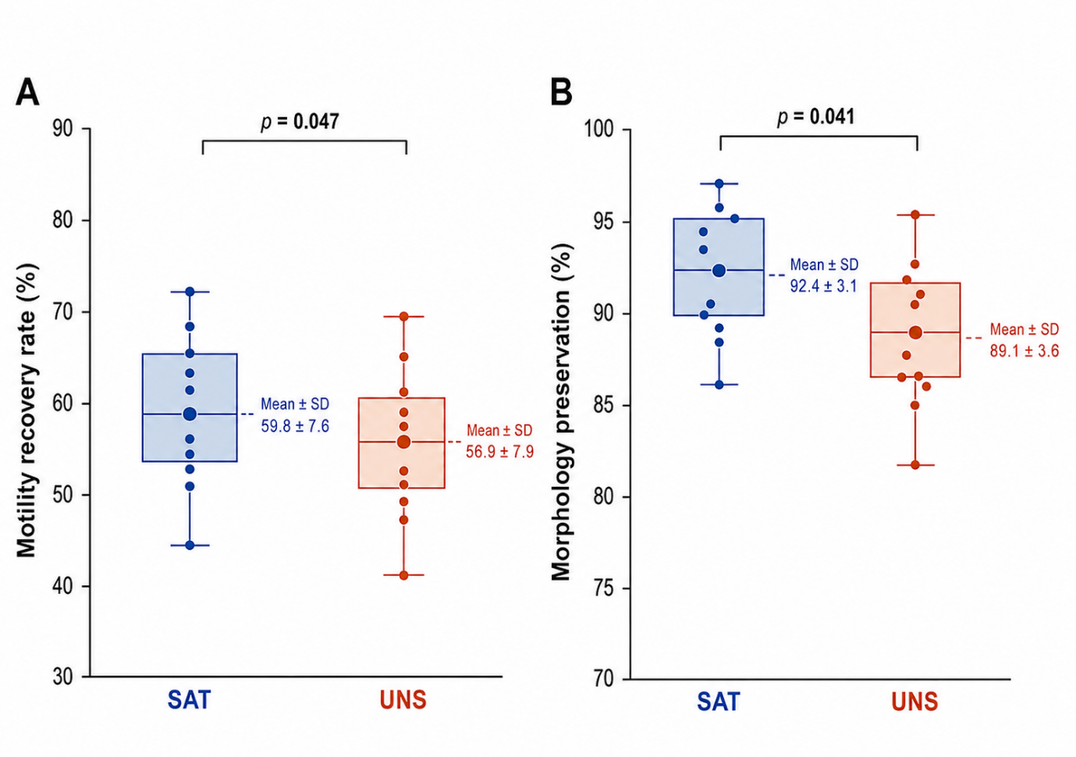

Figure 1. Sperm motility recovery and morphology preservation after cryopreservation in SAT and UNS bucks. (A) Motility recovery rate (B) Morphology preservation.

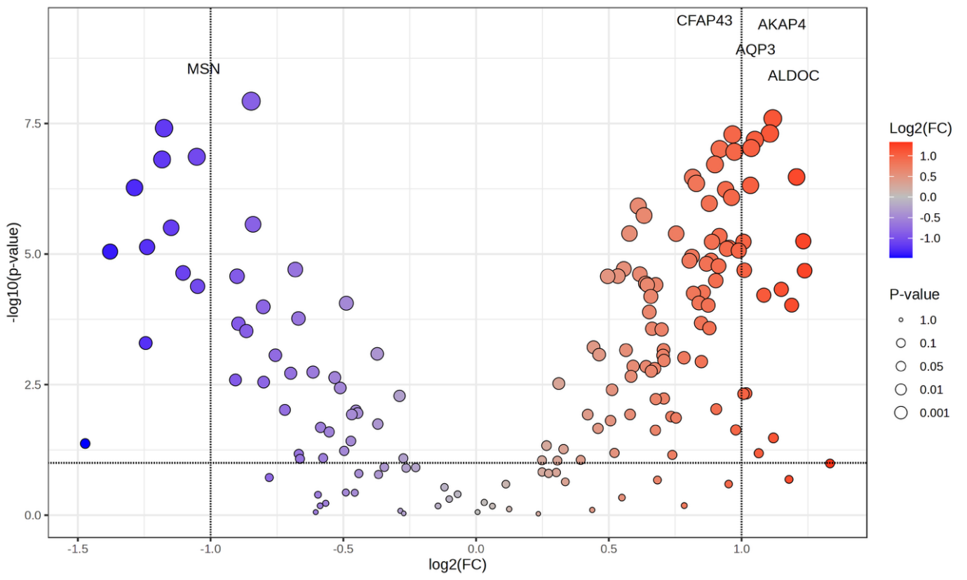

Figure 2. Volcano plot of differentially abundant proteins between SAT and UNS bucks.

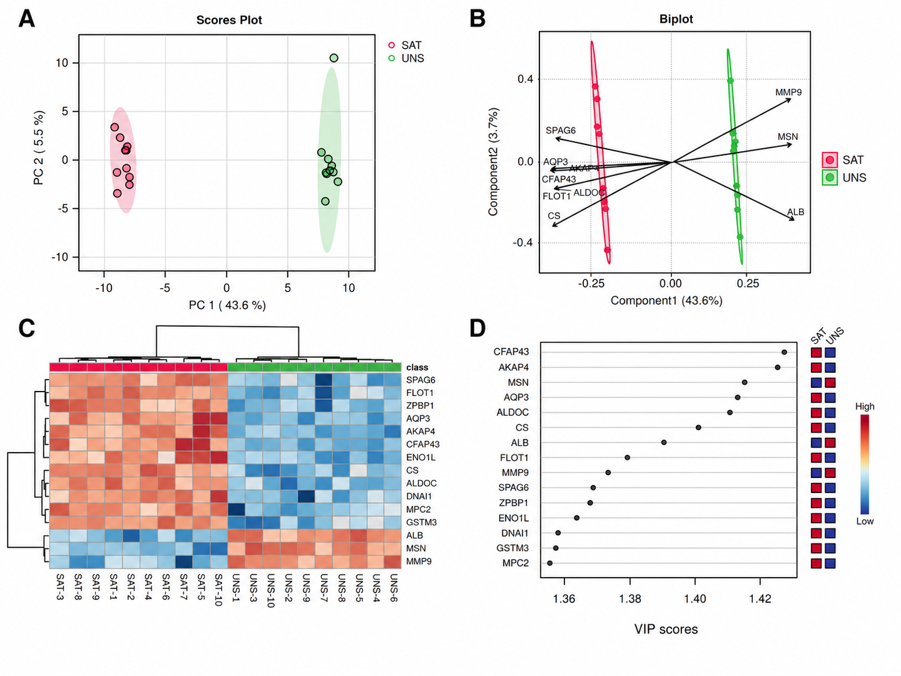

Figure 3. Multivariate proteomic profiles and VIP-ranked proteins separating satisfactory (SAT) and unsatisfactory (UNS) PE bucks. (A) Principal component analysis score plot showing proteomic clustering between SAT and UNS bucks. (B) Biplot showing proteins contributing to group separation. (C) Hierarchical clustering heatmap showing group-specific protein abundance patterns. (D) Variable importance in projection (VIP) score plot showing the top proteins contributing to proteomic separation between groups.

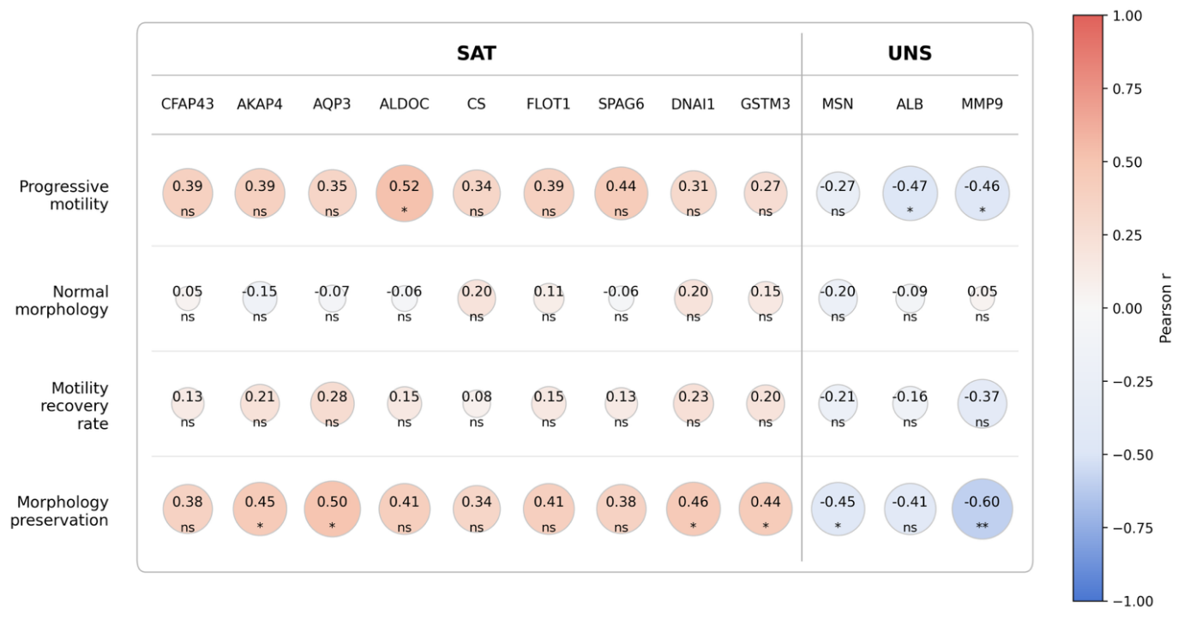

Figure 4. Correlation of candidate protein biomarkers with sperm quality and cryopreservation outcomes. *p < 0.05; **p < 0.01; ns = not significant.

