ANALYSIS OF THE VIABILITY OF OIL-OXIDIZING MICROORGANISMS AFTER LONG-TERM STORAGE AND THE EFFECT OF HUMATE CONCENTRATION ON THEIR ACTIVITY

Zh.M. Kassenova^{1,2}, N. Talgatkyzy^{1,2} , B.T. Yermagambet^{1,2}, M.K. Kazankapova^{1,2}*, A.B. Malgazhdarova¹, U.M. Kozhamuratova¹, N.S. Akimbekov^{3,4}, K.T. Tastambek^{3,4}, M.H. Kozhakhmetova³, B.K. Kamenov³, D.A. Nussipov³ and A.P. Altynbay³

¹ “Institute of Coal Chemistry and Technology” LLP, Astana, Kazakhstan
² Kazakh Agrotechnical Research University named after S. Seifullin, Astana, Kazakhstan
³ Research Institute of Sustainability of Ecology and Bioresources, Al-Farabi Kazakh National University, Almaty, Kazakhstan
⁴ Ecology Research Institute, Khoja Akhmet Yassawi, International Kazakh-Turkish University, Turkestan, Kazakhstan
*Corresponding author: m.kazankapova@mail.ru

ABSTRACT
This study aimed to evaluate the viability of oil-oxidizing microorganisms after long-term refrigerated storage and to determine how different concentrations of potassium humate affect their growth activity and bioremediation potential in oil-contaminated soil. Four bacterial strains, S3, S4, S6, and A1, previously isolated from oil-contaminated soils, were examined after one year of storage. Their viability was assessed by cultivation in meat-peptone broth and on meat-peptone agar, followed by visual observation, microscopy, Gram staining, and spectrophotometric measurement of optical density at 600 nm. Potassium humate obtained from oxidized brown coal was tested at concentrations of 0.5%, 1%, 5%, and 10%. The efficiency of soil purification was evaluated by measuring the mass fraction of petroleum products during a 90-day experiment. After storage, strains S3, S4, and A1 retained viability and showed active growth, whereas S6 did not recover under standard cultivation conditions. The response to humate depended on both strain and concentration. The highest optical density was recorded for S3 at 10% humate, while A1 showed growth at 1% and 10%. In the soil experiment, the greatest reduction of petroleum products was achieved by S4 with potassium humate, reaching 77.11% purification after 90 days. S3 with humate and Bakoyl with humate also showed high efficiencies of 75.49% and 76.07%, respectively. The results confirm that potassium humate can enhance the activity of selected oil-oxidizing microorganisms and support the development of combined biopreparations for the reclamation of oil-contaminated soils.

Keywords: Oil-oxidizing microorganisms, Humate, Concentration, Viability, Oil-contaminated soil.

- INTRODUCTION
Oil and petroleum product pollution is one of the most complex forms of anthropogenic impact on the environment. Oil entering water bodies can be transported by currents for hundreds and thousands of kilometers from the discharge site, penetrate into the water column, and accumulate in bottom sediments, thereby affecting all groups of organisms. Modern bioremediation technologies actively use oil-oxidizing microorganisms (OOMs) for the treatment of hydrocarbon-contaminated soils and water bodies. These microorganisms are capable of degrading a wide range of hydrocarbon compounds, including alkanes, aromatic hydrocarbons, and petroleum derivatives, converting them into less toxic substances (Daffonchio et al. 2013). However, the efficiency of biodegradation largely depends on the viability of microorganisms after storage and on the environmental conditions into which they are introduced (Bashkin et al. 2010).
One of the important approaches to increasing the stability and activity of OOMs after long-term storage is the use of growth stimulants, such as humic substances, particularly humates. Humic acids, as a key organic component of soils, natural waters, and peat, show increased reactivity toward oil and its components due to their hydrophobic aromatic structure. This reactivity allows humic acids to play an important role in self-purification processes and in mitigating the impact of oil pollution on the environment. The efficiency of bioremediation of oil-contaminated water bodies can be significantly improved through the use of biological preparations combining humic acids with microorganisms capable of degrading crude oil. Acting as dispersing agents, humic acids contribute to the breakdown of oil emulsions into smaller components, which are then more easily degraded by microorganisms. Under abiotic stress, when the uptake of essential nutrients by microorganisms slows down, humic acids serve as a substrate that provides bacteria with components necessary for their vital activity.
Microorganisms can partially utilize molecules of humic substances and peripheral fragments represented by oligosaccharides and peptides, thereby supplying nutrients. Humates are natural organic compounds obtained from peat, brown coal, and sapropel and are known for their biostimulating and adaptogenic properties (Dmitrieva et al. 2015; Kassenova et al. 2024; Yakimov et al. 2007). Their application can not only maintain the metabolic activity of microorganisms but also enhance the biodegradation of petroleum pollutants (Chugunov et al. 2000).
Nevertheless, the effect of humate concentration on the viability and oil-oxidizing activity of microorganisms after long-term storage remains insufficiently studied. Systematic studies are needed to determine optimal storage conditions and stimulation approaches for microbial consortia intended for subsequent effective application in bioremediation technologies (Manucharova et al. 2021).
The use of oil-oxidizing microorganisms (OOMs) in environmental purification biotechnologies has become one of the most promising and environmentally safe methods for eliminating oil pollution. Such microorganisms include bacteria of the genera Pseudomonas, Rhodococcus, Acinetobacter, and Alcanivorax, which are capable of degrading hydrocarbons through specialized enzymatic systems (Chugunov et al. 2000). The process of bioremediation of ecosystems contaminated with oil and petroleum products is based on the ability of microorganisms to decompose complex organic compounds of petroleum. However, one of the major limitations of using OOMs under field conditions is the decrease in their activity and abundance after long-term storage, especially at low temperatures or under lyophilization conditions (Vaccari et al. 2019; Viruel et al. 2011).
To improve the efficiency of bioremediation preparations, it is necessary to use approaches that help preserve the viability of microbial cells and restore their metabolic activity. One such approach is the use of humic substances, which can stimulate the growth and enzymatic activity of microorganisms and protect cells from stress factors (Cong et al. 2020). Humates may also act as a nutrient source and pH regulator, promoting better adaptation of microbes in hydrocarbon-contaminated ecosystems (Al-Zahrani & Idris 2010).
Despite the existence of individual studies devoted to the use of humates in agricultural technologies and microbiology, the effect of different concentrations of these compounds on the oil-oxidizing activity of microorganisms after long-term storage remains poorly understood. This is especially relevant for the development of effective long-shelf-life biopreparations suitable for use under extreme climatic conditions (Ichor et al. 2014).
The present study aims to address this gap by conducting a comprehensive analysis of the viability of oil-oxidizing microorganisms after storage under different conditions, as well as by assessing their activity under the influence of humates at different concentrations. The obtained results may be used to develop new generations of biopreparations intended for the ecological rehabilitation of oil-contaminated areas (Kassenova et al. 2024).

- MATERIALS AND METHODS
The objects of the study were oil-oxidizing microorganisms, namely strains S3, S4, S6, and A1, previously isolated from soils contaminated with petroleum products.
The following components were used in the study: meat-peptone agar (MPA) for cultivation and isolation of pure cultures; meat-peptone broth (MPB) for obtaining microbial suspension and assessing growth in liquid medium; and potassium humate at concentrations of 0.5%, 1%, 5%, and 10% as an additive to evaluate its effect on the growth activity of the studied strains.
The nutrient media were prepared according to the manufacturer’s instructions. The media were poured into Petri dishes under sterile conditions in Class II biological safety laminar flow cabinets. For Petri dishes with a diameter of 90 mm, the volume of the poured medium was 18–20 cm³, corresponding to a layer thickness of approximately 3 mm and meeting the requirements of the relevant standard (Interstate Council for Standardization, Metrology and Certification (ISC) 2017).
The nutrient media were sterilized by autoclaving at 110 °C and a pressure of 0.5–1.1 atm for 30 minutes. Glassware was sterilized in a drying oven at (170 ± 10) °C for 2 hours or by autoclaving at 125 °C and a pressure of 1.1–2 atm for 15–30 minutes (State Committee of the USSR for Standards 1976).
The study included the following microbiological methods:
• Gram staining to assess the morphological and tinctorial properties of cells;
• inoculation of microorganisms onto nutrient media for quantitative and qualitative characterization of growth;
• identification based on a combination of morphological features, colony morphology, and Gram-negative or Gram-positive reaction.
After inoculation, the Petri dishes were incubated in a thermostat at (28 ± 1) °C for 48–72 hours. Changes in colonies and biomass were analyzed visually and using a microscope (State Committee of the USSR for Standards 1976).
To study the effect of humate, growth activity tests were performed in MPB supplemented with humate at different concentrations. Activity was assessed by measuring the optical density of the culture liquid using spectrophotometry at a wavelength of 600 nm.
The following laboratory equipment was used in the experiment:
• TS-1/80 SPU thermostat for incubation of microbial cultures;
• Olympus BX43 binocular microscope (Japan, 2017) for microscopy and identification;
• Class II biological safety cabinet to ensure sterility when working with cultures;
• laboratory autoclave for sterilization of nutrient media and instruments;
• shaker for preparing homogeneous suspensions;
• spectrophotometer for measuring optical density and assessing biomass.
In this study, potassium humate was obtained from oxidized brown coal mined from the Sarykol deposit in Kazakhstan. The coal was preliminarily ground to a particle size of less than 0.5 mm. The following characteristics of the obtained coal were determined, expressed as mass percentages: Ad — 66.09; Wr — 5.73; Vd — 17.78; Std — 0.71; Ctd — 21.01; Htd — 1.68; Ntd — 2.09; Na — 0.61; Al — 0.89; K — 0.58; Ca — 0.31; Ti — 0.22; Fe — 1.11; Zr — 0.08. The coal particle size distribution was as follows: 2.95 μm — 10%, 63.8 μm — 50%, and 452 μm — 90%.
Humate was obtained by processing the raw material in a rotary-pulsation apparatus and an ultrasonic reactor. These processes were aimed at reducing coal particles to sizes ranging from 19.2 nm to 3.57 μm. In both cases, air was supplied into the reactor, which promoted coal oxidation and increased the content of humic substances. During grinding and ultrasonic treatment, the temperature of the mixture did not exceed 50–55 °C, which is acceptable for coal oxidation by atmospheric oxygen and extraction of the resulting salts of humic, fulvic, and other acids.
As a result of air oxidation, a micellar dispersed system was formed, namely a solution of humic substances with particle sizes below one micrometer. This technology is based on cavitation dispersion of humate-containing substances, particularly coal, using electrophysical treatment (Yermagambet et al. 2021).

- RESULTS AND DISCUSSION
After one year of storage under refrigerated conditions, an assessment of the vital activity of four strains of oil-oxidizing microorganisms was carried out: S3, S4, S6, and A1. All cultures were transferred under sterile conditions into MPB liquid culture medium (100 ml per 500 ml flask), after which they were placed on a shaker and incubated at 32 °C for two days (Fig. 1).
As can be seen from Fig. 1, on the second day the following was recorded:
• intensive growth of strains S3, S4, and A1, accompanied by sediment formation and a change in the color of the medium to a lighter shade;
• absence of growth in strain S6, indicating loss of viability.
Therefore, the preservation of microorganism viability after storage is determined by both their physiological characteristics and external conditions:
- Stability of cellular structures: Strain S6 may have undergone cell membrane disruption or DNA degradation as a result of long-term storage, even at low temperature, which led to a complete loss of vital activity.
- Metabolic activity: Strains S3, S4, and A1 retained the ability to metabolize and use MPB components, which is confirmed by active reproduction. This indicates their resistance and potential for adaptation after a dormant period.
- Role of MPB: Meat-peptone broth contains the necessary amino acids, peptides, and carbon sources that contribute to the rapid recovery of metabolic activity in viable strains. It acts both as an energy source and as a growth regulator.
- Possibility of damage during preservation: If storage conditions were unstable, for example, temperature fluctuations or insufficient density of the preservation medium, this could have led to the inactivation of sensitive strains such as S6.
After cultivation in the MPB liquid nutrient medium, all strains were transferred onto the solid MPA nutrient medium to confirm their viability. The inoculation results showed that strains S3, S4, and A1 actively developed on agar, forming characteristic colonies. At the same time, strain S6 again showed no signs of growth, which confirms its loss of viability even after transfer to a more favorable nutrient medium. This indicates deep damage to the cells of strain S6 during storage, preventing it from restoring metabolic activity in either liquid or solid medium (Fig. 2).
Conclusion on the viability of oil-oxidizing microorganisms: among the four studied strains of oil-oxidizing microorganisms, S3, S4, and A1 retained viability after long-term refrigerated storage. Strain S6 was found to be non-viable, which may be associated with individual sensitivity to storage conditions or loss of adaptive potential. The MPB medium used proved effective as a restorative nutrient base for the revival of bacteria, promoting metabolic activation of viable cultures. These data should be taken into account when selecting strains for bioremediation technologies and when developing storage strategies for collection cultures.
In addition, strain S6 requires additional conditions for activation or restoration of viability.
Influence of oil-oxidizing bacteria on the properties of humate at different concentrations.
Soil contamination with petroleum products is one of the most acute environmental problems in oil-producing regions. The use of oil-oxidizing microorganisms capable of degrading hydrocarbons and restoring microbiological balance in the soil is considered an effective method of bioremediation. One of the factors contributing to the improvement of the activity of these microorganisms is humate, an organic compound that improves soil structure and stimulates the growth of microflora. The objects of the study were bacterial strains S3, S4, S6, and A1. Sodium humate was used in four concentrations. Bacterial growth was assessed visually and also by spectrophotometry based on optical density. Morphological identification of microorganisms was carried out by microscopy after Gram staining (Fig. 3).
As can be seen from Table 1, the growth of cultures on humate of different concentrations showed dependence on the strain:
The most active growth at 10% humate was observed in strain S3 (OD = 246).
Strain A1 showed growth at 1% and 10% (OD = 130 and 114, respectively).
Strain S4 demonstrated negative OD values, which may indicate an inhibitory effect of humate.
Strain S6 did not show growth at 1%, but showed OD = 127 and 107 at 0.5% and 10%, respectively.
A slight decrease in the pH of humate solutions was observed with an increase in concentration up to 10% (7.75 → 7.58), followed by an increase at 20% (pH = 7.85). This may indicate the buffering properties of humate at high concentration.
This behavior can be explained by the following factors: Presence of weakly acidic functional groups: Humates contain various functional groups, such as carboxyl (-COOH) and phenolic (-OH) groups, which can dissociate in diluted solutions, releasing hydrogen ions (H⁺), causing slight acidification of the medium. Therefore, with an increase in concentration up to 10%, the amount of available H⁺ increases, causing a decrease in pH. Buffering properties of humates: With a further increase in concentration up to 20%, the buffering properties of humates come into effect. At high concentrations, humate solutions are able to absorb or neutralize both hydrogen ions (H⁺) and hydroxide ions (OH⁻) due to their polyfunctional groups, which retain ions in coordination bonds. This leads to stabilization or even an increase in pH. Simply put, at high concentrations, humate works as a buffer system, counteracting changes in the acidity of the medium. Ionic interactions and structural organization: At high concentrations, humate molecules can form aggregates or associates, in which the availability of functional groups for dissociation may decrease. This reduces the amount of free H⁺ ions in the solution and, consequently, leads to an increase in pH. Influence of alkaline cations: Humates often contain alkali metals, such as Na⁺ or K⁺, especially if they are sodium or potassium humates. As the humate concentration increases, the content of these cations also increases, which can shift pH toward the alkaline side due to ion exchange.
Thus, the decrease in pH up to a concentration of 10% is associated with an increase in the number of dissociating weakly acidic groups, whereas the increase in pH at 20% is caused by the activation of buffering properties, reduced availability of acidic groups, and increased influence of alkaline components of the solution.
The mass fraction of petroleum products in soil with the introduction of humic preparations was determined by the gravimetric method according to GOST RD 52.18.647-2003. The results obtained are presented in Table 3.
Analysis of the data in Table 3 shows the effectiveness of biopreparations that include combinations of potassium humate with oil-oxidizing microorganism strains in the treatment of soil contaminated with petroleum products. On the 30th and 60th days of the experiment, all variants with the addition of humate and bacteria showed a significant decrease in petroleum product content compared with the initial concentration (86528 mg/kg). The highest degree of purification was recorded in the variant with the strain Pseudomonas zhaodongensis (S4) + potassium humate — 59.44%, indicating the high biodegradation potential of this strain in a humate-containing medium. A comparable efficiency was also shown by the variant with the industrial biopreparation “Bakoil” + potassium humate — 58.39%. Strains Kocuria rosea (A1) and Cytobacillus firmus (S3) also demonstrated a high level of purification, more than 55%. Even strain Bacillus atrophaeus (S6), previously recognized as non-viable in recovery tests, provided a purification degree of 55.04% in the presence of potassium humate, which suggests the possible presence of residual metabolic activity or the involvement of humate in the physicochemical sorption of oil. These results confirm the high efficiency of using humate-containing bacterial preparations for the bioreclamation of oil-contaminated soils.
The use of this diagram confirms that the addition of potassium humate significantly enhances the biodestructive activity of both individual strains and ready-made preparations and should be considered an important element of the bioremediation strategy. The S4 + potassium humate variant demonstrated the highest degree of purification — 46.83%, while Bakoil without humate showed the lowest — 38.74%. All variants with the addition of potassium humate provided improved decomposition of petroleum products compared with the control. Table 4 presents the results of IR spectroscopy of the samples.
All spectra contain a broad intense signal in the region of 3400–3560 cm⁻¹, indicating the presence of O–H groups, alcohols or phenols, or N–H groups, amines or amides. In the region of 2920–2850 cm⁻¹, bands of stretching vibrations of aliphatic C–H bonds (–CH₂, –CH₃) are recorded, indicating the presence of alkyl fragments. Characteristic bands at ~1620–1635 cm⁻¹ correspond to vibrations of C=C bonds of the aromatic ring or amide groups (C=O + N–H). Bands at 1415–1420 cm⁻¹ are associated with deformation vibrations of –CH₂/–CH₃ and breathing of the aromatic ring.
In the region of 900–690 cm⁻¹, intense peaks are observed that are characteristic of out-of-plane deformations of aromatic ring C–H bonds, indicating the presence of substituted benzene rings. The combination of several bands in this region mainly corresponds to meta- or para-substituted aromatic structures. Low-frequency bands (~510–420 cm⁻¹) belong to the “fingerprint” region and correspond to skeletal vibrations of the aromatic nucleus or heavy atoms.
Thus, based on the totality of the data, it can be concluded that the studied samples are aromatic compounds with substituted benzene rings, containing aliphatic chains and, probably, functional groups of the –OH type, phenolic or alcoholic, and/or –NH type, amine or amide. Clearly expressed bands characteristic of ketones, aldehydes, or ester C=O groups (1700–1750 cm⁻¹) were not detected in the spectra.

- CONCLUSION
During the study, it was established that the strain Bacillus atrophaeus (S6), stored in meat-peptone broth (MPB) at +4 °C for one year, lost its viability. The absence of growth after subculturing indicates degradation of the cell population. This is due to the fact that MPB is not intended for long-term storage of strains, as it lacks cryoprotectants and buffer components necessary for cell stabilization. In addition, the accumulation of toxic metabolites and changes in the pH of the medium during long-term storage contribute to bacterial death. This case emphasizes the need to use specialized preservation methods, such as storage in glycerol at –20 °C or lyophilization, to preserve the viability of microorganisms.
It was also established that oil-oxidizing bacteria interact with humates, changing their properties depending on concentration. This indicates the mutual influence of microorganisms and humic substances, which should be taken into account when developing biopreparations and bioremediation technologies. At low humate concentrations, a decrease in the pH of the medium was observed, probably associated with the activation of weakly acidic functional groups of humic substances. When the concentration increased to 20%, an increase in pH was noted, which may indicate the manifestation of the buffering properties of humate and changes in its colloidal structure under the influence of bacterial metabolites.
The results presented in Table 3 clearly demonstrate that the maximum degree of purification of oil-contaminated soil is achieved through the combined application of potassium humate with active oil-oxidizing bacteria, especially strain S4. This confirms the feasibility of developing combined biopreparations for the reclamation of oil-contaminated areas, with an emphasis on selecting an effective strain and humic base. Thus, the interaction of oil-oxidizing bacteria with humates is accompanied by changes in the acid-base balance, indicating their ability to modify the physicochemical characteristics of humic substances. These data may be useful in the development of biopreparations for the reclamation of contaminated soils and in biostimulation systems based on humic compounds.

Funding: 1) This research was funded by the Science Committee of the Ministry of Science and Higher Education of the Republic of Kazakhstan (Grant No. BR24992814, Grant No. AR19577512).
2) This research has been funded by the Science Committee of the Ministry of Science and Higher Education of the Republic of Kazakhstan (Grant No. AP19679324 "Research and reclamation of oil-contaminated lands with humic substances").

Conflict of Interest: The authors declare no conflicts of interest.

Data Availability: Data will be available upon request.

Generative AI Statement: The authors declare that no Gen AI/DeepSeek was used in the writing/creation of this manuscript.

REFERENCES
Al-Zahrani, A. A., & Idris, G. M. (2010). Biological treatment of hydrocarbon contaminants: Petroleum hydrocarbon uptake by Pseudomonas alkanolytica. Journal of King Abdulaziz University-Engineering Sciences, 21(1), 39-53.
Bashkin, V. N.,Galiulin, R. V., & Galiulina, R. A. (2010). Emergency floods of hydrocarbons in aqueous medium: Problems and ways of their solution. Environmental Protection in Oil and Gas Complex, 11, 4-7.
Chugunov, V. A., Ermolenko, Z. M., Zhigletsova, S. K., Martovetskaya, I. I., Mironova, R. I., Zhirkova, N. A., Kholodenko, V. P., & Urakov, N. N. (2000). Development and application of a liquid preparation with oil-oxidizing bacteria. Applied Biochemistry and Microbiology, 36(6), 577-581. https://doi.org/10.1023/A:1026696506947
Cong, W. F., Suriyagoda, L. D., & Lambers, H. (2020). Tightening the phosphorus cycle through phosphorus-efficient crop genotypes. Trends in Plant Science, 25(10), 967-975. https://doi.org/10.1016/j.tplants.2020.04.013
Daffonchio, D., Ferrer, M., Mapelli, F., Cherif, A., Lafraya, A., Malkawi, H. I., Yakimov, M. M., Abdel-Fattah, Y. R., Blaghen, M., Golyshin, P. N., Kalogerakis, N., Boon, N., Magagnini, M., & Fava, F. (2013). Bioremediation of Southern Mediterranean oil polluted sites comes of age. New Biotechnology, 30(6), 743-748. https://doi.org/10.1016/j.nbt.2013.05.006
Dmitrieva, E. D., Karimova, V. T., & Nechaeva, I. A. (2017). The effect of humic substances from different origin peats of the Tula Region on the growth of microbial degraders of oil rhodococcus erythropolis S67 and rhodococcus erythropolis X5. Izvestiya TulGU. Estestvennye Nauki, 2, 60-68.
Ichor, T., Okerentugba, P. O., & Okpokwasili, G. C. (2014). Biodegradation of total petroleum hydrocarbon by aerobic heterotrophic bacteria isolated from crude oil contaminated brackish waters of bodo creek. Journal of Bioremediation & Biodegradation, 5(5), 236. https://doi.org/10.4172/2155-6199.1000236
Interstate Council for Standardization, Metrology and Certification (ISC). (2017). GOST 7.32–2017. Research report. Structure and design rules. Moscow: Standartinform.
Kassenova, Zh., Iskakov, Y., Yermagambet, B., Kapsalyamov, B., Saulebekova, M., Imbayeva, D., Kazankapova, M., & Nasyrova, D. (2024). Effectiveness of oil-contaminated soil reclamation with humic preparations. International Journal of Agriculture and Biosciences, 13(3), 474-487. https://doi.org/10.47278/journal.ijab/2024.154
Manucharova, N. A., Pozdnyakov, L. A., Vlasova, A. P., Yanovich, A. S., Ksenofontova, N. A., Kovalenko, M. A., Stepanov, A. L., Gennadiev, A. N., Golovchenko. A. V., & Stepanov, A. L. (2021). Metabolically active prokaryotic complex in grassland and forests’ sod-podzol under polycyclic aromatic hydrocarbon influence. Forests, 12(8), 1103. https://doi.org/10.3390/f12081103
State Committee of the USSR for Standards. (1976). GOST 12.1.007–76. Occupational safety standards system. Noxious substances. Classification and general safety requirements. Moscow: Standartinform.
Vaccari, D. A., Powers, S. M., & Liu, X. (2019). Demand-driven model for global phosphate rock suggests paths for phosphorus sustainability. Environmental Science and Technology, 53(17), 10417-10425. https://doi.org/10.1021/acs.est.9b02464
Viruel, E., Lucca, M. E., & Sineriz, F. (2011). Plant growth promotion traits of phosphobacteria isolated from Puna, Argentina. Archives of Microbiology, 193, 489-496. https://doi.org/10.1007/s00203-011-0692-y
Yakimov, M. M., Timmis, K. N., & Golyshin, P. N. (2007). Obligate oil-degrading marine bacteria. Current Opinion in Biotechnology, 18(3), 257-266. http://dx.doi.org/10.1016/j.copbio.2007.04.006
Yermagambet, B. T., Kasenova, Zh. M., Nurgaliev, N. U., & Kazankapova, M. K. (2021). Patent of the Republic of Kazakhstan for invention No. 35020 “Method for obtaining humic substances from oxidized weathered and brown coals”. Applicant and patent holder LLP SPO “Kazteсhnougol”.
Table 1: Results of microorganism OD measured by spectrophotometer
Cultures | 0,5% | 1% | 5% | 10%
S3 | 174 | 75 | 73 | 246
S4 | -0,105 | -0,161 | -0,90 | -0,154
S6 | 127 | -0,117 | 0,144 | 107
A1 | -0,081 | 130 | -0,142 | 114

Table 2: Acid-base balance indicators at different concentrations of humate solution
Humate concentration, % | Solution рН | Nature of change
0.5% | 7.75 | Neutral medium with a tendency toward weakly alkaline
1% | 7.70 | Slight decrease in pH compared with 0.5%
5% | 7.59 | Stabilization of pH in the weakly alkaline zone
10% | 7.58 | Minimal fluctuations relative to the 5% solution
20% | 7.85 | Return to a more pronounced alkaline reaction

Table 3: Efficiency of oil-contaminated soil purification under the action of humate-containing biopreparations based on different microorganism strains
Sample name | Mass fraction of petroleum products, mg/kg |  |  | Degree of purification, %
Initial oil-contaminated soil | 86528 |  |  | 0
Days | 30th day | 60th day | 90th day | %
А1 + Potassium humate (1:1) | 49000 | 38400 | 24400 | 71.80
S3 + Potassium humate (1:1) | 48300 | 36900 | 21200 | 75.49
S4 + Potassium humate (1:1) | 46000 | 35100 | 19800 | 77.11
S6 + Potassium humate (1:1) | 50400 | 38900 | 25100 | 70.99
Bakoil (30 ml) + Potassium humate | 48000 | 36000 | 20700 | 76.07
Bakoil (30 ml) | 53000 | 40400 | 25900 | 70.06

Table 4: Results of IR spectroscopy of the samples
IR spectrum of the sample | Main bands and interpretations
Initial soil from the “Zhetybay” deposit
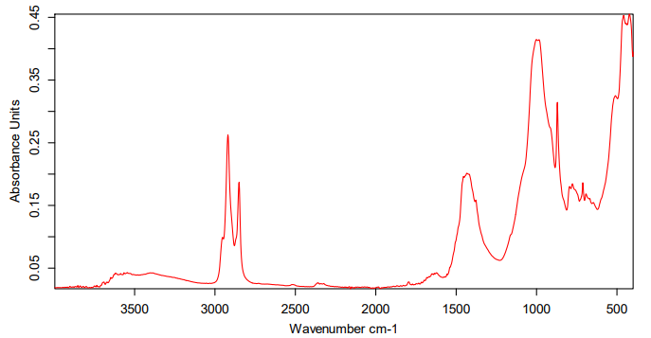 | ~3420–3440 cm⁻¹ – broad band: corresponds to O–H stretching vibrations. Typical for hydroxyl groups of alcohols, phenols, or carboxylic acids.  ~2920–2850 cm⁻¹ – weak to medium intensity bands: correspond to C–H (sp³) stretching vibrations of alkanes.  ~1720–1710 cm⁻¹ – strong absorption: characteristic of the C=O (carbonyl group). May belong to ketones, aldehydes, or carboxylic acids.  ~1620–1600 cm⁻¹ – vibrations of C=C bonds in aromatic rings or conjugated systems.  ~1380–1450 cm⁻¹ – deformation vibrations of –CH₂ and –CH₃ groups.  ~1100–1050 cm⁻¹ – strong band: corresponds to C–O stretching vibrations (alcohols, ethers, phenols)
А1 + Potassium humate (1:1)
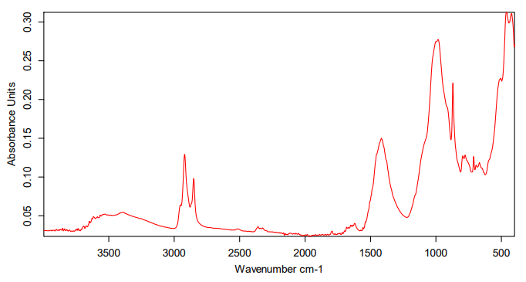 | ~3392 cm⁻¹ – Broad O–H stretching vibration (alcohols or phenols) or N–H stretching (amines).  ~2920 - 2851 cm⁻¹ – C–H stretching vibrations of aliphatic groups (–CH₂, –CH₃).  ~2360 cm⁻¹ – Possible CO₂ interference or stretching of –C≡N / –C≡C groups.  ~1794 cm⁻¹ – Strong absorption of C=O stretching (carbonyl group, e.g., ester, anhydride, or acid chloride).  ~1621 cm⁻¹ – C=C stretching (aromatic ring or alkene) or amide C=O.  ~1417 cm⁻¹ – C–H bending (–CH₂/–CH₃ scissoring).  ~983, 870, 777, 712 cm⁻¹ – Out-of-plane bending of aromatic C–H or alkene =C–H (substitution pattern of aromatic rings).  ~668 cm⁻¹ – Possible aromatic C–H bending (monosubstituted or para-substituted benzene).  ~459 - 423 cm⁻¹ – Fingerprint region, may correspond to skeletal vibrations of aromatic or inorganic components.
S3 + Potassium humate (1:1)
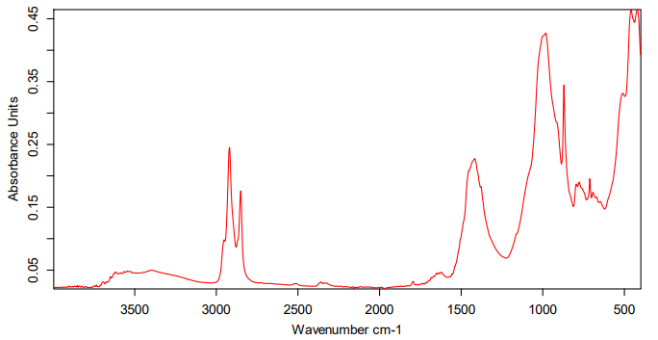 | ~3401 cm⁻¹ – Broad O–H (alcohol/phenol) or N–H (amine/amide) stretch.  ~2919 - 2851 cm⁻¹ – Aliphatic C–H stretches (–CH₂/–CH₃).  ~2360 cm⁻¹ – Likely CO₂ (atmospheric) artifact.  ~1623 cm⁻¹ – C=C stretch of an aromatic ring (or amide C=O if N–H is present).  ~1418 cm⁻¹ – CH₂/CH₃ bending (scissoring).  ~983, 871, 777, 712, 693 cm⁻¹ – Aromatic C–H out-of-plane bends; pattern suggests a substituted benzene ring (often consistent with meta-substitution).  ~459 - 423 cm⁻¹ – Fingerprint/ skeletal vibrations.
S4 + Potassium humate (1:1)
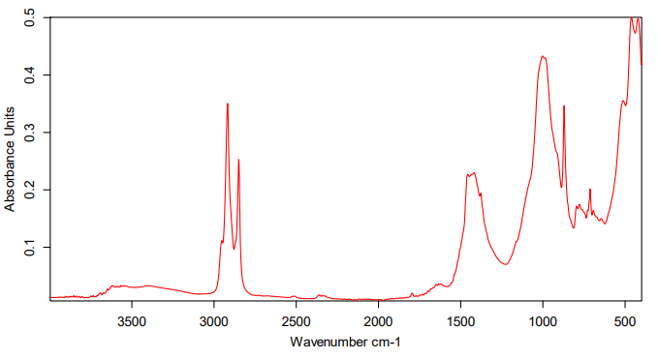 | ~3566 cm⁻¹ – Sharp “free” O–H stretch (non-H-bonded alcohol/phenol).  ~2918 - 2849 cm⁻¹ – Aliphatic C–H stretches (–CH₂/–CH₃).  ~1419 cm⁻¹ – CH₂/CH₃ bending (scissoring).  ~1003 cm⁻¹ – C–O stretch of an alcohol/phenol or ether.  ~871, 777, 712, 693 cm⁻¹ – Aromatic C–H out-of-plane bends; pattern consistent with a meta-substituted benzene ring.  ~512, 461, 420 cm⁻¹ – Skeletal/fingerprint vibrations.
S6 + Potassium humate (1:1)
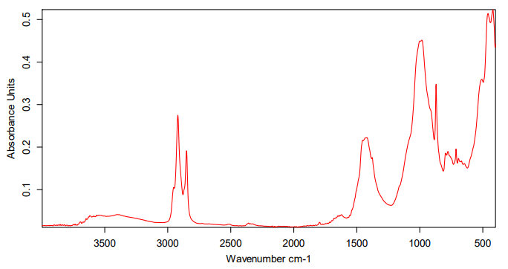 | ~3401 cm⁻¹ — Broad O–H stretch (alcohol/phenol) or N–H stretch (primary/secondary amine or amide).  ~2919 - 2851 cm⁻¹ — Aliphatic C–H stretching (–CH₂, –CH₃).  ~1622 cm⁻¹ — C=C stretch (aromatic) or possibly amide I (C=O of amide) if N–H present; not a typical ester/ketone C=O (which appears ~1700 cm⁻¹).  ~1419 cm⁻¹ — C–H bending / CH₂/CH₃ scissoring or aromatic ring breathing contribution.  ~983, 871, 777, 712, 693 cm⁻¹ — Aromatic C–H out-of-plane bending modes — pattern consistent with a substituted benzene (these bands can help identify substitution pattern; presence of multiple bands around 700–900 cm⁻¹ often indicates disubstitution, e.g., meta- or para- types).  ~458 - 420 cm⁻¹ — Fingerprint/skeletal vibrations (low-energy ring or heavy-atom bends).
Bakoil (30 ml) + Potassium humate
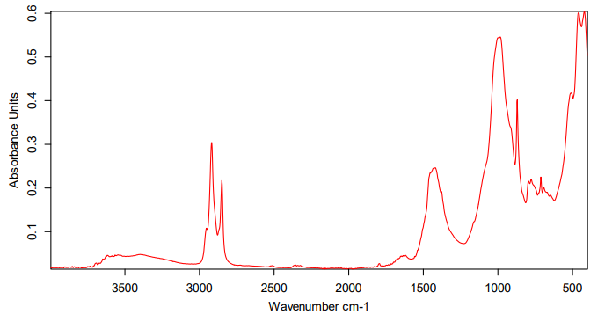 | ~3399 cm⁻¹ — Broad O–H stretch (alcohol/phenol) or N–H stretch (amine/amide).  ~2918 - 2850 cm⁻¹ — Aliphatic C–H stretching (–CH₂, –CH₃).  ~1623 cm⁻¹ — C=C stretch (aromatic ring) or possibly amide I (if N–H present); not a typical saturated carbonyl (~1700 cm⁻¹).  ~1419 cm⁻¹ — C–H bending / CH₂/CH₃ scissoring; can also include aromatic ring breathing contributions.  ~984 cm⁻¹ — C–H out-of-plane bending / =C–H wag (often associated with substituted alkenes or aromatic substitution patterns).  ~871, 777, 712, 693 cm⁻¹ — Aromatic C–H out-of-plane bending modes — pattern suggests a disubstituted benzene (commonly meta- or para- substitution; exact pattern leans toward meta-type when multiple bands appear in this region).  ~510, 458, 420 cm⁻¹ — Fingerprint / skeletal vibrations (heavy-atom bends, ring deformations).
Bakoil (30 ml)
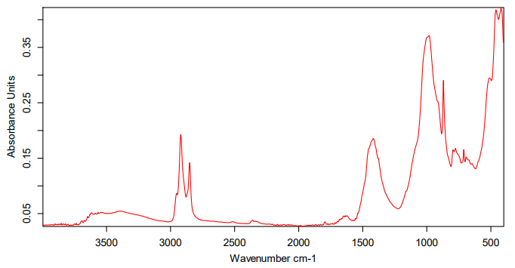 | ~3402 cm⁻¹ — Broad O–H stretch (alcohol/phenol) or N–H stretch (primary/secondary amine or amide).  ~2920 - 2851 cm⁻¹ — Aliphatic C–H stretching (–CH₂, –CH₃), indicating alkyl chains.  ~2359 cm⁻¹ — Likely atmospheric CO₂ artifact (common) — not a structural feature unless sample contains CO₂-derived species.  ~1636 cm⁻¹ — C=C stretching (conjugated/ aromatic) or amide I (C=O) if an amide is present; less typical for unconjugated ester/ketone (which usually appear closer to ~1700 cm⁻¹).  ~1418 cm⁻¹ — CH₂/CH₃ bending (scissoring) and/or aromatic ring breathing contribution.  ~983, 871, 777, 712, 693 cm⁻¹ — Aromatic C–H out-of-plane bending modes — pattern consistent with a disubstituted (likely meta- or mixed-substitution) benzene ring.  ~460 - 421 cm⁻¹ — Low-frequency fingerprint/skeletal vibrations (ring deformations or heavy-atom bends).

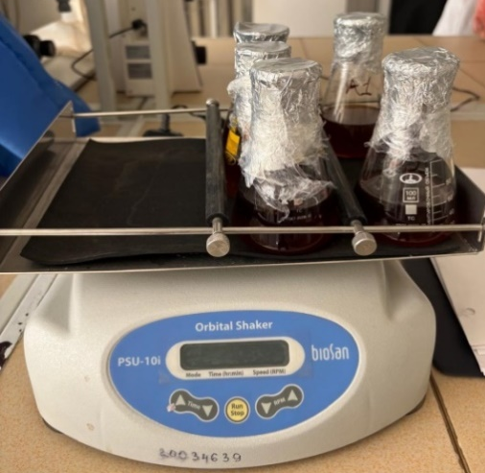
S3 | S4 | S6 | A1
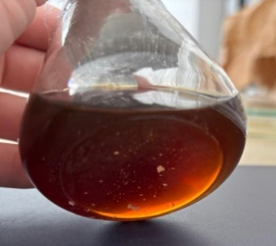 | 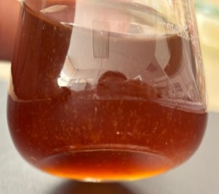 | 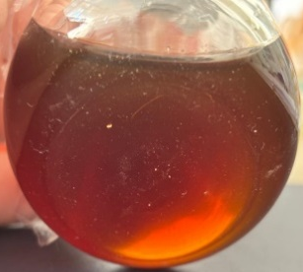 | 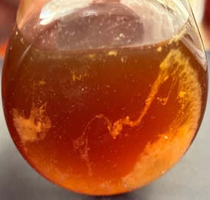
Fig. 1: Analysis of the viability of microorganisms preserved in containers (S3, S4, S6, A1)

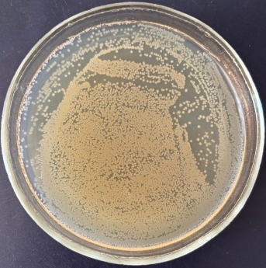 | 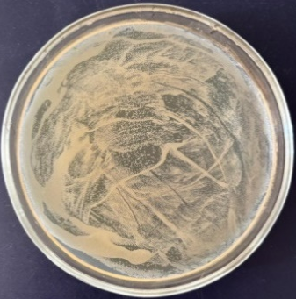 | 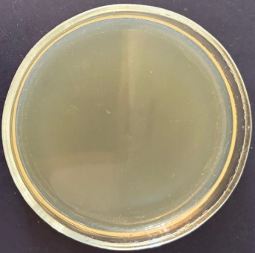 | 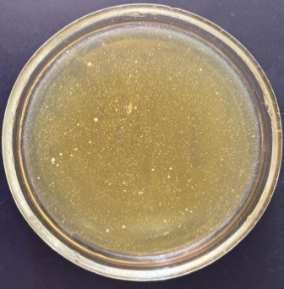
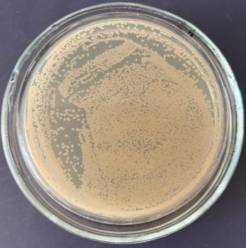 | 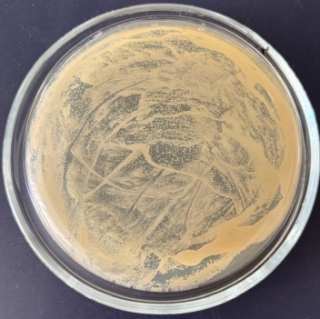 | 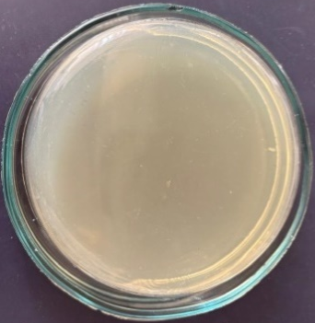 | 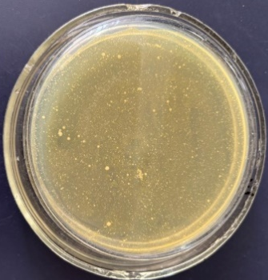
Fig. 2: Growth of cultures on solid nutrient medium

Cultures | 0,5% | 1% | 5% | 10%
S3 | 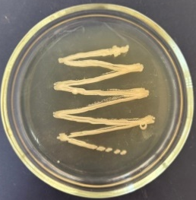 | 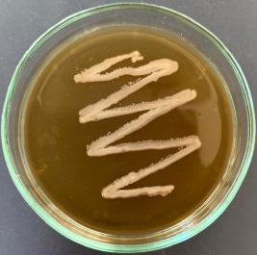 | 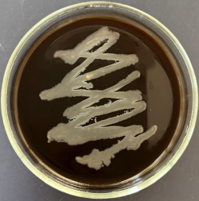 | 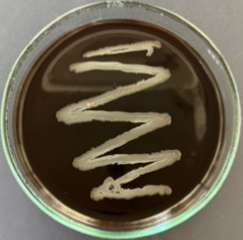
S4 | 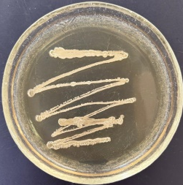 | 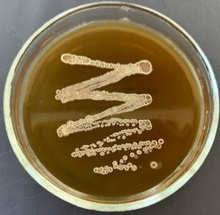 | 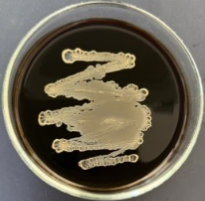 | 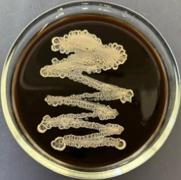
S6 | 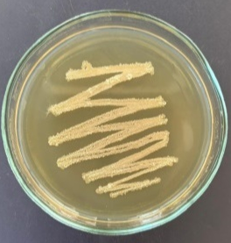 | 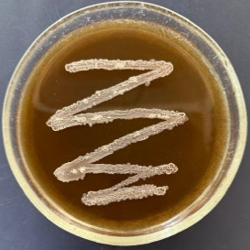 | 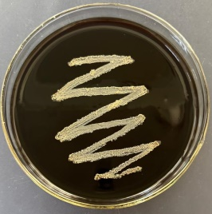 | 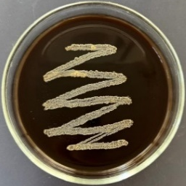
A1 | 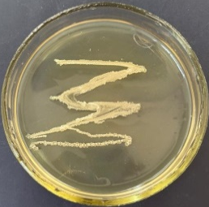 | 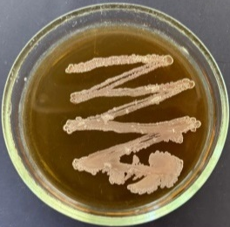 | 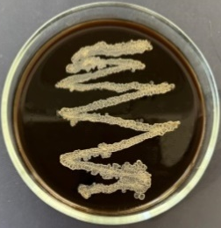 | 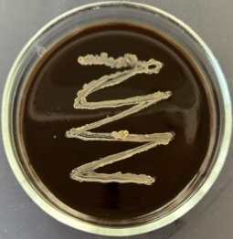
Fig. 3: Growth of oil-oxidizing microorganism strains on nutrient media with different humate concentrations (0.5%, 1%, 5%, 10%)

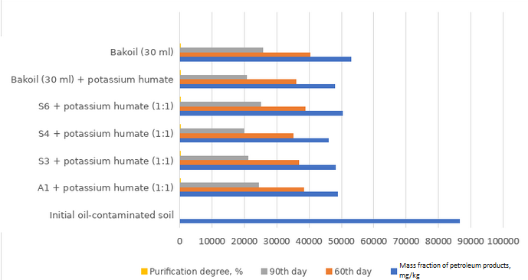
Fig. 4: Determination of the content of petroleum products in soil

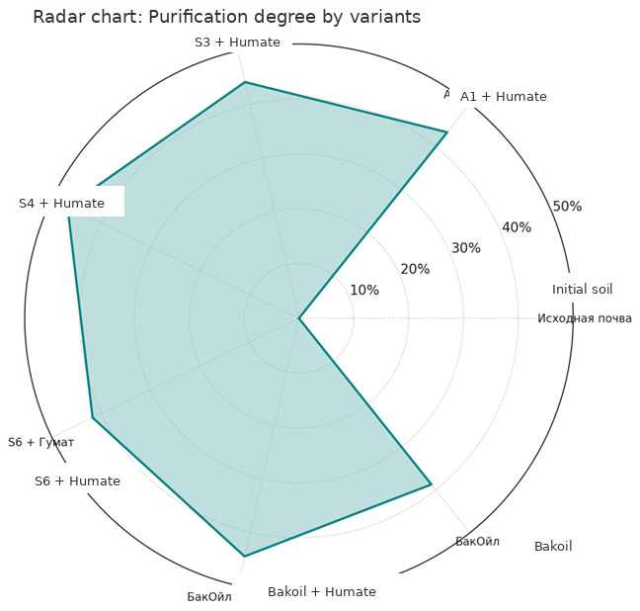
Fig. 5: Comparative efficiency of bioremediation of oil-contaminated soil

