Solarization and Groundwater Depletion: The Hidden Costs of Solar-Powered Agriculture Balochistan
Ameenullah¹, Abdulaziz Thabet Dabiah², Raza Ullah³, Syed Muhammad Khair⁴, Syed Sadiq Agha⁵, Rizwan khan⁶, *Muhammad Muddassir², Mortala Boye⁷

¹Department of Agriculture Economics, Balochistan Agriculture College, Quetta, Pakistan
²Department of Agricultural Extension and Rural Society, College of Food and Agriculture Science, King Saud University, Riyadh 11451, Saudi Arabia
³Institute of Agricultural and Resource Economics, University of Agriculture Faisalabad, Punjab, Pakistan
⁴Faculty of Agriculture Economics, University of Pehsawar,
⁵Value Chain Specialist, FAO
⁶Agriculture Production Specialist, FAO
⁷School of Agriculture and Environmental sciences, University of The Gambia, P. O Box 3530 Serekunda, The Gambia
*Corresponding Author: mrajpoot@ksu.edu.sa
Abstract
Balochistan, Pakistan's arid south-western province, is experiencing a severe groundwater crisis, with levels falling by 5-40 feet per year due to an overreliance on tube wells for irrigation. This depletion endangers agricultural sustainability, particularly given the government's solarisation policy, which aims to convert over 29000 tube wells to solar power. For the rural societies of Baluchistan, groundwater is not merely an agricultural input but the singular economic lifeline upon which household income, food security, and intergenerational livelihoods are anchored, making any policy that alters extraction dynamics a matter of acute socioeconomic consequence. The socioeconomic fragility of these communities means they are simultaneously the primary drivers of groundwater stress and the most exposed to its depletion, a duality that demands urgent empirical attention. To date, no comprehensive research has been conducted to assess the impact of solar-powered electric tube wells (ETs) on groundwater resources in Balochistan. This study was conducted in three highland basins: The Zhob River Basin (ZRB), the Nari River Basin (NRB), and the Pishin Lora Basin. It examined farmer perceptions and socioeconomic drivers of groundwater use. Using logistic regression on primary data from 320 respondents, the study finds a significant relationship between solarisation and increased groundwater depletion, with older farmers and those without high-efficiency irrigation systems (HEIS) contributing disproportionately to inefficient groundwater use. Unconditioned solarisation will have a negative impact on the province's shallow aquifers, potentially resulting in generational disputes among key basin residents. To address this paradox, the study suggests combining solarisation with mandatory HEIS adoption, implementing net-metering for solar wells, and improving water governance to protect shallow aquifers and ensure the long-term viability of agriculture in Balochistan.

Keywords: Solarization, Groundwater depletion, Electric Tubewells (ETs), high-efficiency irrigation systems (HEIS), Rural societies
Introduction
Pakistan's energy crisis is not just an inconvenience; it severely hinders the country's economic and social development. Electricity shortages result in a loss of roughly 2% of the country's annual Gross Domestic Product (GDP), rendering them a major hindrance to growth and economic progress (Irfan et al., 2019). These shortages affect sectors dependent on a stable energy supply, including households, businesses, industry, and agriculture. The agricultural industry is especially susceptible because it relies on electricity for irrigation, a key farming practice. The lack of reliable power sources in rural societies has reduced agricultural output, adversely affected livelihoods, and obstructed rural development (Yaqoob et al., 2021).
Pakistan has not managed to integrate renewable energy into its national grid, despite its significant renewable energy potential, particularly solar. This underutilization has resulted in prolonged dependence on conventional energy sources, which are frequently expensive, unreliable and environmentally unsustainable (Wakeel et al., 2016). However, a transformation is taking place, particularly in rural societies, where solar systems are being used as an alternative energy source (Shah and Solangi, 2019). Solar energy is extensively regarded as a feasible solution to energy shortages, especially in agriculture, where uninterrupted power is a prerequisite for irrigation. Balochistan, Pakistan's largest province by area, has the highest average daily sunlight hours in the world, making it an ideal place for solar energy development (Shah et al., 2018). Balochistan's abundant solar radiation offers a unique opportunity to power tube wells with solar PV systems, which are crucial for groundwater extraction and agricultural sustainability in the province (Ali et al., 2020).
Energy and Water Crisis in Balochistan
The transition to solar energy in Balochistan is taking place despite significant water shortages. Balochistan is currently experiencing severe water stress, exacerbated by recurrent droughts, insufficient rainfall, and over-dependence on groundwater. Groundwater is essential for water resource management, fulfilling irrigation water needs and supplying drinking water to a major portion of the population (Wakeel et al., 2016). Balochistan is experiencing a significant crisis, as groundwater tables in many regions are declining at alarming rates (Shah et al., 2018). Since the late 1990s, the groundwater table in most of Balochistan has been consistently declining, indicating extraction rates that significantly exceed natural replenishment. In Quetta, the provincial capital, groundwater levels have fallen to depths beyond 900-1300 feet in certain regions, presenting a significant risk to the city's three million residents (Mustafa et al., 2022; Khair et al., 2021). This depletion pattern is not limited to the capital city of Quetta but spreads throughout the province's highland regions. In the last four decades, regions such as Pishin, Kuchlak, and Ziarat have experienced a decline in groundwater levels from 50-100 feet to 900-1500 feet, indicating significant overexploitation (Ashraf, 2020). In the Pishin Lora Basin (PLB), the Zhob River Basin (ZRB), and the Nari River Basin (NRB), groundwater levels are decreasing by 10 to 40 feet per year. Of the 18 basins in Balochistan, 10 are nominated as over-exploited (Halcrow-Pakistan and Cameos, 2008; Rana et al., 2020). The rapid exhaustion of groundwater in these areas jeopardises both agricultural viability and the accessibility of fresh water for local populations. If these patterns persist, Balochistan may face significant intergenerational challenges, including possible water conflicts among residents of different basins (Ahmad, 2006).
Political Economy of Groundwater Development
Groundwater development has been termed as a vibrant policy tool in numerous developing nations, including Pakistan, to enhance agricultural growth. Nonetheless, these regulations frequently result in unforeseen environmental and societal consequences. Groundwater is a common-pool resource, characterized by non-excludability and non-rivalry, which complicates effective regulation without robust institutional governance. In Balochistan, inadequate institutional frameworks have led to irrational extraction, resulting in the unsustainable depletion of groundwater resources (Nagaraj et al., 1999). Government initiatives aimed at promoting groundwater development, such as tube well electrification and subsidies, have exacerbated the issue, leading to over-extraction of this resource.
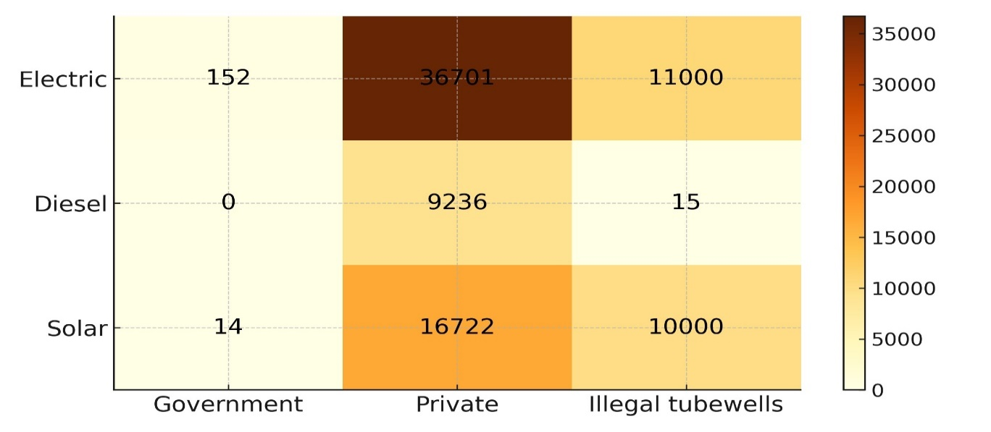
A key policy in Balochistan that contributes to groundwater over-extraction is the subsidization of electricity for agricultural tubewells. Intended to enhance agricultural output by reducing irrigation costs, these incentives have increased the use of electric tubewells. From the late 1980s to 2008, the number of tubewells in Balochistan surged significantly, specifically in the Pishin Lora Basin, Zhob River Basin, and Nari River Basin, which are home to 40-45% of the province's populace (Khair et al., 2021). Figure 01 illustrates the rapid increase of tubewells, with the province's total exceeding 62000 registered wells by 2020, in addition to an anticipated 21300 unregistered wells (Rana et al., 2020; GOB, 2021-2022). Though these strategies have enhanced agricultural production, they have simultaneously resulted in significant environmental deterioration. The subsidisation of energy has permitted farmers to pump out groundwater at unsustainable levels. In 2015, farmers incurred a fixed flat-rate electricity cost of 10000 rupees, which accounted for merely 10% of the total expenditure, while the government subsidised the remaining amount (Rana et al., 2020).
Figure 01: Total Number of Tube Wells in Balochistan by Government and Private Sector Source: Rana et al., 2020; GoB, 2021-2022; Field survey, 2023
This has imposed a substantial financial strain on the government, leading to the rapid exhaustion of groundwater supplies (Ahmad, 2006; GOB, 2021-2022; Rafi-Khan and Maria, 2023).
The Solarization Initiative: A Double-Edged Sword
In light of the financial and environmental issues associated with tubewell irrigation, the Balochistan government has proposed an ambitious initiative to transform the province's 29,000 tubewells into a solar-powered system. The solarisation program, anticipated to cost Rs75 billion, seeks to eliminate power subsidy burdens, boost energy security, and release 900 MW of electricity for alternative uses, perhaps mitigating the province's current power deficit (DAWN, 2024). Solar-powered tubewells have the potential to transform the agricultural sector by providing a reliable, cost-effective energy source for irrigation, thereby reducing financial burdens on farmers and the government.
This policy shift presents its own drawbacks. The implementation of autonomous, solar-powered tubewells, operating independently of the national energy grid, may lead to unregulated groundwater extraction. Inadequate regulation significantly intensifies the risk of worsening groundwater depletion, especially in regions such as Balochistan, where groundwater recharge is weak enough due to inadequate rainfall (250-300 mm annually) and limited surface water resources. Solar-powered irrigation systems, although environmentally beneficial in terms of energy use, may exacerbate the region's severe water shortage if not properly regulated.
In rural societies of Baluchistan, groundwater extraction through tube wells is not simply an irrigation practice, it is the structural foundation of an agrarian economy that sustains millions of smallholder households across ecologically fragile highland basins. Farming families in areas such as the Zhob, Nari, and Pishin Lora basins depend on subsurface water for every stage of agricultural production, and by extension, for income generation, debt repayment, and basic food provisioning (Hanjra & Qureshi, 2010; Watto & Mugera, 2016). This socioeconomic dependence is so deeply embedded that fluctuations in groundwater availability translate directly into household poverty, seasonal migration, and long-term agrarian distress (Qureshi et al., 2022). It is within this context of structural water dependency that the government’s solarization initiative must be critically examined, as policies designed to reduce energy costs for irrigation inevitably reshape the incentive structures governing how much water rural societies extract, when, and at what ecological cost (Shah, 2022; Ahmad et al., 2023)
Groundwater Development Policies and Their Implications
The government's groundwater development initiative in Balochistan has focused primarily on expanding irrigated agriculture through tubewells. The spread of tubewells has enabled farmers to grow high-value crops, including fruits and vegetables, thereby encouraging the region's economic development. Nonetheless, these advancements have resulted in significant environmental impacts, particularly groundwater depletion. In 2008, there were approximately 2123 tubewells in Balochistan, representing 62% of the province's total wells, mainly located in the Pishin Lora, Zhob, and Nari River Basins (WAPDA, 1930). Figure 02 illustrates a significant reduction in groundwater levels in these basins, with the water table decreasing from 50-100 feet to over 200-800 feet within a decade (Ahmad, 2006).
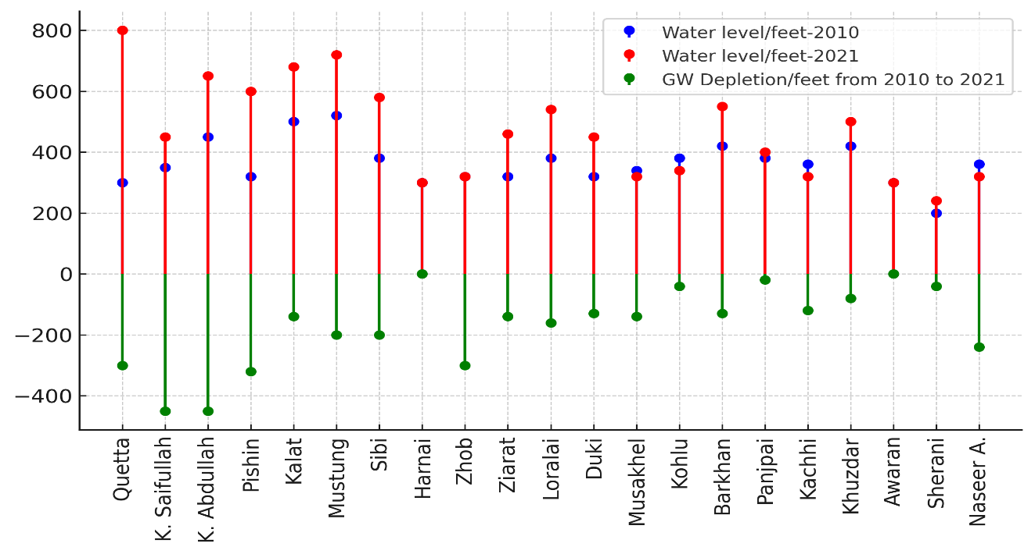
Figure 02: Declining Groundwater Levels in Balochistan
Source: Ahmad, 2006a; GOB, 2021-2022
The dependence on electric- and diesel-powered tubewells, combined with over-extraction, has adversely affected the traditional Kareze irrigation system, which has historically been important to Balochistan's community water management. The Kareze system, consisting of underground canals that convey water from aquifers to surface regions for irrigation, has been used for centuries but is currently in decline due to the widespread adoption of tubewells. Karezes, which previously accounted for 60% of irrigation systems in districts such as Killa Saifullah, Loralai, Pishin, and Ziarat, are rapidly disappearing (Ashraf, 2020).

Problem Statement
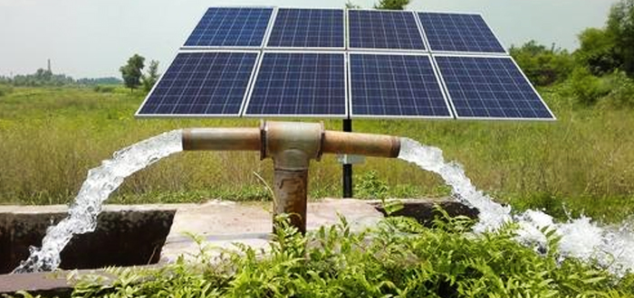
This study thoroughly analyses farmers' perspectives on the solarisation program for tubewells in Highland Balochistan, emphasising the associated social and environmental threats. The principal issue is the potential for unregulated water withdrawal from independent solar-powered tube wells, which may aggravate groundwater depletion in an area already experiencing significant water scarcity.
Figure 03: Groundwater extraction with the use of solar power
Source: Field survey, 2023
This study critically evaluates the perceptions of the agricultural community and examines the key deficiencies in the solarisation policy. A primary concern is the diminished control over the functioning of these autonomous solar-powered tube wells, which may exacerbate the depletion of already strained groundwater resources. The study assesses whether the policy of solarising tube wells is detrimental or beneficial for agriculture in the highlands of Balochistan. This study investigates whether solarisation can offer a sustainable solution to severe water scarcity or exacerbate the problem. The investigation examines the complex trade-offs, weighing the economic incentives for adopting solar technology against the potential impacts on groundwater sustainability.

Materials and Methods
Study area
This research was conducted in Balochistan, a Southwestern region of Pakistan, including over 347190 square kilometres and situated between latitudes 25°-32° N and longitudes 61°-71° E. Balochistan, characterized by an arid environment and average annual rainfall below 250 mm, predominantly depends on groundwater for agricultural purposes (GOB, 2021-22). The highlands region, one of the province's six agroecological zones, is arid, receiving only 200-250 mm of rainfall annually, underscoring the need for sustainable irrigation supplies (IUCN, 2000). This area involves significant agricultural districts such as Killa Saif Ullah, Pishin, and Quetta. In the study, the highlands were categorised by elevation into low-altitude areas (1050-1550 meters), medium-altitude areas (1551-2050 meters), and high-altitude areas (above 2051 meters), acknowledging the varied climatic, agricultural, and water resource conditions at these elevations (Chudhary et al., 2008; Rana et al., 2021).
Questionnaire Design and Sampling Framework
A comprehensive questionnaire was created, evaluated by research experts, and enhanced based on their feedback to ensure data reliability. The Department of Agriculture provided a thorough list of villages of three important basins, ensuring a representative sampling frame for the sampling framework. Sample villages were selected to reflect the diverse topographic conditions of the respondents accurately.
Sample Size Selection and Data Collection
The highlands were selected among six agroecological zones due to their declining groundwater levels and acute water constraints. In this area, three principal basins were deliberately chosen: Zhob River Basin (ZRB), Nari River Basin (NRB), and Pishin Lora Basin (PLB). Primary data were gathered from five deliberately selected settlements within each basin. Using the formula by Yamane (1968), n = N/(1 + N*e²), a representative sample of 350 respondents was selected through a proportionate stratified sampling technique.
Econometric Modelling
Logit Regression.
The binary logistic regression technique is commonly employed in empirical research to analyse and forecast dichotomous outcomes, like the adoption or non-adoption of an entity. (Sanni and Doppler 2007; Benerjee and Martin, 2009). The cumulative logistic probability model (Aidoo et al., 2013) is presented thus;
$$P_{i}\left(Y=\frac{1}{X_{i}}\right)=f\left(Z_{i}\right)= \frac{1}{{1+℮}^{-\left(α+β_{i}X_{i}+ ε_{i}\right)}}………………………………………………(01)$$
Where $P_{i}$ = probability that a farmer is an adopter of HEIS in the face of explanatory variables ($X_{i})$ and $P_{i}$ ranges between 0 to 1, $℮$ = natural logarithm base, $X_{i}$ = the vector of an independent variable, $α and β_{i}$ = the model parameters need to be estimated, and $ε_{i}$ = the stochastic error term.
The model is expressed in terms of odds and log-odds to make it easy to interpret the estimated coefficients. Therefore, the odds ratio is the ratio between the probability that a farmer will adopt HEIS ($P_{i})$ to the probability Farmer will not tend to opt for HEIS (${1-P}_{i}$).
Thus;
$${℮^{z_{i}}=\frac{P_{i}}{1-P}}_{i}…………………………..……………………………………………….……….…(02)$$
$$\ln\left(\frac{P_{i}}{1-p_{i}}\right)= z_{i}………….……………………………………………………….…………….(03)$$
$$Z_{i}= α+ \sum_{1=0}^{n}{β_{i}X_{i}+ ε_{i}}………………………………………………………………………..….(04)$$
By the introduction of a dichotomous response variable, $Y_{i}$, $Y_{i}= \left\{\begin{aligned}1 if Y^{*}>0 \\ 0 otherwise\end{aligned}\right.$
Where 1 = adopters, 0 = Non Adopters, $i$ = total number of respondents, Solving for the probability that Y = 1, Equation becomes,
$\left(\frac{P_{i}}{1-P_{i}}\right)= ℮^{z_{i}}$………………………………………………………………………………………………........................... (05)
Then, $P_{i}= \frac{℮^{z_{i}}}{1+℮^{z}}$…………….……………………………………………………………………………………………………… (06)
Validity and Reliability
This study addressed validity and reliability to ensure dependable outcomes. Validity was strengthened through expert review of the questionnaire, pre-testing, and achieving an adequate sample size, in line with Hair et al.'s (1998) guidelines. Triangulation, or mixed methods, was also applied to enhance qualitative validity (Maxwell, 2013). Reliability, defined as consistency in research methodology (Saunders, 2015), was maintained by including diverse farmer groups in sampling, training and monitoring enumerators, and pre-testing the survey instrument to eliminate ambiguous questions. A Cronbach's Alpha of 0.67 was calculated, indicating acceptable reliability for sociological research (Louangrath, 2018; Wudil et al., 2023).
Results and Discussions
Table 01 explains that groundwater depletion emerges from its open-access nature and lack of regulation. Key factors include low rainfall (<250 mm/year), high water-demand crops (750 mm/year), widespread unregulated tubewell drilling, inefficient irrigation, and prolonged over-pumping due to energy subsidies (Ahmad, 2007). The survey data highlights respondents' perceptions of groundwater depletion caused in highland Balochistan, illustrating distinct priorities across electric, solar, and combined electric-solar tubewell users. Among electric tubewell users, nearly half (48.37%) identified low aquifer recharge as the primary cause for groundwater decline, suggesting a solid awareness of environmental limitations. This is further supported by the finding that 37.21% attribute the depletion to the mass installation of tubewells, indicating that overuse of groundwater infrastructure is perceived as a significant contributing factor. Additionally, cropping intensity was noted by 6.98% of electric tubewell users, consistent with prior research by Khair et al. (2012), which observed that cultivating high-water-demand crops, like apples, is associated with lowered water tables. These findings highlight the ecological strain imposed by intensive agriculture in areas reliant on groundwater.
Users of solar tubewells, however, prioritised various factors: Depletion was mostly attributable to subsidised power (28%), followed by inadequate aquifer replenishment (22%) and extensive tubewell installations (20%). This perspective indicates that economic incentives might unintentionally encourage over-extraction of groundwater, a notion supported by Ahmad (2006) and Qureshi et al. (2008), who found that higher energy costs and inadequate water management practices intensify groundwater depletion in the area. Users of combined electric-solar systems predominantly identified low aquifer recharge (30%) and extensive tubewell installations (22%) as contributing factors, while acknowledging cropping intensity at 14%, indicating a measured concern on both infrastructure and agricultural intensity.
The replies collectively suggest that participants acknowledge natural constraints, such as insufficient aquifer recharge, and human-induced pressures, including widespread tubewell installations and high-water-demand crops, as significant factors contributing to groundwater depletion. The evidence corroborates the concerns raised by Qureshi et al. (2008), who noted that declining water tables result in escalating pumping costs and declining groundwater quality, and by Rana et al. (2021), who forecasted that ongoing groundwater extraction may lead to intergenerational sustainability challenges and water conflicts. Given that more than 60% of Balochistan's groundwater has been depleted (Ahmad 2006; Rana et al., 2021), these findings underscore the critical necessity for strategic groundwater management and a reassessment of agricultural and economic strategies to guarantee water security for present and future generations.
Table 01: Perception of the respondents about the causes of groundwater depletion
Reasons for water table decline | Electric tubewell users |  | Solar tubewell users |  | Electric + Solar tubewell users
Reasons for water table decline | Freq. | Percent | Freq. | Percent | Freq. | Percent
Cropping intensity | 15 | 6.98 | 4 | 8.00 | 7 | 14.00
Subsidized electricity | 3 | 1.40 | 14 | 28.00 | 1 | 2.00
Low aquifer recharge | 104 | 48.37 | 11 | 22.00 | 15 | 30.00
Inefficient irrigation techniques | 3 | 1.40 | 2 | 4.00 | 8 | 16.00
Mass installation of tubewells | 80 | 37.21 | 10 | 20.00 | 11 | 22.00
Solarization | 15 | 4.65 | 8 | 18.00 | 8 | 16.00
Total | 220 | 100 | 50 | 100 | 50 | 100
Source: Field survey, 2023
Groundwater Ownership and Government Policies
Table 02 provides critical insights into users' perceptions of electric, solar, and combined electric-solar tubewells concerning government groundwater policy, their readiness to adopt solar energy, and their opinions on groundwater ownership. A significant observation is the pervasive unawareness regarding groundwater-related policies among all demographics. Among electric tubewell users, 81.82% reported being uninformed of any policies, whereas only 0.45% confirmed the presence of a policy, and 17.73% clearly said that no policy was in effect. A comparable trend is noted among solar tubewell users, with 65% indicating ignorance of any groundwater-related government regulation and 32.50% asserting that no such policy exists. The collective cohort of electric and solar tubewell users exhibited a significant degree of unawareness, with 87.50% of respondents reporting unfamiliarity with policies. These findings indicate a significant deficiency in the communication or implementation of governmental groundwater management policies, especially in a region where water shortage is becoming an increasingly urgent concern. If policies are in place, they have not been sufficiently communicated to the agricultural communities and essential players involved in groundwater resource management.
The second section of the table analyses respondents' readiness to shift from electricity upon receiving subsidies for solarisation. Among solar tubewell users, 65% indicated a preference to discontinue electricity usage, demonstrating this group's positive attitude towards solar energy. Conversely, merely 36.36% of electric tubewell users expressed a willingness to discontinue electricity usage if offered solarisation incentives, whilst 59.55% indicated they would persist in using electricity. This indicates substantial reluctance or dependence on existing electricity systems among this group, likely attributable to established infrastructure or a perceived lack of reliability in solar systems. Sixty percent of combined users indicated a readiness to completely migrate to solar energy, reflecting a favourable attitude towards the adoption of solar-powered irrigation systems. The significant percentage of electric tubewell users resistant to transition underscores possible obstacles in adopting renewable energy, especially if electricity continues to be subsidized or more readily available.
The final section of the table examines perceptions of groundwater ownership, which varied markedly among the various populations. Among electric tubewell users, 43.64% perceived groundwater as private property, reflecting a robust conviction in individual ownership of this common pool resource. A substantial percentage (23.18%) perceived groundwater as belonging to God, indicating a communal or spiritual viewpoint on natural resources, whereas 26.36% regarded it as public property. Conversely, among solar tubewell users, a clear majority (55%) regarded groundwater as divinely owned, indicating a more communal and spiritual perspective on water resources within this demographic. Merely 25% regarded it as private property, while 15% perceived it as public property. Notably, of all users, 52.50% perceived groundwater as public property, 32.50% attributed ownership to God, and hardly 5% regarded it as private property. The varied perspectives on groundwater ownership underscore the socio-cultural intricacies of groundwater regulation and management. The prevalence of community or spiritual perspectives on water resources, especially among solar and mixed users, may contest laws aimed at regulating or privatising groundwater extraction. Effective water management methods must account for these differing ideas of ownership to ensure that restrictions are socially accepted and enforceable.

Table 02: Respondents' perceptions of groundwater ownership and the Govt policies
GW ownership and policies | Electric tubewell users |  | Solar tubewell users |  | Electric + Solar tubewell users
GW ownership and policies | Freq. | Percent | Freq. | Percent | Freq. | Percent
Is there any government groundwater-related policy in effect?
Yes | 1 | 0.45 | 1 | 2.50 | 2 | 5
No | 39 | 17.73 | 13 | 32.50 | 3 | 7.50
Don’t know | 180 | 81.82 | 26 | 65 | 35 | 87.50
Total | 220 | 100 | 40 | 100 | 40 | 100
Is solarization of electric tubewells an economically and environmentally viable policy
Yes | 80 | 36.36 | 26 | 65 | 24 | 60
No | 131 | 59.55 | 9 | 22.50 | 12 | 30
Don’t know | 9 | 4.09 | 5 | 12.50 | 4 | 10
Total | 220 | 100 | 40 | 100 | 40 | 100
Groundwater ownership
God | 51 | 23.18 | 22 | 55 | 13 | 32.50
State | 15 | 6.82 | 2 | 5 | 4 | 10
Public property | 58 | 26.36 | 6 | 15 | 21 | 52.50
Private property | 96 | 43.64 | 10 | 25.00 | 2 | 5.00
Total | 220 | 100 | 50 | 100 | 50 | 100
Source: Field survey, 2023
Perception of the Respondents about Existing and Future Govt. Legislations
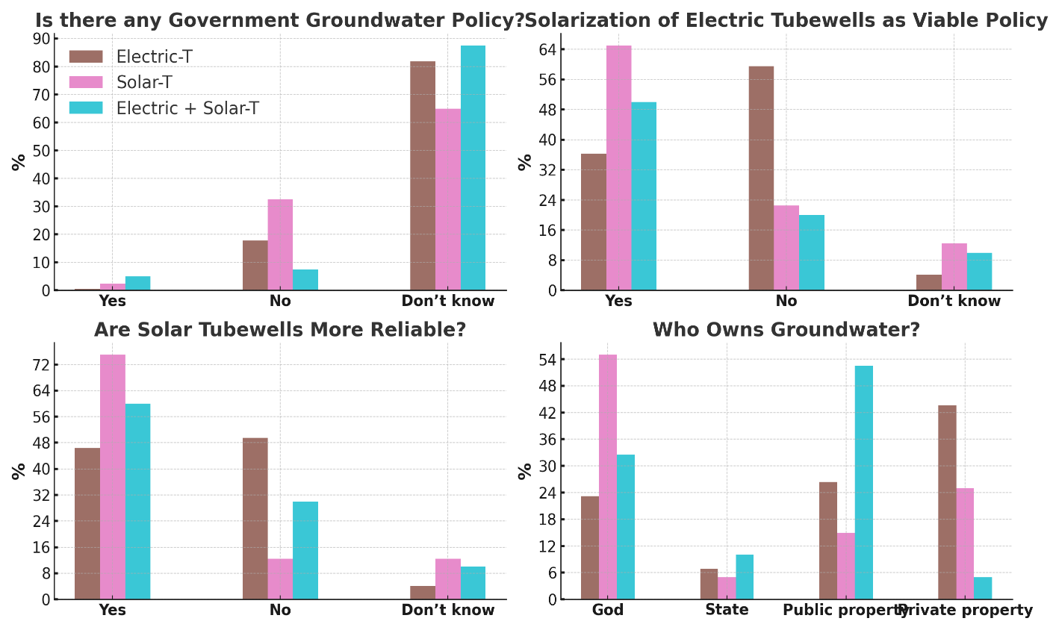
Figure 04 indicates that although the solarisation of tubewells is perceived as a feasible and dependable approach by 65% of Solar Tubewell users and 50% of Electric and Solar Tubewell users, it directly exacerbates groundwater depletion. Solar tubewells, regarded as more dependable by 75% of their users and 60% of users of both electric and solar tubewells, can function with fewer financial limitations than electric tubewells. This results in over-extraction, especially in regions experiencing declining groundwater levels. Moreover, 87.5% of users of Electric and Solar Tubewells are unaware of any governmental policy regarding groundwater, underscoring a lack of awareness or enforcement of restrictions. Moreover, 55% of Solar Tubewell users saw groundwater as "owned by God," thereby diminishing their sense of human accountability for sustainable water utilisation. Consequently, although solarisation is regarded favourably, it is exacerbating groundwater depletion in the research area, necessitating the immediate establishment of more robust regulatory frameworks and heightened awareness to foster sustainable groundwater management.
Figure 04: Perception of the respondents of three groups about groundwater related policies
Source: Field survey, 2023
Table 03 presents an examination of socio-economic variables distinguishing solar and electric tubewell users, revealing significant disparities that underscore potential effects on groundwater depletion in Highland Balochistan. Users of solar tubewells are generally younger and more educated than their peers, suggesting greater receptiveness to adopting innovative technologies. Notably, although solar tubewell users possess greater average farm sizes (43.76 acres), they cultivate less land (11.32 acres) compared to electric tubewell users, who cultivate an average of 15.47 acres. Both groups, however, contain significant expanses of unproductive land, with solar users averaging 19.88 acres.
This raises concern that using solar tubewells, which offer more affordable, accessible energy, may entice farmers to expand crop production, leading to increased water extraction. Although solar tubewells reduce reliance on electricity and provide a more sustainable energy alternative, they may inadvertently exacerbate groundwater over-extraction, further depleting aquifers.
Table 03: Socioeconomic characteristics of the respondents
Socio-economic variables | Solar tubewells user (N=100) |  |  |  | Electric tubewells farmer (N=220)
Socio-economic variables | Mean | Std. Dev. | Min | Max | Mean | Std. Dev. | Min | Max
Age (years) | 43.72 | 10.53 | 29.12 | 64.00 | 45.00 | 12.17 | 24.00 | 82.00
Schooling(years) | 7.77 | 5.18 | 3.00 | 16.00 | 5.80 | 4.18 | 0.00 | 16.00
Family size (no.) | 17.00 | 10.92 | 5.00 | 44.00 | 19.52 | 13.37 | 3.00 | 59.00
Farm size (acres) | 43.76 | 55.79 | 5.00 | 210.00 | 34.82 | 32.27 | 5.00 | 231.00
Cultivated land (acres) | 11.32 | 12.89 | 3.00 | 55.00 | 15.47 | 14.90 | 4.00 | 121.00
Barren land (acres) | 19.88 | 25.20 | 2.00 | 109.00 | 22.96 | 27.24 | 3.00 | 199.00
This paradox, in which a sustainable energy solution exacerbates environmental degradation, presents a significant barrier to long-term agricultural viability in the region.
Econometric Estimation
Table 04 presents the logistic regression results, elucidating the elements that affect groundwater depletion in relation to solarised tubewells. The most notable finding is a positive, statistically significant correlation between tubewell solarisation and groundwater depletion (β = 3.143, p < 0.01). This affirms the study's primary assertion: whereas solarising tubewells reduces energy costs, it unintentionally promotes excessive water consumption, leading to greater groundwater depletion. Solarisation may give the impression of "free water" as energy costs are reduced, encouraging excessive extraction. Furthermore, age shows a positive correlation with groundwater depletion (β = 0.057, p < 0.01), indicating that older farmers, perhaps due to their established agricultural techniques and reliance on irrigation, are more likely to contribute to depletion.
Aged farmers may oppose the adoption of water-conserving technologies or alternative irrigation methods, leading to increased water consumption. Although schooling shows a positive, albeit small, correlation (β = 0.047, p = 0.125), this suggests that education, in this context, does not significantly affect groundwater use habits. Schooling, although typically associated with improved decision-making, may not immediately affect irrigation or water management practices in this agricultural context. Cultivated land shows a negative correlation with groundwater depletion (β = -0.103, p < 0.01), suggesting that farmers with larger landholdings are more likely to manage water resources more sustainably, perhaps due to economies of scale or superior irrigation methods. More extensive agricultural operations may prioritise the conservation of groundwater resources to sustain productivity, thereby elucidating the inverse correlation.
The depth of the water table exerts a positive and significant influence on depletion (β = 0.004, p < 0.01), suggesting that deeper water tables require more extensive extraction, leading to overexploitation. Farmers must increase water extraction when water levels decline, exacerbating depletion. The frequency of irrigation is a crucial factor in depletion (β = 1.768, p < 0.01), reinforcing the idea that frequent irrigation intensifies groundwater overexploitation. Frequent irrigation indicates inadequate water utilisation or the cultivation of high-water-demand crops, thereby exacerbating the strain on water supplies. Finally, the utilisation of high-efficiency irrigation systems shows a negative correlation with depletion (β = -0.695), although this association is not statistically significant (p = 0.159). This indicates that although these technologies may reduce water use, their impact is insufficient to offset the consequences of increased tubewell utilisation. Farmers may implement high-efficiency systems for reasons beyond water conservation, such as labour reduction or convenience, thereby diminishing the anticipated environmental benefits.
The data indicate that solarisation, although advantageous for reducing energy consumption, results in unforeseen environmental repercussions by increasing water use, thereby exacerbating groundwater depletion. This highlights the need for comprehensive policies that promote energy efficiency and sustainable water management.

Table 04: Logistic estimates of different factors contributing to groundwater depletion (N =320)
Explanatory variables |  | Coef. | St. Err. | t-value | p-value | 95% coeff | Interval] | Sig
Adoption of solarization of tubewells (0=no, 1=yes) |  | 3.143 | .577 | 5.45 | 0 | 2.012 | 4.274 | ***
Age (year) |  | .057 | .015 | 3.75 | 0 | .027 | .087 | ***
Schooling (year) |  | .047 | .031 | 1.53 | .125 | -.013 | .107
Cultivated land (acre) |  | -.103 | .024 | -4.30 | 0 | -.15 | -.056 | ***
Watertable depth nowadays (feet) |  | .004 | .001 | 5.13 | 0 | .002 | .005 | ***
Irrigation frequency (numbers) |  | 1.768 | .448 | 3.95 | 0 | .89 | 2.646 | ***
Use of High-efficiency irrigation system (0=no, 1=yes) |  | -.695 | .494 | -1.41 | .159 | -1.664 | .273
Constant |  | -4.103 | .902 | -4.55 | 0 | -5.871 | -2.334 | ***
Mean dependent var |  | 0.545 |  | SD dependent var |  | 0.499
Pseudo r-squared |  | 0.385 |  | Number of obs |  | 319
Chi-square |  | 169.428 |  | Prob > chi2 |  | 0.000
Akaike crit. (AIC) |  | 286.160 |  | Bayesian crit. (BIC) |  | 316.281
 | *** p<0.01, ** p<0.05, * p<0.1
Source: Field survey, 2023

Conclusion
The study investigates the influence of solarisation on tubewells in Highland Balochistan, focusing on the paradox of addressing electricity shortages while increasing groundwater depletion. Solar-powered tubewells are commonly used to lessen dependency on traditional energy sources, especially in rural societies where electricity is intermittent. While solarisation provides a cost-effective and sustainable energy option, the study found that it has unanticipated environmental impacts, including over-extraction of groundwater. The deployment of solar tubewells is significantly associated with increasing groundwater depletion (β = 3.143, p < 0.01). The lower energy costs associated with solarisation encourage farmers to draw more water, treating it as a less expensive resource, hastening the loss of already-stressed groundwater sources.
Older farmers may be less likely to adopt water-saving measures, contributing to groundwater depletion (β = 0.057, p < 0.01). Additionally, irrigation frequency (β = 1.768, p < 0.01) and water table depth (β = 0.004, p < 0.01) have a substantial impact on groundwater extraction, further stressing water resources. The analysis suggests that farmers with larger landholdings manage water more sustainably, as seen by a negative correlation between cultivated land and depletion (β = -0.103, p < 0.01). Although high-efficiency irrigation systems (HEIS) have the potential to cut water use, their implementation has not significantly reduced groundwater depletion (β = -0.695, p = 0.159).
To summarise, while solarisation addresses electricity concerns, it unintentionally exacerbates groundwater loss, posing a substantial risk to agricultural sustainability in the region. The report advocates immediate legislative action to incorporate energy efficiency and sustainable water management. Without effective control, the environmental benefits of solar energy will be outweighed by the rapid loss of crucial groundwater resources, jeopardizing the long-term viability of agriculture in Balochistan.
Recommendations
To promote sustainable groundwater use in Balochistan, solarisation of tube wells should be supplemented with high-efficiency irrigation systems (HEIS). This rule would promote water conservation by limiting the amount of groundwater drawn and addressing over-extraction caused by unregulated solar-powered wells. Furthermore, incorporating a net-metering option for solar-powered wells would allow farmers to sell excess energy back to the national grid on non-irrigation days, providing a financial incentive to conserve water. This program would improve water efficiency by raising the opportunity cost of over-pumping, encouraging farmers to prioritise irrigation efficiency.
To support sustainable irrigation, additional ideas include developing drought-resistant, low-delta, high-value crops, lowering agricultural water demand, and enhancing water literacy and on-farm water management. Strengthening water governance, such as revising the Balochistan Ground Water Rights Administration Ordinance (BGWRA) and establishing a Balochistan Groundwater Regulatory Authority, would provide the regulatory framework required to protect aquifers and ensure effective water resource management for long-term sustainability.

Ameenullah
Abdulaziz Thabet Dabiah adabiah@ksu.edu.sa (https://orcid.org/0000-0002-9540-1127)
Muhammad Muddassir mrajpoot@ksu.edu.sa (https://orcid.org/0009-0003-2636-7513)
Asghar Ali asgharali2878@gmail.com (https://orcid.org/0000-0002-7702-2983)
Syed Muhammad Khair
Syed Sadiq Agha
Rizwan khan

References
Ahmad, M., Mustafa, U., & Iqbal, M. (2023). Groundwater governance and smallholder agriculture in Pakistan: Institutional gaps and reform pathways. Water Policy, 25(2), 310–328. https://doi.org/10.2166/wp.2023.004
Ahmad, S. (2006). Issues restricting capping of tube well subsidy and strategy for introducing the smart subsidy in Balochistan. Water for Balochistan Policy Briefings, 2.
Aidoo, R., Mensah, J. O., & Tuffour, T. (2013). Determinants of household food security in the Sekyere-Afram plains district of Ghana. European Scientific Journal, 9(21), 514–521.
Ali, M. A., Yamin, M., Arslan, C., Farid, U., & Nasir, A. (2020). A feasibility study: Off-grid photovoltaic solar power supply to the remote areas of Pakistan. Pakistan Journal of Agricultural Sciences, 57(5), 1313–1316.
Ashraf, M. (2020). Groundwater management in Balochistan, Pakistan: A case study of Karez rehabilitation. AGRIS. https://agris.fao.org/search/en/providers/122582/records/647481f9bf943c8c7988a522
Banerjee, S., & Martin, S. W. (2009). A binary logit analysis of factors impacting adoption of genetically modified cotton. African Journal of Agricultural Research, 4(12), 1445–1451.
Choudhary, M. A., Lodhi, A. S., Ahmad, M., & Ahmed, M. (2008). A comparative study of cost of production and decision making analysis in case of onion and sunflower crops in Quetta district. Sarhad Journal of Agriculture, 24(3), 469–478.
Government of Balochistan. (2021–22). Agriculture statistics of Balochistan. Department of Agriculture Extension.
Hair, J. F., Tatham, R. L., Anderson, R. E., & Black, W. C. (1998). Multivariate data analysis (5th ed.). Prentice Hall.
Halcrow-Pakistan & Cameos Consultants. (2008). Identification of recharge potential zones in three over-drawn basins (PLB, Nari, and Zhob): Final report. Irrigation and Power Department, Government of Balochistan; Royal Government of the Netherlands.
Hanjra, M. A., & Qureshi, M. E. (2010). Global water crisis and future food security in an era of climate change. Food Policy, 35(5), 365–377. https://doi.org/10.1016/j.foodpol.2010.05.006
Irfan, M., Zhao, Z. Y., Ahmad, M., & Mukeshimana, M. C. (2019). Solar energy development in Pakistan: Barriers and policy recommendations. Sustainability, 11(5), 1206. https://doi.org/10.3390/su11051206
IUCN. (2000). Balochistan conservation strategy. IUCN Pakistan & Government of Balochistan.
Khair, S. M., Rasheed, A., & Culas, R. (2021). Improving groundwater management to enhance agriculture and farming livelihoods: Socio-economic analysis of groundwater resource management for Balochistan, Pakistan (ILWS Report No. 155). Institute for Land, Water and Society, Charles Sturt University.
Louangrath, P. (2018). Reliability and validity of survey scales. International Journal of Research & Methodology in Social Science, 4(3), 50–62.
Maxwell, J. C. (2013). The 17 indisputable laws of teamwork: Embrace them and empower your team. HarperCollins Leadership.
Mustafa, Z., Iqbal, R., Siraj, M., & Hussain, I. (2022). Cost–benefit analysis of solar photovoltaic energy system in agriculture sector of Quetta, Pakistan. Environmental Sciences Proceedings, 23(1), 26. https://doi.org/10.3390/environsciproc2022023026
Nagaraj, N., Frasier, W. M., & Sampath, R. K. (1999). Groundwater institutions in US and India: Sustainable and equitable resource use. Economic and Political Weekly, 34(26), A93–A104.
Qureshi, A. S., Shah, T., & Akhtar, M. (2022). The groundwater economy of Pakistan: Challenges and prospects for sustainable management. Hydrogeology Journal, 30(4), 1145–1161. https://doi.org/10.1007/s10040-022-02451-2
Qureshi, A. S., Gill, M. A., & Sarwar, A. (2008). Sustainable groundwater management in Pakistan: Challenges and opportunities. Irrigation and Drainage, 57(3), 373–388. https://doi.org/10.1002/ird.400
Rafi-Khan, D., & Maria, M. (2023). Scarcity of water in Quetta–a way forward. Journal of Positive School Psychology, 7(2), 1–10.
Rana, A. W., Davies, S., Moeen, M. S., Shikoh, S. H., & Rizwan, N. (2020). Solarization of electric tube-wells for agriculture in Balochistan: Economic and environmental viability. International Food Policy Research Institute.
Rizwan, N., Shikoh, S. H., Davies, S., Moeen, M. S., Rana, A. W., & Haider, Z. (2021). Assessing the economic cost of depleting groundwater in Balochistan: A social accounting matrix (SAM) multiplier approach (IFPRI Discussion Paper). International Food Policy Research Institute. https://doi.org/10.2499/p15738coll2.134349
Sanni, S. A., & Doppler, W. (2007). Socio-economic determinants of household fertilizer use intensity for maize-based production systems in the Northern Guinea Savannah of Nigeria. Journal of Applied Sciences, 7(12), 1774–1779.
Saunders, F. C. (2015). Toward high reliability project organizing in safety-critical projects. Project Management Journal, 46(3), 25–35.
Shah, S. A. A., & Solangi, Y. A. (2019). A sustainable solution for electricity crisis in Pakistan: Opportunities, barriers, and policy implications for 100% renewable energy. Environmental Science and Pollution Research, 26(29), 29687–29703. https://doi.org/10.1007/s11356-019-05995-3
Shah, S. A. A., Valasai, G. D., Memon, A. A., Laghari, A. N., Jalbani, N. B., & Strait, J. L. (2018). Techno-economic analysis of solar PV electricity supply to rural areas of Balochistan, Pakistan. Energies, 11(7), 1777. https://doi.org/10.3390/en11071777
Shah, T. (2022). Solar irrigation pumps and groundwater depletion: Reframing the debate. Nature Sustainability, 5(7), 562–564. https://doi.org/10.1038/s41893-022-00896-3
Solangi, Y. A., Shah, S. A. A., Zameer, H., Ikram, M., & Saracoglu, B. O. (2019). Assessing the solar PV power project site selection in Pakistan: Based on AHP-fuzzy VIKOR approach. Environmental Science and Pollution Research, 26(30), 30286–30302. https://doi.org/10.1007/s11356-019-06107-x
Wakeel, M., Chen, B., & Jahangir, S. (2016). Overview of energy portfolio in Pakistan. Energy Procedia, 88, 71–75. https://doi.org/10.1016/j.egypro.2016.06.010
Water and Power Development Authority (WAPDA). (1993). Groundwater resources of Balochistan Province, Pakistan. Directorate General Hydrology.
Watto, M. A., & Mugera, A. W. (2016). Groundwater depletion in the Indus Plain of Pakistan: Imperatives, repercussions and management issues. International Journal of River Basin Management, 14(4), 447–458. https://doi.org/10.1080/15715124.2016.1204474
Wudil, A. H., Ali, A., Mushtaq, K., Baig, S. A., Radulescu, M., Prus, P., Usman, M., & Vasa, L. (2023). Water use efficiency and productivity of irrigated rice cultivation in Nigeria: An application of the stochastic frontier approach. Sustainability, 15(10), 7824. https://doi.org/10.3390/su15107824
Yamane, T. (1967). Statistics: An introductory analysis (2nd ed.). Harper & Row.
Yaqoob, H., Teoh, Y. H., Din, Z. U., Sabah, N. U., Jamil, M. A., Mujtaba, M., & Abid, A. (2021). The potential of sustainable biogas production from biomass waste for power generation in Pakistan. Journal of Cleaner Production, 307, 127250. https://doi.org/10.1016/j.jclepro.2021.127250

