Research article
Water holding capacity of dominant species at different grazing intensities in semi-desert rangelands under gypseous and sandy soil conditions
^{*1} Shuhrat Valiyev, ² Toshpulot Rajabov, ¹ Muhtor Nosirov, ³Mahmud Muminov ¹Flora Kabulova, ¹Sirojiddin Urokov, ¹Jamshid Amirov, ¹Burkhan Avutkhanov, ⁴Savetov Qaroqul
¹Department of Plant Physiology and Microbiology, Institute of Biochemistry of Samarkand State University named after Sharof Rashidov, Samarkand City 140 104, Uzbekistan
²Institute of Agrobiotechnology and Food Security of Samarkand State University named after Sharof Rashidov Samarkand Region Jambay Destrict, Uzbekistan
³Institute of Fundamental and Applied Research, “TIIAME” National Research University, Kary-Niyaziy Str. 39, Tashkent 100000, Uzbekistan
⁴Samarkand State Medical University
⁴Samarkand State Medical University, Department of Biological Chemistry

* Corresponding author’s email: valiyev_89@list.ru
Abstract. Understanding plant water relations is critical for assessing ecosystem resilience in arid and semi-desert rangelands, yet the ecophysiological responses of dominant species to grazing and soil conditions remain insufficiently studied, particularly in Central Asia. This study aims to evaluate how soil type and grazing intensity influence the water-holding capacity (WHC) of dominant plant species in the Karnabchul semi-desert of Uzbekistan. Field experiments were conducted across eight sites representing two soil types (gypseous and sandy) and four grazing intensity levels. The WHC of three dominant species (Artemisia diffusa, Peganum harmala, and Iris songarica) was measured under varying environmental conditions. The results showed that WHC was significantly affected by species, soil type, grazing intensity, and their interactions (p < 0.05). Artemisia diffusa consistently exhibited higher WHC compared to the other species, indicating a greater capacity for water storage. Plants growing on gypseous soils generally showed higher WHC than those on sandy soils, reflecting differences in soil moisture retention. Grazing intensity had a pronounced effect, with significant changes observed under high grazing pressure, particularly in sandy soils. In addition, WHC varied throughout the day, with peak values typically recorded during midday, highlighting the dynamic nature of plant water status.
These findings support the hypothesis that plant water-holding capacity is shaped by the combined effects of environmental and anthropogenic factors, and that species exhibit distinct adaptive strategies under semi-desert conditions. The study provides new insights into plant ecophysiological responses in degraded rangelands and highlights the importance of sustainable grazing management for maintaining ecosystem stability in arid regions.

Keywords: rangelands, desertification grazing intensity, water holding capacity, A.diffusa, P.harmala, I.songarica, degradation
Intraduction.
The rangelands are one of the most important ecosystems, covering 40% of the world's land area [1]. A very large part of the existing rangelands areas is made up of semi-desert and desert areas [2]. Semi-desert rangelands are characterized by their arid climate, limited water resources, and soil physicochemical properties [3]. For a variety of reasons, mainly related to overgrazing and the resulting problems of soil erosion and noxious weed invasion, many of the world's natural rangelands are in poor condition and are showing signs of decline [4]. Overgrazing in rangeland reduces the height of plants, decreases the length of shoot internodes, and decreases leaf area [5]. The degradation of rangelands under livestock grazing is a concern in many regions worldwide, including Central Asia and Uzbekistan [6,7]. Rangelands are one of the most important ecosystems that make up the main land areas of Uzbekistan [8]. For centuries, rangelands have been widely used for grazing livestock and are important in providing agricultural products [9].
Nowadays, the existing rangeland areas of Uzbekistan occupy more than 21 million hectares [10]. The existing desert rangeland in Uzbekistan are formed by three large rangeland areas (Ustyurt, Kyzylkum, Karnabchul). The existing rangelands differ from each other in terms of plant species composition and soil conditions [11]. In recent years, due to the increasing impact of various anthropogenic factors on desert rangelands, including overgrazing of livestock, degradation processes have been significantly increasing [12]. As a result, many plant species are decreasing or are under threat of complete extinction [13]. Overgrazing of livestock accelerates desertification processes in rangelands, which ultimately leads to the intensification of various duststorms [14,15].
Previous studies on rangelands in Uzbekistan have primarily focused on vegetation productivity and monitoring [16]. However, the ecophysiological responses of dominant plant species to environmental stressors, particularly grazing intensity, remain poorly understood [17]. (Understanding plant physiological responses is essential for assessing ecosystem resilience and adaptation to grazing and drought conditions [18]. One of the important indicators of plant water metabolism is the water holding capacity of tissues, which, depending on many factors, has a significant impact on the physiological processes taking place in the plant [19]. Water availability is a limiting factor for plant growth in arid and semi-arid ecosystems. The ability of plants to water holding is determined by their root system, leaf area, transpiration rate, and interactions with the soil [20]. For example, studies by show that plants in semi-arid regions often have deep root systems and low transpiration, which indicates their water-saving strategy [21]. Gypseous soils are more hydroscopic, and their physical and chemical composition may hinder plant water uptake [22]. In contrast, sandy soils have lower water retention rates, but these soils have deeper root penetration, which increases the ability to access water [23].
The morphophysiological characteristics of dominant plant species, in particular the structure of the root system and the water holding capacity of their leaves, directly affect the intensity of grazing they can withstand [24,25]. Studies related to water regimes are important for assessing the physiological recovery properties of plants and analyzing changes in drought and different grazing intensities [26,27]. In particular, by studying the water holding properties of dominant rangelnd plants (Artemisia diffusa, Peganum harmala, Iris songarica), it is important to understand their tolerance levels under different soil conditions and different grazing intensities, and to understand which species are more tolerant to drought and grazing intensities under conditions of increased degradation [28]. The lack of water in plants causes negative changes, especially in plants growing in arid environments [29]. Lack of water for plants can occur as a result of low rainfall and various environmental factors. With increasing aridity due to climate change, understanding how plant species store and retain water becomes crucial [30]. From the few studies conducted on the relationship between the water use efficiency of rangeland plants at the dominant species, and functional group level to grazing intensity, it is known that at medium grazing intensities, water use efficiency can be significantly increased [31]. However high grazing intensities can have negative effects on plants. Under low to medium grazing conditions, dominant species maintain root biomass, which plays an important role in soil moisture retention [32]. However, heavy grazing reduces vegetation cover, compacts the soil, and increases erosion, which hinders water infiltration into the soil [33]. Soil conditions are also important, and this process can occur more rapidly in sandy soils than in gypseous soils [34]. Due to different levels of grazing intensities, significant competition can be observed between the dominant species A. diffusa and the native invasive species P. harmala and I. songarica in the rangelands of Uzbekistan, especially in Karnabchul. Especially under conditions of overgrazing, native invasive species have become increasingly dominant and have spread widely over large areas [35].
This indicates that invasive species have adapted to drought and overgrazing conditions [36]. In such conditions, it may contribute to the preservation of forage species for livestock such as A. diffusa and to a certain extent to reduce desertification processes [37].
This study aims to investigate the water-holding capacity of dominant rangeland species (Artemisia diffusa, Peganum harmala, and Iris songarica) under different soil conditions (gypseous and sandy) and grazing intensities in the Karnabchul desert rangelands of Uzbekistan. We hypothesize that plant species exhibit distinct water retention strategies depending on soil type and grazing pressure, which influence their drought tolerance and competitive ability. By addressing the limited knowledge of plant ecophysiological responses in Central Asian rangelands, this study seeks to improve understanding of vegetation resilience and support sustainable rangeland management.
MATERIALS AND METHODS
Site description
The Karnabchul semi-desert is a wavy plain on the left bank of the middle reaches of the Zarafshan River, located in the territories of the Samarkand and Navoi regions. The plain is stretched from the southeast to the northwest by several rows of low hills, separated from each other by dry streams. The row of low hills adjoins the Ziyovuddin and Zirabulak mountains to the north.
Karnabchul is bordered to the south by the Karshi steppes to the west and the Bukhara oasis to the east with the Jam hills, with a total area of ​​500 thousand hectares. It stretches from west to east for 120 km. The average width is 40-50 km. The average height is 300 m (350 m in the central part, 450 m in the eastern part) (Fig. 1).
A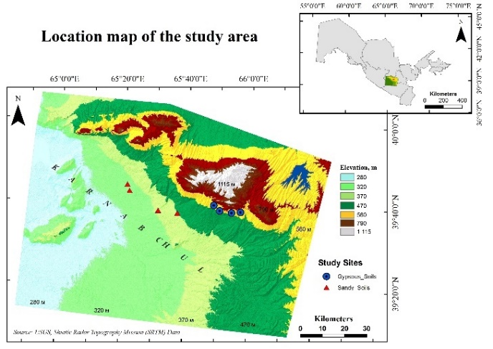
Figure 1. Location and elevation indicators of study sites of Karnabchul semi-desert of Uzbekistan. Note: 4 points in red triangles are study plots in a sandy light gray soil rangelands area, 4 points in blue are study plots in a gypseous gray-brown soil.
The average relative humidity of the air is 30%, and does not exceed 10-20% in the summer months. The climate of Karnabchul, like all deserts of Central Asia, is characterized by aridity and sharply continentality. The average annual air temperature for many years is +17.10C. The hottest air temperature is observed in June-July, reaching 37-40⁰C. The coldest air temperature is observed in December-February, sometimes reaching minus 20-30⁰C (Fig 2).

Figure 2. rainfall and temperature of the studied area, the green line is rainfall, and the red line is temperature.
Experimental designs
In the spring of 2023, a study was conducted to determine the water holding capasity properties of dominant plant communities under the influence of livestock grazing intensity. The research was conducted in a total of 8 rangelands with 2 different soil conditions (4 gypseous and 4 sandy) and four levels of grazing intensity (Table 1).
Table 1. Geographical coordinates of selected rangeland areas on gypseous and sandy soils with four different grazing intensities and WP numbers of each study area
Soil type | Grazing intensities | GPS coordinates
Gypseous | Initial (IG) | N39°9'00.6'' E065°50'34.1''
Gypseous | Low (LG) | N39°40'00.7''E065°48'35.4''
Gypseous | Medium (MG) | N39°38'43.0'' E065°57'10.8''
Gypseous | High (HG) | N39°38'11.4'' E065°52'34.1''
Sandy | Initial (IG) | N39°43'09.5'' E065°21'54.1''
Sandy | Low (LG) | N39°44'40.3'' E065°21'11.4''
Sandy | Medium (MG) | N39°38'06.3'' E065°37'15.1''
Sandy | High (HG) | N39°38'36.6'' E065°31'09.8''

The geographical coordinates of the studied area were recorded using a Garmin 60 CSx GPS device. The main dominant species of the Karnabchul semi-desert (Fig 3).
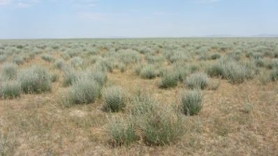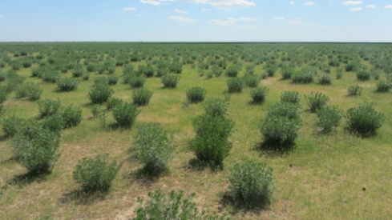
B
A
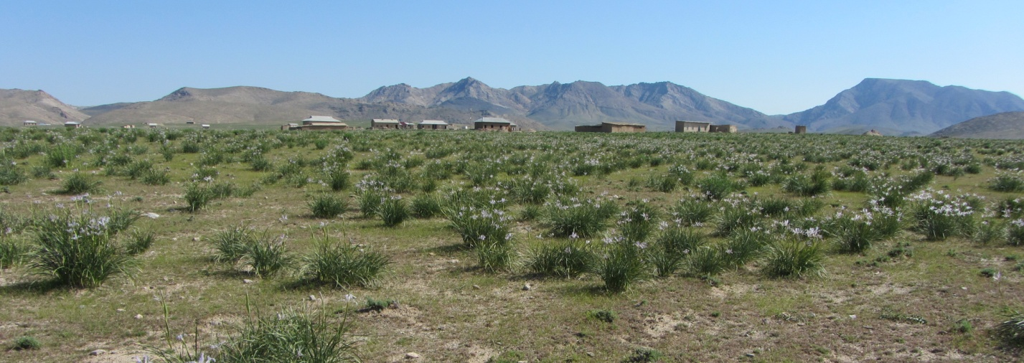
C
Figure 3. Dominant plants in different grazing intensities of Karnabchul desert rangelands
A) Artemisia diffusa, B) Peganaum harmala, C) Iris songarica (Photo by Rajabov T.F).
Data Collection
In each plot, 3 dominant plant species were selected on 2 gypseous soils under sandy soil conditions, which were ecologically and biomass dominant. The stem and leaf were measured separately for each plant sample. The study areas were divided into different grazing intensities (initial, low, medium and high), and plant samples were collected from each study plot. Sampling was carried out in 5 replicates for each study plot. After the obtained samples were initially saturated in distilled water for 2 hours, the samples were dried in a laboratory oven at 105 ⁰C for 2 hours and the dry mass of the samples was determined. The water holding capacity is based on the following formula: WHC=Wdry​(Wsat​−Wdry​)​×100
Statistical Analysis
All data were analyzed using ANOVA to assess the significance of differences in water holding capacity between grazing intensities and soil types. Tukey’s post-hoc test was applied to determine pairwise differences at a 95% confidence level. Data visualization was done using RStudio (version 4.2.1).
Results and discussion
Gypseous soil rangelands
It was observed that the water holding capacity of A. diffusa during the day differs sharply from each other depending on the grazing intensities.
ANOVA also showed that the interaction between grazing intensity dominant plant species and soil type affected water holding capacity (F = 8.9, p = 0.017; Table 2).
Table 2. Comparison of mean values ​​of WHC characteristics among three treatments, grazing intensity, soil type, and combined effects.

ANOVA |  |  |  | F- value | P-value
Grazing intensities |  |  |  | 8.9 | 0.017
Time |  |  |  | 44.5 | <0.001
Temperature |  |  |  | 184.6 | <0.001
Soil type |  |  |  | 3 | 0.014
Species |  |  |  | 729.8 | 0.0001
Grazing intensities: Species |  |  |  | 906.0 | <0.001
Grazing intensities: Soil type |  |  |  | 546.2 | <0.034
Grazing intensities: Time |  |  |  | 348.7 | <0.001

At the IG intensites, A. diffusa showed the lowest water holding capacity, which was 15.4% in the first and middle part of the day, while water holding indicators also differed at different times of the day. By the middle of the day of the study, the green mass of A. diffusa increased from 21.4% to 23.2%, indicating the maximum level for the IG level grazing intensities. The results from the second half of the day of the study (16⁰⁰) showed that the water holding capacity properties were closer to the results obtained in the first part of the day, decreasing to 16.8%. If we analyze the rangelands with low levels of grazing intensities, the green mass of A. diffusa in the first half of the day of the study was 18.6% (Fig 4).

Figure 4. Water holding capacity of Artemisia diffusa at different grazing intensities in sandy soil rangelands
It was found that the temperatures of the days when the experiments were conducted also had a significant effect on the WHC properties of dominant plants, especially in HG rangelands (Fig 5).

Figure 5. Temperature and humidity on the day of the experiment
The results at 10⁰⁰ hours of the first day of the study showed that 1 g of green mass of I. songarica was 12.2%, which was relatively high in P. harmala, but when analyzing the results obtained from A. diffusa, it was found that it was significantly lower (Fig 6).
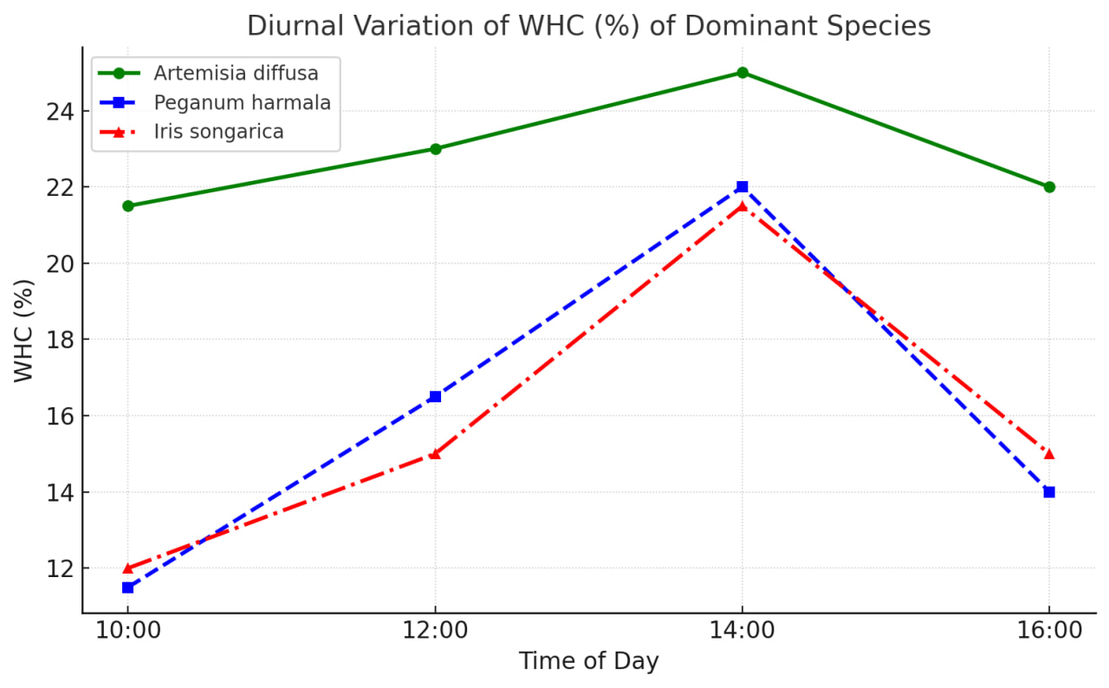
Figure 6. Water holding capacity of dominant plants in the condition gypseous soils.
The results obtained at other times of the day of the study were distinguished by being lower than both dominant species. At 14⁰⁰ hours, the water retention property of I. songarica was the highest at 22.1%, while the results obtained at the end of the day decreased to 14.9%.
Sandy soil rangelands
The results showed that both grazing intensity and daily temperature of plant species significantly affect WHC characteristics in the sandy soil of the Karnabchul semi-desert (Table 2 p<0.001).
The experiments showed that, in addition to climatic factors, the effects of grazing intensities also have a significant impact on water holding capacity properties. These effects were particularly pronounced at the high grazing intensites (Fig7).

Figure 7. Water holding capacity of Artemisia diffusa at different grazing intensities in sandy soil rangelands
At the IG intensities, the result at 10⁰⁰ of the day was 16.6%, while at the low LG intensites it decreased slightly to 15.4%. However, a significant increase was observed at the MG and HG intensities, increasing from 19.7% to 21.4%. At all grazing intensites, the highest water holding capacity rate was observed in the middle of the day during which the experiments were conducted. It was found that it was up to 27.6% at the HG intensities.
The water holding capacity of A. diffusa at the beginning of the day was 19.7% and increased throughout the day (Fig 8).

Figure 8. Water holding capacity of dominant plants in the condition sandy soils.

The water holding capacity of P. harmala at the same time was found to be much lower, at 9.3%. Although the water retention capacity increased in both species at 12⁰⁰ and 14⁰⁰ in the middle of the day, it was found that P. harmala used water sparingly compared to A. diffusa. The relatively low results of P. harmala in the experiments at the end of the day also indicate that it is a drought-tolerant species in sandy soil conditions.
It is known from the literature that rangelands with relatively gypseous soils differ from rangeland with sandy light gray soils in terms of soil composition [38]. The mineral composition of gypseous soils can enhance water retention, benefiting plant growth. Sandy soils, with their coarse texture, allow rapid water drainage, posing challenges for vegetation in retaining adequate moisture [39].
However, the high livestock grazing and the changes in the water holding capacity function of gypseous soils used unsystematically were discussed in the above chapters [40]. In the experiments we conducted, it was found that grazing also has a significant effect on the water holding capacity of plants.
Studies on the water holding properties of leaves and young annual assimilation shoots showed that in semi-desert rangelands, the water content of leaves and young annual shoots, which indicates the degree of change in the water storage capacity of plants, differs significantly between plants of seasonally wet and very dry habitats [41]. The nature of the distribution of roots is more stable in communities with sufficient or optimal moisture conditions. he data support the hypothesis that reduced grazing pressure promotes soil health and water holding capacity, which are essential for sustaining vegetation under arid and semi-arid climates.
Importantly, these insights could inform land use policies and restoration practices. Raising awareness among local stakeholders about the impact of grazing intensity on soil-plant-water relationships is crucial. Converting heavy and medium grazing regimes to low grazing within the framework of eco-compensation projects led by governmental and non-governmental organizations may significantly contribute to the long-term sustainability of rangeland ecosystems.
Future studies should further investigate seasonal variation in WHC, the role of root architecture, and long-term effects of grazing exclusion or rotational grazing systems across broader geographic scales.

Conclusions
The results demonstrate that WHC is significantly influenced by species identity, soil conditions, grazing intensity, and their interactions, confirming the importance of both environmental and biological factors in regulating plant water relations. Among the studied species, Artemisia diffusa exhibited consistently higher WHC compared to Peganum harmala and Iris songarica, indicating greater capacity for water storage under variable environmental conditions. Soil type played a critical role, with gypseous soils generally supporting higher WHC values than sandy soils, reflecting differences in soil moisture retention. Grazing intensity also significantly affected WHC, with pronounced effects observed under high grazing pressure, particularly in sandy soils. Diurnal variation further influenced WHC, with peak values observed during midday, highlighting the dynamic nature of plant water storage in response to environmental conditions. These findings support the hypothesis that plant water-holding capacity is shaped by the combined effects of soil properties and grazing pressure, and that species exhibit distinct adaptive strategies under semi-desert conditions. The results contribute to addressing the limited knowledge on ecophysiological responses of dominant rangeland species in Central Asian ecosystems. From a practical perspective, the study suggests that managing grazing intensity, especially in vulnerable sandy soils, is essential for maintaining plant water balance and ecosystem stability.
Competing Interests
The authors declare that they have no competing interests.
Acknowledgments:
I would like to express my sincere gratitude to all those who contributed to the successful completion of this research. Special thanks are due to Mukhtor Nasirov, whose guidance, support, and insightful feedback were invaluable throughout the study.
I am also deeply grateful to the Samarkand state university and the Department of Plant physiology and microbiology for providing the necessary resources and facilities.
Authors contributions:
SV contributed to formal data analysis, methodolo gy, writing-original draft, writing review and editing. TR and MG analyzed and recommended the methodology. AKh, FK, SU, JM re viewed this manuscript.

REFERENCES

- Zhou G.Y, Luo Q., Chen Y.J, He M, Zhou, L.Y, Frank D. He, Y.H, Fu Y.L, Zhang B. C, Zhou X.H. 2018. Effects of livestock grazing on grassland carbon storage and release override impacts associated with global climate change. Global Change Biol. 25, 1119–1132. https://doi.org/10.1111/gcb.14533.
- Chen X, Duan Zh, Luo T. 2014. Changes in soil quality in the critical area of desertification surrounding the Ejina Oasis, Northern China. Environmental Earth Sciences, 72:2643–2654
- Bai Y.F, Han X.G, Wu J., Chen Z.Z, Li L.H. 2004. Ecosystem stability and compensatory effects in the Inner Mongolia grassland. Nature 431, 181–184. https://doi.org/10.1038/nature02850.
- O’Mara F. 2012. The role of rangelands in food security and climate change. Pub Med 110:263-270
- Liu J, Feng Ch, Wang D, Wang L, Wilsey B, Zhong Zh. 2015. Impacts of grazing by different large herbivores in grassland depend on plant species diversity. Journal of Applied Ecology, 53:1053- 1062
- Mirzabaev A, Ahmed M, Werner J, Pender J, Louha M. 2015. Rangelands of central Asia: challenges and opportunities. Journal of Arid Land. 8, 93–108.
- Naumov Y, Pugach I. 2019. Problems and prospects for the development of animal husbandry in Uzbekistan. Discussion Paper, [IAMO], Halle Salle Germany. 6–23
- Valiyev Sh, Rajabov T, Avutkhanov B, Ataeva Sh. 2023. Changes of photosynthetic pigments of Artemisia diffusa under the influence of grazing stress of livestock grazing in Karnabchul semi-desert, Uzbekistan. Plant science today 2348-1900 https://doi.org/10.14719/pst.2430
- Rajabov T, Ramsey R, Mardonov B, Nasirov M, Rakhimova T, Valiyev S. 2020. Sensitivity of Landsat 7 & 8-derived vegetation indices on semi-arid rangelands of southwestern Uzbekistan. Geocarto International 37:510-525
- Valiyev Sh, Rajabov T, Nasirov M, Kabulova F, Ataeva Sh, Kuziev M. 2024. Changes in the Water Deficit Characteristics of Rangeland Dominant Species at Different Grazing Intensities in Gypseous and Sandy Soil Conditions. Journal of Ecological Engineering 2024, 25(11), 143–151 https://doi.org/10.12911/22998993/192830
- Rajabov T, Rakhimova T, Valiyev Sh, Abdurakhmanov Z, Allayarov M. 2021. Changes in desert rangeland soil conditions as a result of livestock grazing. Karakalpakstan Department of the Academy of Sciences of the Republic of Uzbekistan 3: 70-75
- Yusupov U. 2003. Взаимодействие животноводства и пустынной среды в Узбекистане [Interaction between livestock and the desert environment in Uzbekistan]. Pages 93-96. In: Schrader F, Alibekov L, Toderich K (eds) Proceedings of NATO Advanced Research Workshop, "Desertification Problems in Central Asia and its Regional Strategic Development" Samarkand, Uzbekistan, 11-14 June 2003. Deutsche National Bibliography, Berlin (in Russian)
- Tajibaev K, Beshko Yu, Kodirov Kh, Batoshov R, Mirzalieva U. 2018. Кадастр флоры Узбекистана: Самаркандская область [Cadastre flora of Uzbekistan: Samarkand region]. Academy of Sciences of the Republic of Uzbekistan, Tashkent (in Russian)
- Adler P, Raff D, Lauenroth W. 2001. The effect of grazing on the spatial heterogeneity of vegetation. Oecologia 128:465–479 DOI 10.1007/s004420100737.
- Kinugasa T, Ishibashi K, Miyawaki M, Gantsetseg B. 2019. Germination characteristics and phytotoxic inhibition of germination in Artemisia adamsii,alow palatability weed in the Mongolian steppe. Seed Science Research 29,197–203. https://doi.org/10.1017/S0960258519000163
- Valiyev Sh, Rajabov T, Kabulova F, Khujanov A, Urokov S. 2024. Changes in the amount of photo synthetic pigments in the native Artemisia diffusa in the semi-desert rangelands of Uzbekistan under the infulence different sheep grazing intensities and different seasons. Plant Biota. 3, 1–4. DOI: https:// doi.org/10.51470/JPB.2024.3.1.24
- Zhao L, Zhao Y, Zhou L, Zhang H, Drake S. 2005. Desertification processes due to heavy grazing in sandy rangeland, Inner Mongolia. Journal of Arid Environments 62:309–319
- Zihe Zhang, Bo Yang, Jirui Gong, Xiaobing Li, Yong Ding, Biao Wang, Jiayu Shi, Min Liu. 2021. Underlying mechanism on source-sink carbon balance of grazed perennial grass during regrowth: Insights into optimal grazing regimes of restoration of degraded grasslands in a temperate steppe. Journal of Environmental Management, 277. 11143
- Altesor A, Leoni, E, Guido, A, Paruelo, J.M. 2017. Differential responses of three grasses to defoliation, water and light availability. Plant Ecol. 218, 95–104. https:// doi.org/10.1007/s11258-016-0669-7.
- Xue C, Lv S, Wu Y, Yun J, Dong R, Wang W. 2025. Effects of different grazing intensities on plant species diversity at different spatial scales in a desert steppe in Inner Mongolia. PeerJ 13:e19087 https://doi.org/10.7717/peerj.19087
- Shen X, Liu B, Zhou D. 2015. Effects of grassland degradation on air and soil temperature in Songnen plain of northeast China. Curr.Sci. India, 108, 2098–2101.
- Villamil B, Amiotti M, Peinemann N. 2001. Soil degradation related to overgrazing in the Semi-Arid Southern Caldenal Area of Argentina. Soil Science. 7, 441–452.
- An H, Li, G.Q. 2015. Effects of grazing on carbon and nitrogen in plants and soils in asemiarid desert grassland, china. J. Arid Land 7, 341–349. https://doi.org/10.1007/s40333-014-0049-x.
- Jin Li, Fujiang Hou, Jizhou Ren. 2021. Grazing Intensity Alters Leaf and Spike Photosynthesis, Transpiration, and Related Parameters of Three Grass Species on anAlpine Steppe in the Qilian Mountains. Plants, 10, 294. https://doi.org/10.3390/ plants1002029
- Jeddi K, Chaieb M. 2010. Changes in soil properties and vegetation following livestock grazing exclusion in degraded arid environments of South Tunisia. Flora - Morphology, Distribution, Functional Ecology of Plants., 3, 184–189 DOI:10.1016/j.flora.2009.03.002.
- Usmanova M, Urokov S, Xadjayev Dj, Jurayeva Z, Keldiyarova X. Valiyev Sh. 2024. The influence of conditions on water holding capacity characteristics of triticale varieties planted in the Samarkand region. PLANT SCIENCE TODAY Vol 11(4): 752–760
- Avutxonov B, Sayfiddinov Sh, Ubaydullaev Z. 2024. E3S Web of Conferences 527, 03004 https://doi.org/10.1051/e3sconf/202452703004
- Dangal R, Tian H, Lu C, Pan S, Pederson N, Hessl A. 2016. Synergistic effects of climate change and grazing on net primary production of Mongolian grasslands. Ecosphere.7:5e01274
- Li C, Hao, X, Zhao, M, Han, G, Willms, WD. 2008. Influence of historic sheep grazing on vegetation and soil properties of a Desert Steppe in Inner Mongolia. Agriculture, Ecosystems & Environment. 1, 109–116.
- Mohamed A. E. Abdel Rahman. 2023. An overview of land degradation, desertifcation and sustainable land management using GIS and remote sensing applications. Rendiconti Lincei. Scienze Fisiche e Naturali, 34:767–808 https://doi.org/10.1007/s12210-023-01155-3
- Ingram J, Stahl D, Schuman E, Buyer S, Vance F, Ganjegunte K, Welker M, Derner D. 2008. Grazing impacts on soil carbon and microbial communities in a mixed-grass ecosystem. Soil Science Society of America Journal. 72, 939–948.
- Sun J, Wang X, Cheng G, Wu J, Hong J, Niu S. 2014. Effects of grazing regimes on plant traits and soil nutrients in an alpine steppe, Northern Tibetan Plateau. PLoS One 9, e108821. https://doi.org/10.1371/journal.pone.0108821
- Geng Y, Wang, Y, Yang, K., Wang S, Zeng H, Baumann F, He J.S. 2012. Soil respiration in Tibetan alpine grasslands: belowground biomass and soil moisture, but not soil temperature, best explain the large-scale patterns. PLoS One 7, e34968. https://doi.org/10.1371/journal.pone.0034968
- Gao, Y, Guo, Y, Zhang, T, Cao, R, Wang R. 2010. Effects of Grazing Intensity on Soil Water Holding Capacity in an Achyranthes bidentata Community in the Loess Plateau, China. Water. 12, 3238. DOI: 10.1186/2193-1801-2-S1-S1.
- Gang Li, Zhi Zhang Linlu Shi, Yan Zhou, Meng Yang, Jiaxi Cao, Shuhong Wu, Guangchun Lei. 2018. Effects of Different Grazing Intensities on Soil C, N, and Pinan Alpine Meadowonthe Qinghai Tibetan Plateau, China. International Jurnal Environmental Research. Public Health, 15, 2584; doi:10.3390/ijerph15112584
- Milgo C. 2006. Effects of grazing pressure on plant species composition and diversity in the semi-arid rangelands of Mubulu District, Tanzania. Agricultural Journal 4: 277-283
- Lhoussaine Bouchaou, Mohamed El Alfy, Margaret Shanafield, Abdelfettah Siffeddine, John Sharp. 2024. Groundwater in Arid and Semi-Arid Areas. Geosciences, 14, 332. https://doi.org/10.3390/geosciences 14120332
- Lei G, Hua P, Peth H, Horn R. 2012. Effects of grazing intensity on soil water regime and flux in Inner Mon golia Grassland, China. Pedosphere. 2, 165–177. https://doi.org/10.1016/S1002-0160 12/ 60003-4
- Mulloy T, Barrio I, Jónsdóttir S, Hik D. 2021. The effects of different management interventions on degraded rangelands in Iceland. Land Degradation and Development. 32, 4583–4594.
- Liu Y, Wang Z, Li J, Zhang Y, Qin S. 2020. Effects of grazing intensity on soil water holding capacity and vegetation characteristics in desert steppe. Catena 195:104849.
- Zhang T, Wang X, Zhou G, Li Y, Hou L. 2021. Grazing effects on plant water use efficiency and soil moisture dynamics in arid and semi-arid grasslands. Agricultural and Forest Meteorology 308–309:108565.

