STUDY OF THE POSSIBILITIES OF USING UNMANNED AERIAL VEHICLES AND MACHINE LEARNING TO ASSESS GREEN BIOMASS AND UNDERGROWTH IN THE AREAS OF THE AMANKARAGAY PINE FOREST

Seitbek Kuanyshbayev ¹, Bekmyrza Zhumash ^{1,*}, Almabek Nugmanov ¹, Mikhail Zarubin ², Aliya Yskak ¹, Gulnaz Yermoldina ¹, Vladimir Fominov ¹, Andrey Kupriyanov ³, Oleg Kuprijanov ³, Petr Lyanga ¹, Adil Nurpeisov ¹, Yevgeniy Sokharev ⁴, Zhanna Suimenbayeva⁵, Akhmet Bugubaev¹, Zayna Zhussupbekova⁶

¹Akhmet Baitursynuly Kostanay Regional University, Kostanay, Republic of Kazakhstan
²Kostanay Engineering and Economics University named after M. Dulatov, Kostanay, Republic of Kazakhstan
³Kuzbass Botanical Garden Russian Federal State Research Center of Coal and Coal Chemistry, Siberian Branch of the Russian Academy of Sciences, Novosibirsk, Russian Federation
⁴Municipal State Company “Kostanay Regional Pathoanatomical Bureau” of the Health Department of the Akimat of the Kostanay Region, Kostanay, Kazakhstan
⁵Institute of Information and Computing Technologies, Almaty, Kazakhstan
⁶National Institute of Intellectual Property, Astana, Kazakhstan
*Corresponding author:

ABSTRACT
The study examined the possibilities of using unmanned aerial vehicles to assess the density of green biomass and undergrowth in areas of the Amankaragay pine forest affected by the catastrophic fires of 2022. Comparative characteristics were obtained for two variants of the Random Forest model on homogeneous and heterogeneous sites. The implementation of the proposed approach made it possible to obtain high-precision distribution maps of birch undergrowth and other vegetation types. The study recommended that, in order to improve the accuracy class of the Modified Mode and Basic Model methods, additional investigation of undergrowth areas in multispectral ranges should be carried out to examine the influence of plant physiological indices. In the analyzed areas, covering approximately 10 hectares, the density of birch undergrowth was determined. The average value was 0.0022 per 1 m². It was noted that, on heterogeneous sites, the error of the Modified Mode model was approximately 85%, while the error of the Basic Model was approximately 95%. The developed technology can substantially increase the speed, detail, and reliability of forest stand assessment without the need for labor-intensive ground surveys. The obtained results are of significant practical importance for forest restoration, monitoring, and forest ecosystem management, demonstrating the potential of modern UAVs and machine learning methods for rapid vegetation assessment at the landscape level.

Keywords: Multispectral photo and video surveying, Remote sensing, Forest inventory, Vegetation, Plant physiological index, Automated monitoring.

- INTRODUCTION
Over the past two decades, according to Jolly et al. (2015) and van der Werf (2017), the frequency of fire-danger seasons has increased, leading to a significant rise in fires on a global scale. Thus, from 2023 to 2024, approximately 3.9 million km² were burned. As a result of these events, assessment of the state of post-fire ecosystems requires increasing resources, which creates economic costs and demands highly qualified specialists and equipment. The scale of the fires that occurred in Kostanay Region in the first half of September 2022 had no previous precedent of this kind. Abnormally high air temperatures exceeding 36 °C for September, together with the absence of rainfall, created a difficult fire situation in Kostanay Region. The fires damaged 43 thousand hectares of forest lands in Kostanay Region (Akhmet 2022; Bolbot 2022; Dosanova 2022; Makarov 2022; Nasha Gazeta 2022; Official website of the President of the Republic of Kazakhstan 2022; Sputnik 2022). High temperature and reduced humidity are among the key factors in fire formation. The restoration of forests affected by fires is an extremely complex process with a long duration. Successional processes may also be characterized by changes in the original species composition, which is particularly dangerous for relict forests. Discussion of the restoration of forests in Northern Kazakhstan after fires is therefore highly relevant (Dancheva et al. 2015; Kupriyanov et al. 2003; Makhanova et al. 2022). A detailed description of the pine relict forest of Kostanay Region is presented in a number of studies (Gribanov 1960; Pugachev 1994).
During 2024–2025, the authors of the present study have been conducting multifactorial ecological research to assess the restoration of the pine relict forest of Kostanay Region affected by fires. The authors have practical experience in assessing the restoration of forest ecosystems after fires (Kupriyanov et al. 2003), assessing the recovery of vegetation cover on lands affected by technogenic impact (Bugubaeva et al. 2023; Chashkov et al. 2024; Nugmanov et al. 2022), and organizing and conducting assessments of environmental monitoring objects using Earth remote sensing methods, including specialized unmanned systems and satellite remote sensing data (Chashkov et al. 2023; Zarubin et al. 2025a, b).
At present, the development and implementation of methods for assessing and inventorying the condition of forest systems is a regulatory requirement and is extremely relevant (Parliament of the Republic of Kazakhstan 2003; Wikipedia, the free encyclopedia n.d.; [22]). Modern assessment methods mostly include ground-based monitoring of undergrowth recovery, which is difficult to perform over large areas. Against the background of fires, there is a growing need for methods that allow rapid and accurate assessment of forest ecosystem conditions using remote sensing methods and tools.
UAV-based imagery represents a set of methods for reconstructing plant species conditions using remote sensing techniques. Obtaining a primary RGB assessment, that is, image assessment based on three color channels, makes it possible to determine the number and density of undergrowth and its morphological characteristics. This is a relevant problem due to the increasing trend in the occurrence of large fires (Banskota et al. 2014; Bousquet et al. 2022; van der Werf et al. 2017). In addition, it should be noted that machine learning methods have previously demonstrated their effectiveness in the analysis of orthophotoplans, significantly accelerating data analysis and reducing human error.
Global trends increasingly involve the use of remote sensing methods for the assessment and monitoring of forest ecosystems. Traditional approaches are limited by the time required for manual assessment. Satellite-based approaches are limited by maximum resolution, where a single pixel may represent several trees, which affects the quality of forest system assessment. Kleinsmann et al. (2023) actively discussed the problem of satellite image quality and the possibilities of using drone technology. New possibilities for monitoring forest systems were considered. The study demonstrated high accuracy in tree segmentation using multispectral images, with an F-score of 0.92 for deciduous trees, 1.0 for coniferous trees, and an overall mean F-score of 0.79; however, limitations were identified for heterogeneous areas. In addition to the work of Kleinsmann et al. (2023), the present study focuses on assessing and inventorying undergrowth density under conditions of post-fire ecosystem recovery, where assessment may be complicated by partial overlap, small crowns, and a large amount of noise in the form of understory vegetation.
The use of UAVs brings researchers closer to the possibility of analyzing each tree individually, although such methods are limited by computational resources, imaging seasons, degree of detail, and site homogeneity. UAV use is an effective monitoring method, especially when combined with machine learning technologies, including both basic algorithms and deep learning algorithms, as well as convolutional neural networks. In the works of Gan et al. (2023) and Xi et al. (2024), various methods and model architectures were actively compared for heterogeneous forest assessment, and it was noted that accuracy varied between tree species. In the present article, the models have the following characteristics: DeepForest — F-score = 0.52, Detectree2 — F-score = 0.57, Random Forest — F-score = 0.71, ResNet — F-score = 0.84, and SegFormer — F-score = 0.89. These results reflect the advantage of using deep learning for in-depth assessment and may be used for assessing strictly protected tree species.
One of the most significant studies for the present research is the work of Feduck (2018), which examines in detail the use of UAVs for detecting coniferous undergrowth on an orthophotoplan, or orthophotomosaic. This work also became one of the important reference points in selecting the methodology and approaches to data assessment and analysis. In the study by Feduck et al. (2018), high-quality RGB images and red-edge imagery, an additional image channel in the operating range of 680–730 nm, were used. The authors note that automation reduces labor costs in assessment compared with traditional ground-based methods and achieved an efficiency of 75.8% using the CART algorithm (Feduck et al. 2018).
In the context of the present study, a direct comparison of the automated method with manual validation was performed for rapid field inventory tasks. This required a method suitable for applied tasks of mass monitoring of undergrowth over large areas, providing fast and accessible solutions. The Random Forest algorithm demonstrated its effectiveness in the works of Feduck et al. (2018) and Gan et al. (2023). The Random Forest algorithm appears to be the most justified for use in processing two-dimensional images without the use of point clouds or LiDAR. This approach has also proven to be more resistant to overfitting and requires a limited amount of labeled data for its operation. The algorithm shows a smaller decline in model quality when working with similar data compared with neural networks.
The aim of the present work is to test and evaluate a methodology for monitoring individual undergrowth plants in the post-fire forest area of the Amankaragay pine forest using UAV-based RGB channels as a more accessible alternative compared with multispectral image channels. For more effective inventorying and monitoring of undergrowth recovery, the quality of manual validation was compared with automated validation in this study. This quality assessment made it possible to metrically evaluate the effectiveness of each method.
This method is potentially limited in specific tasks compared with more complex architectures such as ResNet or SegFormer (Feduck et al. 2018). It should be noted that interseasonal validation and testing of this model were not carried out within the framework of this study. The results obtained using the developed and examined model and its variations in other seasons of the year may be distorted and require additional work for clarification and validation.
Model classification is available only by morphological characteristics, without physiological indices. Based on the results of the conducted studies, in order to improve the model, it is recommended to investigate an algorithm for secondary data validation based on multispectral images, which would make it possible to describe the physiological state of the undergrowth.
The following tasks were set in the course of the study:
- Development and testing of an automated method for assessing forest cover recovery, in particular birch undergrowth, using the Amankaragay pine forest as an example, based on a UAV-mounted hybrid multispectral camera with RGB/G/R/RE/NIR channels and machine learning algorithms.
- Obtaining data on undergrowth density in selected areas using the developed method.
- Validation of manual and automated assessment.
- Determination of the limitations and advantages of using this method, and development of recommendations for improving the accuracy class of the method for assessing undergrowth and vegetation mass objects.

- MATERIALS AND METHODS
  - Study Subjects
The subject of the present study is the Amankaragay pine forest, the largest isolated forest massif in the territory of the North Kazakhstan Region of the Republic of Kazakhstan (Wikipedia, the free encyclopedia 2025). The forest is located within the southern part of the Kostanay, or North Turgay, Plain and occupies a considerable area on the border of the steppe zone. The coordinates of the central part of the study area are 52°25′14.70″ N, 64°10′11.59″ E (Fig. 1).
The formation of the landscape in this territory is determined by the alternation of alluvial and aeolian processes, resulting in the predominance of sandy ridges, sandy loams, and loams. The dominant soil-forming materials are white sands, sod-pine soils, and brown forest soils. The relief is characterized by gentle hills and shallow depressions that are temporarily moistened during the spring period (Baysholanov 2017).
The main forest-forming species is Scots pine (Pinus sylvestris); however, after the fires of 2022, silver birch (Betula pendula) undergrowth, characterized by rapid vegetation growth during the first years of recovery, has been actively developing on burned areas. Aspen, shrubs, and mosaic patches of herbaceous vegetation are also present.
The climate of the area is sharply continental, with hot dry summers and long cold winters. The average annual precipitation is approximately 300–350 mm, which determines the high fire hazard of forest lands, especially under drought conditions. From 2001 to 2019, 88 forest fires were recorded in the Amankaragay pine forest, covering more than 5,000 ha. The last major fire, which occurred in September 2022, became the largest in the region over the past 30 years (Parliament of the Republic of Kazakhstan 2003; Wikipedia, the free encyclopedia n.d).
The ecological conditions after fire impact are characterized by severe degradation of the ground cover, loss of the humus layer, reduced water-retention capacity of soils, and accumulation of heavy metals in surface horizons. This creates prerequisites for changes in successional processes and transformation of phytocenoses. In this regard, the study area represents a suitable example of forest territories exposed to acute technogenic and natural pressures and serves as an appropriate model site for testing methods for monitoring undergrowth recovery using UAVs and machine learning algorithms.
Within the framework of this study, tasks were set to survey seven forested and cleared sites, for each of which high-resolution orthophotomosaics were to be constructed. The geographical location, spatial resolution, area, and coverage coordinates of each site are presented in the table below (Ozgeldinova et al. 2025).

  - DJI Mavic 3 Multispectral Unmanned Aerial Vehicle
The DJI Mavic 3 Multispectral unmanned aerial vehicle (Fig. 2), equipped with a hybrid multispectral camera and multispectral sensors (RGB/G/R/RE/NIR), was used as the main aerial survey tool for obtaining primary spatial data.
Mission setup and launch were carried out through the standard control interface, taking into account the parameters of the site and the expected density of objects on the ground. The flight parameters were set as follows:
- Flight altitude — 31 m, which provided a safe clearance above tree crowns and the required coverage area.
- Spatial resolution, or ground sampling distance (GSD), — 1.45 cm/pixel, allowing individual trees and other vegetation objects to be detected and distinguished.
Image overlap: in areas with sparse vegetation, including cleared forest sites, standard settings were used: 80% frontal overlap and 70% side overlap. Under conditions of high density of woody debris and pronounced vertical structure, namely sites affected by fire, increased overlap values of 90% in both directions were applied. This made it possible to ensure reliable image stitching during the construction of orthophotoplans and to minimize potential data loss due to insufficient coverage of the survey area. After completion of the fieldwork, all collected aerial photographic material was subjected to post-processing and structuring for subsequent analysis.

  - Processing of Orthophotoplan Images (Orthophotomosaics)
Image processing was carried out using the specialized DJI Terra software (DJI n.d.), designed for generating high-quality orthophotoplans, or orthophotomosaics, and reconstructing digital terrain models. For each individual test site, a separate project was created in the software, with the reconstruction mode set to “Visible Light.” This mode makes it possible to reproduce the visual characteristics of vegetation objects as accurately as possible, which is critically important when working with mosaics of forest structures and recognizing woody forms.
The projects were processed using standard reconstruction settings, including automatic exposure correction and overlap optimization. All images within one test site were automatically aligned and stitched into a single orthophotomosaic georeferenced to the WGS 84 coordinate system (EPSG.io n.d.). The resulting orthophotoplans can be exported in GeoTIFF format while preserving high spatial resolution and ensuring a high level of unreferenced orthophotomosaic indicators. This makes it possible to minimize spatial distortions at all subsequent stages.
Fig. 3 shows an orthophotoplan of a burned forest area of the Amankaragay pine forest with an area of 2.1 hectares, created using DJI Terra software.
To form the training sample in the present study, manual polygonal annotation of orthophotos was performed in the QGIS environment, version 3.40.4. This approach made it possible to ensure high-quality delineation of objects of interest, including seedlings, undergrowth, and other categories. Despite the advantage of this method compared with traditional image division into regular patches, several studies note the possibility of incomplete accounting of the full crown area due to the morphological characteristics of the objects (Buades et al. 2005).
The term “patch” is widely used in machine learning to refer to local fragments of an image. Such fragments are used in local classification and segmentation, or in the formation of the feature space (Buades et al. 2005).
To improve the generalization ability of the model and increase the size of the training sample, a data augmentation procedure was implemented. Data augmentation includes the application of geometric and photometric transformations to the original images. These include mirror reflections, rotations by fixed angles of 90°, 180°, and 270°, brightness and contrast adjustment, and the addition of noise, specifically Gaussian noise (Krizhevsky et al. 2012; Shorten and Khoshgoftaar 2019).
In this study, the augmentation procedure was implemented using the Rasterio library. Rasterio provides tools for working with georeferenced raster images. It enables reading, writing, spatial transformation, and metadata handling (Gillies 2013).
This approach increases the diversity and robustness of the training sample. In addition, it accelerates data preparation for automated analysis of orthophotos. Before augmentation, all images were manually categorized by class. This made it possible to create relevant synthetic examples for each category of objects. Thus, augmentation became an effective tool for improving the quality of model training and validation, especially under conditions of a limited amount of initial data.

- COURSE OF THE STUDY. DATA PROCESSING
  - Fieldwork with the Study Objects
For model training and independent validation, three study sites were selected: two homogeneous sites and one heterogeneous site. This approach ensures the statistical independence of the test data and makes it possible to assess the transferability of the models to sites with different vegetation structures.

  - Machine Learning of the Random Forest Model for Creating Tree-Based Decisions
The Random Forest algorithm, which belongs to ensemble machine learning methods, was used to train the classification models. Ensemble methods involve the simultaneous construction and combination of several base models, for example decision trees, in order to improve the accuracy, stability, and generalization ability of the final solution compared with a single model (Dietterich 2000; Opitz and Maclin 1999). In the case of Random Forest, multiple decision trees are trained independently on different random subsamples of data and features, while the final class is determined by majority voting across all trees. This approach reduces the risk of overfitting and is particularly effective when working with high-dimensional and complex data. The Random Forest algorithm was first proposed by Breiman (2001) and is widely used in spatial data analysis, ecology, and remote sensing.
In addition, the key hyperparameters of the Random Forest ensemble were tuned during the study, in particular the number of trees in the composition. The optimal value of this parameter was selected based on the minimum error on the validation sample, which ensures a balance between model stability and computational efficiency.
To realize the advantages of this algorithm, the quality of the initial training sample is of key importance. In this study, a vector mask was manually annotated for each seedling or undergrowth plant, covering only the inner and most clearly visible part of the crown, without including background and shadow pixels (Fig. 4). This approach ensures high purity of the training sample, although it may lead to slight underestimation of the full crown area (Gan et al. 2023; Xi et al. 2024). It provides higher object-delineation accuracy compared with dividing images into regular patches (see Section 2.3 of this publication).
To train the model, manual polygonal annotation of the orthophotoplan was carried out in QGIS version 3.40.4. Six object classes were identified within the study area of 2.5 hectares. Various objects were annotated polygonally:
- 200 tree units based on the inner crown, excluding soil;
- 200 polygons of green grass of different areas, each not exceeding 1 m²;
- 200 polygons of yellow grass of different areas, each not exceeding 1 m²;
- 200 polygons of moss of different areas, each not exceeding 0.5 m²;
- 200 polygons of tree stumps;
- 200 land plots of different areas, each not exceeding 1 m².
Tree annotation was carried out along the inner crown, while soil was excluded to minimize the influence of background and shadow pixels. For other classes, polygons with areas close to the typical size of the corresponding vegetation type or element were used. The number 200 was selected as the maximum possible number for homogeneous and clearly distinguishable objects on this orthophotoplan, or orthophotomosaic, which ensures the statistical representativeness of the sample under spatial and morphological constraints. This uniform approach minimizes the initial class imbalance. Imbalance occurs when certain categories are represented by a substantially larger number of examples, which may reduce the identification accuracy of less represented classes (Buda et al. 2018).
The patch size corresponded to the morphological characteristics of the selected objects and the spatial resolution of the images. This made it possible to fully cover the target object and avoid the inclusion of irrelevant background (Buades et al. 2005). In this study, a patch is understood as a local image fragment corresponding to the annotated object or its immediate surroundings.
To improve recognition accuracy for the priority class, namely birch undergrowth, targeted data augmentation was applied. The number of patches for this class was increased using photometric transformations, including random brightness changes in the range from 0.8 to 1.2 and variation in the intensity of the green channel from 0.9 to 1.1. In addition, random noise, specifically Gaussian noise of 0.005–0.01, was added (Section 4 of this publication), which simulated the diversity of imaging conditions. This strategy is aimed at increasing recall and the robustness of recognition for complex classes and corresponds to the principles of cost-sensitive learning (He and Garcia 2009). Despite the emergence of artificial imbalance in favor of the key class, this approach contributes to improving the overall efficiency and transferability of the models (Shorten and Khoshgoftaar 2019).
Before augmentation, the original annotation and all patch variants were distributed in advance into training, validation, and test samples. Each patch and its modified versions were included in only one of these samples, which prevents data leakage between the training and evaluation stages (Kaufman et al. 2012). This control makes it possible to objectively assess the generalization ability of the models.
Moving on to the analysis of texture features, the following should be noted. All models were trained on a single image database, taking into account the above-described augmentation procedures. In particular, the same photometric transformations, including noise transformations, were applied to birch undergrowth, despite the potential reduction in the discriminative ability of texture features.
In this study, Haralick features were calculated based on the gray-level co-occurrence matrix (GLCM). Two key indicators were used: contrast and correlation (Haralick et al. 1973). These features reflect the spatial heterogeneity of the image and statistical relationships between pixels. Haralick features are widely used in texture analysis in computer vision and remote sensing tasks (Clausi and Jernigan 2000).
For model training, validation, and testing, the augmented patches were divided in a ratio of 0.7/0.15/0.15. This distribution is widely used in machine learning tasks, as it provides a sufficient number of examples for training and allows model performance to be objectively assessed on independent samples (Kuhn and Johnson 2013). It is especially important to maintain a fixed split before the augmentation stage in order to prevent identical patches from overlapping between the training and test samples and thereby avoid data leakage.

  - Selection of Model Hyperconfiguration
    - Base Model
The Random Forest algorithm, described in Section 3.2 of this publication and first proposed by L. Breiman (2001), was used to construct the base model. To ensure the reproducibility of the experiments, the random seed parameter was fixed at 42, which corresponds to accepted practice in machine learning and is recommended for correct model evaluation and comparison (Bouthillier et al. 2021; Pedregosa et al. 2011).
In the present study, the term “Base Model” refers to the standard implementation of Random Forest, in which only two hyperparameters were varied: the target class weight and the number of decision trees, or n_estimators. All other parameters remained at their default values. To construct the feature space in the Base Model, averaged values of the red, green, and blue channels (RGB) were extracted from each image, together with simple spectral indices traditionally used for vegetation analysis in digital images.
Excess Green (ExG) was calculated using the following formula:

$$E×G=2×G-R-B$$ | (1)

where R, G, and B are the values of the red, green, and blue channels, respectively.
This index emphasizes the intensity of green tones, which is especially characteristic of vegetation (Pedregosa et al. 2011).
Excess Red (ExR) is defined by Formula (2) and allows areas with a predominance of red color to be identified (Woebbecke et al. 1995).

$$E×R=1.4×R-G$$ | (2)

$E×G$ –$E×R$ is the difference between ExG and ExR, allowing a clearer separation of areas with different predominance of green or red tones, which is important for identifying different types of vegetation cover. This set of features was selected due to its high informativeness in the classification of vegetation and background objects under RGB orthophotography conditions, as confirmed by its wide application in monitoring and remote sensing tasks (Meyer and Neto 2008).
The optimal number of decision trees (n_estimators) was selected empirically. For each value of this parameter, the model was retrained, and its quality was evaluated on the validation sample using precision, recall, and F1-score metrics (see Section 5) (Sokolova and Lapalme 2009).
Out-of-bag error (OOB error) is a method for internally estimating the error of a Random Forest model without using a separate validation sample. It shows how well the model generalizes to data that were not used to build individual trees. Each tree is trained on its own subsample, and for some objects, referred to as “out-of-bag” objects, the tree does not see them during training. Fig. 6 shows that the out-of-bag error rapidly decreases as the number of trees increases to 50–100, after which it reaches a plateau. Reaching the OOB plateau means that the model, or its variation, has reached the minimum possible error.
For the model variation with a target class weight of 5, the minimum error was achieved with a smaller number of trees than for the model variation with a target class weight of 3. This confirms the stability of ensemble methods when a sufficient number of base models is used (Dietterich 2000; Sokolova and Lapalme 2009). In the experiment, particular attention was paid to class balance: an increased weight was assigned to the priority class, “birch,” in order to increase sensitivity to the target class under conditions of imbalance. This approach is widely used when working with imbalanced data (He and Garcia 2009). It was found that, for the model variation with a target class weight of 5, increasing the number of trees above 50 had almost no effect on the quality metrics, as shown in Fig. 6.
For the model variation with a target class weight of 3, a similar quality “ceiling” was achieved at 100 trees. For the model variation with a target class weight of 0.85, a similar quality “ceiling” was also achieved at 100 trees. This is consistent with the known effects of ensemble methods: increasing the number of base models after a certain threshold does not provide a substantial increase in accuracy, while excessive complication only increases computational costs without a noticeable improvement in results (Dietterich 2000; Opitz and Maclin 1999).
For the independent quality assessment of the base Random Forest model, or “Base Model,” an orthophotomosaic of the homogeneous Kalininskaya 2 site, shown in Fig. 7, was used. This site was not included in the training or validation samples. A manual count of the number of seedlings had been carried out in advance for this site, which made it possible to objectively compare the results of automatic and manual assessment.
The graph in Fig. 8 presents the results of the Base Model at different values of the target class weight (“Weight”): the “Model Detection” columns show the number of seedlings identified by the model, while “Real Detection” shows the results of manual validation. These metrics were calculated using the heat map described in Section 3.4 of this publication.
A comparative analysis of different model variants showed that the model variation with a target class weight of 0.85 was optimal. In this case, the deviation from the results of the manual assessment in absolute terms amounted to twelve objects, four of which were false positives (FP). A false positive is defined as a case in which the model incorrectly assigns an object to the target class. The model variation with a weight of 3 demonstrated a similar FP level; however, the best correspondence with the reference results was observed specifically for the model variation with a weight of 0.85. When the weight was increased to 5, an increase in FP was recorded, up to 5 for weight 5, together with greater discrepancies from the real data, indicating the onset of overfitting and a decrease in generalization ability.
To convert probabilistic predictions into binary labels, the optimal probability threshold BEST_THRESH = 0.563 was used, the same for all Base Model variations. This threshold was determined automatically on the validation sample to maximize the F1-score, which improves the balance between sensitivity, or recall, and specificity, or precision, under conditions of class imbalance. The use of an optimal threshold is more justified than the standard value of 0.5, especially for imbalanced data, as it provides a more objective assessment of classification effectiveness.
It should be noted that the obtained conclusions apply to the homogeneous site and the considered model configuration. The assessment of generalization and transferability of the results to heterogeneous sites is presented further in Section 3.3.2 of this publication.

    - Modified Model
As an alternative model variation, a “Modified Model” based on the Random Forest algorithm was implemented. Unlike the Base Model, which used standard spectral and morphological features as well as spectral indices, the Modified Model used two approaches to describe texture in images.
The first approach involves calculating statistical features from the gray-level co-occurrence matrix (GLCM), which estimates how often pairs of pixels with certain intensity values occur at a fixed distance and in a specified direction. Based on this matrix, texture characteristics such as contrast, energy, entropy, and homogeneity are extracted, making it possible to quantitatively describe spatial patterns of brightness distribution characteristic, for example, of different vegetation types, tree bark, or soil.
The second approach involves the recognition of local binary patterns (LBP), which transform the texture around each pixel into simple numerical codes reflecting sharp transitions between light and dark areas. This method effectively highlights details such as leaf edges or soil roughness. The combined use of these features allows object and structure types in orthophotos to be distinguished more accurately, provided that their appearance is complex and variable (Haralick et al. 1973; Ojala et al. 2002).
As in the Base Model, the random seed parameter was fixed at 42 to ensure the reproducibility of the experiments. The target class weight was set at 0.85, which had previously been identified as the optimal value. The optimal number of decision trees (n_estimators) was selected empirically, with a stepwise assessment of out-of-bag error (OOB error) on the validation sample.
Analysis of the results (Fig. 9) showed that, for the Modified Model, increasing the number of trees to 300 provides a substantial reduction in OOB error and stabilization of model quality. This distinguishes it from the base configuration, where the error plateau was reached with a smaller number of trees.
The increased complexity of the feature space associated with the expanded set of texture features requires a larger number of base models to achieve stable and accurate classification. This is consistent with conclusions on ensemble methods reported in the literature (Dietterich 2000; Opitz and Maclin 1999).
Fig. 10 shows a comparison of the results of automatic and manual seedling detection at different quantization levels of RGB patches. The light-blue columns represent the number of objects identified by the Random Forest model. The dark-blue columns show the actual number of seedlings according to manual validation, namely 167 objects in all variants.
The same classification probability threshold, BEST_THRESH = 0.537, and target class weight of 0.85 were used in all experiments. Five quantization levels were analyzed: 8, 16, 32, 64, and 256.
At 8 and 16 quantization levels, the model identified 150 seedlings, which is 17 fewer than the reference value. This indicates a loss of important information under strong compression of color data.
At 32 and 64 levels, the number of detections increased to 158, which is 9 fewer than the reference value. This result demonstrates an optimal balance between detail and robustness to noise. At the maximum level of 256, the model again identified only 150 objects, which may indicate the influence of excessive detail on classification stability.
Thus, moderate quantization, at 32–64 levels, produced the smallest discrepancy with manual validation in the present study. This confirms that tuning the quantization parameter is critically important for reliable model performance under conditions of imbalanced classes. It also indicates low noise levels, which did not have a real effect on the training sample.

  - Binary Heat Map and Density Determination
In this study, a four-neighborhood connected-component clustering algorithm, or 4-neighborhood connectivity, was used to merge adjacent patches. This method combines neighboring patches that touch horizontally or vertically into one connected component, which is then interpreted as a separate object, in this case as one birch undergrowth plant. This approach avoids double or triple counting of overlapping patches and provides a more accurate quantitative assessment of objects. It also makes it possible to approximately convert the number of patches into the number of undergrowth plants.
To calculate the number of undergrowth plants, a heat map built from the results of the classification model was used, with a discrete patch size of 64 × 64 pixels. This size was selected in accordance with the previous stages of analysis and is optimal for the spatial resolution of the original orthophotos. In the present study, a heat map refers to the visual distribution of classes based on the initial data.
Fig. 11 shows the original site before applying the heat map, while Fig. 12 shows the final heat map with marked clusters, clearly illustrating the process of identifying and counting undergrowth plants.

- RESULTS AND DISCUSSION
The best individual variants of the Base Model and Modified Model have the metric characteristics presented in Table 2.
An interpretation of the tabular data is provided below. To evaluate the accuracy of the models and their variations, metrics were used based on the following logical outputs of the models:
True Positive (TP) — seedlings that were marked and matched the annotation during model evaluation, measured in units;
False Positive (FP) — objects that the model classified as seedlings but that were marked as other objects, measured in units;
False Negative (FN) — objects that were marked as seedlings but that the model classified as another object, measured in units.
These logical outputs of the models made it possible to construct accuracy metrics for the models and their variations. The accuracy metrics and their definitions used in the present article are listed below.
Precision is a metric that reflects the proportion of tree detections without false positives, indicating the model’s tendency toward false-positive results. The higher the value, the fewer over-selection errors occur. Excessively high values may be caused by a small amount of total data or by overfitting to a specific test site, according to Section 3.2 of this publication.

$$Recall=\frac{TP}{TP+FN}$$ | (3)

Recall is a metric that reflects the proportion of actually existing trees detected by the models. The higher the Recall value, the fewer original values are missed. Low Recall values may be due to insufficient annotation of objects of this class or overfitting to another class.

$$Precision=\frac{TP}{TP+FP}$$ | (4)

F-Score is a metric that represents the average between the model’s recall and precision, reflecting the model’s balance between false positives and missed positive cases.

$$F-Score=2×\frac{precision×recall}{precision+recall}$$ | (5)

Accuracy is a metric that reflects the proportion of correctly classified objects among the total number of observations.
Macro average (macro avg) is a metric that reflects the average value of logical metrics across all classes, regardless of their size.
Support is a metric that reflects the number of objects of each class used in metric calculation.
Best threshold is the value that indicates the probability threshold at which the maximum F1-score is achieved on the validation sample. This threshold is selected individually for each model and provides the optimal balance between sensitivity and specificity when working with imbalanced classes.
The combined use of the above metrics makes it possible to comprehensively evaluate classifier performance and correctly compare different model configurations.
Comparison of the Base Model and the Modified Model on the test sample (N = 1230) demonstrates a substantial advantage of the modified configuration across all key quality metrics. Both model variants were trained on the same data; however, the Base Model operates with simple spectral and morphological features, while the Modified Model includes an extended texture description based on GLCM and LBP.
The Base Model achieved an overall accuracy of 0.785, whereas the Modified Model achieved 0.947, corresponding to an absolute quality increase of 16.2 percentage points.
The improvement is noticeable across all polygonal objects, or classes, but is especially pronounced for “moss,” where the F-score increased from 0.591 to 0.854; “green grass,” from 0.649 to 0.896; and “soil,” from 0.675 to 1.0. This indicates improved separability of difficult-to-distinguish classes, which is also confirmed by the increase in the macro average F-score from 0.753 to 0.945.
The macro average F1-score for the Base Model is 0.753, while for the Modified Model it is 0.945.
The weighted average F1-score changed from 0.778 to 0.947, reflecting improvement even under class imbalance.
For both models, an individual optimal probability threshold, or “Best threshold,” was selected by maximizing the F1-score on the validation sample: 0.593 for the Base Model and 0.537 for the Modified Model. This allows the best balance between sensitivity and specificity to be achieved.
The increase in the number of features and in model complexity was accompanied by an increase in processing time from 2 to 3 minutes; however, high computational efficiency was maintained for the full analysis of 1230 objects.
Within the framework of this study, two model architectures were implemented and tested: the Base Model and the Modified Model. A more detailed description of the models used and their hyperparameters is provided in Sections 3.3.1 and 3.3.2 of this publication. The effectiveness of the models was evaluated on sites with different degrees of homogeneity and heterogeneity, selected as the Baganaly 2 and Kalininskaya 1 test sites (Figs 13 and 14). This approach makes it possible to test the transferability and adaptability of the models across different landscape scenarios.
Analysis of the results presented in Fig. 15 demonstrates a substantial decrease in the number of false positives on heterogeneous sites when using the Modified Model compared with the Base Model. Thus, for heterogeneous data, the base models overestimate the number of target objects by more than 2–3 times relative to the actual value (492–575 versus 2). At the same time, the modified models, which use texture features and the optimal class weight, show a noticeable decrease in the number of erroneous detections (202–303), although the absolute error still remains high.
This difference in results between homogeneous and heterogeneous sites emphasizes the importance of accounting for the spatial structure and texture characteristics of images when solving problems of automatic classification of vegetation objects. The addition of texture features, such as GLCM and LBP, contributes to more accurate differentiation between target and background objects, especially under conditions of high landscape heterogeneity.
The obtained results indicate that even the most advanced variants of the Random Forest model remain sensitive to the characteristics of the sample, and when the target class is extremely poorly represented on heterogeneous sites, the probability of overestimation remains. This indicates the need for further refinement of the approach, for example through the integration of additional contextual or multispectral features, the application of data-balancing methods, and the use of more complex ensemble and deep learning architectures. Recognition quality may also be improved by changing the dimensionality of heat-map sections. The conducted study demonstrates the potential of using complex feature spaces to improve the accuracy of automated undergrowth detection in orthophotos and highlights the limitations of existing approaches as well as directions for further research. The full code for reproducibility is available at: https://github.com/Vel5id/qgis-forest-ml/ (GitHub, Inc. 2025).

- CONCLUSION
The aim of the present study was to assess forest undergrowth using ultra-high-resolution orthophotos obtained from an unmanned aerial vehicle (UAV). To achieve this aim, an approach based on the Random Forest algorithm was developed in combination with expansion of the training sample through various data augmentation options and the use of a set of spectral and texture features, including GLCM and LBP metrics. The proposed methodology successfully addressed the stated task, making it possible to effectively identify undergrowth in aerial photographs. Particular attention was paid to the problem of class imbalance in order to improve the model’s recognition of the target class, “birch.” During training, this imbalance was compensated by adjusting class weight coefficients. These measures substantially increased the recall and precision of target-class detection, which is consistent with known evidence that strong sample imbalance can significantly reduce the classification effectiveness of poorly represented classes while improving classification effectiveness for the target class.
The developed Random Forest classifier demonstrated high-quality recognition of undergrowth on test data. On homogeneous sites, the model achieved especially high accuracy in detecting the presence of undergrowth; on more complex heterogeneous sites, the quality decreased noticeably. All obtained cartographic results were verified by expert assessment through manual validation, which confirmed their reliability. The calculated quality metrics — accuracy, precision, recall, and F1-score — indicate reliable model performance. In particular, the high F1-score for the “undergrowth” class indicates that the classifier provides both high completeness of undergrowth detection and a low level of false positives, reflecting a balance between Precision and Recall.
Thus, the conducted study clearly demonstrated the possibility of effectively using UAV data to assess and map forest undergrowth. The obtained results are of important practical significance for forestry and vegetation monitoring: the proposed technology makes it possible to quickly and in detail identify the distribution of undergrowth over large areas without labor-intensive ground surveys. The use of combined spectral-texture features together with the Random Forest algorithm ensured high classification accuracy, thereby confirming the conclusions of other studies on the advantages of using texture features and expanding the remote sensing toolkit for forest ecosystem management tasks.
Nevertheless, the proposed approach has certain limitations. First, it was tested using data from only one region and under specific imaging conditions; further confirmation of its universality is needed for other types of forest ecosystems and different seasonal conditions. Second, drone-based orthophotos do not make it possible to “look” beneath a dense canopy; therefore, under a closed tree layer, the effectiveness of undergrowth detection may decrease. Third, during augmentation, the addition of noise in the range from 0.005 to 0.01 did not have a significant effect on model quality due to its low influence on 256-bit RGB channel values, which should be reconsidered in future work.
In the future, this study is planned to be expanded by including data from other sensors, such as multispectral imagery or LiDAR surveys to account for the vertical structure of the forest, and by testing combinations of modern deep learning methods. This will improve the accuracy and robustness of undergrowth assessment and ensure the applicability of the method under a wider range of conditions.

Funding: BR24992785 "Organization and implementation of comprehensive research to ensure sustainable development of the agro-industrial complex of the Kostanay region with the creation of a research and technology center".

Conflict of Interest: The authors declare that they have no conflict of interest.

Data Availability: Data will be available upon request.

Generative AI Statement: The authors declare that no Gen AI/DeepSeek was used in the writing/creation of this manuscript.

REFERENCES
Akhmet, Zh. (2022, September 5). Pozhar v Kostanayskoy oblasti. Khronologiya sobytiy [Fire in Kostanay Region: Timeline of events]. https://otyrar.kz/2022/09/pozhar-v-kostanajskoj-oblasti-hronologiya-sobytij/
Banskota, A., Kayastha, N., Falkowski, M. J., Wulder, M. A., Froese, R. E., & White, J. C. (2014). Forest monitoring using Landsat time series data: A review. Canadian Journal of Remote Sensing, 40(5), 362-384. https://doi.org/10.1080/07038992.2014.987376
Baysholanov, S. S. (Ed.). (2017). Agroklimaticheskiye resursy Kostanayskoy oblasti: nauchno-prikladnoy spravochnik [Agroclimatic resources of the Kostanay region: Scientific and applied reference book]. Astana, 139 p.
Bolbot, I. (2022, September 12). Okhvachennyye ognem: v Kazakhstane boryutsya s bedstviyem i yego posledstviyami [Engulfed in flames: Kazakhstan struggles with the disaster and its aftermath]. https://vpoanalytics.com/2022/09/12/ohvachennye-ognem-v-kazahstane-boryutsya-s-bedstviem-i-ego-posledstviyami/
Bousquet, E., Mialon, A., Rodriguez-Fernandez, N., Mermoz, S., & Kerr, Y. (2022). Monitoring post-fire recovery of various vegetation biomes using multi-wavelength satellite remote sensing. Biogeosciences, 19(13), 3317-3336. https://doi.org/10.5194/bg-19-3317-2022
Bouthillier, X., Delaunay, P., Bronzi, M., Trofimov, A., Nichyporuk, B., Szeto, J., Sepahvand, N. M., Raff, E., Madan, K., Voleti, V., Kahou, S. E., Michalski, V., Arbel, T., Pal, C., Varoquaux, G., & Vincent, P. (2021). Accounting for variance in machine learning benchmarks. Proceedings of Machine Learning and Systems, 3, 747-769. https://doi.org/10.48550/arXiv.2103.03098
Breiman, L. (2001). Random forests. Machine Learning, 45(1), 5-32. https://doi.org/10.1023/A:1010933404324
Buades, A., Coll, B., & Morel, J. M. (2005). A non-local algorithm for image denoising. In IEEE Computer society conference on computer vision and pattern recognition (CVPR'05) (Vol. 2, pp. 60-65). New York, NY: IEEE. https://doi.org/10.1109/CVPR.2005.38
Buda, M., Maki, A., & Mazurowski, M. A. (2018). A systematic study of the class imbalance problem in convolutional neural networks. Neural Networks, 106, 249-259. https://doi.org/10.1016/j.neunet.2018.07.011
Bugubaeva, A., Chashkov, V., Mamikhin, S., Kuprijanov, A., Kuanyshbaev, S., Nugmanov, A., Bulaev, A., Shcheglov, A., Manakhov, D. V., Zharlygasov, Zh., Isakaev, Y., Uxikbayeva, M., Badawy, W. M., & Joldassov, A. (2023). Assessment of the state of vegetation cover of recultivated dumps of uranium deposits in Northern Kazakhstan. Brazilian Journal of Biology 83(5), 1-17. https://doi.org/10.1590/1519-6984.279616
Chashkov, V., Bugubaeva, A., Kuprijanov, A., Bulaev, A., Mamikhin, S., Joldassov, A., Shcheglov, A., & Paramonova, T. (2024). Formation of vegetation cover and soil quality indicators at the mine sites of a gold-bearing deposit (the case of Kara-Agash, Kazakhstan). OnLine Journal of Biological Sciences, 24(4), 877-887. https://doi.org/10.3844/ojbsci.2024.877.887
Chashkov, V. N., Kuanyshbayev, S. B., Bugubayeva, A. U., & Bashev, A. V. (2023). Main approaches to monitoring the effect of diffuse surface run off from agricultural fields on the water quality of the Karatomar Reservoir using earth’s remote sensing. 3i: intellect, idea, innovation – intellekt, ideya, innovatsiya, 3, 108-118. https://doi.org/10.52269/22266070_2024_3_108
Clausi, D. A., & Jernigan, M. E. (2000). Designing Gabor filters for optimal texture separability. Pattern Recognition, 33(11), 1835-1849. https://doi.org/10.1016/S0031-3203(99)00181-8
Dancheva, A. V., Zalesov, S. V., & Portyanko, A. V. (2015). Assessment of the successfullness of post-fire forest regeneration of pine forest in Northern Kazakhstan. Aktualʹnye problemy lesnogo kompleksa, 43, 77-79.
Dietterich, T. G. (2000). Ensemble methods in machine learning. In Multiple classifier systems (pp. 1-15). Berlin, Heidelberg: Springer. https://doi.org/10.1007/3-540-45014-9_1
DJI. (n.d.). DJI Terra. https://enterprise.dji.com/dji-terra (accessed on May 27, 2025).
Dosanova, A. (2022, September 21). OAE vydelili million dollarov na vosstanovleniye lesov v Kostanayskoy oblasti [The UAE has allocated $1 million for forest restoration in the Kostanay region]. https://the-steppe.com/novosti/oae-vydelili-million-dollarov-na-vosstanovlenie-lesov-v-kostanayskoy-oblasti
EPSG.io. (n.d.). EPSG:32641 – WGS 84 / UTM zone 41N. https://epsg.io/32641 (accessed on May 27, 2025).
Feduck, C., McDermid, G. J., & Castilla, G. (2018). Detection of coniferous seedlings in UAV imagery. Forests, 9(7), 432. https://doi.org/10.3390/f9070432
Gan, Y., Wang, Q., & Iio, A. (2023). Tree crown detection and delineation in a temperate deciduous forest from UAV RGB imagery using deep learning approaches: Effects of spatial resolution and species characteristics. Remote Sensing, 15(3), 778. https://doi.org/10.3390/rs15030778
Gillies, S. (2013). Rasterio: Geospatial raster I/O for Python programmers. https://rasterio.readthedocs.io/en/latest/
GitHub, Inc. (2025). vel5id / qgis-forest-ml. https://github.com/Vel5id/qgis-forest-ml
Gribanov, L. N. (1960). Stepnyye bory Altayskogo kraya i Kazakhstana [Steppe pine forests of the Altai region and Kazakhstan]. Moscow-Leningrad: Goslesbumizdat, 156 p.
Haralick, R. M., Shanmugam, K., & Dinstein, I. H. (1973). Textural features for image classification. IEEE Transactions on Systems, Man, and Cybernetics, SMC-3(6), 610-621. https://doi.org/10.1109/TSMC.1973.4309314
He, H., & Garcia, E. A. (2009). Learning from imbalanced data. IEEE Transactions on Knowledge and Data Engineering, 21(9), 1263-1284. https://doi.org/10.1109/TKDE.2008.239
Jolly, W., Cochrane, M., Freeborn, P., Holden, Z. A., Brown, T. J., Williamson, G. J., & Bowman, D. M. J. S. (2015). Climate-induced variations in global wildfire danger from 1979 to 2013. Nature Communications, 6, 7537. https://doi.org/10.1038/ncomms8537
Kaufman, S., Rosset, S., & Perlich, C. (2012). Leakage in data mining: Formulation, detection, and avoidance. In Proceedings of the 17th ACM SIGKDD International conference on knowledge discovery and data mining (pp. 556-563). New York, NY: Association for Computing Machinery. https://doi.org/10.1145/2020408.2020496
Kleinsmann, J., Verbesselt, J., & Kooistra, L. (2023). Monitoring individual tree phenology in a multi-species forest using high resolution UAV images. Remote Sensing, 15(14), 3599. https://doi.org/10.3390/rs15143599
Krizhevsky, A., Sutskever, I., & Hinton, G. E. (2012). ImageNet classification with deep convolutional neural networks. In F. Pereira, C. J. C. Burges, L. Bottou, & K. Q. Weinberger (Eds.), Advances in neural information processing systems (Vol. 25, pp. 1097-1105). Red Hook, NY: Curran Associates, Inc.
Kuhn, M., & Johnson, K. (2013). Applied predictive modeling. New York, NY: Springer. https://doi.org/10.1007/978-1-4614-6849-3
Kupriyanov, A. N., Trofimov, I. T., Zablotskiy, V. I., et al. (2003). Vosstanovlenie lesnykh ekosistem posle pozharov [Restoration of forest ecosystems after fires]. Kemerovo: KREOO “Ibris”.
Makarov, A. (2022, September 5). Pozhary v Kostanayskoy oblasti v Kazakhstane: polnaya khronologiya [Fires in Kazakhstan's Kostanay region: A complete timeline]. https://bizmedia.kz/2022/09/05/pozhary-v-kostanajskoj-oblasti-hronologiya
Makhanova, N. B., Berdenov, Zh. G., Sansyzbayeva, A. B., & Sagynbayeva, A. B. (2022). Assessment of the structural dynamics of the Amankaragai pine forest using remote sensing data. Journal of Geography and Environmental Management, 66(3), 17-27. https://doi.org/10.26577/JGEM.2022.v66.i3.02
Meyer, G. E., & Neto, J. C. (2008). Verification of color vegetation indices for automated crop imaging applications. Computers and Electronics in Agriculture, 63(2), 282-293. https://doi.org/10.1016/j.compag.2008.03.009
Nasha Gazeta. (2022, October 17). Sgorevshiye lesa v Kostanayskoy oblasti nachali vosstanavlivat’ [Burnt forests in the Kostanay region have begun to be restored]. https://www.ng.kz/modules/news/article.php?storyid=46940
Nugmanov, A. B., Mamikhin, S., Valiev, Kh. Kh., Bugubaeva, A. U., Tokusheva, A. S., Tulkubaeva, S. A., & Bulaev, A. (2022). Poly-species phytocenoses for ecosystem restoration of degraded soil covers. OnLine Journal of Biological Sciences, 22(3), 268-278. https://doi.org/10.3844/ojbsci.2022.268.278
Official website of the President of the Republic of Kazakhstan. (2022, November 29). Prezident Respubliki Kazakhstan Kasym-Zhomart Tokayev v khode zasedaniya operativnogo shtaba po likvidatsii pozharov v Kostanayskoy oblasti ukazal na neobkhodimost' razrabotki i vnedreniya kompleksa mer po vosstanovleniyu lesnogo fonda i obespecheniyu profilakticheskoy raboty s tsel'yu nedopushcheniya podobnykh krizisnykh situatsiy v budushchem [During a meeting of the operational headquarters for fire suppression in the Kostanay region, President of the Republic of Kazakhstan Kassym-Jomart Tokayev emphasized the need to develop and implement a set of measures to restore forest resources and ensure preventive work to prevent similar crises in the future]. http://president.kz/ru/prezident-provel-zasedanie-operativnogo-shtaba-po-likvidacii-pozharov-v-kostanayskoy-oblasti-58212
Ojala, T., Pietikäinen, M., & Mäenpää, T. (2002). Multiresolution gray-scale and rotation invariant texture classification with local binary patterns. IEEE Transactions on Pattern Analysis and Machine Intelligence, 24(7), 971-987. https://doi.org/10.1109/TPAMI.2002.1017623
Opitz, D., & Maclin, R. (1999). Popular ensemble methods: An empirical study. Journal of Artificial Intelligence Research, 11, 169-198. https://doi.org/10.1613/jair.614
Ozgeldinova, Z., Mukayev, Z., Zhanguzhina, A., Ulykpanova, M., & Aidarkhanova, G. (2025). Impact of forest fire on the heavy metal content in the soil cover of the Amankaragay pine forest, Kostanay Region. Journal of Ecological Engineering, 26(3), 350-364. https://doi.org/10.12911/22998993/199472
Parliament of the Republic of Kazakhstan. (2003). Forest Code of the Republic of Kazakhstan of 8 July, 2003 No. 477. https://adilet.zan.kz/rus/docs/K030000477_
Pedregosa, F., Varoquaux, G., Gramfort, A., Michel, V., Thirion, B., Grisel, O., Blondel, M., Prettenhofer, P., Weiss, R., Dubourg, V., Vanderplas, J., Passos, A., Cournapeau, D., Brucher, M., Perrot, M., & Duchesnay, E. (2011). Scikit-learn: Machine learning in Python. Journal of Machine Learning Research, 12, 2825-2830. https://doi.org/10.48550/arXiv.1201.0490
Pugachev, P.G. (1994). Sosnovyye lesa Turgayskoy vpadiny [Pine forests of the Turgay depression]. Kostanay: Kostanayskiy pechatnyy dvor, 408 p.
Shorten, C., & Khoshgoftaar, T. M. (2019). A survey on image data augmentation for deep learning. Journal of Big Data, 6(1), 60. https://doi.org/10.1186/s40537-019-0197-0
Sokolova, M., & Lapalme, G. (2009). A systematic analysis of performance measures for classification tasks. Information Processing & Management, 45(4), 427-437. https://doi.org/10.1016/j.ipm.2009.03.002
Sputnik. (2022, October 4). V Kostanayskoy oblasti nachinayut vosstanavlivat' les posle krupnogo pozhara – akim [Forest restoration efforts are underway in Kostanay Oblast following a major fire, the mayor said]. https://ru.sputnik.kz/20221004/v-kostanayskoy-oblasti-nachinayut-vosstanavlivat-les-posle-krupnogo-pozhara---akim-28152373.html
Van der Werf, G. R., Randerson, J. T., Giglio, L., van Leeuwen, T. T., Chen, Y., Rogers, B. M., Mu, M., van Marle, M. J. E., Morton, D. C., Collatz, G. J., Yokelson, R. J., & Kasibhatla, P. S. (2017). Global fire emissions estimates during 1997–2016, Earth System Science Data, 9, 697-720. https://doi.org/10.5194/essd-9-697-2017
Wikipedia, the free encyclopedia. (n.d.). 2023 Kazakhstan wildfires. https://en.wikipedia.org/wiki/2023_Kazakhstan_wildfires
Wikipedia, the free encyclopedia. (2025). Amankaragay forest. https://ru.wikipedia.org/wiki/%D0%90%D0%BC%D0%B0%D0%BD%D0%BA%D0%B0%D1%80%D0%B0%D0%B3%D0%B0%D0%B9%D1%81%D0%BA%D0%B8%D0%B9_%D0%B1%D0%BE%D1%80
Woebbecke, D. M., Meyer, G. E., Von Bargen, K., & Mortensen, D. A. (1995). Color indices for weed identification under various soil, residue, and lighting conditions. Transactions of the ASAE, 38(1), 259-269. https://doi.org/10.13031/2013.27838
Xi, Z., Hopkinson, C., & Chasmer, L. (2024). Supervised terrestrial to airborne laser scanner model calibration for 3D individual-tree attribute mapping using deep neural networks. ISPRS Journal of Photogrammetry and Remote Sensing, 209, 324-343. https://doi.org/10.1016/j.isprsjprs.2024.02.010
Zarubin, M., Kuanyshbayev, S., Chashkov, V., Yskak, A., Nugmanov, A., Salykova, J., Bashev, A., Nurpeisov, A. (2025a). Assessing the accuracy of 3D modeling of hydrotechnical structures using bathymetric drones: A study of the Karatomara Reservoir. Sustainability, 17(11), 4858, https://doi.org/10.3390/su17114858
Zarubin, M., Kuanyshbayev, S., Chashkov, V., Yskak, A., Nugmanov, A., Salykova, O., Bashev, A., & Nurpeisov, A. (2025b). On the question of assessing the accuracy of 3D modeling of water reserves using the example of the Karatomar Reservoir. Preprints, 2025040253. https://doi.org/10.20944/preprints202504.0253.v1

Table 1: Spatial parameters of experimental sites for UAV monitoring, including pixel size, area, and coordinate coverage
No. | Object | X | Y | Pixel size X | Pixel size Y | Area (ha) | Coverage (coordinates)
1.1 | Baganaly Forest 1 | 38459 | 15555 | 1.20487e-07 | 7.36897e-08 | 3.25 | 63.65997, 52.40575: 63.66460, 52.40689
1.2 | Baganaly Forest 1.2 | 45074 | 12632 | 1.14611e-07 | 7.00928e-08 | 3.62 | 63.65983, 52.40508: 63.66499, 52.40596
1.3 | Baganaly Forest 1.3 | 59097 | 8336 | 1.14603e-07 | 7.00970e-08 | 3.95 | 63.65975, 52.40474: 63.66652, 52.40532
2 | Baganaly Clear-Cut 2 | 64424 | 33848 | 1.20527e-07 | 7.36862e-08 | 5.72 | 63.65463, 52.41790: 63.66240, 52.42039
3 | Kalininskaya Clear-Cut 1 | 29554 | 27761 | 8.52777e-08 | 5.21207e-08 | 1.39 | 64.16615, 52.43305: 64.16867, 52.43450
4 | Kalininskaya Clear-Cut 2 | 44005 | 55587 | 4.85182e-08 | 2.96551e-08 | 0.72 | 64.16897, 52.43155: 64.17111, 52.43320
5 | Kalininskoye General Site | 18451 | 14220 | 5.19005e-07 | 3.17222e-07 | 4.31 | 64.16419, 52.43110: 64.17377, 52.43561
6 | Novonezhenka 1 | 35267 | 38930 | 1.69305e-07 | 1.03345e-07 | 2.31 | 64.07245, 52.49106: 64.07842, 52.49509
7 | Novonezhenka 2 | 9999 | 13348 | 1.60476e-07 | 9.79513e-08 | 2.10 | 64.07641, 52.49246: 64.07801, 52.49377

Table 2: Metric characteristics of individual variants of the Base Model and Modified Model
Basic Model | Basic Model |  |  |  | Basic Model | Basic Model
Object | Precision | Recall | F-score | Support | Object | Precision | Recall | F-score | Support
Birch | 0.932 | 1 | 0.965 | 330 | Birch | 0.967 | 0.97 | 0.968 | 330
Green grass | 0.663 | 0.6 | 0.63 | 180 | Green grass | 0.881 | 0.906 | 0.893 | 180
Yellow grass | 0.757 | 0.9 | 0.822 | 180 | Yellow grass | 0.956 | 0.967 | 0.961 | 180
Moss | 0.605 | 0.561 | 0.582 | 180 | Moss | 0.879 | 0.85 | 0.864 | 180
Stumps | 0.766 | 0.872 | 0.816 | 180 | Stumps | 1 | 0.989 | 0.994 | 180
Soil | 0.819 | 0.578 | 0.678 | 180 | Soil | 1 | 1 | 1 | 180
accuracy | 0.782 |  |  | 1230 | accuracy | 0.95 |  |  | accuracy
macro avg | 0.757 | 0.752 | 0.749 | 1230 | macro avg | 0.947 |  |  | 1230
weighted avg | 0.778 | 0.782 | 0.775 | 1230 | weighted avg | 0.95 |  |  | 1230
Best threshold | 0.982 | 0.997 | 0.989 | Value = 0.543 | Best threshold | 0.982 | 0.997 | 0.989 | Value = 0.507

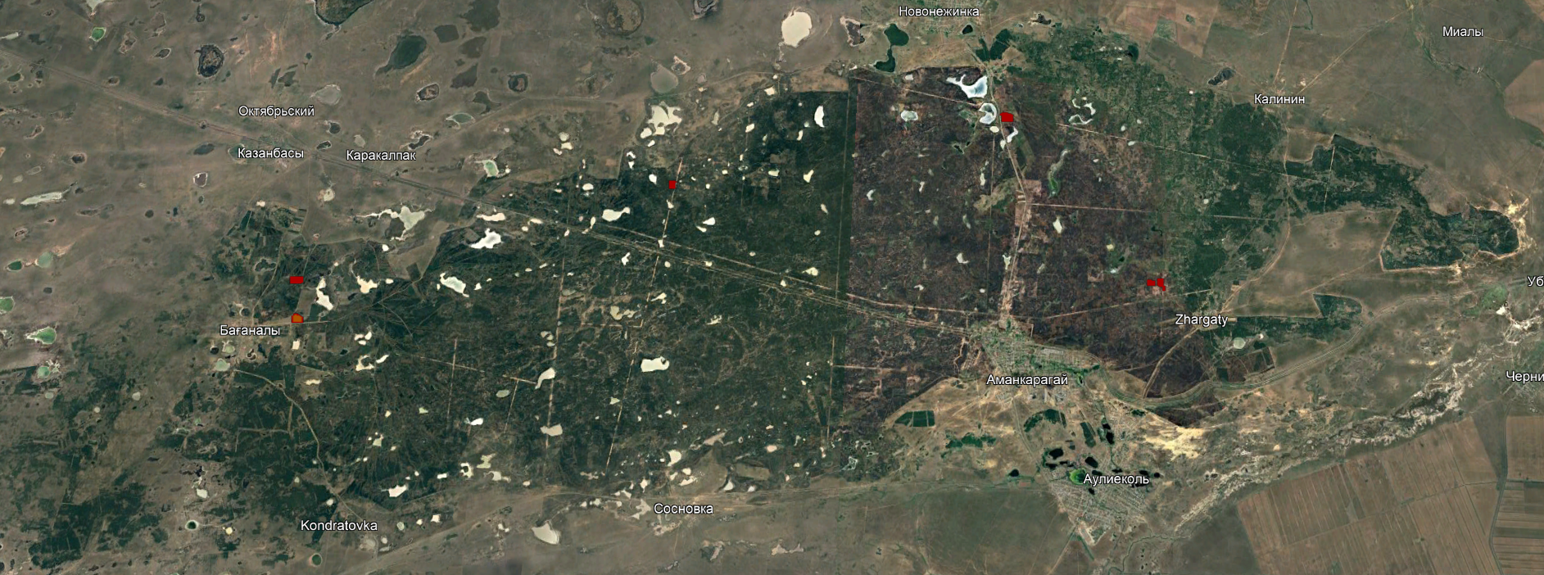
Fig. 1: Satellite image of the pine forest area

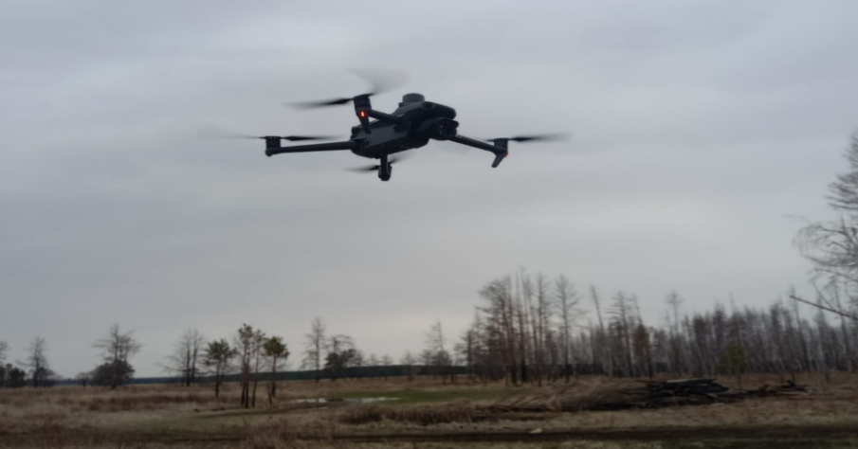
Fig. 2: DJI Mavic 3 Multispectral unmanned aerial vehicle in flight

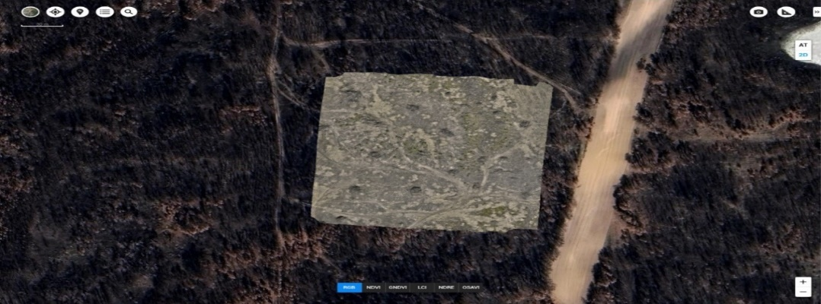
Fig. 3: Orthophotoplan of a burned forest area of the Amankaragay pine forest created using DJI Terra software

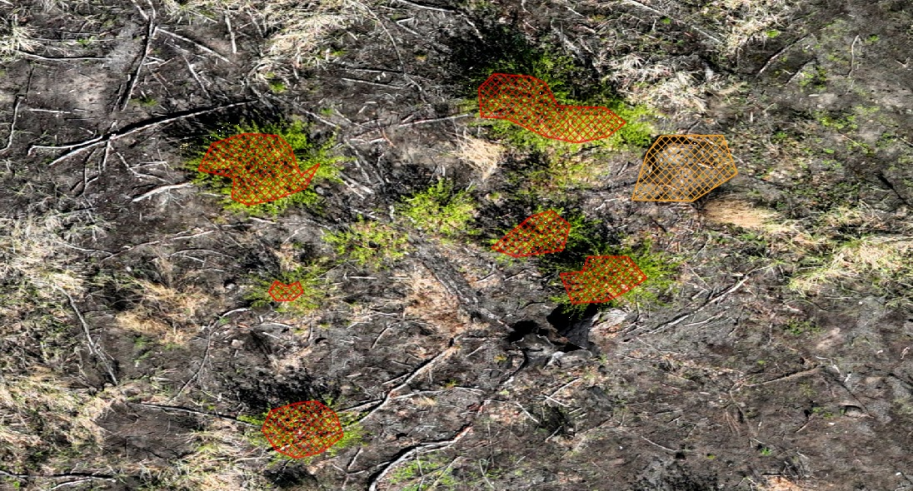
Fig. 4: Example of polygonal annotation. UAV flight altitude: 31 m

Fig. 5: Percentage ratio of the areas occupied by the objects

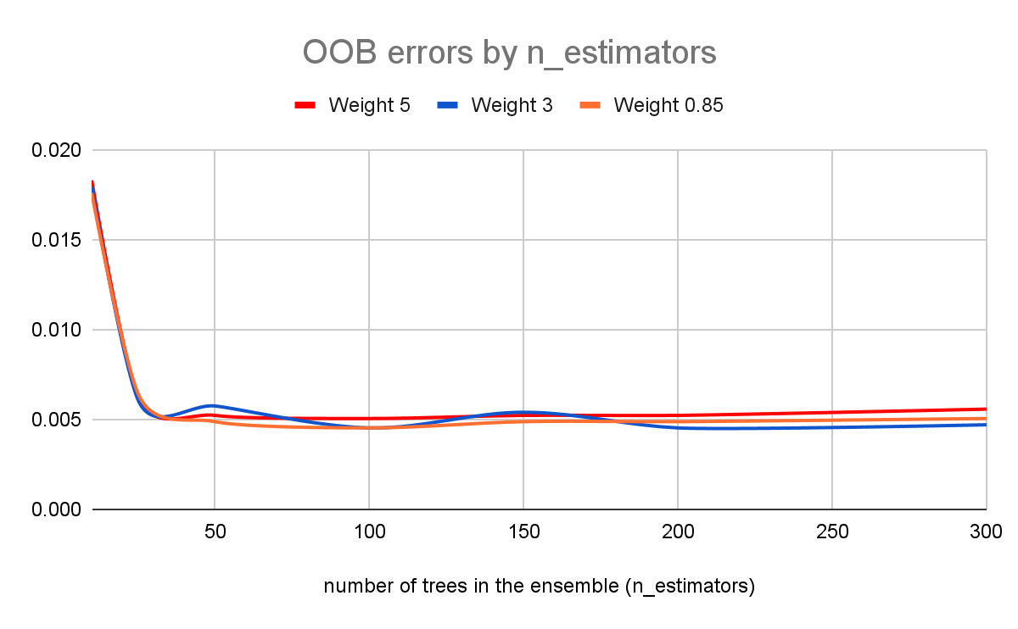
Fig. 6: Effect of the number of trees in the ensemble on error depending on the weights of model variations

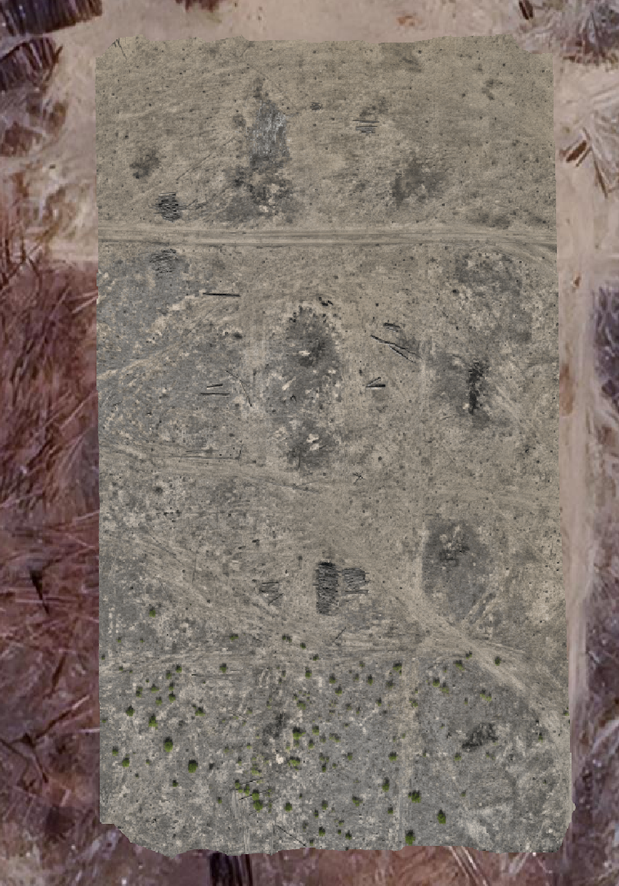
Fig. 7: Homogeneous Kalininskaya 2 site for independent assessment

Fig. 8: Comparison of automatic and manual seedling counts at different training weights of the target class

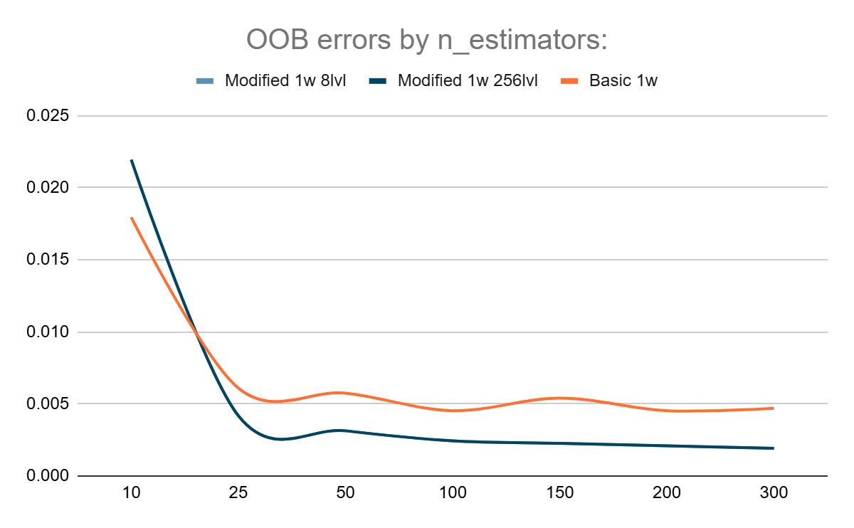
Fig. 9: Effect of the number of trees in the ensemble on error depending on the weights and quantization levels of model variations

Fig. 10: Comparison of automatic and manual counts of undergrowth plants, or seedlings, at different quantization levels (class weight = 0.85)

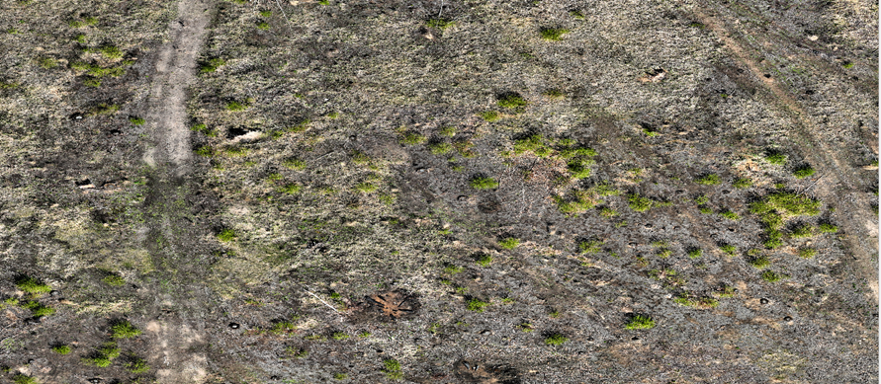
Fig. 11: Image of the site without the heat map overlay

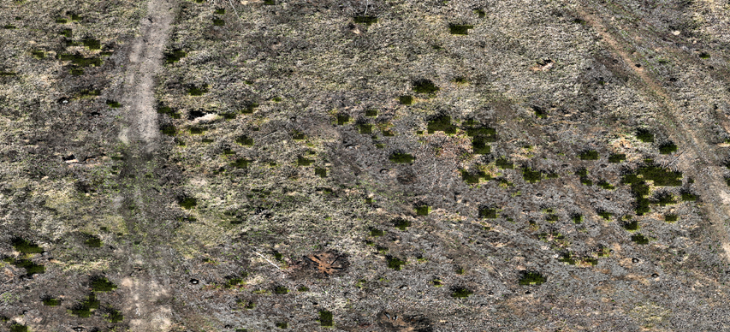
Fig. 12: Image of the site with the heat map overlay

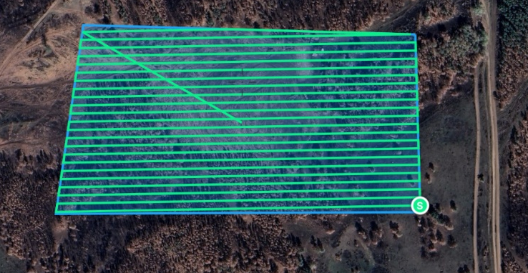
Fig. 13: Flight trajectory and coverage scheme of the Baganaly-2 site during UAV-based aerial photography (GSD — 1.45 cm/pixel, area — 0.12 km²)

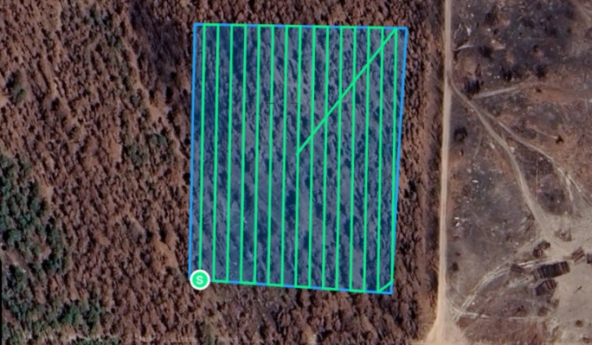
Fig. 14: Flight trajectory and coverage scheme of the Kalininskaya-1 site during UAV-based aerial photography (GSD — 1.45 cm/pixel, area — 15,596.3 m²)

Fig. 15: Comparison of variations of the two models

