IMPACT OF AGROCLIMATIC VARIABILITY ON HARMFUL NON-GREGARIOUS LOCUST POPULATIONS: DEVELOPMENT OF A MACHINE LEARNING–GIS FORECASTING MODEL

Kurmet Baibussenov , Arman Rustembayev *, Aigul Bekbayeva , Zhasulan Amanbay , Askar Zhubatkanov and Arsen Dzhumagulov

Saken Seifullin Kazakh Agrotechnical University, Astana, Republic of Kazakhstan
*Corresponding author: arman.rustembayev@mymail.academy

ABSTRACT
Agroclimatic variability plays a major role in the population dynamics of harmful non-gregarious locusts in arid and semi-arid agricultural landscapes. This study aimed to assess the impact of hydrothermal conditions on locust population density and to develop a Machine Learning–GIS forecasting model for spatially differentiated phytosanitary risk assessment in Kazakhstan. Long-term phytosanitary monitoring data for 2003–2024 were integrated with meteorological variables, remote sensing indicators, and derived agroclimatic predictors. Agroclimatic zones were classified into high-, moderate-, and low-risk groups according to the absolute population index. Five forecasting approaches were tested: Gradient Boosting, Support Vector Regression, Random Forest, SARIMA, and Linear Regression. Model performance was evaluated using MAE, RMSE, and R². The results showed that locust population regulation differed among risk zones. High-risk areas were mainly associated with thermal predictors and 5–7-year outbreak periodicity, while moderate-risk zones reflected the combined influence of temperature and moisture with 7–10-year cyclicity. Low-risk zones were characterized by moisture-limited stabilization and longer 10–12-year cycles. Gradient Boosting performed best in high-risk areas, whereas Support Vector Regression was more effective in moderate- and low-risk zones. The identified hydrothermal thresholds, including land surface temperature of 30–35°C, precipitation of 20–50 mm, and soil moisture of 0.60–0.75, may serve as early-warning indicators for targeted locust management.

Keywords: non-gregarious locusts, agroclimatic variability, machine learning, GIS, phytosanitary forecasting.

- INTRODUCTION
  - Ecological and Agro-Economic Relevance of Non-Gregarious Locusts
Locusts and grasshoppers (Orthoptera: Acrididae) are among the most ecologically influential herbivorous insects in arid and semi-arid agroecosystems. Foundational acridological synthesis established that locust population dynamics are regulated by density-dependent phase transitions, climatic variability, and trophic interactions (Uvarov, 1977). Subsequent ecological research demonstrated that grasshopper outbreaks alter primary productivity, nutrient cycling, and rangeland stability (Branson et al. 2006).
In addition to the gregarious locust species Calliptamus italicus (Linnaeus, 1758), Dociostaurus maroccanus (Thunberg, 1815), and Locusta migratoria (Linnaeus, 1758) (Azhbenov et al. 2015), a complex of economically significant non-gregarious acridid species constitutes a persistent phytosanitary threat to agricultural production in Kazakhstan (Baibussenov et al. 2022). Their distribution across the country exhibits pronounced agroclimatic zonation determined by gradients of moisture availability and thermal resources (Baibussenov et al. 2022; Childebaev 2017; Uspanov et al. 2012). In the forest-steppe and northern steppe zones, characterized by comparatively higher precipitation and moderate temperature regimes, the dominant species include Gomphocerus sibiricus (Linnaeus, 1767), Chorthippus albomarginatus (De Geer, 1773), Oedaleus decorus (Germar, 1825), Pararcyptera microptera (Fischer von Waldheim, 1833), Podisma pedestris (Linnaeus, 1758), and Stauroderus scalaris (Fischer von Waldheim, 1846). The abundance of these species is closely associated with the productivity and structural composition of grass–forb communities.
In the dry-steppe and semi-desert regions, where the climate is strongly continental and characterized by periodic droughts, Dociostaurus brevicollis (Eversmann, 1848), Dociostaurus kraussi (Ingenitsky, 1897), and Oedipoda caerulescens (Linnaeus, 1758) predominate. These species demonstrate high ecological plasticity and the capacity to form localized outbreak foci under favorable spring soil moisture conditions. In the semi-desert and desert zones of southern and western Kazakhstan, stable populations are formed by Calliptamus turanicus (Tarbinsky, 1930), Calliptamus barbarus (Costa, 1836), Oedipoda miniata (Pallas, 1771), and Ramburiella turcomana (Fischer von Waldheim, 1833). The population density of these taxa is primarily regulated by cumulative heat supply and soil moisture dynamics during embryonic development.
Long-term ecological studies confirmed that population regulation depends on both abiotic forcing and density-dependent mortality (Jonas et al. 2015; Lockwood and Lockwood 2008). Regional analyses in Asian steppe ecosystems revealed spatial clustering of outbreak foci linked to vegetation heterogeneity. Climatic variability plays a central role in outbreak dynamics. Rainfall anomalies and temperature accumulation explain interannual population fluctuations at continental scales. Coupled vegetation–locust feedbacks further reinforce these dynamics (Retkute et al. 2024), while density-dependent phase transitions amplify demographic responses (Sword et al. 2010). Geographic variation in recruitment patterns under projected climate change highlights the vulnerability of steppe ecosystems to outbreak intensification (Humphreys et al. 2022).
Climate-driven ecological responses have been widely documented across terrestrial insect systems (Bale et al. 2002; Deutsch et al. 2008; Ladányi and Horváth 2010; Parmesan 2006). Global climate assessments indicate increasing aridity and thermal variability in continental interiors (Mingalev 2021), directly affecting agricultural productivity (Lobell et al. 2011) and food security (Wheeler and Von Braun 2013). In Kazakhstan, such climatic instability increases the probability of locust population surges.

  - Classical Phytosanitary Forecasting: Structure and Limitations
Traditional phytosanitary monitoring systems rely on standardized accounting methods, field surveys, and expert threshold assessments (Gahramanov et al. 2024; Sagitov et al. 2016). Operational manuals emphasize descriptive extrapolation of previous-year densities and climatic analogues (Dubrovin et al. 2011).
However, statistical ecology has demonstrated that multicollinearity among environmental predictors biases parametric estimation (Dormann et al. 2013; Elith and Leathwick 2009; Olden et al. 2008). Remote sensing integration into vegetation science further revealed that ecological drivers operate across multiple spatial scales (Xie et al. 2008).
Insect population responses are inherently nonlinear and interaction-driven. Ensemble tree-based algorithms such as Random Forest mitigate multicollinearity and overfitting issues (Breiman 2001), while boosting methods iteratively optimize prediction error (Friedman 2001). Statistical learning theory formalized the advantages of nonparametric modeling under high-dimensional predictor spaces (Hastie et al. 2009).
Deep neural architectures expanded predictive capability in nonlinear systems (Goodfellow et al. 2016). Ecological classification tasks confirmed improved robustness of Random Forest in species–environment relationships (Cutler et al. 2007). In agricultural pest modeling, machine learning significantly reduced forecasting error compared to classical biometeorological models (de Oliveira Aparecido et al. 2020; Singh et al. 2024).
Temporal dependencies further necessitate recurrent neural architectures. LSTM networks effectively capture lagged climatic effects (Hochreiter and Schmidhuber 1997; Xiao et al. 2019). Advances in deep learning demonstrate transformative capacity in complex environmental prediction (LeCun et al. 2015; Reichstein et al. 2019).

  - Machine Learning and Spatiotemporal Modeling in Pest Forecasting
The rapid development of machine learning (ML) methods has fundamentally transformed predictive ecological modeling. Breiman (2001) introduced Random Forest (RF) as a nonparametric ensemble learning algorithm capable of handling nonlinear relationships and high-dimensional predictor spaces. Its robustness to multicollinearity and overfitting made it particularly suitable for ecological applications. Shortly thereafter, Friedman (2001) formalized Gradient Boosting Machines (GBM), demonstrating that iterative error minimization significantly improves regression and classification accuracy in complex datasets.
The theoretical foundations of statistical learning were consolidated by Hastie, Tibshirani, and Friedman (2009), who showed that flexible, nonparametric models outperform traditional parametric regression when predictor–response relationships are nonlinear and interaction-driven. The subsequent emergence of deep learning architectures expanded this capacity. Goodfellow et al. (2016) demonstrated how multilayer neural networks approximate complex functional mappings, providing a computational basis for modeling ecological systems characterized by threshold responses and feedback loops.
Cutler et al. (2007) were among the first to systematically apply Random Forest to ecological classification problems, showing improved performance in species distribution tasks compared to logistic regression. In agricultural systems, De Oliveira Aparecido et al. (2020) applied machine learning algorithms to forecast pest and disease incidence in Coffea arabica, reporting substantial improvements in predictive accuracy and reduction of false-positive outbreak signals relative to biometeorological regression models.
Temporal dynamics represent a critical component of insect population modeling. Xiao et al. (2019) applied Long Short-Term Memory (LSTM) networks to forecast cotton pest outbreaks based on meteorological time series. Their study confirmed that recurrent neural networks significantly outperform static models by capturing lagged climatic dependencies. The theoretical foundation for LSTM networks was established by Hochreiter and Schmidhuber (1997), who addressed the vanishing gradient problem in recurrent architectures, enabling long-range temporal memory representation.
LeCun et al. (2015) and Reichstein et al. (2019) further demonstrated that deep learning frameworks provide superior pattern recognition capacity in environmental and Earth system sciences, particularly where nonlinearities and high-frequency variability dominate system behavior. Reichstein et al. (2019) emphasized that deep neural networks enable extraction of latent ecological relationships from large, heterogeneous datasets, a key requirement in multi-source phytosanitary forecasting.
In the specific context of locust ecology, Sun et al. (2022) developed a multivariate time-lag sliding window ML framework for forecasting desert locust presence. By integrating NDVI, soil moisture, precipitation, and temperature variables with temporal lags, they demonstrated marked improvements in predictive stability. Gómez et al. (2018) applied machine learning to ESA CCI soil moisture data for identifying desert locust breeding areas, revealing that soil moisture anomalies serve as leading indicators of reproductive site formation.
Lawton et al. (2022) advanced locust ecological modeling by incorporating spatiotemporal hierarchy into predictive frameworks. Their findings showed that accounting for nested spatial structure improves model generalization and reduces prediction bias. This aligns with broader geospatial methodological advances outlined by Goodchild (2009), who formalized spatial data structures and geostatistical modeling within GIS science.
Accuracy assessment remains central to ML–GIS integration. Congalton and Green (2019) established rigorous protocols for evaluating classification accuracy in remotely sensed data, emphasizing confusion matrices, kappa statistics, and spatial validation procedures. These standards are particularly relevant when forecasting models inform policy-level phytosanitary decisions.
Comprehensive syntheses by Klein et al. (2021) highlighted the increasing integration of Earth observation data with locust monitoring systems. Their review documented how NDVI anomalies, land surface temperature, and soil moisture products contribute to early warning frameworks. In a subsequent applied study, Klein et al. (2023) demonstrated operational geospatial integration of EO-derived predictors into locust management platforms, confirming the feasibility of linking ML predictions with spatial decision-support systems.
Collectively, these studies indicate that contemporary locust forecasting requires:
- Nonparametric ensemble algorithms for nonlinear ecological relationships (Breiman 2001; Cutler et al. 2007; de Oliveira Aparecido et al. 2020; Friedman 2001; Goodfellow et al. 2016; Hastie et al. 2009; Singh et al. 2024);
- Recurrent neural networks for temporal dependency modeling (Hochreiter and Schmidhuber 1997; Xiao et al. 2019);
- Deep learning architectures for complex environmental pattern extraction (LeCun et al. 2015; Reichstein et al. 2019);
- Lag-integrated ML frameworks for outbreak prediction (Gómez et al. 2018; Sun et al. 2022);
- Hierarchical and spatially explicit modeling structures (Congalton and Green 2019; Goodchild 2009; Lawton et al. 2022);
- Operational ML–GIS integration for decision-support systems (Klein et al. 2021, 2023).
However, while these methodological advances have been widely applied to desert locust systems and selected crop pests, comparable ML–GIS frameworks for non-gregarious locust populations in continental Eurasian agroecosystems remain limited. This gap justifies the development of regionally calibrated ensemble-based phytosanitary forecasting systems integrating multi-source environmental predictors within a spatial decision-support architecture.

  - GIS and Remote Sensing for Spatial Risk Modeling
The transition from descriptive habitat assessment to fully operational forecasting platforms requires the integration of machine learning algorithms with spatially explicit GIS infrastructures. Recent empirical studies demonstrate that such integration substantially improves outbreak detection accuracy and spatial prioritization of intervention zones.
Klein et al. (2021) systematically analyzed remote sensing applications in locust ecology and demonstrated that vegetation greening dynamics derived from NDVI time series provide early signals of breeding habitat formation. Their review emphasized the predictive value of MODIS-derived vegetation indices in identifying pre-outbreak ecological conditions.
Building on this approach, Klein et al. (2023) implemented a geospatial decision-support framework integrating Earth observation datasets into operational locust management systems. Their study showed that combining satellite-derived vegetation metrics with climatic thresholds allows for spatially prioritized intervention planning, reducing response time during outbreak phases.
At the methodological level, Elith and Leathwick (2009) demonstrated that species distribution modeling (SDM) frameworks enable robust estimation of nonlinear environmental response curves. Phillips et al. (2006) formalized the Maximum Entropy (MaxEnt) approach for presence-only ecological data, providing a mathematically consistent solution for habitat suitability modeling under incomplete sampling conditions. Subsequent methodological refinement by Elith et al. (2009) improved interpretability and predictive performance of SDMs through regularization and cross-validation strategies.
In the context of ensemble forecasting, Thuiller et al. (2009) introduced BIOMOD, demonstrating that combining multiple algorithms significantly increases robustness under environmental uncertainty. Araújo and New (2007) further showed that ensemble approaches outperform single-model predictions when projecting species distributions under climate change scenarios.
Cross-scale ecological theory supports these modeling strategies. Peters et al. (2009) highlighted that ecosystem processes operate across spatial and temporal scales, necessitating hierarchical modeling structures. Reichstein et al. (2019) demonstrated that deep learning techniques can detect nonlinear patterns in Earth system data beyond the capacity of traditional regression models. Ibrahim et al. (2022) provided an applied example of expert-system integration with machine learning for agricultural pest population forecasting, illustrating operational feasibility.
High-resolution climatic datasets such as WorldClim (Fick and Hijmans 2017) enable spatially continuous predictor surfaces, while SRTM-based digital elevation models (Farr et al. 2007) improve topographic stratification of ecological niches. Interpretability frameworks such as SHAP (Lundberg and Lee 2017) further enhance transparency of machine learning predictions, allowing identification of dominant climatic drivers influencing outbreak probability.
Within the Central Asian context, habitat suitability and phytosanitary zoning of harmful non-gregarious locusts have been investigated by K.S. Baibussenov and co-authors (2024). Their work demonstrated that integrating satellite-derived vegetation indices with agro-climatic zoning significantly improves identification of high-risk reproductive habitats in Northern Kazakhstan. This regional evidence confirms that non-gregarious locust systems require spatially stratified modeling approaches calibrated to local environmental gradients.
Despite these advances, no fully integrated ML–GIS forecasting architecture currently exists for harmful non-gregarious locust populations in Kazakhstan.
Existing regional studies focus primarily on habitat suitability rather than dynamic population forecasting coupled with web-based decision-support platforms. Therefore, the development of an ensemble-based predictive framework combining multi-source environmental predictors, machine learning algorithms, and GIS deployment represents both a methodological and operational advancement in phytosanitary management.

  - Research Gap and Objective
Given the agro-climatic heterogeneity of Kazakhstan and the ecological specificity of non-gregarious locust species, region-specific predictive modeling frameworks are required. Previous GIS-based niche simulations in Northern Kazakhstan demonstrated feasibility of habitat modeling however, these efforts did not incorporate deep learning architectures, ensemble validation, or interactive web deployment
Therefore, this study aims to develop and validate an integrated Machine Learning–GIS framework for phytosanitary forecasting of harmful non-gregarious locust populations across agro-climatic zones of Kazakhstan. The system integrates:
- Multi-year phytosanitary monitoring data
- Climatic and meteorological predictors
- Satellite-derived vegetation and soil moisture indices
- Ensemble machine learning algorithms
The framework is designed to transition phytosanitary management from reactive intervention toward proactive ecological population regulation.

- MATERIALS AND METHODS
  - Study Area
The study encompasses forest-steppe, steppe, dry-steppe, semi-desert, and desert agro-climatic zones of Kazakhstan. These regions exhibit strong continentality, with annual temperature amplitudes exceeding 35–40°C and precipitation gradients from 150 to 400 mm annually (Mingalev 2021).
The study employed a two-dimensional classification of agroclimatic zones based on two principal parameters: the moisture regime and the thermal regime (Fig. 1).
The delineated agroclimatic zones were consolidated into eight groups according to shared diagnostic characteristics. Below, these groups are described in terms of their spatial distribution and their association with specific natural–climatic conditions.
I. Extremely arid zones: Extremely arid / Hot - this zone occupies the southwestern part of Kyzylorda Region within the Aral Sea basin and limited sectors of the Ustyurt Plateau in Mangystau Region, corresponding to the southern desert subzone of the Turan Lowland characterized by extremely low precipitation and intense continental heat conditions.
II. Highly arid zones: Highly arid / Moderately warm - distributed across the northern Caspian Lowland and the southern part of Aktobe Region, this zone coincides with the transitional belt between dry steppe and northern semi-desert landscapes; Highly arid / Warm - extending over central Aktobe Region, the southern margins of Karaganda Region, and parts of the Ulytau area, it corresponds predominantly to semi-desert and dry steppe environments of Central Kazakhstan; Highly arid / Moderately hot - covering most of Kyzylorda Region and the plain territories of Turkistan and southern Zhambyl Regions, this zone is associated with the clay and sandy deserts of the Turan Lowland; Highly arid / Hot -
occupying Mangystau Region, southern Atyrau Region, and extensive desert tracts of Turkistan and Zhambyl Regions, it corresponds to the arid desert landscapes of the Caspian Lowland, Betpak-Dala, and Moyynkum.
III. Moderately arid zones: Moderately arid / Moderately warm - located in southern Kostanay Region, northern Karaganda Region, and western Akmola Region, this zone aligns with the dry steppe belt of northern Central Kazakhstan; Moderately arid / Warm - observed in southern West Kazakhstan Region, western Kostanay Region, and parts of Abai Region, it corresponds to the dry steppe transitioning toward semi-desert conditions; Moderately arid / Moderately hot - distributed in eastern Turkistan Region and southern Zhetysu Region, this zone reflects semi-desert landscapes and foothill plains adjacent to the mountain systems of southeastern Kazakhstan; Moderately arid / Hot - extending across the foothill areas of Zhambyl and Turkistan Regions and northern Almaty Region, it corresponds to semi-desert and pre-mountain steppe environments.
IV. Slightly humid zones: Slightly humid / Slightly warm - confined to northern Kostanay Region, this zone coincides with the southern forest-steppe subzone; Slightly humid / Moderately warm - covering large parts of Kostanay Region as well as northern Aktobe, western Pavlodar, and Akmola Regions, it corresponds to the typical steppe zone of northern Kazakhstan; Slightly humid / Moderately hot - located in central Karaganda Region and southern Abai Region, this zone reflects steppe landscapes transitioning toward dry steppe conditions; Slightly humid / Hot - distributed in the foothill areas of Almaty and southern Zhetysu Regions, it corresponds to pre-mountain steppe landscapes of southeastern Kazakhstan.
V. Sufficiently humid zones: Sufficiently humid / Slightly warm - occupying most of North Kazakhstan Region and northern Pavlodar Region, this zone corresponds to the forest-steppe landscapes of northern Kazakhstan; Sufficiently humid / Moderately warm - found across central and northern Akmola Region and northwestern Karaganda Region, it aligns with steppe landscapes characterized by relatively stable moisture availability; Sufficiently humid / Moderately hot - present in eastern Pavlodar Region and the foothill areas of East Kazakhstan Region, this zone corresponds to pre-mountain steppe environments influenced by orographic effects; Sufficiently humid / Hot - located in the southern foothills of Almaty Region, it corresponds to the lower mountain belts of the Northern Tien Shan.
VI. Persistently humid zones: Persistently humid / Slightly warm - extending over northern parts of North Kazakhstan and Akmola Regions, this zone corresponds to the northern forest-steppe subzone with stable moisture conditions; Persistently humid / Hot -
confined to mountainous areas of Almaty Region, it corresponds to mountain forest and meadow belts characterized by enhanced orographic precipitation.
VII. Optimally humid zones: Optimally humid / Slightly warm - located in central and northern North Kazakhstan Region, this zone coincides with the most climatically balanced segments of the forest-steppe zone; Optimally humid / Hot - distributed within mountainous areas of Zhetysu and Almaty Regions, it corresponds to well-watered mountain forest and meadow belts.
VIII. Extremely humid zones: Extremely humid / Slightly warm - observed in the northeastern part of East Kazakhstan Region, this zone corresponds to the mountain-taiga landscapes of the Altai; Extremely humid / Moderately warm - occupying mountainous territories of East Kazakhstan Region, it aligns with the Altai mountain-forest zone characterized by high annual precipitation; Extremely humid / Warm - distributed in southeastern mountainous areas, this zone corresponds to forested belts of the Tien Shan mountain system; Extremely humid / Hot - confined to high-mountain areas of Almaty Region, this zone corresponds to upper mountain meadow and nival belts with maximum moisture availability.

  - Data Sources
2.2.1. Phytosanitary Monitoring Data
Multi-year historical records of population density, infestation area, and developmental stages were obtained from state phytosanitary services
Data were standardized into a continuous density index (individuals m²).
To determine the phase of non-gregarious locust pests in the analyzed years, the main indicators of crop pest population — relative (Prel), average (Pav), and absolute (Pabs) population — were calculated by the following formula:

𝑃𝑟𝑒𝑙=𝐴𝑝100/𝐴𝑠 | (1)

where
Prel — relative population, %
Ap — populated area, thousand ha
As — surveyed area, thousand ha

𝑃𝑎𝑣=[𝐴𝑝(0−5)𝑁𝑎𝑣(0−5)]++[𝐴𝑝(30)𝑁𝑎𝑣(30)]/𝐴𝑝 | (2)

where
Pav — average population, pcs./m2
Ap (0-5),..(>30) — populated area (ths. ha) with the given population density (pcs./m2)
Nav (0-5)...030; — average population density, pcs./m2
Ap — populated area, thousand ha

𝑃𝑎𝑏𝑠=𝑃𝑟𝑒𝑙𝑃𝑎𝑣/100 | (3)

where
Pabs — absolute population, pcs./m2
Prel — relative population, %
Pav — average population, pcs./m2
The final indicator of absolute population (Pabs) was the one used to train the neural network-based forecasting models because it reflects changes in the population of the studied pests. All calculations were performed automatically in MS Excel.
2.2.2. Meteorological and Climatic Data
Meteorological variables included: Mean, minimum, maximum air temperature; Growing Degree Days (GDD); Precipitation totals; Relative humidity; Soil moisture.
Climatic datasets were derived from national meteorological services and global databases (WorldClim v2, https://www.worldclim.org) (Fick and Hijmans 2017).
2.2.3. Remote Sensing Predictors
Satellite sources: MODIS (NDVI, EVI, LST) (Didan et al. 2019); Sentinel-2 multispectral imagery; Landsat 8/9 thermal bands; SMAP/SMOS soil moisture datasets (Entekhabi et al. 2010).
Vegetation indices were calculated using standard formulations (Didan et al. 2019; Huete et al. 2002):
NDVI=NIR−RedNIR+RedNDVI = \frac{NIR - Red}{NIR + Red}NDVI=NIR+RedNIR−Red​ EVI=2.5⋅NIR−RedNIR+6Red−7.5Blue+1EVI = 2.5 \cdot \frac{NIR - Red}{NIR + 6Red - 7.5Blue + 1}EVI=2.5⋅NIR+6Red−7.5Blue+1NIR−Red​
Topographic variables were derived from SRTM DEM data (Farr et al. 2007).

  - Data Preprocessing and Feature Engineering: Outlier removal via IQR method; Missing value imputation using kNN; Multicollinearity control (VIF < 5); Time-lag construction (1–3 month windows); Feature normalization (Min–Max scaling). Exploratory Data Analysis (EDA) identified nonlinear and threshold responses (Hastie et al. 2009).

  - Machine Learning Modeling
To model nonlinear, interaction-driven, and temporal relationships between environmental predictors and locust population density, five supervised learning approaches were implemented: Multiple Linear Regression (MLR), Support Vector Regression (SVR), Seasonal Autoregressive Integrated Moving Average (SARIMA), Random Forest (RF), and Gradient Boosting Machine (GBM). The response variable y represents standardized locust population density (individuals m⁻²), and X denotes the predictor matrix.
Multiple Linear Regression (MLR):

$$y_i = β_0 + Σ_(j=1)^p β_j x_(ij) + ε_i$$ | (4)

where:
y_i – observed locust density;
β_0 – intercept;
β_j – regression coefficients;
x_(ij) – predictor variables;
ε_i – random error term;
p – number of predictors.
Support Vector Regression (SVR):

$$min 1/2 ||w||^2 + C Σ_(i=1)^n (ξ_i + ξ_i*)$$ | (5)

where:
w – weight vector;
C – regularization parameter;
ξ_i, ξ_i* – slack variables;
n – number of observations.
Seasonal ARIMA (SARIMA):

$$SARIMA(p,d,q)(P,D,Q)_s$$ | (6)

where:
p,d,q – non-seasonal autoregressive, differencing, and moving average orders;
P,D,Q – seasonal components;
s – seasonal period.
Random Forest (RF):

$$ŷ = (1/T) Σ_(t=1)^T f_t(x)$$ | (7)

where:
ŷ – predicted density;
T – number of trees;
f_t(x) – regression tree;
x – predictor vector.
Gradient Boosting Machine (GBM):

$$F_m(x) = F_(m-1)(x) + ν h_m(x)$$ | (8)

where:
F_m(x) – boosted model at iteration m;
ν – learning rate;
h_m(x) – weak learner;
m – boosting iteration index.
Performance Metrics:

$$RMSE = sqrt\left(\left(\frac{1}{n}\right)Σ_{i=1}^{n}{\left(y_{i}- ŷ_{i}\right)}^{2}\right)$$ | (9)

where:
y_i – observed values;
ŷ_i – predicted values;
n – number of observations.

$$MAE = (1/n) Σ_(i=1)^n |y_i - ŷ_i|$$ | (10)

where symbols are defined as above.

$$R^2 = 1 - [Σ_(i=1)^n (y_i - ŷ_i)^2 / Σ_(i=1)^n (y_i - ȳ)^2]$$ | (11)

where ȳ – mean of observed values.
Model Interpretability (SHAP):

$f(x) = φ_0 + Σ_(j=1)^p φ_j$ | (12)

where:
φ_0 – base prediction;
φ_j – contribution of predictor j;
p – number of predictors.

- RESEARCH RESULTS
  - Data Collection and Processing
In our study, long-term datasets on the distribution and infestation patterns of harmful non-gregarious locusts were compiled, systematized, and statistically processed in order to identify regularities in their multiannual population dynamics and to provide a basis for subsequent forecasting. In particular, extensive historical records documenting long-term fluctuations in the abundance of harmful non-gregarious locusts across the entire territory of Kazakhstan were assembled and analyzed.
For subsequent processing and analysis using machine learning techniques, data on the abundance and spatial distribution of the target species were compiled for the period 2003–2024.During the processing of the long-term datasets, the following parameters were employed as quantitative indicators of pest population levels: relative population (Prel, %), average population (Ap, pcs./m2), and absolute population (Pabs, pcs./m2).
Thus, the mean absolute population index (Pabs, pcs./m2) was calculated for each agroclimatic zone. Table 1 below presents the temporal variation of this indicator within each agroclimatic zone of Kazakhstan.
Thus, Kazakhstan comprises 25 agroclimatic zones (Table 1), which were consolidated into eight major groups according to shared climatic characteristics. The analysis covers the period 2003–2024 and presents averaged indicators for each identified agroclimatic zone of Kazakhstan. In addition, the dataset includes the number of observations and the mean value of the population index of harmful non-gregarious locusts—the absolute infestation index (Pabs, pcs./m²). The latter demonstrates substantial variability across zones, necessitating structured ranking for subsequent analytical procedures.
For the purpose of stratification, and based on the mean population density and the frequency of outbreaks of non-gregarious locust pests, all agroclimatic zones were classified into three outbreak risk categories (Table 2).
The ranking of Kazakhstan’s agroclimatic zones according to the outbreak risk of non-gregarious locust pests was performed based on the mean value of the absolute population index (Pabs, pcs./m²) for the period of 2003–2024. The classification comprises three risk risk of reproduction and harmfulness: high (> 8.0 pcs./m²), moderate (2.0–8.0 pcs./m²), and low (< 2.0 pcs./m²).
High-risk zones include (23) Highly arid / Warm, (42) Slightly humid / Moderately warm, and (75) Optimally humid / Hot. These territories are characterized by a favorable thermal regime combined with the absence of excessive moisture, which promotes accelerated embryonic development, high larval survival, and a shortened generation cycle. In zone (23), pronounced aridity creates optimal conditions for xerophilous non-gregarious locust species. In zone (42), moderate warmth under limited moisture availability sustains stable foci of elevated population density. In zone (75), the dominant driver is a hot climatic regime that intensifies developmental rates even under optimal moisture supply. Collectively, these zones represent areas of persistent reproduction and potential chronification of outbreak foci.
Moderate risk was identified for (15) Extremely arid / Hot, (22) Highly arid / Moderately warm, (25) Highly arid / Hot, (35) Moderately arid / Hot, (41) Slightly humid / Slightly warm, (44) Slightly humid / Moderately hot, and (85) Extremely humid / Hot. Under extremely and highly arid hot conditions, stimulating thermal regimes are counterbalanced by limiting effects of reduced forage availability and substrate overheating. In moderately arid and slightly humid zones, transitional ecotopes prevail, where populations maintain relatively stable densities without pronounced outbreak dynamics. In zone (85), elevated temperatures partially compensate for excessive moisture; however, enhanced biotic regulation and increased soil humidity constrain further population growth.
Low risk is characteristic of (24) Highly arid / Moderately hot, (32) Moderately arid / Moderately warm, (33) Moderately arid / Warm, (34) Moderately arid / Moderately hot, (45) Slightly humid / Hot, (51) Sufficiently humid / Slightly warm, (52) Sufficiently humid / Moderately warm, (54) Sufficiently humid / Moderately hot, (55) Sufficiently humid / Hot, (61) Persistently humid / Slightly warm, (65) Persistently humid / Hot, (71) Optimally humid / Slightly warm, (81) Extremely humid / Slightly warm, (82) Extremely humid / Moderately warm, and (83) Extremely humid / Warm. These zones are characterized either by insufficient thermal resources for accelerated ontogenesis or by elevated soil moisture levels that increase egg mortality and promote the development of entomopathogenic microflora. Consequently, populations persist at background, ecologically stabilized densities without prerequisites for mass reproduction.
Overall, the findings indicate that the decisive factor for non-gregarious locust population proliferation is the optimal combination of a favorable thermal regime and moderate aridity. Excessive moisture and reduced temperatures function as primary limiting factors. The spatial configuration of outbreak risk exhibits a mosaic pattern, reflecting the adaptive strategy of resident populations that achieve maximum density under hydrothermal optimum conditions.

  - Principal Predictors for Forecasting the Population Dynamics of the Studied Pests
To identify the principal predictors for forecasting the population dynamics of harmful non-gregarious locusts within each agroclimatic zone of Kazakhstan, the analysis was grounded on the previously delineated three risk categories of reproduction and harmfulness: the high-risk zone, the moderate-risk zone, and the low-risk zone. Each risk category comprises a defined set of agroclimatic zones characterized by comparable ecological and climatic conditions. Accordingly, the identification of key predictive variables was conducted within the framework of these three reproduction and harmfulness risk zones.
Table 3 presents the predictors incorporated into the modeling of population dynamics using a range of analytical and machine learning approaches.
Subsequently, the importance of climatic predictors was assessed through correlation analysis examining the relationships between climatic variables and locust abundance, in combination with feature importance estimation using the Random Forest and Gradient Boosting algorithms. The analysis was performed separately for each reproduction and harmfulness risk zone, within which the top 15 most influential predictors were identified.
Across the three risk categories (high, moderate, and low), distinct patterns and strengths of association between climatic variables and the population density of non-gregarious locust pests were observed. These differences indicate zone-specific climatic controls on population dynamics and underscore the necessity of differentiated predictive modeling frameworks. The comparative results of the correlation structure and feature importance ranking for each risk zone are presented in Figs 2, 3, and 4.
The comparative analysis of Figs 2–4 reveals a clear zonal differentiation in the climatic regulation of harmful non-gregarious locust populations, as identified by the Random Forest model. The ranking of the top 15 predictors across high-, moderate-, and low-risk zones demonstrates that the structure of environmental control shifts systematically along the hydrothermal gradient, confirming that population dynamics are governed by distinct ecological mechanisms under contrasting agroclimatic regimes.
In the high-risk zone (Figure 2), which includes the Highly arid / Warm (23), Slightly humid / Moderately warm (42), and Optimally humid / Hot (75) agroclimatic types, the predictor hierarchy is dominated by thermal and surface energy variables. Heat_Stress_Index, LSTEvap_interaction, AirTemp_squared, and Energy_Balance consistently occupy the highest importance ranks. This indicates that, in outbreak-prone territories, temperature-driven acceleration of embryogenesis and larval development constitutes the primary regulatory mechanism. The strong contribution of AirTemp_squared demonstrates pronounced nonlinear temperature responses, suggesting the existence of a climatic optimum beyond which density increases disproportionately. Soil moisture and precipitation variables, while present, exhibit comparatively lower importance scores, implying that in these zones moisture does not act as a limiting factor. Instead, the system operates under conditions of thermal saturation, where energy availability and land surface temperature variability determine interannual fluctuations in Pabs. Lagged temperature indicators (Prev_temperature, Temp_ma3) further reinforce the cumulative nature of heat accumulation effects.
In contrast, the moderate-risk zone (Fig. 3) displays a more balanced predictor structure. Alongside thermal indices, Aridity_Index, Moisture_Index, PrecipSPI_interaction, and SoilMoisture_squared gain substantially higher importance relative to the high-risk configuration. The increased contribution of precipitation–SPI interaction terms indicates that interannual rainfall variability becomes a decisive factor for population amplification. Unlike the high-risk zone, where heat alone drives reproduction, moderate-risk territories require a synchronised combination of adequate thermal resources and optimal soil moisture. The prominence of SoilMoisture_squared confirms a hump-shaped response curve, where both drought and excessive wetness suppress egg survival. Moreover, lagged precipitation variables exert stronger influence than in the high-risk group, suggesting that antecedent hydrological conditions modulate habitat suitability in transitional steppe ecotones. This pattern reflects a dual-control regime, where population outbreaks emerge only when thermal and moisture thresholds coincide.
The low-risk zone (Fig. 4) is characterized by a marked shift toward humidity-related constraints. Moisture_Index, Aridity_Index, SoilMoisture_squared, and Temp_Amplitude dominate the importance ranking, while direct thermal stress indicators lose relative explanatory power. Compared with Figs 2 and 3, Heat_Stress_Index and Energy_Balance show noticeably reduced contributions, indicating that temperature no longer acts as the primary growth-limiting factor. Instead, excessive or unstable moisture conditions increase egg mortality and promote biotic regulation. The high importance of Temp_Amplitude suggests that large diurnal or seasonal temperature contrasts introduce developmental instability, preventing synchronous cohort formation. Year_trend also gains relative significance, implying that long-term climatic tendencies, rather than short-term anomalies, shape background population levels in these humid or cooler environments.
Direct comparison among the three figures demonstrates a progressive transition from energy-driven regulation (high risk) to interaction-driven balance (moderate risk) and finally to moisture-limited suppression (low risk). Thermal quadratic terms are strongest in the high-risk zone, moderate in the transitional zone, and weakest in the humid zone. Conversely, soil moisture and aridity indices show minimal influence in high-risk territories but become central in moderate and especially low-risk areas. Interaction terms involving precipitation gain peak importance in moderate-risk zones, highlighting the requirement of hydrological synchrony for outbreak formation.
Overall, the results indicate that the most favorable conditions for the development and spatial expansion of locust pests are characterized by the following parameter ranges: land surface temperature (LST) of 30–35°C, corresponding to the thermal optimum for reproduction; precipitation totals of 20–50 mm, ensuring sufficient but not excessive moisture supply; soil moisture values of 0.60–0.75, reflecting moderately humid conditions; and a Standardized Precipitation Index (SPI) close to neutral or slightly positive (0–0.5), indicative of near-normal or mildly humid climatic conditions.
Conversely, unfavorable conditions for locust development and spread are associated with thermal extremes (LST < 25°C or > 40°C), very low (< 15 mm) or excessive (> 70 mm) precipitation, and critically low (< 0.5) or excessively high (> 0.9) soil moisture levels. These findings highlight the nonlinear and threshold-dependent responses of non-gregarious locust populations to climatic variability.

  - Predictive modeling of Harmful Non-Gregarious Locust Population Dynamics across Kazakhstan’s Agroclimatic Zones Using Machine Learning Techniques
The management of harmful non-gregarious locusts in arid and semi-arid agroecosystems remains a major phytosanitary challenge in Kazakhstan, where pronounced agroclimatic heterogeneity drives spatially uneven population growth and chronic infestations. Unlike gregarious species, non-gregarious locusts maintain persistent damaging populations requiring continuous monitoring and fine-scale forecasting. Their dynamics are shaped by nonlinear interactions among temperature, soil moisture, vegetation productivity, land use, and anthropogenic factors, limiting the predictive capacity of conventional statistical models.
Machine learning (ML) provides an effective framework for modeling these complex spatiotemporal systems. By capturing nonlinear relationships and high-order interactions within long-term monitoring datasets, ML algorithms improve predictive accuracy and generalization across agroclimatic gradients. This enables integrated forecasting of population density and threshold exceedance risk, supporting spatially explicit risk assessment.
The shift from descriptive monitoring to predictive analytics is central to the digital transformation of phytosanitary systems. ML-based models convert surveillance data into operational forecasts, enabling targeted interventions, spatial prioritization of control measures, and optimization of pesticide use.
For each agroclimatic zone classified by reproduction and harmfulness risk, a standardized analytical pipeline was applied. Data were divided into training (80%) and testing (20%) subsets using a temporally consistent split to preserve chronological structure and prevent data leakage. Feature standardization was performed on training data and applied to the test set to ensure numerical stability and methodological rigor.
Five models were trained independently within each zone: Support Vector Regression (SVR), Seasonal Autoregressive Integrated Moving Average (SARIMA), Linear Regression, Gradient Boosting, and Random Forest. This design enabled comparison between parametric, time-series, and ensemble ML approaches in capturing temporal dependence and nonlinear interactions.
Model performance was evaluated on the independent test set using standard regression metrics to assess predictive accuracy and generalization. Cross-zone comparison allowed identification of the most robust modeling strategies under varying agroclimatic conditions, providing a reproducible basis for digital phytosanitary forecasting and decision-support systems.

Figs 5–7 present the results of phytosanitary forecasting of harmful non-gregarious locust populations in Kazakhstan based on machine learning algorithms integrated with GIS technologies, stratified by the three reproduction and harmfulness risk zones (high, moderate, and low). These figures illustrate the spatially explicit modeling outputs and the differentiated forecast patterns across the respective risk categories.
The high-risk zone (Fig. 5) is characterized by the most pronounced amplitude of population fluctuations and the highest outbreak intensity among all risk categories. Under conditions of persistent aridity combined with elevated temperatures, non-gregarious locust populations remain at low densities for several years but respond sharply to favorable climatic triggers. Key drivers include moisture deficit concentrating populations in vegetated refugia, accelerated development under warm conditions, reduced interspecific competition at low densities, episodic precipitation stimulating vegetation growth, and weakened pressure from natural enemies in arid ecosystems.
In the training period (2003–2018), distinct population increases were recorded in 2006, 2009, and 2015, with the 2009 outbreak representing the most extreme peak. These rises were separated by intervals of approximately 5–6 years, confirming a quasi-cyclic outbreak pattern within the 5–7-year periodicity range. During the test period (2019–2024), a renewed increase was observed in 2021, followed by a decline and partial stabilization, indicating preservation of cyclical behavior rather than a linear trend.
Among the evaluated models, Gradient Boosting most accurately reproduced the magnitude and timing of observed increases in the test period. It achieved the lowest error metrics (MAE = 1.660722; RMSE = 2.636057; R² = 0.004572) relative to Random Forest, SVR, Linear Regression, and SARIMA, demonstrating superior capacity to capture nonlinear responses under highly variable climatic conditions (Table 4).
The forecast for 2025–2030, based solely on Gradient Boosting, suggests moderate overall density levels with projected increases in 2027 and 2030, consistent with the established 5–7-year quasi-cyclic structure. Thus, the high-risk zone maintains recurrent outbreak dynamics driven primarily by climatic variability rather than sustained long-term population growth.
The moderate-risk zone of reproduction and harmfulness (Fig. 6) is characterized by lower outbreak amplitude compared with high-risk territories, with mean population densities typically 2–10 times lower. Nevertheless, areas experiencing hydrological extremes—both moisture deficit and excess—tend to display relatively elevated average values within this category. Warm and moderately hot thermal regimes remain important risk factors even under moderate overall conditions, whereas territorial extent does not directly correlate with population density, indicating that climatic suitability rather than area determines outbreak potential.
During the training period (2003–2018), population increases were observed in 2007 and 2014, separated by roughly seven years, confirming a 7–10-year outbreak periodicity. These peaks were moderate and substantially lower than those recorded in high-risk zones. In the test period (2019–2024), no significant outbreak occurred; instead, population dynamics remained relatively stable with moderate seasonal variability, indicating preservation of cyclic behavior without escalation.
Among the evaluated models, Support Vector Regression (SVR) demonstrated the closest approximation to observed dynamics in the test interval, particularly in capturing moderate peaks without overestimation. It achieved the best predictive performance (MAE = 1.135353; RMSE = 3.039394; R² = –0.022965) relative to Random Forest, Gradient Boosting, Linear Regression, and SARIMA (Table 5).
The forecast for 2025–2030, based solely on SVR, indicates stable density levels without warning of a major outbreak. This projection is consistent with the established 7–10-year cyclic structure, suggesting that the next substantial increase is unlikely within the forecast horizon.
The low-risk zone of reproduction and harmfulness (Fig. 7) is primarily regulated by ecological constraints that limit large-scale population growth. Excessive soil moisture creates unfavorable conditions for oviposition and larval development, while relatively cool climatic regimes slow ontogenesis and shorten the active period. Stable humidity enhances natural enemy pressure, and a short vegetation season further restricts harmfulness.
Within the training period (2003–2018), a moderate population increase was recorded in 2012, representing the only clearly expressed peak within this interval. Earlier minor elevation in 2004 remained weak and did not reach outbreak magnitude. The temporal distance between the 2004 minor rise and the 2012 peak supports the established 10–12-year periodicity of substantial population amplification in this zone. In the test period (2019–2024), population levels remained stable, with fluctuations not exceedingly approximately 10% of the long-term mean, confirming the absence of outbreak conditions.
Among the evaluated models, Support Vector Regression (SVR) demonstrated the closest approximation to observed values in the test interval (MAE = 1.211944; RMSE = 1.940160; R² = –0.009623), outperforming Random Forest, Gradient Boosting, Linear Regression, and SARIMA (Table 6).
The forecast for 2025–2030, based exclusively on SVR, indicates continued stability without evidence of critical density escalation. Overall, the low-risk zone maintains a regulated population regime in which substantial outbreaks occur infrequently—approximately once every 10–12 years—and remain strongly constrained by climatic and ecological limiting factors.

- DISCUSSION
The sustainable management of harmful non-gregarious locusts requires continuous ecological monitoring due to their chronic presence in agroecosystems and capacity for periodic density amplification (Azhbenov et al. 2015; Baibussenov et al. 2022; Branson et al. 2006; Uvarov, 1977). Unlike gregarious migratory locusts addressed within continental early warning frameworks (Childebaev 2017; Jonas et al. 2015; Uspanov et al. 2012), non-gregarious species form spatially persistent populations whose dynamics are closely linked to local hydrothermal conditions (Lockwood and Lockwood 2008; Retkute et al. 2024; Sword et al. 2010). Previous regional studies in Kazakhstan and adjacent steppe systems have demonstrated that temperature accumulation, precipitation variability, and vegetation productivity jointly determine reproductive success and larval survival (Bale et al. 2002; Deutsch et al. 2008; Humphreys et al. 2022; Ladányi and Horváth 2010; Mingalev 2021; Parmesan 2006). Agroclimatic zonation analyses further emphasized that spatial heterogeneity in aridity and thermal regimes leads to differentiated outbreak potential across territories (Dubrovin et al. 2011; Gahramanov et al., 2024; Lobell et al. 2011; Sagitov et al. 2016; Wheeler and Von Braun 2013).
The integrated structure of the forecasting framework is conceptually summarized in Fig. 8. The Results of the present study confirm and extend these findings by demonstrating that predictor dominance varies systematically across high-, moderate-, and low-risk zones. In the high-risk zone, temperature-related variables (LST, AirTemp, quadratic temperature terms, Heat_Stress_Index) exhibited the highest importance scores. Such nonlinear temperature effects correspond to established insect physiological response curves and biometeorological principles described in earlier modeling research (Breiman 2001; Dormann et al. 2013; Elith and Leathwick 2009; Olden et al. 2008; Xie et al. 2008). The observed 5–7-year periodicity in this zone aligns with quasi-cyclic density fluctuations reported for grasshopper and locust systems under strong climatic forcing (Jonas et al. 2015; Sun et al. 2022). Under arid conditions, episodic precipitation pulses following drought periods may trigger vegetation surges, enabling rapid demographic release when thermal accumulation is sufficient.
In contrast, the moderate-risk zone displayed increased importance of precipitation indices and interaction terms (e.g., SPI–temperature coupling). Previous agroecological analyses have emphasized the combined role of soil moisture and accumulated heat in determining locust reproductive output (Klein et al. 2021; Lawton et al. 2022; Mingalev 2021). The 7–10-year periodicity observed in the Results suggests a transitional regulatory regime in which outbreaks require simultaneous alignment of thermal and hydrological drivers. This dual control mechanism reduces outbreak amplitude relative to high-risk territories and reflects stronger background environmental buffering.
Low-risk zones were characterized by dominance of moisture-related predictors and reduced thermal signal. Excessive soil moisture, relatively cooler conditions, and shorter vegetation periods constrain oviposition success and larval development (Azhbenov et al. 2015; Lockwood and Lockwood 2008). Earlier studies in humid and forest-steppe environments demonstrated that increased vegetation stability enhances biotic regulation and suppresses large-scale amplification (Dubrovin et al. 2011; Wheeler and Von Braun 2013). The extended 10–12-year periodicity identified in the Results indicates rare coincidence of favorable hydrothermal conditions and confirms the presence of stronger ecological constraints.

  - Interzonal Comparative Interpretation
A direct comparison across zones reveals structured ecological differentiation. First, outbreak amplitude decreased progressively from high- to low-risk territories. Second, dominant predictors shifted from thermally driven nonlinear responses in arid systems toward moisture-dominated regulation in humid zones. Third, cyclicity extended from 5–7 years (high-risk) to 10–12 years (low-risk), reflecting increasing environmental constraint. Finally, algorithmic suitability varied with ecological regime: Gradient Boosting performed optimally under strong nonlinear thermal forcing, whereas Support Vector Regression (SVR) provided superior stability under moderate and moisture-regulated conditions.
These patterns confirm that model selection is ecologically contingent rather than universally transferable. The Results therefore demonstrate both zonal differentiation in population dynamics and zonal dependence of optimal predictive architecture.

  - Machine Learning Performance and Ecological Nonlinearity
The comparative evaluation of ML algorithms is consistent with established statistical learning principles (Cutler et al. 2007; de Oliveira Aparecido et al. 2020; Friedman 2001; Goodfellow et al. 2016; Hastie et al. 2009; Singh et al. 2024). Ensemble tree-based methods are particularly effective in capturing nonlinear interactions and threshold effects, while kernel-based regression provides smooth nonlinear approximation under moderate variance conditions. Remote sensing–derived predictors (NDVI, LST) have previously improved locust habitat modeling and early warning accuracy (Gómez et al. 2018; Hochreiter and Schmidhuber 1997; LeCun et al. 2015; Reichstein et al. 2019; Sun et al. 2022; Xiao et al. 2019), and their integration within a zonal ML framework strengthens ecological interpretability.
Gradient Boosting achieved the lowest MAE and RMSE values in high-risk territories, confirming its suitability for systems characterized by abrupt density amplification and interaction-driven responses (Baibussenov et al. 2024; Didan et al. 2019; Entekhabi et al. 2010; Huete et al. 2002; Phillips et al. 2006). In moderate- and low-risk zones, SVR demonstrated improved generalization and reduced overfitting, consistent with findings in ecological regression modeling under moderate amplitude variability (Araújo and New 2007; Peters et al. 2009; Reichstein et al. 2019; Thuiller et al. 2009). The application of SHAP-based interpretability methods enhances transparency and addresses common concerns regarding “black-box” ML systems in ecological management (Farr et al. 2007; Fick and Hijmans 2017; Ibrahim et al. 2022; Lundberg and Lee 2017).
Although R² values remained relatively low across zones, such metrics must be interpreted in the context of stochastic outbreak systems. Insect population dynamics driven by episodic climatic pulses rarely exhibit high variance explanation through deterministic predictors alone. Error-based metrics (MAE, RMSE) therefore provide more meaningful evaluation of short-term forecasting performance in applied phytosanitary contexts.

  - Climate Variability and Future Risk
The persistence of quasi-cyclic behavior without monotonic density increase suggests that current climatic variability maintains oscillatory rather than directional regimes. However, global climate assessments indicate increasing thermal variability in continental interiors (Legg 2021). Experimental and theoretical studies show that warming within physiological optima can intensify ectotherm population growth, whereas exceeding thermal thresholds may suppress survival. Climate-forced density oscillations similar to those observed in the high-risk zone have been documented in semi-arid locust systems under large-scale atmospheric anomalies (Belovsky and Slade 1995; Schmitz 2008; Stige et al. 2007).
Under projected warming scenarios, moderate-risk territories may experience shortened periodicity if thermal accumulation increases without compensatory moisture limitation. Conversely, excessive aridification may constrain survival in currently high-risk zones. Integrating climate scenario ensembles into the present ML–GIS framework represents a critical direction for improving anticipatory risk assessment.

  - Integrated ML–GIS Architecture
The conceptual architecture developed in this study (Fig. 8) formalizes the forecasting process as a two-layer circular system integrating modeling and operational deployment. The inner layer comprises the ML core, zonal stratification, and model evaluation, while the outer layer encompasses data acquisition, preprocessing, GIS-based spatial prediction, and decision support.
Such modular design aligns with ensemble ecological forecasting strategies and adaptive management principles (Araújo and New 2007; Friedman 2001; Hastie et al. 2009; Levin 1992). By incorporating iterative feedback, the system allows recalibration as new monitoring data become available. The spatial translation of predictions into rasterized risk classes enhances operational applicability and supports targeted phytosanitary intervention. Integration of ML with GIS has been increasingly advocated in ecological decision-support systems (Dormann et al. 2013; Elith and Leathwick 2009; Phillips et al. 2006), yet its application to non-gregarious locust forecasting remains limited. The present framework therefore bridges methodological advances in statistical learning with region-specific agroclimatic stratification.

  - Management Implications
The hydrothermal thresholds identified in the Results (LST 30–35°C, moderate precipitation pulses, soil moisture 0.60–0.75) provide practical early-warning criteria. High-risk zones require proactive monitoring of cumulative temperature indices, while moderate-risk territories demand synchronized rainfall and moisture analysis. Low-risk areas may prioritize surveillance efficiency rather than preventive chemical treatment.
This stratified approach aligns with sustainable agricultural intensification strategies that emphasize targeted intervention and reduced chemical load (Foley et al. 2011; Tilman et al. 2002). By linking predictive analytics with spatial deployment, the framework enhances phytosanitary efficiency while minimizing ecological disturbance.

  - Limitations and Research Directions
Despite the robustness of the dataset, extension of temporal coverage would improve detection of low-frequency cycles, particularly in humid zones. Incorporating land-use change, grazing intensity, and vegetation nutrient dynamics may further refine ecological realism. Hybrid integration of process-based population models with ML algorithms could enhance extrapolation under novel climatic regimes.
Cross-border integration within Central Asia would strengthen regional coherence and improve forecasting reliability under transboundary climatic influences.

- CONCLUSION
This study establishes an ecologically stratified ML–GIS framework for forecasting harmful non-gregarious locust populations under heterogeneous agroclimatic conditions. The central contribution lies in demonstrating that population dynamics, predictor dominance, outbreak periodicity, and optimal modeling algorithms vary systematically along a hydrothermal gradient, thereby requiring zonal differentiation rather than uniform national-scale modeling.
Three structurally distinct regulatory regimes were identified: (i) thermally amplified nonlinear dynamics in high-risk zones with 5–7-year cyclicity, most accurately captured by Gradient Boosting; (ii) interaction-driven regulation in moderate-risk territories with 7–10-year periodicity, where Support Vector Regression ensures superior generalization; and (iii) moisture-limited stabilization in low-risk zones with extended 10–12-year cycles and reduced amplitude variability. These findings confirm that algorithmic suitability is ecologically contingent and directly linked to variance structure and climatic forcing intensity.
Methodologically, the study advances locust forecasting by integrating nonlinear machine learning, agroclimatic stratification, SHAP-based interpretability, and GIS-based spatial deployment within a unified adaptive architecture. The proposed two-layer circular system formalizes the transition from environmental monitoring to spatially explicit decision support, enabling iterative recalibration under evolving climatic conditions.
Operationally, the identification of hydrothermal thresholds (LST 30–35°C; moderate precipitation pulses; soil moisture 0.60–0.75) provides actionable early-warning indicators and supports differentiated monitoring strategies across risk zones. By aligning predictive analytics with zonal ecological structure, the framework enhances phytosanitary precision while reducing unnecessary chemical intervention.
Taken together, this research demonstrates that ecologically structured machine learning is not merely a technical refinement but a necessary paradigm shift for climate-sensitive pest forecasting, establishing a transferable foundation for adaptive phytosanitary management in semi-arid agroecosystems under accelerating environmental change.

Funding: The research was carried out with financial support from the Committee of Science of the Ministry of Science and Higher Education of the Republic of Kazakhstan for 2024–2026 within the framework of the scientific project IRN AP22784639 "Development of phytosanitary forecasting models for harmful grasshoppers' population in Kazakhstan based on machine learning algorithms and GIS technologies".

Conflict of Interest: The authors declare that they have no conflict of interest.

Data Availability: If you have presented all the data in the article, then write: All the data is available in the article. Alternatively, if you cannot present all the data and have additional information to share, write "Data will be available upon request.".

Ethics Statement: State, like, the animal study was approved by the Ethics Committee of the [insert name of institute/University; approved vide number: ?? Dated: ??] and conducted in accordance with local legislation and institutional requirements.

Authors’ Contributions:

Generative AI Statement: The authors declare that no Gen AI/DeepSeek was used in the writing/creation of this manuscript.

REFERENCES
Araújo, M. B., & New, M. (2007). Ensemble forecasting of species distributions. Trends in Ecology & Evolution, 22(1), 42-47. https://doi.org/10.1016/j.tree.2006.09.010
Azhbenov, V. K., Baibussenov, K. S., Sarbaev, A. T., & Harizanova, V. B. (2015). Preventive approach of phytosanitary control of locust pests in Kazakhstan and adjacent areas. In Proceedings of the International conference on agricultural, ecological and medical sciences (AEMS-2015), February 10-11, 2015, Penang, Malaysia (pp. 33-37). http://dx.doi.org/10.15242/IICBE.C0215122
Baibussenov, K., Bekbayeva, A., & Azhbenov, V. (2022). GIS-based potential distribution modeling for harmful non-gregarious locusts in agricultural areas of Northern Kazakhstan to improve preventive pest management. In Proceedings of the 24th Paris International conference on advances on chemical, agricultural, biological & environmental sciences (CABES-22), April 19-21, 2022, Paris, France (pp. 48-56). https://doi.org/10.17758/EARES11.EAP0422106
Baibussenov, K., Bekbayeva, A., & Azhbenov, V. (2024). Simulation of favourable habitats and potential spread for non-gregarious locust pests for preventive measures in North Kazakhstan based on satellite data. Innovations in Biological Science, 6, 153-174. https://doi.org/10.9734/bpi/ibs/v6/715
Bale, J. S., Masters, G. J., Hodkinson, I. D., Awmack, C., Bezemer, T. M., Brown, V. K., Butterfield, J., Buse, A., Coulson, J. C., Farrar, J., Good, J. E. G., Harrington, R., Hartley, S., Jones, T. H., Lindroth, R. L., Press, M. C., Symrnioudis, I., Watt, A. D., Whittaker, J. B. & Whittaker, J. B. (2002). Herbivory in global climate change research: direct effects of rising temperature on insect herbivores. Global Change Biology, 8(1), 1-16. https://doi.org/10.1046/j.1365-2486.2002.00451.x
Belovsky, G. E., & Slade, J. B. (1995). Dynamics of two Montana grasshopper populations: Relationships among weather, food abundance and intraspecific competition. Oecologia, 101(3), 383-396. https://doi.org/10.1007/bf00328826
Branson, D. H., Joern, A., & Sword, G. A. (2006). Sustainable management of insect herbivores in grassland ecosystems: New perspectives in grasshopper control. BioScience, 56(9), 743-755. https://doi.org/10.1641/0006-3568(2006)56[743:SMOIHI]2.0.CO;2
Breiman, L. (2001). Random forests. Machine Learning, 45, 5-32. https://doi.org/10.1023/A:1010933404324
Childebaev, M. K. (2017). Materials on the fauna and ecology of orthopteran insects (orthoptera) of karaganda region (Central Kazakhstan). News of the National Academy of Sciences of the Republic of Kazakhstan. Series of Biological and Medical, 3(321), 113-119. (in Russian)
Congalton, R. G., & Green, K. (2019). Assessing the accuracy of remotely sensed data: Principles and practices. Boca Raton: CRC Press.
Cutler, D. R., Edwards Jr, T. C., Beard, K. H., Cutler, A., Hess, K. T., Gibson, J., & Lawler, J. J. (2007). Random forests for classification in ecology. Ecology, 88(11), 2783-2792. https://doi.org/10.1890/07-0539.1
de Oliveira Aparecido, L. E., de Souza Rolim, G., da Silva Cabral De Moraes, J. R., Costa, C. T. S., & de Souza, P. S. (2020). Machine learning algorithms for forecasting the incidence of Coffea arabica pests and diseases. International Journal of Biometeorology, 64(4), 671-688. https://doi.org/10.1007/s00484-019-01856-1
Deutsch, C. A., Tewksbury, J. J., Huey, R. B., Sheldon, K. S., Ghalambor, C. K., Haak, D. C., & Martin, P. R. (2008). Impacts of climate warming on terrestrial ectotherms across latitude. Proceedings of the National Academy of Sciences, 105(18), 6668-6672. https://doi.org/10.1073/pnas.0709472105
Didan, K., Munoz, A. B., Solano, R., & Huete, A. (2019). MODIS vegetation index user’s guide (MOD13 series). University of Arizona: Vegetation index and Phenology Lab, 35, 2-33. https://vip.arizona.edu/MODIS_ATBD.php
Dormann, C. F., Elith, J., Bacher, S., Buchmann, C., Carl, G., Carré, G., García Marquéz, J. R., Gruber, B., Lafourcade, B., Leitão, P. J., Münkemüller, T., McClean, C., Osborne, P. E., Reineking, B., Schröder, B., Skidmore, A. K., Zurell, D., & Lautenbach, S. (2013). Collinearity: A review of methods to deal with it and a simulation study evaluating their performance. Ecography, 36(1), 27-46. https://doi.org/10.1111/j.1600-0587.2012.07348.x
Dubrovin, V. V., Teniaeva, O. L., & Kritskaia, V. P. (2011). Metody fitosanitarnogo monitoringa v zashchite rastenii ot vrednykh nasekomykh [Methods of phytosanitary monitoring in the protection of plants from harmful insects]. Saratov: Saratov State Agrarian University named after N. I. Vavilov, 230 p.
Elith, J., & Leathwick, J. R. (2009). Species distribution models: Ecological explanation and prediction across space and time. Annual Review of Ecology, Evolution, and Systematics, 40, 677-697. https://doi.org/10.1146/annurev.ecolsys.110308.120159
Entekhabi, D., Njoku, E. G., O'neill, P. E., Kellogg, K. H., Crow, W. T., Edelstein, W. N., Entin, J. K., Goodman, S. D., Jackson, T. J., Johnson, J., Kimball, J., Piepmeier, J. R., Koster, R. D., Martin, N., McDonald, K. C., Moghaddam, M., Moran, S., Reichle, R., Shi, J. C., Spencer, M. W., Thurman, S. W., Tsang, L., & Van Zyl, J. (2010). The soil moisture active passive (SMAP) mission. Proceedings of the IEEE, 98(5), 704-716. https://doi.org/10.1109/JPROC.2010.2043918
Farr, T. G., Rosen, P. A., Caro, E., Crippen, R., Duren, R., Hensley, S., Kobrick, M., Paller, M., Rodriguez, E., Roth, L., Seal, D., Shaffer, S., Shimada, J., Umland, J., Werner, M., Oskin, M., Burbank, D., & Alsdorf, D. (2007). The shuttle radar topography mission. Reviews of Geophysics, 45(2), RG2004. https://doi.org/10.1029/2005RG000183
Fick, S. E., & Hijmans, R. J. (2017). WorldClim 2: New 1‐km spatial resolution climate surfaces for global land areas. International Journal of Climatology, 37(12), 4302-4315. https://doi.org/10.1002/joc.5086
Foley, J. A., Ramankutty, N., Brauman, K. A., Cassidy, E. S., Gerber, J. S., Johnston, M., Mueller, N. D., O'Connell, C., Ray, D. K., West, P. C., Balzer, C., Bennett, E. M., Carpenter, S.R., Hill, J., Monfreda, C., Polasky, S., Rockström, J., Sheehan, J., Siebert, S, Tilman, D., & Zaks, D. P. M. (2011). Solutions for a cultivated planet. Nature, 478(7369), 337-342. https://doi.org/10.1038/nature10452
Friedman, J. H. (2001). Greedy function approximation: A gradient boosting machine. Annals of Statistics, 29(5), 1189-1232. https://doi.org/10.1214/aos/1013203451
Gahramanov, S., Ismayilova, V., Taghiyev, M., Mammadov, H., & Musayeva, K. (2024). Study of the resistance of economically important pine species to dangerous pests on the Absheron Peninsula. BIO Web of Conferences, 100, 04035. https://doi.org/10.1051/bioconf/2024100
Gómez, D., Salvador, P., Sanz, J., Casanova, C., Taratiel, D., & Casanova, J. L. (2018). Machine learning approach to locate desert locust breeding areas based on ESA CCI soil moisture. Journal of Applied Remote Sensing, 12(3), 36011. https://doi.org/10.1117/1.JRS.12.036011
Goodchild, M. F. (2009). Geographic information systems and science: Today and tomorrow. Annals of GIS, 15(1), 3-9. https://doi.org/10.1080/19475680903250715
Goodfellow, I., Bengio, Y., Courville, A., & Bengio, Y. (2016). Deep learning. Cambridge: MIT press, 800 p.
Hastie, T., Tibshirani, R., Friedman, J. H., & Friedman, J. H. (2009). The elements of statistical learning: Data mining, inference, and prediction (2nd ed.). New York: Springer, 745 p. https://doi.org/10.1007/b94608
Hochreiter, S., & Schmidhuber, J. (1997). Long short-term memory. Neural Computation, 9(8), 1735-1780. https://doi.org/10.1162/neco.1997.9.8.1735
Huete, A., Didan, K., Miura, T., Rodriguez, E. P., Gao, X., & Ferreira, L. G. (2002). Overview of the radiometric and biophysical performance of the MODIS vegetation indices. Remote Sensing of Environment, 83(1-2), 195-213. https://doi.org/10.1016/S0034-4257(02)00096-2
Humphreys, J. M., Srygley, R. B., & Branson, D. H. (2022). Geographic variation in migratory grasshopper recruitment under projected climate change. Geographies, 2(1), 12-30. https://doi.org/10.3390/geographies2010003
Ibrahim, E. A., Salifu, D., Mwalili, S., Dubois, T., Collins, R., & Tonnang, H. E. (2022). An expert system for insect pest population dynamics prediction. Computers and Electronics in Agriculture, 198, 107124. https://doi.org/10.1016/j.compag.2022.107124
Jonas, J. L., Wolesensky, W., & Joern, A. (2015). Weather affects grasshopper population dynamics in continental grassland over annual and decadal periods. Rangeland Ecology & Management, 68(1), 29-39. http://dx.doi.org/10.1016/j.rama.2014.12.011
Klein, I., Oppelt, N., & Kuenzer, C. (2021). Application of remote sensing data for locust research and management – A review. Insects, 12(3), 233. https://doi.org/10.3390/insects12030233
Klein, I., Uereyen, S., Eisfelder, C., Pankov, V., Oppelt, N., & Kuenzer, C. (2023). Application of geospatial and remote sensing data to support locust management. International Journal of Applied Earth Observation and Geoinformation, 117, 103212. https://doi.org/10.1016/j.jag.2023.103212
Ladányi, M., & Horváth, L. (2010). A review of the potential climate change impact on insect populations- general and agricultural aspects. Applied Ecology and Environmental Research, 8(2), 143-152.
Lawton, D., Scarth, P., Deveson, E., Piou, C., Spessa, A., Waters, C., & Cease, A. J. (2022). Seeing the locust in the swarm: Accounting for spatiotemporal hierarchy improves ecological models of insect populations. Ecography, 2022(2), e05763. https://doi.org/10.1111/ecog.05763
LeCun, Y., Bengio, Y., & Hinton, G. (2015). Deep learning. Nature, 521(7553), 436-444. https://doi.org/10.1038/nature14539
Legg, S. (2021). IPCC, 2021: Climate change 2021 – The physical science basis. Interaction, 49(4), 44-45. https://search.informit.org/doi/10.3316/informit.315096509383738
Levin, S. A. (1992). The problem of pattern and scale in ecology: The Robert H. MacArthur award lecture. Ecology, 73(6), 1943-1967. https://doi.org/10.2307/1941447
Lobell, D. B., Schlenker, W., & Costa-Roberts, J. (2011). Climate trends and global crop production since 1980. Science, 333(6042), 616-620. https://doi.org/10.1126/science.1204531
Lockwood, D. R., & Lockwood, J. A. (2008). Grasshopper population ecology: Catastrophe, criticality, and critique. Ecology and Society, 13(1), 34. https://doi.org/10.5751/ES-02496-130134
Lundberg, S. M., & Lee, S. I. (2017). A unified approach to interpreting model predictions. In Advances in neural information processing systems 30: Proceedings of the 31st Conference on neural information processing systems (NIPS 2017), Long Beach, CA, USA (pp. 4766-4775). Red Hook, NY: Curran Associates, Inc.
Mingalev, D. E. (2021). Agroclimatic zoning of Russia and Kazakhstan under current climate change. Geography and Natural Resources, 42(2), 24-31. https://doi.org/10.15372/GIPR20210203
Parmesan, C. (2006). Ecological and evolutionary responses to recent climate change. Annual Review of Ecology Evolution and Systematics, 37(1), 637-669. https://doi.org/10.1146/annurev.ecolsys.37.091305.110100
Peters, D. P., Bestelmeyer, B. T., Knapp, A. K., Herrick, J. E., Monger, H. C., & Havstad, K. M. (2009). Approaches to predicting broad-scale regime shifts using changing pattern-process relationships across scales. In S. Miao, S. Carstenn, & M. Nungesser (Eds.), Real world ecology: large-scale and long-term case studies and methods (pp. 47-72). New York, NY: Springer. https://doi.org/10.1007/978-0-387-77942-3_3
Phillips, S. J., Anderson, R. P., & Schapire, R. E. (2006). Maximum entropy modeling of species geographic distributions. Ecological Modelling, 190(3-4), 231-259. https://doi.org/10.1016/j.ecolmodel.2005.03.026
Olden, J. D., Lawler, J. J., & Poff, N. L. (2008). Machine learning methods without tears: A primer for ecologists. The Quarterly Review of Biology, 83(2), 171-193. https://doi.org/10.1086/587826
Reichstein, M., Camps-Valls, G., Stevens, B., Jung, M., Denzler, J., Carvalhais, N., & Prabhat. (2019). Deep learning and process understanding for data-driven Earth system science. Nature, 566(7743), 195-204. https://doi.org/10.1038/s41586-019-0912-1
Retkute, R., Thurston, W., Cressman, K., & Gilligan, C. A. (2024). A framework for modelling desert locust population dynamics and large-scale dispersal. PLoS Computational Biology, 20(12), e1012562. https://doi.org/10.1371/journal.pcbi.1012562
Sagitov, A. O., Duisembekov, B. A., Ismukhambetov, J. D., Koishibaev, M., Ashikbaev, N. Zh., Zhanarbekova, A. B., Amanov, S. B., Kochorov, A. S., Toleubayev, K. M., Niyazbekov, Zh. B., & Kopirova, G. I. (2016). Fitosanitarnyi monitoring vrednykh i osobo opasnykh vrednykh organizmov (vreditelei, boleznei, sornykh rastenii) [Phytosanitary monitoring of harmful and especially dangerous harmful organisms (pests, diseases, weeds)]: Manual (3rd ed.). Almaty: Kazakh Research Institute of Plant Protection and Quarantine, 376 p. (in Kazakh)
Schmitz, O. J. (2008). Effects of predator hunting mode on grassland ecosystem function. Science, 319(5865), 952-954. https://doi.org/10.1126/science.1152355
Singh, A. K., Yeasin, M., Paul, R. K., Paul, A. K., & Sarkar, A. (2024). Dynamic ensemble-based machine learning models for predicting pest populations. Frontiers in Applied Mathematics and Statistics, 10, 1435517. https://doi.org/10.3389/fams.2024.1435517
Sun, R., Huang, W., Dong, Y., Zhao, L., Zhang, B., Ma, H., Geng, Y., Ruan, C., Xing, N., Chen, X., & Li, X. (2022). Dynamic forecast of desert locust presence using machine learning with a multivariate time lag sliding window technique. Remote Sensing, 14(3), 747. https://doi.org/10.3390/rs14030747
Sword, G. A., Lecoq, M., & Simpson, S. J. (2010). Phase polyphenism and preventative locust management. Journal of Insect Physiology, 56(8), 949-957. https://doi.org/10.1016/j.jinsphys.2010.05.005
Thuiller, W., Lafourcade, B., Engler, R., & Araújo, M. B. (2009). BIOMOD – A platform for ensemble forecasting of species distributions. Ecography, 32(3), 369-373. https://doi.org/10.1111/j.1600-0587.2008.05742.x
Tilman, D., Cassman, K. G., Matson, P. A., Naylor, R., & Polasky, S. (2002). Agricultural sustainability and intensive production practices. Nature, 418(6898), 671-677. https://doi.org/10.1038/nature01014
Uspanov, A. M., Dinasylov, A. S., Lednev, G. R., & Niyazbekov, Z. B. (2012). Biological effectiveness of chemicals and formulation of entomopathogenic fungi beauveria bassiana (bals.) vuill. Experimental Biology, 55(3), 135-141. (in Russian)
Uvarov, B. (1977). Grasshoppers and locusts. A handbook of general acridology. Vol. 2. London: Centre for Overseas Pest Research, London, 613 p.
Wheeler, T., & Von Braun, J. (2013). Climate change impacts on global food security. Science, 341(6145), 508-513. https://doi.org/10.1126/science.1239402
Xiao, Q., Li, W., Kai, Y., Chen, P., Zhang, J., & Wang, B. (2019). Occurrence prediction of pests and diseases in cotton on the basis of weather factors by long short term memory network. BMC bioinformatics, 20(Suppl 25), 688. https://doi.org/10.1186/s12859-019-3262-y
Xie, Y., Sha, Z., & Yu, M. (2008). Remote sensing imagery in vegetation mapping: A review. Journal of Plant Ecology, 1(1), 9-23. https://doi.org/10.1093/jpe/rtm005
Table 1: Statistics of the number of observations and the mean absolute infestation index (pabs, pcs./m²) within the agroclimatic zones of Kazakhstan (2003–2024)
# | Agroclimatic Zone | Period | Number of Observations | Mean Pabs (pcs./m²) | Median | Min | Max | Std. Dev.
I. Extremely arid zones
1 | (15) Extremely arid / Hot | 2003–2024 | 87 | 2.91 | 0.429 | 0.00 | 155.5 | 16.70
II. Highly arid zones
2 | (22) Highly arid / Moderately warm | 2003–2024 | 65 | 3.359 | 1.100 | 0.000 | 52.776 | 8.907
3 | (23) Highly arid / Warm | 2003–2024 | 455 | 23.1 | 0.540 | 0.00 | 9955.0 | 466.6
4 | (24) Highly arid / Moderately hot | 2003–2024 | 939 | 1.507 | 0.438 | 0.000 | 155.55 | 7.864
5 | (25) Highly arid / Hot | 2003–2024 | 224 | 2.72 | 1.500 | 0.00 | 68.78 | 6.326
III. Moderately arid zones
6 | (32) Moderately arid / Moderately warm | 2003–2024 | 512 | 1.84 | 0.81 | 0.0 | 38.45 | 3.21
7 | (33) Moderately arid / Warm | 2003–2024 | 723 | 1.75 | 0.735 | 0.00 | 43.69 | 3.093
8 | (34) Moderately arid / Moderately hot | 2003–2024 | 76 | 1.96 | 0.922 | 0.00 | 15.32 | 2.636
9 | (35) Moderately arid / Hot | 2003–2024 | 687 | 2.39 | 0.516 | 0.00 | 474.7 | 19.14
IV. Slightly humid zones
10 | (41) Slightly humid / Slightly warm | 2003–2024 | 356 | 2.98 | 1.02 | 0.0 | 112.4 | 9.87
11 | (42) Slightly humid / Moderately warm | 2003–2024 | 923 | 12.455 | 1.352 | 0.000 | 9436.275 | 310.687
12 | (44) Slightly humid / Moderately hot | 2003–2024 | 478 | 3.65 | 1.24 | 0.0 | 186.75 | 12.54
13 | (45) Slightly humid / Hot | 2003–2024 | 401 | 1.69 | 0.829 | 0.00 | 86.78 | 4.815
V. Sufficiently humid zones
14 | (51) Sufficiently humid / Slightly warm | 2003–2024 | 66 | 1.951 | 0.994 | 0.000 | 11.667 | 2.326
15 | (52) Sufficiently humid / Moderately warm | 2003–2024 | 75 | 1.997 | 1.035 | 0.000 | 13.411 | 2.544
16 | (54) Sufficiently humid / Moderately hot | 2003–2024 | 58 | 1.73 | 0.88 | 0.0 | 9.85 | 2.11
17 | (55) Sufficiently humid / Hot | 2003–2024 | 32 | 1.092 | 0.503 | 0.000 | 6.645 | 1.643
VI. Persistently humid zones
18 | (61) Persistently humid / Slightly warm | 2003–2024 | 142 | 1.62 | 0.72 | 0.0 | 21.4 | 3.34
19 | (65) Persistently humid / Hot | 2003–2024 | 169 | 1.99 | 0.900 | 0.00 | 36.99 | 4.051
VII. Optimally humid zones
20 | (71) Optimally humid / Slightly warm | 2003–2024 | 240 | 1.275 | 0.550 | 0.000 | 11.211 | 1.699
21 | (75) Optimally humid / Hot | 2003–2024 | 65 | 8.057 | 1.871 | 0.000 | 343.40 | 42.38
VIII. Extremely humid zones
22 | (81) Extremely humid / Slightly warm | 2003–2024 | 74 | 1.41 | 0.63 | 0.0 | 12.75 | 2.26
23 | (82) Extremely humid / Moderately warm | 2003–2024 | 88 | 1.513 | 0.558 | 0.000 | 11.530 | 2.124
24 | (83) Extremely humid / Warm | 2003–2024 | 88 | 1.99 | 1.010 | 0.00 | 15.32 | 2.548
25 | (85) Extremely humid / Hot | 2003–2024 | 169 | 3.30 | 1.500 | 0.00 | 183.9 | 14.33

Table 2: Risk zones of reproduction and harmfulness of non-gregarious locust pests across the agroclimatic zones of Kazakhstan
Risk Level | Mean Pabs (pcs./m²) | Included Agroclimatic Zones
High risk of reproduction and harmfulness | > 8.0 | (23); (42); (75)
Moderate risk of reproduction and harmfulness | 2.0 – 8.0 | (15); (22); (25); (41); (44); (85)
Low risk of reproduction and harmfulness | < 2.0 | (24); (32); (33); (34); (45); (51); (52); (54); (55); (61); (65); (71); (81); (82); (83)

Table 3: Principal predictors used for modelling the forecast of population dynamics of harmful non-gregarious locusts
Predictor | Description
Interactions between predictors
TempMoisture_interaction | Product of air temperature and soil moisture — reflects the combined influence of thermal and moisture conditions
PrecipSPI_interaction | Product of precipitation and the Standardised Precipitation Index — amplifies the signal of precipitation influence
LSTEvap_interaction | Interaction between land surface temperature and evaporation — characterises the surface energy balance

Polynomial features
AirTemp_squared, Precipitation_squared, SoilMoisture_squared | Squares of key variables to account for non-linear effects
Aridity and humidity indices
Aridity_Index | Ratio of evaporation to precipitation — an indicator of territorial aridity
Moisture_Index | Inverse index — an indicator of moisture availability

Temperature indices
Heat_Stress_Index | Mean value between land surface temperature (LST) and air temperature — an integrated indicator of thermal stress
Temp_Amplitude | Difference between land surface temperature (LST) and air temperature — characterises thermal contrasts

Energy balance
Energy_Balance | Difference between solar radiation and evaporation — reflects the availability of energy for the ecosystem

Temporal characteristics
Season_numeric | Numerical representation of the season (spring = 1, summer = 2, spring–summer = 1.5).
Prev_quantity, Prev_precipitation, Prev_temperature | Variables of the preceding period
Quantity_ma3, Temp_ma3 | Three-period moving averages for smoothing random fluctuations
Year_trend | Temporal trend variable to account for long-term changes

Table 4: Quality of pest population predicting models (error in the 2019-2024 test period) for zone of high risk of reproduction and harmfulness
Tested Models | MAE | RMSE | R²
GradientBoosting | 1.660722 | 2.636057 | 0.004572
SVR | 1.306799 | 2.644319 | -0.001678
SARIMA | 143.747525 | 153.630271 | -3380.069133
LinearRegression | 155.025247 | 184.883099 | -4895.602819
RandomForest | 64.074679 | 199.979978 | -5727.929638

Table 5: Quality of pest population predicting models (error in the 2019-2024 test period) for zone of moderate risk of reproduction and harmfulness
Tested Models | MAE | RMSE | R²
SVR | 1.135353 | 3.039394 | -0.022965
SARIMA | 1.892770 | 3.323565 | -0.223193
Linear Regression | 2.835916 | 3.833372 | -0.627229
Gradient Boosting | 2.150645 | 7.444469 | -5.136973
Random Forest | 2.308242 | 8.660798 | -7.306204

Table 6: Quality of pest population predicting models (error in the 2019-2024 test period) for zone of low risk of reproduction and harmfulness
Tested Models | MAE | RMSE | R²
SVR | 1.211944 | 1.940160 | -0.009623
SARIMA | 1.761853 | 2.095881 | -0.178196
RandomForest | 1.669998 | 2.146758 | -0.236090
GradientBoosting | 1.607066 | 2.198644 | -0.296564
LinearRegression | 1.868226 | 2.214488 | -0.315319

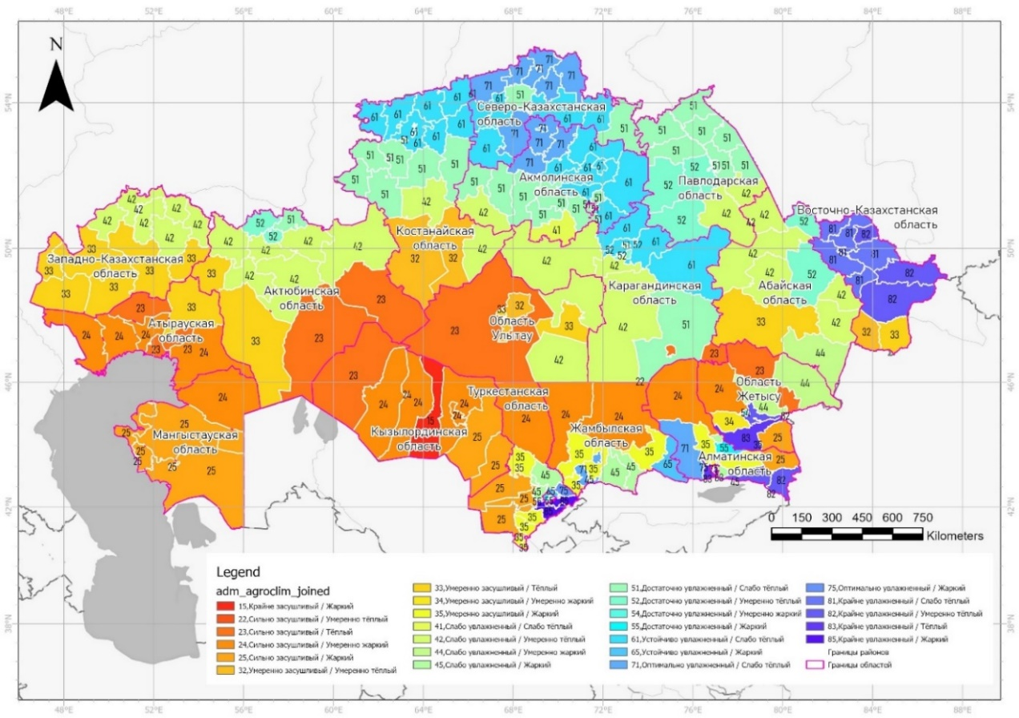
Fig. 1: Agroclimatic zones of Kazakhstan

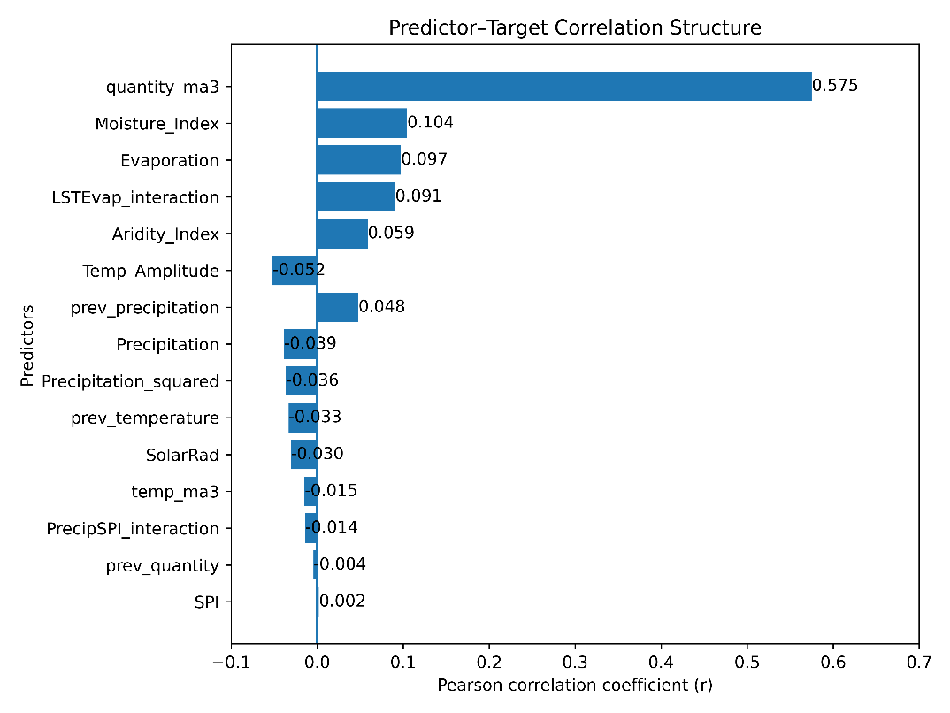
Fig. 2: Top 15 most important predictors of population forecasting for the high reproduction and harmfulness risk zone according to the Random Forest algorithm

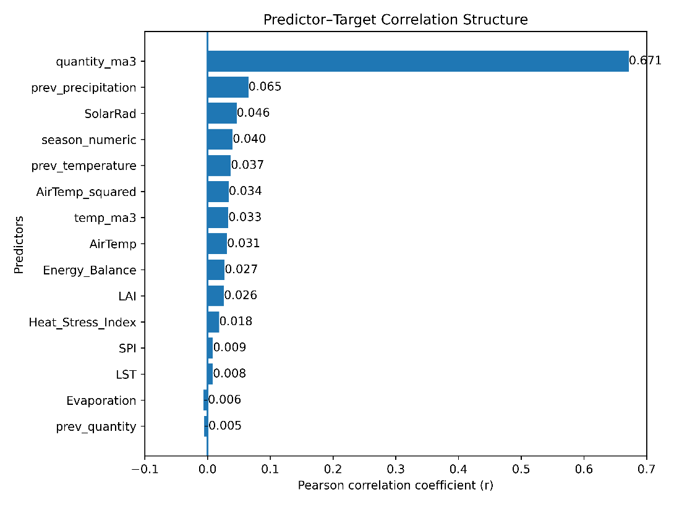
Fig. 3: Top 15 most important predictors of population forecasting for the moderate reproduction and harmfulness risk zone according to the Random Forest algorithm

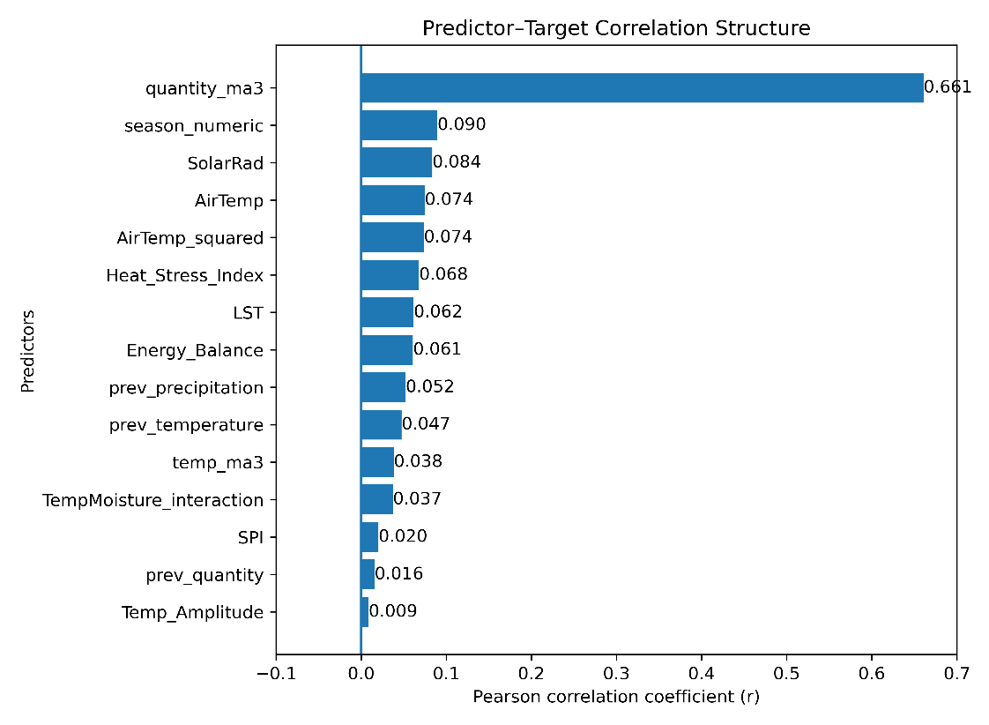
Fig. 4: Top 15 most important predictors of population forecasting for the low reproduction and harmfulness risk zone according to the Random Forest algorithm

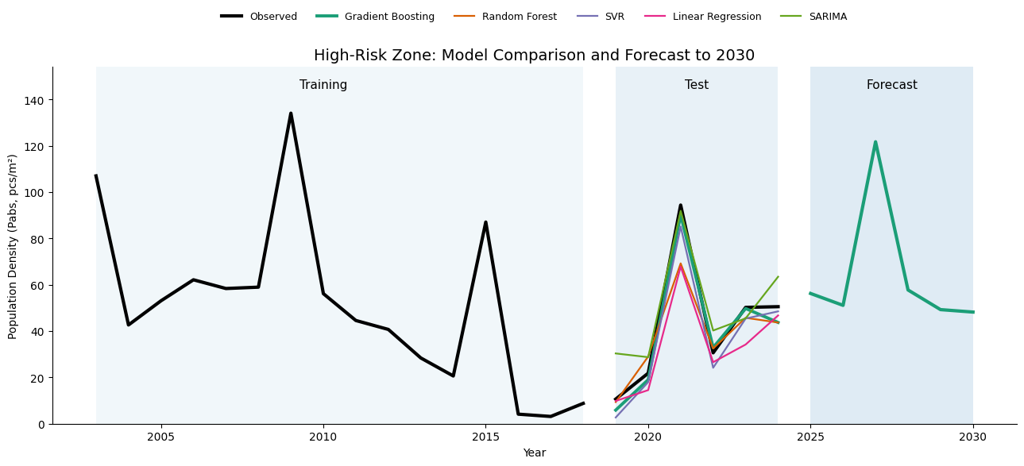
Fig. 5: Predictive modeling of harmful non-gregarious locust population dynamics for zone of high risk of reproduction and harmfulness

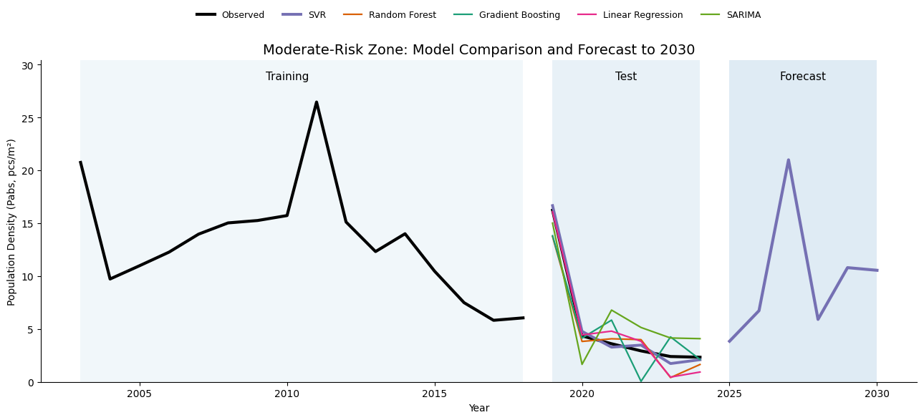
Fig. 6: Predictive modeling of harmful non-gregarious locust population dynamics for zone of moderate risk of reproduction and harmfulness

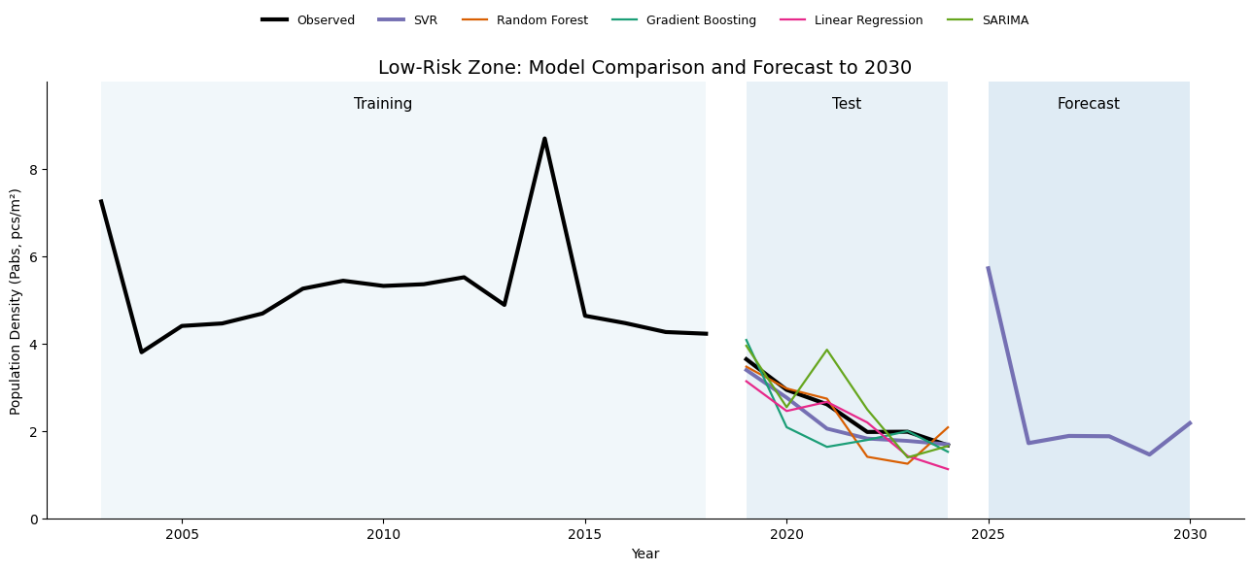
Fig. 7: Predictive modeling of harmful non-gregarious locust population dynamics for zone of low risk of reproduction and harmfulness

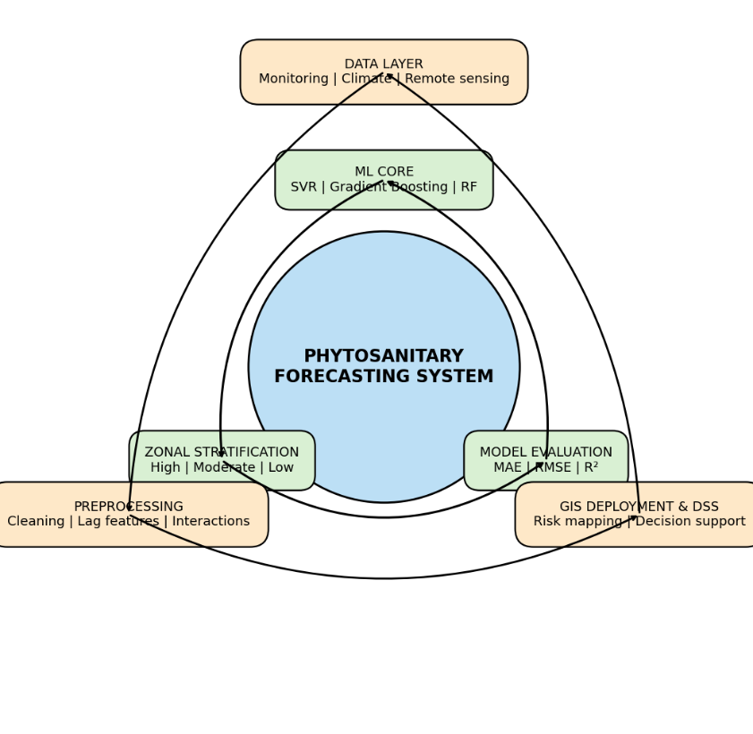
Fig. 8: Two-layer circular architecture of the ML–GIS phytosanitary forecasting system integrating zonal machine learning modeling and spatial decision support

