IMPACT OF SUBSTRATE DIVERSITY ON LICHEN SPECIES STRUCTURE IN CENTRAL KAZAKHSTAN

Anel Myrzakhan^{1,2}, Yelena Rakhimova¹, Igor Evdokimov¹, Lyazzat Kyzmetova¹* and Assem Assylbek¹

¹Institute of Botany and Phytointroduction, Almaty, Republic of Kazakhstan
²Al-Farabi Kazakh National University, Almaty, Republic of Kazakhstan
*Corresponding author: lyazz.kyzmetova@gmail.com

ABSTRACT
The Betpak-Dala floristic region of Kazakhstan includes the clay desert of Betpak-Dala, the deserts of the northern shore of Lake Balkhash and low hills of the Balkhash western shore. This region is the most sparsely populated and least studied. The aim of our research was to review all available data and compile an up-to-date list of lichenobiota species in the Betpak-Dala floristic region based on specimens from the Herbarium of the Institute of Botany and Phytointroduction, the authors' own collections, the iNaturalist database, and other accessible sources. Lichen samples were collected within the Betpak-Dala floristic region in 2024. An annotated list of lichenobiota species of the floristic region was compiled, including 115 species from 54 genera, 19 families, 12 orders, and 3 classes. Forty-two species are reported for this territory for the first time. The largest genus Acarospora includes 11 species (10% of the total number of species), Lecanora – 9 species (8%), Circinaria – 8 (7%), Physcia – 6 (5%), and Aspicilia – 6 species (5%). Three genera are represented by 4 species each, three by 3 species, 11 genera by 2 species, and 32 genera by one species each. Most of the identified lichen species are associated with outcrops of rock (70 species, 56% of the total number), soil (22 species, 18%), and crushed stones (17 species, 13%). Two species (1%) were observed on mosses. Three species (2%) were found on the bark of branches of Artemisia sp., Oreosalsola laricifolia, and Salsola sp.; six species (5%) were found on plant debris. Two species (1%) occur on fragments of old slate and two – can exist as free-living forms. The species Acarospora stapfiana develops on another lichen, Golubkovia trachyphylla. The most widespread forms in the studied area are crustose areolate and narrow-lobed foliose lichens. This study significantly expands prior knowledge of Central Asian desert lichenobiota by offering thorough, integrative evaluation of lichen diversity and substrate specificity throughout the Betpak-Dala floristic region. The discovery of new species in the area emphasizes the significance of systematic surveys in understudied deserts and draws attention to the underappreciated biodiversity of arid landscapes. For future research directions; biogeographical, ecological, and conservation-focused studies in Kazakhstan's desert ecosystems, these results set a crucial baseline.The research is valuable for documenting the diversity of lichens in the Betpak-Dala floristic region.

Keywords: Betpak-Dala desert, Lichen, Life form, Substrate affiliation, Taxonomic spectrum.

- INTRODUCTION
Lichens are formed by symbiotic partnerships between algae or cyanobacteria and fungi. Lichens perform an important part in keeping the natural system functioning. They contribute to the global biological diversity. Good air quality, the availability of suitable substrate, habitat continuity, and a favorable climate all support lichen diversity (Kolita and Gogoi 2024). In desert environments, algae and lichens also play important roles as primary producers. They are frequently found in biological soil crusts. These crusts help to stabilize soil, reduce erosion, and increase soil fertility by fixing nitrogen and carbon from the atmosphere. Algae and lichens can photosynthesize, making them critical to desert ecosystem resilience and long-term sustainability. Their ability to survive and function in such circumstances demonstrates the different tactics used by primary producers to thrive in deserts. As a result of their sensitivity to ambient moisture and temperature since they are unable to actively regulate water intake and storage, lichen have distinguished themselves as reliable bioindicators for climate change and extreme conditions (Rawat et al. 2025). These poikilohydric organisms have exhibited significant intraspecific and interspecific variety in thallus physiology, anatomy, morphology, and architecture, allowing lichens to adapt to a wide range of environmental conditions (Phinney et al. 2021). Desert plant communities play an important role in boosting desert ecosystem production and stability, but they are very susceptible to environmental changes because of their weak resilience and tolerance to perturbations. Studies have reported on different lichen diversity across deserts, with some displaying strong correlations between abiotic factors such as water and temperature (Temina 2021; Tu et al. 2024).
According to the floristic region zoning developed for the "Flora of Kazakhstan" (Pavlov 1956), the Betpak-Dala floristic region includes the claydesert of Betpak-Dala, the deserts of the northern shore of Lake Balkhash and low hills of the Balkhash western shore (Fig. 1).
The Betpak-Dala desert is located almost in the center of Kazakhstan, between the lower reaches of the Chu (Shu) and Sarysu rivers and the western shore of Lake Balkhash. Betpak-Dala is a flat and gently undulating plain with an area of about 75,000 km², stretching from west to east for about 500 km, from north to south up to 170 km, with absolute altitude of 450–500 m in the northeast, 200 m – in the southwest and the highest point – Mount Zhambyl (972 m above sea level). The average altitude of the desert is around 300 m. The eastern part is a plain with low ridges alternating with depressions, while the western part features a plain with closed depressions and dry basins (Wikipedia contributors 2024). In the central part of the desert lies the Kogashik stow, characterized by diverse relief such as low mountains, hilly plains, and plains with takyrs, salt flats, and solonchaks (Byzova 1974).
In Betpak-Dala, the predominant soils are brown and desert grey-brown, often saline or subsaline. Takyrs and salt marshes are frequently found in depressions. Stabilized and hummocky-ridge sands are observed near the Sarysu and Chu rivers. Lakes and rivers are generally saline and seasonal. Freshwater lakes are few and small. Groundwater lies at depths of 2 to 30 meters (Geosfera 2025).
The climate is continental, with dry and hot summers and moderately cold, low-snowfall winters (snow cover depth does not exceed 10–15 cm). The average annual air temperature reaches 3.6–5°C, with January averaging −12 to −14°C and July 24–26°C. Annual precipitation amounts to 100–150 mm, with the highest levels occurring in spring (Wikipedia contributors 2024). These circumstances are advantageous because deserts are a natural setting for researching ecological processes. Their harsh, resource-constrained circumstances, which serve as potent environmental filters, are the cause of this state. Compared to more complex, resource-rich environments, this strong selection pressure simplifies the ecosystem, making the relationships between organisms and their surroundings, as well as the ensuing community dynamics, more obvious and simpler to study (Jiang et al. 2021; Qu et al. 2020). Recent research on deserts in China, Mongolia, and the Middle East supports this idea (Ameen et al. 2020; Kherlenchimeg et al. 2024; Tumur et al. 2021).
Vegetation cover in the Betpak-Dala desert varies from north to south. The main ecological-physiognomic desert types include sagebrush (dominant), perennial saltwort, psammophytic-sagebrush and psammophytic-grass communities, psammophytic-shrub formations, and black saxaul stands (Rachkovskaya et al. 2003). In the depressions of the desert, the relict ornamental shrub Spiraeanthus schrenckianus (C. A. Mey.) Maxim. is found. The Kogashik tract is characterized by a diverse range of plant communities: sagebrush-anabasis, Calligonum-sagebrush, anabasis, black-sagebrush-Salsola, Anabasis salsa, shrub, Glycyrrhiza-Atriplex, Petrosimonia, Halostachys, and Halocnemum associations (Abutalip et al. 2024; Byzova 1974).
The chemistry and texture of their substrates frequently have a significant influence on desert lichen communities. The majority of lichens (56%) were saxicolous (on rock), with much smaller fractions on soil, debris, or bark, according to a survey conducted in Kazakhstan's Betpak-Dala desert. In the Kalahari region of South Africa, rock-dwelling lichens showed noticeably greater diversity than bark-dwellers, reflecting this pattern (Ward et al. 2024). Studies also found that saxicolous species outnumbered corticolous or terricolous lichens in China's arid Tian Shan. Overall, these and other data show that substrate type (plant litter, soil texture, bedrock geochemistry) and lithology serve as powerful filters, producing substrate-specific lichen assemblages in desert environments (Tumur et al. 2025).
Within the Betpak-Dala desert, there are two state nature reserves: the Betpakdala State Nature Reserve of local significance, covering 1,415,861 hectares, and the Kogashik State Nature Reserve (Botanical), covering 150 km².
The Betpak-Dala floristic region is the most sparsely populated and least studied area. A preliminary list of lichens from the Betpak-Dala desert included 72 species: 51 were found in the Kogashik tract (Andreeva 1978, 1983, 1987), 16 in the vicinity of the city of Karazhal (Nurkenova and Sadykova 2012), and 5 species were shared between both locations. Despite being understudied, recent surveys show that Central Asian deserts have a high diversity of lichens. Systematic sampling in a single reserve in arid northwest China (Western Tianshan, Xinjiang) revealed 596 lichen taxa (580 species plus subspecies) (Tumur et al. 2025). Similarly, there are more than 1000 known species of lichens in Mongolia's flora (Hauck et al. 2013b). These studies demonstrate that a variety of endemic and widespread lichens, many of which had not previously been identified, may be found in Central Asian deserts.
The aim of our research was to revise all existing data and compile an up-to-date list of lichenobiota species in the Betpak-Dala floristic region of Kazakhstan, based on herbarium specimens from the Institute of Botany and Phytointroduction, the authors’ own collections, the iNaturalist database (iNaturalist 2025), and other available sources.

- MATERIALS AND METHODS
  - Sample Collection
Lichen samples were collected within the territory of the Betpak-Dala floristic region of Kazakhstan in 2024 (Fig. 2). The geographic coordinates of the sampling points were recorded using a GPS device (Garmin). Most of the samples were collected from rock outcrops, soil, and crushed stones; significantly fewer were found on shrub and semi-shrub branches and other substrates.

  - Light Microscopy
Morphological and anatomical characteristics of the lichens were studied using a Levenhuk MED D45T LSD light microscope. The following morphological features were evaluated: growth form; color and texture of the upper and lower surfaces of the thallus; presence, type, and location of attachment organs; type, size, and location of fruiting bodies, soralia, isidia, pycnidia, etc. (Andreeva 1978; Tsurikov and Korchikov 2018). Anatomical features were studied by examining thin sections of the thallus and fruiting bodies (either fresh or fixed). These sections were used to assess thallus type, the structure and taxonomic identity of the photobiont, internal structure of the fruiting bodies, shape and size of asci, presence and structure of paraphyses, and type, color, size, and number of spores per ascus.

  - Chemical Staining
Staining was performed using a 10% aqueous solution of potassium hydroxide, a saturated aqueous solution of calcium hypochlorite, a 10% aqueous solution of hydrochloric acid, and an alcohol solution of iodine.

  - Identification
Species identification was based on key diagnostic features including morphological, anatomical, and biochemical characteristics specific to lichens. Identification was conducted using relevant taxonomic keys (Abramov 1971, 1975; Andreeva 1983, 1987; Golubkova 2008: Tsurikov and Korchikov 2018, etc.). The species list was verified against the MYCOBANK Database (2025) and arranged following the classification system by Hyde et al. (2024).

- RESULTS
  - Taxonomic Analysis of the Lichenobiota in the Betpak-Dala Floristic Region of Kazakhstan
The annotated list of lichenobiota species for the Betpak-Dala floristic region (see Appendix) includes 115 taxa (Table 1), arranged in systematic order according to Hyde et al. (2024). Of these, 42 species are recorded for the first time in this area.
The lichen species of the Betpak-Dala floristic region belong to three classes. The class Lichinomycetes includes only five species: Lichinella nigritella (order Lichinales, family Lichinellaceae), Candelariella aggregata, C. aurella, C. oleifera, and C. vitellina (order Candelariales, family Candelariaceae). The latter three species are associated with rock outcrops, with C. vitellina being the most frequently encountered. C. aggregata has been found on plant debris.
The class Eurotiomycetes comprises six species from the genera Dermatocarpon, Endocarpon, Endopyrenium, and Verrucaria (subclass Chaetothyriomycetidae, order Verrucariales, family Verrucariaceae). All members of this class are relatively rare.
The largest class represented is Lecanoromycetes, which includes three subclasses. The subclass Acarosporomycetidae accounts for 13 species in the genera Acarospora, Myriospora, and Sarcogyne (order Acarosporales, family Acarosporaceae). The subclass Lecanoromycetidae is the most diverse, comprising 6 orders, 12 families, 40 genera, and 70 species. Notable species include Collema tenax, common on soil, and Rusavskia elegans, which is widely distributed across both hemispheres and typically found on rocks and boulders in well-lit conditions (Andreeva 1987; Ezhkin 2020; Yatsyna et al. 2012). Also noteworthy is Xanthoparmelia camtschadalis, which initially attaches to substrates but later becomes free-living. This species is characteristic of southern dry steppe and northern desert habitats (Andreeva 1983). The subclass Ostropomycetidae is represented by two orders, three families, five genera, and 21 species. Among them, Circinaria caesiocinerea is the most frequently encountered species.
The most species-rich genera are: Acarospora with 11 species (10% of the total number of species), Lecanora with 9 species (8%), Circinaria with 8 species (7%), Physcia with 6 species (5%), and Aspicilia with 6 species (5%) (Fig. 3).
Three genera are represented by 4 species each, three – by 3 species, 11 – by 2 species, and 32 genera – by a single species each.

  - Substrate Specificity of Lichens in the Betpak-Dala Floristic Region
The majority of the identified lichen species are associated with rock outcrops – 70 species, accounting for 56% of the total (Fig. 4). Another 22 species (18%) grow on soil, and 17 species (13%) on gravel. Two species (1%) were found on mosses. Three species (2%) were observed on the bark of Artemisia sp., Oreosalsola laricifolia, and Salsola sp. Six species (5%) were found on plant debris. Two species (1%) occur on fragments of old slate, and two others are able to exist as free-living forms. The species Acarospora stapfiana develops on another lichen, Golubkovia trachyphylla.

  - Lichen Life Forms in the Betpak-Dala Floristic Region
Two types of life forms are characteristic of the lichens in this region. The endogenous type is represented by only one species (Table 2).
The life form spectrum in the region is dominated by crustose tightly adhering and narrow-lobed foliose lichens. The vast majority of species (98.2%) are xerophytes, while xeromesophytes are typical only for northern, shaded exposures of rock outcrops.

- DISCUSSION
When comparing our data with the results of previous studies (Andreeva 1961, 1978, 1983, 1987; Lichen Checklist and Identifier 2025; Nurkenova and Sadykova 2012), an increase of 42 taxa in the lichen biota of the Betpak-Dala floristic region can be noted. This expansion is primarily attributed to the thoroughness of the mycological surveys conducted in the area. In earlier years (1961–1987), only the Kogashik tract of the Betpak-Dala desert was studied (Andreeva 1961, 1978, 1983, 1987), and in 2012, research focused on the surroundings of Karazhal (Nurkenova and Sadykova 2012). Our study encompassed the northern and eastern parts of the Betpak-Dala clay desert, the deserts of the northern shore of Lake Balkhash and low hills of the Balkhash western shore. It is also worth noting that the creation of two nature reserves in the Betpak-Dala desert – the Betpakdala State Nature Reserve of local significance (2024) and the Kogashik State Botanical Reserve (2006) – is likely to promote environmental conservation and increase biodiversity in the region.
The preliminary checklist of lichens of Kazakhstan (Wagner and Spribille 2005) included 555 species. Eight years later, the list grew to 706 species (Sedelnikova 2013), and eventually to 747 species (Hauck et al. 2013a), primarily due to new taxa discovered in the mountainous regions of the Altai and Saur systems (Table 3). Within the Betpak-Dala floristic region, 10 species were recorded (Lichinella nigritella, Aspicilia goettweigensis, A. arida (syn. Circinaria arida), Gyalolechia bracteata, Ramalina sp., Rhizoplaca subdiscrepans, Physcia aipolia subsp. scopulorum (syn. Ph. mediterranea), Endocarpon vagans, Myriospora molybdina, and Acarospora laqueata) that were previously unlisted in Kazakhstan’s lichen biota (Hauck et al. 2013a; Lichen Checklist and Identifier 2025; Sedelnikova 2013; Wagner and Spribille 2005).
A comparison of the lichen species composition in the Betpak-Dala floristic region of Kazakhstan with arid territories in other countries (Table 3) reveals that 34 species are shared with Afghanistan’s lichenobiota (Mayrhofer et al. 2023). It is important to note that all arid and semi-arid regions of Afghanistan are located in the southwestern part of the country, between 1000 and approximately 500 meters above sea level, across the provinces of Farah, Helmand, Kandahar, and Nimruz. These areas remain almost entirely unexplored in terms of lichen diversity (Mayrhofer et al. 2023), even though the total known lichenobiota of Afghanistan includes 230 species.
Russia’s lichen flora consists of 3388 species (Urbanavichus 2010), but only about 340 of these are associated with arid regions. Sixty-three species are common between Russian arid territories and the Betpak-Dala region.
In China, the checklist for the Xinjiang region includes 268 species of lichens from the mountainous areas of the Altai, Tien Shan, Karakoram, Kunlun, and the deserts of Taklamakan and Gurbantunggut (Abbas et al. 2001). Unfortunately, the list does not specify which species were found in the deserts. Nonetheless, 33 species are shared with the Betpak-Dala floristic region.
An analysis of Mongolia’s lichenobiota shows that its desert zones are characterized by a very poor and monotonous species composition (Golubkova 1983). In the vast expanses of the Gobi’s sandy and rocky deserts, lichens are often completely absent. In general, around 120 species have been recorded in the Gobi deserts of Mongolia, with the leading family being Acarosporaceae, which includes 19 species. Fifty-five species are common to both the Mongolian and Betpak-Dala lichen floras. In contrast, the dominant family in Kazakhstan’s Betpak-Dala region is Lecanoraceae, with 20 species.
Turkey's lichenobiota includes 1,769 species (John 1996; John and Türk 2017; John et al. 2020), reflecting the wide range of natural and climatic conditions in the country. In the Mediterranean coastal provinces alone, 459 species have been identified. Turkey has only one sandy desert, Karapynar, with an area of 4,000 hectares, located in Konya Province. Lichens are practically absent in this area. A total of 37 species are shared between the Turkish and Betpak-Dala lichenobiotas. The Negev Desert in Israel contains about 81 lichen species, mostly saxicolous crusts and a few foliose cyanolichens, demonstrating that even small deserts can have unique flora (Temina 2021). Larger floras are typically found in areas with different climates or relief, whereas hyperarid lowlands typically support fewer taxa. According to these results, Betpak-Dala's lichen richness is in this range: it is lower than mesic steppe areas but higher than extremely extreme deserts. These comparisons highlight biogeographic and climatic limitations on species richness by demonstrating that Betpak-Dala's diversity is lower than lichen-rich montane areas and comparable to other Central Asian deserts. Because Betpak-Dala in Kazakhstan is situated where Siberian, Persian, and Mongolian flora converge, its lichens probably include both regional specialists and a wide variety of Eurasian taxa. Although biogeographic surveys in Central Asia are still fragmentary overall, the data that is currently available points to a high turnover gradation from temperate (north) to arid (south). In this regard, Betpak-Dala's lichens connect Mongolian and Middle Eastern faunal elements within the larger Eurasian-desert flora.
Initiatives for conservation rarely focus on desert lichens, despite their ecological significance. In national biodiversity reports and red-listing, lichens are typically ignored. According to recent reviews, IUCN assessments of lichens are difficult due to their small size and taxonomic complexity (Yahr et al. 2024). Few lichens found in arid regions have official conservation status. However, lichens are essential to desert ecosystems because they improve soil stability and nutrient cycling and dominate biological soil crusts that cover a large portion of arid terrain (Zhang et al. 2023). By preserving ungrazed areas or stopping damaging off-road use, protecting lichen communities promotes the overall health of the landscape. Lichens can serve as biomarkers of ecosystem integrity in monitoring frameworks. For example, changes in the biological cover of soil crusts or the functional diversity of lichens could indicate degradation. Monitoring vegetation can be aided by satellite or UAV mapping, but field surveys are necessary for lichens. Incorporating lichen conservation into biosurvey, as well as IUCN red-list initiatives that take these mysterious but important desert organisms into consideration, would be beneficial for arid regions.
Although the study offers a vital baseline for lichen biodiversity in Central Kazakhstan, it has ecological and geographic limitations that offer prospects for further research. The vast western plains, which are characterized by distinctive closed depressions and dry basins, remain a significant geographic gap requiring comprehensive mycological surveys, even though the current research successfully expanded the known taxa by focusing on the northern and eastern clay deserts and the Lake Balkhash shores (Faleyev et al. 2024). The substrate distribution of the gathered specimens, which strongly favors lithophilic and terricolous species over epiphytic ones, is another significant drawback. Future studies should focus on conducting thorough surveys of arboreal substrates, especially since only 2% of identified species were found on desert shrubs like Artemisia and Salsola. Given that only 2% of identified species were found on desert shrubs like Artemisia and Salsola, future research should prioritize intensive surveys of arboreal substrates, particularly focusing on the relict shrub, which may harbor specialized or rare taxa (Manzitto‐Tripp et al. 2022).
In terms of methodology, the use of conventional morphological and chemical staining required outside expert help for "difficult species," indicating that molecular phylogenetic analysis should be used in future research to resolve taxonomic ambiguities and possibly unearth cryptic species within the dominant genera Acarospora and Lecanora. Furthermore, the recent creation of nature reserves in the area presents a rare chance for long-term ecological monitoring to evaluate how these primarily xerophytic communities react to rising salinity and climate change in the desert's "takyrs" and salt flats. The lack of desert-specific data from nearby arid regions like Xinjiang and Afghanistan further limits comparative research, underscoring the need for more extensive international collaborative surveys to further understand trans-regional lichen migration and adaptation in Central Asia (Wang et al. 2024).

- CONCLUSION
As a result of our study, an annotated list of lichen biota species in the Betpak-Dala floristic region of Kazakhstan has been compiled. It includes 115 species from 54 genera, 19 families, 12 orders, and 3 classes. Forty-two species are recorded for this region for the first time. In our opinion, the increase in the number of species is primarily due to the comprehensiveness of the mycological research conducted. Most of the identified lichen species are associated with rock outcrops (70 species), soil (22 species), and gravel (17 species). The most widespread lichen types in the region are crustose tightly adherent and narrow-lobed foliose species. The value and practical significance of this research lies in the acquisition of data on the lichen diversity of the Betpak-Dala floristic region.

Funding: This research was funded by the scientific-technical program “Development of a Plant Cadastre for the Ulytau Region as an Implementation of the Objectives of the Law of the Republic of Kazakhstan ‘On the Plant World’ for the Sustainable Use of Botanical Resources of the Region” (IRN BR23591088).

Acknowledgments: The authors express their gratitude to E.A. Davydov and L.S. Yakovchenko for their assistance in identifying difficult species.

Conflict of Interest: The authors declare that they have no conflict of interest.

Data Availability: Data will be available upon request.

Ethics Statement: This article contains original, unpublished material. All authors have read the manuscript and no ethical concerns were reported.

Authors’ Contributions: Conceptualization, Y. Rakhimova and A. Myrzakhan; Methodology, A. Myrzakhan and L. Kyzmetova; Formal Analysis, A. Assylbek; Investigation, Y. Rakhimova, A. Myrzakhan L. Kyzmetova and I. Yevdokimov; Writing – Original Draft Preparation, Y. Rakhimova; Writing – Review & Editing, Y. Rakhimova.

Generative AI Statement: The authors declare that no Gen AI/DeepSeek was used in the writing/creation of this manuscript.

REFERENCES
Abbas, A., Mijit, H., Tumur, A., & Jinong, W. (2001). A checklist of the lichens of Xinjiang, China. Harvard Papers in Botany, 5(2), 359-370.
Abramov, I. I. (Ed.). (1971). Opredelitel' lishaynikov SSSR. Vyp. 1: Pertuzariyevyye, lekanorovyye, parmeliyevyye [Handbook of the Lichens of the USSR. Issue 1: Pertusariaceae, Lecanoraceae, Parmeliaceae]. Leningrad: Nauka, Leningrad Branch, 412 p.
Abramov, I. I. (Ed.). (1975). Opredelitel' lishaynikov SSSR. Vyp. 3. Kalitsiyevyye-Gialektovyye [Handbook of the Lichens of the USSR. Issue 3: Caliciaceae, Gyalectaceae]. Leningrad: Nauka, Leningrad Branch, 275 p.
Abutalip, A., Suchshikh, V., Aitzhanov, B., Ospanov, Y., & Kanatov, B. (2024). Current state of animal anthrax problems in the Republic of Kazakhstan and ways to solve it. International Journal of Veterinary Science, 13(6), 922-930. https://doi.org/10.47278/journal.ijvs/2024.198
Ameen, F., Stephenson, S. L., Nadhari, S. A., & Yassin, M. A. (2020). A review of fungi associated with Arabian desert soils. Nova Hedwigia, 112(1-2), 173-195. https://doi.org/10.1127/nova_hedwigia/2020/0611
Andreeva, E. I. (1961). Lichens of the boyalic and biyurgun formations of the Betpak-Dala desert. In Materialy Kazakhstanskoy konferentsii po probleme "Biologicheskiye kompleksy rayonov novogo osvoyeniya, ikh ratsional'noye ispol'zovaniye i obogashcheniye", Alma-Ata, Kazakhskaya SSR, 25-30 marta 1960 g. [Proceedings of the Kazakhstan conference on the problem of " Biological Complexes of New Development Areas, Their Rational Use and Enrichment", Alma-Ata, Kazakh SSR, March 25-30, 1960] (pp. 195-200). Moscow, Leningrad: Izd-vo Akad. nauk SSSR. Leningr. otdeleniye.
Andreeva, E. I. (1978). Flora sporovykh rasteniy Kazakhstana. T. 11: Lishayniki [Flora of spore plants of Kazakhstan. Vol. 11: Lichens (Lichenes)]. Alma-Ata: Nauka KazSSR, 264 p.
Andreeva, E. I. (1983). Flora sporovykh rasteniy Kazakhstana. T. 11: Lishayniki – Lichenes. Kn. 2: Letsideyevyye (Lecideales) - Lekanorovyye (Lecanorales) [Flora of spore plants of Kazakhstan. Vol. 11: Lichens (Lichenes), Book 2: Lecideales - Lecanorales]. Alma-Ata: Nauka, 308 p.
Andreeva, E. I. (1987). Flora sporovykh rasteniy Kazakhstana. T. 11: Lishayniki – Lichenes. Kn. 3: Lekanorovyye (Lecanorales) - fistsiyevyye (Physciales) [Flora of spore plants of Kazakhstan. Vol. 11: Lichens (Lichenes). Book 3: Lecanorales – Physciales]. Alma-Ata: Nauka, 296 p.
Byzova, Z. M. (1974). Materials on the mycoflora of the Betpak-Dala desert (Kogashik tract). In Botanicheskiye materialy gerbariya Instituta botaniki Akademii nauk Kazakhskoy SSR [Botanical materials of the Herbarium of the Institute of Botany of the Academy of Sciences of the Kazakh SSR] (Vol. 8, pp. 84-92). Alma-Ata: Nauka.
Ezhkin, A. K. (2020). Lishayniki pamyatnika prirody “Vysokogor'ya gory Chekhova” (ostrov Sakhalin) [Lichens of the natural monument “Highlands of Chekhov Mountain”, Sakhalin Island]. Biodiversity and Environment of Protected Areas, 4, 25-38.
Faleyev, D., Fedorina, O., Agapov, O., Kairambaev, S., Bolshakova, N., & Baibossunova, G. (2024). Changes in vegetation cover as a result of anthropogenic and technogenic impact on arid ecosystems of the Ashchykol depression (Betpak-Dala): Problems and prospects for the recultivation of uranium mines. BIO Web of Conferences, 128, 00006. https://doi.org/10.1051/bioconf/202412800006
Geosfera. (2025). Betpak-Dala. https://geosfera.org/aziya/kazaxstan/1573-betpak-dala.html
Golubkova, N. S. (1981). Konspekt flory lishaynikov Mongol'skoy Narodnoy Respubliki [Synopsis of the lichen flora of the Mongolian People's Republic]. Leningrad: Nauka, 200 p.
Golubkova, N. S. (1983). Analiz flory lishaynikov Mongolii [Analysis of the lichen flora of Mongolia]. Leningrad: Nauka, 248 p.
Golubkova, N. S. (2008). Opredelitel' lishaynikov Rossii [Handbook of the Lichens of Russia]. Issue 10: Agyriaceae, Anamylopsoraceae, Aphanopsidaceae, Arthrorhaphidaceae, Brigantiaeaceae, Chrysotrichaceae, Clavariaceae, Ectilechiaceae, Gomphillaceae, Gypsoplacaceae, Lecanoraceae, Lecideaceae, Mycoblastaceae, Phlyctidaceae, Physciaceae, Pilocarpaceae, Psoraceae, Ramalinaceae, Stereocaulaceae, Vezdaeaceae, Tricholomataceae]. St. Petersburg: Nauka, 515 p.
Hauck, M., Tønsberg, T., Mayrhofer, H., & Breuss, O. (2013a). Lichen-forming and lichenicolous fungi new to Kazakhstan. Herzogia, 26(1), 103-116. https://doi.org/10.13158/heia.26.1.2013.103
Hauck, M., Tønsberg, T., Mayrhofer, H., De Bruyn, U., Enkhtuya, O., & Javkhlan, S. (2013b). New records of lichen species from western Mongolia. Folia Cryptogamica Estonica, 50, 13-22. https://doi.org/10.12697/fce.2013.50.03
Hyde, K. D., Noorabadi, M. T., Thiyagaraja, V., He, M. Q., Johnston, P. R., Wijesinghe, S. N., Armand, A., Biketova, A. Y., Chethana, K. W. T., Erdoğdu, M., Ge, Z. W., Groenewald, J. Z., Hongsanan, S., Kušan, I., Leontyev, D. V., Li, D. W., Lin, C. G., Liu, N. G., Maharachchikumbura, S. S. N., … Zvyagina E. (2024). The 2024 outline of fungi and fungus-like taxa. Mycosphere 15(1), 5146-6239. https://doi.org/10.5943/mycosphere/15/1/25
iNaturalist. (2025). https://www.inaturalist.org/
Jiang, L., Lv, G., Gong, Y., Li, Y., Wang, H., & Wu, D. (2021). Characteristics and driving mechanisms of species beta diversity in desert plant communities. PLoS ONE, 16(1), e0245249. https://doi.org/10.1371/journal.pone.0245249
John, V. (1996). Preliminary catalogue of the lichenised and lichenicolous fungi of Mediterranean Turkey. Bocconea, 6, 173-216.
John, V., Güvenç, Ş., & Türk, A. (2020). Additions to the checklist and bibliography of the lichens and lichenicolous fungi of Turkey. Archive for Lichenology, 19, 1-32.
John, V., & Türk, A. (2017). Türkiye likenleri listesi [Checklist of the lichens of Turkey]. İstanbul: Nezahat Gökyiğit Botanik Bahçesi Yayını, 831 p.
Kherlenchimeg, N., Burenbaatar, G., Baasanmunkh, S., Tsegmed, Z., Urgamal, M., Bau, T., Han, S., Oh, S., & Choi, H. J. (2024). Improved understanding of the macrofungal diversity of Mongolia: species richness, conservation status, and an annotated checklist. Mycobiology, 52(1), 13-29. https://doi.org/10.1080/12298093.2023.2297485
Kolita, B., & Gogoi, R. K. (2024). Lichen as pioneer of natural ecosystem. In A. K. Das, A. Sharma, D. Kathuria, M. J. Ansari, & G. Bhardwaj (Eds.), Chemistry, biology and pharmacology of lichen (pp. 81-89). Hoboken, NJ: John Wiley & Sons Ltd. https://doi.org/10.1002/9781394190706.ch7
Lichen Checklist and Identifier. (2025). http://lichens.asu.ru/forms/docs/index.php?lang=0&region_all=1&region_109=109&form_list=1
Manzitto‐Tripp, E. A., Lendemer, J. C., & McCain, C. M. (2022). Most lichens are rare, and degree of rarity is mediated by lichen traits and biotic partners. Diversity and Distributions, 28(9), 1810-1819. https://doi.org/10.1111/ddi.13581
Mayrhofer, H., Plattner, K., Breuss, O., Knudsen, K., Sohrabi, M., Rafiqpoor, M. D., & Breckle, S. W. (2023). The lichenized and lichenicolous fungi of Afghanistan. Plant and Fungal Systematics, 68(2), 440-461. https://doi.org/10.35535/pfsyst-2023-0026
MYCOBANK Database. (2025). Fungal Databases, Nomenclature & Species Banks. https://www.mycobank.org/
Nurkenova, A. T., & Sadykova, A. Zh. (2012). Otsenka ekologicheskogo sostoyaniya territorii predpriyatiya TOO “Örken-Atasu” s pomoshch'yu lishaynikov [Assessment of the ecological state of the “Örken-Atasu” LLP enterprise area using lichens]. Bulletin of Karaganda University. Biology. Medicine. Geography Series, 4(68), 24-29.
Paukov, A. G. (2023). Semeystvo Megasporaceae (likhenizirovannyye askomitsety): raznoobraziye, sistematika, rasprostraneniye i ekologiya [Family Megasporaceae (lichenized ascomycetes): Diversity, systematics, distribution, and ecology]: Doctoral dissertation. Ural Federal University named after the First President of Russia B.N. Yeltsin, Yekaterinburg, 500 p.
Pavlov, N. V. (Ed.). (1956). Printsipy sostavleniya Flory, sokrashcheniya i oboznacheniya [Principles of compiling “Flora”, abbreviations, and designations]. In Flora Kazakhstana [Flora of Kazakhstan]. Vols. 1, 30-32. Alma-Ata: Publishing House of the Academy of Sciences of the Kazakh SSR. (+Map insert of floristic regions of Kazakhstan).
Phinney, N. H., Ellis, C. J., & Asplund, J. (2021). Trait‐based response of lichens to large‐scale patterns of climate and forest availability in Norway. Journal of Biogeography, 49(2), 286-298. https://doi.org/10.1111/jbi.14297
Qu, E. B., Omelon, C. R., Oren, A., Meslier, V., Cowan, D. A., Maggs-Kölling, G., & DiRuggiero, J. (2020). Trophic selective pressures organize the composition of endolithic microbial communities from global deserts. Frontiers in Microbiology, 10, 2952. https://doi.org/10.3389/fmicb.2019.02952
Rachkovskaya, E. I., Volkova, E. A., & Khramtsov, V. N. (Eds.). (2003). Botanicheskaya geografiya Kazakhstana i Sredney Azii (v predelakh pustynnoy oblasti) [Botanical geography of Kazakhstan and Middle Asia (desert region)]. St. Petersburg, 424 p.
Rawat, S., Kumar, N., Bhoria, R., & Chauhan, P. (2025). An assessment of lichens as bioindicators of the effects of climate change on agriculture. THE AGBIZ TODAY E-Magazine, 2(1), 24-31.
Sedelnikova, N. V. (2013). Vidovoye raznoobraziye likhenobioty Altaye-Sayanskogo ekoregiona [Species diversity of lichen biota of the Altai-Sayan ecological region]. Rastitelʹnyj mir Aziatskoj Rossii, 2(12), 12-54.
Temina, M. (2021). Lichens of the Negev Desert (Israel): Diversity, distribution, and relationship with microclimate. In M. Öztürk, V. Altay, & R. Efe (Eds.), Biodiversity, conservation and sustainability in Asia (pp. 23-37). Cham: Spinger. https://doi.org/10.1007/978-3-030-59928-7_2
Tsurikov, A. G. (2020). Zhiznennyye formy lishaynikov Belarusi [Life forms of lichens in Belarus]. Botanical Journal, 105(6), 523-541. https://doi.org/10.31857/S0006813620040092
Tsurikov, A. G., & Korchikov, E. S. (2018). Opredelitel' lishaynikov Samarskoy oblasti. Ch. 1: Listovatyye, kustistyye i slizistyye vidy: uchebnoye posobiye [Guide to the lichens of the Samara region. Part 1: Foliose, fruticose, and gelatinous species: Textbook]. Samara: Samara University Publishing House, 128 p.
Tu, W., Lu, W., Gu, J., & Lou, A. (2024). The species diversity and phylogenetic structure patterns of desert plant communities in the Turpan-Hami region, Xinjiang. Global Ecology and Conservation, 55, e03239. https://doi.org/10.1016/j.gecco.2024.e03239
Tumur, A., Mamut, R., & Seaward, M. R. D. (2021). An updated checklist of lichens of Xinjiang Province, China. Herzogia, 34(1), 62-92. https://doi.org/10.13158/heia.34.1.2021.62
Tumur, A., Mamut, R., & Seaward, M. R. D. (2025). Diversity and elevational levels of lichens in Western Tianshan National Nature Reserve in Xinjiang, China. Diversity, 17(2), 102. https://doi.org/10.3390/d17020102
Urbanavichus, G. P. (2010). Spisok likhenoflory Rossii [Checklist of the lichen flora of Russia]. St. Petersburg: Nauka, 194 p.
Wagner, V., & Spribille, T. (2005). Preliminary checklist of the lichens of Kazakhstan. https://www.researchgate.net/publication/237216241_Preliminary_checklist_of_the_lichens_of_Kazakhstan
Wang, S., Zhao, G., Niu, D., Wang, L., Ren, X., Wu, J., & Qu, H. (2024). Three New Species and a New Record of the Lichen Genus Peltula (Peltulaceae) from Helan Mountain in China. Biology, 13(8), 590. https://doi.org/10.3390/biology13080590
Ward, D. A., Adhikari, S., Struwig, M., Skikne, S., Fryday, A., Smith, D., & Rajakaruna, N. (2024). Lichen morphospecies diversity and community composition across the Tswalu Kalahari Reserve, South Africa. South African Journal of Botany, 174, 978-987. https://doi.org/10.1016/j.sajb.2024.10.003
Wikipedia contributors. (2024). Betpak-Dala. Wikipedia, The Free Encyclopedia. https://ru.wikipedia.org/?curid=351416&oldid=139121874
Yahr, R., Allen, J. L., Atienza, V., Burgartz, F., Chrismas, N., Forno, M. D., Degtjarenko, P., Ohmura, Y., Pérez-Ortega, S., Randlane, T., Næsborg, R. R., Simijaca-Salcedo, D., Von Hirschheydt, G., Anderson, F., Aptroot, A., Balderas, E., Borukhiyah, N., Chandler, A. M., Marro, …, & Stone, D. F. (2024). Red Listing lichenized fungi: Best practices and future prospects. The Lichenologist, 56(6), 345-362. https://doi.org/10.1017/s0024282924000355
Yatsyna, A., Moisejevs, R., & Degtjarenko, P. (2012). Lichens and allied fungi from Gauja National Park (Latvia), including new records for the country. Folia Cryptogamica Estonica, 58, 135-144. https://doi.org/10.12697/fce.2021.58.16
Zhang, T., Grube, M., & Wei, X. (2023). Host selection tendency of key microbiota in arid desert lichen crusts. iMeta, 2(4), e138. https://doi.org/10.1002/imt2.138
Zhurbenko, M. P., Enkhtuya, O. & Javkhlan, S. (2019). A first synopsis of lichenicolous fungi of Mongolia, with the description of five new species. Plant and Fungal Systematics, 64(2), 345-366. https://doi.org/10.2478/pfs-2019-0023
Zhurbenko, M. P., Enkhtuya, O., & Javkhlan, S. (2020). Additions to the checklist of lichenicolous fungi of Mongolia. Folia Cryptogamica Estonica, 57, 9-20. https://doi.org/10.12697/fce.2020.57.03
APPENDIX
The following abbreviations were used: AO – Almaty oblast, ZhO – Zhambyl oblast, KO – Karagandy oblast, UO – Ulytau oblast, AR – Aktogay region, ZhamR – Zhambyl region, ZhanR – Zhanaarka region, MR – Moyinkum region, ShR – Shet region, * – species discovered for the first time for the Betpak-Dala floristic region of Kazakhstan, m asl – meters above sea level.

Kingdom Fungi Bartling
Phylum Ascomycota Caval.-Sm.
Subphylum Pezizomycotina O.E. Erikss. & Winka
Class Eurotiomycetes O.E. Erikss. & WinkaSubclass Chaetothyriomycetidae Doweld
Order Verrucariales Mattick ex D. Hawksw. & O.E. Erikss.
Family Verrucariaceae Zenker
Dermatocarpon desertorum Tomin – UO, ZhanR, Betpak-Dala desert, Kogashik landscape unit, meteorological station vicinity, among thickets of Anabasis salsa, Atriplex cana, Xylosalsola arbuscula, 09.06.1961, E.I. Andreeva.
Endocarpon halophilum Tomin ex E.I. Andrejeva – on soil, UO, ZhanR, Betpak-Dala desert, among Xylosalsola arbuscula, Kogashik landscape unit; same locality, 5-7 km south of meteorological station, Salsola-Artemisia association; ibid., 5 km north of meteorological station, among Anabasis salsa, 27.07.1961, E.I. Andreeva.
Endocarpon subfoliaceum Tomin – UO, ZhanR, Betpak-Dala desert, Xylosalsola arbuscula stands, 20 km west of meteorological station in Kogashik landscape unit, Artemisia glauca association; ibid., Xylosalsola arbuscula stands; ibid., 20 km north of meteorological station, Xylosalsola arbuscula thickets, 21.06.1961, E.I. Andreeva.
Endopyrenium hepaticum var. hepaticum (Endopyrenium hepaticum (Ach.) Koerb.) – UO, ZhanR, Betpak-Dala desert, Kogashik landscape unit, in the thickets of Anabasis salsa and Atriplex cana, 03.07.1961, E.I. Andreeva.
*Verrucaria muralis Ach. – on rock with Candelariella vitellina (Hoffm.) Müll. Arg., ZhO, MR, Almaty-Astana track, in between Shyganak and Burybaytal stations, shore of Balkhash lake, 3 km north-west of Baytal recreation area, rock outcrops, 352 m asl, N45º03′44.2″, EO74º00′48.0″, 09.10.2024, E.V. Rakhimova.
Verrucaria nigrescens Pers. – UO, ZhanR, Betpak-Dala desert, Kogashik landscape unit, in the thickets of Anabasis salsa, 27.07.1961, E.I. Andreeva.

Class Lecanoromycetes O.E. Erikss. & Winka
Subclass Acarosporomycetidae Reeb, Lutzoni & Cl. Roux
Order Acarosporales Reeb, Lutzoni & Cl. Roux
Family Acarosporaceae Zahlbr.
Acarospora badiofusca (Nyl.) Th. Fr. – UO, ZhanR, Betpak-Dala desert, takyr by Borkanak well, dense rock outrcrops south-east of meteorological station at Kogashik landscape unit, marble outcrops at Kogashik landscape unit, Xylosalsola arbuscula association at Kogashik landscape unit, 28.06.1961, E.I. Andreeva.
*Acarospora bullata Anzi – on rock with Aspicillia arida (Owe-Larss., A. Nordin & Tibell) McCune (Circinaria arida Owe-Larss., A. Nordin & Tibell), KO, ShR, nearby of Saryshagan village, into the heart of the desert, 411 m asl, N46°6'55.5″, EO73°17'38.8″, 10.09.2024, D.I. Maralov.
Acarospora cervina A. Massal. (Fig. 1A) – on rock, ZhO, MR, Almaty-Astana track, shore of Balkhash lake, rock outcrops, 360 m asl, N44º52′10.0″, EO74º09′03.0″, 07.10.2024, E.V. Rakhimova; UO, ZhanR, Betpak-Dala desert, Kogashik landscape unit, limestone hills, Konur-Tobe massif, granite outcrops, 1967, E. Leontyeva.
Acarospora fuscata (Schrad.) Arnold – UO, ZhanR, Betpak-Dala desert, Kogashik landscape unit, quartz, limestone and rock outrcops, in the thickets of Xylosalsola arbuscula, Anabasis salsa, 01.07.1961, E.I. Andreeva; ibid., rock outcrops, 44 km north-east of Karazhal city, mound with rock outcrops, 528 m asl, N48º14′53.80″, EO71º14′58.60″, 20.08.2024, E.V. Rakhimova.
Acarospora glaucocarpa (Ach.) Arnold – UO, ZhanR, Betpak-Dala desert, takyr by the Borkandak well, dense rock outcrops south-west of meteorological station in Kogashik landscape unit, Anabasis salsa and Xylosalsola-Artemisia association, 26.06.1961, E.I. Andreeva.
*Acarospora laqueata (Stizenb.) Stizenb. – ZhO, MR, shore of Balkhash lake, 25 km south-west of Ulken town, rock outcrops, 374 m asl, N45º21′07.70″, EO73º41′08.00″, 20.08.2024, E.V. Rakhimova.
Acarospora macrospora (Hepp ex Nyl.) A. Massal. ex Bagl. – on rocks, AO, ZhamR, Almaty-Astana track, vicinity of Burybaytal village, 342 m asl, N44º58′24.8″, EO74º04′01.1″, 11.05.2023, E.V. Rakhimova; UO, ZhanR, Betpak-Dala desert, mounds east of meteorological station in Kogashik landscape unit, 27.07.1961, E.I. Andreeva.
*Acarospora schleicheri (Ach.) A. Massal. – on rock, KO, ShR, vicinity of Saryshagan village, into the desert, 410 m asl, N46°19'6.1″, EO73°20'6.2″, 10.09.2024, D.I. Maralov; ibid., Balkhash city akimat land unit, 1 km south-east of Balkhash, 350 m asl, N46°29'31.9″, EO75°1'44.4″, 11.09.2024, D.I. Maralov.
*Acarospora stapfiana (Müll. Arg.) Hue – on Golubkovia trachyphylla (Tuck.) S.Y. Kondr., Kärnefelt, Elix, A. Thell, J. Kim, M.-H. Jeong, N.-N. Yu, A.S. Kondr. & Hur, UO, ZhanR, Beptak-Dala desert, undulating plane (with takyrs, salt marshes and low rocky hills), gentle rise with gravely loam, N46°37′27.8″, EO70°42′47.3″, 15.05.2022, I. Evdokimov.
Acarospora tominiana H. Magn. – UO, ZhanR, Betpak-Dala desert, tertiary clay outcrops west of meteorological station in Kogashik landscape unit, on gravel in Xylosalsola association by takyr, 31.07.1961, E.I. Andreeva.
Acarospora veronensis A. Massal. – UO, ZhanR, Betpak-Dala desert, Kogashik landscape unit, hills by meteorological station, 13.06.1961, E.I. Andreeva.
*Myriospora molybdina (Wahlenb.) M. Westb. (Acarospora molybdina (Wahlenb.) Trevis.) – on rock, KO, AR, toward Balkhash lake, nearby Gulshat village, 411 m asl, N46°36'0.8″, EO74°24'36.0″, 11.09.2024, D.I. Maralov; ibid., Balkhash city akimat land unit, 1 km south-east of Balkhash, 350 m asl, N46°29'31.9″, EO75°1'44.4″, 11.09.2024, D.I. Maralov; UO, ZhanR, Betpak-Dala desert, 78 km south of Shalginskiy village, N46°37′30.0″, EO70°42′53.8″, 2023, I. Evdokimov.
Sarcogyne lapponica (Ach. ex Schaer.) K. Knudsen & Kocourk. (Acarospora lapponica (Ach.) Th. Fr.) – UO, ZhanR, Betpak-Dala desert, mounds west of meteorological station in Kogashik landscape unit, 01.07.1959, E.I. Andreeva.

Subclass Lecanoromycetidae P.M. Kirk, P.F. Cannon, J.C. David &
Stalpers ex Miądl., Lutzoni & Lumbsch
Order Caliciales Bessey
Family Caliciaceae Chevall.
Amandinea punctata (Hoffm.) Coppins & Scheid. (Buellia punctata (Hoffm.) Massal.) – UO, ZhanR, Betpak-Dala, Kogashik landscape unit, Bulaktau mounds with gravely hilltops, 30.07.1961, E.I. Andreeva.
*Dimelaena oreina (Ach.) Norman (Fig. 2A) – on rock outcrops, UO, ZhanR, 44 km north-east of Karazhal city, mound with rock exposures, 528 m asl, N48º14′53.80″, EO71º14′58.60″, 20.08.2024, E.V. Rakhimova.
*Diplotomma venustum (Körb.) Körb. (Fig. 3A) – on rock outcrops, ZhO, MR, shore of Balkhash lake, 25 km north-west of Ulken city, rock exposures, 374 m asl, N45º21′07.70″, EO73º41′08.00″, 20.08.2024, E.V. Rakhimova.

Family Physciaceae Zahlbr.
Kudratovia terrestris (Tomin) S.Y. Kondr., Lőkös & Hur (Rinodina terrestris Tom.) – UO, ZhanR, Betpak-Dala, Kogashik landscape unit, on the mound slope among Xylosalsola association, 21.06.1961, E.I. Andreeva.
Physcia adscendens H. Olivier – UO, ZhanR, Betpak-Dala, Kogashik landscape unit, 01.07.1959, E.I. Andreeva.
Physcia aipolia (Ehrh. ex Humb.) Fürnr. – UO, ZhanR, Karazhal city vicinity, land unit of “Orken-Atasu” LLC (Nurkenova and Sadykova 2012).
*Physcia aipolia subsp. scopulorum Lambinon & Vězda (Physcia mediterranea Nimis) – on rock outcrops with Aspicilia cinerea (L.) Körb., ZhO, MR, Almaty-Astana track, in between Shyganak and Burybaytal stations, shore of Balkhash lake, 3 km north-west of Baytal recreation area, rock outcrops, 352 m asl, N45º03′44.2″, EO74º00′48.0″, 09.10.2024, E.V. Rakhimova.
*Physcia dubia (Hoffm.) Lettau – on rock exposures, UO, ZhanR, 36 km north-east of Karazhal city, mound with rock outcrops, 523 m asl, N48º10′07.30″, EO71º12′26.40″, 20.08.2024, E.V. Rakhimova; with Candelariella vitellina (Hoffm.) Müll. Arg., UO, ZhanR, 44 km north-east of Karazhal city, moud with rock outcrops, 528 m asl, N48º14′53.80″, EO71º14′58.60″, 20.08.2024, E.V. Rakhimova.
Physcia stellaris (Ach.) Nyl. – on bark of branches, UO, ZhanR, Betpak-Dala, Kogashik landscape unit, 07.09.1967, E.I. Andreeva; ibid., Karazhal city vicinity, land unit of “Orken-Atasu” LLC (Nurkenova and Sadykova 2012).
Physcia tenella (Scop.) DC. – UO, ZhanR, Karazhal city vicinity, land unit of “Orken-Atasu” LLC (Nurkenova and Sadykova 2012).
*Physconia muscigena (Ach.) Poelt. – on mosses, UO, ZhanR, 44 km north-east of Karazhal city, moud with rock outcrops, 528 m asl, N48º14′53.80″, EO71º14′58.60″, 20.08.2024, E.V. Rakhimova.
Rinodina archaea (Ach.) Arnold – UO, ZhanR, Betpak-Dala, Kogashik landscape unit, Bulaktau mounds with gravely hilltops, 28.06.1961, E.I. Andreeva.
Rinodina bischoffii (Hepp) A. Massal. – UO, ZhanR, Betpak-Dala, Kogashik landscape unit, 09.06.1959, E.I. Andreeva.
Rinodina calcarea (Hepp ex Arnold) Arnold – UO, ZhanR, Betpak-Dala, Kogashik landscape unit, 14.07.1961, E.I. Andreeva.

Order Lecanorales Nannf.
Family Cladoniaceae Zenker
*Cladonia pyxidata (L.) Hoffm. – on soil among rocks, KO, ShR, the road from Zhairyk village to Aksu-Ayuly village, nearby the spring, rock exposures, 750 m asl, N48º53′02.7″, EO73º11′39.4″, 9.10.2024, E.V. Rakhimova.
Squamarina lentigera (Weber) Poelt – UO, ZhanR, Betpak-Dala, mounds east of meteorological station in Kogashik lanscape unit, 29.06.1961, E.I. Andreeva.

Family Lecanoraceae Körb.
Chlorangium asperum (Mereschk.) S.Y. Kondr., Gromakova & Khodos. – UO, ZhanR, Betpak-Dala, Kogashik landscape unit, in thickets of Anabasis salsa, Xylosalsola arbuscula, Atriplex cana, Salsola and Artemisia, 27.07.1961, E.I. Andreeva; ibid., 76 km south of Shalginskiy village, 506 m asl, N46°37′31.7″, EO70°42′37.4″, 15.05.2022, I. Evdokimov.
*Lecanora argopholis (Ach.) Ach. (Fig. 4A) – on rocks, AO, ZhamR, Almaty-Astana track, Burybaital village vicinity, 342 m asl, N44º58′24.8″, EO74º04′01.1″, 11.05.2023, E.V. Rakhimova; UO, ZhanR, Betpak-dala, 78 km south of Shalginskiy village, N46°37′16.5″, EO70°43′21.6″, 2023, I. Evdokimov; ibid., 36 km north-east of Karazhal city, mound with rock outcrops, 523 m asl, N48º10′07.30″, EO71º12′26.40″, 20.08.2024, E.V. Rakhimova; on rock with Acarospora molybdina (Wahlenb.) Trevis., KO, AR, toward Balkhash lake in the vicinity of Gulshat village, 411 m asl, N46°36'0.8″, EO74°24'36.0″, 11.09.2024, D.I. Maralov.
Lecanora baicalensis Zahlbr. – UO, ZhanR, Karazhal city vicinity, land unit of “Orken-Atasu” LLC (Nurkenova and Sadykova 2012).
*Lecanora changaica Klem. (Aspicilia changaica (Klem.) N.S. Golubk.) – on rocks, KO, AR, 20 km further of Gulshat village, N46°52'22.2″, EO74°24'11.4″, 22.05.2018, I. Evdokimov.
Lecanora chlorophthalma Poelt & Tomin – UO, ZhanR, Karazhal city vicinity, land unit of “Orken-Atasu” LLC (Nurkenova and Sadykova 2012).
Lecanora frustulosa (Dicks.) Ach. – UO, ZhanR, Betpak-Dala, mounds south-east of meteorological station in Kogashik landscape unit, 14.07.1959, E.I. Andreeva; ibid., Karazhal city vicinity, land unit of “Orken-Atasu” LLC (Nurkenova and Sadykova 2012).
Lecanora gangaleoides Nyl. – UO, ZhanR, Karazhal city vicinity, land unit of “Orken-Atasu” LLC (Nurkenova and Sadykova 2012).
Lecanora lithophila Oxner – UO, ZhanR, Betpak-Dala desert, rocky low-angle mound slopes, on gravel, 02.06.1953, M.P. Vasyagina.
Lecanora substellaris Ach. – UO, ZhanR, Karazhal city vicinity, land unit of “Orken-Atasu” LLC (Nurkenova and Sadykova 2012).
Lecanora umbrina (Ehrh.) Röhl. – UO, ZhanR, Betpak-Dala desert, mounds west of meteorological station in Kogashik landscape unit, 14.07.1959, E.I. Andreeva.
*Lecidella carpathica Körb. – on rock, UO, ZhanR, 44 km north-east of Karazhal city, mound with rock outcrops, 528 m asl, N48º14′53.80″, EO71º14′58.60″, 20.08.2024, E.V. Rakhimova.
Lecidella stigmatea (Ach.) Hertel & Leuckert (Buellia stigmatea (Ach.) Koerb.) – UO, ZhanR, Betpak-Dala desert, Kogashik landscape unit, sandstone outcrops, 11.06.1961, E.I. Andreeva.
Myriolecis crenulata (Ach.) Śliwa, Zhao Xin & Lumbsch – UO, ZhanR, Betpak-Dala desert, mounds with saline soil by meteorological station in Kogashik landscape unit, on gravel, 15.07.1959, E.I. Andreeva.
Plyozosia albescens (Hoffm.) S.Y. Kondr., Lőkös & Farkas (Placolecanora albescens (Ach.) Mak.) – UO, ZhanR, Betpak-Dala desert, gravely mounds by meteorological station in Kogashik landscape unit, 29.06.1961, E.I. Andreeva.
*Polyozosia dispersa (Pers.) S.Y. Kondr., Lőkös & Farkas (Myriolecis dispersa (Pers.) Śliwa, Zhao Xin & Lumbsch, Lecanora dispersa (Pers.) Röhl.) – on rock with Candelariella vitellina (Hoffm.) Müll. Arg., KO, ShR, nearby of Saryshagan village, into the heart of the desert, 411 m asl, N46°6'55.5″, EO73°17'38.8″, 10.09.2024, D.I. Maralov; on old slate with Rusavskia elegans (Link) S.Y. Kondr. & Kärnefelt, ZhO, MR, Almaty-Astana track, shore of Balkhash lake, rock outcrops, 360 m asl, N44º52′10.0″, EO74º09′03.0″, 07.10.2024, E.V. Rakhimova.
*Protoparmeliopsis muralis (Schreb.) M. Choisy – on rock, KO, ShR, nearby of Saryshagan village, into the heart of the desert, 411 m asl, N46°6'55.5″, EO73°17'38.8″, 10.09.2024, D.I. Maralov; UO, ZhanR, Betpak-Dala desert, 78 km south of Shalginskiy village, N46°37′30.0″, EO70°42′53.8″, 2023, I. Evdokimov; ibid., 44 km north-east of Karazhal city, mound with rock outcrops, point 126, 528 m asl, N48º14′53.80″, EO71º14′58.60″, 20.08.2024, E.V. Rakhimova.
Protoparmeliopsis peltata (Lam. & DC.) Arup, Zhao Xin & Lumbsch (Fig. 5A) – on rock, KO, ShR, nearby Turangyl village, 340 m asl, N46°27'20.5″, EO74°28'23.1″, 11.09.2024, D.I. Maralov; UO, ZhanR, Betpak-Dala desert, 79 km south of Shalginskiy village, N46°37′11.2″, EO70°43′22.4″, 2023, I. Evdokimov; ibid., Karazhal city vicinity, land unit of “Orken-Atasu” LLC (Nurkenova and Sadykova 2012); on rock outcrops with Aspicilia desertorum (Kremp.) Mereschk., UO, ZhanR, 36 km north-east of Karazhal city, mound with rock outcrops, 523 m asl, N48º10′07.30″, EO71º12′26.40″, 20.08.2024, E.V. Rakhimova.
Rhizoplaca chysoleuca (Sm.) Zopf (Fig. 6A) – UO, ZhanR, Betpak-Dala desert, 79 km south of Shalginskiy village, N46°37′11.2″, EO70°43′22.4″, 2023, I. Evdokimov; ibid., Karazhal city vicinity, land unit of “Orken-Atasu” LLC (Nurkenova and Sadykova 2012); on rock with Rhizocarpon disporum (Nägeli ex Hepp) Müll. Arg., 44 km north-east of Karazhal city, mound with rock outcrops, 528 m asl, N48º14′53.80″, EO71º14′58.60″, 20.08.2024, E.V. Rakhimova; ibid., 36 km north-east of Karazhal city, mound with rock outcrops, 523 m asl, N48º10′07.30″, EO71º12′26.40″, 20.08.2024, E.V. Rakhimova.
Rhizoplaca melanophthalma (DC.) Leuckert (Placolecanora melanophthalma (Ram.) Kopacz.) (Fig. 7A) – UO, ZhanR, Betpak-Dala desert, gravely mounds by meteorological station in Kogashik landscape unit, 30.06.1961, E.I. Andreeva; ibid., 79 km south of Shalginskiy village, N46°37′11.2″, EO70°43′22.4″, 2023, I. Evdokimov; ibid., Karazhal city vicinity, land unit of “Orken-Atasu” LLC (Nurkenova and Sadykova 2012); ibid., 36 km north-east of Karazhal city, mound with rock outcrops, point 125, 523 m asl, N48º10′07.30″, EO71º12′26.40″, 20.08.2024, E.V. Rakhimova.
*Rhizoplaca subdiscrepans (Nyl.) R. Sant. – KO, AR, south-west of Bektau-ata mound, slightly undulating plane with rocky hills, low hill with gravel blocks alluvium, N47°18′46.15″, EO74°33′12.60″, 20.06.2018, I. Evdokimov; UO, ZhanR, Betpak-Dala desert, 78 km south of Shalginskiy village, N46°37′30.0″, EO70°42′53.8″, 2023, I. Evdokimov.

Family Parmeliaceae F. Berchtold & J. Presl
Melanelia stygia (L.) Essl. (Parmelia stygia (L.) Ach.) – UO, ZhanR, Betpak-Dala, Bayzhanzhal limestone hills, on gravel, 19.07.1957, E.I. Andreeva.
Parmelia aurantiaca (Lightf.) Th. Fr. var. aurantiaca – UO, ZhanR, Karazhal city vicinity, land unit of “Orken-Atasu” LLC (Nurkenova and Sadykova 2012).
Protoparmelia badia (Hoffm.) Hafellner (Lecanora badia (Hoffm.) Ach.) – UO, ZhanR, Betpak-Dala desert, crumbling rock outcrops on mounds north of meteorological station in Kogashik landscape unit, 15.07.1959, E.I. Andreeva.
Xanthoparmelia camtschadalis (Ach.) Hale (Borrera camtschadalis Ach.) – UO, ZhanR, Karazhal city vicinity, land unit of “Orken-Atasu” LLC (Nurkenova and Sadykova 2012); on rock outcrops, UO, ZhanR, Betpak-dala, 78 km south of Shalginskiy village, N46°37′16.5″, EO70°43′21.6″, 2023, I. Evdokimov; ibid., 6 km north-east of Karazhal city, mound with rock outcrops, 523 m asl, N48º10′07.30″, EO71º12′26.40″, 20.08.2024, E.V. Rakhimova.
*Xanthoparmelia conspersa (Ehrh. ex Ach.) Hale (Fig. 8A) – on rock outcrops, 44 km north-east of Karazhal city, mound with rock outcrops, point 126, 528 m asl, N48º14′53.80″, EO71º14′58.60″, 20.08.2024, E.V. Rakhimova.
*Xanthoparmelia pulla (Ach.) O. Blanco, A. Crespo, Elix, D. Hawksw. & Lumbsch (Fig. 9A) – on rock outcrops, 44 km north-east of Karazhal city, mound with rock outcrops, 528 m asl, N48º14′53.80″, EO71º14′58.60″, 20.08.2024, E.V. Rakhimova; on rock with Candelariella vitellina (Hoffm.) Müll. Arg., KO, AR, toward Balkhash lake in the vicinity of Gulshat village, 411 m asl, N46°36'0.8″, EO74°24'36.0″, 11.09.2024, D.I. Maralov.
Xanthoparmelia stenophylla (Ach.) Ahti & D. Hawksw. – on rock with Aspicilia maculata (H. Magn.) Oxner, KO, AR, toward Balkhash lake in the vicinity of Gulshat village, 411 m asl, N46°36'0.8″, EO74°24'36.0″, 11.09.2024, D.I. Maralov; UO, ZhanR, Karazhal city vicinity, land unit of “Orken-Atasu” LLC (Nurkenova and Sadykova 2012).

Family Pilocarpaceae Zahlbr.
Micarea melaena (Nyl.) Hedl. (Bilimbia melaena (Nul.) Arn.) – UO, ZhanR, Betpak-Dala desert, south-east of meteorological station in Kogashik landscape unit, salt marshes, on plant debris of Anabasis salsa, 09.07.1959, E.I. Andreeva.

Family Psoraceae Zahlbr.
Psora decipiens (Hedw.) Hoffm. (Fig. 10A) – on soil, AO, ZhamR, Almaty-Astana track, vicinity of Burbaytal village, 342 m asl, N44º58′24.8″, EO74º04′01.1″, 11.05.2023, E.V. Rakhimova; UO, ZhanR, Betpak-Dala desert, Kogashik landscape unit, with on-soil lichens, in thickets of Atriplex cana, Anabasis sp., Anabasis salsa, Artemisia pauciflora, Camphorosma in Salsola-Artemisia, Anabasis salsa, Artemisia glauca, Xylosalsola arbuscula, Atriplex cana, Xylosalsola-Artemisia and Artemisia-Salsola associations, 03.07.1961, E.I. Andreeva; ibid., 78 km south of Shalginskiy village, N46°37′16.5″, EO70°43′21.6″, 2023, I. Evdokimov.

Family Ramalinaceae C. Agardh
*Ramalina pollinaria (Westr.) Ach. – UO, ZhanR, 36 km north-east of Karazhal city, mound with rock outcrops, 523 m asl, N48º10′07.30″, EO71º12′26.40″, 20.08.2024, E.V. Rakhimova.
Thalloidima candidum (Weber) A. Massal. (Toninia candida Th. Fr.) – UO, ZhanR, Betpak-Dala desert, with on-soil lichens, in the thickets of Xylosalsola arbuscula, Anabasis, Artemisia, 01.07.1961, E.I. Andreeva.
*Thalloidima sedifolium (Scop.) Kistenich, Timdal, Bendiksby & S. Ekman (Toninia sedifolia (Scop.) Timdal) – UO, ZhanR, Beptak-Dala desert, undulating plane (with takyrs, salt marshes and low rocky hills), gentle rise with gravely loam, N46°37′27.8″, EO70°42′47.3″, 15.05.2022, I. Evdokimov.
Thalloidima tabacinum A. Massal. (Toninia tabacina Flag.) – UO, ZhanR, Beptak-Dala desert, Kogashik landscape unit, on soil among gravel, 21.06.1961, E.I. Andreeva.
Toninia coeruleonigricans (Lightf.) Mong. – UO, ZhanR, Beptak-Dala desert, Kogashik landscape unit, in thickets of Atriplex cana, Xylosalsola arbuscula, on soil crust, 23.06.1961, E.I. Andreeva.

Order Lecideales Vain.
Family Lecideaceae Chevall.
*Lecidea atrobrunnea (DC.) Schaer. (Fig. 11A) – on rock outcrops, UO, ZhanR, 44 km north-east of Karazhal city, mound with rock exposures, 528 m asl, N48º14′53.80″, EO71º14′58.60″, 20.08.2024, E.V. Rakhimova; ibid., 36 km north-east of Karazhal city, mound with rock outcrops, 523 m asl, N48º10′07.30″, EO71º12′26.40″, 20.08.2024, E.V. Rakhimova.

Order Peltigerales Walt. Watson
Family Collemataceae Zenker
Enchylium tenax (Sw.) Gray (Collema tenax Sommerf.) – UO, ZhanR, small slate outcrops in the thalweg near the Kogashik landscape unit meteorological station; ibid., 20 km west of meteorological station, thickets of Xylosalsola arbuscula; ibid., on Artemisia pauciflora patches among thickets of Anabasis salsa around meteorological station; ibid., among Camphorosma, 20 km south of meteorological station; ibid., among Artemisia glauca association in vicinity of meteorological station; ibid., Anabasis salsa shrubland on hills by meteorological station; ibid., small ridge in steppe, 13 km west of Rostovka village, among gravel, cracked bare soil; ibid., among Atriplex cana thickets at the base of the hills north of meteorological station; ibid., gravelly hills and gentle slopes north of the meteorological station, on soil and gravel; ibid., in a saline valley between two ridge chains near the meteorological station; ibid., Anabasis-Salsola association, 3 km north of meteorological station; ibid., Xylosalsola-Artemisia association; ibid., Artemisia glauca association; ibid., 20-25 km north of meteorological station, among Anabasis salsa; ibid., 5-7 km north of meteorological station; ibid., salt marshes south of meteorological station, among Halocneumum strobilaceum; ibid., solonchak by the meteorological station; ibid., Atriplex cana shrubland, 5 km west of meteorological station; ibid., Xylosalsola arbuscula association on western slopes of mounds by meteorological station; ibid., takyr-like flat hilltop covered with Anabasis salsa; ibid., gravely mound hilltops, among Xylosalsola-Artemisia association; ibid., Salsola-Artemisia association, 5-7 km north of meteorological station; ibid., small gravely mounds north-west of meteorological station; ibid., western slope of small hill ridge in the vicinity of meteorological station, 15.07.1961, E.I. Andreeva.

Order Rhizocarpales Miądl. & Lutzoni ex Miądl. & Lutzoni
Family Rhizocarpaceae M. Choisy ex Hafellner
*Rhizocarpon disporum (Nägeli ex Hepp) Müll. Arg. (Fig. 12A) – on rock outcrops, UO, ZhanR, 36 km north-east of Karazhal city, mound with rock outcrops, 523 m asl, N48º10′07.30″, EO71º12′26.40″, 20.08.2024, E.V. Rakhimova; ibid., 4 km north-east of Karazhal city, mound with rock exposures, 528 m asl, N48º14′53.80″, EO71º14′58.60″, 20.08.2024, E.V. Rakhimova.
*Rhizocarpon geographicum (L.) DC. – on rock, KO, ShR, nearby of Saryshagan village, into the heart of the desert, 411 m asl, N46°6'55.5″, EO73°17'38.8″, 10.09.2024, D.I. Maralov.

Order Teloschistales D. Hawksw. & O.E. Erikss.
Family Teloschistaceae Zahlbr.
Bryoplaca jungermanniae (Vahl) Søchting, Frödén & Arup (Caloplaca jungermanniae (Vahl) Th. Fr.) – UO, ZhanR, Betpak-Dala desert, Kogashik landscape unit, on Zygophyllum, Caragana, Anabasis, Xylosalsola arbuscula, Anabasis salsa, Halocnemum strobilaceum, on plant debris, 30.07.1961, E.I. Andreeva; ibid., Karazhal city vicinity, land unit of “Orken-Atasu” LLC (Nurkenova and Sadykova 2012).
*Calogaya lobulata (Flörke) Arup, Frödén & Søchting (Fig. 13A) – on Artemisia sp., AO, ZhamR, Almaty-Astana track, vicinity of Burybaytal village, 342 m asl, N44º58′24.8″, EO74º04′01.1″, 11.05.2023, E.V. Rakhimova; on Oreosalsola laricifolia (Litv. ex Drobow) Akhani, ZhO, MR, Almaty-Astana track, in between Shyganak and Burybaytal stations, shore of Balkhash lake, 3 km north-west of Baytal recreation area, rock outcrops, 352 m asl, N45º03′44.2″, EO74º00′48.0″, 09.10.2024, E.V. Rakhimova; ibid., shore of Balkhash lake, rock outcrops, point 134, 360 m asl, N44º52′10.0″, EO74º09′03.0″, 07.10.2024, E.V. Rakhimova; on Salsola sp., AO, ZhamR, Almaty-Astana track, vicinity of Burbaytal village, 342 m asl, N44º58′24.8″, EO74º04′01.1″, 11.05.2023, E.V. Rakhimova.
*Calogaya saxicola (Hoffm.) Vondrák – on rock, ZhO, MR, Almaty-Astana track, in between Shyganak and Burybaytal stations, shore of Balkhash lake, 3 km north-west of Baytal recreation area, rock outcrops, 352 m asl, N45º03′44.2″, EO74º00′48.0″, 09.10.2024, E.V. Rakhimova.
Caloplaca coronata (Kremp. ex Körb.) J. Steiner – UO, ZhanR, Karazhal city vicinity, land unit of “Orken-Atasu” LLC (Nurkenova and Sadykova 2012).
*Golubkovia trachyphylla (Tuck.) S.Y. Kondr., Kärnefelt, Elix, A. Thell, J. Kim, M.-H. Jeong, N.-N. Yu, A.S. Kondr. & Hur – UO, ZhanR, Beptak-Dala desert, undulating plane (with takyrs, salt marshes and low rocky hills), gentle rise with gravely loam, N46°37′27.8″, EO70°42′47.3″, 15.05.2022, I. Evdokimov.
*Gyalolechia bracteata (Hoffm.) A. Massal. – UO, ZhanR, Beptak-Dala desert, undulating plane (with takyrs, salt marshes and low rocky hills), gentle rise with gravely loam, N46°37′27.8″, EO70°42′47.3″, 15.05.2022, I. Evdokimov.
Gyalolechia desertorum (Tomin) Søchting, Frödén & Arup – UO, ZhanR, Betpak-Dala desert, Kogashik landscape unit, 3 km of meteorological station, in Anabasis salsa, Atriplex cana and Anabasis-Salsola association, 01.08.1961, E.I. Andreeva.
Placodium paulsenii Vain. (Caloplaca paulsenii A. Zahlbr.) – UO, ZhanR, Beptak-Dala desert, Kogashik landscape unit, on gravel and granite outcrops, 02.07.1961, N.G. Kirichenko.
Pyrenodesmia chalybaea (Fr.) A. Massal. (Caloplaca chalybaea (Fr.) Th. Fr.) – UO, ZhanR, Betpak-Dala desert, Kogashik landscape unit, sandstone outcrops, 28.06.1961, E.I. Andreeva.
Pyrenodesmia variabilis (Pers.) A. Massal. (Caloplaca variabilis (Pers.) Müll.) – UO, ZhanR, Beptak-Dala desert, Kogashik landscape unit, on gravel and granite outcrops, 28.06.1961, E.I. Andreeva.
Rusavskia elegans (Link) S.Y. Kondr. & Kärnefelt – on rock, AO, ZhamR, Almaty-Astana track, vicinity of Burybaytal village, 342 m asl, N44º59′12.3″, EO74º04′31.8″, 11.05.2023, E.V. Rakhimova; ZhO, MR, Almaty-Astana track, in between Shyganak and Burybaytal stations, shore of Balkhash lake, 3 km north-west of Baytal recreation area, rock outcrops, 352 m asl, N45º03′44.2″, EO74º00′48.0″, 09.10.2024, E.V. Rakhimova; KO, ShR, nearby of Saryshagan village, into the heart of the desert, 411 m asl, N46°19'6.1″, EO73°20'6.2″, 10.09.2024, D.I. Maralov; ibid., 411 m asl, N46°6'55.5″, EO73°17'38.8″, 10.09.2024, D.I. Maralov; ibid., Balkhash city akimat land unit, 1 km south-east of Balkhash, 350 m asl, N46°29'31.9″, EO75°1'44.4″, 11.09.2024, D.I. Maralov; UO, ZhanR, Betpak-Dala desert, Kogashik landscape unit, on gravel and granite outcrops, 10.09.1967, E.I. Andreeva; ibid., 79 km south of Shalginskiy village, N46°37′11.2″, EO70°43′22.4″, 2023, I. Evdokimov; ibid., on rock exposures, 6 km north-east of Karazhal city, mound with rock outcrops, 523 m asl, N48º10′07.30″, EO71º12′26.40″, 20.08.2024, E.V. Rakhimova; ibid., 44 km north-east of Karazhal city, mound with rock outcrops, 528 m asl, N48º14′53.80″, EO71º14′58.60″, 20.08.2024, E.V. Rakhimova; on pieces of old slate with Myriolecis dispersa (Pers.) Śliwa, Zhao Xin & Lumbsch, ZhO, MR, Almaty-Astana track, shore of Balkhash lake, rock outcrops, 360 m asl, N44º52′10.0″, EO74º09′03.0″, 07.10.2024, E.V. Rakhimova.
Seirophora lacunosa (Rupr.) Frödén (Teloschistes lacunosus (Rupr.) Sav.) – on soil, UO, ZhanR, Betpak-Dala desert, Kogashik landscape unit, 03.07.1961, E.I. Andreeva; ibid., on rock exposures, 6 km north-east of Karazhal city, mound with rock outcrops, 523 m asl, N48º10′07.30″, EO71º12′26.40″, 20.08.2024, E.V. Rakhimova.
Xanthocarpia tominii (Savicz) Frödén, Arup & Søchting (Gasparrinia tominii Sav.) – UO, ZhanR, Beptak-Dala desert, Kogashik landscape unit, on soil, 04.06.1961, E.I. Andreeva.
*Xanthoria calcicola Oxner – on rock, ZhO, MR, Almaty-Astana track, shore of Balkhash lake, rock outcrops, 360 m asl, N44º52′10.0″, EO74º09′03.0″, 07.10.2024, E.V. Rakhimova.
Xanthoria parietina (L.) Th. Fr. – UO, ZhanR, Karazhal city vicinity, land unit of “Orken-Atasu” LLC (Nurkenova and Sadykova 2012); on Oreosalsola laricifolia (Litv. ex Drobow) Akhani, ZhO, MR, Almaty-Astana track, shore of Balkhash lake, rock outcrops, 360 m asl, N44º52′10.0″, EO74º09′03.0″, 07.10.2024, E.V. Rakhimova.
*Zeroviella papillifera (Vain.) S.Y. Kondr. & Hur (Rusavskia papillifera (Vain.) S.Y. Kondr. & Kärnefelt) – on mosses, ZhO, MR, Almaty-Astana track, shore of Balkhash lake, rock outcrops, 360 m asl, N44º52′10.0″, EO74º09′03.0″, 07.10.2024, E.V. Rakhimova.

Subclass Ostropomycetidae Reeb, Lutzoni & Cl. Roux
Order Graphidales Bessey
Family Diploschistaceae Zahlbr.
Diploschistes diacapsis (Ach.) Lumbsch – on sandy soil, UO, ZhanR, Betpak-Dala desert, 1936, A. Sekrin.
Diploschistes scruposus (Schreb.) Norman (Fig. 14A) – on rock, ZhO, MR, Almaty-Astana track, shore of Balkhash lake, rock outcrops, 360 m asl, N44º52′10.0″, EO74º09′03.0″, 07.10.2024, E.V. Rakhimova; UO, ZhanR, Karazhal city vicinity, land unit of “Orken-Atasu” LLC (Nurkenova and Sadykova 2012).

Order Pertusariales M. Choisy ex D. Hawksw. & O.E. Erikss.
Family Megasporaceae Lumbsch
*Aspicilia arida (Owe-Larss., A. Nordin & Tibell) McCune (Circinaria arida Owe-Larss., A. Nordin & Tibell) – on rock with Acarospora bullata Anzi, O, ShR, nearby of Saryshagan village, into the heart of the desert, 411 m asl, N46°6'55.5″, EO73°17'38.8″, 10.09.2024, D.I. Maralov.
*Aspicilia cinerea (L.) Körb. – on rocks, AO, ZhamR, Almaty-Astana track, vicinity of Burbaytal village, 342 m asl, N44º59′12.3″, EO74º04′31.8″, 13.05.2023, E.V. Rakhimova; on rock with Physcia aipolia subsp. scopulorum Lambinon & Vězda (Physcia mediterranea Nimis), ZhO, MR, Almaty-Astana track, in between Shyganak and Burbaytal stations, shore of Balkhash lake, 3 km north-west of Baytal recreation area, rock outcrops, 352 m asl, N45º03′44.2″, EO74º00′48.0″, 09.10.2024, E.V. Rakhimova.
Aspicilia desertorum (Krempelh.) Mereschk. (Lecanora desertorum Kremp.) – UO, ZhanR, Betpak-Dala desert, Kogashik lanscape unit, in the thickets of Anabasis salsa, Xylosalsola arbuscula, Atriplex cana, Salsola sp., Anabasis sp., Artemisia sp., 02.07.1961, E.I. Andreeva.
*Aspicilia desertorum var. semivagans Mereschk. – growths on gravel, UO, ZhanR, Betpak-Dala desert, 79 km south of Shalginskiy village, N46°37′11.2″, EO70°43′22.4″, 2023, I. Evdokimov; on rock outcrops with Protoparmeliopsis peltata Ramond ex Arup, Zhao Xin & Lumbsch, UO, ZhanR, 36 km north-east of Karazhal city, mound with rock outcrops, 523 m asl, N48º10′07.30″, EO71º12′26.40″, 20.08.2024, E.V. Rakhimova.
*Aspicilia goettweigensis (Zahlbr.) Hue – on rock, AO, ZhamR, Almaty-Astana track, vicinity of Burybaytal village, 342 m asl, N44º58′24.8″, EO74º04′01.1″, 11.05.2023, E.V. Rakhimova; ZhO, MR, Almaty-Astana track, in between Shyganak and Burybaytal stations, shore of Balkhash lake, 3 km north-west of Baytal recreation area, rock outcrops, 352 m asl, N45º03′44.2″, EO74º00′48.0″, 09.10.2024, E.V. Rakhimova.
*Aspicilia maculata (H. Magn.) Oxner – on rock, ZhO, MR, Almaty-Astana track, shore of Balkhash lake, rock outcrops, 360 m asl, N44º52′10.0″, EO74º09′03.0″, 07.10.2024, E.V. Rakhimova; KO, ShR, nearby of Saryshagan village, into the heart of the desert, 411 m asl, N46°6'55.5″, EO73°17'38.8″, 10.09.2024, D.I. Maralov; on rock outcrops, UO, ZhanR, 44 km north-east of Karazhal city, mound with rock exposures, 528 m asl, N48º14′53.80″, EO71º14′58.60″, 20.08.2024, E.V. Rakhimova; on rock with Xanthoparmelia stenophylla (Ach.) Ahti & D. Hawksw., KO, AR, toward Balkhash lake, nearby Gulshat village, 411 m asl, N46°36'0.8″, EO74°24'36.0″, 11.09.2024, D.I. Maralov.
Circinaria affinis (Eversm.) Sohrabi – KO, AR, undulating plane, 20 km east of Balkhash city, N46°55′20.1″, EO75°15′54.5″, 12.10.2024, I. Evdokimov; UO, ZhanR, Betpak-Dala desert, Kogashik landscape unit, in the thickets of Anabasis salsa, Xylosalsola arbuscula, Atriplex cana, Anabasis sp., Artemisia sp., 27.07.1961, E.I. Andreeva; ibid., 79 km south of Shalginskiy village, N46°37′11.2″, EO70°43′22.4″, 2023, I. Evdokimov.
Circinaria calcarea (L.) A. Nordin, Savić & Tibell – UO, ZhanR, Betpak-Dala desert, mounds west of meteorological station in Kogashik lanscape unit, 29.07.1961, E.I. Andreeva.
*Circinaria caesiocinerea (Nyl. ex Malbr.) A. Nordin, Savić & Tibell – on rock, ZhO, MR, Almaty-Astana track, in between Shyganak and Burybaytal stations, shore of Balkhash lake, 3 km north-west of Baytal recreation area, rock outcrops, 352 m asl, N45º03′44.2″, EO74º00′48.0″, 09.10.2024, E.V. Rakhimova; ibid., vicinity of Burybaytal village, 342 m asl, N44º58′24.8″, EO74º04′01.1″, 11.05.2023, E.V. Rakhimova; KO, AR, undulating plane, 70 km north of Balkhash city, N47°19′05.8″, EO 74°33′21.1″, 23.06.2018, I. Evdokimov; on rock with Xanthoparmelia stenophylla (Ach.) Ahti & D. Hawksw., KO, ShR, nearby of Saryshagan village, into the heart of the desert, 411 m asl, N46°6'55.5″, EO73°17'38.8″, 10.09.2024, D.I. Maralov; on gravel and blocks with Сhlorangium asperum (Mereschk.) S.Y. Kondr., Gromakova & Khodos., UO, ZhanR, Beptak-Dala desert, undulating plane (with takyrs, salt marshes and low rocky hills), gentle rise with gravely loam, N46°37′27.8″, EO70°42′47.3″, 15.05.2022, I. Evdokimov; 44 km north-east of Karazhal city, mound with rock outcrops, 528 m asl, N48º14′53.80″, EO71º14′58.60″, 20.08.2024, E.V. Rakhimova.
Circinaria esculenta (Pall.) Sohrabi (Aspicilia esculenta (Pall.) Flag.) – UO, ZhanR, Betpak-Dala desert, Kogashik landscape unit, in the thickets of Anabasis salsa, Xylosalsola arbuscula and Artemisia sp., 27.06.1961, E.I. Andreeva.
Circinaria fruticulosa (Eversm.) Sohrabi – UO, ZhanR, Betpak-Dala desert, Kogashik landscape unit, in the thickets of Anabasis salsa, Xylosalsola arbuscula and Artemisia sp., 18.07.1967, E. Leontyeva; ibid., 76 km south of Shalginskiy village, 506 m asl, N46°37′31.7″, EO70°42′37.4″, 2023, I. Evdokimov.
Circinaria hispida (Mereschk.) A. Nordin, Savić & Tibell – UO, ZhanR, Betpak-Dala desert, Kogashik landscape unit, in the thickets of Anabasis salsa, Atriplex cana, Xylosalsola arbuscula and Artemisia sp., 15.06.1959, E.I. Andreeva.
Circinaria lacunosa (Mereschk.) Sohrabi – UO, ZhanR, Betpak-Dala desert, Kogashik landscape unit, on gravely soil, 01.06.1961, H.G. Kirichenko.
Circinaria transbaicalica (Oxner) Q. Ren – on rocks and bedrock exposure, UO, ZhanR, Betpak-Dala desert, Kogashik landscape unit, 10.09.1967, E.I. Andreeva; ibid., Karazhal city vicinity, land unit of “Orken-Atasu” LLC (Nurkenova and Sadykova 2012).
Lobothallia alphoplaca (Wahlenb.) Hafellner (Fig. 15A) – ZhO, MR, Almaty-Astana track, in between Shyganak and Burybaytal stations, shore of Balkhash lake, 3 km north-west of Baytal recreation area, rock outcrops, 352 m asl, N45º03′44.2″, EO74º00′48.0″, 09.10.2024, E.V. Rakhimova; UO, ZhanR, Karazhal city vicinity, land unit of “Orken-Atasu” LLC (Nurkenova and Sadykova 2012).
Lobothallia farinosa (Flörke) A. Nordin, Savić & Tibell (Aspicilia farinosa (Flk.) Arn.) – UO, ZhanR, Betpak-Dala desert, Kogashik landscape unit, limestone mounds, 16.07.1959, E.I. Andreeva.
Lobothallia melanaspis (Ach.) Hafellner – UO, ZhanR, Karazhal city vicinity, land unit of “Orken-Atasu” LLC (Nurkenova and Sadykova 2012).
*Lobothallia subdiffracta (H. Magnusson) Paukov – ZhO, MR, Almaty-Astana track, shore of Balkhash lake, rock outcrops, point 134, 360 m asl, N44º52′10.0″, EO74º09′03.0″, 07.10.2024, E.V. Rakhimova.

Family Pertusariaceae Körb. ex Körb.
Pertusaria bryontha (Ach.) Nyl. – UO, ZhanR, Betpak-Dala desert, Kogashik landscape unit, among Anabasis sp. and Atriplex cana on plant debris, 08.07.1959, E.I. Andreeva.

Class Lichinomycetes Reeb, Lutzoni & Cl. Roux
Order Candelariales Miądl., Lutzoni & Lumbsch
Family Candelariaceae Hakul.
Candelariella aurella (Hoffm.) A. Zahlbr. – UO, ZhanR, Betpak-Dala desert, mounds north-west of meteorological station in Kogashik landscape unit, on gravel, on plant debris, on soil crust, among shrubs of Anabasis salsa, Caragana sp., Xylosalsola arbuscula, Atriplex cana, Artemisia pauciflora, on the side of takyr by west shore of lake Balkhas, 10.09.1967, E.I. Andreeva.
*Candelariella aggregata M. Westb. – on plant debris, AO, ZhamR, Almaty-Astana track, vicinity of Burybaytal village, 342 m asl, N44º58′24.8″, EO74º04′01.1″, 11.05.2023, E.V. Rakhimova.
*Candelariella oleifera H. Magn. – on rock with Myriolecis dispersa (Pers.) Śliwa, Zhao Xin & Lumbsch (Lecanora dispersa (Pers.) Röhl.), KO, ShR, nearby of Saryshagan village, into the heart of the desert, 411 m asl, N46°6'55.5″, EO73°17'38.8″, 10.09.2024, D.I. Maralov; with Verrucaria muralis Ach., ZhO, MR, Almaty-Astana track, in between Shyganak and Burybaytal stations, shore of Balkhash lake, 3 km north-west of Baytal recreation area, rock outcrops, 352 m asl, N45º03′44.2″, EO74º00′48.0″, 09.10.2024, E.V. Rakhimova.
*Candelariella vitellina (Hoffm.) Müll. Arg. (Fig. 16A) – on rock exposures, KO, ShR, vicinity of Saryshagan village, into the desert, 410 m asl, N46°19'6.1″, EO73°20'6.2″, 10.09.2024, D.I. Maralov; UO, ZhanR, 44 km north-east of Karazhal city, mound with rock exposures, 528 m asl, N48º14′53.80″, EO71º14′58.60″, 20.08.2024, E.V. Rakhimova; with Physcia dubia (Hoffm.) Lettau, UO, ZhanR, 36 km north-east of Karazhal city, mound with rock outcrops, 523 m asl, N48º10′07.30″, EO71º12′26.40″, 20.08.2024, E.V. Rakhimova; on bedrock with Xanthoparmelia pulla (Ach.) O. Blanco, A. Crespo, Elix, D. Hawksw. & Lumbsch, KO, AR, toward Balkhash lake, nearby Gulshat village, 411 m asl, N46°36'0.8″, EO74°24'36.0″, 11.09.2024, D.I. Maralov.

Order Lichinales Henssen & Büdel
Family Lichinaceae Nyl.
*Lichinella nigritella (Lettau) P.P. Moreno & Egea – on soil, ZhO, MR, Almaty-Astana track, in between Shyganak and Burybaytal stations, shore of Balkhash lake, 3 km north-west of Baytal recreation area, rock outcrops, 352 m asl, N45º03′44.2″, EO74º00′48.0″, 09.10.2024, E.V. Rakhimova.
Table 1: Taxonomic spectrum of lichenobiota of Betpak-Dala floristic region of Kazakhstan
Class/subclass | Order | Family | Genus | Number of species | % of total number of species
Eurotiomycetes/ Chaetothyriomycetidae | Verrucariales | Verrucariaceae | Dermatocarpon | 1 | 0.87
Eurotiomycetes/ Chaetothyriomycetidae | Verrucariales | Verrucariaceae | Endocarpon | 2 | 1.74
Eurotiomycetes/ Chaetothyriomycetidae | Verrucariales | Verrucariaceae | Endopyrenium | 1 | 0.87
Eurotiomycetes/ Chaetothyriomycetidae | Verrucariales | Verrucariaceae | Verrucaria | 2 | 1.74
Lecanoromycetes/ Acarosporomycetidae | Acarosporales | Acarosporaceae | Acarospora | 11 | 9.56
Lecanoromycetes/ Acarosporomycetidae | Acarosporales | Acarosporaceae | Myriospora | 1 | 0.87
Lecanoromycetes/ Acarosporomycetidae | Acarosporales | Acarosporaceae | Sarcogyne | 1 | 0.87
/Lecanoromycetidae | Caliciales | Caliciaceae | Amandinea | 1 | 0.87
/Lecanoromycetidae | Caliciales | Caliciaceae | Dimelaena | 1 | 0.87
/Lecanoromycetidae | Caliciales | Caliciaceae | Diplotomma | 1 | 0.87
/Lecanoromycetidae | Caliciales | Physciaceae | Kudratovia | 1 | 0.87
/Lecanoromycetidae | Caliciales | Physciaceae | Physcia | 6 | 5.22
/Lecanoromycetidae | Caliciales | Physciaceae | Physconia | 1 | 0.87
/Lecanoromycetidae | Caliciales | Physciaceae | Rinodina | 3 | 2.61
/Lecanoromycetidae | Lecanorales | Cladoniaceae | Cladonia | 1 | 0.87
/Lecanoromycetidae | Lecanorales | Cladoniaceae | Squamarina | 1 | 0.87
/Lecanoromycetidae | Lecanorales | Lecanoraceae | Chlorangium | 1 | 0.87
/Lecanoromycetidae | Lecanorales | Lecanoraceae | Lecanora | 9 | 7.82
/Lecanoromycetidae | Lecanorales | Lecanoraceae | Lecidella | 2 | 1.74
/Lecanoromycetidae | Lecanorales | Lecanoraceae | Myriolecis | 1 | 0.87
/Lecanoromycetidae | Lecanorales | Lecanoraceae | Polyozosia | 2 | 1.74
/Lecanoromycetidae | Lecanorales | Lecanoraceae | Protoparmeliopsis | 2 | 1.74
/Lecanoromycetidae | Lecanorales | Lecanoraceae | Rhizoplaca | 3 | 2.61
/Lecanoromycetidae | Lecanorales | Parmeliaceae | Melanelia | 1 | 0.87
/Lecanoromycetidae | Lecanorales | Parmeliaceae | Parmelia | 1 | 0.87
/Lecanoromycetidae | Lecanorales | Parmeliaceae | Protoparmelia | 1 | 0.87
/Lecanoromycetidae | Lecanorales | Parmeliaceae | Xanthoparmelia | 4 | 3.48
/Lecanoromycetidae | Lecanorales | Pilocarpaceae | Micarea | 1 | 0.87
/Lecanoromycetidae | Lecanorales | Psoraceae | Psora | 1 | 0.87
/Lecanoromycetidae | Lecanorales | Ramalinaceae | Ramalina | 1 | 0.87
/Lecanoromycetidae | Lecanorales | Ramalinaceae | Thalloidima | 3 | 2.61
/Lecanoromycetidae | Lecanorales | Ramalinaceae | Toninia | 1 | 0.87
/Lecanoromycetidae | Lecideales | Lecideaceae | Lecidea | 1 | 0.87
/Lecanoromycetidae | Peltigerales | Collemataceae | Enchylium | 1 | 0.87
/Lecanoromycetidae | Rhizocarpales | Rhizocarpaceae | Rhizocarpon | 2 | 1.74
/Lecanoromycetidae | Teloschistales | Teloschistaceae | Bryoplaca | 1 | 0.87
/Lecanoromycetidae | Teloschistales | Teloschistaceae | Calogaya | 2 | 1.74
/Lecanoromycetidae | Teloschistales | Teloschistaceae | Caloplaca | 1 | 0.87
/Lecanoromycetidae | Teloschistales | Teloschistaceae | Golubkovia | 1 | 0.87
/Lecanoromycetidae | Teloschistales | Teloschistaceae | Gyalolechia | 2 | 1.74
/Lecanoromycetidae | Teloschistales | Teloschistaceae | Placodium | 1 | 0.87
/Lecanoromycetidae | Teloschistales | Teloschistaceae | Pyrenodesmia | 2 | 1.74
/Lecanoromycetidae | Teloschistales | Teloschistaceae | Rusavskia | 1 | 0.87
/Lecanoromycetidae | Teloschistales | Teloschistaceae | Seirophora | 1 | 0.87
/Lecanoromycetidae | Teloschistales | Teloschistaceae | Xanthocarpia | 1 | 0.87
/Lecanoromycetidae | Teloschistales | Teloschistaceae | Xanthoria | 2 | 1.74
/Lecanoromycetidae | Teloschistales | Teloschistaceae | Zeroviella | 1 | 0.87
/Ostropomycetidae | Graphidales | Diploschistaceae | Diploschistes | 2 | 1.74
/Ostropomycetidae | Pertusariales | Megasporaceae | Aspicilia | 6 | 5.22
/Ostropomycetidae | Pertusariales | Megasporaceae | Circinaria | 8 | 6.96
/Ostropomycetidae | Pertusariales | Megasporaceae | Lobothallia | 4 | 3.48
/Ostropomycetidae | Pertusariales | Pertusariaceae | Pertusaria | 1 | 0.87
Lichinomycetes | Candelariales | Candelariaceae | Candelariella | 4 | 3.48
Lichinomycetes | Lichinales | Lichinellaceae | Lichinella | 1 | 0.87
3/4 | 12 | 19 | 54 | 115 | 100

Table 2: Lichen life forms in the Betpak-Dala floristic region (Golubkova 1983; Paukov 2023; Tsurikov 2020, with changes)
Type | Division | Class | Group | Subgroup | Species
Endogenous | Plagiotropic | Crustose | Endolithic |  | Sarcogyne lapponica
Epigenous | Plagiotropic | Crustose | Uniform-crustose | Granular-warty | Candelariella aurella, C. vitellina, Xanthocarpia tominii
 |  |  |  | Densely crusted | Aspicilia maculata, A. arida, A. desertorum var. semivagans, A. goettweigensis, Circinaria calcarea, C. caesiocinerea, Diplotomma venustum, Lecanora argopholis, L. baicalensis, L. chlorophthalma, L. desertorum, L. frustulosa, L. gangaleoides, L. hagenii var. umbrina, L. lithophila, L. substellaris
 |  |  |  | Rimose | Verrucaria muralis, V. nigrescens
 |  |  |  | Fissured-areolated | Diploschistes diacapsis, D. scruposus, Kudratovia terrestris, Rinodina archaea, R. bischoffii, R. calcarea
 |  |  |  | Areolated | Acarospora badiofusca, A. bullata, A. cervina, A. stapfiana, A. veronensis, Aspicilia cinerea, Myriospora molybdina, Pyrenodesmia chalybaea, P. variabilis, Rhizocarpon disporum, Rh. geographicum, Lecidella carpathica, L. stigmatea
 |  |  |  | Placodioid | Dimelaena oreina, Calogaya lobulata
Epigenous | Plagiotropic | Crustose | Dimorphic | Lobed | Protoparmeliopsis muralis, Lobothallia farinosa, L. melanaspis
 |  |  |  | Rosetted | Calogaya saxicola, Caloplaca coronata
Epigenous | Plagiotropic | Crustose | Scabious | Uniform-scaly | Endocarpon halophilum, E. subfoliaceum
 |  |  |  | Scaly-areolated | Acarospora glaucocarpa, A. fuscata, A. laqueata, A. macrospora, A. schleicheri, A. tominiana
 |  |  |  | Scaly-lobed | Psora decipiens
 |  |  |  | Toninia -  shaped | Thalloidima candidum, T. sedifolium, T. tabacinum, Toninia coeruleonigricans
Epigenous | Plagiotropic | Crustose | Radial | Subfoliate radial-foliosed | Lobothallia alphoplaca
Epigenous | Plagiotropic | Umblicate | Umblicate-foliose |  | Dermatocarpon desertorum
Epigenous | Plagiotropic | Foliose | Narrow-lobed |  | Gyalolechia bracteata, G. desertorum, Placodium paulsenii, Placolecanora albescens, Protoparmeliopsis peltata, Rhizoplaca chrysoleuca, Rh. melanophthalma, Rh. subdiscrepans, Squamarina lentigera, X. calcicola, Xanthoria parietina, Zeroviella papillifera
Epigenous | Plagiotropic | Foliose | Medium- to broad-lobed |  | Melanelia stygia, Parmelia aurantiaca, Protoparmelia badia, Xanthoparmelia conspersa, X. pulla, X. stenophylla
Epigenous | Plagiotropic | Foliose | Dissected rhizoidal |  | Golubkovia trachyphylla, Physcia adscendens, Ph.aipolia, Ph.aipolia subsp. scopulorum, Ph.caesia, Ph. stellaris, P. tenella, Rusavskia elegans
Epigenous | Plagiotropic | Foliose | Gelatinous |  | Collema tenax
Epigenous | Monotropic | Fruticose | Upright |  | Circinaria hispida
Epigenous | Monotropic | Fruticose | Pendant | Flat-lobed | Ramalina sp., Seirophora lacunosa
Epigenous | Monotropic | Fruticose | Pulvinate |  | Circinaria transbaicalica
Epigenous | Free-living | Crustose | Aegagropilous |  | Circinaria esculenta, C. lacunosa
Epigenous | Free-living | Foliose | Dissected |  | Borrera camtschadalis, Endocarpon vagans
Epigenous | Free-living | Fruticose | Radial-angular-bladed |  | Circinaria affinis, C. fruticulosa

Table 3: Comparative analysis of species composition of lichenobiota of the Betpak-Dala floristic region of Kazakhstan and arid regions of other countries
Country / region | Number of lichen species | Number of lichen species shared with the Betpak-Dala floristic region of Kazakhstan | References
Betpak-Dala floristic region of Kazakhstan | 115 |  | present paper
Kazakhstan | 747 | 102 | Hauck et al. 2013b; Sedelnikova 2013; Wagner and Spribille 2005
Russia | 3388 | 63 | Urbanavichus 2010
China (Xinjiang) | 268 | 33 | Abbas et al. 2001
Mongolia | 736 | 55 | Golubkova 1981; Zhurbenko et al. 2019, 2020
Afghanistan | 230 | 34 | Mayrhofer et al. 2023
Turkey | 1769 | 37 | John 1996; John and Türk 2017;  John et al. 2020

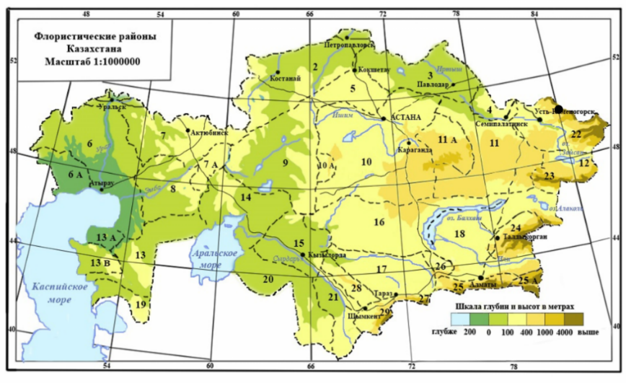
Fig. 1: Floristic Regions of Kazakhstan (https://yandex.kz/images/search): 1 – Obshchy Syrt’s spurs, 2 – Tobol-Ishim, 3 – Irtysh, 4 – Semipalatinsk pine forest, 5 – Kokshetau, 6 – Caspian, 6а – Bukeyev, 7 – Aktobe, 7а – Mugodzhar, 8 – Emba, 9 – Turgay, 10 – West low mountains, 10а – Ulytau, 11 – East low mountains, 11а – Karkaraly, 12 – Zaysan, 13 – North Ust-Urt, 13а – Buzachi, 13б – Mangyshlak, 14 – Aral, 15 – Kyzyl-Orda, 16 – Betpak-dala, 17 – Muyunkum, 18 – Balkhash-Alakul, 19 – South Ust-Urt, 20 – Kzylkum, 21 – Turkestan, 22 – Altai, 23 – Tarbagatai, 24 – Zhongar Alatau, 25 – Trans-Ile, Kungey Alatau, 25а –Ketmen, Terskey Alatau, 26 – Chu-Ile Mountains, 27 – Kyrghyz Alatau, 28 – Karatau, 29 – West Tien-Shan

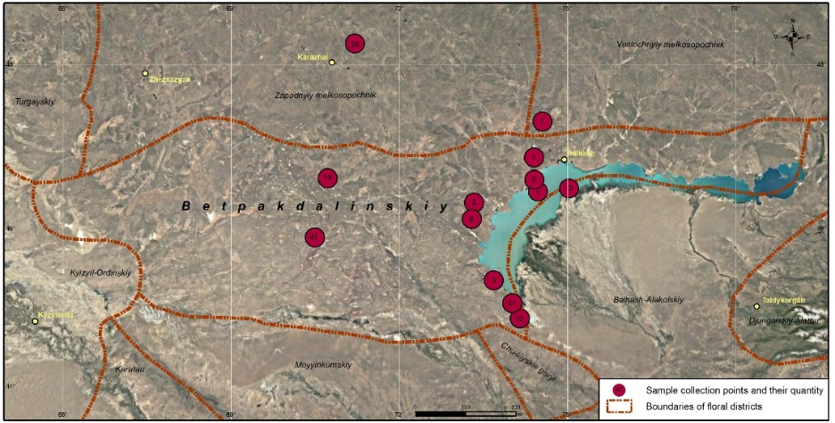
Fig. 2: Map of the Betpak-Dala floristic region with sample collection points marked

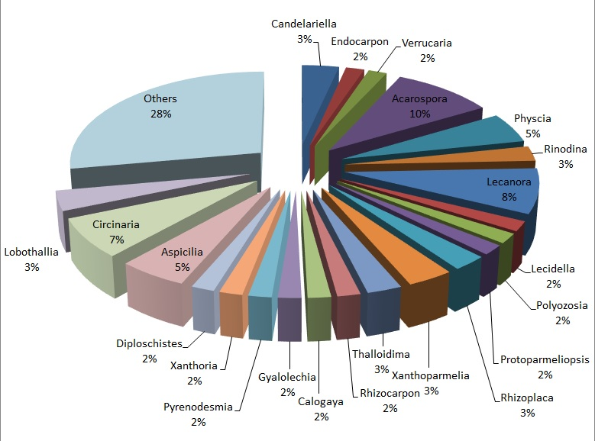
Fig. 3: Quantitive evaluation of lichen genera of the Betpak-Dala floristic region

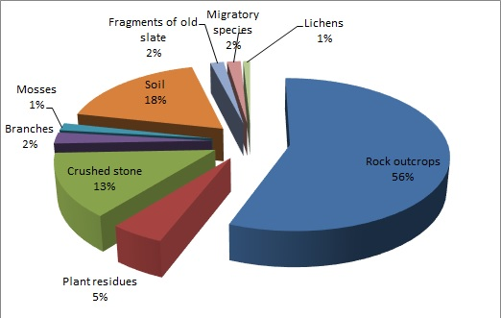
Fig. 4: Substrate specificity of lichens in the Betpak-Dala floristic region

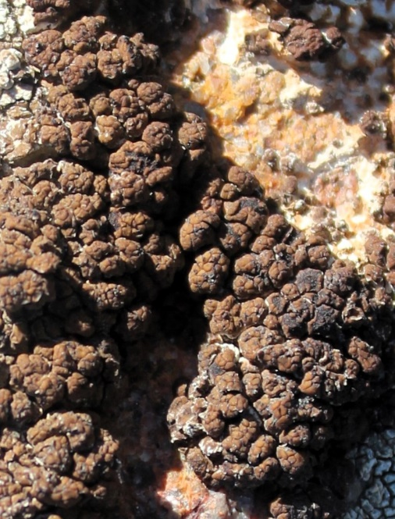 | 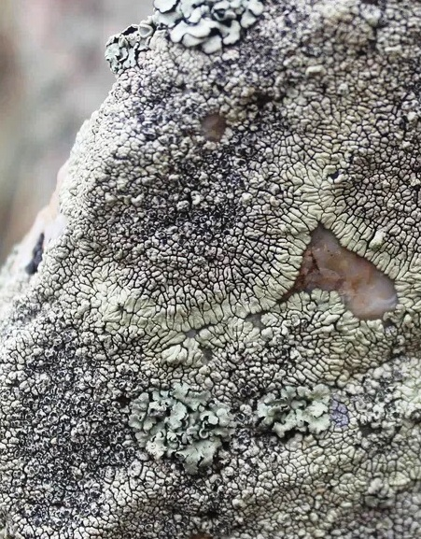
Fig. 1А: Acarospora cervina | Fig. 2А: Dimelaena oreina

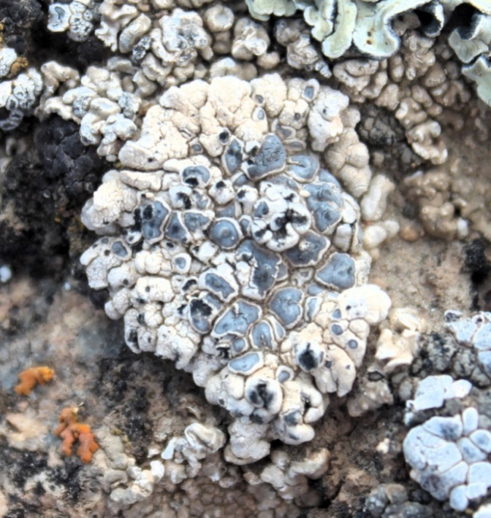 | 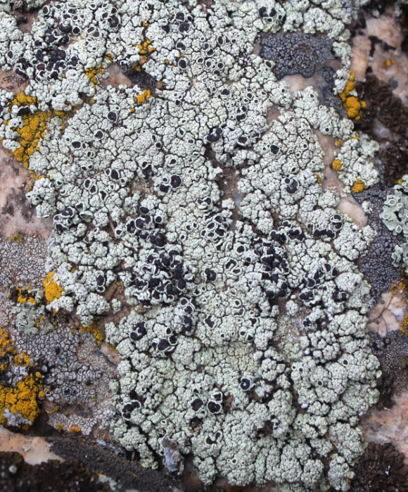
Fig. 3А: Diplotomma venustum | Fig. 4А: Lecanora argopholis

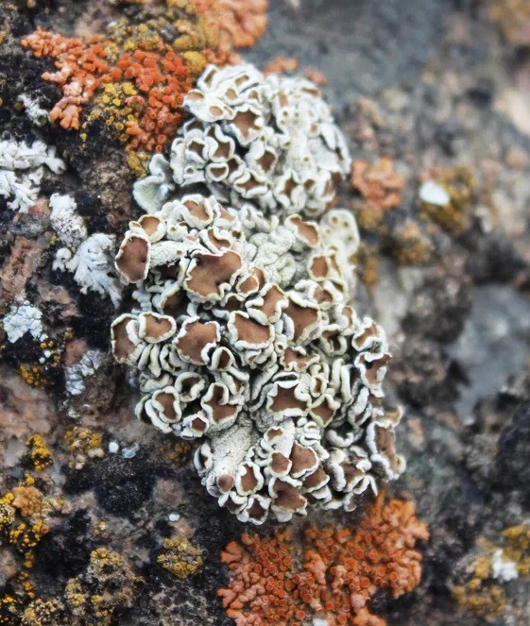 | 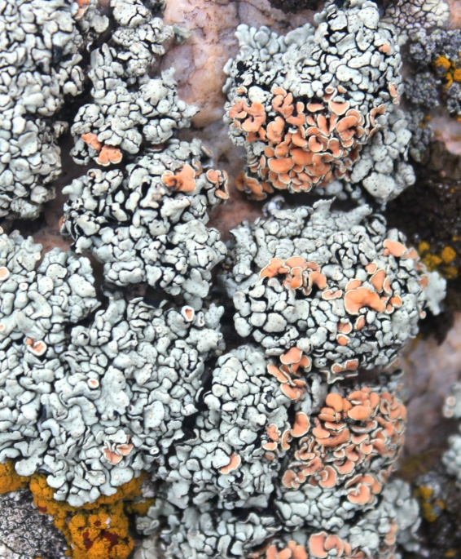
Fig. 5А: Protoparmeliopsis peltata | Fig. 6А: Rhizoplaca chrysoleuca

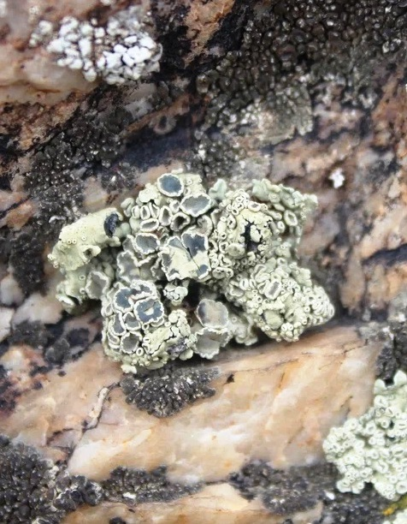 | 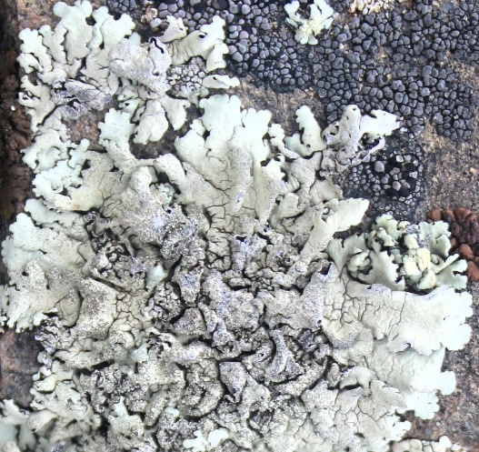
Fig. 7А: Rhizoplaca melanophthalma | Fig. 8А: Xanthoparmelia conspersa

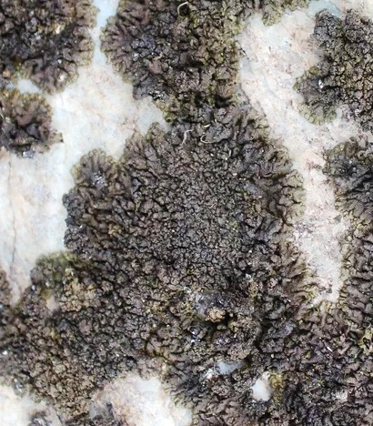 | 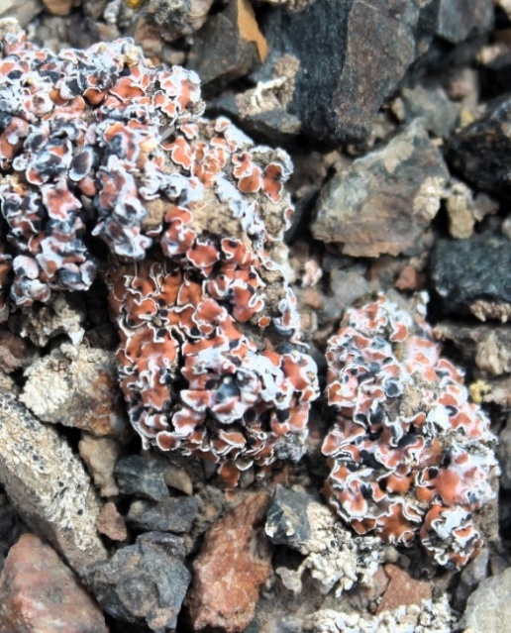
Fig. 9А: Xanthoparmelia pulla | Fig. 10А: Psora decipiens

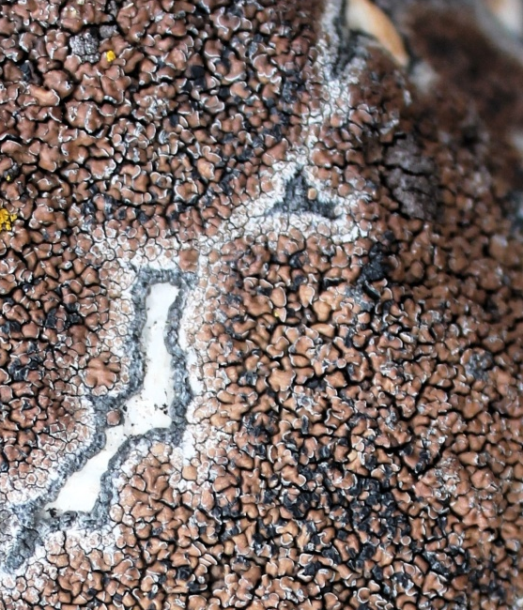 | 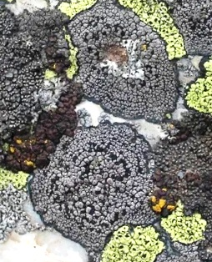
Fig. 11А: Lecidea atrobrunnea | Fig. 12А: Rhizocarpon disporum

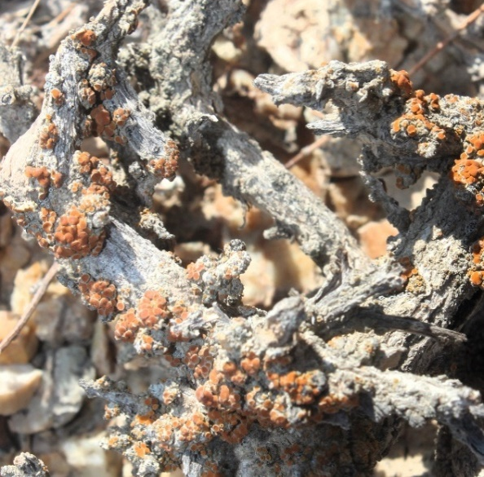 | 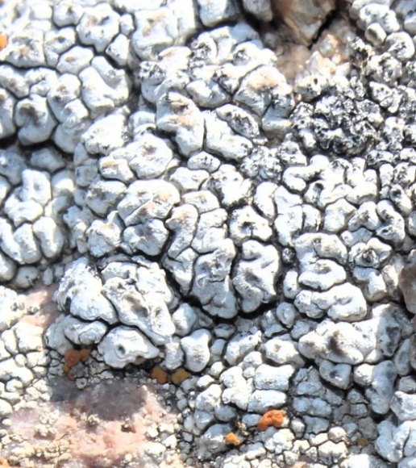
Fig. 13А: Calogaya lobulata on Salsola sp. | Fig. 14А: Diploschistes scruposus

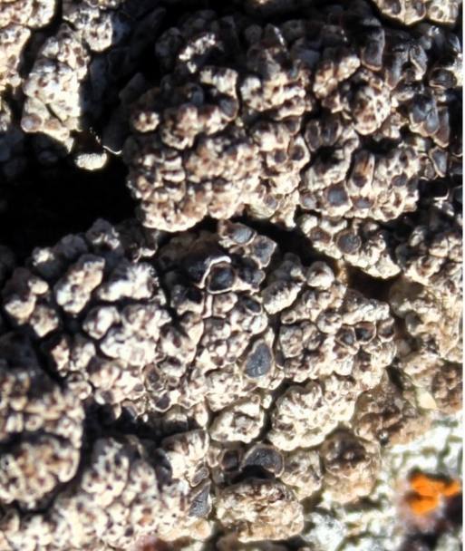 | 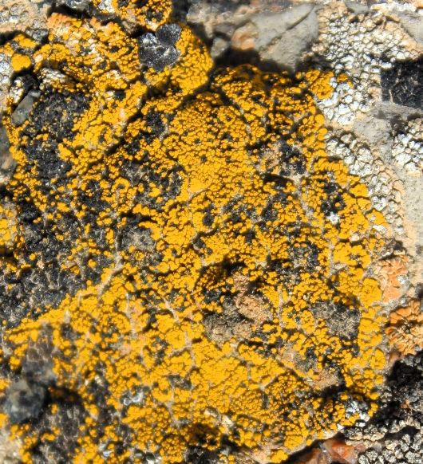
Fig. 15А: Lobothallia alphoplaca | Fig. 16А: Candelariella vitellina

