UTILIZATION OF COAL WASTE-DERIVED CARBON SORBENTS FOR AGRICULTURAL WATER PURIFICATION

Lyubov Dyshlyuk¹, Olga Babich², Svetlana Ivanova²*, Ekaterina Mikhaylova² and Stanislav Sukhikh¹

¹ Immanuel Kant Baltic Federal University, Kaliningrad, Russia
²Kemerovo State University, Kemerovo, Russia
*Corresponding author: svetlana.ivanova@mymail.academy

ABSTRACT
The study was carried out to assess the effectiveness of using local waste from coal processing facilities (Kemerovo region, Russia) to remove heavy metal ions and petroleum products. To increase the adsorption efficiency, coal mining waste was modified with silver nanoparticles. Isotherms and adsorption kinetics curves of sorption-catalytic sample materials in relation to petroleum products and heavy metal ions were studied. Sorption equilibrium on the developed samples is reached after 8 h for petroleum products and for iron ions, after 10 h for copper, manganese, and cadmium ions, and after 12 h for lead ions, which confirms a fairly rapid sorption. The best efficiency was observed for petroleum products. No toxic effect of the studied samples of the sorption-catalytic materials has been established. The tested samples of the sorption-catalytic materials can be recommended for purification of aqueous solutions.

Keywords: Coal mining waste, Nanosilver, Sorption-catalytic materials, Adsorption, Heavy metals and oil products.

- INTRODUCTION
Pollution with heavy metals and oil products has a long-term impact on both human health and the environment through toxic effects on plants, animals and birds (Adekanmi 2021; Alengebawy et al. 2021; Ore and Adeola 2021; Dyshlyuk et al. 2020b). Industrial effluents and sometimes natural waters may contain toxic pollutants such as heavy metals (arsenic, cadmium, chromium, lead, mercury, etc.), oil products, pharmaceutical derivatives, etc. (Aziz et al. 2023; Fulke et al. 2024; Pandey and Kumari 2023). If ingested in excess of the permissible concentration, these components accumulate in the human body which leads to serious diseases. All these compounds must be removed from wastewater or natural water before being released into the environment and/or prior to use. Pollution of the atmosphere with toxic compounds is currently the most dangerous form of environmental degradation in Russia. The environmental situation and emerging environmental problems in some areas of the Russian Federation are caused by local natural conditions as well as the nature of the impacts from industries, transportation, utilities, and agriculture. In general, the magnitude of air pollution relies on the degree of urbanization, anthropogenic modification of the terrain, and meteorological variables that affect the capacity for atmospheric pollution (Bakaeva and Le 2021). Another study showed that mining operations in the Kovdorsky District, Murmansk Oblast, have resulted in significant pollution of water, sediments, and soils, primarily due to manganese. This study evaluated geochemical changes from open-pit mining and predicted future environmental impacts influenced by industrial activity and climate instability. The study revealed dangerously high levels of toxic elements, especially manganese, which pose health risks through drinking water (Matveeva et al. 2022). According to Bobylev et al. (2023), an estimated 2.3 – 6.1% of Russia's GDP is spent on environmental harm to the country's population's health, which is mostly caused by pollution of the air and water.
Traditional water purification methods include chemical precipitation, flocculation, membrane filtration, adsorption, etc. (Abd El-Salam et al. 2017; Ayach et al. 2024). Adsorption technologies have a potential of being applied due to their sustainability, cost-effectiveness and high efficiency without formation of by-products (Bonilla-Petriciolet et al. 2019; Selvaraj et al. 2020). According to Tran (2023), by first treating sepiolite with acid-base (HCl and NaOH) and then impregnating it with FeCl₃, scientist created a novel composite from a sepiolite mineral (magnesium-enriched silicate clay) which was used in adsorbing Antimony (Sb). He also reported that scientist applied utilized graphite to create magnetic graphene oxide (M-GO) and then used M-GO as an adsorbent to remove captopril from wastewater. The magnetic graphene oxide was synthesized using the co-precipitation technique of graphene oxide with FeCl₂ at pH 9.0. Scientist also explored the use of machine learning to optimize and predict the quantity of phenol absorbed by commercially available powdered activated carbon in an aqueous solution. Studies also explored the use of natural clay, and algae and hydrophytes for bioremediation.
Different adsorbents (activated charcoal, ash, peat, alginate, chitosan, etc.) are used to remove heavy metals, dyes, and organic components (Ihsanullah et al. 2016; Selvaraj et al. 2020). Activated charcoal is a popular adsorbent for extracting impurities from water. However, it is known that it either has a low adsorption capacity and removal efficiency, or it is difficult to regenerate. There is a constant ongoing search for new adsorbent materials that are free of these issues.
Some progress has been made in the use of various nanomaterials immobilized on a solid adsorbent (carbon carrier, for example, activated charcoal), which initially concentrate many harmful substances on their surface (Pal et al. 2020; Wu et al. 2019). Metal nanoparticles are often included in the hydrocarbon carrier as potential and cost-effective nanoadsorbents/catalysts. Precipitation and loading of nanoparticles on activated charcoal increase the reactive center and adsorption capacity (Louis et al. 2023). Various extraction tests have shown that heavy metals are firmly retained in sorbents based on low-grade coal (Janoš et al. 2007). Any cheap material with a high carbon content and a relatively low ash content can be used as a raw material for the production of activated charcoal (Simate et al. 2016). Therefore, it is particularly interesting to create sorption-catalytic materials from coal mining waste in which metal nanoparticles (of silver, gold, platinum, etc.) determine the unique properties and multifunctionality (Dastkhoon et al. 2017; Dil et al. 2017; Dyshlyuk et al. 2020a). However, it is necessary to establish appropriate technological conditions for higher sorption efficiency (Abd El-Salam et al. 2017; Park et al. 2019; Queraltó et al. 2018). Nanoparticles are also relevant as remediators, they can be used to perform photocatalysis and disinfection on pollutants of diverse and concentration. They also play roles as disinfectants since they are not time-consuming, easy to use, have less toxicity, and have a wide range of antimicrobial activities. Nanoparticles can also be used in magnetic separation to remove solids, heavy metals, dyes etc (Azeez et al. 2023). Among noble metals, silver nanoparticles (AgNPs) are particularly promising for water purification composites due to their strong antimicrobial properties, high surface-to-volume ratio, and proven efficacy in catalytic oxidation processes. The incorporation of AgNPs into a carbon matrix can create a multifunctional sorbent capable of not only adsorbing contaminants but also catalytically degrading organic pollutants and inhibiting biofilm formation on the sorbent surface, which is a common issue that reduces the longevity of filtration systems. The catalytic activity of silver is highly dependent on its size, shape, and dispersion within the carrier matrix.
Few studies have systematically examined the development, characterization, and use of sorption-catalytic materials made directly from unprocessed coal washing waste and functionalized with AgNPs, despite the fact that prior research has examined the use of coal for adsorption or the use of nanosilver on commercial activated carbon (Ahmed et al. 2022). This work aims to evaluate the potential of carbon structures modified with nanosilver to purify natural and waste water from heavy metal ions and oil products.

- MATERIALS AND METHODS
  - Materials
Five samples of sorption-catalytic materials which composition is presented in Table 1 were the objects of the research. A suspension of coal waste (10.0 wt. %) and Ag nanoparticles (0.25 wt. %) was prepared in polydimethylsiloxane and dimethylsulfoxide. The resulting suspensions were irradiated with infrared light at a wavelength of 1200 nm for 60 min.
Coal-washing waste provided by coal processing facilities in Kemerovo region in years 2018-2019: I – filter press mud (Pervomayskaya mine, average diameter 0.23±0.01 mm); II – filter press mud (Tomusinsky open-pit mine; average diameter 0.21±0.01 mm); III – filter press mud (Antonovskaya mine; average diameter 0.27±0.01 mm); IV – spiral separator waste (Pervomayskaya mine, average diameter 0.71±0.04 мм); V – filter press mud (Beryozovskaya mine, average diameter 0.34±0.02 мм).
Silver nanoparticles were prepared by reducing silver nitrate with ethylene glycol in the presence of polyvinylpyrrolidone. The average diameter of silver nanoparticles was 3-4 nm.
All chemicals, solvents and reagents used in this study were of analytical grade and were purchased from Fluka/Sigma-Aldrich (Sigma-Aldrich Rus, Moscow, Russia).

  - Physical and Chemical Characteristics of the Samples
Chemical composition of the surface of sorption-catalytic sample materials (Table 1) was studied using the IR spectroscopic method (IR spectrometer with the Fourier transform function IRPrestige21 SM, Shimadzu, Japan). The absorption spectra of samples in the IR region were determined by the method of incomplete internal reflection according to the recommendations of the equipment manufacturer.
Phase composition of the samples was studied using the x-ray phase analysis with XRD-7000S diffractometer (Shimadzu, Japan). The data was obtained under the following conditions: Target Cu; Voltage 40.0 kV; Current 30.0 mA; receiving slit 0.15000 mm; drive axis - Theta-2Theta; scan range 10.000 - 70.000; scan mode - Fixed Time; sampling pitch (2 Θ) 0.0300 deg; preset time 0.80 sec. The obtained x-ray data were used to calculate the content of amorphous (carbon component) and crystalline (nanoscale silver) phases.
The surface relief of sorption-catalytic sample materials was studied using the scanning electron microscopy (SEM) with a multifunctional raster electron microscope with an integrated focused ion beam system Quanta 200 3D (FEI Company, USA).
The total pore and micropore volume (less than 2 or 5 nm in size) was determined by the method based on the obtained isotherms of low-molecular sorption and nitrogen desorption in the NOVA 2200 E gas sorption analyzer (Quantachrome, USA).
Hardness of the sample surface was measured using the DUH-211S nanohardometer (Shimadzu, Japan).
Surface areas of the samples were determined by the gas adsorption method using the Sorbi specific surface meter (META LLC, Russia).
Sorption capacity of the samples was measured as the mass of calcium hydroxide absorbed by 1 g of the material.

  - Ecotoxic Properties of the Samples
Impact of the samples on phyto- and zooplankton was studied (FR.1.39.2011.10993 "Method for determining the environmental toxicity index of concentrated water dispersed systems of nanoparticles for inhibiting the growth of test culture of Chlorella algae"; FR.1.39.2010.09102 "Method for determining the toxicity index of nanopowders, products made of nanomaterials, nanocoatings, waste and sewage sludge containing nanoparticles, by mortality of the Daphnia magna Straus test organism" with the STO TGU 137-2015 modification "Nanomaterials and highly dispersive materials, waste and sewage sludge containing nanoparticles. Toxicity index determination by mortality of Daphnia magna Straus").
Method 1. A daily culture of Chlorella vulgaris Beijer algae (2 ml) was added to six glasses each containing 50 ml of control and test samples. The samples were poured into reaction flasks, 5 ml in each. The algae was cultivated for 22 h. After that, the optical density of the test culture was measured and the daily increase in the number of algae cells in the control and experimental versions was compared.
Method 2. Lower crustaceans were used as a test culture. The experiment lasted for 72 h. Death of at least 50% of crustaceans in the test sample within 48 h was the acute toxicity criterion, provided that all species in the control sample were fully viable. Mortality of test organisms was recorded every 24 h. Motionless crustaceans were considered dead if they did not start moving within 15 s after a slight swaying of the test tube. In addition, we took into account the behavior of Daphnia (activity and movement pattern), the degree to which intestines were filled with food, and the number of dropped ephippiums.

  - Structural and Adsorption Characteristics of the Samples
The study determined structural and adsorption characteristics of sorption-catalytic materials to the natural and waste water components (oil products, iron, lead, copper, manganese, and cadmium ions).
The sorption capacity of the developed sorption-catalytic materials was determined under static conditions at room temperature. Solutions containing natural and waste water components in the concentration range of 10-1000 mg/l were prepared, 1g of sample No. 1 of the developed sorption-catalytic materials was added to each solution. The contents of all the flasks were subjected to continuous stirring for 24 h with the components concentration in the clarified solutions being measured every 2 h.
The mass concentration of oil products in water was determined by column chromatography with a gravimetric finish (PND F 14.1:2.116-97. Quantitative chemical analysis of water. Procedure of oil product mass concentration measurement in natural water and waste water samples using column chromatography with a gravimetric finish). The oil product mass concentration measuring method is based on the extraction of oil products from the analyzed waters with an organic solvent, separation of other classes from polar compounds by column chromatography on aluminum oxide, and quantitative determination by the gravimetric method. The error of method at the detection limit level is 25%.
The mass concentration of iron, lead, copper, manganese, and cadmium in water was determined by the Atomic absorption spectroscopy (PND F 14.1:2:4.139-98. Quantitative chemical analysis of water. Methods for measuring mass concentrations of cobalt, nickel, copper, zinc, chromium, manganese, iron, silver, cadmium, and lead in drinking water, natural water, and wastewater samples by atomic absorption spectroscopy). The method is based on measuring the resonance absorption of light by free atoms of the given metal when light passes through the formed in the flame atomic vapor of the test sample. The measurement range is from 0.01 mg/dm³. The error of method at the detection limit level is 30%.
The sorption capacity q_{e} (mg/g) of the developed materials was calculated using the formula:

$q_{e}=\left[\frac{С_{0}-С_{e}}{m}\right]·$V, | (1)

where С₀ and С_{e} are the initial and equilibrium concentrations of the component in solution, respectively, mg/l;
m – sample mass of the sorption-catalytic material, g;
V – sample volume, L.
Sorption isotherms of natural and wastewater components were analyzed for compliance with known theoretical models (Abd El-Salam et al. 2017; Neris et al. 2019; Syafiuddin et al. 2018). Kinetic characteristics of natural and waste water components sorption in order to identify the contribution of the diffusion and chemical components to the overall mechanism of sorbate-sorbent interaction. On each isotherm, the curve slope at the point with zero sorbate concentration was measured using the approximation equation (Langmuir isotherm).
Provisional stability constants of complexes formed between the functional groups of the developed carbon sorbents and the sorbed components of natural and waste water were calculated at a single wavelength and using spectral ranges on the Shimadzu UV-1800 spectrophotometer in quartz cuvettes with a thickness of l = 1.0 cm, in the range of 320-750 nm with a scan step of 0.2 nm.
The Langmuir equation was used as the basis for modeling:

$q_{e}=q_{∞}\frac{KC_{e}}{1+KC_{e}}$, | (2)

where K is the adsorption equilibrium constant.
From this equation, the adsorption constant was graphically determined for all tested components of natural and waste water.

  - Statistical Analysis
Each experiment was repeated three times and data were expressed as means ± SE. Data processing was carried out by standard methods of mathematical statistics. Homogeneity of the sampling effects was checked using the Student’s t-test. Differences between means were considered significant when the confidence interval was smaller than 5% (P≤ 0.05).

- RESULTS AND DISCUSSION
  - Results of the Study of Physical and Chemical Properties and Ecotoxicological Characteristics of the Samples
At the preliminary stage, we worked out the silver nanoparticles synthesis technology, synthesized by the method (Dyshlyuk et al. 2020a, 2020b). Initially, carbon materials were modified by introducing noble metal nanoparticles (silver, gold, platinum, rhodium, and palladium) into the matrix. Suspensions of coal waste (5.0 – 25.0 wt. %) and nanoparticles (0.05 – 0.5 wt. %) in polydimethylsiloxane and dimethylsulfoxide were irradiated with infrared light with a wavelength of 1200 nm for 60 min (the surface area of the samples increased to 18%, the sorption capacity rose to 54% compared to the original carbon carriers). The best indicators (surface area, sorption capacity) were achieved in the samples with a coal waste concentration of 10.0 wt. % and a concentration of silver nanoparticles of 0.25 wt. %. Silver is able to catalytically oxidize organic compounds on its surface and induces more efficient catalytic oxidation than other metals due to its large specific surface area (Fu et al. 2022; Nakatsuji et al. 1997). In addition, it was noted that this ability also depends on the size and/or shape of the nanoparticles (Al-Onazi and Abdel-Lateef 2022).
In his research, Jain et al. (2021) pointed out that a number of toxic elements were removed from drinking water using nanosilver. The author also shows that nanometals are considered highly effective adsorbents for the removal of heavy metals and radionuclides. Singh et al. (2022) also revealed the potential of using noble metal nanoparticles to absorb pollutants and bacteria. Having a high adsorption capacity, nanoparticles successfully absorb mercury, for example.
The results of the study of physical and chemical properties and ecotoxicological characteristics of sorption-catalytic materials are presented in Figures 1-4 and Tables 2-4.
Mineral component (Fig. 1, Table 2) of the surface of sorption-catalytic materials is mainly represented by silicon dioxide (75.4-77.0 %), aluminum oxide (9.5-10.1%) and iron oxide (8.5-8.9%).
Similar results were obtained by other researchers (Kotsiopoulos and Harrison 2017; Letina and Letshwenyo 2018). The following compounds present in different types of coal mining waste are dominant: iron oxide Fe₂O₃ from 5% to 45%, silicon oxide SiO₂ from 15% to 70%, and aluminum oxide Al₂O₃ from 3% to 15%. Content variations are determined by the characteristics of coal formations from the deposits under consideration. It is known that both iron oxide and silicon oxide influence the efficiency of adsorption of heavy metals from aqueous solutions (Rezaee et al. 2019; Tang and Lo 2013), so our samples have a certain adsorbent potential that requires additional research.
The results of calculating the content of amorphous (carbon component) and crystalline (nanoscale silver) phases of sorption-catalytic sample materials are presented in Figure 2. The figure shows a peak with a higher intensity at 2Θ=20 in the spectrum of samples No.No.1-3, which determines their greater crystallinity vs. samples No.4 and No.5.
Figure 3 shows the crystal size distributions in the studied samples. It was found out that 3-4 nm crystallites dominated in all tested samples. Although there exist a level of disparity among silver nanoparticles size. Numerous studies reported on using silver nanoparticles which are above 10nm. On the contrary, the study highlights the increased potential of reduce size particle, it also aligns with the study of Menichetti et al. (2023) who concluded that silver nanoparticles at sizes below 5nm performed better than other tested samples.
X-ray images of the samples' surface relief (Figure 4) showed that silver nanoparticles are evenly distributed in the amorphous carbon matrix. This aligns with the study of Streletskiy et al. (2022) who attributed the stability of nanoparticles and its effective oxidation and reduction reaction to its even distribution or monocrystallinity.
In terms of quality characteristics (Table 2), all samples of the developed sorption-catalytic materials exceed the control sample (the original nanostructured carbon carrier) by total pore volume by 3.32 times, by micropore volume of up to 2 nm by 4.04 times, and by size of up to 5 nm by 4.87 times. This fact indicates the possibility of using the developed materials as highly effective sorbents.
The microhardness values of the developed sorption-catalytic materials vary from 1.42 to 1.60, which is 1.9 times higher than the microhardness of the control sample.
The developed materials are characterized by high surface area and sorption capacity values to Ca (OH)₂ (Table 3).
For coal mining waste samples No.3 - No.5, the surface area change did not exceed 5%, which is in the margin of statistical error. For samples No.1 and No.2, the increase in quality characteristics was 22% and 17%. The sorption capacity of all carbon carrier samples increased from 57% to 80% after the modification with silver nanoparticles. In (Mishra and Ghosh 2020; Poornima Parvathi et al. 2020; Rengga et al. 2017), immobilization of activated charcoal with silver nanoparticles provided more effective adsorption characteristics by increasing the surface area. It is known that almost any carbon-containing material can be converted into activated charcoal. However, the raw material from which this activated charcoal is obtained often has a huge impact on the distribution of its porosity, total surface area, carbon density, particle size distribution, and adsorption capacity. As a result, activated charcoal obtained from different raw materials can have different adsorption properties. For activated charcoals, the specific surface area is determined within 500-1500 m²/g (Bonomo 2008; Cuhadaroglu and Uygun 2008; Yeganeh et al. 2006).
The study (Gonçalves et al. 2016) points at environmental risks (toxic effects on the aquatic organism Hydra attenuate and inhibition of the Lycopersicum esculentum root development) from activated charcoal materials modified with silver nanoparticles.
There was no toxic effect of our tested sorption-catalytic sample materials detected (Table 4). By the environmental impact (toxicity against the components of natural biocenoses), they belong to the 5th hazard category (non-hazardous substance; GOST 12.1.007-76 Occupational safety standards system. Noxious substances. Classification and general safety requirements).

  - Kinetic Characteristics of Natural and Waste Water Component Sorption
To study the potential of the obtained sorption-catalytic materials for the adsorption of petroleum products and heavy metal ions, experimental equilibrium data were determined using the Langmuir isotherm model. Kinetic characteristics of natural and waste water component sorption (oil products, iron ions, lead ions, copper ions, manganese ions, cadmium ions) for the sorption-catalytic sample material No.1 are shown in Figs 5-7.
Studying equilibrium time is essential for the development of wastewater treatment technologies (Vaiopoulou and Gikas 2012). In our experiments, rapid sorption was observed within 10 min of the adsorption process. Equilibrium for sorption on the developed samples is reached after 8 hours for petroleum products and iron ions, after 10 hours for copper, manganese, and cadmium ions, and after 12 h for lead ions, which confirms a fairly rapid sorption. In comparison to the study by Sen (2023), where they explored using agricultural solid wastes based adsorbent materials in the remediation of heavy metal ions they obserevd that this adsorbent material could only equilibrium at 240 mins which shows the adsorbing effectiveness of silver nanoparticles. Studies like Raji et al. (2023) highlighted that fungi bioadsorbent displayed rapid adsorption when compared to AgNPs. They further explained that waste beer yeast from the brewing industry could be a promising adsorbent to remove Cu²⁺ within 30 min.
Apparently, at the initial stage, sorption mainly occurred on the surface. The sorption capacity of the sorption-catalytic sample material No. 1 is 236 mg/g, 70 mg/g, 40 mg/g, 65 mg/g, 56 mg/g, 33 mg/g to oil products, iron ions, copper ions, lead ions, manganese ions and cadmium ions, respectively. As the contact time increases, the adsorption efficiency increases until equilibrium occurs (Abd El-Salam et al. 2017). Oil products were removed almost completely with the sorption-catalytic sample materials. The efficiency of removing Fe, Cu, Pb, Mn, and Cd ions was up to 30% (the lowest efficiency for copper and cadmium) after 12 h of reaction (Figure 5). The significant efficiency for oil products is probably due to the presence of silver nanoparticles as catalysts on the sorbent surface. The difference in the number of sorbed heavy metal ions is explained by the differences in their properties (Merdy et al. 2009). Similar results were obtained with slag-based sorbents (Kwon et al. 2010).
A number of studies have shown the ability of coal and sorbents based on it to remove not only solids and organic carbon (Huang et al. 2022), but also heavy metals (Wu et al. 2007), radionuclides (Huang et al. 2022; Wu et al. 2007), cations and anions from water (Ulrikh et al. 2024). The metal adsorption process is well described by the Langmuir and Freundlich isotherm and depends on the contact time, the acidity of the solution, the temperature and the initial concentrations of the sorbate (Javed et al. 2017; Wu et al. 2007). Javed et al. (2017) studies showed that the adsorption capacity of low-grade coal relative to cerium increased significantly with increasing temperature (283-333 K). While previous studies have demonstrated the efficacy of coal-based sorbents for heavy metal removal, the material fictionalized with AgNPs shows a distinct advantage in both adsorption capacity and kinetics relevant to agricultural settings. For instance, compared to agricultural waste-derived biochars which often require longer equilibrium times, the nanoparticle sorbent reaches equilibrium within 8–12 hours, making it more suitable for continuous-flow water treatment systems commonly used in irrigation
In the study (Zhang et al. 2024), low-grade coal was modified using chemical methods and it was proved that in this modification coal is able to adsorb heavy metals and ammonia present in wastewater. Kinetic and thermodynamic experiments have proved that modified low-grade coal is capable of adsorbing Pb²⁺, Zn²⁺ ions and ammonia. Adsorption phenomena correspond to the typical Langmuir isotherm. At the same time, it is shown that the adsorption of heavy metals proceeds with the release of heat and is an independent (Zhang et al. 2024) and spontaneous process (Zhang et al. 2023).
Jaya et al. (2023) proved that activated carbon based on coconut shell (after microwave irradiation treatment) is able to effectively remove copper ions. In the study, the author showed that the absorption capacity of activated carbon depends on the surface area (Jaya et al. 2023), the presence and volume of pores (Jaya et al. 2023; Prosekov et al. 2022). Thus, in the study (Jaya et al. 2023), activated carbon was characterized by a high surface area and pore area, which allowed it to adsorb a significant amount of copper. Our results are comparable with empirical data (Jaya et al. 2023). First of all, this is due to the fact that coal is characterized by a mesoporous structure, and the surface of coal includes several functional groups that allow heavy metals to be sorbed on them. Thus, it is shown that due to the high specific surface area and a more extensive distribution of pore sizes, the modified coal rock has acquired a high adsorption capacity (Jin et al. 2022). At the same time, chemoadsorption occurred between heavy metal ions and the composite, the maximum exchange capacity of Pb2⁺ reached 268 mg/g (Jin et al. 2022).
Sorption capacity in the q_{e} equilibrium increases with the growing C_{e} (Figs 6-7), which is associated with an increase in the number of available active areas on the sorbent surface (Abd El-Salam et al. 2017).
Analysis of the presented sorption isotherms (Figs 6-7) indicates that the process of adsorption of oil products, iron, copper, lead, manganese, and cadmium ions can be described from the viewpoint of the Brunauer, Emmett, and Teller polymolecular adsorption theory (BET). All six obtained sorption isotherms belong to type IV, which confirms that macro -, meso -, and micro - range pores are present in the developed sorption-catalytic material based on coal mining waste and nanoparticles of noble metals, thus allowing to perform adsorption following a polymolecular mechanism.
In the study (Chen et al. 2024), carbon fiber modified with nanosilver showed high efficiency in the process of adsorption of iodine anions. Analysis of the kinetics of adsorption and isotherms of adsorption revealed that the adsorption of iodine anions on modified carbon fiber is a chemical adsorption process involving a single molecular layer (Chen et al. 2024).
A preliminary analysis of the adsorption mechanism and evaluation of the adsorption performance showed that carbon structures modified with nanosilver have significant prospects for the treatment of real wastewater with anions and cations of heavy metals.
Our AgNP-modified coal waste sorbent exhibits a balanced performance when critically compared to adsorbents frequently used in agricultural water purification, such as activated carbon, biochar, clay minerals, and agricultural residues. It offers notable removal efficiency for petroleum hydrocarbons, a contaminant of increasing concern in farmlands close to industrial zones, in addition to matching or surpassing the adsorption capacities for heavy metals reported for these materials. Furthermore, its rapid sorption kinetics and non-toxic nature make it even more suitable for practical agricultural applications (Ariyanti et al. 2023).

  - Results of Determining the Adsorption Equilibrium Constants for Oil Products, Iron, Copper, Lead, Manganese, and Cadmium Ions
Value of the adsorption equilibrium constant can be used to assess the effectiveness of the sorbent – sorbate interaction. Table 5 shows that these constants for all the studied components get similar values (the K value varies in the range of 11.85-18.85), therefore, the developed sorption-catalytic materials are characterized by high selectivity to oil products, iron, copper, lead, manganese and cadmium ions.
In (Wierzba and Kłos 2019), sorption characteristics of used beer grains to heavy metal ions were evaluated. The conclusion says that the new sorbent is suitable for water and waste water treatment. The calculated values of the sorption equilibrium constant were as follows: Cu 15.6, Pb 26.8, Mn 16.3, Ni 13.9, Zn 16.5, Cd 14.9, which in most cases is comparable to our results.

  - Ecological implications of silver nanoparticles in agricultural
Silver nanoparticles have been shown to provide significant benefits such as its impact on seed germination and plant growth, photosynthesis and also its effectiveness as a non-toxic pest management alternative. Irrespective of these benefits, it is imperative that we consider the phytotoxicity of silver nanoparticles. Khan et al. (2023) reported that although AgNPs played vital roles in germination and growth, certain plants displayed toxicity at certain concentrations during application. They also recorded the presence of reduced germination, seed growth, root/shoot length and mass and these phenomena could be attributed to the accumulation of AgNPs in leaves and roots which subsequently activates the defense mechanism at cellular/tissue levels and modifies proteomic expression, antioxidant activities, and metabolism (Khan et al. 2023).
Jangid et al. (2025) highlighted that silver nanoparticles (AgNPs) despite possessing antimicrobial properties they also harbour unprecedented effects such as interference in nutrient cycling patterns and accumulation through food webs. AgNPs can potentially disrupt critical microbial ecosystems involved in nutrient cycling, reduce soil microbial diversity and enzymatic activity, with long-term implications for soil fertility and ecosystem imbalances. Studies also show it has negative impacts on nitrogen fixing and nitrification Nitrosomonas and Nitrobacter and in cases of agricultural runoff, AgNPs is dispersed into the water ecosystem, thus posing a significant risk to aquatic ecosystems.
Studies like Chen et al. (2022) emphasize the need for more research on the effect of silver nanoparticles infiltration into the food chain. Advanced analytical tools with low detection limits are necessary for determining the threshold concentrations of AgNPs that cause hazardous effects. Future research is also recommended to create comprehensive concentration standards for every plant so as to encourage effectiveness and reduce the probability of run offs. Padhye et al. (2023) in a broader study, highlights the importance of source reduction for places with potential silver contamination which may be caused by silver nanoparticles. To encourage ecological sustainability, numerous studies such as Fahim et al. (2024), Husain et al. (2023) and Gong et al. (2023) suggest employing a green synthesis approach which is cost effective, non-toxic and environmentally friendly and basically involves the oxidation/reduction of metallic ions by organic molecules derived from biological sources.

- CONCLUSION
These days, biotechnologies are being actively developed in various areas of human life, including water treatment. With all the advantages of "green" methods, activated charcoal rightly continues to be used for purifying various water solutions. Coal mining waste can be an environmental and economic alternative to activated charcoal in natural and waste water treatment processes. Modified with silver nanoparticles, coal waste improved its characteristics (adsorption capacity, surface area) without forming an ecotoxic effect on the environment. For the first time, the effect of modifying of carbon carrier with silver nanoparticles (sorption-catalytic materials based on coal waste and nanosilver particles) on the adsorption of heavy metal ions and oil products was studied. A simultaneous decrease in the concentration of heavy metals and oil products in aqueous solutions was observed.
Thus, the study determines the potential of carbon structures modified with silver nanoparticles in the process of purification of natural and wastewater from petroleum products and heavy metals. The study shows that low-grade coal modified with nanometals has adsorption properties. However, for further development of the direction, it is necessary to study the possibility of presenting sorption-catalytic materials for sampling in a form suitable for collecting oil (fine powders, microcapsules, etc.), as well as restoring sorption characteristics after purification and extraction of petroleum products to reduce the economic and environmental components of the technology for purifying water surfaces and solutions.

Funding: The research was funded the Ministry of Science and Higher Education of the Russian Federation within the framework of the comprehensive scientific and technical program of full innovation cycle (Order of the Government of the Russian Federation No. 1144-r from 11.05.2022., Agreement No. 075-15-2022-1201).

Conflict of Interest: The authors declare that they have no conflict of interest.

Data Availability: The data are included in the manuscript. The authors declare no competing financial interest.

Institutional Review Board Statement: Not applicable.

Informed Consent Statement: Not applicable.

Ethics Statement: State, like, the animal study was approved by the Ethics Committee of the [insert name of institute/University; approved vide number: ?? Dated: ??] and conducted in accordance with local legislation and institutional requirements.

Authors’ Contributions: Lyubov Dyshlyuk: Conceptualization, Methodology, Data curation, Writing - original draft, Supervision. Olga Babich: Resources, Software, Writing - review & editing. Svetlana Ivanova: Writing - review & editing, Supervision. Ekaterina Mikhaylova: Software, Data curation, Writing - original draft. Stanislav Sukhikh: Resources, Data curation.

Generative AI Statement: The authors declare that no Gen AI/DeepSeek was used in the writing/creation of this manuscript.

REFERENCES
Abd El-Salam, A. H., Ewais, H. A., & Basaleh, A. S. (2017). Silver nanoparticles immobilised on the activated carbon as efficient adsorbent for removal of crystal violet dye from aqueous solutions. A kinetic study. Journal of Molecular Liquids, 248, 833-841. https://doi.org/10.1016/j.molliq.2017.10.109
Adekanmi, A. T. (2021). Health hazards of toxic and essential heavy metals from the poultry waste on human and aquatic organisms. In A. Kumar Patra (Ed.), Animal feed science and nutrition-production, health and environment. IntechOpen. https://doi.org/10.5772/intechopen.99549
Ahmed, A. S., Alsultan, M., Hameed, R. T., Assim, Y. F., & Swiegers, G. F. (2022). High surface area activated charcoal for water purification. Journal of Composites Science, 6(10), 311. https://doi.org/10.3390/jcs6100311
Al-Onazi, W. A., & Abdel-Lateef, M. A. (2022). Catalytic oxidation of O-phenylenediamine by silver nanoparticles for resonance Rayleigh scattering detection of mercury (II) in water samples. Spectrochimica Acta Part A: Molecular and Biomolecular Spectroscopy, 264, 120258. https://doi.org/10.1016/j.saa.2021.120258
Alengebawy, A., Abdelkhalek, S. T., Qureshi, S. R., & Wang, M. Q. (2021). Heavy metals and pesticides toxicity in agricultural soil and plants: Ecological risks and human health implications. Toxics, 9(3), 42. https://doi.org/10.3390/toxics9030042
Ariyanti, D., Widiasa, I. N., Widiyanti, M., Lesdantina, D., & Gao, W. (2023). Agricultural waste-based magnetic biochar produced via hydrothermal route for petroleum spills adsorption. International Journal of Renewable Energy Development, 12(3), 499-507. https://doi.org/10.14710/ijred.2023.52180
Ayach, J., El Malti, W., Duma, L., Lalevée, J., Al Ajami, M., Hamad, H., & Hijazi, A. (2024). Comparing conventional and advanced approaches for heavy metal removal in wastewater treatment: An in-depth review emphasizing filter-based strategies. Polymers, 16(14), 1959. https://doi.org/10.3390/polym16141959
Azeez, L., Lateef, A., & Olabode, O. (2023). An overview of biogenic metallic nanoparticles for water treatment and purification: the state of the art. Water Science & Technology, 88(4), 851-873. https://doi.org/10.2166/wst.2023.255
Aziz, K. H. H., Mustafa, F. S., Omer, K. M., Hama, S., Hamarawf, R. F., & Rahman, K. O. (2023). Heavy metal pollution in the aquatic environment: Efficient and low-cost removal approaches to eliminate their toxicity: A review. RSC Advances, 13(26), 17595-17610. http://dx.doi.org/10.1039/D3RA00723E
Bakaeva, N., & Le, M. T. (2021). Determination of urban pollution islands by using remote sensing technology in Moscow, Russia. Ecological Informatics, 67, 101493. https://doi.org/10.1016/j.ecoinf.2021.101493
Bobylev, S. N., Solovyeva, S. V., & Koshkina, N. R. (2023). Sustainable development, ESG and the “price” of health. Population and Economics, 7(3), 124-135. https://doi.org/10.3897/popecon.7.e103302
Bonilla-Petriciolet, A., Mendoza-Castillo, D. I., Dotto, G. L., & Duran-Valle, C. J. (2019). Adsorption in water treatment. In Reference module in chemistry, molecular sciences and chemical engineering. Elsevier Inc. http://dx.doi.org/10.1016/B978-0-12-409547-2.14390-2
Bonomo, L. (2008). Wastewater treatment. McGraw Hill Education.
Chen, S., Yan, X., Peralta-Videa, J. R., Su, Z., Hong, J., & Zhao, L. (2022). Biological effects of AgNPs on crop plants: environmental implications and agricultural applications. Environmental Science Nano, 10(1), 62-71. https://doi.org/10.1039/d2en00801g
Chen, X., Wang, L., Ding, C., Xie, H., Zou, H., Deng, J., Lui, Z., Shi, J., & Ding, Y. (2024). Highly efficient removal of radioactive iodine anions by nano silver modified activated carbon fiber. Applied Surface Science, 643(1), 158644. http://dx.doi.org/10.1016/j.apsusc.2023.158644
Cuhadaroglu, D., & Uygun, O. A. (2008). Production and characterization of activated carbon from a bituminous coal by chemical activation. African Journal of Biotechnology, 7(20), 3703-3710.
Dil, E. A., Ghaedi,M., & Asfaram, A. (2017). The performance of nanorods material as dsorbent for removal of azo dyes and heavy metal ions: Application of ultrasound wave, optimization and modeling, Ultrasonics Sonochemistry, 34, 792-802. http://dx.doi.org/10.1016/j.ultsonch.2016.07.015
Dastkhoon, M., Ghaedi,M., Asfaram, A., Zqhandi, M. H. A., Hajati, S., & Purkait, M. K. (2017). Simultaneous removal of dyes onto nanowires adsorbent use of ultrasound assisted adsorption to clean waste water: chemometrics for modeling and optimization, multicomponent adsorption and kinetic study. Chemical Engineering Research and Design, 124, 222-237. http://dx.doi.org/10.1016/j.cherd.2017.06.011
Dyshlyuk, L., Babich, O., Ivanova, S., Vasilchenco, N., Atuchin, V., Korolkov, I., Russakov, D., & Prosekov, A. (2020a). Antimicrobial potential of ZnO, TiO2 and SiO2 nanoparticles in protecting building materials from biodegradation. International Biodeterioration & Biodegradation, 146, 104821. https://doi.org/10.1016/j.ibiod.2019.104821
Dyshlyuk, L., Babich, O., Ivanova, S., Vasilchenco, N., Prosekov, A., & Sukhikh, A. (2020b). Suspensions of metal nanoparticles as a basis for protection of internal surfaces of building structures from biodegradation. Case Studies in Construction Materials, 12, e00319. https://doi.org/10.1016/j.cscm.2019.e00319
Fahim, M., Shahzaib, A., Nishat, N., Jahan, A., Bhat, T. A., & Inam, A. (2024). Green synthesis of silver nanoparticles: A comprehensive review of methods, influencing factors, and applications. JCIS Open, 16, 100125. https://doi.org/10.1016/j.jciso.2024.100125
Fu, Y., Yin, Z., Qin, L., Huang, D., Yi, H., Liu, X., Liu, S., Zhang, M., Li, B., Li, L., Wang, W., Zhou, X., Li, Y., Zeng, G., & Lai, C. (2022). Recent progress of noble metals with tailored features in catalytic oxidation for organic pollutants degradation. Journal of Hazardous Materials, 422, 126950. https://doi.org/10.1016/j.jhazmat.2021.126950
Fulke, A. B., Ratanpal, S., & Sonker, S. (2024). Understanding heavy metal toxicity: Implications on human health, marine ecosystems and bioremediation strategies. Marine Pollution Bulletin, 206, 116707. https://doi.org/10.1016/j.marpolbul.2024.116707
Gonçalves, S. P. C.; Strauss, M., Delite, F. S., Clemente, Z., Castro, V. L., & Martinez, D. S. T. (2016). Activated carbon from pyrolysed sugarcane bagasse: Silver nanoparticle modification and ecotoxicity assessment. Science of The Total Environment, 565(3), 833-840. http://dx.doi.org/10.1016/j.scitotenv.2016.03.041
Gong, X., Jadhav, N. D., Lonikar, V. V., Kulkarni, A. N., Zhang, H., Sankapal, B. R., Ren, J., Xu, B. B., Pathan, H. M., Ma, Y., Lin, Z., Witherspoon, E., Wang, Z., & Guo, Z. (2023). An overview of green synthesized silver nanoparticles towards bioactive antibacterial, antimicrobial and antifungal applications. Advances in Colloid and Interface Science, 323, 103053. https://doi.org/10.1016/j.cis.2023.103053
Huang, Z., Liu, F., Tang, M., Gao, Y., Bagley, D. M., He, X., Goroncy, A., & Fan, M. (2022). Removal of ions from produced water using Powder River Basin coal. International Journal of Coal Science & Technology, 9(1), 1. https://doi.org/10.1007/s40789-022-00477-1
Husain, S., Nandi, A., Simnani, F. Z., Saha, U., Ghosh, A., Sinha, A., Sahay, A., Samal, S. K., Panda, P. K., & Verma, S. K. (2023). Emerging trends in advanced translational applications of silver nanoparticles: A progressing dawn of nanotechnology. Journal of Functional Biomaterials, 14(1), 47. https://doi.org/10.3390/jfb14010047
Ihsanullah, A., Abbas, A. M., Al-Amer, T., Laoui, M. J., Al-Marri, M. S., Nasser, M. K., & Atieh, M. A. (2016). Heavy metal removal from aqueous solution by advanced carbon nanotubes: Critical review of adsorption applications. Separation and Purification Technology, 157, 141-161. http://dx.doi.org/10.1016/j.seppur.2015.11.039
Jangid, H., Joshi, H. C., Dutta, J., Ahmad, A., Alshammari, M. B., Hossain, K., Pant, G., & Kumar, G. (2025). Advancing food safety with biogenic silver nanoparticles: Addressing antimicrobial resistance, sustainability, and commercial viability. Food Chemistry X, 26, 102298. https://doi.org/10.1016/j.fochx.2025.102298
Jain, A., Kumari, S., Agarwal, S., & Khan, S. (2021). Water purification via novel nano-adsorbents and their regeneration strategies. Process Safety and Environmental Protection, 152(3), 441-454. http://dx.doi.org/10.1016/j.psep.2021.06.031
Janoš, P., Sypecká, J., Mlčkovská, P., Kuráň, P., & Pilařová, V. (2007). Removal of metal ions from aqueous solutions by sorption onto untreated low-rank coal (oxihumolite). Separation and Purification Technology, 53(3), 322-329. http://dx.doi.org/10.1016/j.seppur.2006.08.004
Javed, T., Khalid, N., Mirza, M. L. (2017). Kinetics, equilibrium and thermodynamics of cerium removal by adsorption on low-rank coal. Desalination and Water Treatment, 89, 240-249. http://dx.doi.org/10.5004/dwt.2017.21357
Jaya, E. M. J., Yusop, M. F. M., Aziz, A., Kahar, N. E. A., & Ahmad, M. A. (2023). Removal of copper from aqueous solution using microwave-assisted coconut shell based activated carbon. AIP Conference Proceedings, 2785(1), 030019. http://dx.doi.org/10.1063/5.0149043
Jin, Y., Liu, Z., Han, L., Zhang, Y., Li, L., Zhu, S., Li, Z. P. J., & Wang, D. (2022). Synthesis of coal-analcime composite from coal gangue and its adsorption performance on heavy metal ions. Journal of Hazardous Materials, 423, 127027. https://doi.org/10.1016/j.jhazmat.2021.127027
Khan, S., Zahoor, M., Khan, R. S., Ikram, M., & Islam, N. U. (2023). The impact of silver nanoparticles on the growth of plants: The agriculture applications. Heliyon, 9(6), e16928. https://doi.org/10.1016/j.heliyon.2023.e16928
Kotsiopoulos, A., & Harrison, S. T. L. (2017). Application of fine desulfurised coal tailings as neutralising barriers in the prevention of acid rock drainage. Hydrometallurgy, 168, 159-166. http://dx.doi.org/10.1016/j.hydromet.2016.10.004
Kwon, L.-S., Yun, S.-T., Lee, J.-H., Kim, S.-O., & Jo, H. Y. (2010). Removal of divalent heavy metals (Cd, Cu, Pb, and Zn) and arsenic(III) from aqueous solutions using scoria: Kinetics and equilibria of sorption. Journal of Hazardous Materials, 174(1-3), 307-313. http://dx.doi.org/10.1016/j.jhazmat.2009.09.052
Letina, D., & Letshwenyo, W. M. (2018). Investigating waste rock, tailings, slag and coal ash clinker as adsorbents for heavy metals: Batch and column studies. Physics and Chemistry of the Earth, 105, 184-190. http://dx.doi.org/10.1016/j.pce.2018.02.013
Louis, M., Behera, P., & Sorokhaibam, L. G. (2023). Magnetic iron nanoparticles (Fe₃O₄) supported on activated carbon as a hybrid adsorbent for desulphurisation of liquid fuels. International Journal of Environmental Analytical Chemistry, 103(11), 2659-2680. https://doi.org/10.1080/03067319.2021.1897118
Matveeva, V. A., Alekseenko, A. V., Karthe, D., & Puzanov, A. V. (2022). Manganese Pollution in Mining-Influenced Rivers and Lakes: Current State and Forecast under Climate Change in the Russian Arctic. Water, 14(7), 1091. https://doi.org/10.3390/w14071091
Menichetti, A., Mavridi-Printezi, A., Mordini, D., & Montalti, M. (2023). Effect of size, shape and surface functionalization on the antibacterial activity of silver nanoparticles. Journal of Functional Biomaterials, 14(5), 244. https://doi.org/10.3390/jfb14050244
Merdy, P., Gharbi, L. T., & Lucas, Y. (2009). Pb, Cu, and Cr interactions with soil: Sorption experiments and modeling. Colloids and Surfaces A: Physicochemical and Engineering Aspects, 347(1-3), 192-199. https://doi.org/10.1016/j.colsurfa.2009.04.004
Mishra, S. P., & Ghosh, M. R. (2020). Use of silver impregnated activated carbon (SAC) for Cr(VI) removal. Journal of Environmental Chemical Engineering, 8(1) (2020) 103641. https://doi.org/10.1016/j.jece.2019.103641
Nakatsuji, H., Hu, Z.-M., & Nakai, H. (1997). Theoretical studies on the catalytic activity of Ag surface for the oxidation of olefins. International Journal of Quantum Chemistry, 65(5), 839-855. https://doi.org/10.1002/(SICI)1097-461X(1997)65:5%3C839::AID-QUA48%3E3.0.CO;2-S
Neris, J. B., Luzardo, F. H. M., da Silva, E. G. P., & Velasco, F. G. (2019). Evaluation of adsorption processes of metal ions in multi-element aqueous systems by lignocellulosic adsorbents applying different isotherms: A critical review. Chemical Engineering Journal, 357, 404-420. http://dx.doi.org/10.1016/j.cej.2018.09.125
Ore, O. T., & Adeola, A. O. (2021). Toxic metals in oil sands: review of human health implications, environmental impact, and potential remediation using membrane-based approach. Energy Ecology and Environment, 6(8), 81-91. http://dx.doi.org/10.1007/s40974-020-00196-w
Padhye, L. P., Jasemizad, T., Bolan, S., Tsyusko, O. V., Unrine, J. M., Biswal, B. K., Balasubramanian, R., Zhang, Y., Zhang, T., Zhao, J., Li, Y., Rinklebe, J., Wang, H., Siddique, K. H., & Bolan, N. (2023). Silver contamination and its toxicity and risk management in terrestrial and aquatic ecosystems. The Science of the Total Environment, 871, 161926. https://doi.org/10.1016/j.scitotenv.2023.161926
Pal, A., Uddin, K., Thu, K., Saha, B. B., Kil, H.-S., Yoon, S.-H., & Miyawaki, J. (2020). Thermophysical and adsorption characteristics of waste biomass-derived activated carbons. In S. Hashmi, & I. A. Choudhury (Eds.), Reference module in materials science and materials engineering: Encyclopedia of renewable and sustainable materials (vol. 4, pp. 617-628). Elsevier Inc.
Pandey, S., & Kumari, N. (2023). Impact assessment of heavy metal pollution in surface water bodies. In S. K. Shukla, S. Kumar, S. Kumar, & P. K. Mishra (Eds.), Metals in water (pp. 129-154). Woodhead Publishing. http://dx.doi.org/10.1016/B978-0-323-95919-3.00004-5
Park, C. M., Wang, D., Han, J., Heo, J., & Su, C. (2019). Evaluation of the colloidal stability and adsorption performance of reduced graphene oxide–elemental silver/magnetite nanohybrids for selected toxic heavy metals in aqueous solutions. Applied Surface Science, 471, 8-17. http://dx.doi.org/10.1016/j.apsusc.2018.11.240
Poornima Parvathi, V., Umadevi, M., Sasikala, R., Parimaladevi, R., Ragavendran, V., Mayandi, J., & Sathe, G. V. (2020). Novel silver nanoparticles/activated carbon co-doped titania nanoparticles for enhanced antibacterial activity. Materials Letters, 258, 126775. https://doi.org/10.1016/j.matlet.2019.126775
Prosekov, A. Y., Gorelkina, A. K., Timoshchuk, I. V., Golubeva, N. S., Ivanova, L. A., & Mikhaylova, E. S. (2022). Extraction of organic pollutants by crushed carbon sorbents. Coke and Chemistry, 65(11), 545-548. http://dx.doi.org/10.3103/S1068364X22700284
Queraltó, A., del Pino, A. P., Logofatu, C., Datcu, A., Amade, R., Bertran-Serra, E., & György, E. (2018). Reduced graphene oxide/iron oxide nanohybrid flexible electrodes grown by laser-based technique for energy storage applications. Ceramics International, 44(16), 20409-20416. http://dx.doi.org/10.1016/j.ceramint.2018.08.034
Raji, Z., Karim, A., Karam, A., & Khalloufi, S. (2023). Adsorption of heavy metals: Mechanisms, kinetics, and applications of various adsorbents in wastewater remediation—A review. Waste, 1(3), 775-805. https://doi.org/10.3390/waste1030046
Rengga, W. D. P., Chafidz, A., Sudibandriyo, M., Nasikin, M., & Abasaeed, A. E. (2017). Silvernano-particles deposited on bamboo-based activated carbon for removal of formaldehyde. Journal of Environmental Chemical Engineering, 5(2), 1657-1665. http://dx.doi.org/10.1016/j.jece.2017.02.033
Rezaee, M., Rajagopalan, V. N., & Honaker, R. Q. (2019). Conceptual modifications of coal preparation plants to minimize potential environmental issues associated with coal waste disposal. Fuel, 250(2), 352-361. http://dx.doi.org/10.1016/j.fuel.2019.03.067
Selvaraj, M., Hai, A., Banat, F., & Abu Haij, M. (2020). Application and prospects of carbon nanostructured materials in water treatment: A review. Journal of Water Process Engineering, 33, 100996. https://doi.org/10.1016/j.jwpe.2019.100996
Sen, T. K. (2023). Agricultural solid wastes based adsorbent materials in the remediation of heavy metal ions from water and wastewater by adsorption: A review. Molecules, 28(14), 5575. https://doi.org/10.3390/molecules28145575
Simate, G. S., Maledi, N., Ochieng, A., Ndlovu, S., Zhang, J., & Walubita, L. F. (2016). Coal-based adsorbents for water and wastewater treatment. Journal of Environmental Chemical Engineering, 4(2), 2291-2312. http://dx.doi.org/10.1016/j.jece.2016.03.051
Singh, K. K., Singh, A., & Rai, S. (2022). A study on nanomaterials for water purification. Materials Today: Proceedings, 51(1), 1157-1163. http://dx.doi.org/10.1016/j.matpr.2021.07.116
Streletskiy, O., Perevedentseva, E., Zavidovskiy, I., Karmenyan, A., Sychev, V., Sadykova, V., Kuvarina, A., & Cheng, C. (2022). Amorphous carbon films with embedded well-dispersed nanodiamonds: Plasmon-enhanced analysis and possible antimicrobial applications. Magnetochemistry, 8(12), 171. https://doi.org/10.3390/magnetochemistry8120171
Syafiuddin, A., Salmiati, S., Jonbi, J., & Fulazzaky, M. A. (2018). Application of the kinetic and isotherm models for better understanding of the behaviors of silver nanoparticles adsorption onto different adsorbents. Journal of Environmental Management, 218, 59-70. http://dx.doi.org/10.1016/j.jenvman.2018.03.066
Tang, C. N., & Lo, I. M. C. (2013). Magnetic nanoparticles: Essential factors for sustainable environmental applications. Water Research, 47(8), 2613-2632. http://dx.doi.org/10.1016/j.watres.2013.02.039
Tran, H. N. (2023). Adsorption technology for water and wastewater treatments. Water, 15(15), 2857. https://doi.org/10.3390/w15152857
Ulrikh, E., Babich, O., Ivanova, S., & Mikhaylova, E. (2024). Study of carbon materials using X-ray diffraction method, qualitative and quantitative analysis of adsorption. Microchemical Journal, 198, 110181. https://doi.org/10.1016/j.microc.2024.110181
Vaiopoulou, E., & Gikas, P. (2012). Effects of chromium on activated sludge and on the performance of wastewater treatment plants. Water Research, 46(3), 549-570. http://dx.doi.org/10.1016/j.watres.2011.11.024
Wierzba, S., & Kłos, A. (2019). Heavy metal sorption in biosorbents – Using spent grain from the brewing industry. Journal of Cleaner Production, 225, 112-120. https://doi.org/10.1016/J.JCLEPRO.2019.03.286
Wu, J., Qichu, X., & Bai, T. (2007). Adsorption behavior of some radionuclides on the Chinese weathered coal. Applied Radiation and Isotopes, 65(8), 901-909. https://doi.org/10.1016/j.apradiso.2007.04.004
Wu, Y., Pang, H., Liu, Y., Wanga, X., Yu, S., Fu, D., Chen, J., & Wang, X. (2019). Environmental remediation of heavy metal ions by novel-nanomaterials: A review. Environmental Pollution, 246, 608-620. http://dx.doi.org/10.1016/j.envpol.2018.12.076
Yeganeh, M. M., Kaghazchi, T., & Soleimani, M. (2006). Effect of raw materials on properties of activated carbons. Chemical Engineering & Technology, 29(10), 1247-1251. http://dx.doi.org/10.1002/ceat.200500298
Zhang, H., Jiang, X., Zhao, M., Ma, X., Yang, Y., & Li, T. (2024). Performance of ball-milling-modified coal gangue on Pb ²⁺, Zn²⁺, and NH₄⁺–N adsorption. Journal of Material Cycles and Waste Management, 26(02), 2115-2127. http://dx.doi.org/10.1007/s10163-024-01947-1
Zhang, Y., Yuan, K., Magagnin, L., Wu, X., Jiang, Z., & Wang, W. (2023). Selective adsorption of Pb (II) and Cu (II) on mercapto-functionalized aerogels: Experiments, DFT studies and LCA analysis. Journal of Cleaner Production, 393, 136126. https://doi.org/10.1016/j.jclepro.2023.136126
Table 1: Formulation of carbon nanostructure samples modified with silver
Samples | Types of coal waste (%) |  |  |  |  | Ag nanoparticles (%)
Samples | I | II | III | IV | V | Ag nanoparticles (%)
No. 1 | 10.0 | - | - | - | - | 0.25
No. 2 | - | 10.0 | - | - | - | 0.25
No. 3 | - | - | 10.0 | - | - | 0.25
No. 4 | - | - | - | 10.0 | - | 0.25
No. 5 | - | - | - | - | 10.0 | 0.25

Table 2: Chemical composition of the surface of sorption-catalytic materials (mass fraction of the component, %)
Component | Samples
Component | 1 | 2 | 3 | 4 | 5
SiO₂ | 75.4±3.8 | 76.2±3.8 | 77.0±3.9 | 75.8±3.8 | 76.5±3.8
Al₂O₃ | 9.7±0.5 | 10.1±0.5 | 9.5±0.5 | 10.0±0.5 | 9.9±0.5
Fe₂O₃ | 8.7±0.4 | 8.9±0.4 | 8.6±0.4 | 8.8±0.4 | 8.5±0.4
CaO | 0.92±0.05 | 0.89±0.04 | 0.90±0.05 | 0.91±0.05 | 0.93±0.05
MgO | 1.45±0.07 | 1.42±0.07 | 1.41±0.07 | 1.40±0.07 | 1.38±0.07
MnO | 0.030±0.002 | 0.028±0.001 | 0.032±0.001 | 0.031±0.001 | 0.030±0.001
Na₂O | 0.25±0.01 | 0.25±0.01 | 0.24±0.01 | 0.26±0.01 | 0.25±0.01
S | 0.41±0.02 | 0.39±0.02 | 0.40±0.02 | 0.42±0.02 | 0.38±0.02
TiO₂ | 0.93±0.05 | 0.90±0.05 | 0.91±0.05 | 0.88±0.05 | 0.87±0.04
Ag | 0.23±0.01 | 0.22±0.01 | 0.23±0.01 | 0.22±0.01 | 0.21±0.01
The data are expressed as mean ± standard deviation (n = 3).

Table 3: Results of determining the surface area and sorption capacity of sorption-catalytic materials
Sample material | Surface area (m²/g) |  | Sorption capacity (mg/g)
Sample material | I | II | I | II
1 | 527.5±26.4 | 645.6±32.3 | 4.8±0.2 | 7.7±0.4
2 | 562.0±28.1 | 657.8±32.9 | 5.6±0.3 | 8.8±0.4
3 | 533.1±26.7 | 564.9±28.2 | 5.3±0.3 | 9.5±0.5
4 | 547.2±27.4 | 572.3±28.6 | 5.8±0.3 | 10.3±0.5
5 | 537.0±26.9 | 568.9±28.4 | 5.5±0.3 | 9.9±0.5
I – carbon carrier; II-carbon carrier modified with nanosilver. The data are expressed as mean ± standard deviation (n = 3).

Table 4: Analysts results for ecotoxicity of the tested sorption-catalytic sample materials
Sample material | Test-organism | Test-reaction | Dilution factor for a safe level | Hazard category | General hazard category
1 | CV | ± | 0.75 | V | V
1 | DM | + | 1.15 | V | V
2 | CV | ± | 1.10 | V | V
2 | DM | + | 0.94 | V | V
3 | CV | ± | 0.90 | V | V
3 | DM | + | 1.22 | V | V
4 | CV | ± | 0.88 | V | V
4 | DM | + | 1.15 | V | V
5 | CV | ± | 1.09 | V | V
5 | DM | + | 0.94 | V | V
CV - Chlorella vulgaris Beijer; DM - Daphnia magna;
′±′ - Test-culture growth inhibition; ′+′ - Mortality

Table 5: Results of determining the adsorption equilibrium constants for oil products, iron, copper, lead, manganese, and cadmium ions
Sorbed component | Sorption equilibrium constant (K)
Oil products | 18.85
Iron ions | 12.14
Copper ions | 15.67
Lead ions | 11.85
Manganese ions | 14.34
Cadmium ions | 16.07

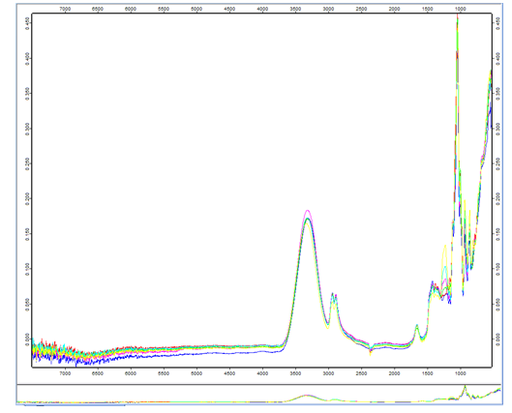
Fig. 1: Absorption spectra of sorption-catalytic materials in the IR region using the method of incomplete internal reflection

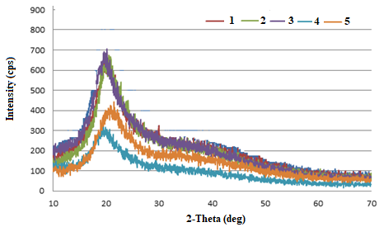
Fig. 2: Diffractograms of sorption-catalytic sample materials: 1 – sample No.1; 2 – sample No.2; 3 – sample No.3; 4 – sample No.4; 5 – sample No.5

Fig. 3: Crystallite size distribution in the sorption-catalytic sample materials: 1 – sample No.1; 2 – sample No.2; 3 – sample No.3; 4 – sample No.4; 5 – sample No.5

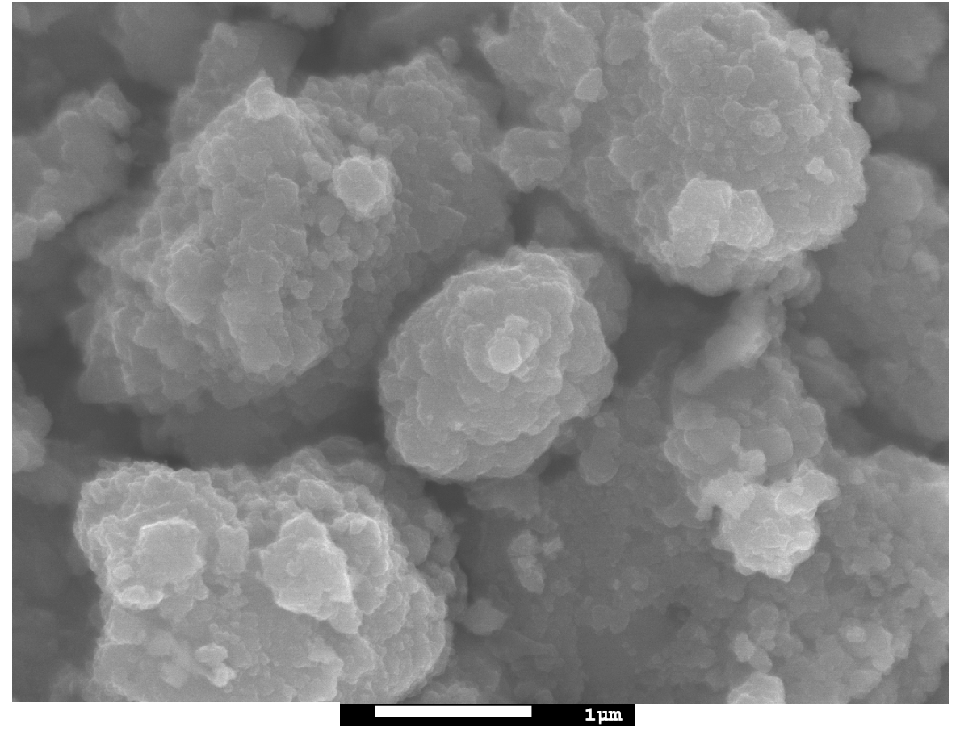(A) | 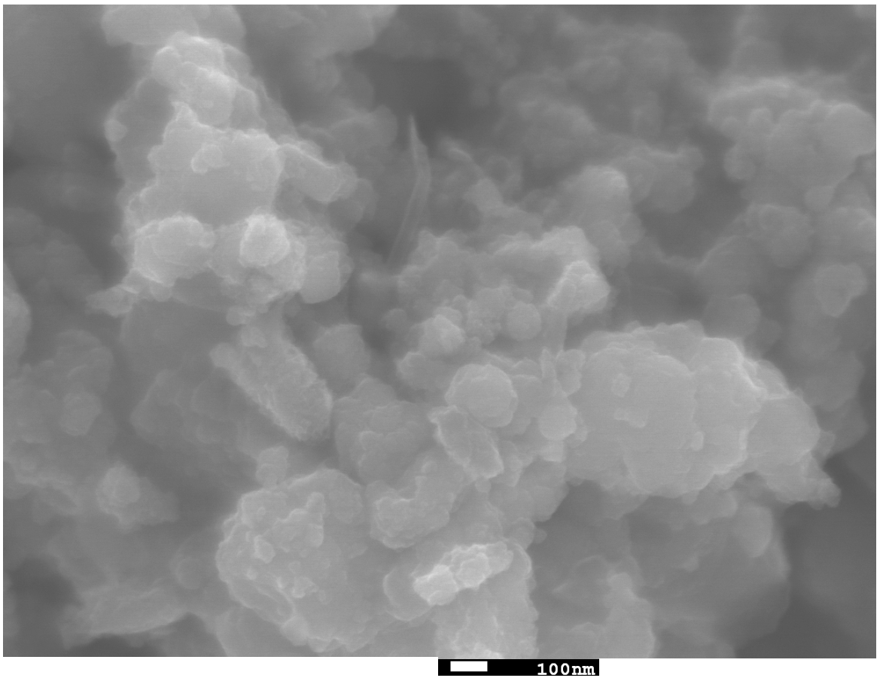(B)
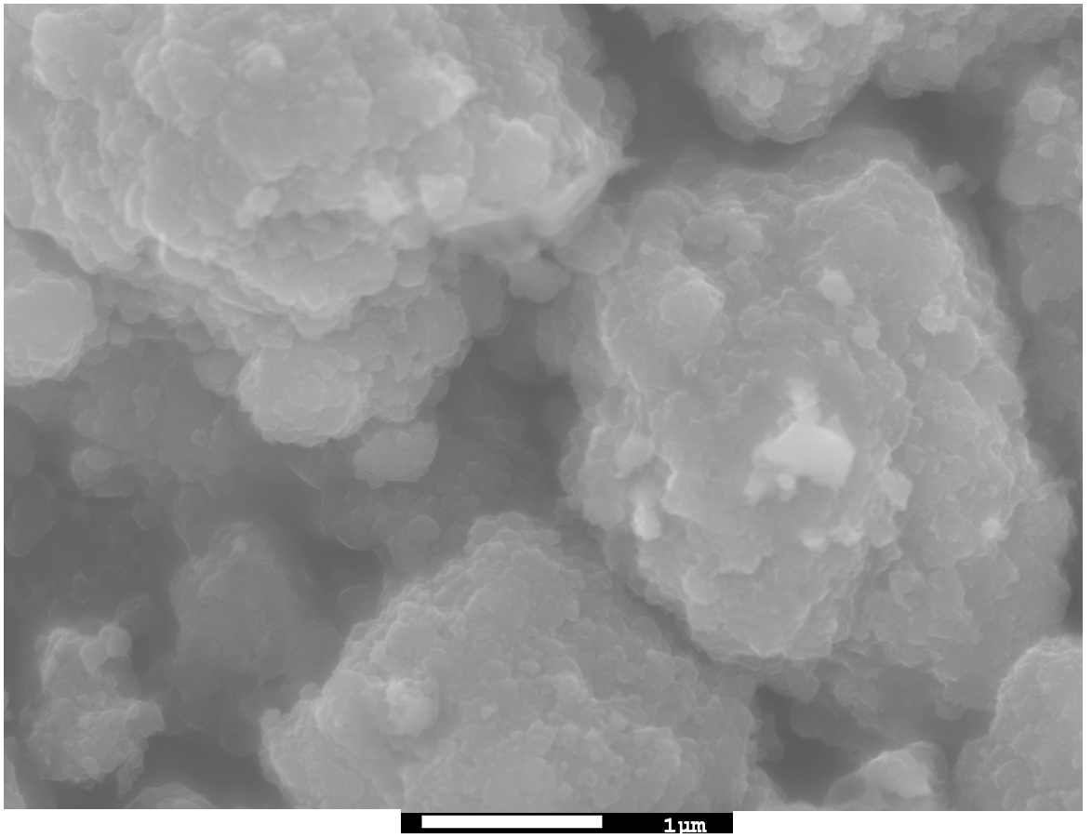 | 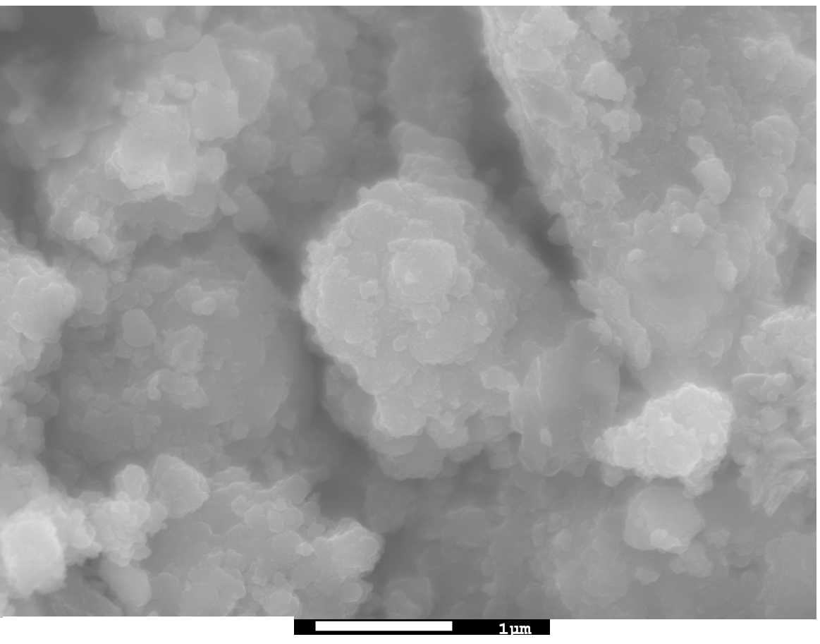
(C) | (D)
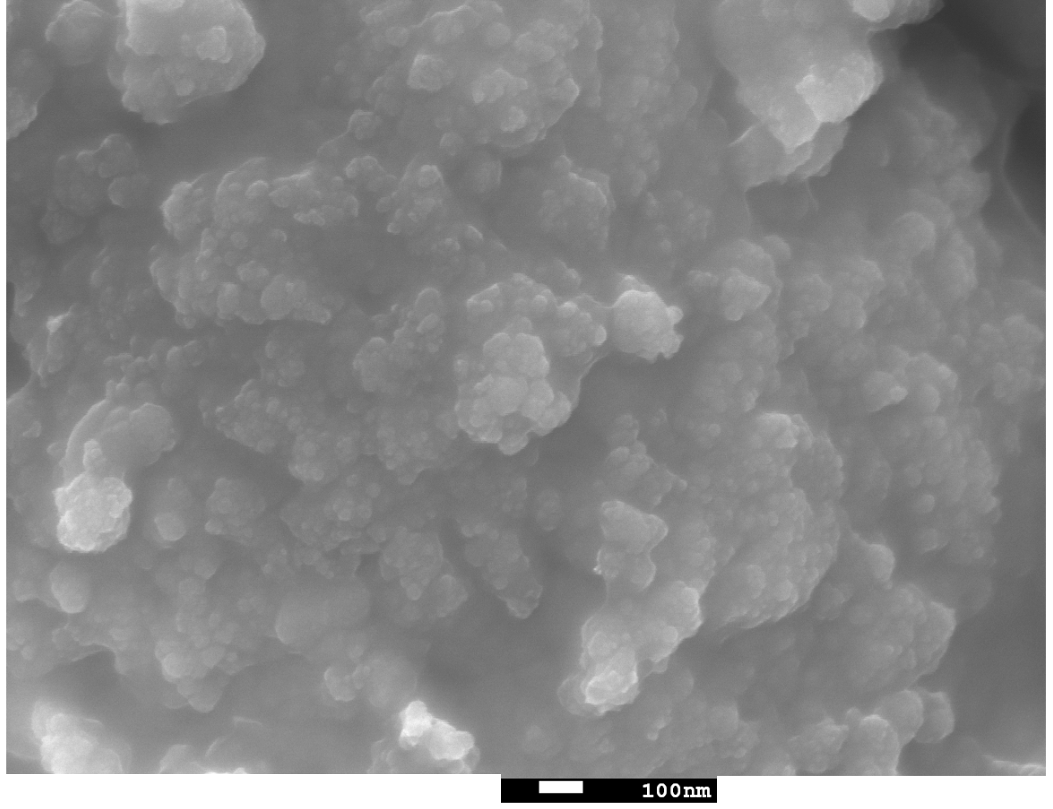
(E)
Fig. 4: Microphotographs of sorption-catalytic sample materials obtained by the SEM method (magnification ×20,000): (A) sample No. 1, (B) sample No. 2, (C) sample No. 3, (D) sample No. 4, (E) sample No. 5

Fig. 5: Kinetic curves of sorption of oil products (1), iron (2), copper (3), lead (4), manganese (5) and cadmium (6) ions on the sorption-catalytic material (sample No.1)

Fig. 6: Isotherm of oil products sorption with a sorption-catalytic material (sample No.1)

Fig. 7: Isotherm of iron (1), copper (2), lead (3), manganese (4), and cadmium (5) ions with a sorption-catalytic material (sample No. 1).

