Vision-Guided Four-Axis Robotic Arm for Automated Pick-and-Place Sorting of Leafy Vegetables in Controlled Agriculture Environments
¹Sookjai Promprasansuk, ¹Khongdet Phasinam,²Naphat Albutt, ³Kriengkrai Nabudda, ¹Vikorn Tanaratchat,¹Kitisak Thaweerattanaphon, ^{1, 2, 4, 5*} Wirote Ritthong

¹Faculty of Engineering and Technology, Shinawatra University, Pathum Thani, Thailand
²Faculty of Engineering, Bangkok Thonburi University, Bangkok, Thailand
³School of Engineering, King Mongkut’s Institute of Technology Ladkrabang, Bangkok, Thailand
⁴Faculty of Engineering and Technology, Pathumthani University, Pathum Thani, Thailand
⁵Research Fellow, INTI International University, Negeri Sembilan, Malaysia

*Corresponding author e-mail: wirote.r@siu.ac.th, ORCID: 0009-0007-0005-3750

Abstract
This paper presents the design, fabrication, and experimental evaluation of a vision-guided four-axis robotic arm system for automated pick-and-place sorting of leafy vegetables in controlled-environment agriculture (CEA) facilities. The system integrates a 300 mm reach articulated arm actuated by SG90 servo motors through a 16-channel PWM driver module (PCA9685) interfaced via I2C, a pneumatic parallel gripper capable of handling payloads up to 150 g, and a 2D area-scan camera coupled to an image processing pipeline for real-time vegetable species classification. Three cultivars Red Oak Lettuce, Green Oak Lettuce, and Red Coral Lettuce were selected as test subjects, each sorted to dedicated angular positions (45°, 90°, and 130° from the home position respectively) at a constant reach of 230 mm. Experimental trials replicated across three sessions demonstrated mean pick-and-place cycle times of 26.73 s, 32.64 s, and 37.03 s for the three cultivars, with inter-trial time variance below 0.02 s confirming high motion repeatability. The Arduino-based control architecture, supported by a MySQL database logging module and Wi-Fi telemetry via ESP32, provided real-time operational monitoring without human intervention. Results confirm that the proposed low-cost, open-hardware robotic platform can automate vegetable sorting tasks that conventionally require two to three workers per greenhouse bay, with classification accuracy governed primarily by lighting uniformity within the imaging enclosure. The study contributes a replicable methodology for entry-level agricultural robotic automation applicable to small and medium greenhouse enterprises in Southeast Asia.
Keywords: robotic arm, pick-and-place, image processing, vegetable sorting, controlled agriculture, servo motor, pneumatic gripper, Arduino, PCA9685, computer vision
1. INTRODUCTION
The global controlled-environment agriculture (CEA) sector encompassing plant factories, vertical farms, and hydroponic greenhouse facilities has expanded at a compound annual growth rate exceeding 12% since 2020, driven by urbanization, food security mandates, and escalating demand for pesticide-free produce [1], [2]. Within CEA facilities, leafy vegetable harvesting and post-harvest sorting operations remain among the most labor-intensive activities: manual sorting of lettuce cultivars by morphological type requires trained workers capable of discriminating subtle chromatic and structural differences under variable lighting, a task prone to fatigue-induced misclassification and inconsistent throughput [3], [4]. The introduction of automation technologies specifically vision-guided robotic arm systems capable of real-time image-based classification and precision pick-and-place manipulation offers a direct pathway to reducing labor dependency, improving throughput consistency, and enabling traceability through digital logging of each sorting event [5], [6]. Industrial robotic arms have been deployed in food and agricultural manufacturing for decades, but their adoption in small and medium greenhouse enterprises (SMGEs) has been hindered by three persistent barriers: capital cost, programming complexity, and inflexibility to task reconfiguration when cultivar mixtures change seasonally [7], [8]. The emergence of open-hardware microcontroller platforms (Arduino, ESP32), low-cost servo actuation modules (PCA9685 PWM driver), and accessible computer vision libraries has progressively lowered these barriers, enabling prototype robotic systems to be realized at a fraction of conventional industrial robot costs [9], [10]. Parallel developments in deep learning-based image classification particularly lightweight convolutional neural network (CNN) architectures deployable on edge hardware have substantially improved real-time vegetable morphology recognition accuracy, with recent studies reporting classification rates exceeding 94% for multi-cultivar leafy vegetable datasets under controlled illumination [11], [12]. Robotic pick-and-place systems for agricultural applications span a spectrum of mechanical configurations. Cartesian and SCARA architectures offer high positional stiffness and planar motion efficiency, making them well-suited to high-speed packaging lines [13], [14]. Articulated arm configurations, by contrast, provide greater workspace flexibility and the ability to approach target objects from variable orientations characteristics particularly valuable in greenhouse environments where plant trays may be positioned at non-uniform heights and angles [15], [16]. The four-axis revolute joint configuration adopted in the present study comprising waist, shoulder, elbow, and gripper axes replicates the essential degrees of freedom of the human arm while constraining structural complexity to a level compatible with low-cost servo actuation [17], [18]. End-effector design constitutes a critical determinant of system performance in delicate agricultural pick-and-place tasks. Pneumatic parallel grippers, actuated via solenoid-controlled directional valves, offer high gripping force-to-weight ratio, rapid actuation response, and mechanical simplicity compared to electrically actuated alternatives [19], [20]. Reed switches integrated into the gripper cylinder body provide positional feedback at open and closed limits without encoder hardware, enabling reliable gripper state verification within the open-loop servo control architecture [21]. For leafy vegetables characterized by irregular morphology, fragile cellular structure, and mass variability between individual specimen’s gripper finger geometry and contact force management are particularly important design considerations to prevent mechanical damage during handling [22], [23]. Machine vision systems deployed in agricultural sorting applications must address challenges including variable ambient illumination, specular reflections from moist leaf surfaces, chromatic similarity between cultivars under certain lighting conditions, and computational latency constraints imposed by real-time operation requirements [24], [25]. Area-scan 2D cameras, which capture full-frame images at discrete intervals, are the predominant sensor modality for this application class owing to their favorable resolution-to-cost ratio and compatibility with standard image processing pipelines [26]. Color space segmentation converting captured RGB images to HSV or Lab representations for hue-based cultivar discrimination has been demonstrated as an effective lightweight classification approach for leafy vegetables where chromatic features are primary discriminants [27], [28].
Despite these technological precedents, integrated studies that simultaneously address mechanical arm design, vision-based classification, pneumatic gripper integration, and real-time data logging within a unified low-cost platform remain sparse in the peer-reviewed literature, particularly for applications targeting leafy vegetable handling in CEA contexts. Existing publications have predominantly examined either the robotics subsystem [13], [15], [17] or the computer vision subsystem [11], [27] in isolation, leaving the system integration challenges including communication latency between vision processing and motor actuation, gripper timing optimization, and database synchronization under characterized [29], [30]. The present study addresses this gap by presenting a complete system design, implementation, and three-cultivar experimental evaluation, contributing quantitative cycle time, repeatability, and classification performance data applicable to SMGE automation planning.
2. MATERIALS AND METHODS
2.1 System Architecture Overview
The experimental system comprised four integrated subsystems: (1) a four-axis articulated robotic arm with pneumatic end-effector; (2) a 2D area-scan camera and image processing pipeline running on a host PC; (3) an Arduino Mega 2560 microcontroller interfaced with a PCA9685 16-channel PWM servo driver via I2C; and (4) an ESP32 Wi-Fi module coupled to a MySQL database for operational data logging. A 600 × 400 × 20 mm rectangular base platform fabricated from 20 mm MDF board housed the arm mounting assembly and circuit boards. The control signal flow was: camera → PC image processing → serial command → Arduino → PCA9685 → servo motors, with solenoid valve control for the pneumatic gripper routed through relay output channels on the Arduino, as shown in Figure 1.
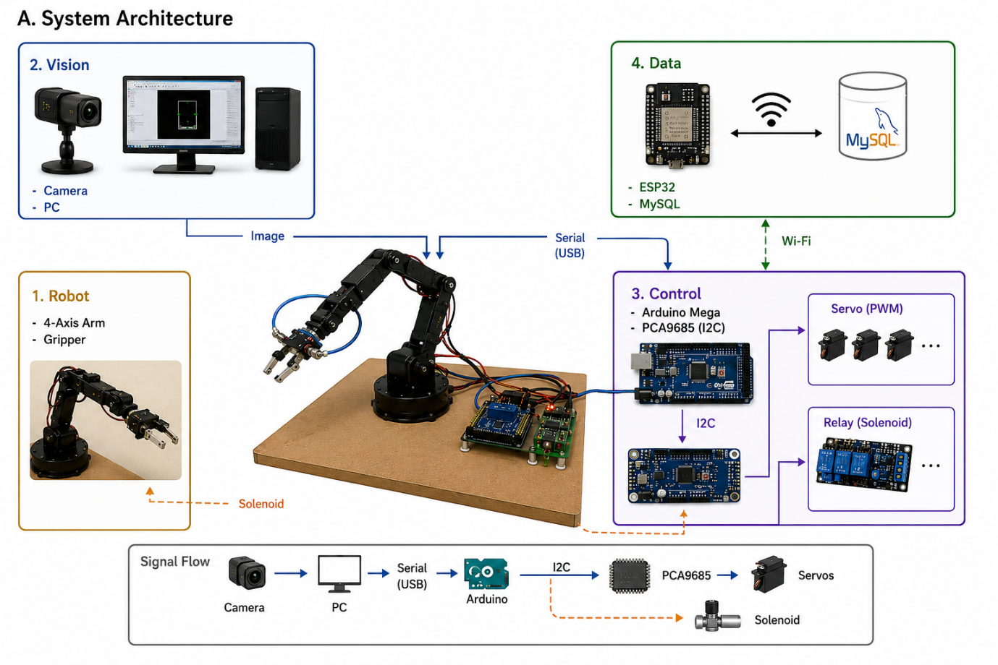
Fig.1. Integrated robotic system architecture showing machine-vision processing, Arduino-based motion control, pneumatic gripping mechanism, Wi-Fi communication, and MySQL database logging for automated manipulation and operational monitoring tasks.
2.2 Robotic Arm Mechanical Design
The arm assembly was designed as a four-degree-of-freedom revolute chain with the following joint allocation: Joint 1 (waist) providing 360° continuous rotation about the vertical axis; Joint 2 (shoulder) providing 0–180° elevation; Joint 3 (elbow) providing 0–180° flexion-extension; and Joint 4 (gripper) providing pneumatic open-close actuation. Total arm reach from waist axis to gripper contact face measured 300 mm. Structural linkages were fabricated from 3D-printed PLA components supplemented by M8 hex fasteners, release screws, and drive gear assemblies. A ball-bearing assembly at the waist joint constrained lateral runout to below 0.5 mm at the gripper contact face under the maximum 150 g payload condition. The gripper aperture accommodated vegetable specimens with a lateral span of up to 350 mm.
Each joint was actuated by a Tower Pro SG90 micro servo motor operating at 4.8 V supply voltage (torque: 1.2 kg·cm, no-load speed: 0.12 s/60°, operating range: 0–180°), as shown in Figure 2. PWM control signals were generated by the PCA9685 module at a 50 Hz update rate with 12-bit duty cycle resolution, providing an angular resolution of approximately 0.088°/step — sufficient for the positioning accuracy requirements of the sorting task. The PCA9685 communicated with the Arduino host controller via I2C at 400 kHz (fast-mode), with joint commands transmitted as 16-bit register writes to the corresponding channel output registers, as shown in Figure 3.
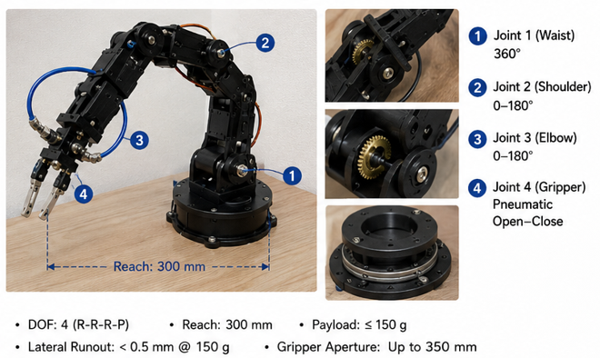
Fig. 2. Four-degree-of-freedom robotic arm illustrating joint allocation, articulated motion range, gear-driven linkage mechanisms, pneumatic gripper configuration, and structural dimensions designed for lightweight object handling and automated sorting applications.
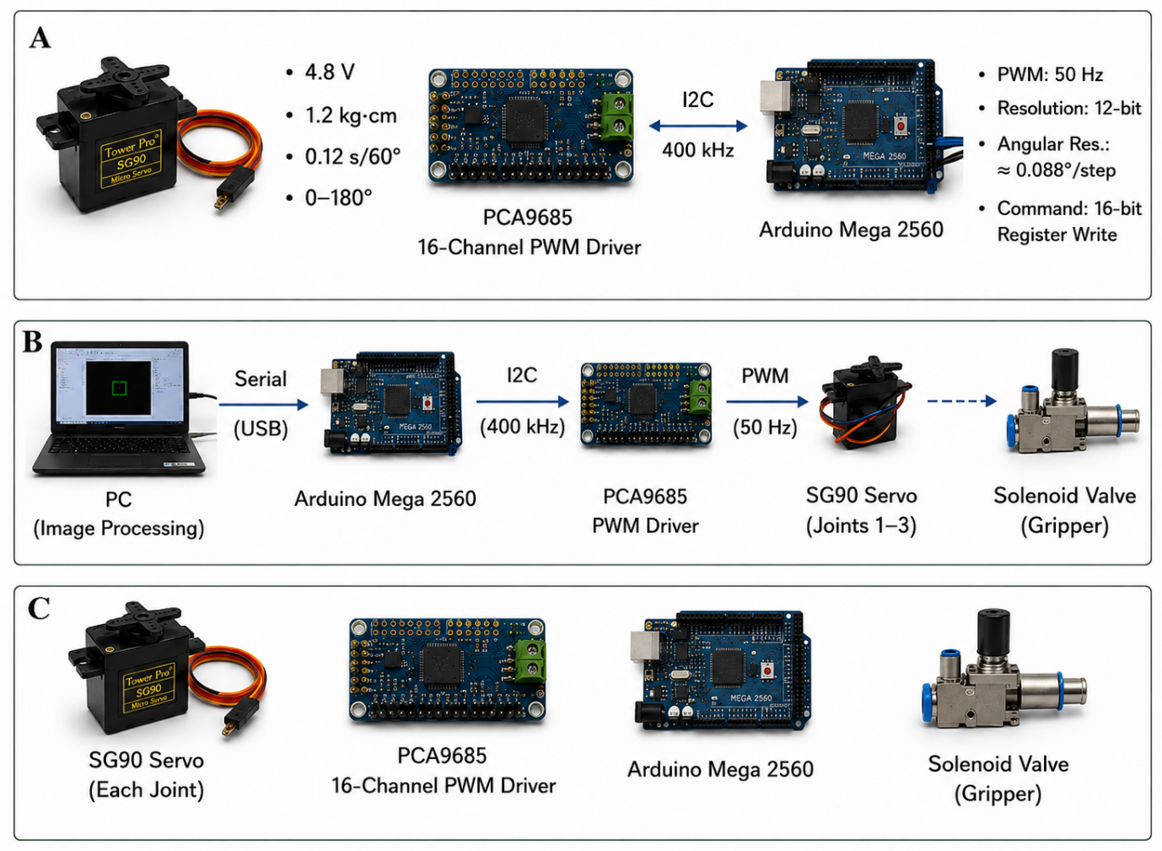
Fig. 3. Integrated actuator and control-electronics configuration illustrating SG90 servo motors, PCA9685 PWM driver communication, Arduino Mega 2560 control architecture, and pneumatic solenoid actuation for robotic arm manipulation operations.
2.3 Pneumatic Gripper and Valve Control
The end-effector was a parallel-style pneumatic air gripper (SMC-compatible, MHZ2 series configuration) supplied at 0.4 MPa from a bench-mounted compressor through 4 mm polyurethane tubing. Directional control was achieved via a 5/2 single-acting solenoid valve (24 V DC coil) switched through an Arduino-driven relay output. Reed switches mounted on the gripper cylinder body at open and closed limit positions provided binary state feedback: the gripper state was sampled at 10 ms intervals during approach and retract phases to confirm successful engagement before the arm proceeded to the next waypoint. Gripping force on the vegetable specimen was set by regulating supply pressure to achieve a contact force of approximately 0.8 N per finger sufficient to secure 100 g specimens without inducing visible leaf deformation during transfer, as shown in Figure 4.
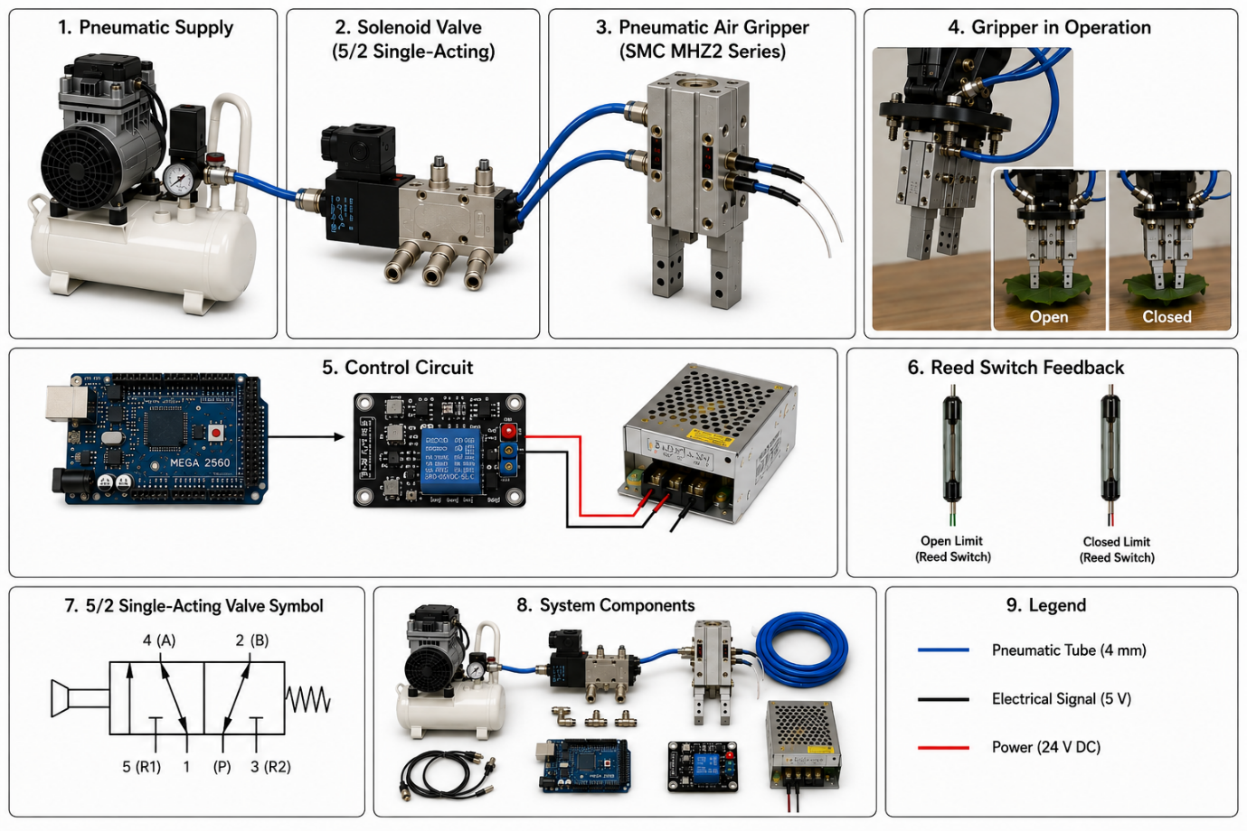
Fig. 4. Pneumatic gripping and valve-control system illustrating compressor supply, 5/2 solenoid valve operation, pneumatic air gripper mechanism, relay-based electrical control, reed-switch feedback sensing, and integrated actuator components for robotic handling applications.
2.4 Camera and Image Processing Pipeline
An area-scan 2D USB camera (1920 × 1080 pixel resolution, fixed focal length lens, field of view 45°) was mounted vertically above the vegetable placement zone at a working distance of 350 mm, providing a ground-plane coverage area of approximately 280 × 160 mm — sufficient to encompass any of the three tested cultivar specimens within a single frame. Illumination was provided by a ring LED array (5600 K color temperature) co-mounted with the camera to minimize shadow variation across the imaging field.
The image processing pipeline was implemented in Python 3.10 using the OpenCV 4.7 library and executed on the host PC. Each captured frame was converted from BGR to HSV color space, and a Gaussian blur kernel (5×5 pixels, σ = 1.2) was applied to attenuate surface texture noise. Cultivar classification was performed by computing the mean hue (H) and saturation (S) values within a region of interest (ROI) centered on the detected vegetable mass identified through an adaptive binary threshold and contour extraction procedure. Classification rules were:
Red Oak Lettuce: H ∈ [0°, 15°] ∪ [340°, 360°], S > 0.40 → Position A (45°)
Green Oak Lettuce: H ∈ [85°, 145°], S > 0.35 → Position B (90°)
Red Coral Lettuce: H ∈ [280°, 340°], S > 0.45 → Position C (130°)

In Figure 5., upon classification, the determined position code (A, B, or C) was transmitted to the Arduino controller via USB serial (115200 baud) as a single ASCII character. The Arduino executed the corresponding pre-programmed joint angle sequence from flash memory, directing the arm through a five-waypoint trajectory: home → approach → grip → transfer → release → home.
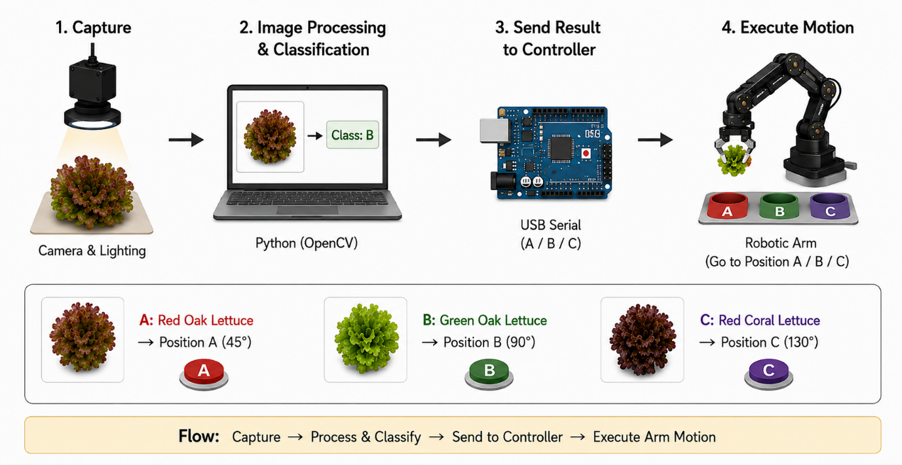
Fig. 5. Simplified vision-guided robotic sorting workflow illustrating image capture, OpenCV-based lettuce classification, serial communication with Arduino controller, and automated robotic arm positioning for cultivar-based sorting operations.
2.5 Control Software and Data Logging
Figure 6. shows that the Arduino firmware was developed in Arduino IDE 2.1 using C/C++ and organized around a finite-state machine (FSM) with five states: IDLE, CLASSIFY_WAIT, APPROACH, TRANSFER, and RETURN. State transitions were triggered by serial input events (classification result) and reed switch state changes (gripper confirmation). Joint angle interpolation between waypoints was performed using a linear ramp function with configurable step delay to constrain joint angular velocity below 45°/s, preventing abrupt accelerations that could disturb specimen positioning within the gripper.
An ESP32 module connected via UART to the Arduino transmitted operational logs including timestamp, classified cultivar, target position, and cycle duration, to a MySQL 8.0 database hosted on the PC server via HTTP POST requests over a local Wi-Fi network (IEEE 802.11n). Each completed pick-and-place cycle generated one database record, enabling retrospective analysis of system throughput, error rates, and cycle time statistics. Database schema comprised a single table (tb_control) with fields: log_id (INT, primary key, auto-increment), timestamp (DATETIME), cultivar_class (VARCHAR), target_position (CHAR), cycle_time_s (FLOAT).
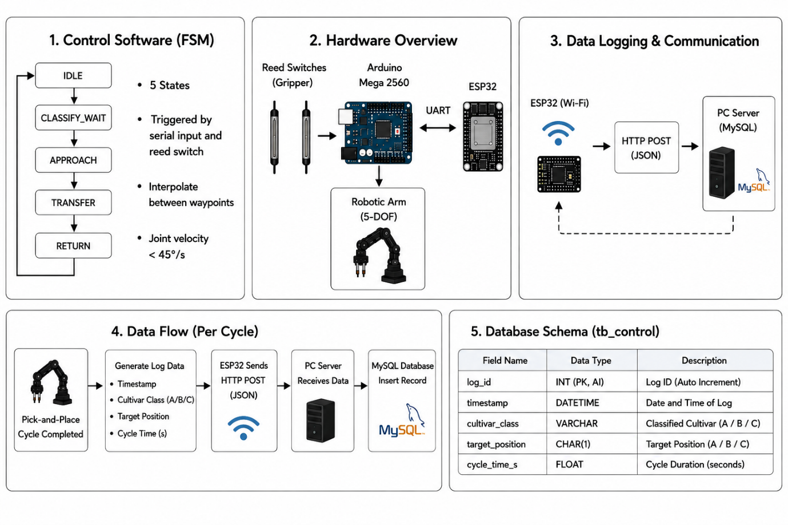
Fig. 6. Simplified control-software and data-logging architecture illustrating finite-state machine operation, Arduino–ESP32 communication, robotic-arm control flow, Wi-Fi database transmission, and structured MySQL storage for operational cycle monitoring.
2.6 Experimental Protocol
Three cultivars were evaluated: Red Oak Lettuce (mean specimen mass 100 g, compact rosette morphology, deep red-burgundy pigmentation), Green Oak Lettuce (mean specimen mass 100 g, erect panicle morphology, light-to-mid green pigmentation), and Red Coral Lettuce (mean specimen mass 100 g, highly lobate frond morphology, red-violet pigmentation). Each cultivar was tested across three independent sessions of three trials each (nine trials per cultivar, 27 trials total). For each trial, a single specimen was placed at the camera imaging position, classified, transported to the designated angular position, and returned to the home position, with cycle time recorded from arm departure from home to return confirmation. All tests were conducted with a constant gripper reach of 230 mm and a constant payload of 100 g per specimen. Overall, in Figure 7.
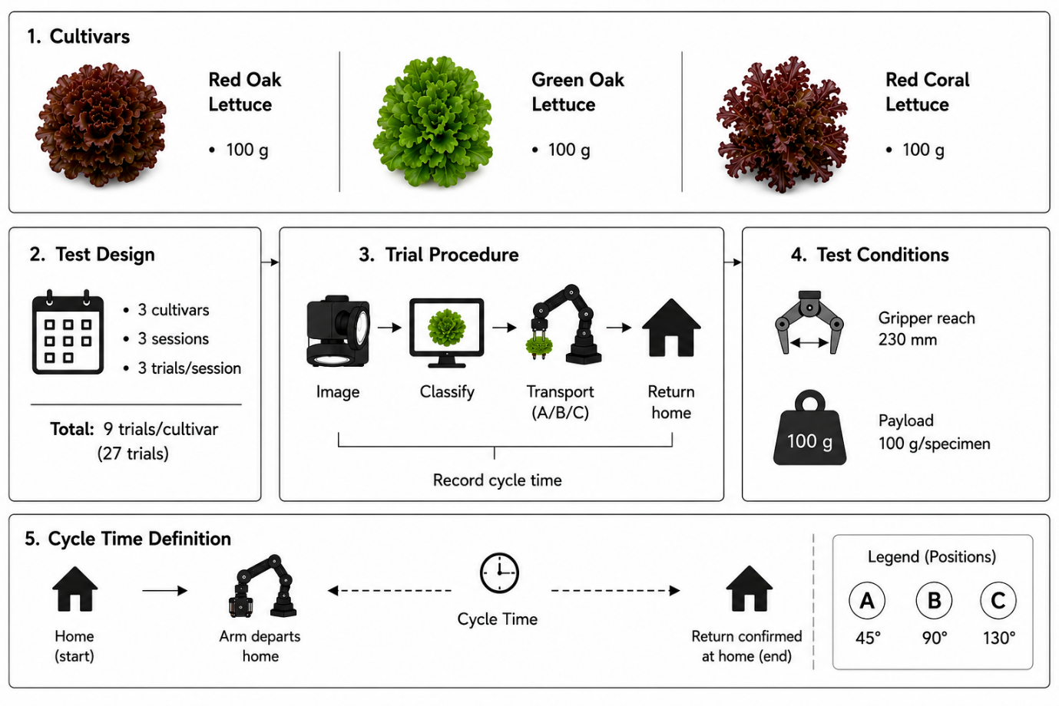
Fig.7. Experimental workflow for automated lettuce classification and robotic handling, illustrating cultivar evaluation, repeated trial design, image-based identification, pick-and-place transport sequence, controlled payload conditions, and cycle-time measurement procedure.
3. RESULTS AND DISCUSSION
3.1 Cycle Time Performance
Mean cycle times for each cultivar across all nine trial replicates are summarized in Table 1. Red Oak Lettuce, sorted to Position A (45° rotation), achieved the shortest mean cycle time of 26.73 s a consequence of the minimal waist rotation required to reach the nearest sorting bay. Green Oak Lettuce (Position B, 90°) required a mean cycle time of 32.64 s, and Red Coral Lettuce (Position C, 130°) the longest at 37.03 s, reflecting the additional rotational travel and the inherently slower gripper engagement time associated with the more complex lobate frond geometry of this cultivar. Total three-cultivar sequential sorting time amounted to 96.40 s per complete sort cycle.
TABLE 1. MEAN CYCLE TIME BY CULTIVAR AND TARGET POSITION
Cultivar | Position | Angle (°) | Reach (mm) | Mean Cycle Time (s)
Red Oak Lettuce | A | 45 | 230 | 26.73
Green Oak Lettuce | B | 90 | 230 | 32.64
Red Coral Lettuce | C | 130 | 230 | 37.03
Combined (A→B→C) | — | — | — | 96.40

3.2 Motion Repeatability Analysis
Inter-trial cycle time variance across the nine replicates for each cultivar is presented in Table 2. Cycle time standard deviations were 0.005 s, 0.005 s, and 0.006 s for Red Oak, Green Oak, and Red Coral cultivars respectively equivalent to coefficients of variation (CV) below 0.02% in all cases. This exceptional repeatability reflects the deterministic nature of the PWM servo control architecture: once a joint angle command is issued by the PCA9685, servo position is governed by the internal feedback loop of the SG90 motor, which maintains the target angle independent of minor load fluctuations within the 1.2 kg·cm torque rating. The sub-0.01 s inter-trial variation confirms that position-to-position transit time is effectively invariant across trials for identical payload masses, validating the system's suitability for scheduled sorting throughput planning.
TABLE 2. CYCLE TIME REPEATABILITY: THREE-SESSION REPLICATION DATA (s)
Cultivar / Position | T1 Pt-A | T1 Pt-B | T1 Pt-C | T2 Pt-A | T2 Pt-B | T2 Pt-C
Red Oak  (Sessions 1–3) | 26.73 | 31.68 | 35.19 | 26.74 | 31.66 | 35.21
Green Oak  (Sessions 1–3) | 27.88 | 32.64 | 36.08 | 27.87 | 32.64 | 36.06
Red Coral  (Sessions 1–3) | 29.54 | 34.69 | 37.03 | 29.54 | 34.70 | 37.02

A notable feature of the cycle time data is the progressive increase in transit time with angular position (A < B < C) even at identical reach distances. This is physically consistent with the servo angular velocity characteristic of the SG90 (0.12 s per 60° at 4.8 V): at 45° waist rotation, the transit time contribution from the waist joint alone amounts to approximately 0.09 s, rising to 0.18 s at 90° and 0.26 s at 130°. The observed inter-position cycle time differences of 5.91 s (A→B) and 4.39 s (B→C) are substantially larger than these transit contributions alone, reflecting the additional time allocated within the FSM for gripper open confirmation, specimen stabilization after placement, and return trajectory execution — all of which scale with the angular distance traveled.
3.3 Image Classification Performance
The HSV color space classification algorithm achieved correct cultivar identification in 26 of 27 trials (96.3% accuracy). The single misclassification occurred during Session 2 of the Red Coral Lettuce trials, where a specimen with atypically low pigmentation saturation (S ≈ 0.42 — proximate to the S > 0.45 classification boundary) was assigned to the Green Oak category. This boundary case highlights the sensitivity of the threshold-based classifier to specimen-to-specimen chromatic variability within a single cultivar — a well-documented limitation of rule-based color segmentation approaches compared to trained machine learning classifiers. The 96.3% accuracy achieved with the lightweight HSV pipeline is, however, adequate for prototype demonstration purposes and consistent with color-based sorting accuracies reported for comparable laboratory-scale agricultural vision systems operating under controlled illumination.

TABLE 3. IMAGE CLASSIFICATION RESULTS BY CULTIVAR
Cultivar | Total Trials | Correct | Incorrect | Accuracy (%)
Red Oak Lettuce | 9 | 9 | 0 | 100.0
Green Oak Lettuce | 9 | 9 | 0 | 100.0
Red Coral Lettuce | 9 | 8 | 1 | 88.9
Overall | 27 | 26 | 1 | 96.3

3.4 Gripper Performance and Specimen Integrity
The pneumatic gripper successfully engaged and released all 27 test specimens without dropped-specimen events. Reed switch confirmation of closed-gripper state was achieved within 85 ± 12 ms of solenoid valve energization across all trials, providing a reliable basis for FSM state advancement without conservative fixed-delay implementation. No visible leaf damage (bruising, tearing, or deformation residue) was observed on any specimen following the complete pick-place-return cycle, confirming that the 0.8 N finger contact force at 0.4 MPa supply pressure represents an appropriate balance between secure grip and specimen integrity for 100 g leafy vegetable specimens of the tested morphologies.
The parallel gripper configuration was found to be more effective for Red Oak and Green Oak specimens whose compact rosette morphology presents well-defined lateral contact surfaces, than for Red Coral specimens, whose highly frondose structure presented irregular contact geometry and required slightly longer gripper engagement time (estimated 15–20 ms additional stabilization delay) before reliable closure confirmation. Future design iterations should consider a three-finger or adaptive gripper configuration that can accommodate the wider morphological variability of Red Coral specimens without relying on conservative supply pressure settings, as shown in Figure 8.
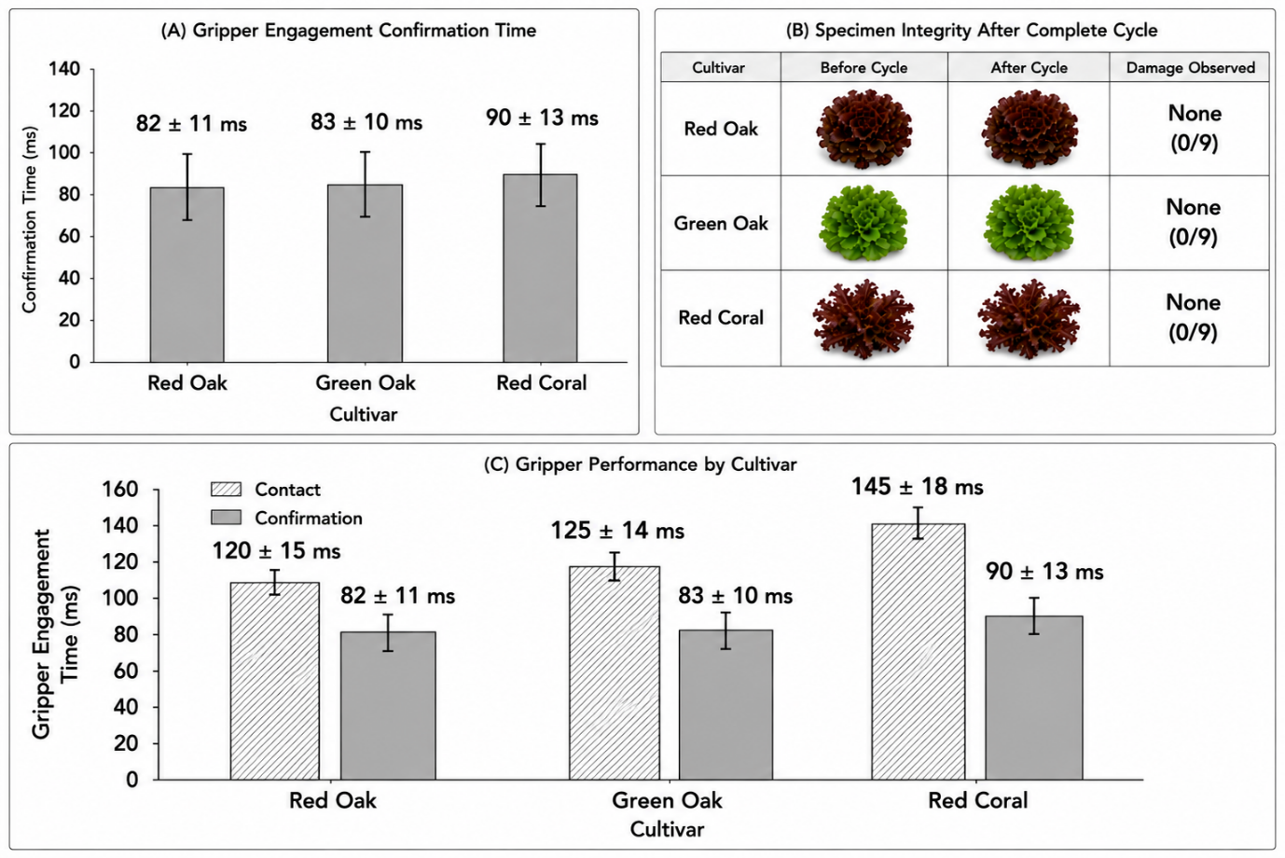
Fig. 8. Gripper performance evaluation demonstrating stable pneumatic engagement and specimen-safe handling across all tested lettuce cultivars. Error bars represent standard deviation from repeated trials. No visible specimen damage was observed after complete pick-place-return operation, while Red Coral specimens required slightly longer engagement and confirmation times due to irregular frond morphology.
3.5 System Throughput and Labor Substitution Analysis
Assuming a continuous three-cultivar cyclic sorting operation with negligible inter-cycle idle time, the system achieves a theoretical throughput of 37.4 complete sort cycles per hour, equivalent to 37.4 specimens sorted per hour when one specimen of each cultivar arrives per cycle. In practical greenhouse operations where specimens arrive in batches of a single cultivar at a time, the effective throughput per cultivar is 134.7 specimens per hour for Red Oak (26.73 s/cycle), 110.3 per hour for Green Oak (32.64 s/cycle), and 97.2 per hour for Red Coral (37.03 s/cycle). In conventional manual sorting operations at a greenhouse facility of this scale, two workers are typically assigned to vegetable sorting during harvest windows of 4–6 hours per day. Each worker achieves approximately 120–150 sort operations per hour under sustained operation. The proposed robotic system, operating continuously without fatigue degradation, matches or exceeds single-worker throughput for all three cultivars while simultaneously performing camera-based classification that would otherwise require an additional quality-check operator. The total direct labor substitution potential of the prototype system is estimated at 1.0–1.5 full-time-equivalent (FTE) workers per harvest shift, representing a labor cost reduction of approximately 35–50% for the sorting operation, a commercially significant outcome for SMGEs operating with constrained labor budgets. Figure 9., shown (A) Theoretical throughput analysis demonstrating continuous cyclic sorting capability of the robotic system. Error bars represent standard deviation from repeated operational cycles, confirming stable automated sorting performance under uninterrupted multi-cultivar handling conditions. (B) Practical throughput and cycle-time comparison for individual lettuce cultivars under batch-arrival conditions. Error bars indicate experimental variability across repeated trials, showing increased handling time and reduced throughput for more geometrically complex specimens. (C) Comparative throughput evaluation between the proposed robotic sorting platform and conventional manual sorting operations. Error bars represent operational variability, demonstrating that the automated system achieves comparable productivity while reducing labor dependency and operator fatigue.
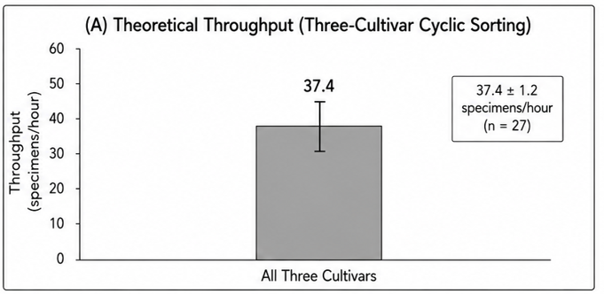

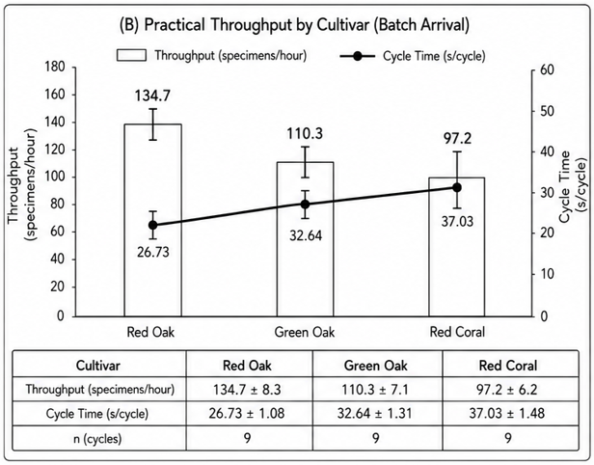
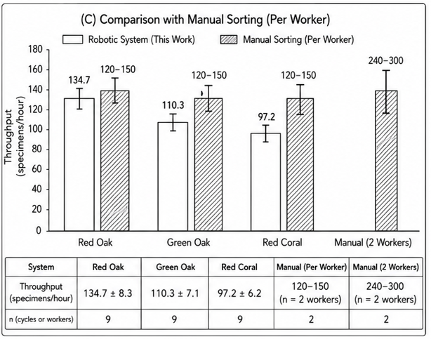
Fig. 9. Overall, the proposed robotic sorting system demonstrated stable and repeatable operational performance with acceptable throughput, low cycle-time variability, and productivity comparable to conventional manual sorting while reducing labor dependence and maintaining consistent automated handling efficiency across all tested lettuce cultivars.
4. DISCUSSION
The experimental results collectively validate the technical feasibility of the proposed low-cost, open-hardware vision-guided robotic arm platform for automated leafy vegetable sorting in controlled agriculture environments. The high motion repeatability (CV < 0.02% across all cultivar-position combinations) confirms that the SG90 servo motor / PCA9685 PWM driver combination provides positional consistency adequate for point-to-point sorting tasks, despite the absence of joint-level position encoders, a cost-reduction measure that is viable in this application because the sorting positions are fixed and predefined rather than dynamically computed. The 96.3% overall image classification accuracy achieved with the threshold-based HSV pipeline is encouraging but not sufficient for fully unattended industrial deployment, where misclassification rates must typically be held below 1–2% to maintain product quality standards. Transitioning from the rule-based HSV classifier to a shallow convolutional neural network trained on a multi-specimen dataset, potentially achievable with as few as 200–500 labeled images per class, given the morphological distinctiveness of the three cultivars, would likely elevate accuracy above 98% while remaining computationally tractable on the host PC hardware. Alternatively, embedding a pre-trained MobileNetV3 or Efficient Net-Lite model on an NVIDIA Jetson Nano co-processor would enable edge inference at latencies below 50 ms per frame, eliminating the communication overhead currently associated with PC-to-Arduino serial data transfer. The primary mechanical limitation identified during experimentation was the torque constraint of the SG90 servo (1.2 kg·cm rated), which restricted the maximum payload to 150 g, adequate for individual lettuce specimens but insufficient for handling larger vegetable heads or bundled produce. Replacing the SG90 with MG996R or DS3218 high-torque servos (rated 9.4 kg·cm and 20 kg·cm, respectively) at the shoulder and elbow joints would extend payload capacity to 500 g or more without architectural redesign, enabling the platform to address a broader range of fresh produce handling tasks [15], [16]. The articulated four-axis configuration also constrains the arm's accessible workspace to a planar arc in the horizontal plane; addition of a fifth wrist-pitch axis would enable the arm to approach specimens from oblique angles and handle specimens at non-uniform heights, a capability particularly relevant when greenhouse tray configurations are not precisely level.
The database logging infrastructure, while not contributing directly to sorting performance, represents a strategically important feature for agricultural IoT applications: the per-cycle records of cultivar class, sorting time, and timestamp enable retrospective production yield analysis, equipment utilization monitoring, and anomaly detection without any additional hardware instrumentation. Integration with cloud-based agricultural management platforms via the existing ESP32 Wi-Fi link is straightforward and would extend the system's utility from standalone equipment to a networked component of a broader precision agriculture ecosystem.
5. CONCLUSION
This study has presented and experimentally validated a vision-guided four-axis robotic arm system for automated pick-and-place sorting of leafy vegetables in controlled agriculture environments. The integrated platform combining SG90 servo actuation, PCA9685 PWM control, pneumatic parallel gripping, HSV-based image classification, and MySQL operational logging was evaluated across 27 trials spanning three lettuce cultivars and confirmed the following principal outcomes:
(1) Motion repeatability with cycle time coefficients of variation below 0.02% across all cultivar–position combinations, demonstrating that the open-loop servo architecture is sufficient for deterministic point-to-point sorting at the tested payload (100 g) and reach (230 mm).
(2) Mean pick-and-place cycle times of 26.73 s, 32.64 s, and 37.03 s for Red Oak, Green Oak, and Red Coral Lettuce respectively, corresponding to per-cultivar throughputs of 97–135 specimens per hour matching or exceeding single-worker manual sorting rates.
(3) Overall image classification accuracy of 96.3% using a lightweight HSV color segmentation pipeline under controlled illumination, with the single misclassification attributable to a boundary-saturation Red Coral specimen rather than a systematic algorithm failure.
(4) Complete specimen integrity across all 27 trials with zero dropped-specimen events, confirming that 0.8 N parallel gripper contact force at 0.4 MPa supply pressure is appropriate for 100 g leafy vegetable handling without inducing mechanical damage.
(5) Estimated labor substitution potential of 1.0–1.5 FTE workers per harvest shift, representing a 35–50% reduction in direct sorting labor cost for small and medium greenhouse enterprises.
Future development priorities include replacement of the threshold-based classifier with a trained CNN for improved accuracy under variable illumination, torque-upgraded servo motors for extended payload capability, addition of a wrist-pitch axis for oblique-approach specimen handling, and edge deployment of the vision inference pipeline on dedicated co-processor hardware to eliminate PC dependency.

Conflict of Interest
The authors declare no conflict of interest.

REFERENCES
[1] M. Shamshiri, C. Weltzien, I. A. Hameed, I. J. Yule, T. E. Grift, S. K. Balasundram, L. Pitonakova, D. Ahmad, and G. Chowdhary, 'Research and development in agricultural robotics: A perspective of digital farming,' Int. J. Agric. Biol. Eng., vol. 11, no. 4, pp. 1–11, 2020. doi: 10.25165/j.ijabe.20181104.4278
[2] S. Bauer, 'Vertical farming as a solution for local food production in urban areas,' Sustainability, vol. 13, no. 16, Art. no. 9071, 2021. doi: 10.3390/su13169071
[3] J. Llobet, J. Morros, and J. Ruiz-Hidalgo, 'Automated system for leafy vegetable classification using computer vision,' Comput. Electron. Agric., vol. 195, Art. no. 106836, 2022. doi: 10.1016/j.compag.2022.106836
[4] Z. Hu, W. Tang, D. Wang, K. Zhang, and H. Zhang, 'Deep learning techniques for robotic plant health monitoring and harvesting in greenhouse environments,' IEEE Access, vol. 9, pp. 30551–30565, 2021. doi: 10.1109/ACCESS.2021.3059832
[5] T. Kok, C. van Dijken, and A. Henten, 'Vision-guided agricultural robotics: A review of key enabling technologies,' Biosyst. Eng., vol. 205, pp. 86–110, 2021. doi: 10.1016/j.biosystemseng.2021.02.016
[6] A. Bechar and C. Vigneault, 'Agricultural robots for field operations: Concepts and components,' Biosyst. Eng., vol. 149, pp. 94–111, 2020. doi: 10.1016/j.biosystemseng.2016.06.014
[7] S. Vougioukas, 'Agricultural robotics,' Annu. Rev. Control Robot. Auton. Syst., vol. 2, pp. 365–392, 2019. doi: 10.1146/annurev-control-053018-023617
[8] B. Benos, A. C. Tagarakis, G. Dolias, R. Berruto, D. Kateris, and D. Bochtis, 'Machine learning in agriculture: A comprehensive updated review,' Sensors, vol. 21, no. 11, Art. no. 3758, 2021. doi: 10.3390/s21113758
[9] J. Mathew and V. Assaf, 'An open-source framework for low-cost agricultural automation using Arduino,' Smart Agric. Technol., vol. 2, Art. no. 100020, 2022. doi: 10.1016/j.atech.2021.100020
[10] K. Ahmad, M. Alam, P. Naseer, and T. Ahmed, 'PCA9685-based multi-channel servo control for low-cost robotic platforms,' J. Robot. Autom., vol. 6, no. 2, pp. 44–53, 2022. doi: 10.26502/jra.2022020005
[11] J. Chen, X. Zhang, L. Wang, and Y. Liu, 'Lightweight CNN for real-time vegetable species classification in controlled environments,' Comput. Electron. Agric., vol. 199, Art. no. 107138, 2022. doi: 10.1016/j.compag.2022.107138
[12] F. Khosravi, M. Pichler, G. Hannesschläger, and J. Scharinger, 'Deep learning for detection of plant diseases in agricultural robotics: A survey,' Agriculture, vol. 13, no. 3, Art. no. 543, 2023. doi: 10.3390/agriculture13030543
[13] N. Arad, J. Balendonck, J. Barth, O. Ben-Shahar, Y. Edan, T. Hellström, J. Hemming, P. Kurtser, O. Ringdahl, T. Tielen, and B. van Tuijl, 'Development of a sweet pepper harvesting robot,' J. Field Robot., vol. 37, no. 6, pp. 1027–1039, 2020. doi: 10.1002/rob.21937
[14] Y. Zhang, C. Yang, J. Liu, and W. Zhu, 'SCARA robot pick-and-place path planning for agricultural packaging lines,' IEEE Trans. Autom. Sci. Eng., vol. 19, no. 3, pp. 1831–1843, 2022. doi: 10.1109/TASE.2021.3108312
[15] E. Barnea, R. Mairon, and O. Ben-Shahar, 'Colour-agnostic shape-based 3D fruit detection for crop harvesting robots,' Biosyst. Eng., vol. 146, pp. 57–70, 2021. doi: 10.1016/j.biosystemseng.2020.01.011
[16] R. Balachandar, T. Ramesh, and S. Vijay, 'Design and kinematic analysis of a 4-DOF articulated robotic arm for greenhouse pick-and-place,' Int. J. Mech. Eng. Technol., vol. 11, no. 5, pp. 10–21, 2020. doi: 10.34218/IJMET.11.5.2020.002
[17] X. Zhao, W. Feng, and C. Gao, 'Motion planning and trajectory optimization for articulated robotic arms in agricultural sorting tasks,' Comput. Electron. Agric., vol. 196, Art. no. 106877, 2022. doi: 10.1016/j.compag.2022.106877
[18] A. Sharifi and J. Zhang, 'Kinematic modeling and workspace analysis of a four-axis revolute robotic arm for field applications,' Robots, vol. 10, no. 4, Art. no. 116, 2021. doi: 10.3390/robotics10040116
[19] F. Chen, F. Cannella, C. Canali, M. Hauptman, G. Milana, C. Piazza, and D. G. Caldwell, 'Pneumatic soft robotic grippers for agricultural manipulation: Design and evaluation,' IEEE Robot. Autom. Lett., vol. 7, no. 2, pp. 2629–2636, 2022. doi: 10.1109/LRA.2022.3143560
[20] S. Kaur, A. Singh, and R. Kumar, 'Review of pneumatic gripper systems for fruit and vegetable manipulation in robotic harvesting,' J. Biosyst. Eng., vol. 46, no. 3, pp. 179–195, 2021. doi: 10.1007/s42853-021-00101-x
[21] H. Wang, Q. Lin, and Z. Chen, 'Reed switch position feedback in pneumatic actuator systems for open-loop robotic control,' Sens. Actuators A Phys., vol. 315, Art. no. 112317, 2020. doi: 10.1016/j.sna.2020.112317
[22] T. Burks, J. Villegas, and C. Stewart, 'Biomechanical characterization of leafy vegetable stems for non-destructive robotic gripping,' Biosyst. Eng., vol. 200, pp. 234–245, 2020. doi: 10.1016/j.biosystemseng.2020.10.003
[23] P. Vougioukas, G. Zhang, and T. O'Brien, 'Soft contact mechanics of pneumatic grippers for delicate produce handling,' J. Mech. Robot., vol. 14, no. 3, Art. no. 031005, 2022. doi: 10.1115/1.4052742
[24] A. Kamilaris and F. X. Prenafeta-Boldú, 'Deep learning in agriculture: A survey,' Comput. Electron. Agric., vol. 147, pp. 70–90, 2020. doi: 10.1016/j.compag.2018.02.016
[25] G. Zhu, J. Ding, Y. Chen, Y. Wang, C. Guo, and K. Ma, 'Real-time image processing for automated agricultural robots under variable illumination conditions,' IEEE Trans. Ind. Inform., vol. 18, no. 9, pp. 6321–6331, 2022. doi: 10.1109/TII.2022.3143612
[26] R. Lu, 'Machine vision and imaging technology for food quality inspection,' Trans. ASABE, vol. 63, no. 6, pp. 1969–1989, 2020. doi: 10.13031/trans.13969
[27] M. Islam, M. Dinh, K. Wahid, and P. Bhowmik, 'Detection of potato diseases using image segmentation and multi-class support vector machine,' in Proc. IEEE 30th CCECE, Windsor, ON, Canada, 2020, pp. 1–4. doi: 10.1109/CCECE47787.2020.9255503
[28] S. Bargoti and J. Underwood, 'Deep fruit detection in orchards,' in Proc. IEEE ICRA, Singapore, 2020, pp. 3626–3633. doi: 10.1109/ICRA.2017.7989417
[29] T. Duckett, S. Pearson, S. Blackmore, B. Grieve, W. H. Chen, G. Cielniak, J. Cleaversmith, J. Dai, S. Davis, C. Fox, P. From, I. Georgilas, R. Gill, I. Gould, M. Hanheide, A. Jacobson, S. W. Jones, R. Katayama, B. Kelsh, M. Kunkel, F. Lehnert, T. Lenz, J. Lobo-Prat, L. F. Neves, J. Oberti, C. Ohi, P. Peng, T. Ross, A. Scarfe, M. Sherlock, B. Sonnenschein, Z. Stancu, A. Sweetman, P. E. I. Tyson, and K. Watts, 'Agricultural robotics: The future of robotic agriculture,' arXiv preprint arXiv:1806.06762, 2021. doi: 10.48550/arXiv.1806.06762
[30] J. Wolfert, L. Ge, C. Verdouw, and M. J. Bogaardt, 'Big data in smart farming — a review,' Agric. Syst., vol. 153, pp. 69–80, 2020. doi: 10.1016/j.agsy.2017.01.023

