A Bibliometric Analysis (1984-2026) on the Future of Maize Productivity: Targeted Molecular and Physical Strategies for Global Water Scarcity
Muhammad Khizar HAYAT ^{1*}, Rahime CENGIZ^{1*}, Sana JAMALI², Saad ZAFAR³, Zia Ullah ASHRAF⁴, Sadid SHAHRIYAR⁵, Mehmet ÖTEN¹, Md. Nahid MAHMUD⁶, Akhi AKTER⁷
¹Sakarya University of Applied Sciences, Faculty of Agriculture, Department of Field Crops, 54580, Sakarya, Türkiye.
²Department of Environmental Science, Institute of Sciences, Sakarya University, 54050, Sakarya, Türkiye.
³Department of Agricultural Biotechnology, Faculty of Agriculture, Atatürk University, Erzurum 25240, Turkey.
⁴Department of Plant Protection, College of Agriculture, Tarim University, Alar, Xinjiang, 843300, P. R. China
⁵Faculty of Agriculture, Sher-e-Bangla Agricultural University, 1207, Dhaka, Bangladesh.
⁶College of Agricultural Sciences, IUBAT- International University of Business Agriculture and Technology, Dhaka 1230, Bangladesh.
⁷Department of Agricultural Botany, Faculty of Agriculture, Sher-e-Bangla Agricultural University, 1207, Dhaka, Bangladesh.
 Corresponding author: 24502305005@subu.edu.tr ; rahimecengiz@subu.edu.tr
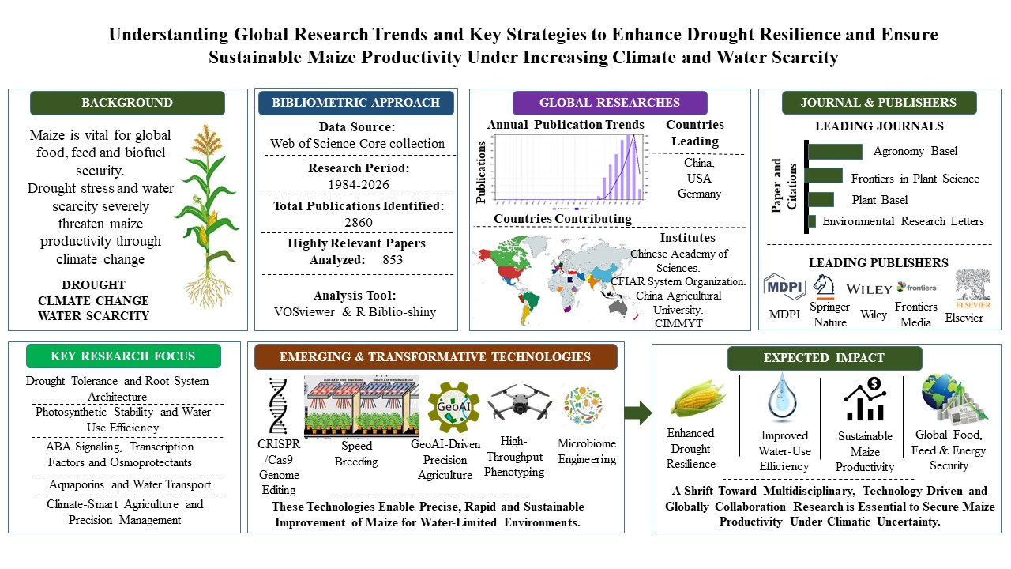
Graphical Abstract
Abstract
Maize (Zea mays L.) plays a critical role in global food, feed and biofuel security; however, its productivity is increasingly threatened by drought stress, climate change and freshwater scarcity. This study aimed to provide a comprehensive bibliometric and scientific assessment of global research trends related to drought stress in maize from 1984 to 2026, while identifying major physiological, molecular and technological strategies for improving drought resilience. Bibliometric data were collected from the Web of Science Core Collection using drought- and maize-related keywords. A total of 2860 publications were identified, from which 853 highly relevant papers were selected for detailed analysis. The datasets were analyzed using VOSviewer to evaluate publication trends, keyword co-occurrence, institutional collaboration, country networks, journals and publisher contributions. The results revealed a substantial increase in research output after 2019, with the highest annual publication number recorded in 2024. China, the United States and Germany emerged as the leading contributors in both publication productivity and citation impact. The Chinese Academy of Sciences, CGIAR System Organization, China Agricultural University and CIMMYT were identified as major research institutions driving innovation in maize drought studies. Among journals, Agronomy Basel, Frontiers in Plant Science, Plants Basel and Environmental Research Letters were the most productive publication sources, while publishers such as MDPI, Springer Nature, Wiley, Frontiers Media and Elsevier dominated scientific dissemination in this field. Keyword analysis demonstrated strong research emphasis on drought tolerance, root system architecture, photosynthetic stability, abscisic acid signaling and transcription factor engineering and climate-smart agriculture. Emerging technologies including CRISPR/Cas9 genome editing, speed breeding, GeoAI-driven precision agriculture and microbiome engineering were recognized as transformative tools for future maize improvement. Overall, this study highlights the transition of maize drought research toward multidisciplinary, technology-driven and globally collaborative approaches aimed at ensuring sustainable maize productivity and food security under increasing climatic uncertainty.
Keywords:
Drought resilience, Climate-smart agriculture, Root system architecture, Precision breeding, Water-use efficiency and VOSviewer.
Introduction
Maize (Zea mays L.) is one of the most strategically important cereal crops worldwide because of its central contribution to food security, livestock feed and biofuel production (Wang & Zhang, 2024). As global populations continue to rise, maize demand is projected to increase substantially. Particularly, in developing regions where it serves as a staple food and economic commodity (Erenstein et al., 2022; Hayat et al., 2025). Moreover, maize-derived bioethanol has become increasingly important in renewable energy systems, reinforcing its role in fuel security. However, the sustainability of maize productivity is under severe threat from climate change-driven drought stress and declining freshwater availability (Li et al., 2026). The Anthropocene era has intensified environmental instability through rising temperatures, erratic precipitation patterns and increasing occurrences of “flash droughts,” which develop rapidly and severely affect crop growth (Pandit & Sharma, 2024). These drought events negatively influence root development, stomatal conductance, photosynthetic efficiency, reproductive synchronization and kernel formation in maize (Yasin et al., 2024). The importance of integrating phenotypic resilience traits such as root system architecture, leaf rolling, hydraulic conductance and reduced anthesis-silking interval with molecular mechanisms including ABA signaling, transcription factor regulation, osmoprotectant accumulation and aquaporin-mediated water transport (Kumar et al., 2024).
Recent advances in genomics and biotechnology have transformed maize improvement strategies from conventional breeding toward precision-based approaches (Seraj & Vafaee, 2026). The integration of CRISPR/Cas9 genome editing, speed breeding, artificial intelligence, GeoAI-driven precision agriculture and high-throughput phenotyping platforms for developing climate-resilient maize hybrids (Akram et al., 2025; Hayat et al., 2026). These multidisciplinary innovations offer significant potential for sustaining maize yield under water-limited environments while supporting future global food, feed and energy demands (Biswas et al., 2025). This paper aims to provide a comprehensive bibliometric and scientific analysis of global research on drought stress in maize from 1984 to 2026. It evaluates physical, physiological and molecular drought-resilience mechanisms. While, highlighting emerging innovations such as CRISPR/Cas9, GeoAI, speed breeding and microbiome engineering to sustain maize productivity, food security and climate resilience under increasing global water scarcity.
Physical Blueprints for Drought Resilience
Drought resilience in maize is strongly governed by physical and morphological adaptations that improve water acquisition, conservation and transport under water-limited environments (Hayat et al., 2025; Zahedi et al., 2025). Among these, root system architecture (RSA) is considered one of the most critical determinants of drought tolerance because roots directly regulate access to deep soil moisture (Guo et al., 2024; Lynch, 2013). The “Steep, Cheap and Deep” root ideotype proposed by Jonathan P. Lynch emphasizes the development of deeper and metabolically efficient root systems to enhance drought adaptation (Lynch, 2013). Steep root angles facilitate deeper soil penetration, in Figure 1, enabling maize plants to access subsoil water reserves during prolonged drought periods, while “cheap” roots reduce metabolic expenditure through fewer cortical cell files and enhanced aerenchyma formation (Chimungu et al., 2014; Shoaib et al., 2022). Studies indicate that deeper nodal roots can improve water uptake efficiency by nearly 20-40% under water-deficit conditions, thereby stabilizing grain yield (Gao & Lynch, 2016; Uga et al., 2013).
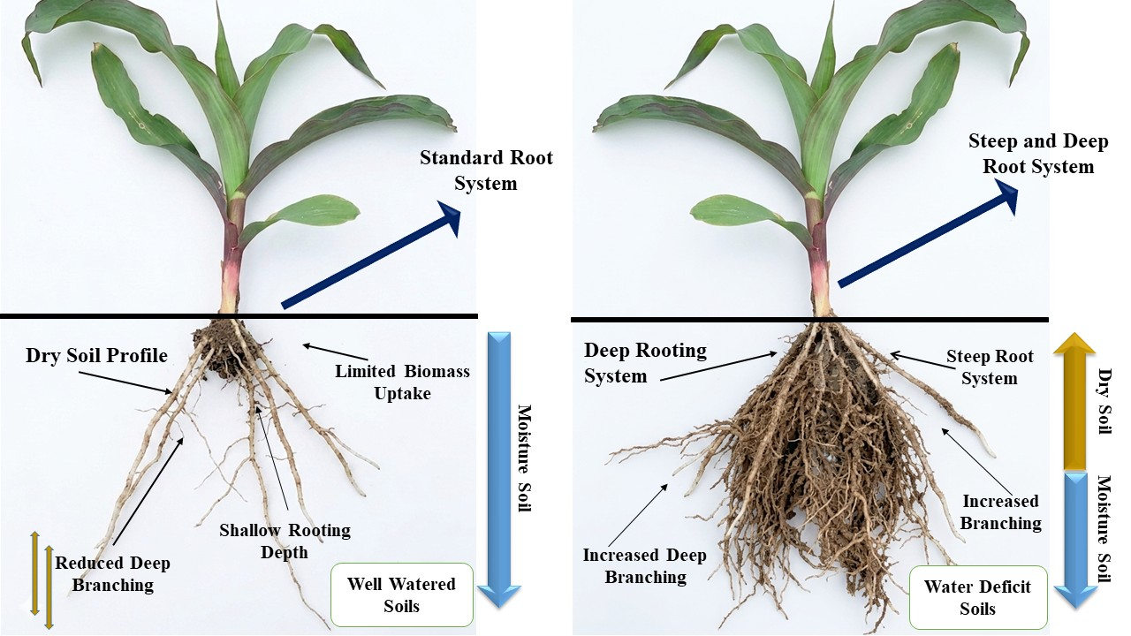Figure 1. Spatiotemporal Dynamics of Root System Architecture (RSA) Under Water Deficit.
Root cortical aerenchyma (RCA) further enhances drought resilience by replacing living cortical tissues with air-filled spaces, thereby reducing root respiration and nutrient requirements (Zhu et al., 2010). According to Chimungu et al. (2014), RCA lowers the carbon cost of soil exploration and allows greater assimilate allocation toward root elongation and reproductive development. Enhanced RCA formation has also been associated with improved penetration into compact soils and superior nitrogen acquisition efficiency (Liu et al., 2021). These anatomical modifications collectively improve hydraulic connectivity and soil moisture extraction under drought stress.
Shoot and canopy morphologies also play fundamental roles in drought avoidance mechanisms. Leaf rolling is a critical adaptive response that reduces transpiration loss by minimizing exposed leaf surface area during high evaporative demand (Ali et al., 2022; Tardieu, 2013). Similarly, upright leaf angles improve radiation use efficiency and optimize light distribution within the canopy, reducing canopy temperature and maintaining photosynthetic stability (Slattery & Ort, 2021). These canopy traits significantly contribute to improved water-use efficiency under drought conditions. Another important physical trait is the reduction of the anthesis-silking interval (ASI), which is strongly associated with reproductive success during water deficit (Welcker et al., 2022). Drought stress delays silk emergence relative to pollen shedding, resulting in poor fertilization and kernel abortion. The shorter ASI values are directly correlated with enhanced drought tolerance and higher grain yield under stress environments (Li et al., 2026).
Hydraulic conductance represents the integrated physical regulation of water flow from soil to atmosphere through roots, stems and leaves. Efficient hydraulic conductance maintains leaf water potential, stomatal function and transpiration balance during drought episodes (Chen et al., 2023). Xylem vessel architecture, root hydraulic conductivity and aquaporin-mediated membrane transport collectively determine water transport efficiency in maize (Suslov et al., 2024). Genotypes possessing optimized hydraulic architecture can sustain photosynthetic activity and reproductive development even under declining soil moisture conditions (Wang et al., 2025). Therefore, integrating RSA optimization, canopy adaptation and hydraulic regulation provides a robust physical blueprint for developing climate-resilient maize cultivars capable of sustaining productivity under increasing global water scarcity (Ahmed et al., 2025).
Physiological Mechanisms: The Internal Balance
Physiological mechanisms play a central role in determining maize drought tolerance by regulating the internal balance between water conservation, photosynthetic efficiency and reproductive success. Under drought stress, maize plants activate a complex network of physiological responses that maintain cellular homeostasis and minimize yield losses (Aslam et al., 2015). Among these responses, stomatal governance is one of the most important adaptive strategies because stomata regulate the balance between carbon dioxide (CO₂) uptake and transpiration-driven water loss. During water deficit, abscisic acid (ABA)-mediated signaling induces stomatal closure to reduce transpiration and preserve leaf water potential (Hsu et al., 2021). However, excessive stomatal closure restricts CO₂ diffusion into mesophyll tissues, thereby reducing photosynthetic carbon assimilation and biomass accumulation (Singh et al., 2013). Drought-tolerant maize genotypes possess optimized stomatal sensitivity that maintains partial stomatal conductance while minimizing unnecessary water loss. This balance enhances water-use efficiency and delays dehydration under prolonged drought conditions.
Metabolic priming is another crucial physiological adaptation that enables maize plants to tolerate osmotic stress. Drought stress disrupts cellular water balance and causes loss of turgor pressure, leading to impaired growth and metabolic dysfunction (Aslam et al., 2015; Rafique, 2023). To counteract this effect, maize accumulates osmo-protectants such as proline, glycine betaine, soluble sugars, and polyamines. Proline functions as an osmotic regulator, molecular chaperone, and reactive oxygen species (ROS) scavenger, thereby protecting cellular membranes and proteins during dehydration stress (Ghosh et al., 2022). Similarly, polyamines stabilize membrane structures, regulate ion transport and contribute to antioxidant defense mechanisms under drought conditions. Studies have demonstrated that drought-tolerant maize hybrids accumulate significantly higher concentrations of proline and polyamines compared with susceptible genotypes, allowing maintenance of cellular turgor and metabolic activity during severe water limitation (Peer et al., 2024).
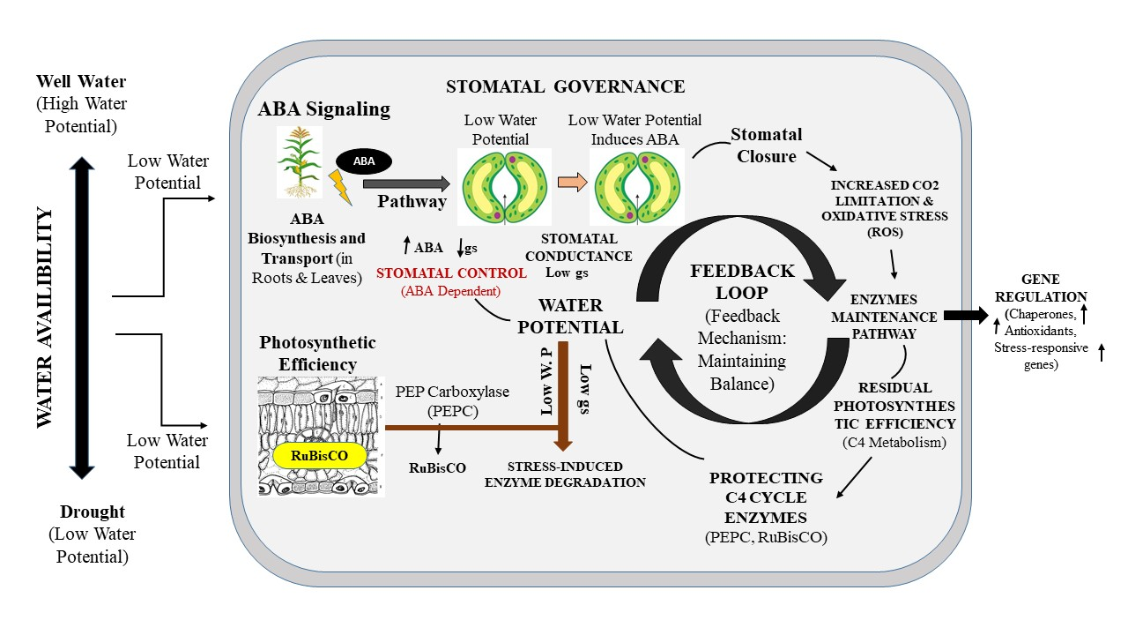Figure 2. The Interplay between Photosynthetic Efficiency and Stomatal Governance in C4 Metabolism.
Photosynthetic stability is particularly important in maize because it is a C4 crop that depends heavily on the coordinated functioning of phosphoenolpyruvate carboxylase (PEPCase), Rubisco, and associated enzymes, Figure 2. Drought and high-temperature stress reduce chlorophyll content, impair electron transport chains, and destabilize C4 metabolic pathways (Karami et al., 2025). Among these effects, inhibition of PEPCase activity is especially critical because this enzyme catalyzes the initial fixation of CO₂ in mesophyll cells. Under drought conditions, oxidative stress and thermal injury reduce enzyme efficiency and ATP availability, ultimately lowering carbon assimilation and grain productivity (Li et al., 2026). However, tolerant maize genotypes maintain higher PEPCase activity, chloroplast integrity and photochemical efficiency under stress, thereby preserving photosynthetic capacity and biomass production.
Source-sink dynamics also determine maize yield stability under drought stress. The “source” refers to photosynthetically active tissues producing assimilates. Whereas, the “sink” includes developing kernels and reproductive organs requiring carbohydrates for growth (Rafique, 2020). Drought stress disrupts assimilate transport by reducing photosynthesis, phloem loading and sucrose translocation to kernels (Du et al., 2024). This imbalance often leads to kernel abortion, reduced grain filling and lower harvest index. Drought-tolerant maize lines maintain stronger sink strength through improved carbohydrate remobilization and efficient carbon partitioning during reproductive development (Aslam et al., 2015). Enhanced sucrose synthase activity, stable phloem transport and delayed leaf senescence collectively contribute to effective kernel filling under water-deficit environments. Therefore, stomatal regulation, osmotic adjustment, photosynthetic stability and efficient source-sink coordination together form the physiological foundation of maize drought resilience (Aslam et al., 2015; Qi et al., 2021).
Targeted Molecular Strategies
Targeted molecular strategies have become fundamental for improving drought tolerance in maize because they directly manipulate stress-responsive genes, signaling pathways and regulatory networks involved in water-deficit adaptation (Peer et al., 2024; Singh et al., 2023). Among these mechanisms, the abscisic acid (ABA) signaling pathway serves as the central molecular hub regulating drought perception and adaptive responses. Under drought stress, ABA accumulates rapidly in plant tissues and activates the PYL-PP2C-SnRK2 signaling cascade (Daszkowska-Golec, 2016). In this pathway, pyrabactin resistance-like receptors (PYL/PYR) bind ABA molecules and inhibit type 2C protein phosphatases (PP2Cs), in Figure 3. Thereby, releasing SNF1-related protein kinases 2 (SnRK2s) from repression (Daszkowska-Golec, 2016; Fidler et al., 2022).
Activated SnRK2 kinases phosphorylate downstream transcription factors and stress-responsive proteins that regulate stomatal closure, osmoprotectant biosynthesis, antioxidant defense, and drought-responsive gene expression (Soma et al., 2021). Manipulation of this signaling cascade through genetic engineering and CRISPR-mediated editing has shown significant potential for enhancing drought sensitivity and water-use efficiency in maize (Feng, 2025). Fine tuning ABA signaling can improve stress adaptation without severely compromising plant growth under normal conditions.
Transcription factor (TF) engineering represents another powerful molecular strategy for broad-spectrum stress tolerance. TFs regulate large networks of downstream genes involved in stress signaling, osmotic adjustment, detoxification and cellular protection (Imran et al., 2025). Among these, dehydration-responsive element-binding (DREB), NAC and WRKY transcription factor families have received major attention in drought-tolerance research. DREB proteins activate stress-inducible genes through ABA-independent pathways and enhance osmo-protectant accumulation, ROS scavenging and membrane stability (Feng et al., 2023). NAC transcription factors regulate root development, senescence and water-use efficiency. While, WRKY proteins coordinate hormonal signaling and defense-related gene expression under combined abiotic stresses (Yang et al., 2025). Overexpression studies in maize have demonstrated that DREB- and NAC-based transgenic lines maintain higher chlorophyll content, improved stomatal regulation, and greater grain yield under drought conditions (Fuertes-Aguilar & Matilla, 2024). These TF families therefore function as master regulators of drought adaptation and represent promising targets for climate-resilient crop engineering (Wang et al., 2025; Wu et al., 2026).
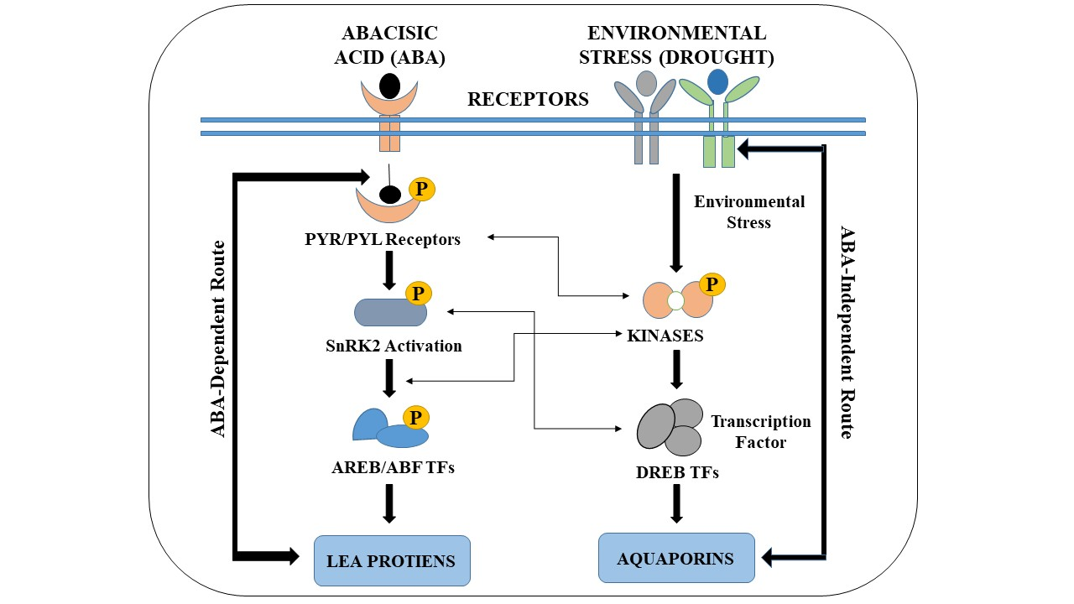Figure 3. The Molecular Signaling Cascade: From Perception to Gene Expression.
The integration of “omics” technologies has revolutionized the understanding of maize drought responses by enabling genome-wide analysis of genes, proteins, metabolites and epigenetic modifications (Rautela et al., 2026; Zhang et al., 2025). Transcriptomics has identified numerous drought-responsive gene networks associated with ABA signaling, osmotic regulation, antioxidant defense and photosynthetic maintenance. RNA sequencing technologies have revealed that drought-tolerant maize genotypes exhibit stronger induction of stress-responsive transcription factors, aquaporins, late embryogenesis abundant (LEA) proteins and heat shock proteins compared with susceptible lines (Peer et al., 2024; Zenda et al., 2019). Additionally, systems biology approaches have enabled the identification of co-expression networks and candidate genes controlling drought resilience.
Epigenetics has emerged as an important area of drought research because environmental stress can induce heritable modifications in gene expression without altering DNA sequences (Banerjee & Roychoudhury, 2017; Yadav et al., 2024). DNA methylation, histone modification and small RNA-mediated regulation contribute to “stress memory,” enabling plants to respond more effectively to repeated drought exposure (Rahman et al., 2025; Rao et al., 2024). Evidence suggests that some epigenetic marks associated with drought tolerance may persist across generations, contributing to transgenerational stress adaptation in maize. Aquaporin modulation further enhances drought resilience by regulating cellular water transport across membranes. Aquaporins are membrane channel proteins that facilitate rapid water movement between cells and tissues (Patel & Mishra, 2021; Zargar et al., 2017). Under drought conditions, selective regulation of plasma membrane intrinsic proteins (PIPs) and tonoplast intrinsic proteins (TIPs) controls root hydraulic conductivity, leaf water status and stomatal behavior. Optimized aquaporin expression improves water-use efficiency and maintains cellular hydration during severe drought stress (Li et al., 2024). Therefore, integrating ABA signaling engineering, transcription factor regulation, omics technologies, epigenetic memory and aquaporin modulation provides a comprehensive molecular framework for enhancing drought resilience in maize (Han et al., 2026; Peer et al., 2025).
Next-Generation Solutions for Global Water Scarcity
Next-generation technologies are revolutionizing maize improvement by integrating molecular biology, digital agriculture and microbial engineering to address the growing challenge of global water scarcity, in Figure 4. Traditional breeding approaches have significantly improved drought tolerance. However, climate change and increasing frequency of extreme drought events require faster, more precise and multidisciplinary solutions (Ma & Ling, 2026; Srivastava et al., 2022). Modern innovations such as CRISPR/Cas9 genome editing, speed breeding, GeoAI-driven precision agriculture and microbiome engineering are now considered critical tools for developing climate-resilient maize hybrids capable of maintaining productivity under water-limited environments, in Figure 4.
Genome editing through CRISPR/Cas9 technology has emerged as one of the most powerful approaches for improving drought resilience in maize (Namata et al., 2025). Unlike conventional transgenic methods that often involve single-gene insertion, CRISPR enables targeted and multiplex editing of multiple genes simultaneously (Lin et al., 2026). This strategy is particularly important because drought tolerance is a polygenic trait controlled by interconnected regulatory pathways. Recent studies have focused on editing negative regulators of drought signaling pathways, including PP2C phosphatases and stress-suppressing transcriptional repressors, to enhance stress responsiveness without severe yield penalties. CRISPR/Cas systems provide unprecedented precision in modifying stress-responsive loci associated with ABA signaling, root development, and osmotic regulation (Khalid et al., 2026). Multiplex editing has also enabled simultaneous improvement of root architecture, stomatal regulation and antioxidant defense systems in maize. Thereby, accelerating the development of drought-resilient genotypes (Qiao et al., 2026).

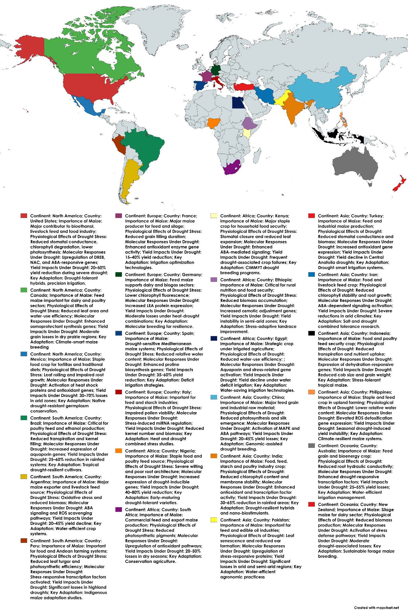
Figure 4. Global overview of maize cultivation, physiological and molecular responses to drought stress, and key adaptation strategies across major producing nations.
Speed breeding further complements genome editing by drastically reducing generation turnover time (Pandey et al., 2022). Traditional maize breeding cycles often require several years to develop stable hybrids. Whereas speed breeding integrates controlled environmental conditions, extended photoperiods and optimized growth chambers to accelerate flowering and seed production (Hayat & Öten, 2026). This approach enables multiple generations per year, significantly shortening the breeding pipeline for climate-ready cultivars. When combined with genomic selection and marker-assisted breeding, speed breeding allows rapid fixation of drought-tolerant alleles and early selection of superior phenotypes (Zhao et al., 2026). The integration of CRISPR editing with speed breeding can reduce the development time of improved maize hybrids by nearly 50%, offering an efficient pathway for responding to rapidly changing climatic conditions (He et al., 2024).
GeoAI and precision agriculture technologies are transforming drought management through real-time monitoring of crop and soil conditions (Hayat et al., 2026). GeoAI integrates artificial intelligence, satellite imaging, unmanned aerial vehicles (UAVs) and geospatial analytics to optimize irrigation scheduling, soil moisture management, and drought forecasting (Aziz et al., 2026). Satellite-based multispectral and thermal imaging systems can detect early physiological signs of drought stress, including canopy temperature changes, chlorophyll decline and reduced transpiration rates (Gerhards et al., 2019). Soil sensors and IoT-enabled platforms further improve irrigation efficiency by providing real-time information on soil water availability and nutrient dynamics, in Figure 5. Remote sensing technologies can significantly reduce water wastage while improving crop productivity under limited water resources. Precision agriculture therefore enables the integration of molecular resilience traits with field-scale environmental monitoring systems (Liang et al., 2025).
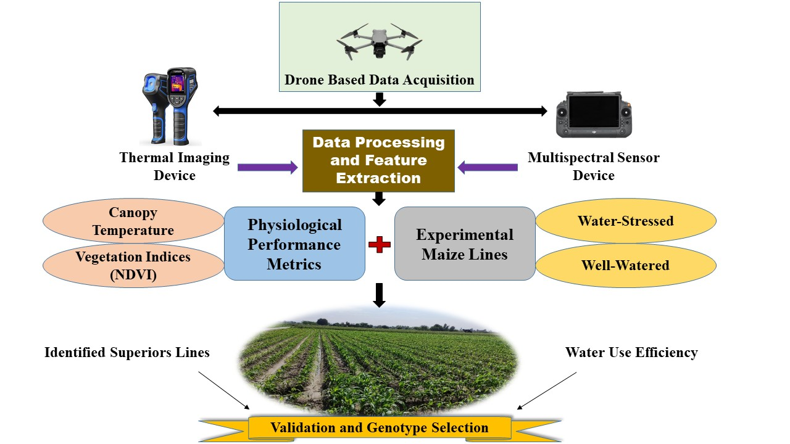Figure 5. Smart Agriculture Ecosystem: Integrating GeoAI with Climate-Ready Genotypes.
Microbiome engineering has also emerged as a promising strategy for enhancing maize drought resilience. Drought-tolerant plant growth-promoting rhizobacteria (PGPR) and beneficial fungi establish synergistic interactions with maize roots, improving nutrient acquisition, hormonal balance, and water uptake (Meel & Saharan, 2024; Mikiciuk et al., 2024). Certain rhizobacteria stimulate root elongation, increase osmoprotectant production and induce systemic stress tolerance through phytohormonal signaling pathways (Das et al., 2025). Microbial inoculation can also improve soil aggregation and rhizosphere moisture retention under drought conditions. According to Microbiology research, microbiome-assisted drought adaptation represents a unique convergence of physical and molecular resilience mechanisms (Zhang et al., 2026). Consequently, the integration of genome editing, accelerated breeding systems, GeoAI technologies and microbiome engineering offers a comprehensive next-generation framework for sustaining maize productivity under increasing global water scarcity (Thingujam et al., 2025).
II. Materials and Methods (Bibliometric Approach)
The Web of Science Core Collection, which is one of the most comprehensive and internationally recognized transdisciplinary citation databases, were used as the primary data sources for this bibliometric analysis. These databases were selected due to their extensive coverage of peer-reviewed literature in environmental sciences, plant biology and physiology and agricultural sciences, thereby ensuring a robust and representative dataset for research on maize production systems. The Clarivate Analytics Web of Science (WoS) is one of the most widely used platforms for academic citation searches and bibliometric analyses and constitutes one of the largest scientific databases worldwide, encompassing a broad range of high-impact scholarly publications (Pranckutė, 2021). Publication records were retrieved from the WoS Core Collection, including the following indices: Science Citation Index Expanded (SCI-EXPANDED), Social Sciences Citation Index (SSCI), Emerging Sources Citation Index (ESCI) and Index Chemicus (IC). Data collection was completed on November 20, 2025, to minimize potential database update bias. The search was conducted using the topic-based keywords “maize,” “abiotic stress,” “drought” and “abiotic stresses.” In total, 2860 publications related to the impact of drought on maize were identified. Out of these 2860 papers only 853 paper were selected on the base criterias were selected for the recent publications on this top, which highlights the significance of this research. All records were exported in “full record and cited references” format and saved as RIS, EndNote, plain text data, Excle and tab-delimited files. The retrieved data were subsequently imported into VOSviewer for further bibliometric visualization and network analysis, in Figure 6.
VOSviewer
The datasets obtained from this search were analyzed and visualized using VOSviewer, a user-friendly, freely available bibliometric visualization software. This tool was chosen for its extensive analytical capabilities, ability to handle large datasets and its capacity to create intuitive visualizations that enhance data interpretation (McAllister et al., 2022; Van Eck & Waltman, 2010). In this study, VOSviewer was used to assess the extent of international collaboration among authors, institutions, countries and to identify research trends through keyword analysis. The software also facilitated cluster and network analyses. All analyses were performed using the default parameters provided by VOSviewer (Suryantoro et al., 2023). In the network visualizations, items are depicted as circles, with the size of each circle indicating the relative weight or importance of the item. Different colors represent clusters of related elements. The spatial distance between circles reflects the strength of their relationships, where closer proximity indicates stronger associations.
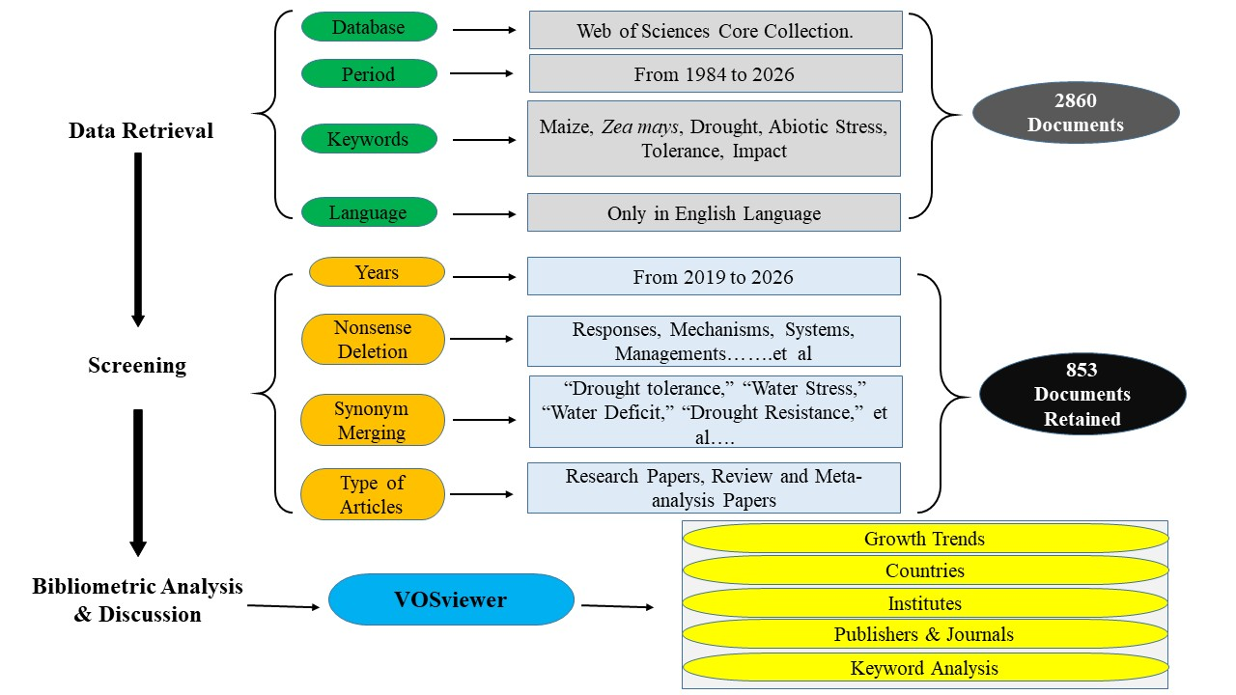Figure 6. A summary of bibliometric analysis procedures through this PRISMA flowchart.
Results of the bibliometric analysis
Type of document and publication language
A total of 853 papers on the imapct of drought stress on maize, published between 1984 and 2026 were identified through keyword-based searches. The publications were indexed in several Web of Science databases, including the Science Citation Index Expanded (SCI-EXPANDED: 771 records), Social Sciences Citation Index (SSCI: 78 records), Emerging Sources Citation Index (ESCI: 68 records) and Index Chemicus (IC: 1 records). Regarding publication language, the vast majority of the papers (852) were published in English, while 1 paper was published in the French Language. Thus, English was the predominant language of publication in this research field.
Publications Trend
The quantification of academic publications is an important indicator for identifying trends and developments within specific scientific fields. Figure 7 illustrates the number of scholarly publications related to maize stress studies published between 1984 and 2026. In 2024, the highest annual publication output was recorded, with 186 papers. Overall, the number of research articles addressing the impact of drought stress on the physiological, molecular and yield of maize has shown a marked increase since 2019. These trends indicate that this research area has attracted increasing scientific attention over the past 10 years, keeping in view the number of papers published and number citations per year.
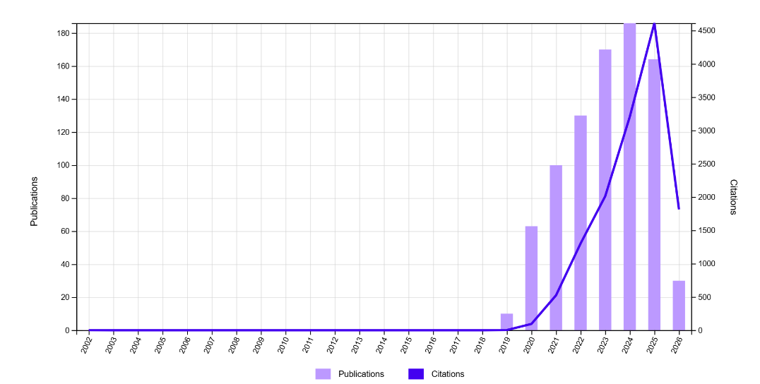
Figure 7. Scholarly article publication trends concerning impact of drought on maize research between 2002 and 2026.
The influence of a scientific publication is commonly assessed by the number of citations it receives, while the overall quality and impact of published research are often evaluated using quantitative indicators such as the h-index. The h-index, originally proposed to measure a researcher’s productivity and citation impact, is defined as the number of publications that have received at least the same number of citations (Hirsch, 2005). The 853 papers analyzed from 2019 to 2026 had an h-index of 51 and received a total of 13,590 citations during the study period, with an average of 15.93 citations per publication.
Web of Science Categories and Research Areas
According to the Web of Science (WOS) classification system, the search terms maize and drought were associated with 46 research subjects and 67 subject categories. The ability of WOS to classify journals and publications into multiple categories highlights the interdisciplinary nature of this field of study. Within the WOS platform, documents may be assigned to one or more research domains. Table 1 presents the top 15 WOS subject categories and research areas related to maize and stress studies published between 1984 and 2026. Among the subject categories 1349 papers were analyzed, the most frequent with at least 10 papers in these categories were Plant Sciences (280 papers: 20.75%), Agriculture (240 papers: 17.79%), Environmental Sciences Ecology (227 papers: 16.82%), Meteorology Atmospherıc Sciences (100 papers: 7.41%), Science Technology Other Topics (98 papers 7.26%), Water Resources (57 papers: 4.23%), Food Science Technology (51 papers: 3.78%), Geology (47 papers 3.48%), Microbiology (29 papers: 2.15%), Chemistry (27 papers: 2%), Remote Sensing (24 papers: 1.78%), Imaging Science Photographic Technology (20 papers: 1.48%), Business Economics (18 papers: 1.33%), Biochemistry Molecular Biology (16 papers: 1.18%), Biotechnology Applied Microbiology (14 papers: 1.04%), Life Sciences Biomedicine Other Topics (11 papers: 0.82%) and Engineering and Genetics Heredity (10 papers: 0.74%)
Table 1. The most important 15 WOS categories and research areas about the impact of drought on Maize.
Sr. No. | WOS categories | Total Papers | % of papers | Research areas | Total Papers | % of papers
1 | Plant Sciences | 280 | 19.59 | Plant Sciences | 280 | 20.75
2 | Environmental Sciences | 209 | 14.62 | Agriculture | 240 | 17.79
3 | Agronomy | 171 | 11.96 | Environmental Sciences Ecology | 227 | 16.82
4 | Meteorology Atmospheric Sciences | 100 | 6.99 | Meteorology Atmospheric Sciences | 100 | 7.41
5 | Water Resources | 57 | 3.98 | Science Technology Other Topics | 98 | 7.26
6 | Multidisciplinary Sciences | 56 | 3.91 | Water Resources | 57 | 4.22
7 | Environmental Studies | 51 | 3.56 | Food Science Technology | 51 | 3.78
8 | Food Science Technology | 51 | 3.56 | Geology | 47 | 3.48
9 | Soil Science | 50 | 3.49 | Microbiology | 29 | 2.14
10 | Geosciences Multidisciplinary | 47 | 3.28 | Chemistry | 27 | 2.00
11 | Green Sustainable Science Technology | 40 | 2.79 | Remote Sensing | 24 | 1.77
12 | Agriculture Multidisciplinary | 30 | 2.09 | Imaging Science Photographic Technology | 20 | 1.48
13 | Microbiology | 29 | 2.02 | Business Economics | 18 | 1.33
14 | Remote Sensing | 24 | 1.67 | Biochemistry Molecular Biology | 16 | 1.18
15 | Imaging Science Photographic Technology | 20 | 1.39 | Biotechnology Applied Microbiology | 14 | 1.03

Core Journals and Publishers
The top 15 core journals are listed in Table 2. These journals were shortlisted from the top 201 journals based on a minimum threshold of 10 articles, total citations and average citations per publication. The proportion of total papers published by the leading journals shows that Agronomy Basel accounted for 6.28% of the publications, followed by Frontiers in Plant Science (5.78%), Plants Basel (4.65%), Environmental Research Letters (3.90%), Sustainability (3.52%) and Scientific Reports (3.27%).
Table 2 also presents the top 20 journals with the highest citation impact, of which the top 10 are illustrated in Figure 8. These journals include the Journal of Experimental Botany (average citations: 70.63), Environmental Health (63.70), Veterinary Journal (42.89), Agronomie (42.67), Environmental Microbiology (41.31), Journal of Dairy Science (38.25), Nature Reviews Microbiology (36.21), Ecotoxicology & Environmental Safety (32.70), Trends in Plant Science (29.93), and Microbiology & Molecular Biology Reviews (27.23). Figure 8 highlights the leading journal categories with the highest number of recorded citations.
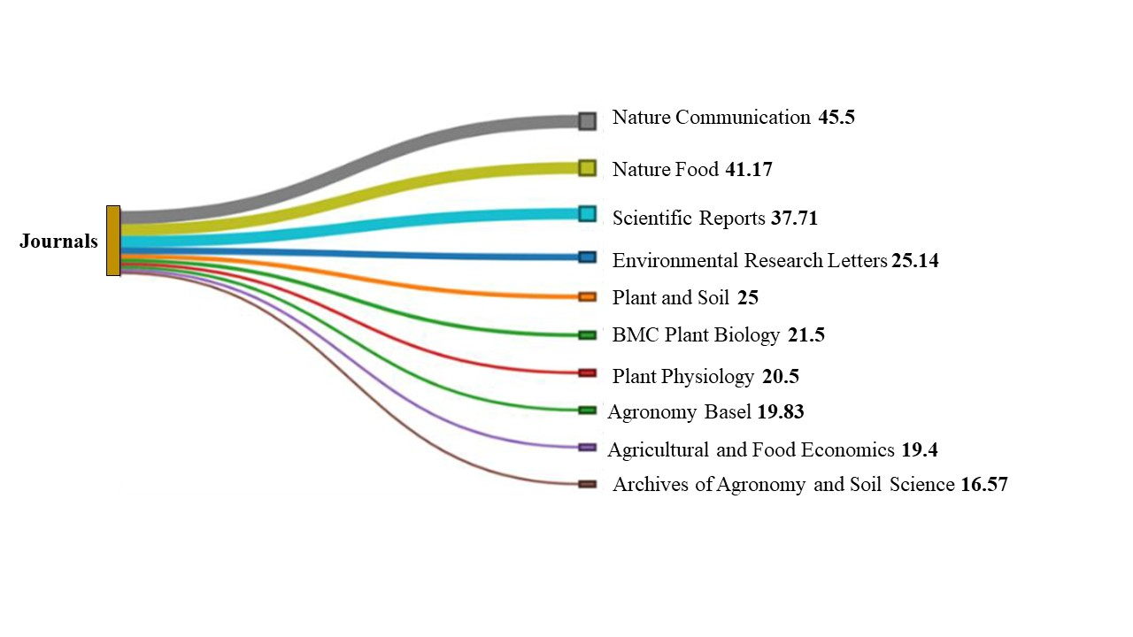Figure 8. Most highly rated journals in which the most papers were cited with an average citation.
Table 2. List of the 15 most important journals pertaining to impact of drought on maize.
Sr. No. | Journals | Total Papers | % of papers | Journals | Total citations | Avg. citations
1 | Agronomy Basel | 50 | 6.28 | Scientific Reports | 264 | 37.71
2 | Frontiers in Plant Science | 46 | 5.78 | Nature Food | 247 | 41.17
3 | Plants Basel | 37 | 4.65 | Nature Communication | 182 | 45.5
4 | Environmental Research Letters | 31 | 3.90 | Environmental Research Letters | 176 | 25.14
5 | Sustainability | 28 | 3.52 | BMC Plant Biology | 129 | 21.5
6 | Scientific Reports | 26 | 3.27 | Plant and Soil | 125 | 25
7 | Water | 23 | 2.89 | Agronomy Basel | 119 | 19.83
8 | Agriculture Basel | 21 | 2.64 | Archives of Agronomy and Soil Science | 116 | 16.57
9 | Frontiers in Sustainable Food Systems | 18 | 2.26 | Agricultural and Food Economics | 97 | 19.4
10 | Plant and Soil | 18 | 2.26 | Journal of Soil Science and Plant Nutrition | 84 | 12
11 | Remote Sensing | 18 | 2.26 | Plant Physiology | 82 | 20.5
12 | BMC Plant Biology | 16 | 2.01 | Agronomy Journal | 81 | 11.57
13 | Journal of Agronomy and Crop Science | 14 | 1.76 | Microbiome | 80 | 11.43
14 | Theoretical and Applied Climatology | 14 | 1.76 | Plant Direct | 78 | 15.6
15 | Journal of Soil Science and Plant Nutrition | 11 | 1.38 | Physiologia Plantarum | 74 | 10.57

Similarly, a wide range of publishers contribute to publications across different research fields. Out of 36 publishers, among these publishers MDPI, Springer Nature, Wiley, Frontiers Media and Elsevier were the top 5, with 239 i.e., 30% papers, 159, 20% papers, 119, 15% papers, 87, 11% papers and 42, 5% publications, respectively. Each of these publishers produced approximately 10 or more articles, as shown in Figure 9.
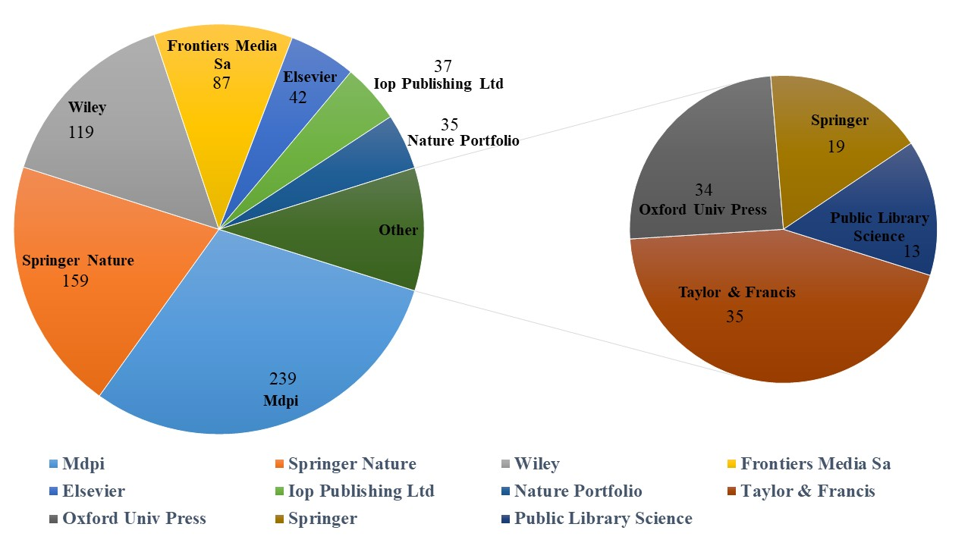Figure 9. Publication Sources and Citation Impact
Authors and co‑authorship analysis
The contribution of researchers from different countries and their collaborative networks, as illustrated in Figure 10, represents a crucial component of this research field. Highly productive researchers often play a significant role in shaping research directions and advancing scientific knowledge within their disciplines. Out of a total of 853 publications, 710 highly ranked papers were shortlisted based on citation counts and the number of publications per author. These papers involved a total of 4399 authors. Using VOSviewer, co-authorship and citation analyses were conducted on the selected 710 papers, of which 613 authors met the threshold for the highest number of papers in Figure 10, while the citation impact 721 authors out pf 3919 were grouped into 26 clusters based on data retrieved from the Web of Science, in Figure 11. In addition, Figure Figure 10 and Figure 11 are well demonstrated in figure SSSSS1 and SSS2, with the overlay and density visualizations.
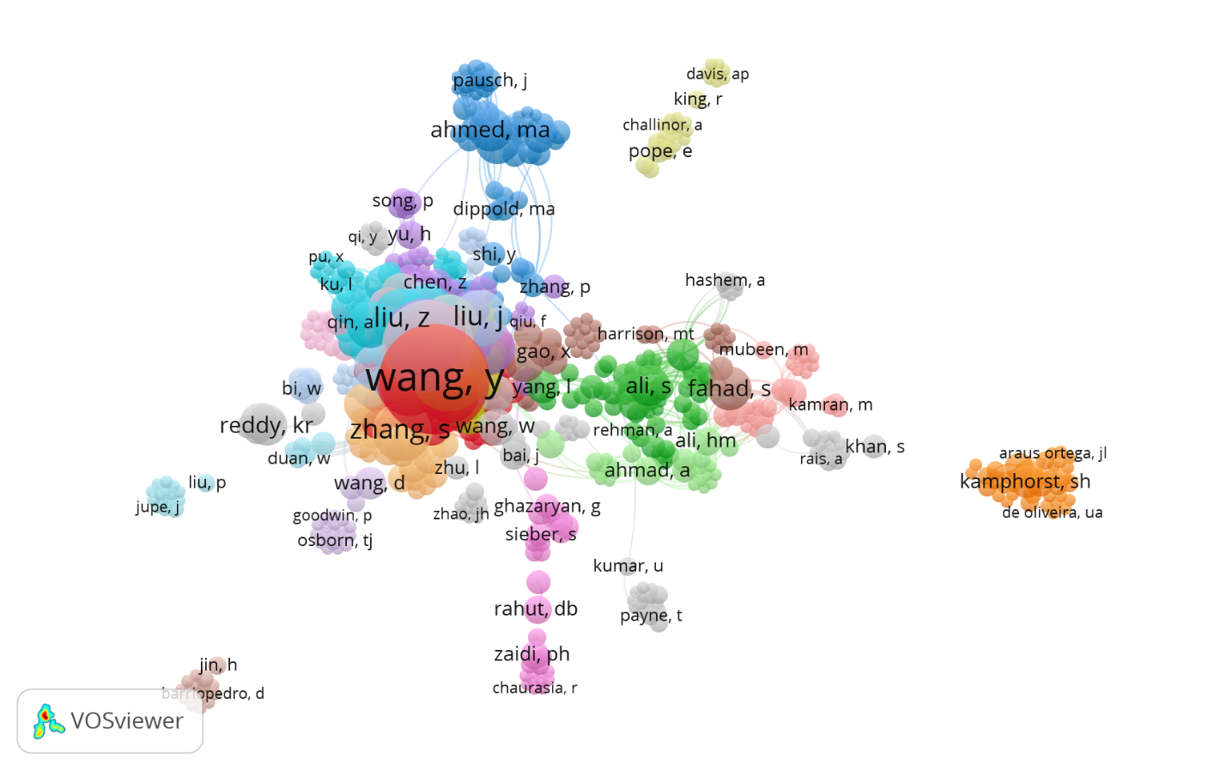Figure 10. Authors met the threshold for the highest number of papers.
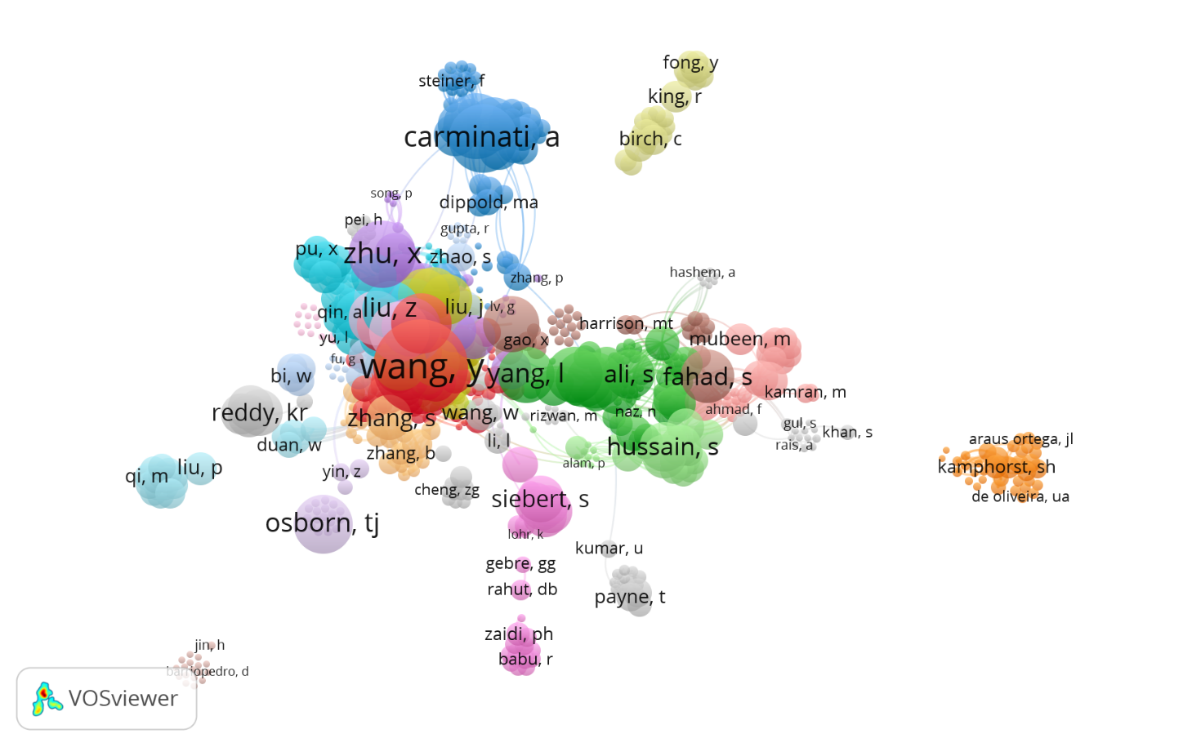Figure 11. Authors met the threshold for the at least 5 citations.
Similarly, institutional-level data obtained from the Web of Science were analyzed to identify the top 200 researchers with 609 papers were affiliated with 42 international institutions worldwide out 201, each with a minimum of 10 publications per institution. From these data, the top 126 researchers were further analyzed based on citation counts derived from the 853 shortlisted papers (Figure 12). Among these researchers, the top ten authors with at least 5 papers were Zhang, Jiquan with 9, Fahad, Shah and Ahmed, Mutez with 8, Liu, Xingpeng with 7, Reddy, K. R., Tong, Zhijun and Bheemanahalli, Raju with 6, Rahman, Muhammad Habib-Ur-, de Lima, Valter Jário, Carminati, Andrea with 5 papers were shortlisted.
These 853 papers were published by 106 countries with minimum 1 paper by each country. Amoung these countries China was leading in both number of papers Figure 12 and citations Figure 13, followed by USA, Germany, Pakistan and Saudi Arabia, are well demonstrated. Till 2026, China 311 papers with 4648 citations, USA 152 papers with 3098 citations, Germany 80 papers with 2247 citations, Pakistan 60 papers with 1295 citations and Saudia Arabia 53 papers with 1349 citations are dominating in this research domain.
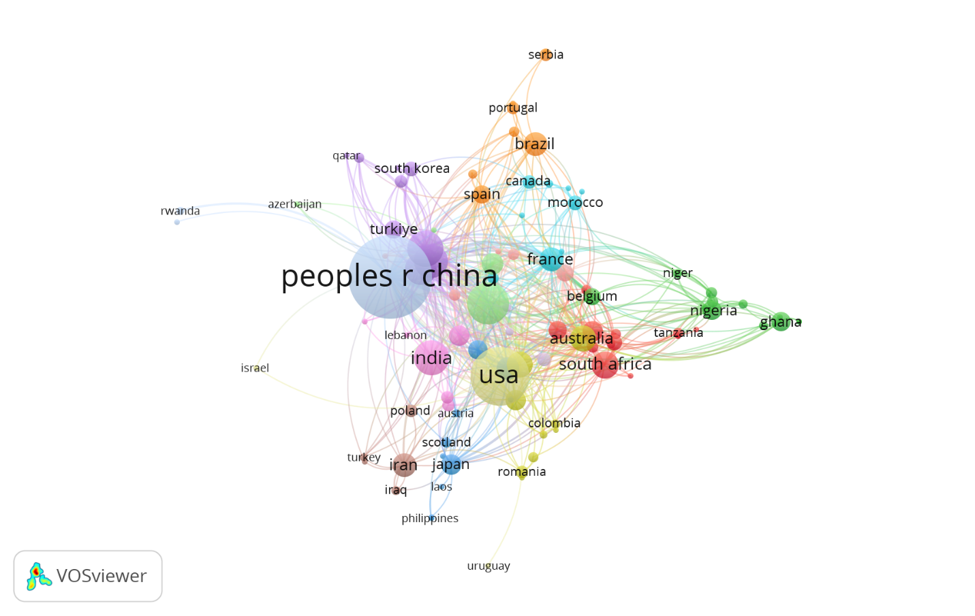Figure 12. Network of country co-authorship working on maize based on number of papers.
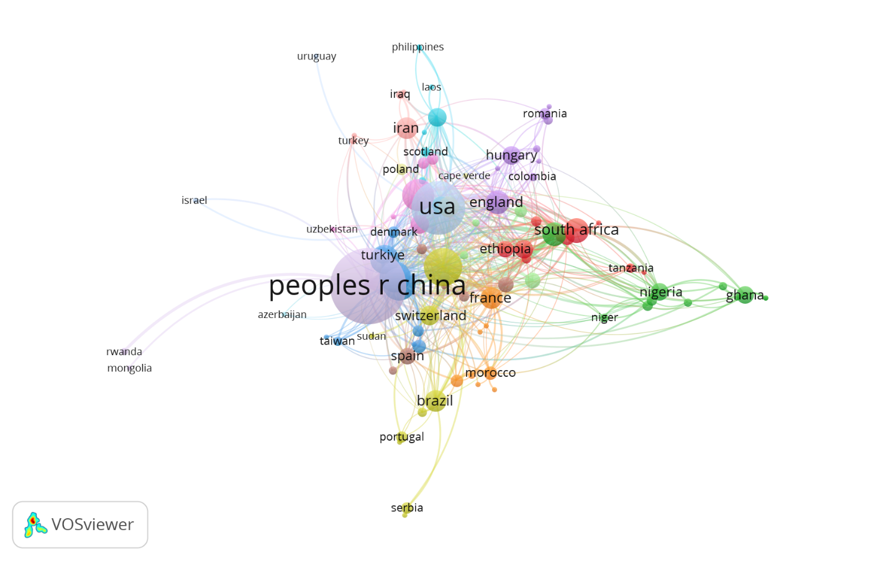Figure 13. Network of country co-authorship working on maize based on number of citations.
Organizations co-authorship analysis
An analysis of research organizations, as illustrated in Figure 14 and Figure 15, provides insight into the institutions leading this field of study. The publication data indicate that a total of 201 organizations contributed to 853 papers. The top 30 institutions and organizations, ranked by total number of publications, are presented in Table 3. These fifteen organizations are distributed across several countries, including the China (11 organizations) is leading followed by, United States Germany, Australia, France, Saudi Arabia, Pakistan India and Switzerland. In addition, the five most productive organizations worldwide the Chinese Academy of Sciences (China), CGIAR System Organization (France), the United States Department of Agriculture (USDA; USA), University of Agriculture Faisalabad (Pakistan), the Swiss Federal Institutes Of Technology Domain (Switzerland) and the Indian Council Of Agricultural Research ICAR (India), each institute published more than 12 papers. These institutions demonstrate a high level of prominence and influence in the scholarly literature related to impact of drought and its significance on maize.
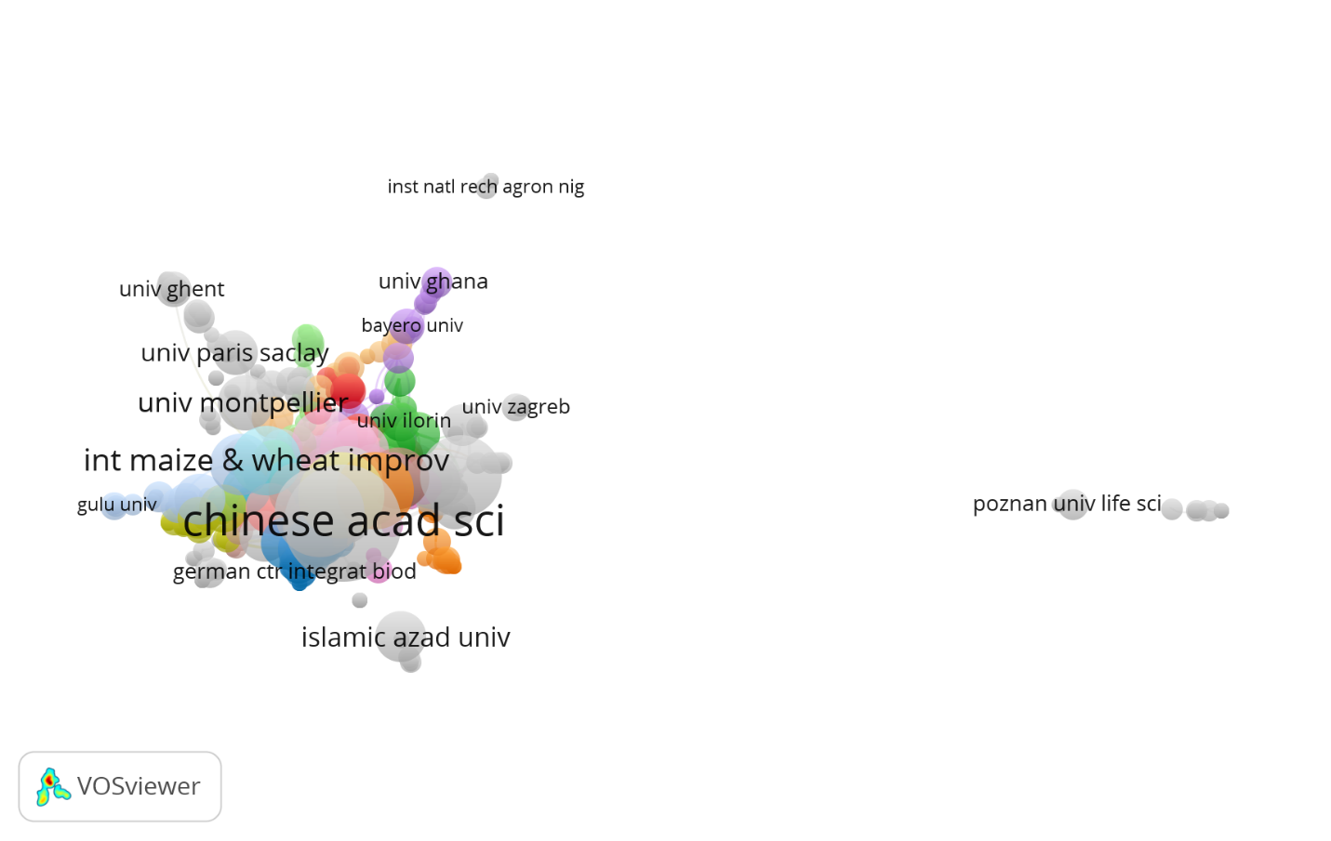Figure 14. Top Research Organizations Institutes on the base of number of papers.
Table 3. List of top 30 most influential organizations working on maize.
Sr. No. | Universities and Institutes |  | Papers | Countries
1 | Chinese Academy of Sciences |  | 62 | China
2 | CGIAR System Organization |  | 44 | France
3 | Egyptian Knowledge Bank EKB |  | 44 | Egypt
4 | University of Chinese Academy of Sciences CAS |  | 32 | China
5 | China Agricultural University |  | 29 | China
6 | China Meteorological Administration |  | 29 | China
7 | King Saud University |  | 26 | Saudi Arabia
8 | Northwest A F University China |  | 24 | China
9 | International Maize Wheat Improvement Center CIMMYT |  | 23 | Mexico
10 | Chinese Academy of Agricultural Sciences |  | 21 | China
11 | University of California System |  | 21 | USA
12 | United States Department Of Agriculture USDA |  | 19 | USA
13 | Helmholtz Association |  | 18 | Germany
14 | INRAE |  | 18 | France
15 | Chinese Academy of Meteorological Sciences Cams |  | 17 | China
16 | University of Agriculture Faisalabad |  | 16 | Pakistan
17 | University of Bonn |  | 16 | Germany
18 | Kansas State University |  | 15 | USA
19 | Swiss Federal Institutes of Technology Domain |  | 15 | Switzerland
20 | Institute of Geographic Sciences Natural Resources Research CAS |  | 14 | China
21 | Islamia University of Bahawalpur |  | 14 | Pakistan
22 | Nanjing University of Information Science Technology |  | 14 | China
23 | ETH Zurich |  | 13 | Switzerland
24 | Gansu Agricultural University |  | 13 | China
25 | Universite De Montpellier |  | 13 | France
26 | Henan Agricultural University |  | 12 | China
27 | Indian Council of Agricultural Research ICAR |  | 12 | India
28 | Leibniz Association |  | 12 | Germany
29 | Leibniz Zentrum Fur Agrarlandschaftsforschung Zalf |  | 12 | Germany
30 | Technical University of Munich |  | 12 | Germany

Total 1434 organizations were recoreded from these paper, from which only 1332 organizations meet the thresholds level of at least one citation with at least one paper. While 1064 organizations meet the thrshold level of at least 5 citations and have at leat one publication on this research. So, out of these 1064 organizations, top 1000 organizations were selected on the base maximum citations and number of papers. In Figure 14, 858 organziations were grouped in 42 different groups with the 3288 links, while the total strenght among them was 3666. Once again, co-occurrence analysis method was used for the organizations with full fraction counting method and ignored the papers co-authored large number of organizations. In this analysis in Figure 14bbbbbbbbbb, maximum 25 number of papers were selected for each organization and 1434 organizations meet the criteria. While only 836 organizations meet the threshold level of having minimum 10 number of citations by each organization with at least one paper, in Figure 15.
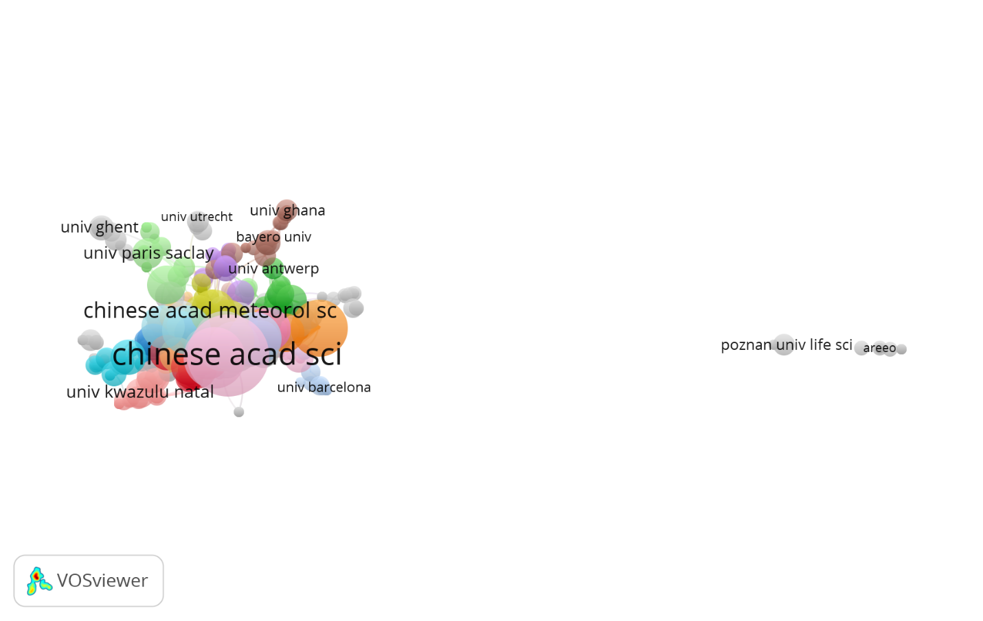
Figure 15. Top Research Organizations Institutes on the base of number of citations.
All keywords co-occurrence analysis
The use of key words is crucial in a given scientific field since they reflect the major ideas of academic publications. It is possible to identify the patterns and trends that define a certain academic subject of study by creating a list of keywords. Using the full counting approach, the current study chose author keywords for co-occurrence analysis and examined the co-occurrence patterns of each term. The full counting method was used to conduct co-occurrence analysis for each keyword. According to the data with 3981 co-occurring keywords were selected with a total link strength of 36229, with 22858 links and 1000 of the 3981 keywords satisfied the minimal criteria of 90% most relevant terms in full counting method are given in 15 different clusters in Figure 16. With a total link strength of 36229, the top 1000 co-occurring keywords were drought, tolerance, impact, maize, yield, adaptability, growth, temperature, management, food security, cereals, grain yield, variability, model, genes, soil, responses and biotic abiotic stresses. While in Figure 17, fractional counting method was used to conduct the co-occurrence analysis for the keywords. According to this data, 4096 keywords were shortlisted and 315 keywords meet the criteria while considering minimum number of occurrences of a keywords should be five. It was discovered that each of these important terms appeared at least nine times. Fields from which these terms were extracted were the title and abstract fields from which structured abstract labels and copyright statements were ignored during the analysis through VOSviewer. The network map of 2 clusters illustrates the relationships between each keyword. A keyword is represented by each node on the base of its occurrence in the Figure 18, 336 items were recorded with 26789 links and 98296 total link strengths. The network reveals two primary thematic clusters mapping the research landscape: the red cluster primarily represents macro-level, environmental, and socio-economic dimensions (e.g., data, region, model, rainfall, policy, farmer), while the green cluster focuses on micro-level, physiological, and biological mechanisms (e.g., growth, plant, treatment, root, chlorophyll, proline). The size of the nodes corresponds to the term occurrence frequency, and the thickness of the connecting lines indicates the strength of the co-occurrence links between terms.
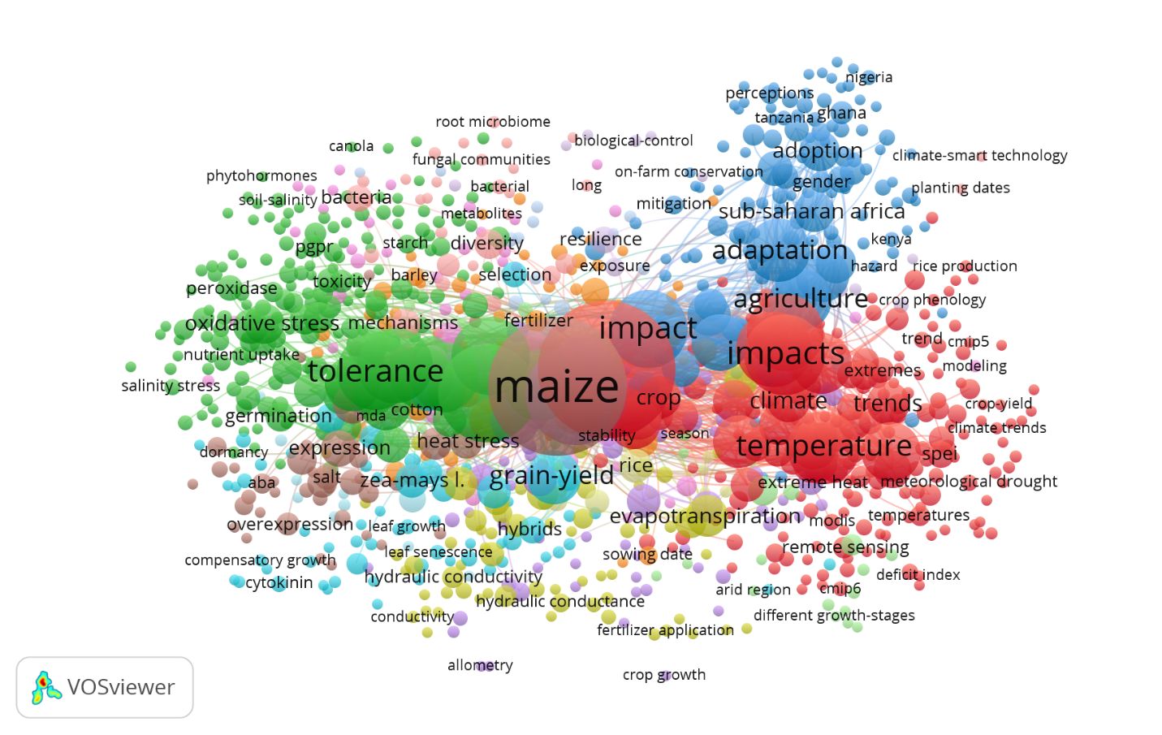Figure 16. Co-occurrence network visualization diagram of the most frequently occurring keywords in full counting, pertaining to stresses impacting maize. Clusters of related terms are represented by nodes that share the same color.
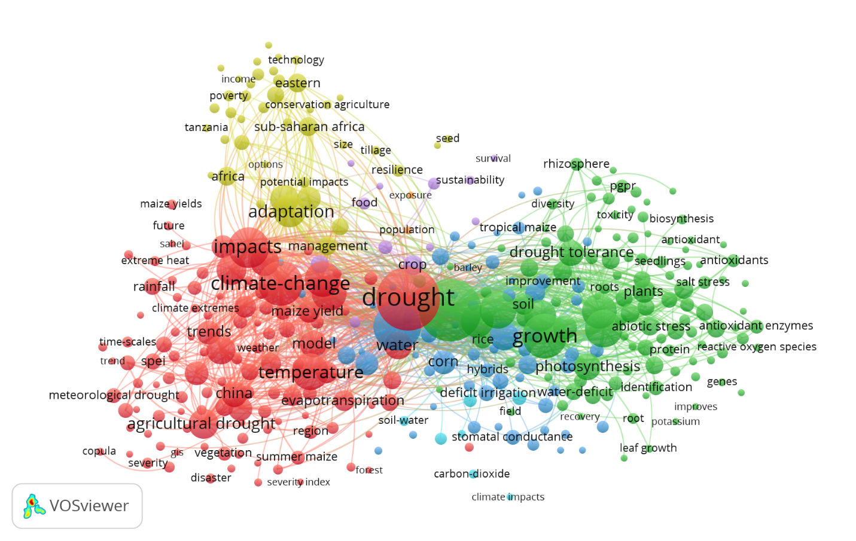Figure 17. Co-occurrence network visualization diagram of the most frequently occurring keywords in fractional counting, pertaining to stresses impacting maize. Clusters of related terms are represented by nodes that share the same color.
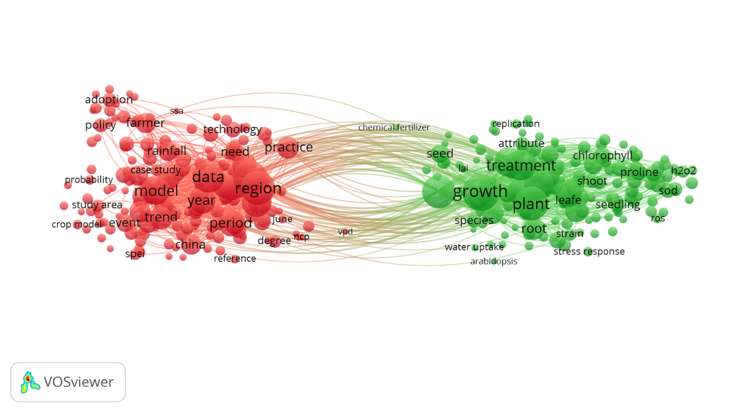Figure 18. VOSviewer co-occurrence network visualization of high-frequency terms extracted from titles and abstracts
Discussion
The present bibliometric analysis highlights the rapidly growing global scientific interest in understanding and mitigating the impact of drought stress on maize productivity between 1984 and 2026. The findings demonstrate that maize drought research has evolved from conventional physiological studies toward multidisciplinary approaches integrating molecular biology, genomics, precision agriculture and climate-smart technologies. The identification of 853 highly relevant publications from an initial pool of 2860 studies reflects the increasing scientific emphasis on developing sustainable strategies for global food, feed and fuel security under climate change-induced water scarcity. The sharp rise in publication output after 2019, with the highest number of publications recorded in 2024 (186 papers), indicates that drought resilience in maize has become a priority research domain worldwide. This increase corresponds closely with growing concerns regarding climate variability, flash drought events and freshwater depletion, which severely threaten cereal productivity (N. Li et al., 2026; Pandit & Sharma, 2024). The h-index of 51 and the accumulation of 13,590 citations further confirm the strong academic impact and international relevance of this field. Similar bibliometric trends have been reported in climate-resilient agriculture and crop stress physiology studies, where drought tolerance research has expanded substantially during the last decade (McAllister et al., 2022; Pranckutė, 2021).
The dominance of Plant Sciences, Agriculture and Environmental Sciences among Web of Science categories demonstrates the interdisciplinary nature of maize drought research. The inclusion of emerging fields such as Remote Sensing, Biotechnology, Microbiology and Imaging Science indicates a major shift toward integrative and technology-driven approaches. These findings align with previous reports emphasizing that modern crop improvement increasingly relies on combining physiological, molecular and digital agricultural tools (Liang et al., 2025; Seraj & Vafaee, 2026).
Keyword co-occurrence analysis revealed that terms such as “drought,” “maize,” “yield,” “tolerance,” “adaptability,” “genes” and “food security” formed the central thematic clusters of global research networks. This demonstrates that improving drought tolerance while maintaining grain yield remains the core objective of contemporary maize research. The coexistence of physiological terms such as “chlorophyll,” “root” and “proline” with socio-environmental terms including “policy,” “model” and “climate” highlights the integration of biological mechanisms with sustainability and food security frameworks (Peer et al., 2024; Peer et al., 2025; Thingujam et al., 2025). The bibliometric findings also emphasize the importance of physical drought-resilience traits such as root system architecture, hydraulic conductance and canopy adaptation. Previous studies demonstrated that deeper and metabolically efficient root systems significantly improve soil moisture acquisition under drought conditions (Gao & Lynch, 2016; Lynch, 2013) (Lynch, 2013; Gao & Lynch, 2016). Similarly, root cortical aerenchyma formation enhances carbon-use efficiency and root penetration into compact soils (Chimungu et al., 2014; Zhu et al., 2010). The strong research focus on anthesis-silking interval (ASI), stomatal regulation and photosynthetic stability confirms that physiological adaptation remains central to drought tolerance breeding programs (Qi et al., 2021; Welcker et al., 2022).
At the molecular level, the increasing prominence of ABA signaling, transcription factor engineering and omics technologies reflects the transition from traditional breeding toward precision-based crop improvement. The extensive discussion surrounding DREB, NAC and WRKY transcription factors demonstrates their significance as master regulators of drought-responsive pathways (Singh et al., 2023; Yang et al., 2025). Moreover, advances in transcriptomics, epigenetics and aquaporin regulation have expanded the understanding of stress memory and transgenerational drought adaptation in maize (Rahman et al., 2025; Rao et al., 2024). Another important outcome of this analysis is the growing global leadership of China, the United States and Germany in maize drought research. China’s dominance in both publications and citations highlights its strategic investment in climate-resilient agriculture and genomic breeding technologies. Institutions such as the Chinese Academy of Sciences, CGIAR and CIMMYT have played major roles in international collaboration networks and innovation dissemination.
Finally, the emergence of CRISPR/Cas9 genome editing, speed breeding, GeoAI and microbiome engineering represents the future direction of drought-resilience research. These technologies offer unprecedented opportunities to accelerate the development of climate-smart maize cultivars capable of sustaining productivity under increasing global water scarcity (Namata et al., 2025; Khalid et al., 2026). Therefore, integrating physical, physiological, molecular and digital agricultural strategies will be essential for ensuring future maize productivity and global food security in the Anthropocene era.
Conclusion
This bibliometric and scientific review demonstrates that drought stress has become one of the most critical threats to global maize productivity under accelerating climate change and increasing water scarcity. The analysis of publications from 1984 to 2026 revealed a substantial rise in international research focusing on drought-resilient maize systems, particularly after 2019. The findings highlight that sustainable maize production depends on the integration of physical adaptations, physiological regulation and targeted molecular mechanisms. Traits such as optimized root system architecture, hydraulic conductance, stomatal governance and photosynthetic stability remain fundamental for drought tolerance. Simultaneously, modern innovations including CRISPR/Cas9 genome editing, speed breeding, GeoAI-driven precision agriculture and microbiome engineering are transforming maize improvement strategies toward climate-smart agriculture. The strong global collaboration among countries, institutions and researchers further emphasizes the urgency of developing resilient maize cultivars capable of sustaining food, feed and biofuel security under future drought scenarios and global environmental instability.
Data Availability Statement
The authors have nothing to report. But the raw data will be provided on demand through the cross-ponding author.
Ethics Statement
The authors have nothing to report.
Consent
The authors have nothing to report.
Author Contributions
MKH, RC, SJ, SZ, ZUA, SS, MÖ, MNM and AA did a significant contribution to this work. In the conception, study design, execution, and interpretation, or all these areas; took part in drafting, revising, or critically reviewing the article; gave final approval of the version to be published. Both of these (RC & MÖ) professors, along with all the authors are agreed on the journal to which the article has been submitted; and agree to be accountable for all aspects of the work.
Funding
This current research did not receive any funding.
References
Ahmed, M., Abid, M., Malik, N. A., Ali, S., Zahid, A., Malik, A., & Cheema, M. (2025). Climate-Resilient Strategies for Sustainable Management of Water Resources and Agriculture. In Climate Resilient and Sustainable Agriculture: Volume 2: Social and Transformative Strategies (pp. 1-25). Springer.
Akram, A., Abdullah, M., Haider, D., Tariq, T., Ali, Q., Hayat, M., Haseeb, A., Yasin, F., & Iqbal, A. (2025). Thriving in adversity: quinoa’s response to drought and the promise of optimized watering. Agrobiological Records, 21, 78-98.
Ali, Z., Merrium, S., Habib-ur-Rahman, M., Hakeem, S., Saddique, M. A. B., & Sher, M. A. (2022). Wetting mechanism and morphological adaptation; leaf rolling enhancing atmospheric water acquisition in wheat crop—a review. Environmental Science and Pollution Research, 29(21), 30967-30985.
Aslam, M., Maqbool, M. A., & Cengiz, R. (2015). Drought stress in maize (zea maysl.) Effects, resistance mechanisms, global achievements and. Cham: Springer.
Aziz, A., Khan, A. W., Khan, L., & Jan, A. (2026). Integration of Artificial Intelligence and Geographic Information Systems for Natural Resource Management. Research Consortium Archive, 4(2), 1245-1263.
Banerjee, A., & Roychoudhury, A. (2017). Epigenetic regulation during salinity and drought stress in plants: Histone modifications and DNA methylation. Plant gene, 11, 199-204.
Biswas, A., Sarkar, S., Das, S., Dutta, S., Choudhury, M. R., Giri, A., Bera, B., Bag, K., Mukherjee, B., & Banerjee, K. (2025). Water scarcity: A global hindrance to sustainable development and agricultural production–A critical review of the impacts and adaptation strategies. Cambridge Prisms: Water, 3, e4.
Chen, S., Chen, Z., Kong, Z., & Zhang, Z. (2023). The increase of leaf water potential and whole-tree hydraulic conductance promotes canopy conductance and transpiration of Pinus tabulaeformis during soil droughts. Trees, 37(1), 41-52.
Chimungu, J. G., Brown, K. M., & Lynch, J. P. (2014). Large root cortical cell size improves drought tolerance in maize. Plant physiology, 166(4), 2166-2178.
Das, S., Shil, S., Rime, J., Alice, A. K., Yumkhaibam, T., Mounika, V., Singh, A. P., Kundu, M., Lalhmangaihzuali, H., & Hazarika, T. K. (2025). Phytohormonal signaling in plant resilience: advances and strategies for enhancing abiotic stress tolerance. Plant Growth Regulation, 105(2), 329-360.
Daszkowska-Golec, A. (2016). The role of abscisic acid in drought stress: how ABA helps plants to cope with drought stress. In Drought stress tolerance in plants, Vol 2: Molecular and genetic perspectives (pp. 123-151). Springer.
Du, X., Zhang, X., Chen, X., Jin, W., Huang, Z., & Kong, L. (2024). Drought stress reduces the photosynthetic source of subtending leaves and the transit sink function of podshells, leading to reduced seed weight in soybean plants. Frontiers in plant science, 15, 1337544.
Erenstein, O., Jaleta, M., Sonder, K., Mottaleb, K., & Prasanna, B. M. (2022). Global maize production, consumption and trade: trends and R&D implications. Food security, 14(5), 1295-1319.
Feng, C., Gao, H., Zhou, Y., Jing, Y., Li, S., Yan, Z., Xu, K., Zhou, F., Zhang, W., & Yang, X. (2023). Unfolding molecular switches for salt stress resilience in soybean: recent advances and prospects for salt-tolerant smart plant production. Frontiers in plant science, 14, 1162014.
Feng, X. (2025). CRISPR/Cas9-Mediated Knockout of Drought-Sensitive Genes Improves Maize Tolerance. Maize Genomics and Genetics, 16.
Fidler, J., Graska, J., Gietler, M., Nykiel, M., Prabucka, B., Rybarczyk-Płońska, A., Muszyńska, E., Morkunas, I., & Labudda, M. (2022). PYR/PYL/RCAR receptors play a vital role in the abscisic-acid-dependent responses of plants to external or internal stimuli. Cells, 11(8), 1352.
Fuertes-Aguilar, J., & Matilla, A. J. (2024). Transcriptional control of seed life: new insights into the role of the NAC family. International Journal of Molecular Sciences, 25(10), 5369.
Gao, Y., & Lynch, J. P. (2016). Reduced crown root number improves water acquisition under water deficit stress in maize (Zea mays L.). Journal of Experimental Botany, 67(15), 4545-4557.
Gerhards, M., Schlerf, M., Mallick, K., & Udelhoven, T. (2019). Challenges and future perspectives of multi-/Hyperspectral thermal infrared remote sensing for crop water-stress detection: A review. Remote Sensing, 11(10), 1240.
Ghosh, U., Islam, M., Siddiqui, M., Cao, X., & Khan, M. (2022). Proline, a multifaceted signalling molecule in plant responses to abiotic stress: understanding the physiological mechanisms. Plant Biology, 24(2), 227-239.
Guo, C., Bao, X., Sun, H., Zhu, L., Zhang, Y., Zhang, K., Bai, Z., Zhu, J., Liu, X., & Li, A. (2024). Optimizing root system architecture to improve cotton drought tolerance and minimize yield loss during mild drought stress. Field Crops Research, 308, 109305.
Han, Y., Song, D., Zhou, R., & Yang, T. (2026). Molecular and physiological mechanisms of heat and drought stress tolerance in maize (Zea mays L.). Trends in Plant Biology, 3, 1-10.
Hayat M. K., & Öten M., (2026). Beyond the shell: a comprehensive review of physical and physiological barriers to seed germination. Plant & Crop Letter, 7: 1-19. https://doi.org/10.65822/j.pcl/2026.19
Hayat, M. K., Khan, A. R., Klutse, S., Rasool, M. W., & Mohsin, M. (2025). Empowering crops: How organic, agronomic practices and technology can fortify our fields. World News of Natural Sciences, 59, 358-383.
Hayat, M. K., Muniza, N. T., Mahmud, M. N., Batool, R., Ullah, Q., Kafi, A. A., Haider, W., Ashraf, Z. U., Tahara, T., Raidah, R., Barman, M., & Bala, S. K. (2026). GeoAI Driven Precision Agriculture: Enhancing Crop Productivity and Sustainability in Changing Climate. World News of Natural Sciences, 66, 165–192. https://doi.org/10.5281/zenodo.20046275.
He, B., Pan, S., Zhao, J., Zou, X., Liu, X., & Wu, S. (2024). Maize improvement based on modern breeding strategies: progress and perspective. ACS Agricultural Science & Technology, 4(3), 274-282.
Hirsch, J. E. (2005). An index to quantify an individual's scientific research output. Proceedings of the National Academy of Sciences, 102(46), 16569-16572.
Hsu, P. K., Dubeaux, G., Takahashi, Y., & Schroeder, J. I. (2021). Signaling mechanisms in abscisic acid‐mediated stomatal closure. The Plant Journal, 105(2), 307-321.
Imran, M., Wu, Q., Guanming, C., & Zhou, L. (2025). Multifaceted roles and regulatory mechanisms of MYB transcription factors in plant development, secondary metabolism, and stress adaptation: Current insights and future prospects. GM Crops & Food, 16(1), 626-655.
Karami, S., Shiran, B., & Ravash, R. (2025). Molecular investigation of how drought stress affects chlorophyll metabolism and photosynthesis in leaves of C3 and C4 plant species: A transcriptome meta-analysis. Heliyon, 11(3).
Khalid, B., Javed, M. U., Ikram, M., Ateeq, M., Ashraf, M. A., Riaz, T., Nawaz, S., & Maqbool, R. (2026). Precision Rewiring of Stress-Responsive Gene Networks Via CRISPR: Mechanistic Pathways Toward Climate-Smart Agriculture. Journal of Crop Health, 78(1), 2.
Kumar, A., Bharati, A., Chandra, A. K., Adhikari, S., Joshi, A., Kumar, L., Dinkar, V., Singh, A., & Kencharaddi, H. (2024). Breeding and Molecular Mechanism of Drought Stress in Maize. In Climate-Resilient Agriculture (pp. 481-508). Apple Academic Press.
Li, L., Xu, J., Liu, J., Bi, W., Li, Y., He, A., Guo, X., & Ai, Z. (2026). Combined Salt and Heat Stress Aggravates Oxidative Stress and Photosynthetic Damage, Disrupting Carbon and Nitrogen Metabolism and Yield in Rice. Antioxidants, 15(3), 308.
Li, N., Li, S., Zhao, B., Yuan, X., & Zhu, J. (2026). Global Agricultural Drought Crisis: Synergistic Impacts of Climate Change and Human Activities and Their Feedback Mechanisms. Water, 18(6), 732.
Li, R., Yang, K., Feng, Z., Jia, M., Guo, H., Wei, Y., Yan, Z., Li, Y., Jia, X., & Wang, Q. (2026). Low Grain Yield of Maize (Zea mays L) due to Stunted Tassel and Limited Sugar Transport Under Drought and Heat During Flowering. Journal of Agronomy and Crop Science, 212(1), e70147.
Li, X., Guo, Y., Ling, Q., Guo, Z., Lei, Y., Feng, X., Wu, J., & Zhang, N. (2024). Advances in the structure, function, and regulatory mechanism of plant plasma membrane intrinsic proteins. Genes, 16(1), 10.
Liang, X., Yu, S., Ju, Y., Wang, Y., & Yin, D. (2025). Multi-scale remote-sensing phenomics integrated with multi-omics: Advances in crop drought–heat stress tolerance mechanisms and perspectives for climate-smart agriculture. Plants, 14(18), 2829.
Lin, J., Hazaisi, H., Guan, Y., & Bai, M. (2026). Multiplex gene editing drives revolution in crop breeding: overlaid editing of multiple genes and customization of complex traits. Advanced Biotechnology, 4(1), 5.
Liu, Z., Chin, C. S., & Xia, J. (2021). Improving recycled coarse aggregate (RCA) and recycled coarse aggregate concrete (RCAC) by biological denitrification phenomenon. Construction and Building Materials, 301, 124338.
Lynch, J. P. (2013). Steep, cheap and deep: an ideotype to optimize water and N acquisition by maize root systems. Annals of Botany, 112(2), 347-357.
Ma, J., & Ling, X. (2026). Synergistic integration of gene editing and traditional breeding for water-saving and drought-resistant crop improvement: Progress and future prospects. Advances in Resources Research, 6(1), 81-109.
McAllister, J. T., Lennertz, L., & Atencio Mojica, Z. (2022). Mapping a discipline: a guide to using VOSviewer for bibliometric and visual analysis. Science & Technology Libraries, 41(3), 319-348.
Meel, S., & Saharan, B. S. (2024). Enhancing crop resilience towards drought: by integrating nanotechnology, microbiomes, and growth-promoting rhizobacteria. Discover Agriculture, 2(1), 112.
Mikiciuk, G., Miller, T., Kisiel, A., Cembrowska-Lech, D., Mikiciuk, M., Łobodzińska, A., & Bokszczanin, K. (2024). Harnessing beneficial microbes for drought tolerance: a review of ecological and agricultural innovations. Agriculture, 14(12), 2228.
Namata, M. J., Xu, J., Habyarimana, E., Palakolanu, S. R., Wang, L., & Li, J. (2025). Genome editing in maize and sorghum: A comprehensive review of CRISPR/Cas9 and emerging technologies. The Plant Genome, 18(2), e70038.
Pandey, S., Singh, A., Parida, S. K., & Prasad, M. (2022). Combining speed breeding with traditional and genomics‐assisted breeding for crop improvement. Plant breeding, 141(3), 301-313.
Pandit, J., & Sharma, A. K. (2024). Impact of Climate Change on Drought: A Comprehensive Review. International Journal of Agriculture, Environment and Biotechnology, 17(4), 749-763.
Patel, J., & Mishra, A. (2021). Plant aquaporins alleviate drought tolerance in plants by modulating cellular biochemistry, root‐architecture, and photosynthesis. Physiologia Plantarum, 172(2), 1030-1044.
Peer, L. A., Bhat, M. Y., Lone, A. A., Dar, Z. A., & Mir, B. A. (2024). Genetic, molecular and physiological crosstalk during drought tolerance in maize (Zea mays): pathways to resilient agriculture. Planta, 260(4), 81.
Peer, L. A., Wani, A. A., Lone, A. A., Dar, Z. A., & Mir, B. A. (2025). Drought stress memory in maize: understanding and harnessing the past for future resilience. Plant cell reports, 44(5), 101.
Pranckutė, R. (2021). Web of Science (WoS) and Scopus: The titans of bibliographic information in today’s academic world. Publications, 9(1), 12.
Qi, M., Liu, X., Li, Y., Song, H., Yin, Z., Zhang, F., He, Q., Xu, Z., & Zhou, G. (2021). Photosynthetic resistance and resilience under drought, flooding and rewatering in maize plants. Photosynthesis Research, 148(1), 1-15.
Qiao, X., Waheed, A., Dong, C., Aili, A., Muhammad, M., & Xu, H. (2026). Harnessing Genetic Innovations for Climate-Resilient and High-Yield Crops: A Pathway to Sustainable Agriculture. Plant and Soil, 1-27.
Rafique, S. (2020). Drought responses on physiological attributes of Zea mays in relation to nitrogen and source-sink relationships. In Abiotic Stress in Plants. IntechOpen.
Rafique, S. (2023). Physiological and biochemical responses in maize under drought stress. In Maize improvement: current advances in yield, quality, and stress tolerance under changing climatic scenarios (pp. 117-136). Springer.
Rahman, M. M., Keya, S. S., Bulle, M., Ahsan, S., Rahman, M. A., Roni, M. S., Al Noor, M. M., & Hasan, M. (2025). Past trauma, better future: how stress memory shapes plant adaptation to drought. Functional Plant Biology, 52(6), FP24355.
Rao, X., Yang, S., Lü, S., & Yang, P. (2024). DNA methylation dynamics in response to drought stress in crops. Plants, 13(14), 1977.
Rautela, I., Chaurasiya, D. K., Singh, S., Pathak, S., Manjeet, Bhoomika, Prasad, R., Ahmed, M., Bhalerao, B. M., & Chettri, D. (2026). Harnessing Omics Technologies to Mitigate Drought Stress in Crop Plants. Journal of Agronomy and Crop Science, 212(1), e70135.
Seraj, R. G. M., & Vafaee, V. (2026). Data-Driven Genomic Design for Next-Generation Crop Breeding. In Plant Genomic Prediction: AI-Enhanced Models for Plant Genomics and Crop Improvement (pp. 68-107). CABI GB.
Shoaib, M., Banerjee, B. P., Hayden, M., & Kant, S. (2022). Roots’ drought adaptive traits in crop improvement. Plants, 11(17), 2256.
Singh, A., Pandey, H., Pandey, S., Lal, D., Chauhan, D., Aparna, Antre, S. H., B, S., & Kumar, A. (2023). Drought stress in maize: stress perception to molecular response and strategies for its improvement. Functional & Integrative Genomics, 23(4), 296.
Singh, S. K., Badgujar, G., Reddy, V. R., Fleisher, D. H., & Bunce, J. A. (2013). Carbon dioxide diffusion across stomata and mesophyll and photo-biochemical processes as affected by growth CO2 and phosphorus nutrition in cotton. Journal of Plant Physiology, 170(9), 801-813.
Slattery, R. A., & Ort, D. R. (2021). Perspectives on improving light distribution and light use efficiency in crop canopies. Plant physiology, 185(1), 34-48.
Soma, F., Takahashi, F., Yamaguchi-Shinozaki, K., & Shinozaki, K. (2021). Cellular phosphorylation signaling and gene expression in drought stress responses: ABA-dependent and ABA-independent regulatory systems. Plants, 10(4), 756.
Srivastava, R. K., Yadav, O., Kaliamoorthy, S., Gupta, S., Serba, D. D., Choudhary, S., Govindaraj, M., Kholová, J., Murugesan, T., & Satyavathi, C. T. (2022). Breeding drought-tolerant pearl millet using conventional and genomic approaches: achievements and prospects. Frontiers in plant science, 13, 781524.
Suryantoro, E., Udin, U., & Qamari, I. (2023). A bibliometric analysis using VOSviewer: Leadership in infection prevention and control. Multidisciplinary Science Journal, 5(2).
Suslov, M., Daminova, A., & Egorov, J. (2024). Real-time dynamics of water transport in the roots of intact maize plants in response to water stress: The role of aquaporins and the contribution of different water transport pathways. Cells, 13(2), 154.
Tardieu, F. (2013). Plant response to environmental conditions: assessing potential production, water demand, and negative effects of water deficit. Frontiers in physiology, 4, 17.
Thingujam, D., Gouli, S., Cooray, S. P., Chandran, K. B., Givens, S. B., Gandhimeyyan, R. V., Tan, Z., Wang, Y., Patam, K., & Greer, S. A. (2025). Climate-resilient crops: Integrating AI, multi-omics, and advanced phenotyping to address global agricultural and societal challenges. Plants, 14(17), 2699.
Uga, Y., Sugimoto, K., Ogawa, S., Rane, J., Ishitani, M., Hara, N., Kitomi, Y., Inukai, Y., Ono, K., & Kanno, N. (2013). Control of root system architecture by DEEPER ROOTING 1 increases rice yield under drought conditions. Nature genetics, 45(9), 1097-1102.
Van Eck, N., & Waltman, L. (2010). Software survey: VOSviewer, a computer program for bibliometric mapping. scientometrics, 84(2), 523-538.
Wang, G., & Zhang, X. (2024). Maize in global food security: Role and challenges. Field Crop, 7.
Wang, M., Zhao, Y., Huang, Y., & Liu, J. (2025). Integrating Drought Stress Signaling and Smart Breeding for Climate-Resilient Crops: Regulatory Mechanisms and Genetic Strategies. Plants, 14(24), 3714.
Wang, S., Zhu, L., Zhang, P., Wang, X., Sun, H., Zhang, K., Zhang, Y., Wang, G., Zhu, N., & Bai, Z. (2025). Synergistic optimisation of root hydraulic architecture enhances drought tolerance in cotton. Plant, cell & environment, 48(9), 6662-6673.
Welcker, C., Spencer, N. A., Turc, O., Granato, I., Chapuis, R., Madur, D., Beauchene, K., Gouesnard, B., Draye, X., & Palaffre, C. (2022). Physiological adaptive traits are a potential allele reservoir for maize genetic progress under challenging conditions. Nature Communications, 13(1), 3225.
Wu, W., Wang, R., Li, J., Zhang, Z., Yao, W., Zhang, N., & Xu, W. (2026). Engineering Climate-Resilient Horticultural Crops: Advances in Transcriptional Regulation, Genome Editing, and Synthetic Networks. Horticulture Research, uhag119.
Yadav, S., Meena, S., Kalwan, G., & Jain, P. (2024). DNA methylation: An emerging paradigm of gene regulation under drought stress in plants. Molecular Biology Reports, 51(1), 311.
Yang, L., Fang, S., Liu, L., Zhao, L., Chen, W., Li, X., Xu, Z., Chen, S., Wang, H., & Yu, D. (2025). WRKY transcription factors: Hubs for regulating plant growth and stress responses. Journal of Integrative Plant Biology, 67(3), 488-509.
Yasin, S., Zavala-García, F., Niño-Medina, G., Rodríguez-Salinas, P. A., Gutiérrez-Diez, A., Sinagawa-García, S. R., & Lugo-Cruz, E. (2024). Morphological and physiological response of maize (Zea mays L.) to drought stress during reproductive stage. Agronomy, 14(8), 1718.
Zahedi, S. M., Karimi, M., Venditti, A., Zahra, N., Siddique, K. H., & Farooq, M. (2025). Plant adaptation to drought stress: the role of anatomical and morphological characteristics in maintaining the water status. Journal of Soil Science and Plant Nutrition, 25(1), 409-427.
Zargar, S. M., Nagar, P., Deshmukh, R., Nazir, M., Wani, A. A., Masoodi, K. Z., Agrawal, G. K., & Rakwal, R. (2017). Aquaporins as potential drought tolerance inducing proteins: towards instigating stress tolerance. Journal of proteomics, 169, 233-238.
Zenda, T., Liu, S., Wang, X., Liu, G., Jin, H., Dong, A., Yang, Y., & Duan, H. (2019). Key maize drought-responsive genes and pathways revealed by comparative transcriptome and physiological analyses of contrasting inbred lines. International Journal of Molecular Sciences, 20(6), 1268.
Zhang, F., Jiang, R., Gao, X., & Wang, H. (2025). The research progress on maize drought resistance metabolic mechanisms: Systematic integration analysis based on gene regulation and metabolic networks. Advances in Resources Research, 5(3), 1698-1714.
Zhang, H., Zhao, H., Qu, T., Jiang, H., Gao, S., Zhang, Y., & Zheng, C. (2026). Halotolerant PGPR at the Soil–Plant–Microbiome Interface: Microbial Strategies to Enhance Crop Adaptation to Salinity. Phyton, 95(3).
Zhao, C., Harrison, M. T., Liu, K., Li, C., Chen, Z., Shabala, S., & Zhou, M. (2026). Fast Backcross Breeding for Climate-Resilient Cereals: Integrating Speed Breeding, Marker-Assisted Backcrossing and Genomic Selection. Biobreeding, 1(1), 10003.
Zhu, J., Brown, K. M., & Lynch, J. P. (2010). Root cortical aerenchyma improves the drought tolerance of maize (Zea mays L.). Plant, cell & environment, 33(5), 740-749.

