A Comparative Histological and Histochemical Study of the Parotid and Submandibular Glands in Adult Persian Cats (Felis catus) and Adult French Lop Rabbits (Oryctolagus cuniculus domesticus)

Siraj Saad Abdulhamza¹, Mohammed Salah Hassan*²
1,2 Department of Anatomy, Histology and Embryology, College of Veterinary Medicine, Al-Qasim Green University. Babylon 51013, Iraq.
* Corresponding author:
Siraj Saad Abdulhamza 1
Email: serajsaad@vet.uoqasim.edu.iq

Abstract
The study compares the histological and histochemical organization of the parotid and submandibular glands in adult Persian cats and adult French Lop rabbits. This study was carried out on 20 healthy adult animals, consisting of 10 Persian cats and 10 French Lop rabbits. The animals were divided into two equal groups of each species: 5 cats and 5 rabbits for histology and 5 cats and 5 rabbits for histochemistry. For the histological study the parotid salivary gland of both animals is solely serous in nature, and the duct system begins with a striated duct, excretory duct, and main duct. The submandibular gland in cats has more mucous acini, a moderate number of serous acini and minimal mixed acini. The gland in rabbits was compact and contained more mucous, mixed and a few pure serous glands. The duct system started with the striated duct, the excretory duct and the main duct. For histochemical study, the slide was stained with (Harris hematoxylin & eosin, Masson’s Trichrome and AB-PAS). The parotid gland of the cat had only serous acini; the basement membrane and duct system gave a strong positive reaction to the AB–PAS stain. In the case of a rabbit, the secretory unit, basement membrane and duct system have moderate to positive responses to PAS and weak to negative responses to AB. The submandibular gland of the cat has mixed acini that have a strong positive response to PAS and a very strong response to AB; the basement membrane, but not the duct system, has a strong response to PAS; the duct system, but not the basement membrane, has a positive response to AB. While in the French loop, the gland with mixed acini and basement membrane gives a moderate positive reaction for PAS-AB, while the duct system only gives a moderate positive reaction for AB.
Keywords: Histological study; Histochemical Study, Parotid gland; Submandibular Gland, Persian Cats; French Lop Rabbits.
- Introduction
The important salivary glands are major and crucial to the oral homeostasis, food processing, lubrication, digestion and antimicrobial defense. The parotid and submandibular glands are of special anatomical and functional interest among them as they are organized and arranged in such a way that they display clear adaptations of the species to the diet- and secretion-related requirements. These glands are histologically made of secretory end pieces, ductal systems, and supportive stromal elements but the relative growth of each is variable among mammals based on feeding behavior and physiological specialization (Johnson, 2020). The parotid gland is commonly known as a grossly tubulo-alveolar exocrine gland that consists of a majority of serous acini. It is surrounded by a thick connective tissue which runs into the gland in the form of septa which subdivides it into lobes and lobules and creates routes of blood vessels, lymphatics and nerves. The serous acini contained in the parenchyma are typically composed of pyramidal cells that have round nuclei at their base, basophilic basal cytoplasm that has a lot of rough endoplasmic reticulum, and apical zymogen granules that contain various digestive enzymes, including amylase. Myoepithelial mystiques around the acini play a role in expelling secretions by contracting (Johnson, 2020; Sisto, 2019). The parotid gland has been characterized in rabbits as having all-serous glandular acini, fine connective tissue septa, numerous long intercalated ducts and broad striated ducts with tall columnar cells and basal intercalated striations which are attributed to ion movement. All these traits relate to the synthesis and adaptation of saliva to the pattern of herbivorous diet, furthermore, alterations in systemic blood pressure can affect vascular dynamics within the gland, potentially leading to microstructural and histochemical modification (AL-Saffar and Simawy, 2014;Hamzah et al., 2019; Amano and Iwase, 2024). The parotid gland in cats is also largely serous but instead of a more diffuse lobular structure, it is compacted and tighter, has less acini, shorter intercalated ducts and moderately developed striated ducts. Mainly a few species-specific differences have also been reported such as occasional mucous cells in interlobular ducts and high levels of autonomic innervation (Abouelela et al., 2021; Amano and Iwase, 2024; Mizrachi et al., 2016). These disparities mean that even in serous glands that are mostly dominant, even carnivorous and herbivorous species can differ significantly in the microscopic structure. The histochemical methods can give further information on the biochemical characteristics of the glandular secretion. Periodic acid Schiff (PAS) stain is normally employed to determine the presence of neutral glycoprotein and associated secretory products, whilst the Alcian blue (AB) stain shows the presence of acidic mucins, sialomucins and sulfomucins. The concomitant use of PAS and AB is thus usable in differentiating serous and mucous type of secretions as well as in evaluating the functional nature of salivary glands (Ranieri & Gatta, 2025). Strong PAS positivity with little or no AB reaction in the parotid gland is believed to be a symptom of serous secretion that is heavily enzyme-containing and includes glycoproteins. This has been observed both in rabbits and cats with evidence that the parotid gland is predominantly serous in these animals (AL-Saffar and Simawy, 2014; Aboueleala et al., 2021; Harrison et al., 1987; Massoud, 2023; Ranieri and Gatta, 2025). Conversely, the submandibular gland is a heterotrophic exocrine gland that comprises of both serous and mucous secretory units though the proportions of each gland component differ among species. A fibrous capsule surrounds the gland, the septa of which run inwards and divide the parenchyma into lobules, following the vascular and neural supply of it. Serous acini are made of pyramidal cells that have basophilic basal cytoplasm and apical zymogen granules; mucus acini are made of flattened basal nuclei cells with cytoplasm that contains mucin. Mucous end pieces are often linked with serous demilunes which are a typical characteristic of the structure of many of the mammalian submandibular glands. A duct system consists of intercalated, striated and excretory ducts, which aid in the transportation and modification of saliva (Johnson, 2020; Chably et al., 2022; Abouelela et al., 2021).The submandibular gland in rabbits is largely typified by mucous acini with highly developed serous demilunes, many intralobular ducts, and conspicuous striated ducts, which aid the viscous saliva production that is challenged by the plant fibrous material (AL-Saffar & Simawy, 2014; Ekstrom & Khosrovani, 20 In contrast, the feline submandibular gland is also reported to be predominantly serous and contain few mucous units, well-developed striatus ducts, which is expected because of the carnivorous diet that relies more on protein-rich enzyme secretion than the extensive mucin production of the gland (Abouelela et al., 2021). It is further supported by histochemical results. Rabbit submandibular glands were characterized by intermediate PAS and AB reactivity since they include neutral and acidic mucins in their secretory units, especially, mucous acini and serous demilunes (AL-Saffar & Simawy, 2014; Ekstrom & Khosvarani, 2020). However, in cats, it is PAS reactivity rather than AB staining, with the gland being mostly, of serous nature, and acidic mucins playing a relatively minor role (Abouelela et al., 2021).

Aim of study
As such, parotid and submandibular glands of rabbits and cats are worth comparative analysis in order to unravel the correlation existing between the glands structure and architecture, histochemical characteristics, and dietary adjustment. The similarities can also be used as a means to gain an insight into the normal biology of the salivary glands as well as a means to explain the differences that occur in the species-specific experiments and veterinary studies.

- Materials and methods
Animals
The participants in the present study were twenty healthy adult Persian cats and healthy adult French Lop Rabbits of each one. Animals were purchased in the special market in Babylon province, directly through the local traders. Animals were put in two categories: 5 cats and 5 rabbits to be used in histology, 5 cats and 5 rabbits to be used in histochemistry.

Preparation of specimens
The cats and rabbits were Weighing, then anesthetized by using Ketamine 15mg/K.g of body weight injected into the muscles by using digital scales (Singh et al., 2013). Through the ventral abdominal incision, the parotid and submandibular glands were removed, followed by rinsing with normal saline to eliminate blood or other attachments (Tutunaru et al., 2013).
Histological study
Parotid and submandibular glands in 10 healthy adult Persian cats and 10 healthy adult French Lop Rabbits that were observed histologically. The specimens were dissected out of each dissected cat and rabbit, they were removed carefully then washed with normal saline to remove any traces that may be left and then fixed in 10% formalin overnight and the formalin were replaced after 48 hours. After fixation the specimens were transferred to the steps of routine histological technique in order to performed histological slides (Suvarna et al., 2012).
Routine histological technique
Dehydration
This was done to extract out all extractable water by pass through uphill series of ethyl alcohol (70, 80, 90, and 2X and 100% repeated twice), and then lasted two hours.
Clearing
It is done by transferring the specimens through xylene in two steps that would take 30 minutes each step to make the dehydrated tissues transparent.
Blocking
The specimens were transferred to melted paraffin wax in two steps, the first step rest four hours on electric oven at 58ºC, and the specimen then was out in block of pure paraffin.

Sectioning
The rotary microtome was used to section it (wes woxoptic, model 1090), the section thickness (5-7um).
Mounting
The sections were performed and fixed on a slide with Mayers albumin (egg albumin mixed with glycerin) in the ratio of which was 1:1, and the slides dried in an oven at 40ºC over a period of 24 hours.
Staining
The five samples were stained histologically during the study to examine the tissue structure and contents. The procedure was carried out to reveal the overall structure of the tissues, with the help of which the tissue sample was stained with Hematoxylin and Eosin stain.
Hematoxylin and Eosin stain
These were naturally occurring substances which have been used in the history of histopathology (Titford, 2009). Willhelm von Waldeyer in 1863 obtained the stain using a log tree growing in Central America. Hematoxylin was a poor stain and it was employed together with a mixture of other agents in oxidized condition (Shostak, 2013). Specifically, the stain was mixed with an oxidizer mordant to increase its distinguishing ability of cell components; these solutions were known as Hematoxylin. This flexibility of the stain has improved the design of several Hematoxylin procedures (Titford and Bowman, 2012). In the past, hematoxylin was prepared as a nuclear stain with a reduced staining time and insensible to acidic solutions; this enabled it to be used in methods of histologic stains that required a number of steps (Anderson, 2011).
Histochemical study
Masson’s Trichrome stain
Historical evaluation of the application of different stains in histology has shown that most pathologists were drawn to stains which produced multicolored results on the tissue materials. In this regard, trichrome stains have been created based on this requirement (Shostak, 2013). Multiple stains like blue-eosin, Ehrlichs so-called triacid stain (1888) and Massons trichrome stain have been widely used in the contemporary histology. The trichrome stains demonstrate that the staining procedures have become complicated in the pursuit of effective and consistent stain to display the fined and differentiated tissues (Musumeci, 2014).
Periodic Acid–Schiff (PAS) stain
The Periodic Acid Schiff technique is widely used in the laboratories to identify the presence of polysaccharides, muco-substances, and glycoproteins in the tissue. When the sugars are oxidized periodically with periodic acid, the 1, 2-glycol group becomes aldehydes which react with Schiff reagent to produce the familiar magenta color. It is possible to use it to demonstrate the presence of carbohydrates in locations like glycogen, basement membranes, mucins and fungal cell walls (Suvarna et al., 2018). Typical diagnostic pathology uses of it are the identification of glycogen storage diseases and the identification of fungal organisms like Candida or Aspergillus and examination of glomerular basement membranes in renal biopsies. PAS and Alcian blue were also carried out concurrently to differentiate between neutral mucins that are perceived as PAS-positive and acidic mucins or Alcian blue-positive in the gastrointestinal and respiratory systems (Pantanowitz and Dezube, 2019).
Alcian blue stain

Alcian blue stain was a special histochemical stain, which appears in presence of acidic mucopolysaccharides and glycosaminoglycans when applied to tissue slides. It binds to the negatively charged groups, carboxyl and sulfate radicals which in turn become blue. With the pH at 2.5, the two types of mucins were visualized, but at pH 1.0, only sulfated mucins are visible (Suvarna et al., 2018). In pathology, alcian blue was frequently used to visualize the presence of acid mucins in goblet cells located in the gastrointestinal and respiratory tracts and it is used to identify mucin-producing adenocarcinomas, it notes that glycosaminoglycans are components of the extracellular matrix. Combined with PAS stain, it assists the doctor in distinguishing between acidic (blue) and neutral (magenta) mucins and enhances the evaluation of epithelial cells and lesions with mucins (Prophet et al., 2021).

Histometric measurements
The quantitative parameters of parotid and submandibular glands that were measured using a histological method included the following parameters: acinar diameter, ductal diameter, glandular capsule thickness, and lobular size. All the measurements were conducted on the color USB 2.0 digital image analysis system (Scope Image 9.0, China). The received data were tabulated and diagrammed in the form of histograms to be evaluated comparatively between the parotid and submandibular glands of cats (Felis catus) and rabbits (Oryctolagus cuniculus). Photomicrographs of some representative sections were taken through a digital camera on an Olympus light microscope. The difference in histoarchitectural and histochemical structure of the two species was indicated by using special histological stains, such as Hematoxylin and Eosin (H&E) to examine the general structure, Periodic Acid-Schiff (PAS) to identify neutral mucopolysaccharides, and Alcian Blue (pH 2.5) to identify acidic mucins.
Statistical analysis
Statistical analysis of the data was done with the help of SPSS (version 26.0). All numerical values have been presented as the mean values with SD error (SE). To compare, the statistician Ronald Fisher has determined the statistical significance using ANOVA. The level of significance was determined to be (P value less than 0.05) (Field, 2017).

- Results
Histological results
Histology of Parotid gland
The parotid salivary gland of cat covered by very thick capsule of irregular connective tissue consist of irregular bundles of fiber and adipose tissue. capsule send several connective tissue septa inside the gland to divided it into many lobes and lobules with different size and shape. Connective tissue rich with blood vessels, nerve fiber with 3 layer and few stellate cells (Figure 1). In cat the gland composed of pure serous acini lined with cuboidal cell rested in basement membrane, the cell has small lumen with large basal round nuclei, the acini surrounded by myo epithelial cell (Figure 2).While in rabbit the parotid gland covered by weak capsule connective tissue consist of very delicate fiber. from this capsule connective tissue penetrate the stroma of gland and divided it into multi lobes and lobules with a variable shape and size. in both animal the parotid gland composed of pure serous acini lined with cuboidal cell rested in basement membrane, the cell has small lumen with large basal round nuclei, the acini surrounded by myo epithelial cell. In cat the diameters and high of epithelial acini is (68.54 ±2.68) and (27.83±0.31) respectively. While in french loop the diameters and high of epithelial acini is (92.35 ±1.87), (38.62±1.68) respectively (Table 1). The interlobular excretory duct has very large lumen and lined by simple high cuboidal epithelium (Figure 3). In french loop, the intralobular duct system started after myo epithelial cell by striated intralobular duct with not clear lumen lined by simple cuboidal epithelium of centrally round located nuclei. Striated duct empty into large interlobular duct called excretory duct lined by simple cuboidal high epithelium with extra-large lumen (Figures 4). In both animal the duct system composed from striated duct, excretory duct and main duct. Lumen and high of epithelium of striated duct are (87.07±2.09), (18.62±0.16) respectively. Lumen and high of epithelium of excretory duct are (468.94±3.86), (31.92±1.23) respectively, high of epithelium of main duct are (36.18±1.42) respectively. While in french loop Lumen and high of epithelium of striated duct are (112.49±3.96) and (24.08±2.16) respectively. Lumen and high of epithelium of excretory duct are (164.98±1.68) and (25.68±1.04) respectively. High of epithelium of main duct are (35.47±2.26) respectively (Table 1).

Histological result of Submandibular gland
Cat submandibular gland was covered by dense C.T capsule formed from few fibers, this capsule sends many septa to divided the gland parenchyma into different size and shape lobes and lobules (Figures 5). While in French loop the submandibular gland was surrounded by very thick dense C.T with few fibers, the gland divided into different shape and size of lobes and lobules by septa send by capsule (Figures 6). Three types of acini show in submandibular gland of cat more mucous acini, median quantity of serous acini and very few mixed acini. serous acini lined with pyramid cell and contain rounded nuclei, mucous acini lined with cuboidal cell and basal nuclei was located, mixed (serous demilune) type appear as half-moon shape of serous cell copping mucous cell with spherical nucleus, all the three types were surrounded by myo epithelial cell (Figures 7). while in french loop the gland was mixed type consisting of more mucous, more mixed and very few pure serous, histologically three types of acini have the same feature of gland in cat. also, the three-type surrounded by myo epithelial cell (Figures 8).
. In cat the diameters and high of epithelial acini is (112.83±3.46) and (53.86±0.43) respectively. While in french loop the diameters and high of epithelial acini is (83.68 ±1.87), (38.92±0.14) respectively (Table 2). Lumen and high of epithelium of striated duct are (118.71±2.91), (46.36±1.47) respectively. Lumen and high of epithelium of excretory duct are (247.08±2.88), (51.14±1.68) respectively, high of epithelium of main duct are (40.72±1.66) respectively (Table 2). While in french loop Lumen and high of epithelium of striated duct are (83.68±1.87), (31.68±1.24) respectively. Lumen and high of epithelium of excretory duct are (208±2.81) (19.53±1.08) respectively, high of epithelium of main duct are (49.72±1.66) respectively (Table 2).

Histochemical results
Histochemical result of Parotid gland
Histochemical finding shows that; the parotid gland of cat was only serous acini; basement membrane and duct system give strong positive reaction to AB – PAS stain indicated present of acidic and neutral mucin (Figures 9). While in french loop the secretory unit, basement membrane and duct system moderate positive reaction for PAS and very weak positive reaction for AB, when staining by AB- PAS indicate to present moderate amount of neutral mucin and very few amount of acidic mucin (Figures 10). While in rabbit the secretory unit, basement membrane and duct system moderate positive reaction for PAS and very weak positive reaction for AB.

Histochemical result of Submandibular gland
Histochemical findings the submandibular gland of cat was mixed acini show strong positive reaction for PAS and very strong to AB indicated to present acidic and neutral mucin, basement membrane only give strong reaction to PAS indicated to present neutral mucin while duct system only positive reaction for AB indicated to present acidic mucin (Figures 11). While in french loop the gland with mixed acini, basement membrane gives moderate positive reaction for PAS – AB indicated to present acidic and neutral mucin, while duct system only moderate positive reaction for AB indicated to present acidic mucin (Figure 12).

- Discussion
Histological results
Histology of Parotid gland
The parotid salivary gland of cat covered by very thick capsule of irregular connective tissue consist of irregular bundles of fiber and adipose tissue. capsule send several connective tissue septa inside the gland to divided it into many lobes and lobules with different size and shape. Connective tissue rich with blood vessels, nerve fiber with 3 layer and few stellate cells (Figure 1). In cat the gland composed of pure serous acini lined with cuboidal cell rested in basement membrane, the cell has small lumen with large basal round nuclei, the acini surrounded by myo epithelial cell (Figure 2). Our result the parotid salivary gland of cat covered by very thick capsule of irregular connective tissue consist of irregular bundles of fiber and adipose tissue. capsule send several connective tissue septa inside the gland to divided it into many lobes and lobules with different size and shape. agreement with Abouelela et al., (2021); Johnson, (2020)) in dog, Kenhub, (2023); Korim et al., (2024) in pig. While our result disagreement with AL-Saffar and Simawy, (2014) in rabbit and Amano and Iwase, (2024) in rabbit because their result was thin capsule. While our result in rabbit the parotid gland covered by weak capsule connective tissue consist of very delicate fiber. from this capsule connective tissue penetrate the stroma of gland and divided it into multi lobes and lobules with a variable shape and size agreement with AL-Saffar and Simawy, (2014) in rabbit, Amano and Iwase, (2024) in rabbit while disagreement with Abouelela et al., (2021); Johnson, (2020);Kenhub, (2023); Korim et al., (2024) in pig there result was thick in capsule. Our result in both animal the parotid gland composed of pure serous acini lined with cuboidal cell rested in basement membrane, the cell has small lumen with large basal round nuclei, the acini surrounded by myo epithelial cell similar to results Abouelela et al., (2021); Ibrahim et al., (2023); Sabreen et all (2025) in cat, Kenhub, (2023); Korim et al., (2024) in pig, AL-Saffar and Simawy, (2014) in rabbit, Amano and Iwase, (2024) in rabbit and disagreement with Mizrachi et al., (2016) in cat the nuclei was elongated. In cat the diameters and high of epithelial acini is (68.54 ±2.68) and (27.83±0.31) respectively. While in french loop the diameters and high of epithelial acini is (92.35 ±1.87), (38.62±1.68) respectively (Table 1). The interlobular excretory duct has very large lumen and lined by simple high cuboidal epithelium (Figure 3). In french loop, the intralobular duct system started after myo epithelial cell by striated intralobular duct with not clear lumen lined by simple cuboidal epithelium of centrally round located nuclei. Striated duct empty into large interlobular duct called excretory duct lined by simple cuboidal high epithelium with extra-large lumen (Figures 4). Our result in both animal the duct system composed from striated duct and excretory duct agreement with Roa and del Sol, (2019); Korim et al., (2024) in pig, while disagreement with Abouelela et al., (2021); Kenhub, (2023); Korim et al., (2024) in pig, Mizrachi et al., (2016) in rat, Johnson, (2020); in dog and Amano and Iwase, (2024) in cat and rabbit because there result record the intercalated duct are present in all animal. Lumen and high of epithelium of striated duct are (87.07±2.09), (18.62±0.16) respectively. Lumen and high of epithelium of excretory duct are (468.94±3.86), (31.92±1.23) respectively, high of epithelium of main duct are (36.18±1.42) respectively. While in french loop Lumen and high of epithelium of striated duct are (112.49±3.96) and (24.08±2.16) respectively. Lumen and high of epithelium of excretory duct are (164.98±1.68) and (25.68±1.04) respectively. High of epithelium of main duct are (35.47±2.26) respectively (Table 1).

Histological result of Submandibular gland
Cat submandibular gland was covered by dense C.T capsule formed from few fibers, this capsule sends many septa to divided the gland parenchyma into different size and shape lobes and lobules (Figures 5). While in French loop the submandibular gland was surrounded by very thick dense C.T with few fibers, the gland divided into different shape and size of lobes and lobules by septa send by capsule (Figures 6). Our result in both animal submandibular gland was covered by dense C.T capsule formed from few fibers, this capsule sends many septa to divided the gland parenchyma into different size and shape lobes and lobules agreement with Chibly et al., (2022) in mammal, AL-Saffar and Simawy, (2014) in rabbit, König and Liebich, (2020); Doğan et al., (2025) in pig and Abouelela et al., (2021) in rabbit and cat. Three types of acini show in submandibular gland of cat more mucous acini, median quantity of serous acini and very few mixed acini. serous acini lined with pyramid cell and contain rounded nuclei, mucous acini lined with cuboidal cell and basal nuclei was located, mixed (serous demilune) type appear as half-moon shape of serous cell copping mucous cell with spherical nucleus, all the three types were surrounded by myo epithelial cell (Figures 7). while in french loop the gland was mixed type consisting of more mucous, more mixed and very few pure serous, histologically three types of acini have the same feature of gland in cat. also, the three-type surrounded by myo epithelial cell (Figures 8).
Our result in each animal was the submandibular gland mixed acini agreement with Ekstrom and Khosravani (2020) in rabbit, Klećkowska-Nawrot et al., (2023) in cat, Chibly et al., (2022) in human, AL-Saffar and Simawy, (2014) in rabbit König and Liebich, (2020); Doğan et al., (2025) in pig, while disagreement with Abouelela et al., (2021) in cat the result was acini is serous. In cat the diameters and high of epithelial acini is (112.83±3.46) and (53.86±0.43) respectively. While in french loop the diameters and high of epithelial acini is (83.68 ±1.87), (38.92±0.14) respectively (Table 2). Lumen and high of epithelium of striated duct are (118.71±2.91), (46.36±1.47) respectively. Lumen and high of epithelium of excretory duct are (247.08±2.88), (51.14±1.68) respectively, high of epithelium of main duct are (40.72±1.66) respectively (Table 2). While in french loop Lumen and high of epithelium of striated duct are (83.68±1.87), (31.68±1.24) respectively. Lumen and high of epithelium of excretory duct are (208±2.81) (19.53±1.08) respectively, high of epithelium of main duct are (49.72±1.66) respectively (Table 2).

Histochemical results
Histochemical result of Parotid gland
Histochemical finding shows that; the parotid gland of cat was only serous acini; basement membrane and duct system give strong positive reaction to AB – PAS stain indicated present of acidic and neutral mucin (Figures 9). While in french loop the secretory unit, basement membrane and duct system moderate positive reaction for PAS and very weak positive reaction for AB, when staining by AB- PAS indicate to present moderate amount of neutral mucin and very few amount of acidic mucin (Figures 10). Our results in cat was only serous acini; basement membrane and duct system give strong positive reaction to AB – PAS stain agreement with Sherif et al., (2018) in dog, while disagreement with AL-Saffar and Simawy, (2014) in rabbit, (Ahmed et al., (2023) in dog and cat, Elewa et al., (2010); Ranieri and Gatta, (2025) in rabbit, Abouelela et al., (2021); Harrison et al., (1987); Massoud, (2023) in cat and Roa and del Sol, (2019); Onwuaso et al., (2015) in rat, there results was negative to AB stain. While our results in rabbit the secretory unit, basement membrane and duct system moderate positive reaction for PAS and very weak positive reaction for AB agreement with Sherif et al., (2018) in rat, while disagreement with Sherif et al., (2018) in dog the result was very strong positive to AB also disagreement with AL-Saffar and Simawy, (2014) in rabbit, Elewa et al., (2010); Ranieri and Gatta, (2025) in rabbit, Abouelela et al., (2021); Harrison et al., (1987); Massoud, (2023) in cat, (Roa and del Sol, (2019); Onwuaso et al., (2015) in rat, there results was negative to AB stain.

Histochemical result of Submandibular gland
Histochemical findings the submandibular gland of cat was mixed acini show strong positive reaction for PAS and very strong to AB indicated to present acidic and neutral mucin, basement membrane only give strong reaction to PAS indicated to present neutral mucin while duct system only positive reaction for AB indicated to present acidic mucin (Figures 11). While in french loop the gland with mixed acini, basement membrane gives moderate positive reaction for PAS – AB indicated to present acidic and neutral mucin, while duct system only moderate positive reaction for AB indicated to present acidic mucin (Figure 12). Our results in cat the submandibular gland of cat was mixed acini show strong positive reaction for PAS and very strong to AB agreement with (König and Liebich, (2020); Doğan et al., (2025) in pig, Kleczkowska-Nawrot et al., (2023) in dog and AL-Saffar and Simawy, (2014) in rabbit, while disagreement with (Ekstrom and Khosravani, 2020; Doasjonen et al., 2025; Mohammed et all.,(2024) Turtle) in horse the result was weak PAS, Abouelela et al., (2021) in cat the result was weak AB . While our result in rabbit the gland with mixed acini, basement membrane gives moderate positive reaction for PAS – AB agreement with König and Liebich, (2020); Doğan et al., (2025) in pig and Kleczkowska-Nawrot et al., (2023) in dog, while disagreement with Ekstrom and Khosravani, (2020); Doasjonen et al., (2025) in horse the result was weak PAS, Abouelela et al., (2021) in cat the result was weak AB.
Table (1): Height of Epithelium in the Parotid Gland in Persian cat and french loop
Structure | Height of epithelium µm,  (Mean ±SD)  In cat | Height of epithelium µm, (Mean ± SD)  In french loop | Diameter µm, (Mean ± SD)  In cat | Diameter µm,  (Mean ± SD)  In french loop
Acini | 27.83 ± 0.31 | 38.62 ± 1.68 | 68.54 ± 2.68 | 92.35 ± 2.87
striated duct | 18.62 ± 0.16 | 24.08 ± 2.16 | 87.07 ± 2.09 | 112.99 ± 3.96
excretory duct | 31.92 ± 1.23 | 25.68 ± 1.04 | 468.94 ± 3.86 | 164.98 ± 1.68
main duct | 36.18 ± 1.42 | 35.47 ± 2.26

Table (2): Height of Epithelium in the submandibular gland in Persian cat and french loop
Structure | Height of epithelium µm,  (Mean ±SD)  In cat | Height of epithelium µm, (Mean ± SD)  In french loop | Diameter µm, (Mean ± SD)  In cat | Diameter µm,  (Mean ± SD)  In french loop
Acini | 53.86 ± 0.43 | 38.92 ± 0.14 | 112.83 ± 3.46 | 83.68 ± 1.87
striated duct | 46.36 ± 1.47 | 31.68 ± 1.24 | 118.71 ± 2.91 | 89.51 ± 1.91
excretory duct | 51.14 ± 1.68 | 19.53 ± 1.08 | 247.08 ± 2.88 | 208 ± 2.81
main duct | 49.72 ± 1.66 | 63.84 ± 2.86

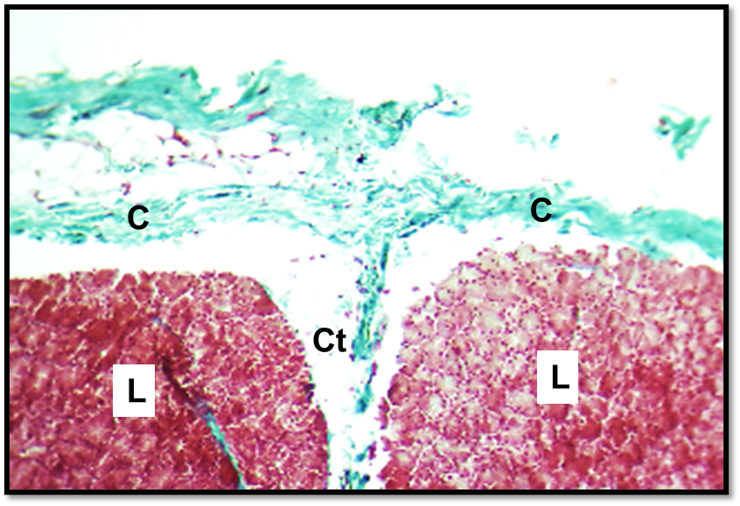
Figure 1: Cross histological section of parotid salivary gland of cat show: capsule (c), lobules (L), interlobular connective tissue (Ct). Masson trichrom stain. x100.
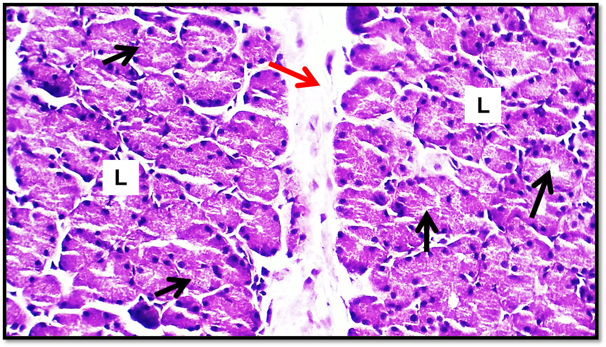
Figure 2: Cross histological section of parotid salivary gland of cat show: lobules (L), interlobular connective tissue (red arrow), serous secretory unit (black arrow). H&E stain.x200.
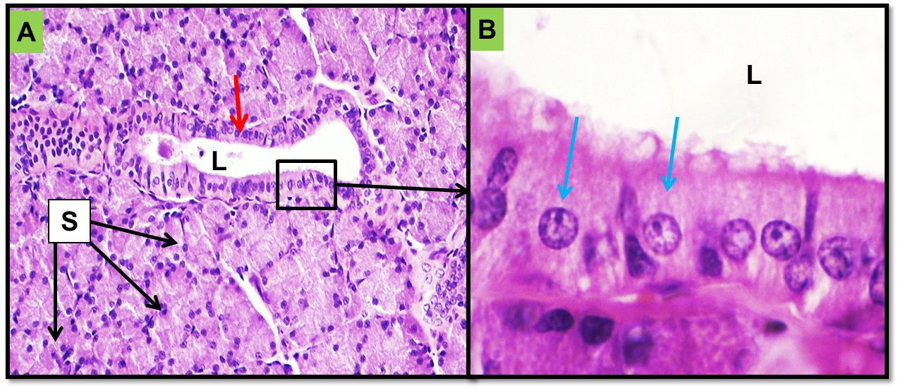
Figure 3: Cross histological section of parotid salivary gland of cat show: serous secretory unit (S), excretory duct (red arrow), lumen of excretory duct (L), simple high cuboidal epithelium (blue arrow). H&E stain.x200. B: Magnified section of excretory duct epithelium. X1000.
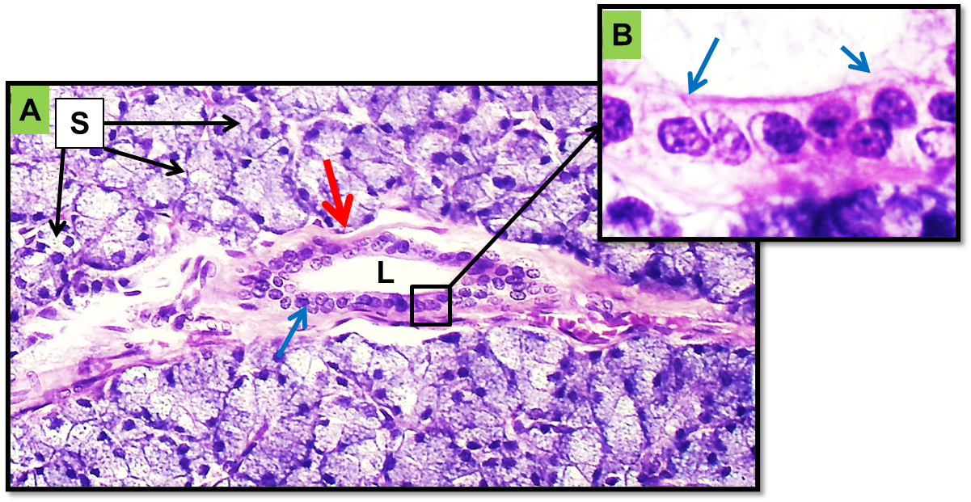
Figure 4: Cross histological of parotid salivary gland of rabbit show: serous secretory unit (S), excretory duct (red arrow), lumen of excretory duct (L), simple high cuboidal epithelium (blue arrow). H&E stain.x200. B: Magnified section excretory duct epithelim. X1000.
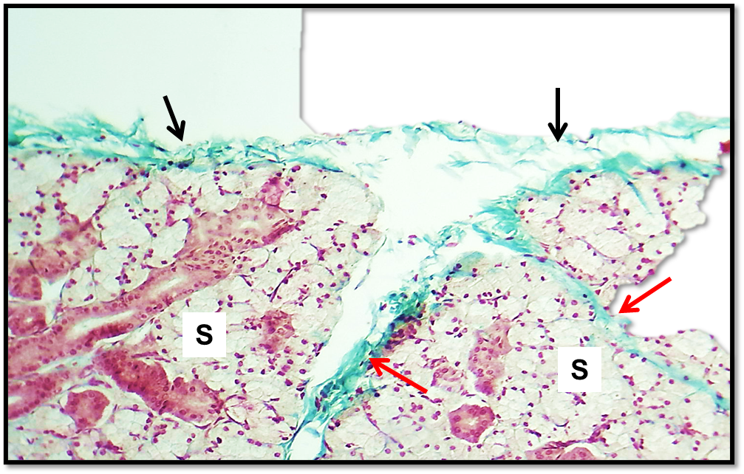
Figure 5: Cross histological section of sub mandibular salivary gland of cat show: connective tissue capsule (black arrow), secretory unit (S), interlobular connective tissue (red arrow). Masson trichrom stain. x100.
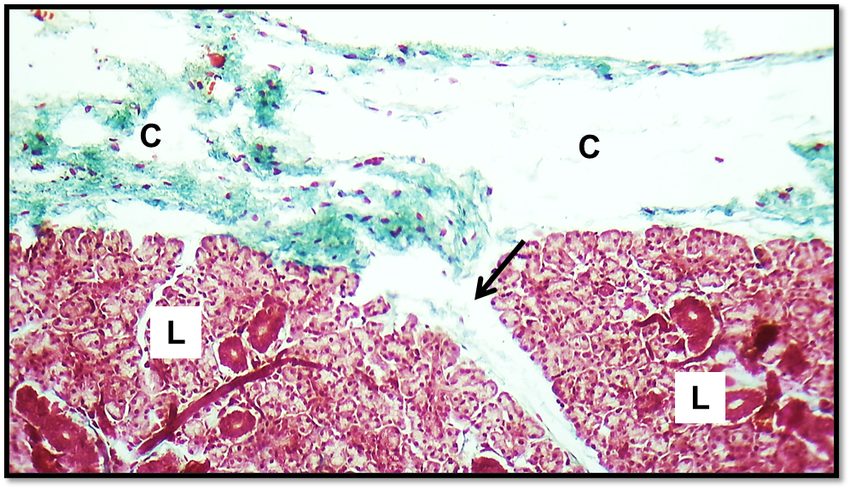
Figure 6: Cross histological section of sub mandibular salivary gland of rabbit show: connective tissue capsule (C), inter lobular connective tissue (black arrow), lobule of mandibular salivary gland (L). Masson trichrom stain.x100.
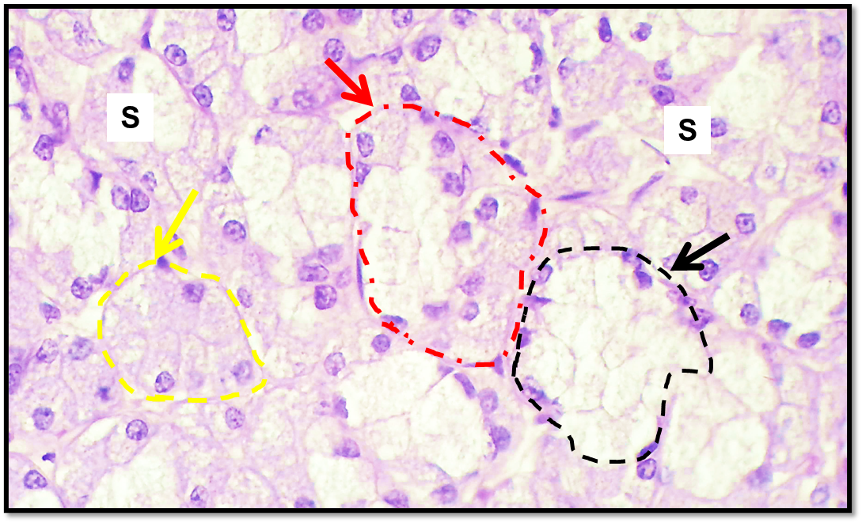
Figure 7: Cross histological section of sub mandibular salivary gland of cat show: secretory unit (S), mucus secretory unit (black arrow), serous secretory unit (yellow arrow), mixed secretory unit (red arrow). H&E stain.x400.
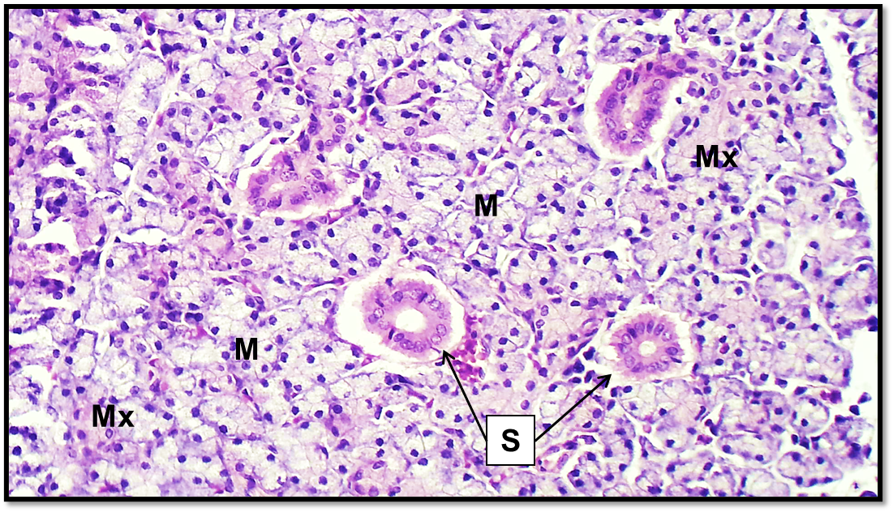
Figure 8: Cross histological section of sub mandibular salivary gland of rabbit show: mucous secretory unit (M), mixed secretory unit (Mx), striated duct (S). H&E stain.x200.
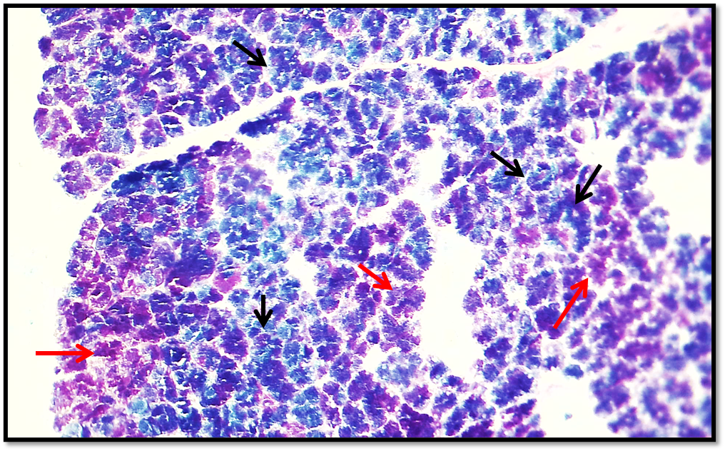
Figure 9: Cross histological section of parotid salivary gland of cat show: the secretory unit was giving positive reaction for AB&PAS, some of them give positive reaction for PAS stain that give indicate for neutral secretion (red arrow), and the other was give positive reaction for AB stain that secretion was acidic (black arrow). AB&PAS combination stain. X100.
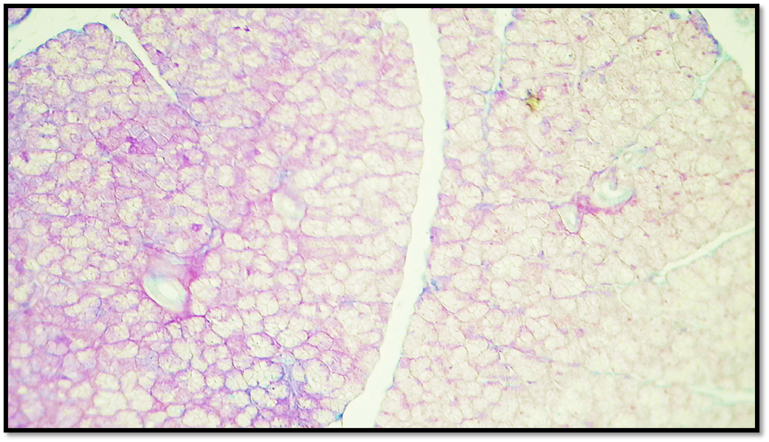
Figure 10: Cross histological section of parotid salivary gland of rabbit show: the secretory unit was giving moderate positive reaction for PAS stain and weak positive reaction for AB stain l. AB&PAS combination stain. X100.
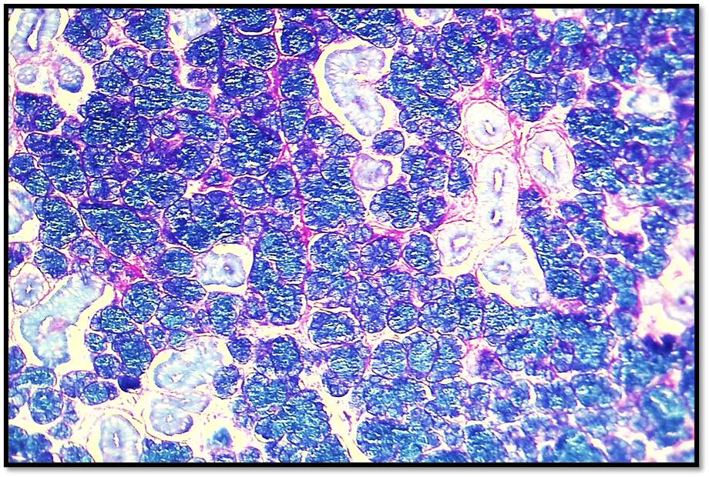
Figure 11: Cross histological section of sub mandibular salivary gland of cat show: the secretory unit was giving positive reaction for PAS stain and strong positive reaction for AB stain that give indicate for the secretion was neutral and acidic. AB&PAS combination stain. X100.
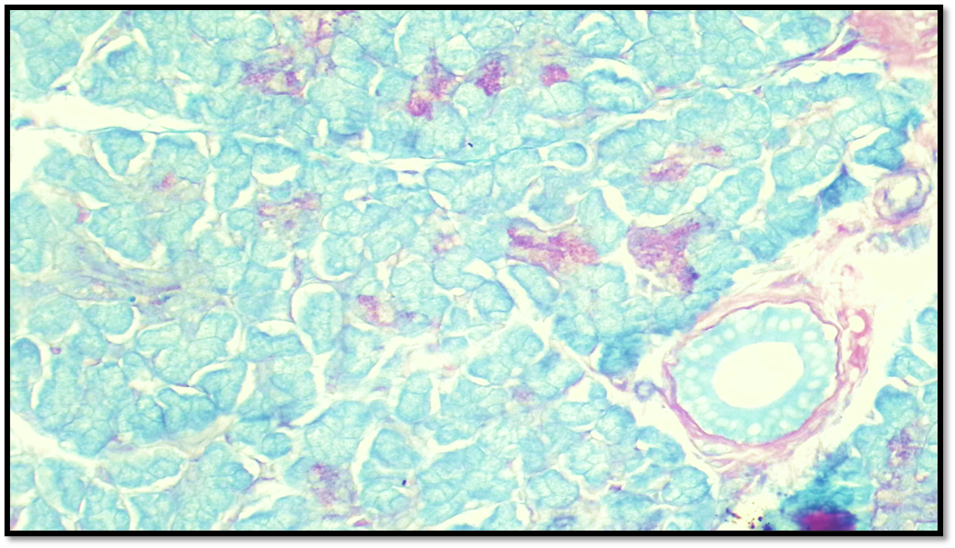
Figure 12: Cross histological section of sub mandibular salivary gland of rabbit show: the secretory unit was giving moderate positive reaction for PAS stain and moderate positive reaction for AB stain that give indicate for the secretion was neutral and acidic. AB&PAS combination stain. X200.
- Conclusions
Microscopically, parotid salivary gland on both animals is solely serous in nature, and the duct system begins with striated duct, excretory duct and main duct. The submandibular gland in cats has more mucous acini, middle number of serous acini and minimal mixed acini. The gland in rabbits was compact and contained more mucous, mixed and a few pure serous glands. The duct system started with the striated duct, excretory duct and the main duct.
Histochemically: the parotid gland of the cat had only serous acini; the basement membrane and duct system give a strong positive reaction to the AB–PAS stain. In case of at rabbit, the secretory unit, basement membrane and duct system have moderate to positive responses to PAS and weak to negative responses to AB. The submandibular gland of the cat has mixed acini that have a strong positive response to PAS and a very strong response to AB; the basement membrane, but not the duct system, has a strong response to PAS; the duct system, but not the basement membrane, has a positive response to AB. While in the French loop, the gland with mixed acini and basement membrane gives a moderate positive reaction for PAS-AB, while the duct system only gives a moderate positive reaction for AB.

Declarations
Funding: This research received no external funding.
Acknowledgement: I would like to express my special appreciation and special thanks to our college for its support.
Conflicts of Interest: The author declares no conflicts of interest regarding the publication of this paper.
Ethics Statement:
The study was approved by the institutional ethics committee and conducted according to animal care guidelines.
Generative AI Statements: The author declare that no Gen AI/DeepSeek was used in the writing/creation of this manuscript.
References
Abouelela, A. A., El-Gendy, S. A., & Farag, F. M. (2021). Comparative anatomical and histological study of the parotid and submandibular salivary glands in some domestic mammals. Journal of Veterinary Anatomy, 14(2), 45–58.
Al-Saffar, F. J., & Simawy, M. S. H. (2014). Histomorphological and histochemical study of the major salivary glands of adult local rabbits. International Journal of Advanced Research, 2(11), 378–402.
Amano, K., & Iwase, S. (2024). Distribution and ultrastructure of myoepithelial cells in mammalian salivary glands. Journal of Morphological Sciences, 41(1), 55–68.
Anderson, J. (2011). An introduction to routine and special staining. Leica Biosystems.
Chibly, A. M., Aure, M. H., Patel, V. N., & Hoffman, M. P. (2022). Salivary gland function, development, and regeneration. Physiological Reviews, 102(3), 1495–1552.
Doğan, N., Alkan, Z., & Ergin, M. (2025). Gross anatomical and morphometric study of the major salivary glands in domestic mammals. Turkish Journal of Veterinary and Animal Sciences, 49(3), 240–257.
Ekström, J., & Khosravani, N. (2020). Functional anatomy and adaptive significance of the salivary glands in herbivorous mammals. Journal of Comparative Physiology B, 190(6), 665–678.
Elewa, Y. H. A., Ahmed, A. M., & Hassan, S. M. (2010). Histochemical study of salivary glands in rabbits. Journal of Veterinary Anatomy, 3(2), 45–56.
Field, A. (2017). Discovering statistics using IBM SPSS statistics. SAGE Publications.
Hamzah, K. J., Mahmood, A. K., & Saad, M. H. (2019). Comparative study of blood pressure between local breed and different breed of dogs in Iraq. Biochemical & Cellular Archives, 19(2).‏
Harrison, J. D., Auger, D. W., Paterson, K. L., & Rowley, P. S. (1987). Mucin histochemistry of salivary glands. Histochemical Journal, 19(10–11), 555–564.
Johnson, F. R. (2020). Anatomical and histological organization of salivary glands in mammals. International Journal of Veterinary Anatomy, 9(1), 12–25.
Kenhub. (2023). Parotid gland – Anatomy, location and function. Kenhub Medical Atlas.
Klećkowska-Nawrot, J., Barszcz, K., Miniajluk, J. P., Melnyk, O., & Goździewska-Harłajczuk, K. (2023). Comparative histology of salivary glands. Animals, 13(10), 1684.
Korim, K. B., Hassan, A. H., & El-Sayed, M. A. (2024). Morphometrical adaptations of salivary glands. Journal of Veterinary Anatomy, 17(1), 33–44.
König, H. E., & Liebich, H. G. (2020). Veterinary anatomy of domestic mammals (7th ed.). Schattauer Verlag.
Massoud, H. M. (2023). Histochemical study of salivary glands. Journal of Veterinary Morphology, 44(3), 188–204.
Mizrachi, D., Cohen, N., & Levi, R. (2016). Fibroelastic stroma in salivary glands. Journal of Microscopic Anatomy, 229(4), 351–359.
Mohammed, S. H. S., Salim, S. A. K., Mustafa, F., Amina, I. J., Dunia, M., & Ranin, S. (2024). Anatomical and histological study of the female reproductive system of green freshwater turtle (Chelonia mydas) during breeding season in Iraq. World Veterinary Journal, 14(1), 26–32.
Musumeci, G. (2014). Past, present and future: Overview on histology and histopathology. Journal of Histology & Histopathology, 1(1), 5.
Onwuaso, M. C., Ibe, C. S., & Nwosu, M. O. (2015). Histochemical studies of salivary glands. African Journal of Morphological Sciences, 8(1), 21–33.
Pantanowitz, L., & Dezube, B. J. (2019). The use of periodic acid–Schiff stain in diagnostic pathology. Archives of Pathology & Laboratory Medicine, 143, 599–602.
Prophet, E. B., Mills, B., Arrington, J. B., & Sobin, L. H. (2021). Laboratory methods in histotechnology.
Ranieri, F., & Gatta, R. (2025). Histochemical differentiation of salivary glands. Acta Histochemica, 127(2), 145–159.
Roa, I., & del Sol, M. (2019). Morphological study of parotid gland in rodents. International Journal of Morphology, 37(2), 641–646.
Sabreen, M., Jafar, G. A., Ahlam, J. H., Salim, S. A., Ekhlas, A., Mohammed, S. H., Osama, M., Mustafa, F., & Dunia, M. (2025). Morphological and histological investigation of prenatal development of spleen in local Awassi sheep fetuses. Journal of Animal.
Sherif, M. H., El-Sayed, A. M., & Abdel-Rahman, S. (2018). Histochemical alterations in salivary glands. Egyptian Journal of Veterinary Pathology, 16(4), 209–222.
Shostak, S. (2013). Histology’s nomenclature: Past, present and future. Biology Systems: Open Access, 2, 122. https://doi.org/10.4172/2329-6577.1000122
Singh, J., Kinjavdekar, P., Aithal, H. P., Pawde, A. M., & Udehiya, R. (2013). Evaluation of ketamine-based anesthesia protocols in rabbits. Veterinary World, 6(8), 555–558.
Sisto, M. (2019). Ultrastructural features of salivary glands. Histology and Histopathology, 34(10), 1097–1110.
Suvarna, S. K., Layton, C., & Bancroft, J. D. (2012). Bancroft’s theory and practice of histological techniques (7th ed.). Elsevier.
Suvarna, S. K., Layton, C., & Bancroft, J. D. (2018). Bancroft’s theory and practice of histological techniques (8th ed.). Elsevier.
Titford, M. (2009). Development of microscopical techniques. Journal of Histotechnology, 32(1), 9–19.
Titford, M., & Bowman, B. (2012). Future of histotechnology. Laboratory Medicine, 43(Suppl. 2), e5–e10.
Tutunaru, A. C., Leau, F., Sonea, A., & Sandersen, C. (2013). Ketamine anesthesia in rabbits. Scientific Works. Series C. Veterinary Medicine, 59(1), 81–84.

