Declarations
Invited by: Invited by Dr. Muhammad Mubashar Zafar, Institute of Cotton Research, Chinese Academy of Agricultural Sciences, China
Funding: This work was supported by the National Tropical Agriculture Science and Technology Innovation Project for the Chinese Academy of Tropical Agricultural Sciences (CATAS202617）Conflicts of Interest: The authors declare no competing interest.
Data Availability: Data will be made available on request.
Ethics Statement: This study involved only plants and pest materials collected from natural freshwater habitats. No experiments involving human participants or animals were conducted. Therefore, ethical approval was not required. All sample collection and experimental procedures were carried out in accordance with relevant institutional guidelines and local regulations.
Author’s Contributions: Khubaib Shakoor: Sample collection, Investigation, Formal analysis, original draft, revision. Umer Imtiaz: Manuscript revision. Review, Validation, Project. Deguan Tan: Formal analysis, Data curation, Revision. Jiaming Zhang: Writing review and editing, Conceptualization, Supervision, Funding acquisition.
Generative AI Statements: The authors declare that no Gen AI/DeepSeek was used in the writing/creation of this manuscript.
Publisher’s Note: All claims stated in this article are exclusively those of the authors and do not necessarily represent those of their affiliated organizations or those of the publisher, the editors, and the reviewers. Any product that may be evaluated/assessed in this article or claimed by its manufacturer is not guaranteed or endorsed by the publisher/editors.

Feeding Ecology and Management of the Invasive Apple Snail P. canaliculata in Duckweed Production Systems
Khubaib Shakoor ^{1,2}, Umar Imtiaz^{1,2}, Deguan Tan¹*, and Jiaming Zhang^{1,2}*
¹Institute of Tropical Bioscience and Biotechnology, Chinese Academy of Tropical Agricultural Science, Hainan, China
²College of Plant Science and Technology, Huazhong Agricultural University, Wuhan 430070, China
*Corresponding authors: zhangjiaming@catasitbb.cn (JZ); tandeguan@catasitbb.cn (DT)
Emails: Khubaib Shakoor, khubaibsulahria143@gmail.com; Umer Imtiaz, imtiaz@webmail.hzau.edu.cn
ORCID Numbers: Jiaming Zhang, 0000-0002-5529-1074; Khubaib Shakoor, 0009-0000-5231-2549; Umer Imtiaz, 0009-0003-8690-2637;

Abstract
The invasive apple snail Pomacea canaliculata poses a serious threat to duckweed-based agricultural systems due to its intense grazing activity. Despite this risk, there is limited quantitative information on the extent of damage caused by this species and on practical methods to reduce its impact. In this study, we investigated the feeding behavior of P. canaliculata on duckweed and evaluated potential mitigation strategies under controlled laboratory conditions. Snails collected from Haikou, Hainan Province, China, were identified using a combination of morphological characteristics and molecular analyses of mitochondrial COI and 16S rRNA genes, confirming their species identity. A series of feeding experiments was conducted to examine how starvation duration, temperature, duckweed surface density, duckweed species (Spirodela polyrhiza and Lemna aequinoctialis), and snail body weight influenced grazing intensity. The results showed that food consumption increased markedly with longer starvation periods, reached its highest level at moderate temperatures, and was greater when duckweed surface density was low. Snails consumed significantly more L. aequinoctialis than S. polyrhiza, and larger individuals exerted substantially higher grazing pressure than smaller ones. In addition, protective experiments evaluated the effectiveness of different concentrations of nutritional medium (E-Medium), niclosamide, and tea saponin in reducing snail damage. All treatments reduced grazing activity and promoted duckweed biomass in a concentration-dependent manner. However, high concentrations of niclosamide and tea saponin caused noticeable phytotoxic effects on duckweed, even in the absence of snails. Moderate concentrations provided the best balance between effective snail control and duckweed preservation. Overall, this study demonstrates the severe impact of P. canaliculata on duckweed cultivation and emphasizes the importance of integrated management strategies that combine ecological understanding of snail feeding behavior with carefully optimized control measures to ensure sustainable duckweed production.
Keywords: P. canaliculata; duckweed cultivation; L. aequinoctialis; S. polyrhiza; integrated pest control.

Introduction
Duckweeds (subfamily Lemnoideae; family Araceae) are diminutive, free-floating aquatic plants noted for their remarkably swift vegetative reproduction and elevated biomass yield, rendering them appealing for contemporary "duckweed farming" focused on protein generation, feed/food utilization, and environmental functions such as nutrient recovery from wastewater. A new assessment highlights the extensive industrial potential of duckweed species and the necessity to optimize growing conditions for specific purposes (Baek et al., 2021). In practical production settings, controlled culture strategies are increasingly being examined to stabilize yields and mitigate biological risks. Coughlan et al. describe indoor "duckweed bioreactors," noting that doubling times as brief as 1.24 days have been observed under such conditions. They propose stacked systems with up to 15 m² of duckweed per 1 m² of floor space, facilitated by a shallow water depth of approximately 5 cm (Coughlan et al., 2022). These advancements endorse the viability of extensive duckweed cultivation, while simultaneously underscoring the necessity to comprehend and mitigate biotic limitations, such as herbivorous damage. A primary factor influencing duckweed crop advancement is its nutritional significance. A new research highlights that specific duckweed species can possess a high protein content (up to 45%) and indicates that duckweed protein can supply essential amino acids in accordance with FAO reference patterns (Xu et al., 2023). These features enhance the appeal of duckweed as a sustainable protein source, rendering the safeguarding of duckweed biomass from pests a significant practical concern. The invasive apple snail P. canaliculata is commonly linked to harm inflicted on wetland flora and aquatic agriculture among aquatic herbivores. The apple snail, P. canaliculata, is an invasive species that significantly affects wetland flora and water agriculture. Although capable of utilizing various trophic supplies through distinct feeding methods, it is typically classified as a macrophytophage (Manara et al., 2024). This ambiguity highlights the necessity of controlled feeding studies in crop-relevant environments, such as duckweed farming systems, to assess grazing damage and relative vulnerability among duckweed taxa.
Precise identification of Pomacea species is crucial for associating observed crop damage with the relevant pest and for determining suitable treatment measures. A 2024 countrywide study from China indicates that P. canaliculata and P. maculata have frequently been conflated as a single species owing to physical resemblance, and the scientists employed COI (mtDNA) markers to investigate genetic diversity and structure (Wei et al., 2024). These findings support the use of combined morphological assessment plus molecular confirmation in studies that evaluate pest damage and management. In addition to damage characterization, duckweed farming requires practical protection options that do not compromise crop health or downstream use. Chemical molluscicides remain commonly used in some settings. For example, report metaldehyde toxicity values for adult P. canaliculata with median lethal concentrations of 3.792, 2.195, 1.833, and 1.706 mg/L at 24, 48, 72, and 96 h, respectively, and they document enzyme activity changes and histopathological damage under exposure (Liu et al., 2024). Such data are useful for understanding efficacy and potential biological impacts, but duckweed-specific protection protocols must also consider non-target effects on duckweed growth and recovery. Therefore, this study presents preliminary investigations into the damage and protection of duckweed farming systems threatened by P. canaliculata. Specifically, we confirm species identity using integrated morphological and molecular analyses, quantify feeding induced damage to two duckweed species, Spirodela polyrhiza and Lemna aequinoctialis, and assess post-feeding protection using pesticide or chemical treatments aimed at controlling P. canaliculata while maintaining duckweed viability. Invasive freshwater molluscs are increasingly recognized as major drivers of ecological change and economic loss, particularly in aquatic agroecosystems where biological invasions interact strongly with human land use and climate trends. The invasive apple snail P. canaliculata is regarded as one of the most detrimental freshwater invaders due to its rapid population expansion, extensive feeding range, and significant resistance to environmental fluctuations. Recent dispersion modeling and synthesis studies indicate that anthropogenic dispersal, coupled with climate change, is expected to exacerbate invasion risk and amplify repercussions in conducive areas (Huang et al., 2026). The successful invasion of P. canaliculata is facilitated by both its life historical characteristics and the development of molecular resources that enhance comprehension of its adaptation, dissemination, and pest potential. Recent whole-genome research elucidates the genetic underpinnings of invasiveness and enhances the creation of superior monitoring and management systems (Lu et al., 2024). Moreover, physiological and microbiome-centric research indicates that thermal stress might modify internal biological mechanisms in P. canaliculata, underscoring the significance of environmental context in assessing feeding harm and management strategies in both laboratory and field settings (Li et al., 2022).
Duckweed (Lemnaceae) is progressively planted for high-yield biomass generation and subsequent applications, including food and value-added bioproducts, with an increasing interest in scalable agricultural systems. Recent evaluations highlight the swift expansion, adaptable cultivation methods, and increasing farm-to-fork potential of duckweed, thereby underscoring the growing significance of crop protection as production scales up (Ujong et al., 2025). As duckweed production expands, herbivory by generalist aquatic herbivores like P. canaliculata may significantly hinder productivity; yet quantitative data connecting feeding ecology to effective conservation techniques in duckweed systems is still scarce. The management of P. canaliculata has predominantly depended on chemical molluscicides and physical extraction; however, there is a growing focus on safer and more sustainable methodologies. Recent evaluations encapsulate prevailing trends in biological and environmentally sustainable control tactics for invasive apple snails, encompassing phytochemical agents and integrated approaches aimed at diminishing dependence on highly toxic interventions (Azmi et al., 2022). Simultaneously, recent applied research are assessing alternate control methods, such as attractant-based strategies, which may facilitate environmentally sustainable suppression in contexts where chemical usage is restricted (Suzuki et al., 2025). Recent studies have evaluated “eco-friendly” agricultural chemicals and plant extracts exhibiting molluscicidal properties against P. canaliculata, hence reinforcing the interest in botanical control alternatives (Cho et al., 2023). Considering the growing significance of duckweed cultivation and the ongoing issue of apple snail invasion, there is a distinct necessity for research that quantifies grazing damage influenced by critical environmental and biological factors (e.g., temperature, food availability, and consumer size) while concurrently assessing protection strategies and their potential non-target effects on duckweed growth. This study investigates the feeding ecology of P. canaliculata on duckweed and evaluates concentration-dependent protective methods to reconcile snail management with the safety and productivity of duckweed.

Materials and Methods

Study Area and Sample Collection
Duckweed and snail specimens were gathered from freshwater environments in Haikou, Hainan Province, China, where high duckweed growth and snail infestations were noted. To reduce stress, collected snails were brought to the lab in aerated containers with site water. In order to preserve freshness, duckweed samples were gathered concurrently and transferred in sterile containers.
Before being used in experiments, snails were acclimated in the lab for acclimatization duration, e.g., 48–72 h under controlled circumstances (temperature28 °C, photoperiod, e.g., 12 h light: 12 h dark). For further analysis, only adult snails of comparable size that were healthy and active were chosen.

Cultivation of Duckweed Strains
Before being tested, duckweed cultures were cleaned of dirt and non-target organisms using clean water. S. polyrhiza and L. aequinoctialis, two kinds of duckweed, were employed in this investigation. Stock cultures E-Stock 1 (KNO₃), E-Stock 2 [Ca(NO₃)₂·4H₂O], E-Stock 3 (KH₂PO₄ and MgSO₄·7H₂O), E-Stock 4 (trace elements: H₃BO₃, MnCl₂·4H₂O, ZnSO₄·7H₂O, CuSO₄·5H₂O, Na₂MoO₄·2H₂O), and E-Stock 5 (iron chelate: FeCl₃·6H₂O and Na₂EDTA) were prepared separately. The working medium was obtained by diluting 10mL each of E-Stocks 1, 2, 3, and 5(100X) and 1mL of E-Stock 4(1000X) into 2000mL of distilled water, followed by sterilization at 121°C for 15min. After cooling, the medium was aseptically dispensed into sterile culture vessels. Prior to inoculation, duckweed plants were surface-sterilized by immersion in 1% sodium hypochlorite for 1–2min followed by repeated rinsing with sterile distilled water. Surface sterilization was confirmed by repeated subculturing were kept in nutrient medium at room temperature with light intensity (Imtiaz et al., 2026). To guarantee steady development, cultures were acclimated to lab conditions before feeding and control trials.

Morphological analysis of P. canaliculata
Morphological identification of P. canaliculata was conducted following established taxonomic descriptions of apple snails. Diagnostic shell characteristics including shell size, shape, deep suture pattern, whorl configuration, aperture morphology, and operculum structure were examined under a stereomicroscope. Representative specimens were photographed, and observed traits were compared with published morphological accounts to preliminarily confirm species identity (shell globosity, indented sutures, large oval aperture) before molecular validation (conventional taxonomy of Pomacea spp.) (Banerjee et al., 2022).

Molecular analysis of P. canaliculata
Genomic DNA was extracted from foot muscle tissue of P. canaliculata specimens using a CTAB-based protocol. DNA quality and concentration were assessed using spectrophotometry and extracted DNA was stored at −20 °C until further analysis.Molecular identification of P. canaliculata was performed using two mitochondrial gene markers: cytochrome c oxidase subunit I (COI) and 16S ribosomal RNA (16S rRNA) were amplified by polymerase chain reaction (PCR) as previously described (Kannan et al., 2020). Details of the PCR reaction mixture composition are provided in Table.1. PCR amplification of the COI gene was carried out using the universal invertebrate primers LCO1490 (5′-GGT CAA CAA ATC ATA AAG ATA TTG G-3′) and HCO2198 (5′-TAA ACT TCA GGG TGA CCA AAA AAT CA-3′). The 16S rRNA gene was amplified using primers 16Sar (5′-CGC CTG TTT ATC AAA AAC AT-3′) and 16Sbr (5′-CCG GTC TGA ACT CAG ATC ACG T-3′). The PCR conditions were pre-denatured at 94ºC for 4min, followed by 30 cycles at 94ºC, 30s; 58ºC, 45s; 72ºC, 1min, and a further extension at 72ºC for 7min. The reaction conditions were pre-denatured at 94ºC for 4min, followed by 30 cycles of 94ºC, 30s; 53ºC, 45s; 72ºC, 1min, and a further extension at 72ºC for 7min (Imtiaz et al., 2026).

Table 1. PCR Reaction mixture Compsition
Components | Volume (μL)
2x Taq PCR master mix with dye (Tiangen, KT211) | 19
Forward Primers | 2
Reverse Primers | 2
DNA Template | 2
Nuclease Free-Water | 25
Total Volume | 50

Sequence processing and phylogenetic analysis
Sequence chromatogram files were processed using MacVector v18.2 (MacVector, Inc., USA) for trimming, editing, and quality assessment. Low-quality regions, primer sequences, and ambiguous nucleotide positions were manually removed, and forward and reverse reads were assembled to generate consensus sequences. Sequences containing more than 2% ambiguous sites or unclear chromatogram signals were re-sequenced to ensure data quality. Multiple sequence alignments were performed in MacVector using the ClustalW algorithm with a gap opening penalty of 15.0, a gap extension penalty of 6.66, and a divergent delay of 30%. Aligned sequences were subsequently imported into MEGA11 for downstream analyses (Tamura et al., 2021). Nucleotide substitution patterns were estimated using the Tamura–Nei model (Tamura & Nei, 1993). and phylogenetic relationships were inferred using the Neighbor-Joining method with 1,000 bootstrap replicates to assess branch support. To validate taxonomic classification, representative reference sequences of P. canaliculata, P. maculata, and related species were obtained from GenBank and incorporated into the analysis. Genetic diversity metrics, such as haplotype diversity (Hd), nucleotide diversity (π), and Watterson’s theta (θw), were computed utilizing DnaSP v6.12.03 (Rozas et al., 2017). Final consensus sequences were compared to the NCBI GenBank database using BLASTn to verify species identity.

Feeding Experiments and Experimental Design
Feeding experiments were conducted to evaluate the effects of starvation duration, temperature, duckweed surface density, duckweed species, and snail body weight on feed intake of P. canaliculata under controlled laboratory conditions. Experimental approaches followed standard grazing assay methods used in freshwater snail feeding studies (e.g., laboratory herbivory trials on macrophytes) and have been applied in recent invasive snail research (Ismail et al., 2021). Small plastic containers filled with dechlorinated water were used for all treatments, with each experimental unit consisting of two snails and three independent replicates per treatment, and treatments randomly assigned. S. polyrhiza and L. aequinoctialis were chosen as representative floating macrophytes for the feeding assays because they are common, rapidly growing duckweed species widely used in aquatic plant research and laboratory feeding studies. Duckweeds provide a standardized food source for herbivory experiments involving freshwater snails (e.g., ecological and toxicology studies of aquatic plants), and P. canaliculata is a known generalist feeder on macrophyte vegetation, which supports the use of floating plants in controlled feeding trials (Manara et al., 2024). Feed intake was quantified as the difference between initial and final duckweed biomass after the trial, with control containers without snails maintained to correct for non-consumptive biomass change. The effect of starvation was assessed by depriving snails of food for 0, 24, 48, or 72 h prior to 24-h feeding trials. The impact of temperature was assessed by monitoring consumption at 20, 24, 28, and 32 °C, in accordance with prior research investigating thermal influences on apple snail grazing behavior and feeding capacity (Miyata & Nakatsubo, 2024). The influence of duckweed surface density was tested by varying plant coverage across container sizes to simulate feeding availability gradients. Species-specific feeding responses were assessed by offering S. polyrhiza or L. aequinoctialis separately for seven consecutive days, with daily measurements and biomass replenishment. Finally, to examine the effect of snail body weight, individuals were grouped by size classes and allowed to feed for five days, with daily and cumulative feed intake calculated, a method comparable to size-dependent feeding experiments in gastropod ecology.

Protection Strategies Against Snail Damage
Protection experiments were conducted over a seven-day period to evaluate the effectiveness of Niclosamide, tea saponin, and nutrient medium strength (E-Medium) in reducing P. canaliculata grazing damage on duckweed under controlled laboratory conditions. Recent investigations have proven the efficacy of Niclosamide and plant-derived saponins as molluscicidal agents against P. canaliculata in the context of chemical and botanical management techniques for invasive apple snails (Lu et al., 2025) . All studies were conducted in polypropylene containers containing dechlorinated water, with three independent replicates per treatment and three snails of similar body weight per container, adhering to established laboratory bioassay techniques for freshwater gastropods (Miyata & Nakatsubo, 2024). Snail mortality was recorded after 72 h of exposure, a commonly used endpoint in molluscicide toxicity and efficacy assessments (Yang et al., 2023), while duckweed biomass was measured at the end of the seven-day experimental period to evaluate protection efficacy and potential phytotoxic effects. In the E-Medium assay, Spirodela polyrhiza and three snails were exposed to four E-Medium concentrations plus a control without E-Medium, reflecting the use of defined nutrient media to regulate duckweed growth under controlled experimental conditions (Pasos-Panqueva et al., 2024). For Niclosamide and tea saponin treatments, eight treatments were established at four concentrations, with treatments T1–T4 containing both snails and duckweed and treatments T5–T8 containing duckweed only to assess direct effects on duckweed in the absence of grazing. Snail mortality was recorded in snail-containing treatments after 72 h, and final duckweed biomass was measured in all treatments at the conclusion of the experiment.

Statistical Analysis
DNA sequence chromatograms were assembled and edited using MacVector software. Multiple sequence alignments were performed prior to downstream analyses. Phylogenetic analyses were conducted using MEGA version 11, employing appropriate nucleotide substitution models and tree-building methods. Node support was assessed using bootstrap analysis with 1,000 replicates. All physiological and biochemical experimental data were analyzed using Microsoft Excel version 365 and STATISTIX software (version 9.1). Prior to analysis, normality was assessed using the Shapiro Wilk test. Differences among treatments were evaluated using one-way analysis of variance (ANOVA). Statistically significant differences were detected; mean values were compared using Tukey’s HSD test. Results are presented as mean ± standard deviation (SD), and differences were considered statistically significant at p < 0.05.

Results

Morphological Analysis of P. canaliculata
The morphological analysis of the specimens obtained diagnostic traits aligned with P. canaliculata. The shell was spherical and sturdy, featuring well-defined whorls and prominent sutures (Figure 1). The shell exhibited a color spectrum from light brown to dark olive, with a somewhat high spire. The aperture was broad and oval, featuring a thickened lip, and was sealed by a well-formed operculum (Figure 1). The cephalic area had paired tentacles, with ocular structures situated at the base of the tentacles. A large, muscular foot was observed, extending beyond the shell aperture during locomotion (Figure 1). Overall, the combination of shell morphology, aperture structure, operculum presence, and soft-body features observed in the specimens matched the established morphological descriptions of P. canaliculata, supporting species-level identification. The observed morphological characteristics of the collected specimens were consistent with registered descriptions of P. canaliculata (Table.2).
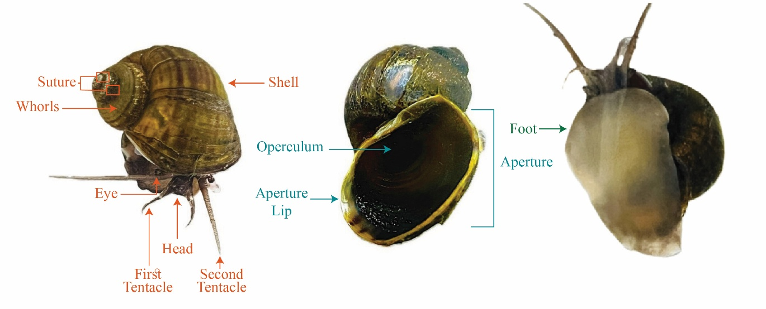
Figure 1. Morphological features of P. canaliculata examined in this study.
The figure shows the globose shell with distinct whorls and sutures, wide aperture with a thick aperture lip, operculum, head region with paired tentacles and eyes, and the muscular foot. These diagnostic characteristics are consistent with species-level identification of P. canaliculata.

Table 2: Comparison of observed morphological traits with registered species
Characteristics | Morphology  (Registered Species)  P. canaliculate | Morphology  (used in this study)  P. canaliculate | References
Shell Shape | Globose, rounded,  large body whorl | Globose with a  large body whorl | (Hayes et al., 2012)
Shell Color | Yellowish to dark brown | Dark brown, yellow | (Joshi & Sebastian, 2006)
Aperture | Wide, oval and elongated | Wide and oval | (Cowie, 2002)
Aperture Lip | Yellow, orange to brown | Yellowish and thin | (Hayes et al., 2012)
Operculum | Corneous, thin, dark  brown with concentric  rings | Corneous, dark  brown and  concentric rings  visible | (Cowie, 2002)
Whorls | 5–6 rounded whorls with  deep sutures and rapid  diameter increase | Rounded spiral  whorls increasing  in size | (Cowie, 2002)
Sutures | Deeply channeled suture | Lines where whorls  meet and deeply indented | (Joshi et al.)
Head | Well  developed, tentacles  and eyes at base | Well, developed,  contains mouth,  eyes, tentacles | (Andrews, 1965)
Eye | Simple eye for light  and movement detection | Located at base of  tentacle; simple  structure | (Hayes et al., 2012)  (Andrews, 1965)
First Tentacle | Sensory function,  food and  environmental  detection | Tactile and  chemosensory  function | (Hayes et al., 2012)  (Andrews, 1965)
Second Tentacle | Tactile and  chemical sensing | Similar sensory  function | (Hayes et al., 2012)  (Andrews, 1965)
Foot | Muscular locomotory  organ with gland cells | Large muscular foot  producing mucus for movement | (Hayes et al., 2012)  (Andrews, 1965)

Tree-Based Identification of P. canaliculata Using COI and 16S rRNA Sequences

Phylogenetic analyses based on mitochondrial COI and 16S rRNA gene sequences supported the identification of the collected specimens as P. canaliculata. In the COI-based phylogenetic tree (Figure 2A), the study sequence (HN snail COI) grouped together with reference sequences of P. canaliculata and P. insularum. This grouping is supported by high bootstrap values (100%), indicating strong statistical support for the clustering. However, the P. canaliculata sequences are not separated from P. insularum, while P. megastoma, P. maculata and P. diffusa form distinct neighboring clades. The phylogenetic tree further shows that other genera, including Lanistes, Marisa, Bellamya, and Opisthosoma, are positioned in more distant lineages with high bootstrap support, providing clear separation from the Pomacea clade and supporting proper tree rooting.
In contrast to the COI tree, the 16S rRNA-based phylogenetic tree (Figure 2B) separated P. canaliculata and P. insularum into distinct clades, clearly showing that the study sequence (HN snail 16S) belongs P. canaliculata. This grouping is supported by a high bootstrap value (83%), indicating reliable node support. The P. canaliculata clade is clearly distinct from other Pomacea species.
Figure 2: Molecular identification of HN snail based on the COI (A) and the 16S rRNA gene (B) sequences. Representative sequences of Pomacea sp. and related species Lanistes carinatus, Marisa cornuarietis, Bellamya quadrata were retrieved from GenBank. Evolutionary history was inferred using the Neighbor-Joining method. The trees are rooted with the percentage of replicate trees in which the associated taxa clustered together in the bootstrap test (1000 replicates) shown below or beside the branches. The scale bars represent the number of base substitutions per site.

Worldwide distribution of P. canaliculata
The global distribution map (Figure 3A) shows the sampling locations and occurrence records of P. canaliculata included in this study. The species is widely distributed across both its native range in South America and multiple introduced regions, including East and Southeast Asia (notably China, including Hainan), North America, and Europe. The concentration of records in Asia and other non-native regions highlights the extensive spread of P. canaliculata beyond its native range, consistent with its well-known invasive potential. The phylogenetic relationships inferred from mitochondrial 16S rRNA gene sequences do not match the geographic distribution (Figure 3B), indicating a lack of genetic isolation among different geographic populations and the presence of extensive gene flow.
Figure 3: (A) Worldwide distribution map showing sampling locations used in this study, including native (South America) and introduced regions such as East and Southeast Asia (e.g., China, including Hainan), North America, and Europe. (B) Phylogenetic tree inferred from mitochondrial 16S rRNA gene sequences. Bootstrap support values are shown at major nodes. P. diffusa was used as an outgroup.

3.4 Feeding Preferences & Consumption Rates of P. canaliculata on Duckweed Species
Feed intake of the freshwater snail P. canaliculata was significantly influenced by starvation duration, temperature, and duckweed density when fed with S. polyrhiza and L. aequinoctialis (Figure 4). Increasing starvation duration resulted in a progressive increase in feed intake by P. canaliculata, with the lowest consumption observed at 0 h starvation and the highest intake recorded after 72 h (Figure 3A). When fed with S. polyrhiza, the snails showed a steady increase in feed intake across the starvation treatments (Figure 4A). A similar increasing pattern was observed when P. canaliculata was fed with L. aequinoctialis (Figure 4A), indicating that prolonged starvation enhances feeding activity and consumption rate in this species. Temperature also had a significant effect on the feeding behavior of P. canaliculata (Figure 4B). Feed intake increased as temperature rose from 20°C to 28°C, reaching the highest level at 28°C, and subsequently declined at 32°C. When fed with S. polyrhiza, P. canaliculata exhibited the highest feeding rate at 28°C (Figure 4B), suggesting that moderate temperature conditions promote optimal metabolic and feeding activity. Similarly, the snails showed maximum feed intake on L. aequinoctialis at 28°C (Figure 4B), whereas both lower (20°C and 24°C) and higher (32°C) temperatures resulted in reduced consumption. These findings indicate that 28°C represents the optimal temperature for feeding activity of P. canaliculata under experimental conditions. Duckweed density also significantly affected feed intake by P. canaliculata (Figure 5C). Feed consumption increased progressively with increasing duckweed density from 0.0165 g cm⁻² to 0.0811 g cm⁻². When fed with S. polyrhiza, the lowest feed intake occurred at the lowest density, whereas the highest intake was recorded at the highest density (Figure 4C). A similar trend was observed when P. canaliculata was fed with L. aequinoctialis, where feed intake increased consistently with increasing duckweed density (Figure 4C). These results suggest that greater food availability enhances feeding efficiency and consumption rates of P. canaliculata when feeding on duckweed species.
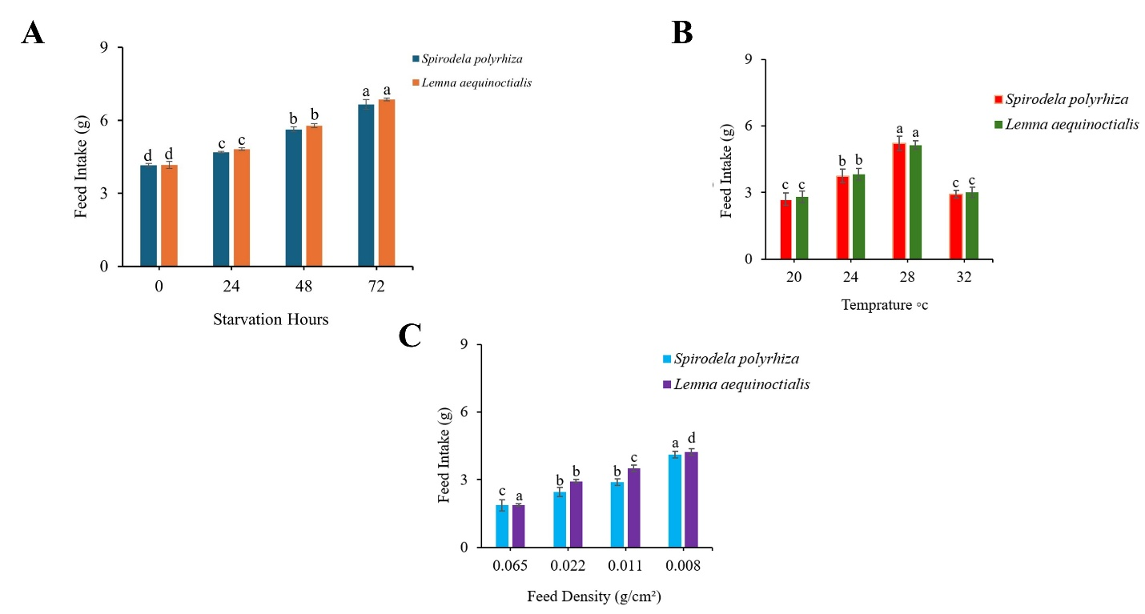
Figure 4. Effects of starvation duration, temperature, and duckweed density on feed intake of the freshwater snail P. canaliculata when fed with S. polyrhiza and L. aequinoctialis. (A) show the effect of starvation duration (0, 24, 48, and 72 h) on feed intake of snails fed with S. polyrhiza and L. aequinoctialis, respectively. (B) illustrate the effect of temperature (20, 24, 28, and 32°C) on feed intake of P. canaliculata feeding on S. polyrhiza and L. aequinoctialis. (C) present the effect of duckweed density (0.0165, 0.0325, 0.0487, and 0.0811 g cm⁻²) on feed intake of P. canaliculata fed with S. polyrhiza and L. aequinoctialis. Values represent mean ± standard error, and different letters above bars indicate significant differences among treatments (p < 0.05).
Duckweed species and snail body weight significantly influenced the feed intake of P. canaliculata (Figure 5). A significant difference in feeding preference was observed between the two duckweed species (Figure 5A). Snails fed with L. aequinoctialis exhibited significantly higher feed intake compared with those fed with S. polyrhiza. The different letters above the bars indicate that the difference between the two treatments was statistically significant (p < 0.05), suggesting that L. aequinoctialis is more readily consumed by P. canaliculata than S. polyrhiza.
Snail body weight also had a significant effect on feeding performance (Figure 5B). Two snail weight groups, 4.5 g and 5.9 g, were used to evaluate the effect of body size on feed intake. The results showed that 5.9 g snails consumed significantly more duckweed than 4.5 g snails when feeding on both S. polyrhiza and L. aequinoctialis. In both duckweed treatments, feed intake increased with increasing snail body weight, indicating that the feeding capacity of P. canaliculata is positively related to body size. Statistical analysis confirmed that the differences between the two weight groups were significant (p < 0.05), as indicated by the different letters above the bars. These findings demonstrate that larger individuals of P. canaliculata have a greater feeding capacity and are able to consume higher amounts of duckweed compared with smaller snails. Overall, these results demonstrate that both duckweed species and snail body weight play important roles in determining the feeding behavior and consumption rate of P. canaliculata.
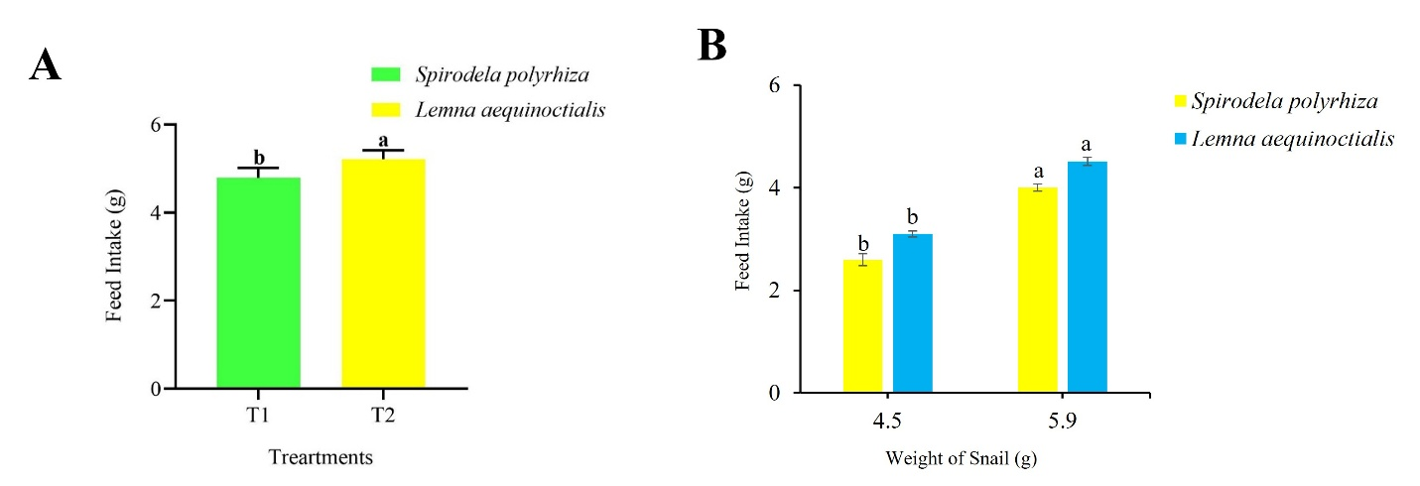

Figure 5. Effects of duckweed species and snail body weight on the feed intake of the freshwater apple snail P. canaliculata. (A) Comparison of feed intake of snails fed with S. polyrhiza and L. aequinoctialis. (B) Effect of snail body weight (4.5 g and 5.9 g) on feed intake when feeding on the two duckweed species. Bars represent mean ± standard error (SE), and different letters above bars indicate statistically significant differences among treatments (p < 0.05).

Protection Strategies Against P. canaliculata Damage

Effect of E-Medium on Feed Intake
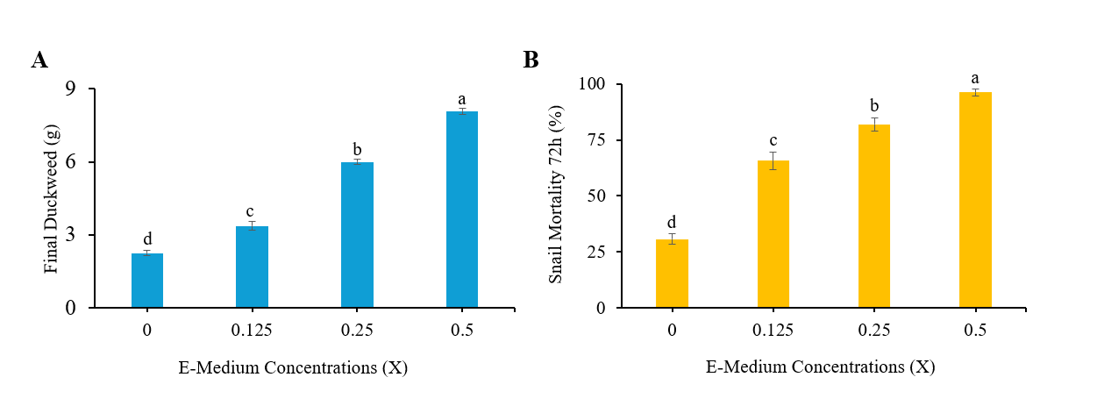
E-Medium concentration significantly affected both duckweed biomass and the mortality of P. canaliculata (Figure 6). Duckweed biomass varied significantly across the tested E-Medium concentrations after seven days of exposure (one-way ANOVA, p < 0.05; Figure 6A). At lower to intermediate E-Medium concentrations, duckweed biomass was significantly higher compared with the control treatment, indicating reduced grazing pressure by P. canaliculata. However, at higher E-Medium concentrations, duckweed biomass decreased significantly, suggesting that excessive nutrient levels may negatively influence duckweed growth and physiological performance. Snail mortality also showed a significant response to increasing E-Medium concentration after 72 h of exposure (one-way ANOVA, p < 0.05; Figure 6B). Mortality of P. canaliculata increased progressively with increasing E-Medium concentration, indicating that higher nutrient concentrations may adversely affect snail survival. The presence of different letters above the bars indicates statistically significant differences among treatments (p < 0.05). Overall, the results demonstrate that E-Medium concentration simultaneously influences duckweed performance and the survival of P. canaliculata, with intermediate concentrations providing a balance between reduced grazing pressure and optimal duckweed biomass production.
Figure 6. Effect of E-Medium concentration on duckweed biomass and mortality of the freshwater apple snail Pomacea canaliculata. (A) Final duckweed biomass measured after seven days of exposure to different E-Medium concentrations. (B) Percentage mortality of P. canaliculata recorded after 72 h of exposure. Values represent mean ± standard deviation (n = 3). Different letters above bars indicate statistically significant differences among treatments based on one-way ANOVA followed by Tukey’s multiple comparison test (p < 0.05).

Effect of Niclosamide on Feed Intake
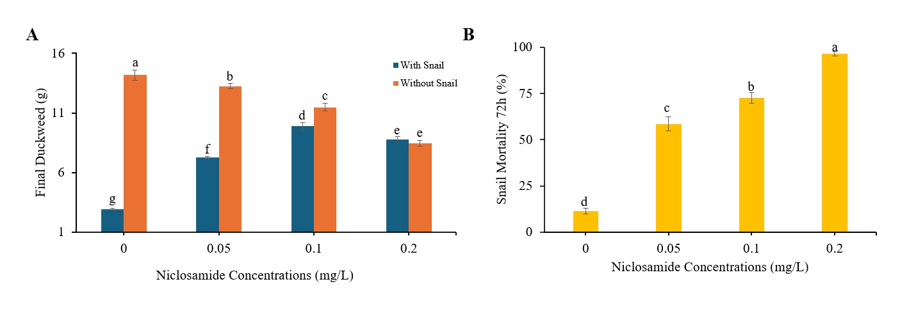
Niclosamide concentration significantly influenced both the mortality of P. canaliculata and duckweed biomass (Figure 7). Duckweed biomass differed significantly among treatments after seven days of exposure to varying Niclosamide concentrations (one-way ANOVA, p < 0.05; Figure 7A). At lower Niclosamide concentrations in the snail-containing treatments, duckweed biomass increased compared with the untreated control, indicating a reduction in grazing pressure by P. canaliculata. However, at higher Niclosamide concentrations, duckweed biomass declined, suggesting that elevated Niclosamide levels may exert phytotoxic effects on duckweed growth. In the duckweed-only treatments, duckweed biomass also decreased significantly with increasing Niclosamide concentration, confirming a direct negative effect of Niclosamide on duckweed development in the absence of snail grazing. Snail mortality showed a significant response to Niclosamide exposure after 72 h (one-way ANOVA, p < 0.05; Figure 7B). Mortality of P. canaliculata increased progressively with increasing Niclosamide concentration, demonstrating the strong molluscicidal activity of the compound. The presence of different letters above the bars indicates statistically significant differences among treatments (p < 0.05). Overall, the results indicate that Niclosamide effectively reduces snail survival and grazing pressure at moderate concentrations, but higher concentrations may negatively affect duckweed growth.
Figure 7. Effects of Niclosamide concentration on duckweed biomass and mortality of the freshwater apple snail P. canaliculata. (A) Final duckweed biomass after seven days of exposure to different Niclosamide concentrations in treatments containing snails and duckweed-only treatments. (B) Snail mortality (%) recorded after 72 h of Niclosamide exposure. Values represent mean ± standard deviation (SD) (n = 3). Different letters above bars indicate statistically significant differences among treatments based on one-way ANOVA followed by Tukey’s multiple comparison test (p < 0.05).

Effect of Tea Saponin on Feed Intake
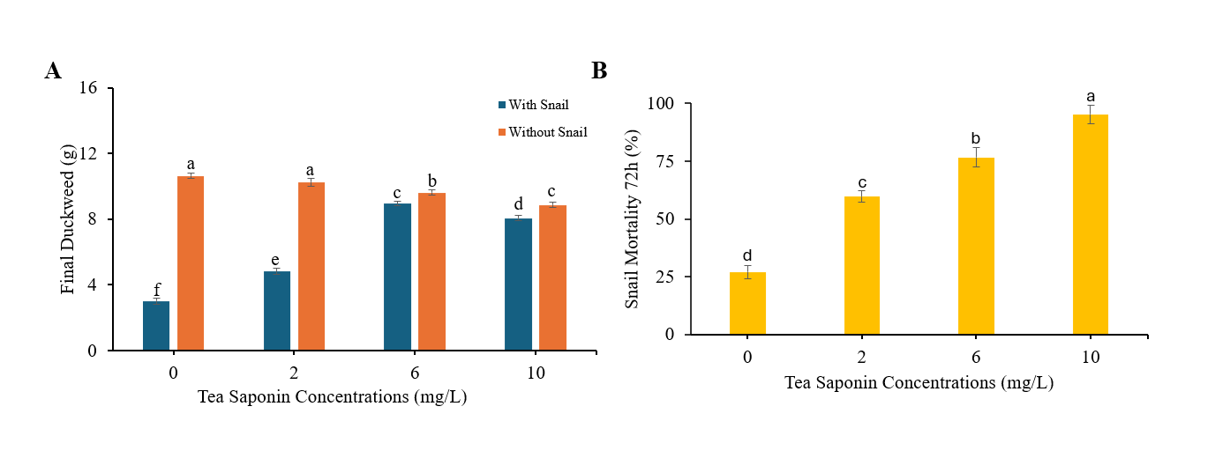
Tea saponin concentration significantly affected both duckweed biomass and the mortality of P. canaliculata (Figure 8). Duckweed biomass varied significantly among treatments after seven days of exposure to different tea saponin concentrations (one-way ANOVA, p < 0.05; Figure 7A). At low to intermediate concentrations in the snail-containing treatments, duckweed biomass increased compared with the untreated control, indicating a reduction in grazing pressure by P. canaliculata. However, at higher tea saponin concentrations, duckweed biomass declined, suggesting that excessive levels of tea saponin may exert phytotoxic effects on duckweed growth. In the duckweed-only treatments, duckweed biomass also decreased progressively with increasing tea saponin concentration, confirming that high concentrations of tea saponin can directly inhibit duckweed development in the absence of snail grazing. Snail mortality showed a significant response to tea saponin exposure after 72 h (one-way ANOVA, p < 0.05; Figure 8B). Mortality of P. canaliculata increased significantly with increasing tea saponin concentration, demonstrating the molluscicidal effect of the compound. The different letters above the bars indicate statistically significant differences among treatments (p < 0.05). Overall, the results indicate that tea saponin can effectively reduce the survival of P. canaliculata and decrease grazing pressure on duckweed at moderate concentrations, whereas excessive concentrations may negatively affect duckweed biomass.
Figure 8. Effects of tea saponin concentration on duckweed biomass and mortality of the freshwater apple snail Pomacea canaliculata. (A) Final duckweed biomass measured after seven days of exposure to different tea saponin concentrations in treatments containing snails (T1–T4) and duckweed-only treatments (T5–T8). (B) Snail mortality (%) recorded after 72 h of tea saponin exposure. Values represent mean ± standard deviation (SD) (n = 3). Different letters above bars indicate statistically significant differences among treatments based on one-way ANOVA followed by Tukey’s multiple comparison test (p < 0.05).

Discussion
This study illustrates that the invasive apple snail P. canaliculata significantly endangers duckweed production systems, with its grazing effects being heavily determined by biological and environmental parameters. The morphological characteristics, along with mitochondrial COI and 16S rRNA analyses, validated the identification of the collected specimens as P. canaliculata (Figures 1-2), underscoring the significance of integrative taxonomic methods due to the prevalent misidentification within the Pomacea species complex (Wei et al., 2024) (Hayes et al., 2012). The global distribution map (Figure 3A) shows that P. canaliculata has expanded far beyond its native range in South America and is now widely distributed across Asia and other regions. This widespread occurrence reflects the strong invasive potential of the species and its ability to establish populations in diverse freshwater environments. Previous studies have reported that human activities such as aquaculture, agriculture, and the aquarium trade have played important roles in facilitating the global spread of P. canaliculata (Seuffert & Martín, 2024). The phylogenetic analysis based on mitochondrial 16S rRNA sequences (Figure 3B) further supports the complex invasion history of this species. The clustering of sequences into several well-supported clades suggests genetic differentiation among populations and indicates that multiple introductory events may have contributed to the current distribution of P. canaliculata. Similar patterns of genetic diversity and population structuring have been reported in previous studies, highlighting the role of repeated introductions and secondary dispersal in shaping the invasion dynamics of this species (Wei et al., 2024).
Feeding investigations indicated that hunger significantly influenced feeding behavior; in both S. polyrhiza and L. aequinoctialis, feed intake progressively increased with extended periods of famine (Figure 4A). This pattern illustrates compensatory eating behavior, wherein snails augment their consumption to restore their energy balance following food deprivation. Recent nutritional studies indicates that P. canaliculata exhibits significant dietary flexibility and can rapidly adjust its consumption based on resource availability. This trait elucidates its invasive efficacy and considerable grazing influence (He et al., 2025). These compensatory feeding responses indicate that acute food scarcity may exacerbate eventual harm to duckweed crops instead of alleviating grazing pressure. Feed intake was significantly influenced by temperature, reaching a maximum at 28 °C and declining at both lower (20 °C) and higher (32 °C) temperatures (Figure 4B). This pattern demonstrates the dependence of ectothermic organisms' feeding and metabolic processes on temperature. Recent experimental findings indicate that the feeding activity of P. canaliculata increases with temperature until it reaches an optimal range, beyond which physiological stress and diminished metabolic efficiency hinder feeding performance (Miyata & Nakatsubo, 2024). The reduction in intake at 32 °C noted in this study likely indicates thermal stress, implying that duckweed damage may be more pronounced during moderately warm temperatures rather than during extreme heat events. Feeding efficiency was similarly affected by feed surface density, with reduced surface densities exhibiting increased intake and elevated densities demonstrating decreased consumption (Figure 4C). This indicates that grazing intensity is markedly affected by the accessibility of duckweed and the efficacy of its management. Narrower coverage facilitates more efficient rasping and eating, but dense duckweed mats may restrict snail mobility or diminish feeding efficiency. Apple snails consuming aquatic macrophytes demonstrate comparable density-dependent feeding responses, wherein plant arrangement influences encounter rates and feeding efficacy (Manara et al., 2024). L. aequinoctialis was consistently consumed in greater amounts than S. polyrhiza, suggesting that duckweed species significantly influenced feeding behavior (Figure 5A). Although apple snails are generalist herbivores, they may display species-specific feeding preferences based on nutritional composition, tissue pliability, and plant structure. Recent nutritional research indicates that P. canaliculata exhibits flexible feeding strategies and alters its dietary composition in response to environmental conditions and plant availability (He et al., 2025). The increased consumption of L. aequinoctialis noted in this study indicates that the selection of duckweed species may affect susceptibility to snail grazing in agricultural systems. Feed intake exhibited a positive correlation with snail body weight, as larger snails ingested more duckweed than their lighter counterparts (Figure 5B). Apple snails demonstrate size-dependent feeding behavior, wherein larger individuals impose significantly greater grazing pressure owing to elevated energetic requirements and feeding capacity (Carlsson & Brönmark, 2006). This finding highlights the importance of targeting larger snails in management programs to reduce overall damage intensity.
Despite their dose-dependent effects, protection studies indicated that E-Medium, Niclosamide, and tea saponin effectively reduced snail eating and increased duckweed biomass. As concentration increased, E-Medium treatments resulted in elevated snail mortality and duckweed biomass (Figure 6A), with mortality assessed after 72 hours. Snail susceptibility is consistently demonstrated through acute toxicity assays conducted over 72 hours, commonly utilized in molluscicide assessment. When applied in appropriate proportions, E-Medium effectively safeguards duckweed by reducing grazing pressure, as evidenced by the concurrent rise in duckweed biomass and snail mortality. Niclosamide exhibited potent molluscicide activity, with snail mortality significantly increasing with concentration and nearing complete mortality at the maximum dosage (Figure 7). In treatments devoid of snails, duckweed biomass diminished at the highest dosage, indicating phytotoxic effects. The trade-off between the efficacy of molluscicides and the toxicity to non-target plants in aquatic ecosystems has been extensively recorded, highlighting the necessity of optimizing treatment rates (Yang et al., 2023). The present results indicate that intermediate niclosamide concentrations provide the most balanced outcome, reducing snail grazing while minimizing adverse effects on duckweed growth. Strong concentration-dependent molluscicide activity was also shown by tea saponin; after 72 hours, full snail mortality was seen at the maximum concentration (Figure 8B). Nevertheless, elevated saponin concentrations in strong tea decreased duckweed biomass in the absence of snails, suggesting phytotoxicity, similar to niclosamide (Fig. 8A). Recent investigations indicate that tea saponin is a promising plant-derived molluscicide against P. canaliculate, however, they also highlight the potential for non-target effects at elevated dosages (Lu et al., 2025). These findings underscore the necessity for meticulous dose optimization when utilizing botanical control agents in duckweed cultivation systems. Overall, the findings show that P. canaliculata is a serious threat to the production of duckweed, and that temperature, meal availability, duckweed species, snail size, and starving history all affect feeding damage. While elevated quantities of chemical and botanical control agents may impede the growth of duckweed, they can effectively reduce snail populations and grazing pressure. Recent study on invasion ecology indicates that sustainable management of P. canaliculata requires a compromise between environmental safety and control efficacy (Seuffert & Martín, 2024). The present study provides experimentally supported guidance for optimizing snail management strategies to protect duckweed farming systems under subtropical conditions.

Conclusion
This study offers a thorough assessment of the grazing effects of the invasive apple snail P. canaliculata on duckweed farming systems and investigates feasible techniques for alleviating snail-related damage in controlled laboratory settings. The experimental specimens were accurately identified by a combination of integrative morphological analysis and mitochondrial COI and 16S rRNA gene sequencing, confirming the species as P. canaliculata. Accurate species identification is crucial for comprehending ecological effects and formulating suitable management measures, especially considering the taxonomic intricacies within the Pomacea species group. Feeding trials revealed that the grazing intensity of P. canaliculata is markedly variable and significantly affected by both biological and environmental factors. Feed intake markedly increased with extended famine durations, suggesting compensatory feeding behavior that may exacerbate duckweed harm after episodes of food shortage. Feeding activity peaked at moderate temperatures, with diminished intake at both lower and higher temperatures, underscoring the significance of thermal circumstances in modulating snail grazing pressure. The surface density of duckweed influenced feeding efficiency, with reduced densities enabling increased intake rates. Distinct species-specific variations in sensitivity to grazing were noted, with L. aequinoctialis being consistently devoured in larger amounts than S. polyrhiza. Larger snails imposed significantly greater grazing pressure than smaller ones, highlighting the importance of population size structure in assessing overall damage severity. Protection tests demonstrated that E-Medium strength, Niclosamide, and tea saponin can significantly diminish snail grazing and augment duckweed biomass when administered at suitable quantities. Nonetheless, elevated levels of Niclosamide and tea saponin induced phytotoxicity in duckweed, even without the presence of snails, indicating that excessive pesticide usage may jeopardize crop health. Intermediate concentrations achieved the optimal equilibrium between snail management and duckweed preservation, highlighting the significance of dosage optimization. This study confirms that P. canaliculata significantly threatens duckweed production systems and emphasizes the necessity for integrated management strategies that merge ecological insights into snail feeding behavior with meticulously optimized control measures to ensure sustainable duckweed cultivation.

References
Andrews, E. B. (1965). The functional anatomy of the gut of the prosobranch gastropod Pomacea canaliculata and of some other pilids. Proceedings of the Zoological Society of London,
Azmi, W. A., Khoo, S. C., Ng, L. C., Baharuddin, N., Abd Aziz, A., & Ma, N. L. (2022). The current trend in biological control approaches in the mitigation of golden apple snail Pomacea spp. Biological Control, 175, 105060. https://doi.org/https://doi.org/10.1016/j.biocontrol.2022.105060
Baek, G., Saeed, M., & Choi, H.-K. (2021). Duckweeds: their utilization, metabolites and cultivation. Applied Biological Chemistry, 64(1), 73. https://doi.org/https://doi.org/10.1186/s13765-021-00644-z
Banerjee, P., Stewart, K. A., Dey, G., Sharma, R. K., Maity, J. P., Chan, M. W., Chang, K. P., Chen, T.-H., Hsu, C.-T., & Chen, C.-Y. (2022). When conventional methods fall short: identification of invasive cryptic Golden Apple Snails (Pomacea canaliculata; P. maculata) using environmental DNA. Hydrobiologia, 849(19), 4241-4257. https://doi.org/https://doi.org/10.1007/s10750-022-04979-6
Carlsson, N. O., & Brönmark, C. (2006). Size‐dependent effects of an invasive herbivorous snail (Pomacea canaliculata) on macrophytes and periphyton in Asian wetlands. Freshwater Biology, 51(4), 695-704. https://doi.org/https://doi.org/10.1111/j.1365-2427.2006.01523.x
Cho, I. K., Cho, W. Y., Cho, I. S., Kim, H. W., Hyeong, S., Park, J. H., Kim, Y. S., Kim, K. Y., & Hyoung, G.-W. (2023). Molluscicidal Effect of Eco-Friendly Agricultural Substances for Controlling Golden Apple Snails (Pomacea canaliculata, Lamarck). Korean Journal of Environmental Agriculture, 42(4), 396-407. https://doi.org/ https://doi.org/10.5338/KJEA.2023.42.4.45
Coughlan, N. E., Walsh, É., Bolger, P., Burnell, G., O'Leary, N., O'Mahoney, M., Paolacci, S., Wall, D., & Jansen, M. A. (2022). Duckweed bioreactors: Challenges and opportunities for large-scale indoor cultivation of Lemnaceae. Journal of Cleaner Production, 336, 130285. https://doi.org/https://doi.org/10.1016/j.jclepro.2021.130285
Cowie, R. H. (2002). Apple snails (Ampullariidae) as agricultural pests: their biology, impacts and management. Molluscs as crop pests, 145192. https://doi.org/https://doi.org/10.1079/9780851993201.0000
Hayes, K. A., Cowie, R. H., Thiengo, S. C., & Strong, E. E. (2012). Comparing apples with apples: clarifying the identities of two highly invasive Neotropical Ampullariidae (Caenogastropoda). Zoological Journal of the Linnean Society, 166(4), 723-753. https://doi.org/https://doi.org/10.1111/j.1096-3642.2012.00867.x
He, X., Qian, Z., Huang, Y., Wang, C., Li, X., Li, H., & Chen, L. (2025). Seasonal dietary shifts in an invasive snail Pomacea canaliculata revealed by 18S rRNA Metabarcoding. Current Zoology, zoaf038. https://doi.org/https://doi.org/10.1093/cz/zoaf038
Huang, C., Yao, J., Xiong, J., Luo, X., Haubrock, P. J., Soto, I., Yang, J., Zhang, Z., Xie, Z., & Li, Z. (2026). Human activities and climate change facilitate the expansion of a notorious invasive snail (Pomacea canaliculata) in a subtropical biodiversity hotspot. Journal of environmental management, 398, 128353. https://doi.org/https://doi.org/10.1016/j.jenvman.2025.128353
Imtiaz, U., Shakoor, K., Wang, X., Liu, K., Tan, D., & Zhang, J. (2026). Genetic diversity of the duckweed family in Pakistan. https://doi.org/ https://doi.org/10.47278/journal.abr/2026.004
Ismail, H. N., Anuar, W. N. H. W., & Noor, N. M. (2021). Herbivory effects and growth rate of invasive species, Pomacea canaliculata on different macrophytes species. Fisheries and Aquatic Sciences, 24(12), 415-427. https://doi.org/https://doi.org/10.47853/FAS.2021.e43
Joshi, R. C., Cowie, R. H., & Sebastian, L. S. INVASIVE APPLE SNAILS. https://doi.org/http://doi.org/10.7717/peerj.8755
Joshi, R. C., & Sebastian, L. S. (2006). Global advances in ecology and management of golden apple snails.
Kannan, A., Rao, S. R., Ratnayeke, S., & Yow, Y.-Y. (2020). The efficiency of universal mitochondrial DNA barcodes for species discrimination of Pomacea canaliculata and Pomacea maculata. PeerJ, 8, e8755. https://doi.org/http://doi.org/10.7717/peerj.8755
Li, S., Qian, Z., Gao, S., Shen, W., Li, X., Li, H., & Chen, L. (2022). Effect of long-term temperature stress on the intestinal microbiome of an invasive snail. Frontiers in Microbiology, 13, 961502. https://doi.org/https://doi.org/10.3389/fmicb.2022.961502
Liu, J., Chen, X., Zhang, J., Yao, F., Shi, Z., Chen, Y., Chen, Q., & Qin, Z. (2024). Effect of Metaldehyde on Survival, Enzyme Activities, and Histopathology of the Apple Snail Pomacea canaliculata (Lamarck 1822). Biology, 13(6), 428. https://doi.org/https://doi.org/10.3390/biology13060428
Lu, Y., Lu, H., Zheng, X., Xu, H., & Lu, Z. (2025). Role of glutathione S-transferases and monoamine oxidase in the detoxification of Pomacea canaliculata exposed to tea saponin. Ecotoxicology and Environmental Safety, 293, 118051. https://doi.org/https://doi.org/10.1016/j.ecoenv.2025.118051
Lu, Y., Luo, F., Zhou, A., Yi, C., Chen, H., Li, J., Guo, Y., Xie, Y., Zhang, W., & Lin, D. (2024). Whole-genome sequencing of the invasive golden apple snail Pomacea canaliculata from Asia reveals rapid expansion and adaptive evolution. GigaScience, 13, giae064. https://doi.org/https://doi.org/10.1093/gigascience/giae064
Manara, E., Maldonado, M. A., & Martín, P. R. (2024). You are what you eat: is the apple snail Pomacea canaliculata a macrophytophage or a detritivore in its native range (southern Pampas, Argentina)? Limnology, 25(3), 305-316. https://doi.org/https://doi.org/10.1007/s10201-024-00755-8
Miyata, Y., & Nakatsubo, T. (2024). Temperature dependence of feeding activity in the invasive freshwater snail Pomacea canaliculata: implications for its response to climate warming. Landscape and Ecological Engineering, 20(4), 589-594. https://doi.org/https://doi.org/10.1007/s11355-024-00619-4
Pasos-Panqueva, J., Baker, A., & Camargo-Valero, M. A. (2024). Unravelling the impact of light, temperature and nutrient dynamics on duckweed growth: A meta-analysis study. Journal of environmental management, 366, 121721. https://doi.org/https://doi.org/10.1016/j.jenvman.2024.121721
Rozas, J., Ferrer-Mata, A., Sánchez-DelBarrio, J. C., Guirao-Rico, S., Librado, P., Ramos-Onsins, S. E., & Sánchez-Gracia, A. (2017). DnaSP 6: DNA sequence polymorphism analysis of large data sets. Molecular biology and evolution, 34(12), 3299-3302. https://doi.org/https://doi.org/10.1093/molbev/msx248
Seuffert, M. E., & Martín, P. R. (2024). Global distribution of the invasive apple snail Pomacea canaliculata: analyzing possible shifts in climatic niche between native and invaded ranges and future spread. Aquatic Sciences, 86(1), 17. https://doi.org/https://doi.org/10.1007/s00027-023-01036-9
Suzuki, E., Yoshida, K., Gaskin, A. F., & Yusa, Y. (2025). Effectiveness of potential attractants to the apple snail Pomacea canaliculata (Caenogastropoda: Ampullariidae). The Journal of Basic and Applied Zoology, 86(1), 37. https://doi.org/https://doi.org/10.1186/s41936-025-00458-1
Tamura, K., & Nei, M. (1993). Estimation of the number of nucleotide substitutions in the control region of mitochondrial DNA in humans and chimpanzees. Molecular biology and evolution, 10(3), 512-526. https://doi.org/https://doi.org/10.1093/oxfordjournals.molbev.a040023
Tamura, K., Stecher, G., & Kumar, S. (2021). MEGA11: molecular evolutionary genetics analysis version 11. Molecular Biology and Evolution, 38(7), 3022-3027. https://doi.org/10.1093/molbev/msab120
Ujong, A., Naibaho, J., Ghalamara, S., Tiwari, B. K., Hanon, S., & Tiwari, U. (2025). Duckweed: exploring its farm-to-fork potential for food production and biorefineries. Sustainable Food Technology, 3(1), 54-80. https://doi.org/https://doi.org/10.1039/D4FB00288A
Wei, R., Chang, Y.-W., Xie, H.-F., Wu, C.-d., Yuan, D.-R., Gong, W.-R., & Du, Y.-Z. (2024). Population genetic structure of Pomacea canaliculata in China based on the COI and ITS1 genes. Scientific Reports, 14(1), 12045. https://doi.org/https://doi.org/10.1038/s41598-024-62554-6
Xu, J., Shen, Y., Zheng, Y., Smith, G., Sun, X. S., Wang, D., Zhao, Y., Zhang, W., & Li, Y. (2023). Duckweed (Lemnaceae) for potentially nutritious human food: A review. Food Reviews International, 39(7), 3620-3634. https://doi.org/10.1080/87559129.2021.2012800
Yang, C., Huang, Y., Lu, Z., Ma, Y., Ran, X., Yan, X., Zhang, M., Qiu, X., Luo, L., & Yue, G. (2023). Sublethal effects of niclosamide on the aquatic snail Pomacea canaliculata. Ecotoxicology and Environmental Safety, 259, 115064. https://doi.org/https://doi.org/10.1016/j.ecoenv.2023.115064

