RESEARCH ARTICLE

RICE STRAW PRODUCTION AND FEED CARRYING CAPACITY UNDER COMBINE HARVESTER SYSTEMS FOR BEEF CATTLE IN PALANGGA DISTRICT, SOUTH KONAWE REGENCY, INDONESIA

Alfian¹, Jamila², Abdul Alim Yamin ², Ichlasul Amal ³ and Jasmal Ahmari Syamsu ^{2,4,}*

¹Center for Agricultural Modernization Application, Southeast Sulawesi, Indonesia
²Faculty of Animal Science, Universitas Hasanuddin, Makassar, Indonesia
³Faculty of Vocational Science, Universitas Hasanuddin, Makassar, Indonesia
⁴Center of Research and Development for Livestock Resources and Tropical Animals,
Universitas Hasanuddin, Makassar, Indonesia

*Corresponding Author: jasmal.syamsu@unhas.ac.id

30-Jan-26; 22-Feb-26; 22-Feb-26

Abstract
This study aimed to compare rice straw production, nutrient quality, and feed carrying capacity for beef cattle between manual and mechanical (combine harvester) harvesting systems in Palangga District, South Konawe Regency, Indonesia. Rice straw production was measured using a 5×5 m quadrat method across four representative villages under both harvesting systems. Proximate and fiber fraction analyses were conducted to determine nutrient composition, while carrying capacity was estimated based on dry matter (DM) production. The results showed that manual harvesting produced significantly (P<0.05) higher yields of fresh straw (8.27 tons/ha), air-dried straw (3.73 tons/ha), and DM (1.40 tons/ha) compared to the combine harvester system (3.90, 1.74, and 0.65 tons/ha, respectively). Although rice straw from combine harvesting contained higher crude protein (5.84%) than manual harvesting (4.54%), it also exhibited increased crude fiber, NDF, and ADF contents, which may reduce digestibility. Total DM production of rice straw was 2,739.10 tons/year under manual harvesting and 1,271.73 tons/year under combine harvesting, with corresponding feed carrying capacities of 1,201.36 and 557.77 AU (approximately 46.4%). The index of feed carrying capacity (IFCC) was generally moderate across most villages, except Aosole Village, which was categorized as high. These findings indicate that harvest mechanization reduces the availability of recoverable rice straw as a feed resource; therefore, integrated straw collection and post-harvest management strategies are essential to sustain feed availability in rice-based livestock systems.
Keywords: rice straw; harvest mechanization; combine harvester; residue production; carrying capacity; beef cattle.

1. INTRODUCTION
Feed availability is a major limiting factor in beef cattle development under smallholder livestock systems, particularly in tropical regions is characterized by pronounced seasonal fluctuations in the quantity and quality of forage resources (Madzingira et al., 2021; Nugraha et al., 2023). During the dry season, forage production declines, leading to a feed zing local feed resources based on agricultural residues is a crucial strategy for strengthening feed security (Kurniawan et al., 2022; Shah et al., 2025; Duguma & Janssens, 2021). Optimizing crop straw utilization is critical for sustainable agricultural development. As crop production expands, policies should prioritize enhancing agricultural waste efficiency (Wan & Wang, 2025).
Rice straw is an agricultural residue available in large quantities. It has the potential to serve as a source of fiber and energy for ruminants (Kurniawan et al., 2022; Munadi et al., 2024; Salman et al., 2025). Singh et al. (2024) reported that rice straw is one of the largest agricultural residues globally, with substantial biomass potential. Its availability plays an important role in sustainable farming systems, including its use as a ruminant feed resource and as a basis for estimating livestock carrying capacity. Nath et al. (2025) emphasized that rice straw is an agricultural by-product with substantial potential as livestock feed and contributes to the sustainability of crop–livestock systems by improving resource efficiency and reducing environmental impacts.
Agricultural modernization is driving a shift from manual to mechanized rice harvesting systems using combine harvesters. Combine harvesters offer efficiency in labor and harvesting time (Iqbal et al., 2020; Goel et al., 2022; Pargi Sanjay et al., 2024; Islam et al., 2024). However, it can impact straw availability at the field. Manual harvesting collects straw in bundles, making it easy to transport. Conversely, with combine harvesting, rice straw is chopped short and scattered across the field, increasing straw loss and reducing its availability as feed. This is crucial due to the increasing use of mechanized harvesting which reduce the quantity of agricultural waste-based feed sources in integrated rice-livestock systems (Nguyen et al., 2023; Paat et al., 2021; Tiro et al., 2023). The increasing use of combine harvesters makes the collection of scattered rice straw more difficult. Although it is needed as animal feed, much of the straw is still burned due to labor shortages and high manual collection costs (Balingbing et al., 2020). Mechanized harvesting systems leave substantial amounts of crop residues in the field, requiring efficient residue management strategies to avoid open burning and to enhance sustainable utilization (Korav et al., 2022).
On the other hand, feed carrying capacity is a quantitative approach to assessing the ability of feed sources to meet the needs of livestock populations in a region (Husnaeni et al. 2025; (Ghonimy et al., 2024). In the context of rice straw, carrying capacity should not only be calculated based on quantitative straw production but also consider nutrient content, especially dry matter content. Comparative information linking different harvesting systems, straw production, nutrient production, and their implications for carrying capacity at the regional level is still limited (Fyka et al., 2021; Summers et al., 2003), particularly in Southeast Sulawesi.
Therefore, this research is crucial for providing a scientific basis for strengthening local feed systems. The aim of this study was to compare rice straw production per unit area between manual and combine harvesters, evaluate the nutritional quality of rice straw under both harvesting systems and calculating the yield and carrying capacity of rice straw as feed for beef cattle.

2. MATERIALS AND METHODS
2.1. Location
The research was conducted in Palangga District, South Konawe Regency. The study area was a rice production area that has implemented two harvesting system: manual harvesting and harvesting using a combine harvester, allowing for comparative analysis of relatively similar agroecosystems (Fig. 1).

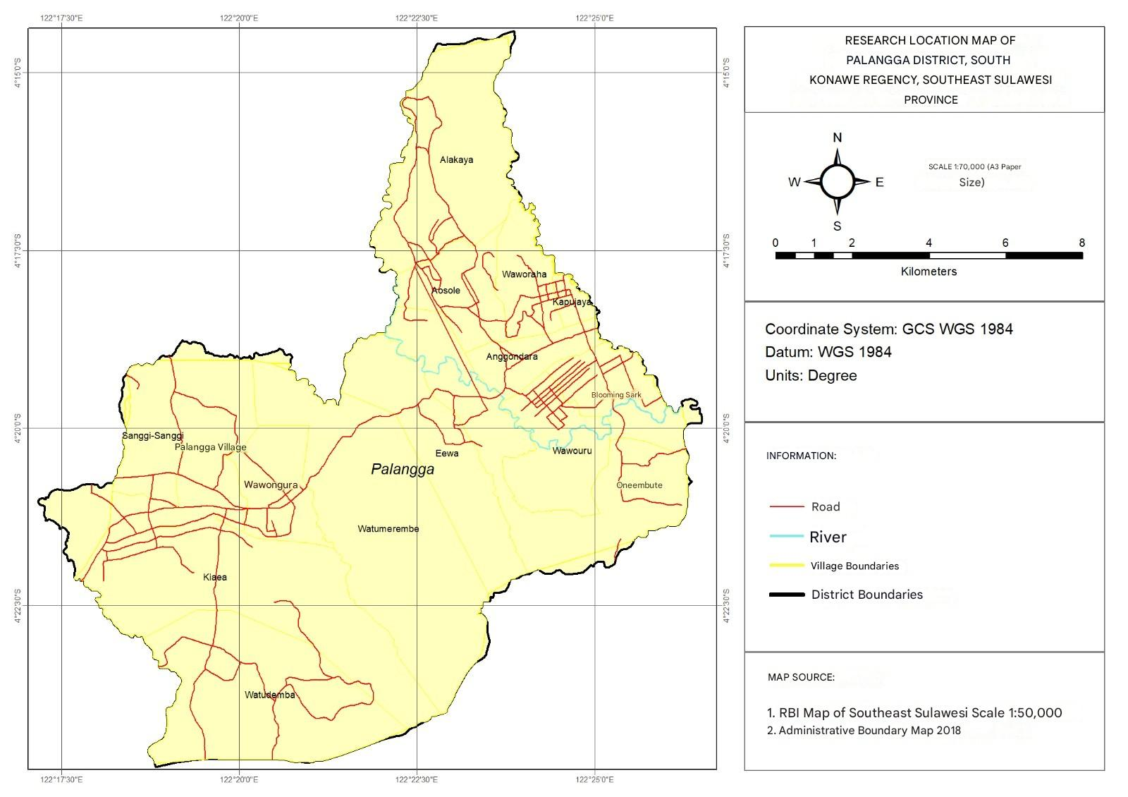
Fig. 1: Location of the study area in South Konawe Regency.

2.2. Design
The study used a comparative design, involving two rice harvesting systems, manual harvesting and mechanical harvesting using a combine harvester. The unit of observation was the rice straw production on the harvested land. Measurements were taken at several points along the harvesting site for each harvesting system to estimate straw production per hectare.

2.3. Sampling Site and Method
Rice straw production was measured through a field survey in four representative villages: Alakaya, Wawouru, Watudemba, and Sanggi-sanggi in Palangga District. Sampling was conducted in rice fields that were currently harvested or ready for harvest.
Straw yield was measured using the tiling method. Three sub-villages were selected in each village. Each hamlet was tiled twice on different harvested land areas, resulting in 24 observation units. Each tiling was measured under two harvesting conditions: manual harvesting and mechanical harvesting (combine harvester), with a tiling size of 5 × 5 m or an area of ​​25 m² (Chinh & Viet Ly, 2001).

2.4. Harvesting Method and Rice Straw Measurement
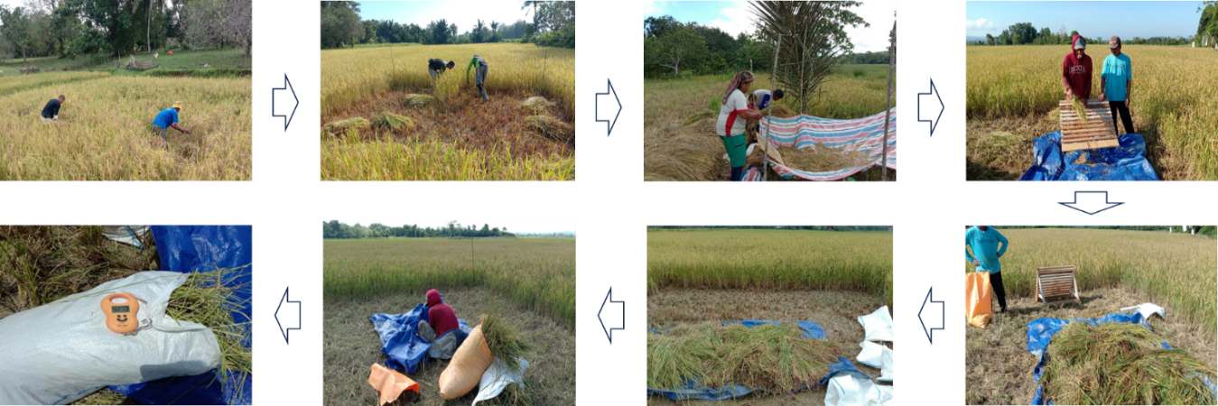
Manual harvesting procedures: rice is cut at the bottom of the stalks with a sickle (cut lengthwise), then threshed by slamming or using a pedal thresher. Mechanical harvesting systems use a combine harvester that cuts, collects, threshes, cleans, and even sifts the grain in one work unit. Tiling measurements in manual harvesting are shown in Fig. 2, while in combine harvesting are shown in Fig. 3.
Fig. 2: Measurement of rice straw yield under manual harvesting.

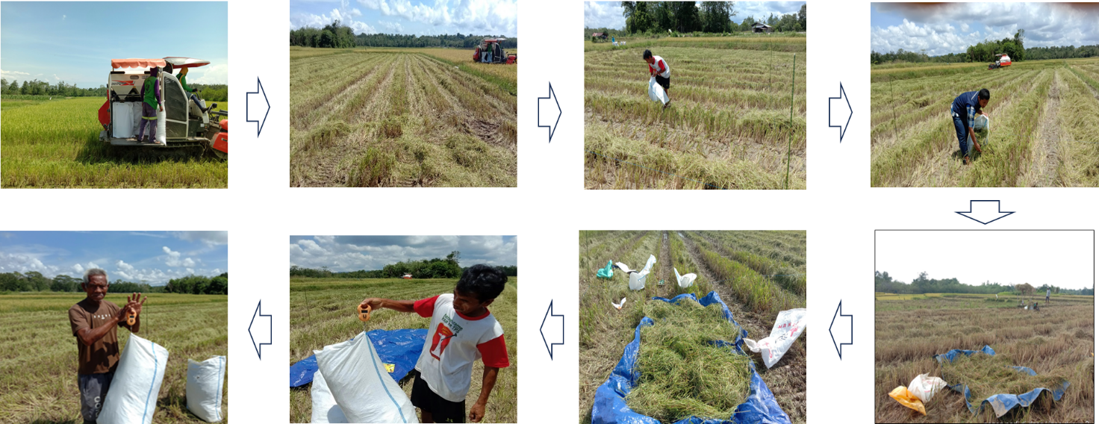
Rice straw from each harvesting system was collected and weighed for fresh weight to determine straw production per tile (kg/25 m²). Furthermore, 250 g of fresh samples were taken for sun-drying to obtain a dry weight. The difference between the fresh and dry weights was used to calculate moisture content; the dried samples were then composited and analyzed in the laboratory.
Fig. 3: Measurement of rice straw yield under combine harvester harvesting.

2.5. Quality Analysis
Nutritional quality of rice straw is carried out through proximate analysis, which includes dry matter, crude protein, crude fat, and crude fiber (AOAC, 1990). Furthermore, fiber fraction analysis is carried out, including neutral detergent fiber (NDF), acid detergent fiber (ADF), cellulose, and hemicellulose (Goering & Van Soest, 1970).
2.6. Data Analysis
Data analysis was conducted sequentially to estimate rice straw production and carrying capacity as a feed resource for beef cattle under manual harvesting and combine harvester systems. Estimates were obtained by integrating quadrat measurements of straw biomass with harvested rice area at village and district levels. Data tabulation and calculations were performed using Microsoft Excel. Differences in rice straw yield per hectare and nutrient production between harvesting systems were assessed using an independent-samples t-test at a significance level of α = 0.05. performed in SPSS. Results are presented as mean ± SD.

2.6.1. Calculation of Rice Straw Yield: Rice straw yield was calculated from quadrat (25 m²) measurements. Fresh and air-dried straw weights measured per quadrat were extrapolated to a hectare basis (tons/ha). and dry matter (DM) yield was estimated using air-dried yield and laboratory-determined DM content. Calculations were performed following Syamsu (2006).
Fresh rice straw yield was calculated from quadrat measurements (25 m²) and converted to tons per hectare:
$$Y_{fresh}​ (tons/ha)=\frac{W_{fresh}\left(kg/25m^{2}\right) x 400}{1000}$$
Air-dried straw yield was calculated as:
$$Y_{air}​ (tons/ha)=\frac{W_{air} \left(kg/25m^{2}\right) x 400}{1000}$$
Dry matter yield was estimated using air-dried yield and laboratory-determined DM content:
$$Y_{DM}​ (tons/ha)=Y_{air}​ x\frac{DM (\%)}{100}$$
Where: Y_{fresh}​ = fresh straw yield (tons/ha); Y_{air}​ = air-dried straw yield (tons/ha); YDM​ = dry matter yield (tons/ha); W_{fresh}​ and W_{air}​ are quadrat weights (kg/25 m²); 400 is the area conversion factor (10.000/25); 1000 converts kg to tons.

2.6.2. Dry Matter, Total Digestible Nutrients and Crude Protein Production of Rice Straw: Total dry matter (DM) production of rice straw were estimated at the village and district levels by integrating dry matter yield per hectare with harvested rice area. Harvested rice area data (ha) for each village in Palangga District in 2022 were obtained from official statistics (BPS Konawe Selatan Regency, 2022). Calculations were performed following Syamsu (2006) as follows:
Total dry matter (DM) production:

$${TP}_{DM}​ (tons/year)=Y_{DM}​ (tons/ha)×H (ha)$$

Where: TP_{DM} denote total DM production of rice straw (tons/year), respectively; Y_{DM} is dry matter yield (tons/ha), and H is harvested rice area (ha).

2.6.3. Carrying Capacity of Rice Straw as a Feed Resource: Rice straw carrying capacity was estimated to assess the production of rice straw to support the beef cattle population. Carrying capacity was calculated based on dry matter (DM) availability. The estimation was performed using total annual DM production (tons/year) and annual DM requirements per animal unit (AU). In this study, one animal unit (AU) of beef cattle was assumed to require 6.25 kg DM/day, corresponding to 2.5% of body weight for a 250 kg reference animal (FAO, 1993). Calculations were performed following Syamsu (2006) as follows:
DM-based carrying capacity:

$${CC}_{DM}​ (AU)=\frac{{TP}_{DM}}{R_{DM}}$$

Where: CC_{DM}​ = rice straw carrying capacity based on dry matter (AU); TP_{DM} = total annual dry matter production from rice straw (tons/year); R_{DM}= annual dry matter requirement per animal unit (AU) (tons/year).

2.6.4. Index of Feed Carrying Capacity: The index of feed carrying capacity (IFCC) represents the ratio between the dry matter (DM)-based carrying capacity of rice straw as a feed resource and the existing beef cattle population. The index was calculated following (Syamsu., 2006) as:
$${IFCC}_{DM}​=\frac{{CC}_{DM}}{P}$$
Where : IFCC_{DM}​ denotes the DM-based index of feed carrying capacity (unitless); CC_{DM}​ = rice straw carrying capacity based on dry matter (AU); P represents the total cattle population (AU).
Based on the mean IFCC value and standard deviation (SD), areas were classified into three carrying capacity categories: low, medium, and high. IFCC was categorized as low when the value was lower than the mean minus one SD (< mean − SD), medium when it fell within the range of mean ± one SD (mean − SD to mean + SD), and high when it exceeded the mean plus one SD (> mean + SD).

3. RESULTS AND DISCUSSION

  - Rice Straw Yield per Hectare under Manual Harvesting and Combine Harvester Systems
Rice straw production per hectare differed significantly between manual harvesting and combine harvesting systems (Table 1; Fig. 4). Manual harvesting produced 8.27 tons of fresh straw/ha, higher than the 3.90 tons/ha produced by the combine harvester (P<0.05). A similar pattern also occurred for air-dried straw and dry matter, where manual harvesting reached 3.73 tons/ha and 1.40 tons/ha, respectively, while the combine harvester only produced 1.74 tons/ha and 0.65 tons/ha (P<0.05). This indicates that mechanized harvesting with a combine reduces the amount of rice straw available as a feed source for beef cattle. This difference is primarily influenced by the cutting mechanism and straw collection efficiency.
Table 1. Rice straw yield per hectare under manual harvesting and combine harvester systems
Parameters | n | Manual | Combine harvester
Fresh straw yield (tons/ha) | 24 | 8.27 ± 2.02ª | 3.90 ± 1.49^{b}
Air-dried straw yield (tons/ha) | 24 | 3.73 ± 0.95ª | 1.74 ± 0.64^{b}
Dry matter (DM) yield (tons/ha) | 24 | 1.40 ± 0.36ª | 0.65 ± 0.24^{b}
Different superscripts within the same row indicate significant differences (P < 0.05) among the mean ± SD values.

Fig. 4: Rice straw yield per hectare under manual harvesting and combine harvester systems. Bars (mean+SD) of each yield (n=24) under manual and combine harvester systems differ significantly (P<0.05).

Manual harvesting involves cutting lower, closer to the base, allowing more stem biomass to be removed and rice straw to be collected higher up (Rahman et al. 2016; Singh & Brar, 2021). Conversely, combine harvesters tend to cut at a certain height, leaving some of the lower stem (stump) in the field, with straw loss due to scattering and redistribution during the harvesting process. The consistent decrease in dry matter yield confirms that the difference is not solely due to moisture content, but it rather reflects a reduction in straw biomass available for use as feed. Therefore, the use of combine harvesters has the potential to reduce the availability of rice straw per hectare and impact the carrying capacity of rice straw as feed (Balingbing et al. 2019; Reaño et al., 2021).
Practically, strategies are needed to minimize rice straw loss in mechanized systems, including adjusting cutting height and implementing post-harvest straw collection technologies (e.g., balers or integrated transport systems). Optimizing post-harvest management is also crucial to utilize scattered straw through mechanized collection, either as direct feed or through feed processing technologies, so that mechanization continues to increase harvest efficiency without reducing straw's potential as a livestock feed source. An integrated combined machine for collecting and chopping rice straw should be designed and fabricated to perform multiple operations in a single pass. The system is capable of simultaneously collecting, chopping, and storing rice straw in a large onboard tank, thereby enhancing operational efficiency. The machine exhibits a simple yet robust structural design, reliable performance under field conditions, and ease of operation and maintenance. Its integrated mechanism minimizes manual handling and time consumption, offering a highly efficient and practical solution for post-harvest rice straw management (Awad et al. 2022; Pandey et al., 2023; Sahni et al., 2024; Srivastava et al., 2024).

  - Nutrient composition of rice straw under manual harvesting and combine harvester systems
Table 2 shows that the nutrient composition of rice straw differed significantly (P<0.05) between the manual harvesting system and the harvesting system using a combine harvester. The dry matter content of rice straw in both harvesting systems was relatively high and not significantly different among harvesting method (94.01% in the manual harvest and 93.02% in the combine harvester). This indicates that moisture of the samples was relatively uniform, so differences in nutrient components better reflect the characteristics of the straw produced by each harvesting system.

Table 2: Nutrient composition of rice straw under manual harvesting and combine harvester systems
Component | Harvester Systems
Component | Manual | Combine harvester
Proximate composition (%)
Dry matter (DM) | 94.01 ± 1.36ᵃ | 93.02 ± 1.35ᵃ
Crude protein (CP) | 4.54 ± 1.45ᵃ | 5.84 ± 1.24ᵇ
Ether extract (EE) | 2.09 ± 0.41ᵃ | 2.37 ± 0.56ᵃ
Crude fiber (CF) | 32.92 ± 1.83ᵃ | 34.74 ± 0.86ᵇ
Fiber fractions (Van Soest, %)
Acid detergent fiber | 44.85 ± 2.92ᵃ | 48.77 ± 1.06ᵇ
Neutral detergent fiber | 69.82 ± 2.61ᵃ | 74.71 ± 3.74ᵇ
Cellulose | 35.56 ± 2.01ᵃ | 37.05 ± 1.35ᵇ
Hemicellulose | 24.98 ± 1.34ᵃ | 25.94 ± 1.34ᵃ
Different superscripts within the same row indicate a significant difference (P<0.05).

In the proximate component, straw from combine harvesters had a higher crude protein content (5.84%) (P<0.05) than from manual harvesting (4.54%). However, combine harvesters also produced straw with higher crude fiber (34.74%) than from manual harvesting (32.92%) (P<0.05). Crude fat content did not show a significant difference between the two harvesting systems (P>0.05). The increase in crude protein in combine straw may indicate a difference in the proportion of plant parts transported, for example, more leaves/stems were carried along. However, the simultaneous increase in crude fiber indicates that combine straw remains dominated by high-fiber structural tissue. More consistent differences were seen in the fiber fraction. The ADF, NDF, and cellulose values ​​of straw in the combine harvester system were higher than manual harvesting (P<0.05), respectively 48.77 vs 44.85%, 74.71 vs 69.82%, and 37.05 vs 35.56%, while hemicellulose was not significantly different (P>0.05). Dry matter digestibility ranging from 45 – 50%, which impacts digestibility for ruminants (Aquion et al. 2020).
The differences in nutrient composition are likely influenced by the harvesting mechanism and the characteristics of the collected straw. Manual harvesting involves lower cutting, resulting in more intact straw and a higher quantity. Combine harvesters generally have higher cutting rates, and mechanical processes (cutting and threshing) can select and fragment the collected straw, thereby increasing the structural fiber fraction. Consequently, although combine harvesters have higher crude protein content, higher NDF/ADF, and SK values, they have potentially lower digestibility (Ma et al., 2020). Thus, Rice straw is a potential energy source for ruminants, containing about 70% carbohydrates on a dry-matter basis (Goswami et al., 2020). Therefore, in areas dominated by combine harvesters, straw utilization as a feed source should be accompanied by quality-improvement technologies (e.g., ammoniation, fermentation, or silage) to enhance digestibility and nutrient utilization (Fan et al., 2022).

  - Rice Straw Production and Carrying Capacity as a Feed Resource for Beef Cattle
Table 3 shows estimation of rice straw dry matter production and the carrying capacity of DM-based at the village level in Palangga District, based on two harvesting systems. Overall, rice straw DM production in the manual harvesting system reached 2,739.10 tons DM/year, while in the combine harvesting system was 1,271.73 tons DM/year. Therefore, rice straw DM production in the combine harvesting system was only about 46.4% of that in the manual system, indicating a decrease in the potential usable straw biomass due to harvesting mechanization. (Suretno et al., 2024) stated that rice straw production is affected by rice varieties and harvest method.

Table 3. Dry matter production and carrying capacity of rice straw in Palangga District
Village | Dry matter production  (tons) |  | Carrying capacity based on DM (AU)
Village | Manual | Combine | Manual | Combine
Mekar Sari | 96.60 | 44.85 | 42.37 | 19.67
Wawouru | 99.40 | 46.15 | 43.60 | 20.24
Waworaha | 81.20 | 37.70 | 35.61 | 16.54
Alakaya | 698.60 | 324.35 | 306.40 | 142.26
Aosole | 513.80 | 238.55 | 225.35 | 104.63
Anggondara | 30.80 | 14.30 | 13.51 | 6.27
Onembute | 56.00 | 26.00 | 24.56 | 11.40
Eewa | 63.70 | 29.58 | 27.94 | 12.97
Watumerembe | 81.20 | 37.70 | 35.61 | 16.54
Wawonggura | 37.10 | 17.23 | 16.27 | 7.55
Kiaea | 581.00 | 269.75 | 254.82 | 118.31
Palangga | 80.50 | 37.38 | 35.31 | 16.39
Kapu Jaya | 67.20 | 31.20 | 29.47 | 13.68
Watudemba | 218.40 | 101.40 | 95.79 | 44.47
Sanggi-sanggi | 33.60 | 15.60 | 14.74 | 6.84
Total | 2.739.10 | 1.271.73 | 1.201.36 | 557.77

In line with the decline in DM production, the carrying capacity of DM-based rice straw also decreased in the combine harvesting system. The total carrying capacity in the manual harvesting system was 1,201.36 AU, while in the combine system it was 557.77 AU (approximately 46.4%). This confirms that the change from manual to combine harvesting systems directly impacts the reduced capacity of rice straw to support beef cattle populations in rice-based areas.
At the village level, production and carrying capacity contributions are uneven and are strongly influenced by the harvested area and the characteristics of the harvesting system. Alakaya Village is the largest contributor to DM production and carrying capacity, namely 698.60 tons of DM with a carrying capacity of 306.40 AU in manual harvesting, and 324.35 tons of DM with a carrying capacity of 142.26 AU in combine harvesting. Kiaea and Aosole villages also show significant contributions, producing 581.00 tons of DM (254.82 AU) and 513.80 tons of DM (225.35 AU) respectively in manual systems. Meanwhile, villages with low DM production and carrying capacity such as Anggondara and Sanggi-sanggi showed limited potential for straw as a primary feed source and therefore require support from other feed sources. Hence, it is needed a modification of harvest machine for optimal production according to Hashem et al. (2022) report.

  - Index of Feed Carrying Capacity
Table 4 presents the Feed Carrying Capacity Index (IFFC) of rice straw relative to the beef cattle population at the village level. The IFFC reflects the adequacy of rice straw availability as a feed source compared to the needs of the existing livestock population; a higher IFFC value indicates a greater level of feed availability relative to the livestock population. In general, IFFC values ​​in manual harvesting systems range from 0.10 to 2.49, while in combine harvesting systems ranged from 0.05 to 1.16. It indicates that harvesting mechanization tends to reduce the availability of rice straw as a feed source.

Table 4. Beef cattle population and index of feed carrying capacity in Palangga District
Village | Beef cattle population (AU) | Manual harvesting |  | Combine harvester
Village | Beef cattle population (AU) | IFCC | Category | IFCC | Category
Mekar Sari | 314.69 | 0.14 | Medium | 0.06 | Medium
Wawouru | 442.74 | 0.10 | Medium | 0.05 | Medium
Waworaha | 214.86 | 0.17 | Medium | 0.08 | Medium
Alakaya | 936.11 | 0.33 | Medium | 0.15 | Medium
Aosole | 90.43 | 2.49 | High | 1.16 | High
Anggondara | 62.94 | 0.22 | Medium | 0.10 | Medium
Onembute | 91.15 | 0.27 | Medium | 0.13 | Medium
Eewa | 206.90 | 0.14 | Medium | 0.06 | Medium
Watumerembe | 214.13 | 0.17 | Medium | 0.08 | Medium
Wawonggura | 158.43 | 0.10 | Medium | 0.05 | Medium
Kiaea | 732.11 | 0.35 | Medium | 0.16 | Medium
Palangga | 88.98 | 0.40 | Medium | 0.18 | Medium
Kapu Jaya | 277.80 | 0.11 | Medium | 0.05 | Medium
Watudemba | 190.98 | 0.50 | Medium | 0.23 | Medium
Sanggi-sanggi | 137.45 | 0.11 | Medium | 0.05 | Medium

Most villages in Palangga District fall into the moderate category, using both manual and combine harvesting systems. Only Aosole Village falls into the high category, with an IFFC of 2.49 for manual harvesting and 1.16 for combine harvesting. This indicates that the availability of rice straw in Aosole Village is relatively sufficient, even surplus, compared to the needs of the local beef cattle population. It is due to a combination of high straw potential and/or a relatively lower livestock population compared to other villages. Conversely, the predominance of the moderate category in most villages indicates that rice straw is generally limited or moderately sufficient for the existing livestock population, making the sustainability of feed supply vulnerable if straw production declines or livestock populations increase without the support of additional feed sources.

  - Policy implications
The findings indicate that the adoption of combine harvesters may reduce recoverable rice straw, thereby lowering rice straw DM production and feed carrying capacity. Mechanization policies in rice-producing areas should be integrated with straw management policies, including technical guidelines on cutting height, straw collection standards, and strengthening farmer/livestock groups to ensure efficient straw utilization.
In addition, acceleration to adopt post-harvest straw technologies needed including straw transport and storage system. Incentive schemes, financing mechanisms, and technical extension services are essential to maintain harvesting efficiency while sustaining rice straw availability as a feed resource for beef cattle.

- CONCLUSION
The rice harvesting system significantly impacts rice straw production as a feed source for beef cattle in Palangga District. Manual harvesting produces higher straw production per hectare than combine harvesters, both for fresh rice straw, air-dried rice straw, and dry matter production. The decrease in dry matter production in the combine harvesting system directly impacts the low carrying capacity of rice straw as feed. In terms of nutrient quality, straw produced by combine harvesters has a slightly higher crude protein content, but this is accompanied by an increase in the fiber fraction (crude fiber, NDF, ADF, and cellulose), which can potentially reduce digestibility. Regional estimates indicate that total dry matter production and carrying capacity in combine harvesting are only about 46% of those achieved by manual harvesting.
Based on the feed carrying capacity index (IFFC), most villages categorized in the medium category for both harvesting systems, while Aosole Village categorized the high category. This finding emphasizes the need to balance harvest mechanization with straw collection and processing strategies to ensure that harvest efficiency does not reduce straw availability as a feed source or regional feed carrying capacity.

Conflict of Interest
The authors declared that all the material presented in this manuscript has no conflict of interest regarding any financial issues.

References
AOAC. (1990). Official methods of analysis (15th ed.). Association of Official Analytical Chemists. https://doi.org/10.5962/bhl.title.44636
Aquino, D., Barrio, A. D., Trach, N. X., Hai, N. T., Khang, D. N., Toan, N. T., & Hung, N. V. (2020). Rice straw based fodder for ruminants. In Sustainable rice straw management (pp. 111–129). Springer. https://doi.org/10.1007/978-3-030-32373-8_7
Awad, M., Fouda, O., Fathy, W., El Balkemy, W., Egela, M., El Fakhrany, W., & Okasha, M. (2022). A combined machine for collecting and chopping rice straw. Heliyon, 8(8), e10412. https://doi.org/10.1016/j.heliyon.2022.e10412
Balingbing, C., Van Hung, N., Roxas, A. P., Aquino, D., Barbacias, M. G., & Gummert, M. (2020). An assessment on the technical and economic feasibility of mechanized rice straw collection in the Philippines. Sustainability, 12(17), 7150. https://doi.org/10.3390/su12177150
Duguma, B., & Janssens, G. P. J. (2021). Assessment of livestock feed resources and coping strategies with dry season feed scarcity in mixed crop–livestock farming systems around the Gilgel Gibe catchment, Southwest Ethiopia. Sustainability, 13(19), 10713. https://doi.org/10.3390/su131910713
Fan, G. J., Chen, M. H., Lee, C. F., Yu, B., & Lee, T. T. (2022). Effects of rice straw fermented with spent Pleurotus sajor caju mushroom substrates on milking performance in Alpine dairy goats. Animal Bioscience, 35(7), 999–1009. https://doi.org/10.5713/ab.21.0340
Fyka, S., Limi, M., Batoa, H., Yusria, W., Arif, L., Slamet, A., & Salamah. (2021). Analysis of rice–cattle integrated system model to support increased farmer income in Buke District, South Konawe Regency, Indonesia. IOP Conference Series: Earth and Environmental Science, 759, 012053. https://doi.org/10.1088/1755-1315/759/1/012053
Ghonimy, M., Suliman, A., Morsy, M., Abdel-atty, A., & Alzoheiry, A. (2024). Development of a mechanical system to produce animal feed from rice straw. Turkish Journal of Agricultural Engineering Research, 5(1), 35–48. https://doi.org/10.46592/turkager.1432932
Goel, N., Singh, S. K., Dixit, A. K., Singh, A., Singh, M., & Jain, L. (2022). Refinement of wheat straw harvester for paddy straw harvesting and bruising. Journal of Agricultural Engineering, 59(3), 201. https://doi.org/10.52151/jae2022593.1776
Goswami, S. B., Mondal, R., & Mandi, S. K. (2020). Crop residue management options in rice–rice system: A review. Archives of Agronomy and Soil Science, 66(9), 1218–1234. https://doi.org/10.1080/03650340.2019.1661994
Iqbal, Supratomo, & Azis, A. (2020). Combine rice harvester performance test in Takalar Regency. IOP Conference Series: Earth and Environmental Science.
Islam, M.A., Hasan, M.M., Akter, T., & Islam, S.M.S. (2024). Agronomic performance and grain quality assessment of small-grain aromatic rice advanced breeding lines in Bangladesh. Agrobiological Records, 17, 30-41. https://doi.org/10.47278/journal.abr/2024.022
Korav, S., Rajanna, G. A., Yadav, D. B., Paramesha, V., Mehta, C. M., Jha, P. K., Singh, S., & Singh, S. (2022). Impacts of Mechanized Crop Residue Management on Rice-Wheat Cropping System—A Review. Sustainability, 14(23), 15641. https://doi.org/10.3390/su142315641
Kurniawan, W., Ramdani, A., Bain, A., Bachtiar, T., & Wahyono, T. (2022). Influences of manure and biochar on biomass yield and nutrient value of Pennisetum purpureum cv. Mott grown on post-nickel mining soil. JAPS: Journal of Animal & Plant Sciences, 32(5). https://doi.org/10.36899/japs.2022.5.0537
Ma, Y., Chen, X., Khan, M. Z., Xiao, J., Liu, S., Wang, J., He, Z., Li, C., & Cao, Z. (2020). The impact of ammoniation treatment on the chemical composition and in vitro digestibility of rice straw in Chinese Holsteins. Animals, 10(10), 1854. https://doi.org/10.3390/ani10101854
Madzingira, O., Hepute, V., Mwenda, E. N., Kandiwa, E., Mushonga, B., & Mupangwa, J. F. (2021). Nutritional assessment of three baled rice straw varieties intended for use as ruminant feed in Namibia. Cogent Food & Agriculture, 7(1), 1950402. https://doi.org/10.1080/23311932.2021.1950402
Munadi, L., Purwanti, B., Sasmita, F., Haloho, R., Telupere, F., Mekiuw, Y., Rizal, M., Adrianus, A., Rosmalah, S., & Kasmin, M. (2024). Optimizing the utilization of plantation waste for carrying capacity of beef cattle feed in Southeast Sulawesi, Indonesia. In Technological innovations in tropical livestock development for environmental sustainability and food security (pp. 163–170). CRC Press. https://doi.org/10.1201/9781003468943-26
Nath, B., Ahmed, M. M., Paul, S., Huda, M. D., Hossain, M. A., & Islam, S. (2025). Unlocking the potential of rice straw: Sustainable utilization strategies for Bangladesh. Circular Economy, 4(1), 100126. https://doi.org/10.1016/j.cec.2025.100126
Nguyen, T. T., Sasaki, Y., Aizawa, M., Kakuda, K., & Fujii, H. (2023). Potassium balance in paddy fields under conventional rice straw recycling versus cow dung compost application in mixed crop–livestock systems in Japan. Soil Science and Plant Nutrition, 69(1), 36–44. https://doi.org/10.1080/00380768.2022.2162670
Nugraha, R., Shiddieqy, M., Laconi, E., & Jayanegara, A. (2023). Estimation of rice straw adequacy as ruminants feed in Java based on yield area conversion. IOP Conference Series: Earth and Environmental Science, 1187, 012004. https://doi.org/10.1088/1755-1315/1187/1/012004
Paat, P. C., Polakitan, D., Ifada, R. R., & Rembang, J. (2021). Carrying capacity of maize as cattle feed in North Sulawesi, Indonesia. E3S Web of Conferences. https://doi.org/10.1051/e3sconf/202130605010
Pandey, S. M., Kudesia, S., Pandey, J., & Singh, U. (2023). A sustainable approach for soil amendment: Available plant nutrients in rice straws. Journal of the Indian Chemical Society, 100(3), 100938. https://doi.org/10.1016/j.jics.2023.100938
Pargi Sanjay, J., Gupta, P., Balas, P., & Bambhaniya, V. (2024). Comparison between manual harvesting and mechanical harvesting. Journal of Scientific Research and Reports, 30(6), 917–934. https://doi.org/10.9734/jsrr/2024/v30i62110
Reaño, R. L., de Padua, V. A. N., & Halog, A. B. (2021). Energy efficiency and life cycle assessment with system dynamics of electricity production from rice straw using a combined gasification and internal combustion engine. Energies, 14(16), 4942. https://doi.org/10.3390/en14164942
Sahni, T., Verma, D., & Kumar, S. (2024). Biochar: A Pyrolyzed Green Fuel from Paddy Straw. In Paddy straw waste for biorefinery applications (pp. 213-229). Singapore: Springer Nature Singapore. https://doi.org/10.1007/978-981-99-8224-0_10
Salman, M., Waqas, M., Bölükbaş, B., & Nastoh, N.A. (2025). Assessment of nutrient content, In vitro true digestibility, digestible protein content and In vitro fermentation of rice straw ensilaged with artichoke leaves. International Journal of Agriculture and Biosciences, 14(5), 985-993. https://doi.org/10.47278/journal.ijab/2025.095
Shah, A. M., Zhang, H., Shahid, M., Ghazal, H., Shah, A. R., Niaz, M., Naz, T., Ghimire, K., Goswami, N., & Shi, W. (2025). The vital roles of agricultural crop residues and agro-industrial by-products to support sustainable livestock productivity in subtropical regions. Animals, 15(8), 1184. https://doi.org/10.3390/ani15081184
Singh, S., Kaur, G., Singh, D. P., Arya, S. K., & Krishania, M. (2024). Exploring rice straw’s potential from a sustainable biorefinery standpoint: Towards valorization and diverse product production. Process Safety and Environmental Protection, 184, 314–331. https://doi.org/10.1016/j.psep.2024.01.105
Singh, L., & Brar, B. S. (2021). A review on rice straw management strategies. Natural Environment and Pollution Technology, 20(4), 1485–1493. https://doi.org/10.46488/nept.2021.v20i04.010
Srivastava, N., Verma, B., & Mishra, P. K. (2024). Paddy straw waste for biorefinery applications. Springer Nature. https://doi.org/10.1007/978-981-99-8224-0
Summers, M., Jenkins, B., Hyde, P., Williams, J., Mutters, R., Scardacci, S., & Hair, M. (2003). Biomass production and allocation in rice with implications for straw harvesting and utilization. Biomass and Bioenergy, 24(3), 163–173. https://doi.org/10.1016/S0961-9534(02)00132-0
Suretno, N. D., Adriyani, F. Y., Tambunan, R. D., Diptaningsari, D., Meidaliyantisyah, M., Zahara, Z., & Maryanto, A. (2024). The potency of rice straw for ruminant feed on several rice varieties. BIO Web of Conferences. https://doi.org/10.1051/bioconf/20249901001
Syamsu, J. A. 2006. The study of crop residues potency as feed resources for ruminant in South Sulawesi. Dissertation. Graduate School, Bogor Agricultural University, Bogor, Indonesia. https://repository.ipb.ac.id/handle/123456789/40673
Tiro, B. M., Beding, P. A., Suprihadi, K., & Ondikeleuw, M. (2023). Utilization of rice straws as feed for beef cattle during the dry season in Merauke Regency, South Papua, Indonesia. Nongye Jixie Xuebao/Transactions of the Chinese Society of Agricultural Machinery, 54(9). https://doi.org/10.62321/issn.1000-1298.2023.09.07
Wan, Y., & Wang, Y. (2025). Study on comprehensive utilization of crop straw and spatial distribution of cattle and sheep in China: 1978–2023. Agriculture, 15(8), 853. https://doi.org/10.3390/agriculture15080853

