Climate change and its impact on sequestration are posing the question of natural cork oak renewal in the northwest of Tunisia: the Tabarka forest case
Nouri Jdaidi¹, Houcine Selmi¹, Foued Hasnaoui¹, Abbes Chaabane¹
¹University of Jendouba, Sylvo-Pasotral Institue of Tabarka, Tunisia
*Corresponding author: jdaidi.nouri25@gmail.com
Abstract
This study was carried out in three different stands of cork oak trees in the Tabarka region in the northwest of Tunisia. The study had two main objectives: to present the current diameter structure and to determine the total carbon stock in the different cork oak ecosystems (pure and mixed with zeen oak and maritime pine). Particularly, we sought to determine the distribution of the density of diameter classes, as well as the composition of aboveground and underground biomass. To achieve these objectives, we conducted an investigation into the cork oak biomass of the study area for each stand, employing direct estimates based on allometric equations across 75 sampling plots. Our analysis revealed notable differences in the density of diameter classes between the three stands. The total biomass was estimated at 188.46 Mg ha⁻¹ (pure cork oak), 449.80 Mg ha⁻¹ (mixed with zeen oak), and 83.83 Mg ha⁻¹ (mixed with maritime pine). Consequently, the carbon stock values vary according to the stand type, with the following figures: 88.57 tC ha⁻¹ (pure cork oak), 217.59 tC ha⁻¹ (mixed with zeen oak), and 39.39 tC ha⁻¹ (mixed with maritime pine). This study offers valuable insights into the dynamics of the pure or mixed cork oak ecosystem in Tunisia and carbon sequestration, which will be of interest to those involved in this field. To guarantee the long-term sustainability of this site, it is vital to optimize the potential of this ecosystem to minimize degradation and establish it as a dependable source of carbon sequestration.
Keywords: Carbon sequestered, Cork Oak, Total biomass, Diameter classes, northwestern Tunisia
Introduction
The current global warming is perceived as a consequence of the elevated concentration of greenhouse gases in the atmosphere, notably carbon dioxide (CO₂). The Intergovernmental Panel on Climate Change (IPCC) forecasts a rise in global temperatures of approximately 2°C by 2100. The impact of climate change on living organisms is evident in the increase in average and extreme temperatures. However, it is the indirect consequences that are likely to have the greatest impact on biodiversity. These include increased drought periods, which result in elevated water stress for vegetation (such as tree dieback) and alterations to ecosystems. Furthermore, changes in environmental parameters have an impact. Furthermore, alterations to the water regime and rising sea levels could result in the modification or alteration of many species' habitats. The deterioration of forest ecosystems is occurring at an accelerated rate on a global scale, with the Mediterranean region experiencing this phenomenon for a considerable length of time.
The cork oak plays a key role in the Mediterranean forest ecosystem, providing significant environmental, socio-economic, and landscape benefits. The bark of the cork oak is an extremely valuable natural resource with a wide range of applications (APCOR 2020). In addition, the acorns produced by the tree are an essential component of animal feed due to their biochemical and energetic properties (Igueld Belghith et al., 2015).
Cork oak forests span approximately 2,306,000 hectares globally, with 37.5% situated in North Africa. The region encompasses 376,000 hectares in Morocco, 400,000 hectares in Algeria, and 90,000 hectares in Tunisia (Jdaidi, 2009; Jdaidi and Hasnaoui, 2014). The cork oak is well adapted to the Mediterranean climate, with an average annual temperature of 11-18 °C and a yearly precipitation of 600-1500 mm.
In the Mediterranean basin, cork oak forests are of critical importance for carbon sequestration. As trees reach maturity, they begin to absorb and store carbon dioxide from the atmosphere in their biomass. This natural process helps to mitigate climate change by reducing greenhouse gas levels. Moreover, cork products manufactured from cork oak bark continue to store carbon, thereby contributing to carbon sequestration efforts. It should be noted that the carbon storage capacity of cork oak forests is subject to several factors, including natural dynamics, the state of degradation, the intensity of forest management, market conditions, and public policies.
The majority of cork oak populations in Tunisia are situated in the northern regions of Kroumirie and Mogods. These oak trees play a significant role in the country's ecological and economic landscape. As detailed in the National Forest and Pastoral Inventory (2010), cork oak is present in 91,767 hectares of Tunisia, comprising 70,113 hectares of pure stands and 21,654 hectares of mixed habitats with the species Quercus canariensis (Zribi et al., 2017). Climatic abnormalities, including rising temperatures, repeated and prolonged droughts (Branco & Ramos, 2009), and recurring wildfires (Catry et al., 2022), represent a significant contributing factor to this occurrence (Hasnoui et al., 2017). Soil degradation, overgrazing, and overexploitation of forest resources resulting from poor land management practices also contribute to this phenomenon (Branco and Ramos, 2009; Pereira et al., 2012; Branco et al., 2014; Jdaidi et al., 2022). Furthermore, biotic variables, particularly plant infections and insect pests (Ben Jamâa et al., 2005), have a significant influence on tree mortality. This may be explained in part by predisposition factors caused by tree physiological stress. The recent climatic warming may have had a detrimental effect on cork oaks, similar to what has been found in other Mediterranean Basin countries.
In line with the requirements of the Kyoto Protocol, many countries now undertake carbon storage assessments as part of their standard practice. However, there is currently no research in Tunisia examining the relationship between carbon storage and the diametric structure of pure Mediterranean cork oak stands. It is therefore crucial to assess the potential of cork oak ecosystems to store carbon, as this provides valuable information that can inform decision-making.
Material & methods
Study area
The study was carried out in the cork oak forest of the Tabarka region in north-western Tunisia. The geographical coordinates of the study area are as follows: Hamdia (36°.9022; 8°.7976), Ain Sobah (36°.9409; 8°.7898), and Malloula (36°.9491; 8°.7187) (Fig. 1). The study area is characterized by rainfall in excess of 890 mm per year, indicating a humid bioclimate. The alternating presence of sandstone and clay has facilitated the formation of slopes with a mantle influenced by the deposition of sandstone colluvium. The average temperature is 18 °C, with the coldest month being January, with a minimum temperature of 7 °C. The area has peaks over 600 meters above sea level. This mountain range is in the Northern Atlas. The area is often mountainous and made of sedimentary rock. Slopes and poor soils contribute to the formation of the mountains.
The forest has a diverse vegetation, with a variety of forest formations and a particularly dense shrub layer. The most common species are Quercus canariensis, Quercus suber, Pinus halepensis, Pinus pinaster, Pinus pinea and others.

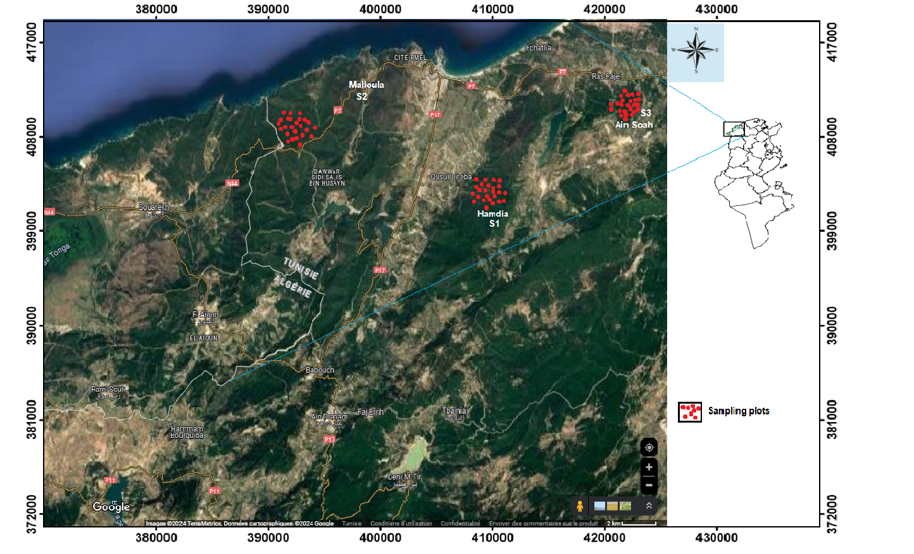
Fig.1: The location of sampling plots in the three cork oak forests

Environmental data and carbon stock assessment
The equipment includes a Global Positioning System (GPS) for geographical location, a tape measure for tree diameter, a decameter for measuring plot dimensions and the circumference of some large trees, a clinometer for measuring tree height, and inventory sheets. Dendrometric, environmental and carbon stock assessment sheets.
Sampling and data collection
The relationship between diameter structure and carbon stock with the type of cork oak stand (pure or mixed) was studied using permanent circular plots.
Given the large geographical area of the north-western region of Tunisia and the specific characteristics of the cork oak ecological habitat, we decided to use a stratified sampling method according to the type of stand. A series of circular plots of 500 m² each were established in a stratified manner. A total of 75 plots were equitably distributed among three types of cork oak stands (Table1 and Fig. 1).
The variables in question were quantified or described as follows: anthropogenic factors (human and animal actions) and dendrometric factors (number of individuals per plot, total height, diameter at 1.30 m and basal area).
In order to present the diameter structure of cork oaks according to stand type, the following diameter classes were selected (Jdaidi and Hasnaoui, 2014): Ø < 5 cm; (2): 5 < Ø < 10 cm; (3): 10 < Ø < 20 cm; (4): 20 < Ø < 30 cm; (5): 30 < Ø < 40 cm; (6) 40 < Ø < 50 cm; (7) 50 < Ø < 60 cm; (8) Ø > 60 cm.
Table 1. Site variables
 | Hamdia | Ain Sobah | Malloula
Longitude | 36.9022° | 36.9409° | 36.9491°
Latitude | 8.7976° | 8.8798° | 8.7178°
Bioclimate | Lower humid | Lower humid | Lower humid
Nature of the stand | S1: Pure cork oak | S3: Mix of cork oak and maritime pine | S2: Mix of cork oak with zeen oak
Number of plots | 25 | 25 | 25
Altitude (m) | 250 | 150 | 450
Exposure | North East | North East | North West
Soil type | Sandy-clay soil | Sandy-soil | Mull type soil

Structure Parameters
The calculated dendrometric parameters are density and basal area. In the initial approach, the density of trees (individuals per hectare) was calculated using the following formula:
$N=\frac{n}{A}$ (1)
N: trees/ha, n: trees on the area, A: area (ha).
Basal area (m².ha⁻¹): it is expressed in m²/ha according to the following formula:
$gi=\frac{ π {Di}^{2}}{4}$ (2)
Di: Diameter of tree i;
gi: Basal area of ​​tree i (m²/ha).
$G=\sum_{i=1}^{n}{gi ×\frac{d}{n}}$ (3)
d: density of the stand per hectare;
n: Number of the population in the plot.
Estimation of total biomass and carbon stock
The total biomass (TB) is the sum of the aboveground biomass (AB) and the belowground biomass (BB) of all individuals included in the inventory.
In order to minimise resource waste and time constraints, as well as to comply with the regulations governing tree felling in Tunisia, we have opted for a non-destructive method in this study.
Estimation of aboveground biomass (AB)
The aboveground biomass is the result of equation 4.
B_{A} (𝑛) = 𝑉₇ (𝑛) × 𝐹𝐸𝐵 × 𝑑_{i} (4)
The calculation uses the following variables:
B_{A} = aerial biomass (in tMS)
V₇ = volume of strong stem wood (m³)
FEB = "branches" expansion factor
d_{i} = infradensity of species i
To convert the volumes of strong stem wood into total volumes, we applied a "branches" expansion factor of 1.56 for hardwoods such as cork oak, as these values never deviate more than 1% from the published values (Dhôte and Impact, 2016).
In the case of employing total volumes, equation 4 is transformed into equation 5:
B_{A} (𝑛) = 𝑉_{t} (𝑛) × 𝑑_{i} (5)
With: Vt represents the total volume (in m³), while di denotes the infradensity of species i (in tMS/m³).
To streamline the calculations, the following equation 6 can be employed irrespective of the species, size, silviculture, or station (Deleuze et al., 2014).
$Vt=0,496×\frac{Ht ×{C_{1,3}}^{2}}{4Π}$ (6)
Vt: Total volume of the tree (m³); C_{1.3}: Circumference at 1.3 m (cm) and Ht: Total height of the tree (m).
Estimation of belowground biomass (BB)
In order to ascertain the belowground biomass of cork oak trees in Tunisia, we employed the Cairns equations (Cairns et al., 1997). The equation below, Equation 7, represents the Cairns equation adapted to the temperate forest, which was utilized in our study.
𝐵_{B} (𝑛) = exp (−1,0587 + 0,8836 × ln (𝐵_{A} (𝑛)) + 0,2840) (7)
B_{B} (n): root biomass (in tMS).
Estimation of carbon stock and CO2 equivalent
The total carbon sequestration in the tree is calculated by multiplying (B_{A} + B_{B}) by tc (carbon rate = 0.47 tC/tMS), as outlined by IPCC (2006) and Eggleston et al. (2006).
C_{T} = (B_{A} + B_{B}) × T_{C} (8)
The equivalent stock of atmospheric CO2 is calculated by multiplying the stock of carbon from biomass by 3.67 ($\frac{44}{12}=3,67)$.
Q_{CO2} = T_{C}×B_{T} ×3,67 (9)
Q_{CO2}: The quantity of CO2 captured by a tree (in tons);
T_{C}: The carbon rate, which can be approximated at 0.475 tC/tMS;
B_{T}: The total biomass, comprising both aerial and root components (tMS).
Statistical analyses
The statistical analyses were carried out using the XLSTAT software package, version 2020. The following analyses were performed:
A test of comparison of means was performed to determine the relationship between diameter classes, basal area, belowground biomass, aboveground biomass and total biomass. This was achieved by using analysis of variance, which is a quantitative dependent variable, and the type of cork oak stand, whether pure or mixed. A model was constructed based on the stand classes and the stand type.
In order to determine the significance of a given test, it was necessary to refer to the value of the statistic (p-value) provided by the XLSTAT software version 2020 at the end of each analysis.
The following criteria were used to determine the significance of the results
- If the p-value is 5% or less, the difference is not considered significant;
- If the p-value is between 5% and 5%, the difference is considered significant;
- If the p-value is between 5% and 1%, the difference is considered to be highly significant;
- If the p-value is between 5% and 0.1%, the difference is considered to be highly significant.
Results
Structural variability of cork oak depending on the type of the stands
To enable a more effective comparison of the diametric structure of different cork oak stands in terms of tree diameter, eight diameter classes were established. The distribution of stands across the Tabarka region follows a progressive succession with an inverted J-shaped diameter structure (Fig. 2). The diameter class histograms for all stands demonstrate an inverted J-shaped pattern, indicating a decline in the number of stems as we move from small diameter to larger diameter classes.
Table 2. Analysis of variations in the parameters used
Source | DDL | Sum of squares | Mean of squares | F | Pr > F
Stand | 2 | 8000,000 | 8000,000 | 35,480 | <0,0001
Error | 73 | 6313,367 | 225,477
Corrected total | 75 | 14313,367
The data shows a clear and consistent decline in the number of stems across all diameter classes, with highly significant differences (p<0.0001). Stems in diameter classes below 5 cm (regeneration classes) account for over 50% of the stems observed in the various stands. These classes are of particular significance because of the number of stems observed in the mixed cork oak and zeen oak stands (780 stems/ha) and in the pure cork oak stand (380 stems/ha). There was considerable variation in the proportion of stems exhibited in the intermediate diameter classes (5 to 40 cm), ranging from 6.42% to 13.14% across the different stands. Furthermore, stands comprising cork oak in combination with zeen oak and pure cork oak also demonstrated a notable abundance of stems. In diameter classes exceeding 40 cm, this value is notably low (1 to 2%) in stands comprising pure cork oak and those mixed with maritime pine.
The stands of cork oak mixed with zeen oaks display a notable high density of large-diameter trees. In light of these findings, it can be concluded that cork oak stands, whether pure or mixed with maritime pine, are highly susceptible to anthropogenic and climatic disturbances. This explains the high proportion of small-diameter stems and the low proportion of large-diameter stems observed in these stands.
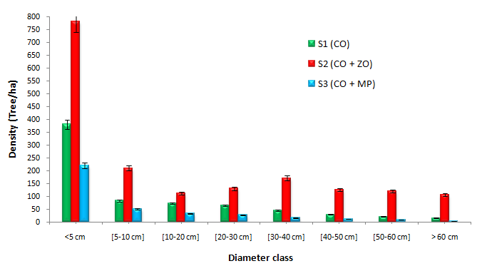
Fig. 2: Variation in the diameter structure of cork oak according to the type of stand

The relationship between the different densities of diameter classes within the three cork oak stands (pure, mixed with zeen oak, mixed with maritime pine) was determined using this model. This model was selected based on the lowest information criterion and the lowest standard error (Table 3). It was therefore chosen to establish the variation between the diameter structure and the nature of the cork oak stands (Fig. 3 and 4).

Table 3. Model parameters for the relationship between daimetric structure and stand type
Source | Value | Standard error | t | Pr > |t| | Lower terminal (95%) | Upper terminal (95%)
Constant | 5,194 | 1,198 | 4,336 | 0,000 | 2,732 | 7,656
S1 (CO) | -0,007 | 0,026 | -0,278 | <0,0001 | -0,060 | 0,046
S2 (CO + ZO) | -0,030 | 0,027 | -1,106 | <0,0001 | -0,087 | 0,026
S3 (CO+MP) | -0,003 | 0,019 | -0,148 | <0,0001 | -0,042 | 0,036

The cork oak stands, whether pure or mixed with maritime pine, in the study area are less conducive to the natural renewal of this species. These stands are subject to intensive exploitation, characterized by agricultural practices. These practices result in a reduction in the density of different classes of diameter per hectare, which in turn subjects the soil to intense sunlight. This has an adverse effect on the density of seedlings and the physiology of trees. The repeated fires in recent years, especially in mixed cork oak and maritime pine forests, have resulted in the removal of large-diameter trees.
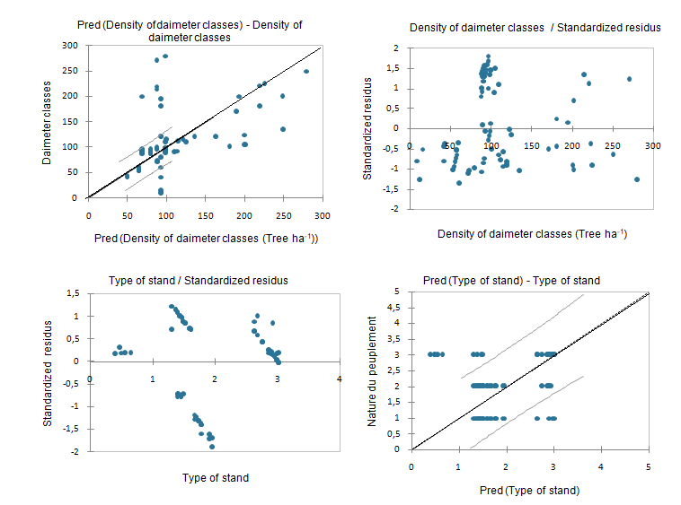
Fig. 3: Prediction accuracy of overestimates greater than 10% of the following constructed models of linear regressions of diameter structure (a and b) and stand type (d and c).

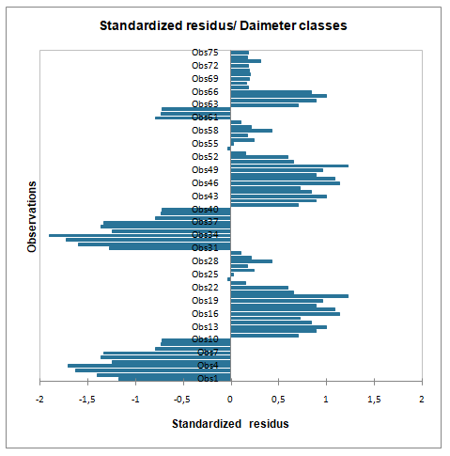
Fig. 4: Study of the mean square error with indication of the different classes of diameter overestimation and underestimation
However, these stands show clear signs of desiccation, particularly in trees with a diameter exceeding 30 cm. All areas studied, whether pure or mixed cork oak, have been found to exhibit clear signs of parasitic infestation by Platypus cylindrus, Biscogniauxia mediterranea, and Diplodia corticola. The infestation is particularly severe in mixed maritime pine stands. Recent years have seen an increase in the proportion of trees affected, with a correlation between this and rising annual mean and maximum temperatures, as well as a reduction in annual rainfall at Tabarka (1980-2022) (Fig. 5 and 6).

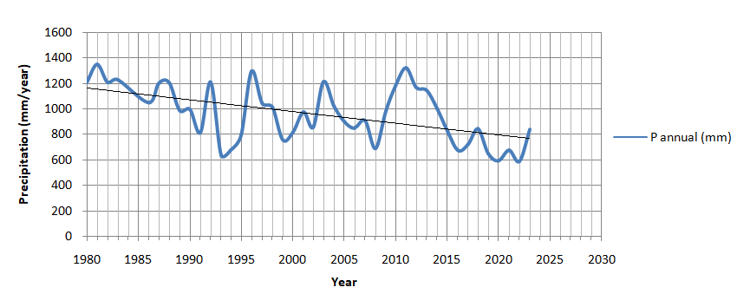
Fig. 5: Evolution of the annual precipitation at the level of Tabarka for the period from 1980 to 2022

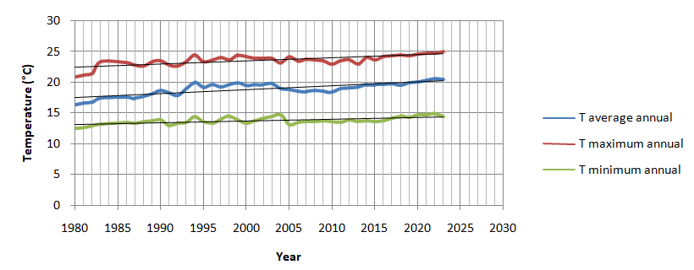
Fig. 6: The evolution of the annual mean, maximum and minimum temperature in Tabarka from 1980 to 2022.

According to 2050 projections, the Tabarka region will see a 16% decrease in precipitation and an increase in mean temperature from 1.6 to 1.8°C. In 2100, there will be a 35% reduction in mean rainfall and an increase in mean temperature between 2.3 and 2.5°C. These findings indicate that the North-West region of Tunisia will be the most susceptible to climate change in the future.
Furthermore, the natural dynamics of the reconstitution of pure cork oak ecosystems or mixed with maritime pine are negatively impacted by the near-total collection of acorns for livestock feed, which presents a significant challenge to the long-term viability of these ecosystems (Fig. 7). The rise in maximum temperature during the summer period, exceeding 40°C during July and August, has resulted in the mortality of seedlings. This has led to a decline in the density of individuals within diameter classes [5-10 cm], which in turn has reduced the potential for future fruiting and the probability of natural regeneration of cork oak.
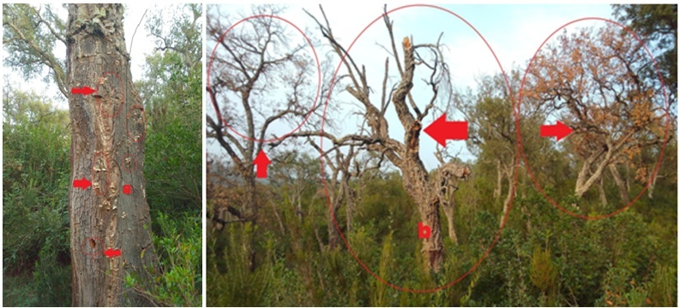
Fig. 7: Symptoms of attack by Platypus cylindrus in a mixed stand with maritime pine (Ain Sobah): (a) and yellowing of foliage in a pure cork oak stand (Hamdia): (b) (Photo Jdaidi 2022)

The combination of cork oak and zeen oak offers the ideal conditions for the regeneration of cork oak, with fertile soil, a northwest exposure at mid-slope, and a sandy silty soil composition. These conditions could play an important role in the defence of the cork oak tree against parasitic attacks and climate changes in recent years, which is an important consideration for any business looking to invest in this area. Conversely, the dendrometric characteristics of the trees, in particular the total height and trunk diameter, have a positive influence on the incidence of parasitic attacks. It is therefore important to ensure that the distance of these stands from the forest population is sufficient to limit the incidence of overgrazing.
The cork oak has been weakened by some inadequate forestry policies and management methods provided for in the development plans. In the Tabarka region, for example, sea pines are planted in combination with pure cork oak stands.
Estimation of biomass and carbon stock according to the nature of the stands
The mean total biomass of the aboveground and belowground parts was 188.46±0.23 Mg ha⁻¹, 446.80±0.33 Mg ha⁻¹, and 83.83±0.13 Mg ha⁻¹ for the pure cork oak, mixed zeen oak and mixed-cork oak stands, respectively. The ANOVA test at p<0.0001 yielded significant results, confirming a notable distinction between the three stands. The observed differences in biomass are in line with expectations and can be attributed to the distribution of diameters within the three stands. It is worth noting that the highest diameter classes (DBH) were concentrated in the mixed zeen oak stands, which also had the highest biomass stock (Table 4).

Table 4. Analysis of variance of comparison of aboveground and belowground biomasses and total carbon stock for different cork oak stands
Source | DDL | Sum of squares | Mean of squares | F | Pr > F
Stands | 4 | 1620.000 | 1620,000 | 12,486 | 0,0001
Error | 71 | 3632,967 | 129,749
Total corrected | 75 | 5252,967

The aboveground biomass of the cork oak stand demonstrates contingent variability contingent on the specific nature of the stands and the diameter classes. The mean is 129.34±0.09 Mg ha⁻¹, with a range of 0.9 to 285.13±0.13 Mg ha⁻¹, representing 68.62% of the total biomass of pure cork oak stands. The values recorded for the mixed stands of zeen oak vary from 1.21 to 609.23±0.08 Mg ha⁻¹ (mean of 320.14±0.23 Mg ha⁻¹), which is equivalent to 71.65% of the total biomass. The lowest values are observed for mixed stands with maritime pine, ranging from 0.31 to 116.24±0.32 Mg ha-1 (mean of 57.28±0.28 Mg ha⁻¹), which is equivalent to 62.27% of the total biomass (Table 5). The belowground biomass of the pure cork oak stand varies with the diameter classes from 0.3 to 113.61±0.16 Mg ha⁻¹ (mean value of 59.12±0.14 Mg ha⁻¹), representing 31.38% of the total biomass of the stand. The total biomass of the stand for the mixed stands with zeen oak varies from 0.52 to 217.75±0.12 Mg ha⁻¹ (mean value of 126.65±0.09 Mg ha⁻¹), representing 28.34% of the total biomass. The lowest values of belowground biomass are observed for the stands mixed with maritime pine, ranging from 0.07 to 61.33±0.09 Mg ha⁻¹(mean value of 26.61±0.22 Mg ha⁻¹), which is equivalent to 31.72% of the total biomass of the stands (Table 5).
The total biomass content and carbon stock vary according to the different diameter classes for each type of stand. In our case study, the results show that trees with diameter classes greater than 40 cm have the highest biomass and carbon stock contents, at 82 %. The results are grouped in the table. The carbon stocks of all aerial and underground parts are 88.57±0.13 tC ha⁻¹ for pure cork oak stands, 217.59±0.09 tC ha⁻¹ for mixed stands with cork oak, and 39.39±0.34 tC ha⁻¹ for those mixed with maritime pine.
The total biomass and carbon stocks of cork oak in our region are in decline. The extent of this decline varies depending on the nature of the stands and the density of the different diameter classes. This can be attributed to several factors, including the low fertility of the trees, dieback, the failure of the natural renewal of cork oak, the overexploitation of this species by humans over decades, and the influence of climate change in the southern Mediterranean, and northern Africa.

Table 5. Biomass and carbon stocks in the different cork oak stands studied
 |  |  |  | Boimass (Mg ha⁻¹)
Type of the stands | Diameter classes | Density  (Tree ha⁻¹) | Basal area  (m² ha⁻¹) | AB | BB | TB | TC (tC ha⁻¹) | Eq CO2 (t)
S1 (CO) | < 5 cm | 380±0.11 | 0,34±0.13 | 0,90±0.13 | 0,30±0.07 | 1,20±0.09 | 0,56±0.31 | 2,05±0.09
 | [5-10 cm] | 83±0.23 | 0,49±0.16 | 1,45±0.23 | 0,80±0.13 | 2,25±0.10 | 1,06±0.23 | 3,92±0.11
 | [10-20 cm] | 72±0.13 | 1,31±0.36 | 63,25±0.21 | 25,80±0.10 | 89,05±0.15 | 41,85±0.13 | 153,59±0.14
 | [20-30 cm] | 65±0.32 | 2,61±0.25 | 124,33±0.11 | 55,62±0.11 | 179,95±0.23 | 84,58±0.16 | 310,41±0.01
 | [30-40 cm] | 45±0.10 | 9,39±0.21 | 132,52±0.25 | 61,77±0.31 | 194,29±0.24 | 91,31±0.17 | 335,13±0.06
 | [40-50 cm] | 28±0.2. | 15,1±0.26 | 223,63±0.16 | 102,56±0.34 | 326,19±0.36 | 153,31±0.18 | 562,65±0.09
 | [50-60 cm] | 21±0.09 | 17,23±0.23 | 285,13±0.13 | 112,53±0.33 | 397,66±0.031 | 186,92±0.32 | 685,92±0.12
 | > 60 cm | 15±0.13 | 9,23±0.32 | 203,55±0.08 | 113,61±0.16 | 317,15±0.19 | 149,06±0.30 | 547,05±0.32
 | Mean | 88,63±010 | 6,96±0.35 | 129,34±0.09 | 59,12±0.14 | 188,46±0.23 | 88,57±0.13 | 325,09±0.34
S2 (CO + ZO) | < 5 cm | 780±0.21 | 0,53±0.19 | 1,21±0.12 | 0,52±0.12 | 1,71±0.08 | 6,23±0.03 | 22,86±0.13
 | [5-10 cm] | 210±0.09 | 0,84±0.18 | 3,55±0.34 | 1,25±0.32 | 4,82±0.12 | 17,61±0.06 | 64,62±0.17
 | [10-20 cm] | 112±0.15 | 7,57±0.22 | 155,23±0.36 | 93,42±0.09 | 248,65±0.31 | 116,86±0.05 | 428,87±0.23
 | [20-30 cm] | 130±0.23 | 14,87±0.31 | 282,58±0.41 | 136,94±0.19 | 419,52±0.34 | 197,17±0.11 | 723,61±0.08
 | [30-40 cm] | 171±0.12 | 17,66±0.26 | 409,82±0.38 | 184,79±0.34 | 594,61±0.18 | 279,46±0.31 | 1025,61±0.12
 | [40-50 cm] | 125±0.16 | 23,05±0.34 | 584,32±0.21 | 175,79±0.32 | 760,11±0.17 | 357,25±0.09 | 1311,1±0.14
 | [50-60 cm] | 120±0.16 | 25,19±0.31 | 609,23±0.08 | 217,75±0.12 | 826,98±0.18 | 388,68±0.33 | 1426,45±0.21
 | > 60 cm | 106±0.25 | 26,69±0.08 | 515,22±0.11 | 202,82±0.11 | 718,04±0.21 | 377,47±0.12 | 1385,31±0.31
 | Mean | 219,25±0.28 | 14,55±0.07 | 320,14±0.32 | 126,65±0.09 | 446,80±0.33 | 217,59±0.09 | 798,55±0.19
S3 (CO + MP) | < 5 cm | 220±0.02 | 0,04±0.34 | 0,31±0.12 | 0,07±0.16 | 0,37±0.33 | 0,17±0.06 | 0,62±0.21
 | [5-10 cm] | 51±0.12 | 0,16±0.31 | 1,21±0.23 | 0,65±0.12 | 1,85±0.21 | 0,86±0.07 | 3,15±0.35
 | [10-20 cm] | 33±0.31 | 0,72±0.35 | 55,35±0.34 | 21,16±0.09 | 76,51±0.14 | 35,72±0.13 | 129,18±0.18
 | [20-30 cm] | 27±0.09 | 1,20±0.18 | 116,24±0.32 | 61,33±0.09 | 177,57±0.07 | 83,45±0.23 | 306,26±0.11
 | [30-40 cm] | 16±0.21 | 5,27±0.21 | 82,63±0.34 | 42,35±0.13 | 124,98±0.17 | 58,74±0.32 | 215,57±0.31
 | [40-50 cm] | 11±0.32 | 7,65±0.27 | 76,52±0.31 | 37,32±0.07 | 113,84±0.12 | 53,5±0.17 | 196,34±0.14
 | [50-60 cm] | 9±0.11 | 8,76±0.36 | 70,09±0.13 | 30,12±0.13 | 100,21±0.32 | 47,09±0.08 | 172,82±0.35
 | > 60 cm | 4±0.34 | 3,46±0.34 | 55,92±0.26 | 19,88±0.23 | 75,80±0.35 | 35,62±0.11 | 16,74±0.30
 | Mean | 46,47±0.23 | 3,41±0.31 | 57,28±0.28 | 26,61±0.22 | 83,83±0.13 | 39,39±0.34 | 130,08±0.13

D = density of cork oak stands in the plot (stem ha⁻¹); Ba = basal area of the plot (m2 ha⁻¹); AB: aboveground biomass (Mg ha⁻¹); BB: belowground biomass (Mg ha⁻¹); TB: total biomass (Mg ha⁻¹); TC: total carbon (tC ha⁻¹); Eq CO2: CO2 equivalent (t)

Discussion

Structural variability of cork oak depending on the type of stands
Analyzing the main dendrometric parameters correlated with the influence of the nature of the stands, namely height, basal area, and diameter, we observed that the stands of cork oak mixed with maritime pine and pure presented trees with the lowest diameter classes and basal areas.
These stands are distinguished by the attack of Platypus cylindrus and other insects, including Biscogniauxia mediterranea and Diplodia corticola, which have recently been observed in pure and mixed maritime pine forests. These stands present an average phytosanitary situation, with a rate of yellowing and defoliation exceeding 50% in those mixed with maritime pine.
It is worth noting that trees in the diameter classes greater than 40 cm are susceptible to drying out and rotting. These stands have long been utilized by humans for the production of firewood and charcoal, which has resulted in a notable reduction in tree density for diameters exceeding 30 cm. The Tabarka cork oak forest is experiencing challenges due to overgrazing and deforestation, which increases its vulnerability to damage from drought, diseases, and harmful insects. Frequent fires are causing the elimination of mature trees, hindering the natural renewal of cork oak in the Tabarka forest. The stands of cork oak mixed with zeen oak are distinguished by more vigorous trees, with a larger basal area and generally significant diameter classes. Furthermore, the climatic and edaphic conditions of these regions greatly favor the development of cork oak trees, creating optimal fertility. Additionally, the phytosanitary state of the trees (trunk and foliage) is satisfactory. Our findings align with those of other researchers in the field. The following sources were consulted: Hasnaoui (1992), Boussaidi et al. (2010), Jdaidi and Hasnaoui (2014), Jdaidi et al. (2018, 2019), and Mechergui et al. (2023). The diameter structure of the cork oak forest in Tunisia is comprised solely of seedlings and adults, which has failed natural renewal. The same authors have demonstrated that this structure is influenced by the interplay of anthropogenic and environmental factors. Pereira et al. (2009) highlighted the growing threat to cork oak forests posed by climate change. In the Mediterranean region, there has been a notable increase in the frequency of droughts since the 1970s. This is occurring concurrently with a process of aridification in the context of global warming. Similarly, Giannakopoulos et al. (2009) and Pereira et al. (2009) demonstrated that climate change projections indicate a deterioration of cork oak conditions in the Mediterranean, particularly through rising temperatures and decreasing precipitation. These elements can intensify the intensity of plant water stress and the level of degradation of nutrients present in the soil (Pereira et al., 2009). Future droughts may hurt cork oak ecosystems, potentially disrupting tree health and creating favorable conditions for the proliferation of various insect pests and diseases. It is also possible that climate change will affect current fire regimes in several areas, including the Mediterranean. This could result in fires lasting longer and posing a greater threat (Pausas, 2004; Flannigan et al., 2009; Catry et al., 2012). The forests in question have suffered significant degradation as a result of insect and fungal attacks (Ben Jamâa et al., 2005; Hasnaoui, 2008). Rising annual temperatures may result in shorter life spans and an increased number of generations each year for these insects. For the Platypus cylindrus, there is evidence of generational overlap and prolonged egg-laying that begins in late summer-early autumn and continues throughout the winter until the following spring (Catry et al., 2017; Bellahirech et al., 2019). The fungi Biscogniauxia mediterranea and Diplodia corticola have become opportunistic and vulnerable pathogens, representing a significant risk to the industry. Attacks on cork oak have increased considerably in the Mediterranean region over the last few decades. This increase in infections is linked to significant mortality, particularly in cork oaks, and appears to be directly linked to the increase in particularly dry and hot years (Desprez-Loustau et al., 2006; Henriques et al., 2012; Moricca et al., 2016; Hasnaoui et al., 2017).
Estimation of biomass and carbon stock according to the nature of stands
Our findings indicate that the three cork oak stand types in the Tabarka forest have an aboveground biomass stock comparable to that reported by Zribi et al. (2016) of 117.24 ± 16 Mg ha⁻¹ and higher than in other cork oak forests. The figures for Tunisia (Sebei et al., 2001, 2004) are 48.9–113 Mg ha⁻¹, while in Italy (Léonardi et al. 1992) the figure is 42.2 Mg ha⁻¹. However, these figures are close to those reported by Robert et al. (1996) in a cork oak forest in Spain (159 - 328 Mg ha-1). Furthermore, research by Cañellas et al. (2008) indicates that cork oak stands in Portugal, ranging in age from 38 to 158 years, store amounts ranging from 28.82 to 199.9 Mg ha⁻¹. In Portugal, Nunes et al. (2013) found significantly lower levels of aboveground biomass in other oak stands, reaching approximately 61.4 ± 8.9 Mg ha⁻¹ for stands aged between 23 and 100 years. According to Oubrahim et al. (2016), the aboveground biomass from the pure cork oak stand in the Moroccan Mamoura forest ranges from 27.86 to 80.18 Mg ha⁻¹ (mean of 55.11 Mg ha⁻¹).
Sanaa et al. (2022) demonstrated that the aboveground biomass of pure cork oak ranges from 25.26 to 69.94 Mg ha⁻¹ (mean of 52.17 Mg ha⁻¹), which is lower than that observed in the Tabarka forest. The high variability observed is related to some factors, including the age and diameter classes of the trees in the different cork oak stands analyzed, as well as their spatial distribution and soil characteristics. Our study yielded the following belowground biomass figures: 25–113.61±0.14 Mg ha⁻¹ in pure cork oak, 93.42–217.75±0.12 Mg ha⁻¹ in the mixture with zeen oak, and 21.16–61.33±0.09 Mg ha⁻¹ in the mixed with zeen oak. These results exceed those observed by Sebei et al. (2001) in mixed pure cork oak forests in northwestern Tunisia (11–25.8 Mg ha⁻¹). Our findings align with those reported by Zribi et al. (2017), with average biomass values of 70.90 Mg ha⁻¹ for young stands and 98.81 Mg ha-1 for mature stands.
The root biomass values in our study (28.34% to 31.72%) are higher than those found by Oubrahim et al. (2016), ranging from 5.9 to 28.2 Mg ha⁻¹. This represents approximately 14% of the total biomass of the cork oak stand in Morocco. Our results fall within the lower range of 10 to 49% reported for deciduous species (Mac Dick, 1997; Ruiz-Peinado et al., 2012). Indeed, root biomass represents a significant portion of total tree biomass, ranging from 10 to 40% for tree species and 15 to 49% for hardwood species (Ruiz-Peinado et al., 2012). It is commonly assumed that root biomass is dependent on the size of the aerial tissues rather than on the age of the trees or the site where they were grown (Drexhage and Colin, 2001; Le Goff and Ottorini, 2001). However, trees growing in dense or open stands have been observed to exhibit different root/stem ratios (Ritson and Sochaki, 2003). The data collected on the mean total biomass and the importance of the biomass of the aerial parts align with observations made in Spanish cork oak forests (Ruiz-Peinado et al., 2012) and other oak forests, including Additionally, the species Quercus ilex, Quercus pyrenaica, and Quercus lanuginosa are present in Tunisia and throughout the Mediterranean region (Rapp et al., 1999; Regina, 2000; Boulmane et al., 2013). The estimated carbon stock is dependent on the nature of the stands. The values vary considerably, from 88.57±0.13 tC ha⁻¹ for pure cork oak to 217.5±0.09 tC ha⁻¹ for stands mixed with zeen oak and 39.39±0.34 tC ha⁻¹for cork oak mixed with maritime pine. These values remain low in comparison to those recorded at the level of the cork oak forest in Tunisia (538.78 tC ha⁻¹) (Zribi et al., 2016). The same authors demonstrated that the cork oak forest of Bellif, in the northwest of Tunisia, sequesters 153.85 tC ha⁻¹ in the above-ground and below-ground biomass of cork oak trees.
The average carbon stocks for cork oak in Morocco, as reported by Oubrahim et al. (2016), are between 35.8 and 66.9 Mg ha⁻¹ for the aerial part and between 5.04 and 10.8 Mg ha⁻¹ for the underground part. The lowest recorded carbon stock value is for open stands (21.3 Mg ha⁻¹ aboveground, 3.2 Mg ha⁻¹ belowground), while the highest value is for dense stands (94.8 Mg ha⁻¹ aboveground, 15.2 Mg ha⁻¹ belowground). This result is consistent with our results, indicating that the highest carbon stocks are concentrated in dense forests, while the lowest amounts are the consequence of deforestation, degradation, and climate change. The carbon stock of pure cork oak combined with maritime pine in the study area is comparable to that observed for similar species, such as Quercus ilex (17-91 tC ha⁻¹ (Boulmane et al., 2015). According to Ruiz-Peinado et al. (2013), the mean carbon stock of cork oak stands mixed with zeen oak (217.75 tC ha⁻¹) is comparable to the values ​​reported for mature stands of fast-growing exotic species such as Pinus pinaster Ait (166-249 tC ha⁻¹) in the same geographical area. The situation for cork oak stands in the Tabarka region is becoming increasingly challenging due to a combination of factors, including climate change, pest attacks in recent years, overgrazing, degradation, and the abundance of rural areas, as well as the replacement of cork oak by maritime pine plantations. The Maamora cork oak forest is also experiencing similar symptoms, with numerous natural (climate change, diseases, forest fires, etc.) and anthropogenic (overgrazing, pruning, etc.) pressures contributing to its degradation (Sanaa et al., 2022; Sanaa et al., 2024).
Conclusion
The objective of the present study was to estimate the dendrometric parameters, above-ground and below-ground biomass, and carbon stock contained in three different cork oak ecosystems (pure and mixed with zeen oak and maritime pine) in the Tabarka region. Additionally, the objective was to compare the values obtained with those of other researchers. For carbon estimates in Tunisia, we also consulted the work of Sebei et al. (2001, 2004) and Zribi et al. (2016, 2017). The results demonstrate that the diametric structure is influenced by the nature of the stands. The diametric distribution in the three types of stands is inverted J. It was observed that stands mixed with zeen oak exhibited high densities of different diameter classes.
The total biomass of cork oak in the studied area is as follows: 188.46±0.23 Mg ha⁻¹ for pure cork oak, 446.80±0.33 Mg ha⁻¹ for mixed cork and zeen oak, and 83.13 Mg ha⁻¹ for mixed cork and maritime pine. The carbon stock values vary according to the nature of the stands, with figures of 88.75±0.013 tC ha⁻¹ (pure), 217.59±0.59 tC ha⁻¹ (mixed with zeen oak), and 39.39±0.034 tC ha⁻¹ (mixed with maritime pine). The discrepancy between the total biomass and carbon stock values can be attributed to the low density of diameter classes within the species considered per stand. The pure cork oak mixed with maritime pine forests has been significantly impacted by anthropogenic factors, dieback, and the effects of global warming from 1980 to the present.
The above-mentioned values, despite their differences with those recorded in Tunisia and in the southern Mediterranean forest, are of great significance. They reflect more specific cases and will allow us to determine the current state of the pure and mixed cork oak ecosystem, as well as their carbon sequestration potential. It would be beneficial to conduct further studies on the future management of this forest species in Tunisia.
Authors contributions
J. N. developed the research, conducted the fieldwork performed the statistical analysis, and wrote the initial manuscript. S. H. and H. F. conducted the fieldwork and performed the statistical analysis, while A. C. worked jointly on the methodological research. All authors revised and published the manuscript.
Competing interest: The authors declare that they have no conflicts of interest.
Acknowledgments
We would like to express our gratitude to Mr. Chaabane Abbes, Director of the Tabarka Sylvo-Pastoral Resources Laboratory, for his support in the publication of this study. Furthermore, we would like to express our gratitude to the Director General of the Tabarka Sylvo-Pastoral Institute, Mr. Houcine Selmi, for his valuable input regarding the statistical analysis and presentation of the information.
References
APCOR. (2020). APCOR’s Cork Yearbook; APCOR: Santa Maria de Lamas, Portugal.
Bellahirech, A., Branco, M., Catry, F.X., Bonifácio, L., Sousa, E., Ben Jamâa, M.L. (2019). Site- and tree-related factors affecting colonization of cork oaks (Quercus suber L.) by ambrosia beetles in Tunisia. Annals of Forest Science, (76) 45. – https://doi.org/10.1007/s13595-019-0815-1
Ben Jamâa, M.L., Sghaier, T., Mnara, S., Nouri, M., Selmi, H. (2005). Cork oak decline in the Bellif cork oak forest (Tunisia): characterization and evaluation of its impact on cork growth. Bull. IOBC/WPRS, (28), 17-24.
Boulmane, M., Santa-Regina, M., Halim, M., Khia, A., Oubrahim, H., Abbassi, H., Santa Regina, I. (2015). Organic Carbon Storage in Evergreen Oak Forest Ecosystems of the Middle and High Moroccan Atlas Areas. Open Journal of Forestry, (5), 260-273. https://doi.10.4236/ojf.2015.53023
Boulmane, M., Santa Regina, I., Khia, A.R., Abbassi, H., Halim, M. (2013). Aboveground Biomass and Nutrient Pools in Two Evergreen Oak Stands of the Middle Moroccan Atlas Area. Arid Land Research and Management, (27), 188–202.
https://doi.org/10.1080/15324982.2012.723114
Boussaidi, N., Nsibi, R., Hasnaoui, B., Gammar, Z. (2010). Impacts of orographical and anthropic factors on the natural regeneration of cork oak (Quercus Suber) in Kroumirie, Tunisia. Revue d’Ecologie, 65, 235-242.
Branco, M., Ramos, P. (2009). Coping with pests and diseases. Cork Oak Woodlands on the Edge: Ecology, Adaptive Management, and Restoration; Aronson, J., Pereira, JS, Pausas, JG, Eds: 103-113.
Branco, M., Bragança, H., Sousa, E., Phillips, A.J. (2014). Pests and Diseases in Portuguese Forestry: Current and New Threats. In: Reboredo, F. (eds) Forest Context and Policies in Portugal. World Forests, (19). Springer, Cham. https://doi.org/10.1007/978-3-319-08455-8_5
Cairns, A.M., Helmer, H.E.B.S., Baumgardner, A.G. (1997). Root biomass allocation in the world’s upland forests. Oecologia, 111, 1–11. https://doi.org/10.1007/s004420050201
Cañellas, I., Sánchez-González, M., Bogino, S.M., Adame, P., Herrero, C., Roig, S., Tomé, M., Paulo, J.A., Bravo, F. (2008). Silviculture and Carbon Sequestration in Mediterranean Oak Forests. Managing Forest Ecosystems: The Challenge Climate Change, 17, 317-338.
http://dx.doi.org/10.1007/978-1-4020-8343-3_18
Catry, F.X., Branco, M., Sousa, E, Caetano, J., Naves, P., Nóbrega, F. (2017). Presence and dynamics of ambrosia beetles and other xylophagous insects in a Mediterranean cork oak forest following fire. For Ecol Manag, 404, 45–54. https://doi.org/10.1016/j.foreco.2017.08.029
Catry, F.X., Moreira, F., Cardillo, E., Pausas, J.G. (2012). Post-Fire Management of Cork Oak Forests. In: Moreira, F., Arianoutsou, M., Corona, P., De las Heras, J. (eds) Post-Fire Management and Restoration of Southern European Forests. Managing Forest Ecosystems, (24). Springer, Dordrecht. https://doi.org/10.1007/978-94-007-2208-8_9
Catry, F.X., Branco, M., Moreira, F., Sousa, E., Rego, F. (2022). Ambrosia Beetle Attacks in Mediterranean Cork Oak Forests Following Fire: Which Factors Drive Host Selection? Fire, 5(4), 115. https://doi.org/10.3390/fire5040115

Deleuze, C., Morneau, F., Renaud, J.P., Vivien, Y., Rivoire, M., Santenoise, P., Longuetaud, F., Mothe, F., Hervé, J.C., Vallet, P. (2014). Estimate the total volume of a tree regardless of species, size, silviculture, or location. Rendez-vous techniques, (44), 22-32 ⟨hal-01143797⟩
Desprez-Loustau, M.L., Marcais, B., Nageleisen, L.M., Piou, D., Vannini, A. (2006). Interactive effects of drought and pathogens in forest trees. Annals of Forest Science, 63, 597-612.
https://doi.org/10.1051/forest:2006040
Dhôte, J.F., Impact, I.S. (2016). The forest as a lever in the fight against climate change in terms of mitigation. Rapport final. INRA, Paris, France, Pp. 96.
Drexhage, M., Colin, F. (2001). Estimating root system biomass from breast-height diameters. Forestry, 74, 491–497. https://doi.org/10.1093/forestry/74.5.491
Flannigan, M.D., Krawchuk, M.A., Groot, W.J., Wotton, B.M., Gowman, L.M. (2009). Implications of changing climate for global wildland fire. Int. J. Wildland Fire, 18, 483- 507.
https://doi.org/10.1071/WF08187
Giannakopoulos, C., Le Sager, P., Bindi, M., Moriondo, M., Kostopoulou, E., Goodess, C.M. (2009). Climatic changes and associated impacts in the Mediterranean resulting from a 2°C global warming. Glob. Planet Chang, 68, 209-224.
https://doi.org/10.1016/j.gloplacha.2009.06.001
Hasnaoui, F. (2008). Oak-groves decline of northwestern Tunisia: diagnosis, causes and consequences. Thèse de doctorat, Université de Carthage, Tunis, Tunisie, pp. 183.
Hasnaoui, B. (1992). Oak-groves of Northern Tunisia, ecology and regeneration. Thèse de doctorat, Université Aix Marseille I, France, pp. 202.
Hasnaoui, F., Zouaoui, I., Ouled Seghaeiri, W., Abbes C. (2017). Identification and pathogenicity of Fungi associated with Decline of cork oak in the North West of Tunisia. Journal of new sciences, Agriculture and Biotechnology, 40 (3), 2164-2168.
Henriques, J., Inácio, M.L., Lima, A., Sousa, E. (2012). New outbreaks of charcoal canker on young cork oak trees in Portugal. IOBC WPRS Bull, 76, 85-88.
Igueld Belghith, S., Journi, M., Barth, D., Cherif, J.K., Trabelsi-Ayadi, M. (2015). Study of Supercritical CO2 Extraction from Tunisian Psidium guava leaves. Antioxidant Activity of the Extracts. International Journal of Pharmacognosy and Phytochemical Research, 7(5), 1088-1095. ⟨hal-01303529⟩
Intergovernmental Panel on Climate Change [IPCC]. (2006). IPCC Guidelines for National Greenhouse Gas Inventories, In: Eggleston, H.S.; Buendia, L.; Miwa, K.; Ngara, T.; Tanabe, K., eds. (2006). Agriculture, Forestry and Other Land Use. IGES, JP4.
Jdaidi, N. (2009). Structure of the Tunisian cork oak-grove: current situation and future of its ecosystem. Memoire de mastere, Universite de Carthage, Tunis, Tunisie, pp. 90.
Jdaidi, N., Hasnaoui, B. (2019). Influence of the altitude in the diametric distribution of the Quercus suber in the Northwest of Tunisia. Journal of Advanced Research in Science and Technology, 6 (2), 1018-1024. http://www. asjp.cerist.dz/en/downArticle/112/6/2/98159
Jdaidi, N., Chaabane, A., Toumi, L., Hasnaoui, B. (2018). Influence of the sanitary state of acorns on the regeneration of Quercus suber in Tunisia. Revue d’Ecologie, 73 (1), 71-79. http://hal.archives-ouvertes.fr/hal-03 532824/
Jdaidi, N., Hasnaoui, B. (2014). Effects of the distance of stands from the nearest douars on the diameter distribution of the cork oak forest in Kroumirie (Northwest Tunisia). Revue d'Écologie, 69 (2), 173-177. ⟨hal-03530639⟩
Jdaidi, N., Selmi, H., Aloui, F., Chaabane, A. (2022). Dynamics of the natural regeneration of a natural Zean oak (Quercus faginea) ecosystem in Kroumirie, north-western Tunisia. Arabian Journal of Geosciences, 15:1661. https://doi.org/10.1007/s12517-022-10783-2
Léonardi, S., Rapp, M., Dénes, A. (1992). Biomass, mineralomass, productivity and management of some biogenic elements in a Quercus suber L. forest in Sicily (Italy). Ecologia méditerranea XVIII, 89–98.
Le Goff, N., Ottorini, J.M. (2001). Root biomass and biomass increment in a beech (Fagus sylvatica L) stand in North-east France. Annals of Forest Science, 58, 1-13.
https://doi.org/10.1051/forest:2001104
MacDicken, K.G. (1997). A Guide to monotoring carbon storage in forestry and agroforestry projects. Winrock International Arlington. VA. USA.
Mechergui, T., Pardos, M., Boussaidi, N., Jacobs, D.F., Catry, F.X. (2023). Problems and solutions to cork oak (Quercus suber L.) regeneration: a review. iForest, 16, 10-22. doi: 10.3832/ifor3945-015
Moricca, S., Ginetti, B., Ragazzi, A. (2012). Species and organ-specificity in endophytes colonizing healthy and declining Mediterranean oaks. Phytopathologia Mediterranea, 51, 587-598.

Moricca, S., Linaldeddu, B., Ginetti, B., Scanu, B., Franceschini, A., Ragazzi, A. (2016). Endemic and Emerging Pathogens Threatening Cork Oak Trees: Management Options for Conserving a Unique Forest Ecosystem. Plant Disease, 11, 2184-2194.

https://doi.org/10.1094/PDIS-03-16-0408-FE
Oubrahim, H., Boulmane, M., Bakker, M., Augusto, L., Halim, M. (2016). Carbon Storage in Degraded Cork Oak (Quercus Suber) Forests on Flat Lowlands in Morocco. IForest Biogeosciences and forestery, 9, 125–137. https://doi.org/10.3832/ifor1364-008
Nunes, L., Lopes, D., Rego, F.C., Gower, S.T. (2013). Aboveground biomass and net primary production of pine. Oak and mixed pine–oak forests on the Vila Real district. Portugal. Forest Ecology and Management, 305, 38–47. https://doi.org/10.1016/j.foreco.2013.05.034
Pausas, J.G. (2004). Changes in fire and climate in the eastern Iberian Peninsula (Mediterranean Bassin). Climatic Change, 63, 337-350. https://doi.org/10.1023/B:CLIM.0000018508.94901.9c
Pereira, J.S., Correia, A.V., Joffre, R. (2009). Facing climate change. Cork Oak Woodlands on the Edge. Island Press, Washington DC: 219-226.
Pereira, P., Godinho, C., Roque, I., Marques, A., Branco, M., Rabaça, J.E. (2012). Time to rethink the management intensity in Mediterranean oak woodland: the response of insectivorous birds and leaf-chewing defoliators as key groups in the forest ecosystem. Annals Forest Science, 71, 25–32. https://doi.org/10.1007/s13595-012-0227-y
Rapp, M., Santa-Regina, I., Rico, M., Gallego, H.A. (1999). Biomass, nutrient content, litterfall and nutrient return to the soil in Mediterranean oak forests. Forest Ecology and Management, 119, 39-49. https://doi.org/10.1016/S0378-1127(98)00508-8
Regina, I.S. (2000). Biomass estimation and nutrient pools in four Quercus yrenaica in Sierra de Gata Mountains, Salamanca, Spain. Forest Ecology and Management, 132, 127-141. https://doi.org/10.1016/S0378-1127(99)00219-4
Ritson, P., Sochacki, S. (2003). Measurement and prediction of biomass and carbon content of Pinus pinaster trees in farm forestry plantations, south-western Australia. Forest Ecology and Management, 175, 103-117. https://doi.org/10.1016/S0378-1127(02)00121-4
Ruiz-Peinado, R., Montero, G., Rio, M. (2012). Biomass models to estimate carbon stocks for hardwood tree species. Forest Systems, 21, 42–52. http://dx.doi.org/10.5424/fs/2112211-02193

Ruiz-Peinado, R., Bravo-Oviedo, A., Lopez-Senespleda, E., Montero, G., Rıo, M. (2013). Do thinning influence biomass and soil carbon stocks in Mediterranean maritime pinewoods? European Journal of Forest Research, 132, 253–262. http://dx.doi.org/10.1007/s10342-012-0672-z
Sanaa, F., Imane, S., Mohamed, B., Kenza, A.E.K., Souhail, K., Lfalah, H., Khadija, M. (2022). Biomass and Carbon Stock Quantification in Cork Oak Forest of Maamora Using a New Approach Based on the Combination of Aerial Laser Scanning Carried by Unmanned Aerial Vehicle and Terrestrial Laser Scanning Data. Forests, 13 (8), 1211.
https://doi.org/10.3390/f13081211
Sanaa, F., Sebari, I., Moulay, M.A., El Kadi, K.A. (2024). Modeling and spatialization of biomass and carbon stock using unmanned Aerial Vehicle Lidar (Lidar-UAV) metrics and forest inventory in cork oak forest of Maamora. Regional Science Policy & Practice, 16, 100127.
https://doi.org/10.1016/j.rspp.2024.100127
Sebei, H., Albouchi, A., Rapp, M., El Aouni, M.H. (2001). Assessment of tree and shrub biomass in a degradation sequence of the Kroumirie Laburnum cork oak forest (Tunisia). Annals of Forest Science, 58, 175–191. http://dx.doi.org/10.1051/forest:2001117
Sebei, H., Albouchi, A., Rapp, M., El Aouni, M.H. (2004). Biomass productivity of cork oak in a degradation sequence of the Kroumirie Laburnum cork forest (Tunisia). Annals of Forest Science, 61, 347–361. http://dx.doi.org/10.1051/forest:2004028
Touzi, S., Ben Zakour, J. (2015). Tunisian experience in dealing with climate variability and change in coastal zones. Rapport final. Dans le cadre du projet Clim Var (MedPartnership), pp. 40.
Zribi, L., Gharbi, F., Mouillot, F. (2017). Is the Bellif cork oak forest (north-west Tunisia) a carbon sink or a source? Forêt Méditerranéenne XXXVIII , (4): 479-486. (ffhal-03556603f )
Zribi, L., Chaar, H., Khaldi, A., Henchi, B., Mouillot, F., Gharbi, F. (2016). Estimate of biomass and carbon pools in disturbed and undisturbed oak forests in Tunisia. Forest Systems, 25(2), e060. https://doi.org/10.5424/fs/2016252-08062

