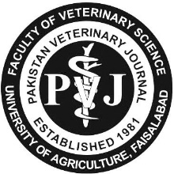 | Pakistan Veterinary Journal  ISSN: 0253-8318 (PRINT), 2074-7764 (ONLINE)  DOI: 10.29261/pakvetj/2025.xxx
RESEARCH ARTICLE

Effect of Dietary L-carnitine Supplementation on Fresh Semen Characteristics and Post-thaw Sperm Quality in Male Rabbits

Chengfang Gaoa, Ming Liua, Liya Bai², Yuxiang Lan³, Shikun Sun¹, Dongjin Chen¹, Jinxiang Wang¹, Xiping Xie¹ and Lei Sang^{1,} *

¹Fujian Key Laboratory of Animal Genetics and Breeding, Institute of Animal Husbandry and Veterinary Medicine, Fujian Academy of Agricultural Sciences, Fuzhou 350013, China; ²Key Laboratory of Livestock and Poultry Multi-omics of MARA, Institute of Animal Science and Veterinary Medicine, Shandong Academy of Agricultural Sciences, Jinan, 250100, China; ³College of Animal Sciences, Fujian Agriculture and Forestry University, Fuzhou 350002, China
*Corresponding author: sanglei1981@163.com

ARTICLE HISTORY (25-779) |  |  | ABSTRACT
Received:  Revised:  Accepted:  Published online: | August 06, 2025  September 16, 2025  September 18, 2025 |  | Oxidative stress is a major factor adversely affecting semen quality in male rabbits. L-carnitine (LC) is an antioxidant that neutralizes harmful free radicals, protecting cell membranes (particularly mitochondrial membranes) from oxidative stress. This study investigated the effects of dietary LC supplementation (0, 75, 150, 300 and 450mg/kg) on sperm kinematic analysis, antioxidant capacity, membrane integrity, acrosome integrity, mitochondrial membrane potential (MMP) and anti-apoptotic changes in 50 Fujian Yellow male rabbits over an 8-week period. Semen samples were subjected to CASA, conventional assay kit, SYBR14/PI double staining, PNA-FITC/PI double staining, JC-1 assay kit and PE/7-AAD double staining. Finally, the relative expression levels of NRF-2, KEAP-1, Bax, Bcl-2, and caspase-3 in sperm were detected using quantitative real-time polymerase chain reaction (qRT-PCR). The results showed that dietary supplementation of LC at 300mg/kg increased ejaculate volume, sperm concentration, progressive motility and key sperm kinematic parameters including VCL, VAP and ALH (P<0.05). It concurrently increased seminal plasma antioxidant markers (SOD, GSH-Px, T-AOC) and LC content and reduced MDA and ROS levels. It also increased SOD, T-AOC and CAT levels in sperm (P<0.05). Supplementation with LC at 150 and 300mg/kg improved sperm acrosomal and plasma membrane integrity (P<0.05), while supplementation at 450mg/kg reduced early and late apoptosis rates (P<0.05). Furthermore, LC supplementation upregulated Bax mRNA expression, downregulated Bcl-2 mRNA expression, and reduced the Bcl-2/Bax ratio (P<0.05) without affecting caspase-3 expression. Additionally, LC300 specifically increased the expression of NRF-2 and KEAP-1 (P<0.05). Furthermore, LC300 also improved post-thaw sperm progressive motility and velocity parameters including VSL, VAP and ALH (P<0.05). These results suggest that dietary LC supplementation could improve fresh semen quality via antioxidant induction, membrane stabilization and anti-apoptotic effects, and enhanced post-thaw sperm motility.
Key words:
Antioxidant capacity
L-carnitine
Oxidative stress
Rabbit
Semen quality
To Cite This Article: Gaoa C, Liua M, Bai L, Lan Y, Sun S, Chen D, Wang J, Xie X and Sang L* 2025. Effect of dietary l-carnitine supplementation on fresh semen characteristics and post-thaw sperm quality in male rabbits. Pak Vet J. http://dx.doi.org/10.29261/pakvetj/2025.xxx

INTRODUCTION

Despite its high production efficiency, feed conversion rate and superior meat quality, global rabbit production is largely based on small-scale and un-intensive (Cullere and Zotte, 2018). To accelerate the pace of intensive production, the rapid development and application of artificial insemination technology is necessary. Semen quality is critical to artificial insemination success in commercial rabbit production (Farhadi et al., 2025). However, male rabbit spermatozoa exhibit particular vulnerability to oxidative stress (OS) owing to their limited cytoplasmic antioxidant reserves and inefficient DNA repair mechanisms, which collectively contribute to cellular damage and diminished fertilizing capacity (Brecchia et al., 2023). This susceptibility, compounded by high polyunsaturated fatty acid (PUFA) contents in sperm plasma membranes (Di Nisio et al., 2023), leads to lipid peroxidation (LPO), which compromises membrane integrity, results in ATP leakage, and impairs flagellar motility, ultimately leading to impaired sperm function (Ofosu et al., 2021). Substantial evidence from multiple studies confirms the profoundly negative effect of oxidative stress on both semen quality and fertility potential (Makris et al., 2023; Abdelnour et al., 2024; Lahimer et al., 2025) with elevated reactive oxygen species (ROS) levels in reproductive tissues showing strong correlation with reduced sperm viability, motility, and fertilization capacity (O'Flaherty and Scarlata, 2022; Wang et al., 2025).
L-carnitine (LC), an amino acid derivative and essential metabolic cofactor, addresses these challenges through multiple protective mechanisms. As a crucial transporter of long-chain fatty acids into mitochondria (Vaz et al., 2002), LC not only supports energy metabolism but also reduces LPO substrate availability, thereby functioning as an effective antioxidant (Neuman et al., 2002). Its importance in male reproduction is well-established, with seminal LC levels directly correlating with sperm quality (Hafezi et al., 2022). Across species, dietary LC supplementation has demonstrated consistent benefits, improving sperm concentration in roosters (Neuman et al., 2002), motility in quails (Ahangari et al., 2014), morphology in pigs (Tatemoto et al., 2022), and overall quality in humans (Lin et al., 2020). In rabbits specifically, LC enhances both production performance and sperm cryo-resistance (Abdelnour et al., 2022).
Given the vulnerability of rabbit spermatozoa to oxidative damage (Brecchia et al., 2023), this study investigated whether dietary LC could mitigate this impairment. It was hypothesized that dietary LC supplementation would improve semen quality and cryo-resistance in rabbits by enhancing antioxidant capacity and reducing oxidative damage and apoptosis. To test this hypothesis, the study aimed to: (1) establish dose-response relationships across five LC concentrations (0–450mg/kg); (2) evaluate comprehensive semen quality parameters in both fresh and post-thaw samples; and (3) elucidate underlying protective mechanisms through antioxidant profiling and molecular analyses.

MATERIALS AND METHODS

Ethical approval and experimental animals: The experimental protocol was reviewed and approved by the Animal Care and Use Committee of the Institute of Animal Husbandry and Veterinary Medicine, Fujian Academy of Agricultural Sciences, Fuzhou, China (Approval No. 202402FJ004). Fifty healthy 32-week-old Fujian Yellow male rabbits with an average body weight of 3.2±0.2kg were used. The animals were individually housed in galvanized wire cages (40×60×45cm) under standard management conditions with natural ventilation. All rabbits had free access to clean drinking water and were fed a commercial pellet diet formulated to meet NRC (1997) nutritional requirements.

Experimental design and semen collection: The composition and nutrient levels of the rabbit diet are presented in Table 1. The basal commercial diet was first mashed into powder, thoroughly mixed with the corresponding concentration of LC, and then prepared into pellet form. Male rabbits were randomly divided into five groups (n=10 per group) receiving different dietary LC supplementation levels: 0(LC0, control), 75(LC75), 150(LC150), 300(LC300) and 450mg/kg (LC450). The feeding trial lasted for 8 weeks, with the first 4 weeks serving as an adaptation period. Semen collection began on day 29 using the rabbit artificial vagina and teaser rabbit doe, as described by Ewuola et al. (2014), with subsequent collections were performed at 3-day intervals. During the 4-week formal experiment, semen was collected a total of 8 times. Immediately after collection, ejaculate volume was measured, and gel plugs were removed before analysis. Ejaculates collected from 10 rabbits of each group on each collection session were pooled. The mean±SD values of semen volume for 10 rabbits of each group before treatment are shown in Table 2. After semen samples collected each time from 10 rabbits of a group were pooled together, approximately 3mL aliquot of this pooled sample was taken for further analysis of various indicators.

Semen quality and kinematic analysis: Sperm concentration was determined using a calibrated Photometer (SDM1, Minitube, Germany). Briefly, 2μL of fresh semen was diluted with Tris-citric acid-glucose (TCG) semen diluent at a 1:9 ratio. Subsequently, 2μL of the diluted sample was used for estimation of the sperm cell concentration. Computer-assisted sperm analysis system (CASA; Hamilton Thorne IVOS II) was used to assess sperm motility parameters including total motility (TM), progressive motility (PM), curvilinear velocity (VCL), straight-line velocity (VSL), average path velocity (VAP), amplitude of lateral head displacement (ALH), beat-cross frequency (BCF), straightness (STR), linearity (LIN) and wobble (WOB). At least 500 sperm per sample were evaluated across five microscopic fields.

Table 1: Composition and nutrient levels of the commercial pellet diet (air-dry basis, %)
Ingredient | Content | Nutrient levels² | Content
Corn | 30 | Digestible energy (MJ/kg) | 10.25
Peanut meal | 10 | Crude protein (%) | 14.46
Bran | 20 | Ether extract (%) | 2.93
Alfalfa meal | 25 | Crude fibre (%) | 16.46
Peanut seedling powder | 10 | Crude ash (%) | 8.93
CaHPO₄ | 0.6 | Calcium (%) | 0.99
Salt | 0.4 | Phosphorus (%) | 0.62
Premix¹ | 4.0
Total | 100

Table 2: Mean values (±SD) for semen volume (mL) per group of 10 rabbits for samples collected at 8 different times
Treatment groups | Sample Number*
Treatment groups | 1 | 2 | 3 | 4 | 5 | 6 | 7 | 8
LC0 | 0.56±0.04 | 0.62±0.02 | 0.48±0.04 | 0.42±0.03 | 0.52±0.01 | 0.53±0.04 | 0.64±0.03 | 0.43±0.02
LC75 | 0.56±0.05 | 0.67±0.03 | 0.57±0.01 | 0.49±0.02 | 0.57±0.01 | 0.47±0.04 | 0.45±0.03 | 0.64±0.01
LC150 | 0.94±0.06 | 0.92±0.04 | 0.84±0.06 | 0.96±0.04 | 1.1±0.15 | 0.95±0.07 | 0.74±0.12 | 0.86±0.07
LC300 | 0.76±0.05 | 0.88±0.06 | 0.73±0.04 | 0.85±0.07 | 0.75±0.02 | 0.72±0.04 | 0.85±0.06 | 0.87±0.05
Lc450 | 0.86±0.04 | 0.88±0.06 | 0.88±0.05 | 0.88±0.04 | 0.82±0.06 | 0.71±0.05 | 0.92±0.06 | 0.78±0.04
*Samples 1-8 were collected at different time points.

Flow Cytometric assessments: Acrosomal membrane integrity, plasma membrane integrity, mitochondrial membrane potential (MMP), and apoptosis rate were each assessed using 200μL of fresh semen. After centrifugation of the fresh semen at 300×g for 5 minutes, the supernatant was discarded. The sperm pellet was washed twice with PBS and finally resuspended the cells in 1×PBS at a concentration of 1×10⁶ cells/mL. Subsequently, the required tests were performed according to the specified indicators. Acrosomal membrane integrity was evaluated using dual-fluorescence methodology and the flow cytometry according to the description of Hu et al. (2022), and it was assessed via dual staining with PNA-FITC (PNA-FITC, 1mg/mL, Sigma-Aldrich, USA) and propidium iodide (PI, 50μg/mL, Sigma-Aldrich). Plasma membrane integrity was examined using SYBR-14/PI (Live/Dead® Sperm Viability Kit, Sigma-Aldrich, USA) staining according to Li et al. (2024). Mitochondrial membrane potential (MMP) was measured using JC-1 dye (JC-1 Mitochondrial Membrane Potential Assay Kit, Beyotime, China), where high MMP (orange fluorescence) and low MMP (green fluorescence) were quantified (Abdelnour et al., 2022). Apoptotic changes were detected using Annexin V PE/7-AAD (eBioscience™ Annexin V Apoptosis Detection Kit PE, Invitrogen, USA) staining to distinguish early and late apoptotic sperm (Peña et al., 2003).

Oxidative stress and antioxidant capacity: After centrifugation of the fresh semen at 300×g for 5 minutes, seminal plasma and sperm were collected separately, 200uL of sperm and seminal plasma were separately used to measure the level of ROS. The remaining samples were stored at -80℃for the subsequent detection of antioxidant capacity. Then the levels of ROS in both sperm and seminal plasma were measured separately according to the method described by Liu et al. (2014) and Mane et al. (2022). The optical density (OD) values of each group at 650nm were determined using a microplate reader, and the results were expressed as NBT reduction. This assay kit was purchased from Genmed Scientifics, USA. Malondialdehyde (MDA) contents were determined as a lipid peroxidation marker, as described earlier (Zhang et al., 2022). Antioxidant enzyme activities (SOD, CAT, GSH-Px) and total antioxidant capacity (T-AOC) were analyzed using commercial kits (Nanjing Jiancheng Bioengineering Institute), based on the method described by Jimoh et al. (2023). For the assays of MDA, SOD, CAT, GSH-Px, and T-AOC, seminal plasma was tested directly using sample volumes of 100, 20, 100, 200 and 10μL, respectively. Sperm samples were adjusted to a concentration of 1×10⁶ sperm/mL using PBS prior to testing, and the same corresponding volumes were used for each assay as indicated for seminal plasma.

L-carnitine content and gene expression: Seminal plasma was obtained by centrifugation of 200μL of fresh semen at 300×g for 5 minutes at room temperature under standardized conditions. The collected seminal plasma was stored at –80 °C until further analysis for LC content. The LC contents were determined using a validated enzymatic assay kit (Abcam, UK) according to the manufacturer’s protocol. The remaining sperm pellet was cryopreserved in liquid nitrogen for subsequent RNA extraction and gene expression analysis. Total RNA was extracted using TRIzol, reverse transcribed, and analyzed via qRT-PCR (Bio-Rad CFX384), with GAPDH as the reference gene. Primer sequences and amplification conditions are presented in Table 3. The relative mRNA levels of KEAP-1, NRF-2, Bax, Bcl-2 and Caspase-3 were investigated.

Sperm cryopreservation and post-thaw evaluation: Fresh semen samples (300uL, >65% motility) from LC0 and LC300 groups were diluted at a 1:8 ratio with TCG-egg yolk extender (4% DMSO, 10% egg yolk) in a 34℃water bath. The diluted semen was loaded into 0.25mL French straws (IMV Technologies, France), equilibrated at 4℃for 2h, and subsequently cryopreserved by exposure to liquid nitrogen vapor positioned 3cm above the liquid nitrogen surface for 10 minutes, followed by final immersion in liquid nitrogen (-196°C) for storage. After 7 days, straws were thawed (37°C, 30 sec) and assessed for post-thaw motility using CASA.

Statistical analysis: All experimental data were analyzed using SPSS Statistics 17.0 (SPSS Inc., USA). A mixed-effects linear model was employed to handle the repeated measures design, with treatment groups as a fixed effect and individual animal as a random effect to account for within-animal correlation. For fresh semen parameters, repeated measures ANOVA evaluated the effects of dietary LC supplementation, with collection day included as a repeated factor. Post-hoc comparisons were conducted using the Least Significant Difference (LSD) test with Bonferroni correction when ANOVA indicated significant effects (P<0.05). Post-thaw sperm quality between LC0 and LC300 groups was compared using independent t-test. Sample size (n=10 per group) was determined by power analysis (β=0.80, α=0.05) based on previous LC studies in rabbits (Abdelnour et al., 2022). Data are presented as least squares means±SEM, with statistical significance set at P<0.05.

RESULTS

Effects of dietary LC supplement on semen characteristics and sperm motility kinetics in fresh semen: As presented in Table 4, dietary supplementation with LC300 significantly increased ejaculate volume, sperm concentration, and nearly all assessed sperm kinetic parameters compared to the LC0 group (P<0.05), with the exceptions of BCF and STR. Lower-dose (LC75) supplementation specifically improved VAP, ALH and LIN (P<0.05), while LC150 supplementation induced broader effects, enhancing ejaculate volume, PM, VCL and ALH compared to control group (P<0.05). Notably, high-dose (LC450) supplementation elicited the most pronounced responses, significantly increasing ejaculate volume, PM, VCL, VAP, ALH, and LIN compared to control group (P<0.05).

Semen antioxidant capacity: As presented in Table 5, dietary LC300 supplementation significantly elevated seminal plasma levels of SOD, T-AOC, CAT, GSH-Px, and LC contents, while reducing MDA and ROS compared to the LC0 group (P<0.05). Similarly, LC75 supplementation significantly increased CAT activity and decreased ROS levels compared to control group (P<0.05). Both LC150 and LC450 supplementation enhanced CAT and GSH-Px activities, while reducing MDA and ROS levels in seminal plasma compared to control group (P<0.05).
In sperm, dietary LC300 supplementation significantly increased sperm levels of SOD, T-AOC, and CAT, while decreasing MDA and ROS compared to the LC0 group (P<0.05). LC150 supplementation significantly elevated T-AOC, CAT, and GSH-Px activities and reduced ROS levels in sperm compared to control group (P<0.05). Both LC75 and LC450 supplementation enhanced T-AOC activity, while reducing ROS levels in sperm compared to control group (P<0.05).

Spermatozoa characteristics using flow cytometry: As shown in Fig. 1, supplementation with both dietary LC150 and LC300 significantly increased sperm acrosomal integrity compared to the LC0 group (P<0.05). However, other LC concentrations had no effect on this parameter when compared with LC0 group (Fig. 1A). Results of Flow cytometric assessment of spermatozoa acrosomal integrity using PNA-FITC/PI dual staining are shown in Fig. 1B.
As indicated in Fig. 2, dietary supplementation with LC150 or LC300 significantly increased sperm plasma membrane integrity compared to the LC0 group (P<0.05). Conversely, other LC concentrations had no effect on this parameter (Fig. 2A). Flow cytometric assessment of spermatozoa plasma membrane integrity using SYBR-14/PI dual staining is shown in Fig. 2B).
The results presented in Fig. 3 show that compared with the LC0 group, dietary LC150 supplementation significantly improved the MMP (P<0.05). However, other LC concentrations had no effect on the MMP (Fig. 3A). Fig. 3B shows the Flow cytometric assessment of spermatozoa MMP using JC-1 staining.
As shown in Fig. 4, LC450 supplementation significantly decreased both early (Fig. 4A) and late (Fig. 4B) apoptosis rates compared to the LC0 group (P<0.05). Conversely, other LC concentrations had no effect on sperm apoptosis. Flow cytometric assessment of spermatozoa apoptosis using dual Annexin V PE and 7-AAD staining is shown in Fig. 4C).

Gene expression: Dietary LC300 supplementation significantly upregulated the mRNA levels of sperm KEAP-1 (Fig. 5A), while NRF-2 expression was upregulated by both LC300 and LC450 (Fig. 5B) compared to LC0 group (P<0.05). However, other LC concentrations had non-significant effects on the mRNA levels of KEAP-1 and NRF-2. The mRNA level of caspase-3 gene was not affected by any LC treatment when compared with control (Fig. 5C).
Dietary LC supplementation across all tested doses significantly upregulated Bax gene mRNA (Fig. 5E) levels compared to the LC0 group (P<0.05). On the other hand, all LC concentrations downregulated Bcl-2 mRNA expression (Fig. 5D) and reduced the Bcl-2/Bax mRNA ratio (Fig. 5F) compared to LC0 group (P<0.05).

Effects of dietary LC supplement on sperm motility kinetics in post-thaw semen: Dietary LC300 supplementation significantly improved the PM, VCL, VSL, VAP, WOB, and ALH compared to the LC0 (P<0.05). However, the inclusion of LC300 had no significant effects on TM, BCF, STR, or LIN compared to LC0 group (Table 6).

Table 3: Information about the genes and qRT-PCR primers used in the study
Gene | Genbank Accession | Primer Sequences (5'to3') | Size (bp) | Annealing (℃)
KEAP-1 | XM_008251548.3 | GCCAAGCAGGAGGAGTTCT | 135 | 60
KEAP-1 | XM_008251548.3 | CTGCTCGCAGTCGTACTTGA | 135 | 60
NRF-2 | XM_051849399.1 | CCAGCTGAGCGTGAACTCAA | 94 | 60
NRF-2 | XM_051849399.1 | GCTGTTGCTGACACTGGGTT | 94 | 60
Bax | XM_008252361.3 | GCCGACGGCAACTTCAACT | 73 | 60
Bax | XM_008252361.3 | GGGCCTTGAGTACCAGCTT | 73 | 60
Bcl-2 | XM_008261439.3 | GCACACCTGGATCCAGGAT | 89 | 60
Bcl-2 | XM_008261439.3 | CCCAGGAGAAGTCTGACAGA | 89 | 60
Caspase3 | NM_001082117.1 | GTCCCTGTGTGCCATGCTGAA | 86 | 60
Caspase3 | NM_001082117.1 | CTGTCGCTACCTTCCGGTTCA | 86 | 60
GAPDH | NM_001082253.1 | CCGCCTGGAGAAAGCTGCTAA | 105 | 60
GAPDH | NM_001082253.1 | ACGACCTGGTCCTCGGTGTA | 105 | 60

Table 4: Effects of diets supplemented with various concentrations of LC on fresh semen quality in Fujian Yellow rabbits
Parameter | Treatments |  |  |  |  | p-value
Parameter | LC0 | LC75 | LC150 | LC300 | LC450 | p-value
Ejaculate volume (mL) | 0.53±0.08^{b} | 0.53±0.09^{b} | 0.91±0.10ª | 0.80±0.07ª | 0.84±0.07ª | 0.002
Sperm concen. (×10⁹) | 2.32±0.13^{bc} | 2.30±0.11^{c} | 2.73±0.17^{ab} | 3.02±1.57ª | 2.31±1.80^{bc} | 0.010
TM (%) | 60.93±5.63^{b} | 69.87±5.76^{ab} | 65.06±6.46^{ab} | 81.86±3.22ª | 77.4±5.84^{ab} | 0.018
PM (%) | 34.98±1.79^{d} | 37.00±1.53^{cd} | 42.86±2.99^{bc} | 52.37±4.20ª | 46.22±1.82^{b} | <0.001
VCL (μm/s) | 204.13±13.49^{b} | 242.06±14.75^{ab} | 253.5±12.46ª | 249.45±17.10ª | 265.77±12.55ª | 0.003
VSL (μm/s) | 49.46±4.83^{b} | 67.57±5.72^{ab} | 64.1±5.79^{ab} | 67.9±9.68ª | 63.63±6.59^{ab} | 0.015
VAP (μm/s) | 86.81±6.64^{b} | 112.79±8.03ª | 112.38±7.68^{ab} | 114.5±13.56ª | 115.79±9.09ª | 0.045
WOB (%) | 42.47±1.22^{b} | 46.41±1.24^{ab} | 43.97±1.23^{b} | 49.79±1.17ª | 43.23±1.77^{b} | 0.006
BCF (Hz) | 31.58±1.11^{ab} | 29.83±1.17^{b} | 32.05±1.27^{ab} | 33.56±1.81^{ab} | 34.92±1.82ª | 0.013
ALH (μm) | 11.73±0.65^{b} | 14.76±0.84ª | 14.84±0.66ª | 14.78±0.68ª | 15.47±0.77ª | 0.005
STR (%) | 50.31±1.33^{ab} | 52.25±1.50ª | 49.42±1.70^{ab} | 51.12±2.30^{ab} | 46.67±1.60^{b} | 0.023
LIN (%) | 26.06±0.99^{c} | 52.25±1.50ª | 49.43±1.70^{ab} | 51.12±2.30ª | 46.67±1.60^{b} | 0.001
Values with different superscripts within the same row differ significantly from one another (P<0.05).
Table 5: Effects of diets supplemented with various concentrations of LC on semen antioxidant capacity in Fujian Yellow rabbits
Semen composition | Parameters | Treatments |  |  |  |  | P-value
Semen composition | Parameters | LC0 | LC75 | LC150 | LC300 | LC450 | P-value
Seminal plasma | SOD (U/ml) | 288.96±24.69^{b} | 287.94±37.41^{b} | 351.72±29.27^{ab} | 398.37±10.60ª | 339.02±6.90^{ab} | 0.038
Seminal plasma | MDA (nmol/ml) | 0.02±0.001ª | 0.02±0.001ª | 0.01±0^{b} | 0.01±0^{b} | 0.02±0.001^{b} | 0.005
Seminal plasma | T-AOC (mM) | 2.11±0.001^{b} | 2.11±0.001^{b} | 2.12±0.001^{ab} | 2.14±0.001ª | 2.14±0.001^{ab} | 0.021
Seminal plasma | CAT (U/ml) | 7.74±0.31^{d} | 15.44±1.24^{bc} | 21.29±1.61ª | 17.99±0.82^{ab} | 13.01±1.23^{c} | 0.001
Seminal plasma | GSH-Px (U/ml) | 177.35±1.76^{b} | 172.16±15.15^{b} | 199.61±1.91ª | 193.95±1.84ª | 191.53±4.73ª | 0.004
Seminal plasma | ROS | 0.25±0.03ª | 0.17±0.02^{b} | 0.14±0.03^{b} | 0.15±0.02^{b} | 0.17±0.02^{b} | 0.041
Seminal plasma | LC content (nmol/ml) | 0.03±0^{b} | 0.03±0^{b} | 0.03±0^{b} | 0.06±0.01ª | 0.04±0^{ab} | 0.047
Sperm | SOD (U/mg prot) | 47.46±1.05^{bc} | 39.78±3.14^{c} | 53.24±2.60^{b} | 122.24±4.25ª | 44.46±2.3^{c} | 0.001
Sperm | MDA (nmol/mgprot) | 14.80±0.96ª | 12.40±1.40ª | 13.27±1.24ª | 5.58±1.17^{b} | 15.92±1.55ª | 0.001
Sperm | T-AOC (mM) | 14.69±1.33^{b} | 29.63±3.80ª | 31.87±3.17ª | 29.94±2.05ª | 30.62±2.18ª | 0.016
Sperm | CAT (U/mg prot) | 124.81±5.25^{c} | 105.18±8.57^{c} | 179.90±10.69^{b} | 362.72±14.84ª | 133.31±14.58^{c} | 0.001
Sperm | GSH-Px (U/mg prot) | 2041.21±239.94^{b} | 3061.83±240.05^{ab} | 4020.18±542.58ª | 3118.07±228.15^{ab} | 2626.08±379.88^{b} | 0.011
Sperm | ROS | 0.26±0.03ª | 0.18±0.02^{b} | 0.18±0.02^{b} | 0.18±0.01^{b} | 0.18±0.018^{b} | 0.047
Values with different superscripts within the same row differ significantly from one another (P<0.05).

Table 6: Effects of diets supplemented with different doses of LC on sperm motility kinetics in post-thaw semen
Parameter | Treatments |  | P-value
Parameter | LC0 | LC300 | P-value
TM (%) | 33.17±8.40ª | 38.62±3.47ª | 0.48
PM (%) | 19.57±3.69^{b} | 25.08±4.94ª | 0.021
VCL (µm/s) | 159.12±17.60^{b} | 194.94±7.59ª | 0.043
VSL (µm/s) | 26.27±3.94^{b} | 47.41±5.02ª | 0.021
VAP (µm/s) | 59.6±7.10^{b} | 83.11±4.63ª | 0.013
WOB (%) | 36.14±1.96^{b} | 43.48±1.98ª | 0.033
BCF (Hz) | 30.35±2.49ª | 35.84±1.41ª | 0.056
ALH (µm) | 9.44±1.11^{b} | 13.03±0.88ª | 0.021
STR (%) | 41.86±2.49ª | 46.00±2.29ª | 0.29
LIN (%) | 21.33±2.00ª | 23.13±1.60ª | 0.50
Values with different superscripts within the same row differ significantly from one another (P<0.05).

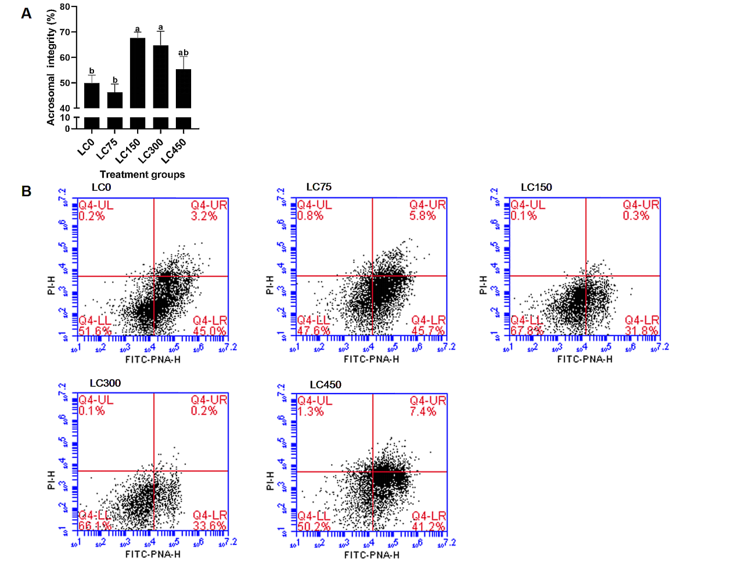

Fig. 1: Effects of supplementation with LC on spermatozoa acrosomal integrity. (A): Histogram of effects of different LC doses on the spermatozoa acrosomal integrity. (B): Flow cytometric assessment of spermatozoa acrosomal integrity using PNA-FITC/PI dual staining. Here, spermatozoa displaying negative PI staining and negative FITC-PNA staining were categorized as viable cells with an intact acrosomal membrane. Different superscript letters indicate significant differences between treatments (P<0.05).

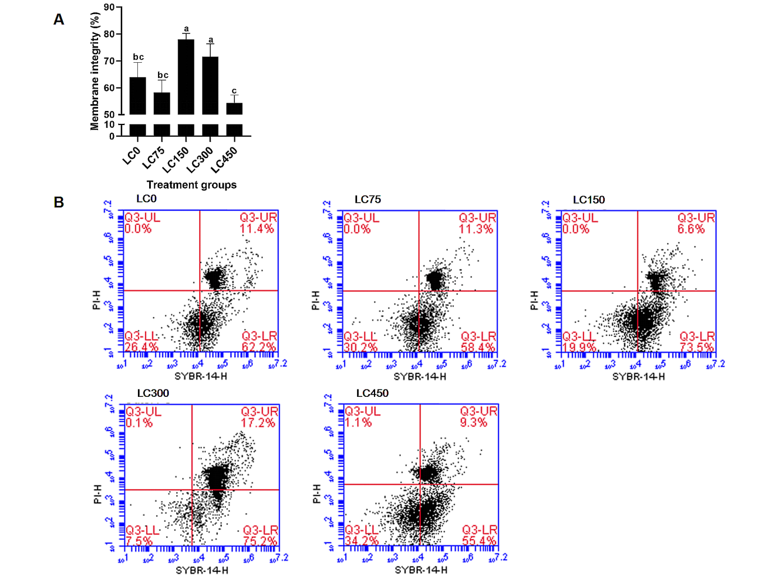

Fig. 2: Effects of supplementation with LC on spermatozoa membrane integrity. (A)Histogram of effects of different LC doses on the spermatozoa membrane integrity. (B): Flow cytometric assessment of spermatozoa plasma membrane integrity using SYBR-14/PI dual staining. Here, spermatozoa exhibiting negative PI staining but positive SYBR-14 staining were classified as viable cells with intact plasma membranes. Different superscript letters indicate significant differences between treatments (P<0.05).

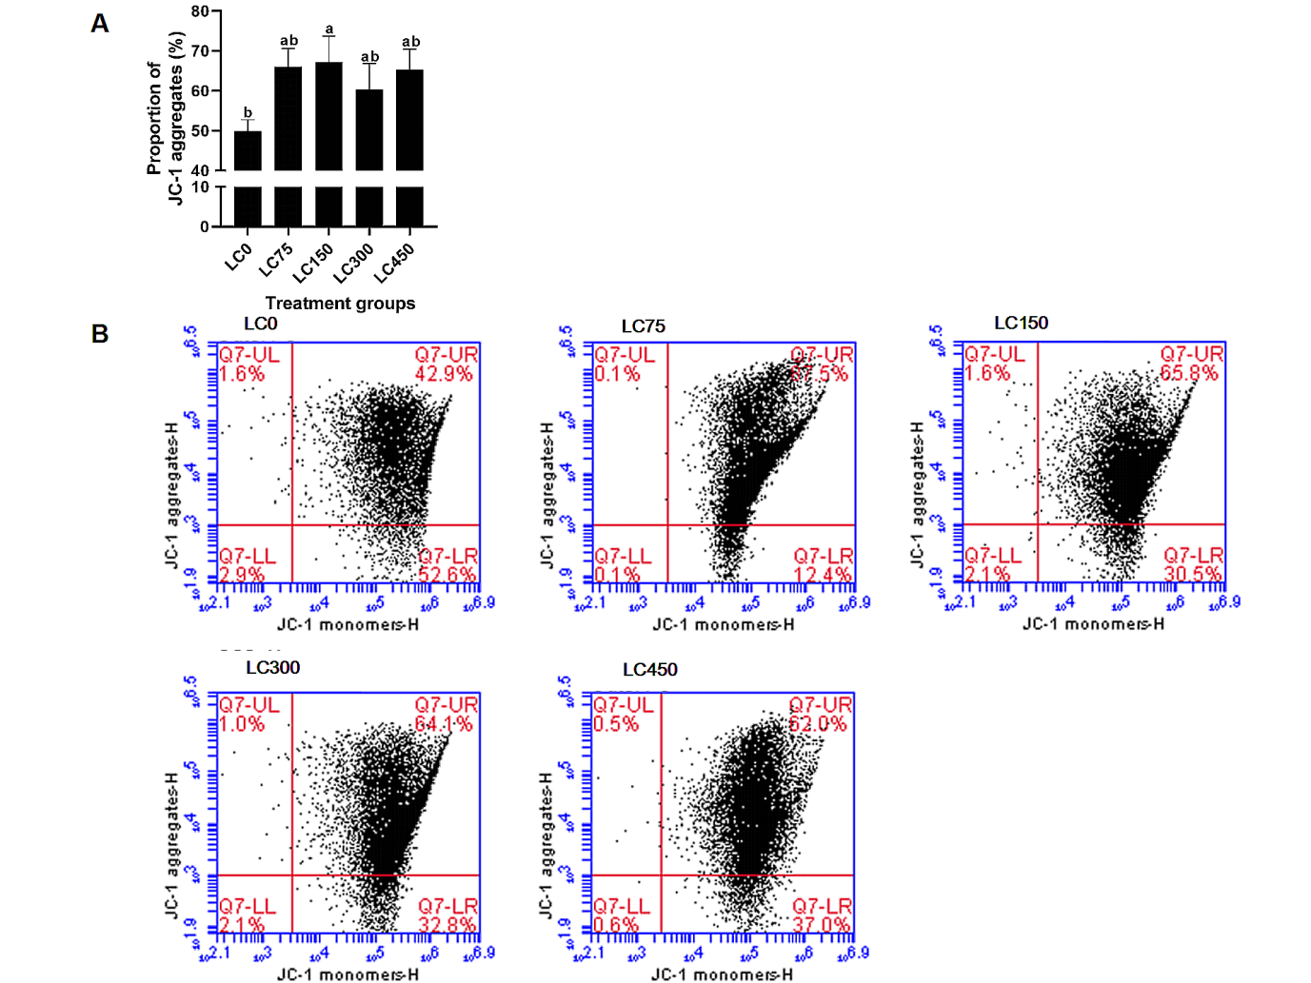

Fig. 3: Effects of dietary LC supplementation on spermatozoa MMP. (A): Histogram of the effects of different LC doses on spermatozoa MMP. (B): Flow cytometric assessment of spermatozoa MMP using JC-1 staining. Here, JC-1 aggregates were indicative of the sperm with normal MMP (emitting red fluorescence), while JC-1 monomers showed the sperm with a reduced MMP (emitting green fluorescence). Different superscript letters indicate significant differences between treatments (P<0.05).

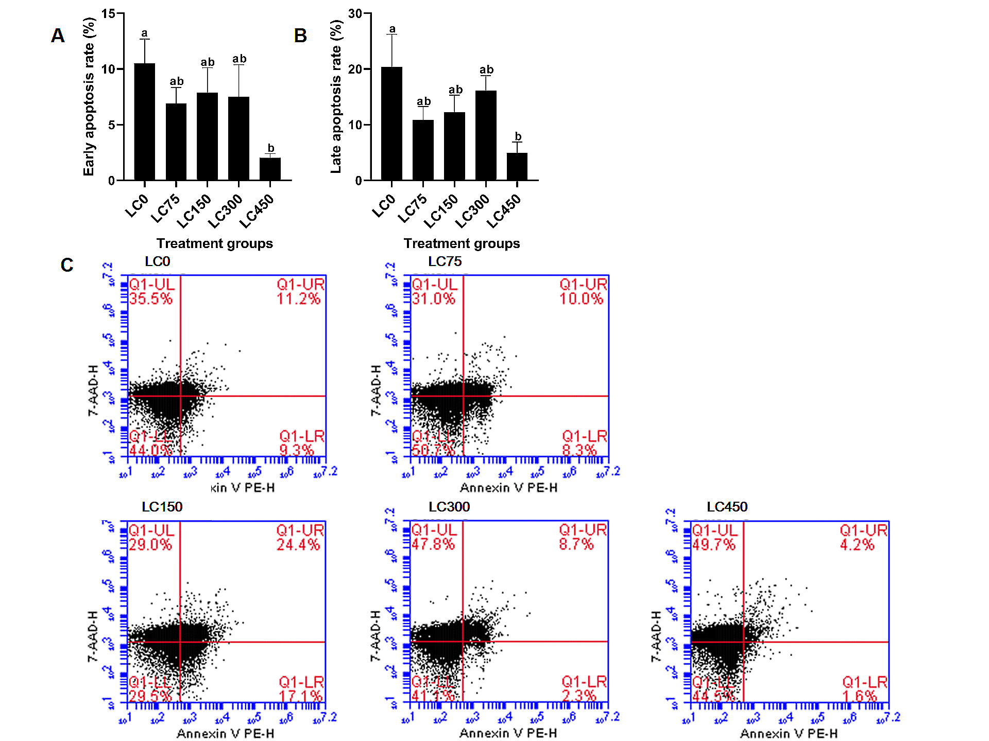

Fig. 4: Effects of dietary LC supplementation on spermatozoa apoptosis. (A): Histogram of the effects of different LC doses on spermatozoa early apoptosis. (B): Histogram of the effects of different LC doses on spermatozoa late apoptosis. (C): Flow cytometric assessment of spermatozoa apoptosis using dual Annexin V PE and 7-AAD staining. Here, spermatozoa with negative 7-AAD staining but positive Annexin V-PE staining were classified as early apoptotic, while those with positive 7-AAD and Annexin V-PE staining were defined as late apoptotic. Different superscript letters indicate significant differences between treatments (P<0.05).

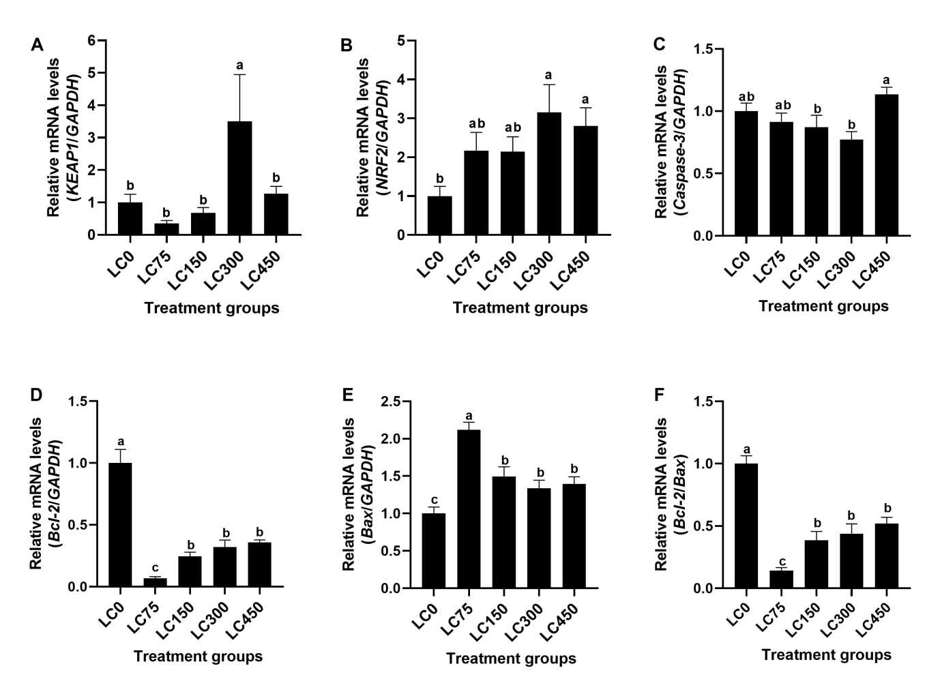

Fig. 5: The qRT-PCR of mRNA levels in semen after dietary LC supplementation: (A): KEAP-1, (B): NRF-2, (C): Caspase-3, (D): Bcl-2, (E): Bax, (F): Bcl-2/Bax ratio. Different superscript letters indicate significant differences between treatments (P< 0.05).

DISCUSSION

Dietary supplementation is commonly employed in intensive livestock production, particularly when enhanced animal growth and reproductive performance are required (Wu et al., 2020). Inadequate nutrition has the potential to impair fertility and exert adverse effects on production economics (Dong et al., 2016). Thus, incorporating key nutrients that are essential for spermatogenesis into the feed may contribute to the improvement of semen quality. These nutritional interventions are likely to improve the function of the reproductive axis in male rabbits, ultimately resulting in improved reproductive performance (Blagojević et al., 2024). Numerous studies have demonstrated that supplemented diets containing antioxidants, trace elements, omega-3 fatty acids, and other bioactive compounds can positively influence buck semen quality, including sperm motility, viability, and DNA integrity (Díaz-Cano et al., 2021; El-Ratel et al., 2021; Dhaigude et al., 2025). In the present study, LC300 supplementation exerted significant beneficial effects, not only increasing semen volume, sperm concentration, improving total and progressive sperm motility but also improving sperm kinematic parameters such as VCL, VAP, BCF, ALH, STR, and LIN.
Overproduction of ROS, triggered by physiological or environmental factors, impairs male fertility by causing oxidative stress, sperm DNA damage, and membrane dysfunction, ultimately compromising reproductive performance (Martin-Hidalgo et al., 2019). To address the imbalance between natural defense systems of the body and ROS and improve fertility, antioxidants play a key role in restoring balance and reducing oxidative damage (Cilio et al., 2022). Commonly used antioxidants are divided into enzymatic (such as SOD, GSH-Px and CAT, which catalyzes the dismutation of superoxide radicals) and non-enzymatic, such as Vitamin C, Vitamin E, which are endogenous or dietary free radical scavengers (Cilio et al., 2022). L-carnitine (LC) is a powerful free radical scavenger and can regulate mitochondrial β-oxidation, thereby reduce ROS production and enhances endogenous antioxidant defenses of the body in mammals (Vaz et al., 2002; Neuman et al., 2002) It is mainly sourced 75% from diet (such as meat, milk, fish) and 25% from endogenous synthesis in the liver and kidneys using amino acids. Studies indicate that stress, vegetarian diets, or excessive exercise may reduce LC synthesis, potentially causing muscle weakness, metabolic disorders, and reproductive dysfunction (Karlic and Lohninger, 2004; Pekala et al., 2011). The content of free LC in seminal plasma is positively correlated with sperm count and motility (Jeulin and Lewin, 1996). In the present study, the activity of antioxidant enzymes in seminal plasma and sperm increased to varying degrees in all LC treatment groups, while ROS levels decreased significantly. The effect was most obvious in the 300mg/kg LC group, where the activities of SOD, CAT, and GSH-Px increased significantly compared to LC0 group (P<0.05), indicating enhanced enzymatic antioxidant capacity. In addition, in each LC treatment group, the increase in antioxidant enzyme activity and the decrease in ROS were closely associated with varying degrees of improvement in semen quality parameters, confirming a link between LC supplementation, redox regulation, and improved reproductive performance.
NRF-2 serves as a master regulator of endogenous antioxidant responses, orchestrating a gene network essential for maintaining cellular redox homeostasis (Signorini et al., 2024). Under oxidative stress, NRF-2 dissociates from its cytoplasmic repressor KEAP-1, translocates to the nucleus, and binds antioxidant response elements (AREs). This activates downstream cytoprotective genes, including heme oxygenase-1 (HO-1), enhancing ROS scavenging capacity and mitigating oxidative damage (Kensler et al., 2007). Critically, reduced NRF-2 expression in sperm from oligospermic patients underscores its pivotal role in spermatogenesis and male fertility (Han et al., 2022; Ghareghomi et al., 2022). LC counteracts oxidative stress partly through NRF-2 interaction (Aydos et al., 2021). By activating this pathway, LC upregulates genes involved in ROS elimination, improving spermatogenesis, sperm motility, and DNA repair, thereby supporting male reproductive function (Cao et al., 2015; Han et al., 2022). Supporting this mechanism, it has been demonstrated that LC treatment elevates NRF-2, HO-1, and γ-glutamyl cysteine synthetase (γ-GCS) while suppressing KEAP-1 expression in retinal cells, indicating that LC modulates the KEAP-1-NRF-2 axis to improve antioxidant defenses (Cao et al., 2015; Aydos et al., 2021). Consistent with this, our study found LC300 supplementation significantly upregulated both NRF-2 and KEAP-1 mRNA expression in sperm. It appears that sustained NRF-2 activation under LC300 may induce compensatory KEAP-1 upregulation via feedback mechanisms involving other transcription factors, ultimately maintaining redox homeostasis (Wakabayashi et al., 2010).
While physiological ROS levels are essential for sperm capacitation and fertilization, excessive ROS generation overwhelms antioxidant defenses, leading to LPO and membrane damage (Wright et al., 2014). This process impairs the functional integrity and fluidity of the sperm plasma membrane, which is rich in polyunsaturated fatty acids (PUFAs), and generates toxic byproducts like MDA and 4-hydroxynonenal (4-HNE) that further degrade sperm quality (Gomez et al., 1998; Hosen et al., 2015). LC mitigates oxidative imbalance by transporting long-chain fatty acids into mitochondria (Vaz et al., 2002), reducing LPO substrates and enhancing antioxidant capacity (Neuman et al., 2002), consistent with its role in male fertility (Hafezi et al., 2022. In this study, supplementation with LC at 150 or 300mg/kg to commercial rabbit diet improved the integrity of both the sperm plasma membrane and acrosome. Furthermore, during liquid storage or cryopreservation of human (Ghorbani et al., 2021), boar (Li et al., 2022) and rabbit sperm (Abdelatty et al., 2022), LC exhibited excellent protective effects on the integrity of the sperm plasma membrane and acrosome. It enhances sperm motility and viability through multiple mechanisms, including mitigating plasma membrane lipid peroxidation by inhibiting ROS production, chelating iron ions critical for hydroxyl radical formation, and scavenging free radicals, as well as eliminating toxic metabolites by binding to acyl residues from amino acid intermediary metabolism (Virmani and Cirulli, 2022). It also stabilizes membrane structures via interactions between its tri-methylamino and carboxylic groups and the polar heads of membrane phospholipids, glycolipids, and proteins, potentially through effects on phospholipid acetylation and its amphiphilic properties that enable charge-based interactions with the cell membrane surface (Virmani and Binienda, 2004). Collectively, these actions preserve cellular homeostasis, prevent toxic metabolite accumulation, and support the structural and functional integrity of sperm membranes.
Mitochondria serve as indispensable organelles central to ROS generation, energy metabolism, and cellular apoptosis (Mazat et al., 2020). However, excessive ROS induce mitochondrial damage by targeting PUFAs in mitochondrial membranes, thereby disrupting membrane permeability, reducing MMP, and impairing the electron transport chain and ATP synthesis (Li et al., 2021). Concurrently, ROS trigger the release of cytochrome C into the cytoplasm, initiating apoptotic cascades and overwhelming antioxidant defenses (Hosen et al., 2015; Virmani and Cirulli, 2022). Collectively, these mechanisms destabilize bioenergetic balance, promote sperm apoptosis, and compromise cellular homeostasis, with significant implications for sperm function and fertility (Treulen et al., 2015). LC counteracts these detrimental effects through multifaceted mechanisms. It potently safeguards sperm mitochondria against electron transport chain-derived ROS by scavenging free radicals, chelating iron ions, and upregulating mitochondrial antioxidants such as SOD, GSH, CAT, and GSH-Px (Elokil et al., 2019; Alharthi et al., 2020). Additionally, LC preserves the structural and genetic integrity of sperm mitochondria by stabilizing membrane architecture and protecting DNA, thereby modulating apoptotic signaling pathways in sperm cells (Modanloo and Shokrzadeh, 2019). The protective role of LC in mitochondrial function was validated in this study through multiple lines of evidence. Results from MMP assays, sperm apoptosis rate analyses, and mRNA expression profiling of apoptosis-related genes demonstrated enhanced mitochondrial stability, reduced cell death, and molecular-level confirmation of regulatory effects of LC on apoptotic cascades. Collectively, these findings directly and indirectly corroborate the mitochondrial protective efficacy of LC, underscoring its potential in preserving sperm quality and fertility.

Conclusions: Dietary LC300 supplementation enhances semen quality in Fujian Yellow male rabbits by improving fresh semen parameters, elevating antioxidant capacity in seminal plasma and sperm, preserving sperm membrane integrity, modulating mitochondrial function and apoptosis. Moreover, dietary LC300 supplementation also activates the NRF-2 pathway, improving the cryopreservation resilience. Therefore, LC demonstrates efficacy in mitigating oxidative damage and supporting reproductive function for commercial rabbit production.

Authors’ contributions: Chengfang Gao was responsible for data curation, formal analysis, investigation, methodology, visualization, and writing original draft. Ming Liu and Liya Bai are co-first authors and were responsible for formal analysis, methodology, writing, review and editing. Yuxiang Lan, Shikun Sun and Jinxiang Wang assisted with testing, data analysis and method guidance. The main responsibility of Xiping Xie and Dongjin Chen was conceptualization, funding acquisition and project administration. Lei Sang was responsible for conceptualization, funding acquisition, project administration, resources, supervision, writing review and editing. All authors approved the final version of the manuscript.

Declaration of competing interest: The authors declare that there is no conflict of interest.

Funding: This work was supported by the China Modern Agriculture Industry Technology System Construction Project (CARS-43-G-5); Fujian Academy of Agricultural Sciences Free Exploration of Technological Innovation Project (ZYTS202424); Fujian Province Science and Technology Public Welfare Special Project (2023R1024008); International Collaboration Project of Fujian Academy of Agricultural Sciences (DWHZ2024-04); Open Fund of the Key Laboratory of Livestock and Poultry Genetic Breeding of Fujian Province (FJXQKFJJ2024).

Acknowledgements: The authors are thankful to the Lianjiang Yuhuashan Yellow Rabbit Ecological Farm for the supply of the rabbits for this experiment. Thanks to the Institute of Agricultural Biotechnology, Fujian Academy of Agricultural Sciences for the provision of flow cytometer. We are particularly grateful to Mr. Lan Yuxiang for his help during the experiment.

REFERENCES

Abdelatty AM, Badr OAM, Mohamed SA, et al., 2022. Long term conjugated linoleic acid supplementation modestly improved growth performance but induced testicular tissue apoptosis and reduced sperm quality in male rabbit. PLoS One 15(1): e0226070.
Abdelnour SA, Hassan MAE, El-Ratel IT, et al., 2022. Effect of addition of L-carnitine to cryopreservation extender on rabbit post-thaw semen parameters, antioxidant capacity, mitochondrial function, apoptosis and ultrastructure changes. Reprod Domest Anim 57(8):902-11.
Abdelnour SA, Khalil WA, Khalifa NE, et al., 2024. L-proline: a promising tool for boosting cryotolerance and fertilizing ability of cryopreserved sperm in animals. Anim Reprod Sci 263:107429.
Ahangari JY, Parizadian B, Akhlaghi A, et al., 2014. Effect of dietary L-carnitine supplementation on semen characteristics of male Japanese quail. Comp Clin Pathol 23(1):47-51.
Alharthi WA, Hamza RZ, Elmahdi MM, et al., 2020. Selenium and L-carnitine ameliorate reproductive toxicity induced by cadmium in male mice. Biol Trace Elem Res 197:619-27.
Aydos OS, Yukselten Y, Aydos D, et al., 2021. Relationship between functional NRF2 gene promoter polymorphism and sperm DNA damage in male infertility. Syst Biol Reprod Med 67:399-412.
Blagojević J, Stanimirović Z, Glavinić U, et al., 2024. Impact of supplemented nutrition on semen quality, epigenetic-related gene expression, and oxidative status in boars. Animals (Basel) 14(22):3297.
Brecchia G, Muça G, Munga A, et al., 2023. Goji berry in the diet of the rabbit buck: effects on semen quality, oxidative status and histological features of the reproductive tract. Antioxidants (Basel) 12(11):1959.
Cao Y, Li X, Wang C, et al., 2015. Role of NF-E2-related factor 2 in neuroprotective effect of L-Carnitine against high glucose-induced oxidative stress in the retinal ganglion cells. Biomed Pharmacother 69:345-348.
Cilio S, Rienzo M, Villano G, et al., 2022. Beneficial effects of antioxidants in male infertility management: a narrative review. Oxygen 2(1):1-11.
Cullere M and Zotte AD, 2018. Rabbit meat production and consumption: State of knowledge and future perspectives. Meat Sci 143:137-46.
Dhaigude V, Chaudhary P, Nair MP, et al., 2025. Effects of specific micronutrients on semen quality and reproductive outcomes in peripubertal Sahiwal bulls. Biol Trace Elem Res (prepublish):1-17. doi: 10.1007/s12011-025-04733-8.
Di Nisio A, De Toni L, Sabovic I, et al., 2023. Lipidomic profile of human sperm membrane identifies a clustering of lipids associated with semen quality and function. Int J Mol Sci 25(1):297.
Díaz-Cano JV, Argente MJ and García ML, 2021. Effect of postbiotic based on lactic acid bacteria on semen quality and health of male rabbits. Animals (Basel) 11(4):1007.
Dong HJ, Wu D, Xu SY, et al., 2016. Effect of dietary supplementation with amino acids on boar sperm quality and fertility. Anim Reprod Sci 172:182-89.
Elokil AA, Bhuiyan AA, Liu H, et al., 2019. The capability of L-carnitine-mediated antioxidant on cock during aging: evidence for the improved semen quality and enhanced testicular expressions of GnRH1, GnRHR, and melatonin receptors MT 1/2. Poult Sci 98:4172-81.
El-Ratel IT, Attia KAH, El-Raghi AA, et al., 2021. Relief of the negative effects of heat stress on semen quality, reproductive efficiency and oxidative capacity of rabbit bucks using different natural antioxidants. Anim Biosci 34(5):844-54.
Ewuola E, Lawanson, A and Adeyemi, AA, 2014. An improvised artificial vagina for rabbit semen collection and the characteristics of the extended rabbit semen as panacea for artificial insemination. Trop Anim Prod Invest 17: 19-24.
Farhadi R, Farshad A, Najafi A, et al., 2025. Improvement of cryopreserved epididymal ram sperm quality and fertility through curcumin nanoparticles. Theriogenology 243:117462.
Ghareghomi S, Habibi-Rezaei M, Arese M, et al., 2022. NRF2 modulation in breast cancer. Biomedicines 10(10):2668.
Ghorbani F, Nasiri Z, Koohestanidehaghi Y, et al., 2021. The antioxidant roles of L-carnitine and N-acetyl cysteine against oxidative stress on human sperm functional parameters during vitrification. Clin Exp Reprod Med 48(4):316-21.
Gomez E, Irvine DS and Aitken RJ, 1998. Evaluation of a spectrophotometric assay for the measurement of malondialdehyde and 4-hydroxyalkenals in human spermatozoa: relationships with semen quality and sperm function. Int J Androl 21(2):81-94.
Han P, Wang X, Zhou T, et al., 2022. Inhibition of ferroptosis attenuates oligospermia in male NRF2 knockout mice. Free Radic Biol Med 193:421-29.
Hafezi H, Vahdati A, Forouzanfar M, et al., 2022. Ameliorate effects of resveratrol and L-carnitine on the testicular tissue and sex hormones level in busulfan induced azoospermia rats. Theriogenology 191:47-53.
Hosen MB, Islam MR, Begum F, et al., 2015. Oxidative stress induced sperm DNA damage, a possible reason for male infertility. Iran J Reprod Med 13(9):525-32.
Hu Y, Hu J, Pang W, et al., 2022. Astaxanthin improves preserved semen quality at 17°C by enhancing sperm antioxidant and motility properties. Reprod Domest Anim 57(10):1187-97.
Jeulin C and Lewin LM, 1996. Role of free L-carnitine and acetyl-L-carnitine in post-gonadal maturation of mammalian spermatozoa. Hum Reprod Update 2(2):87-102.
Jimoh OA, Temidayo OD, Ololade HO, et al., 2023. Effect of phytogenic supplements on the reproductive physiology and metabolic hormones of rabbits exposed to heat stress conditions. J Therm Biol 112: 103438. doi: 10.1016/j.jtherbio.2022.103438.
Karlic H and Lohninger A, 2004. Supplementation of L-carnitine in athletes: does it make sense? Nutrition 20(7-8):709-15.
Kensler TW, Wakabayashi N and Biswal S, 2007. Cell survival responses to environmental stresses via the Keap1-NRF2-ARE pathway. Annu Rev Pharmacol Toxicol 47:89-116.
Lahimer M, Capelle S, Lefranc E, et al., 2025. Micronutrient-antioxidant therapy and male fertility improvement during ART Cycles. Nutrients 17(2):324.
Li D, Yang SJ, Xing YW, et al., 2021. Novel insights and current evidence for mechanisms of atherosclerosis: mitochondrial dynamics as a potential therapeutic target. Front Cell Dev Biol 9:673839.
Li JW, Li JC, Wang SB, et al., 2024. Post-thaw storage temperature influenced boar sperm quality and lifespan through apoptosis and lipid peroxidation. Animals 14:87.
Li RN, Wu XD, Zhu ZD, et al., 2022. Polyamines protect boar sperm from oxidative stress in vitro. J Anim Sci 100(4): skac069.
Lin L, Tao L, Famingzi L, et al., 2020. The influence of L-carnitine on the expression of miRNAs in asthenospermia spermatozoa and the network regulation of the associated molecules. Andrologia 52(1): e13478.
Liu C, Cao X, Yang FY, et al., 2014. Effects of angiotensin-(1-7) on oxidative stress and adiponectin in adipocytes. J Capital Med Univ 35(1):45-50.
Makris A, Alevra AI, Exadactylos A, et al., 2023. The role of melatonin to ameliorate oxidative stress in sperm cells. Int J Mol Sci 24(20):15056.
Mane NS, Puri DB, Mane Sanjay, et al., 2023. Separation of motile human sperms in a T-shaped sealed microchannel. Biomed Engineer Letters 12(3): 331-42.
Martin-Hidalgo D, Bragado MJ, Batista AR, et al., 2019. Antioxidants and male fertility: from molecular studies to clinical evidence. Antioxidants (Basel) 8(4):89.
Mazat JP, Devin A and Ransac S, 2020. Modelling mitochondrial ROS production by the respiratory chain. Cell Mol Life Sci 77(3):455-65.
Modanloo M and Shokrzadeh M, 2019. Analyzing mitochondrial dysfunction, oxidative stress, and apoptosis: potential role of L-carnitine. Iran J Kidney Dis 13(2):74-86.
National Research Council (NRC), 1997. Nutrient Requirements of Rabbits. 2nd Ed, Washington, DC, USA: National Academies Press.
Neuman SL, Lin TL and Hester PY, 2002. The effect of dietary carnitine on semen traits of white Leghorn roosters. Poult Sci 81:495-503.
O'Flaherty C and Scarlata E, 2022. Oxidative stress and reproductive function: the protection of mammalian spermatozoa against oxidative stress. Reproduction 164(6): F67-F78.
Ofosu J, Qazi IH, Fang Y, et al., 2021. Use of melatonin in sperm cryopreservation of farm animals: A brief review. Anim Reprod Sci 233:106850.
Peña FJ, Johannisson A, Wallgren M, et al., 2003. Assessment of fresh and frozen-thawed boar semen using an Annexin-V assay: A new method of evaluating sperm membrane integrity. Theriogenology 60(4):677-89.
Pekala J, Patkowska-Sokoła B, Bodkowski R, et al., 2011. L-carnitine--metabolic functions and meaning in human life. Curr Drug Metab 12(7):667-78.
Signorini C, Saso L, Ghareghomi S, et al., 2024. Redox homeostasis and NRF2-regulated mechanisms are relevant to male infertility. Antioxidants (Basel) 13(2):193.
Tatemoto H, Osokoshi N, Hirai M, et al., 2022. Addition of L-carnitine to the freezing extender improves post-thaw sperm quality of Okinawan native Agu pig. Theriogenology 188:170-76.
Treulen F, Uribe P, Boguen R, et al., 2015. Mitochondrial permeability transition increases reactive oxygen species production and induces DNA fragmentation in human spermatozoa. Hum Reprod 30(4):767-76.
Vaz FM, Melegh B, Bene J, et al., 2002. Analysis of carnitine biosynthesis metabolites in urine by HPLC-electrospray tandem mass spectrometry. Clin Chem 361(3):417-29.
Virmani A and Binienda Z, 2004. Role of carnitine esters in brain neuropathology. Mol Aspects Med 25(5-6):533-49.
Virmani MA and Cirulli M, 2022. The Role of L-carnitine in mitochondria, prevention of metabolic inflexibility and disease initiation. Int J Mol Sci 23(5):2717.
Wakabayashi N, Shin S, Slocum SL, et al., 2010. Regulation of notch1 signaling by NRF2: implications for tissue regeneration. Sci Signal 3(130):ra52.
Wang X, Huang S, Zhao Y, et al., 2025. Activation of autophagy is required for clearance of mitochondrial ROS in patients with asthenozoospermia. Peer J 13: e18827.
Wright C, Milne S and Leeson H, 2014. Sperm DNA damage caused by oxidative stress: modifiable clinical, lifestyle and nutritional factors in male infertility. Reprod Biomed Online 28(6):684-703.
Wu Y, Zhao JF, Xu CC, et al., 2020. Progress towards pig nutrition in the last 27 years. J Sci Food Agric 100(14):5102-10.
Zhang W, Min L, Li Y, et al., 2022. Beneficial effect of proline supplementation on goat spermatozoa quality during cryopreservation. Animals 12: 2626.

